**CREATE A CHATBOT USING PYTHON**

**INTRODUCTION:**

the essential activities of feature engineering and model training, ensuring your chatbot becomes a proficient communicator. This project will equip you with the skills to enhance your chatbot's ability to understand, respond, and engage in meaningful conversations. Whether you're a beginner or a seasoned developer, this guide will provide you with valuable insights into the world of chatbot development.

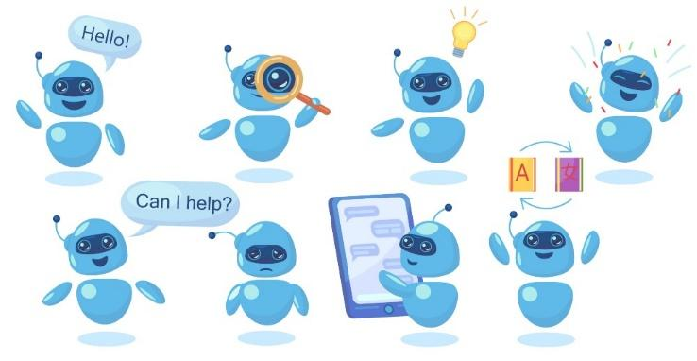

**Table of contents:**

* Data collection
* Data preprocessing

-->Test Cleaning

-->Tokenization

-->Normalization

* feature engineering.

-->Word Embeddings

-->Contextual Embeddings

* Data labeling.
* Model selection.
* Model training.
* Integration.
* User interface.
* Testing and evaluation.
* Deployment.
* Data Collection:

Start by gathering the necessary data for your chatbot. This could be existing Conversations of data related to the chatbot's domain.

* Data Preprocessing:

--->Text Cleaning:

Remove any irrelevant characters, Symbols or special characters.

---> Tokenization:

Spilt text into words or phrases.

--->Normalization:

Convert text to lower cases

* Feature Engineering:

---> Word embeddings:

Convert words into numerical vectors using a technique like word2Vec, Fast text, or pre-trained embeddings like Word2Vec and gloVe.

---> Contextual embeddings:

Use models like BERT or GPT to capture contextual information.

* Data labeling:

Annotate Your data with labels or intents that your chatbot should understand.

* Model selection:

Choose a suitable Natural language processing (NLP) or machine learning model. Common choices include RNNs, CNNs, Transforms, or pre-trained models like gpt-3

* Model training:
* Spilt your data into training and validation sets
* Train your model on the labeled data
* Fine-tune the model if necessary.
* Integration:
* Integrate your trained model into a chatbot framework or platform, like Dailogflow, Rasa, or your custom python application
* User Interface:

Create a user-friendly interface for users to interact with your chatbot.

You can use web frameworks like flask or django for this.

* Testing and Evaluation:

Test your chatbot with real user interaction.

Evaluate its performance using metrics like accuracy, precision, recall and F1-scores.

* Deployment:

Deploy your chatbot on a web server or cloud platform, such as AWS, Azure, or Heroku.

**Flow chart**

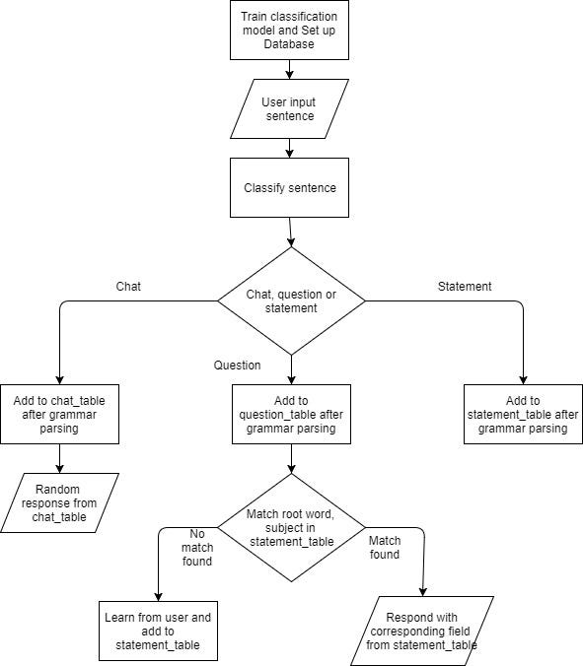

**Libraries to build training model for chatbot:**

* **Natural Language Processing (NLP) Libraries**
* **Machine Learning Frameworks**
* **Pre-trained Models**
* **Web Frameworks**
* **Data Storage and Retrieval**
* **Front-end Development (Optional)**
* **APIs and Integration**
* **Deployment and Hosting**
* **Natural Language Processing (NLP) Libraries:**

NLTK (Natural Language Toolkit)

spaCy

TextBlob

Gensim

* **Machine Learning Frameworks:**

Scikit-learn:

For building machine learning models.

TensorFlow and Keras:

Useful for building deep learning models, including neural networks.

PyTorch:

Another deep learning framework, widely used for NLP tasks.

* **Pre-trained Models:**

Hugging Face Transformers:

Offers pre-trained models for a variety of NLP tasks.

OpenAI GPT-3:

If you have access, GPT-3 can be used for chatbot development.

* **Web Frameworks:**

Flask or Django:

For building the backend of your chatbot.

* **Data Storage and Retrieval:**

SQLite or MySQL:

To store and manage data.

Redis or Memcached:

For catching and optimizing responses.

* **Front-end Development (Optional):**

HTML, CSS, JavaScript, and web frameworks like React or Vue.js if you want to create a web-based user interface.

* **APIs and Integration:**

If you want to integrate your chatbot with other platforms or services, you'll need to use various APIs relevant to your use case.

* **Deployment and Hosting:**

Platforms like Heroku, AWS, or Azure can be used for deploying your chatbot.

**Source Code to build a chatbot in python:**

|  |
| --- |
| import nltk  from nltk.chat.util import Chat, reflections    # Define a list of patterns and responses  pattern_response_pairs = [  (r'hello|hi|hey', ['Hello!', 'Hi there!', 'Hey!']),  (r'how are you', ['I am just a computer program, but I am doing well. How can I help you?']),  (r'what is your name', ['I am a chatbot, and you can call me ChatGPT.']),  (r'bye|goodbye', ['Goodbye!', 'Have a great day!']),  ]    # Create a chatbot  chatbot = Chat (pattern_response_pairs, reflections)    # Start the conversation  print ("ChatGPT: Hello! How can I assist you today? (type 'bye' to exit)")  while True:  user_input = input ("You: ")  if user_input.lower() == 'bye':  print ("ChatGPT: Goodbye!")  break  response = chatbot.respond(user_input)  print ("ChatGPT:", response) |

**libraries to build the feature engineering for chatbot:**

**Data Preprocessing**:

* Tokenization: Split text into words or subword tokens.
* Lowercasing: Convert text to lowercase for uniformity.
* Removing Stop Words: Eliminate common words that don't carry much meaning.

|  |
| --- |
| **import nltk**  **from nltk.corpus import stop words**  **from nltk.tokenize import word_tokenize**    **nltk.download('stopwords')**  **nltk.download('punkt')**    **def preprocess_text(text):**  **# Tokenization**  **tokens = word_tokenize(text)**  **# Lowercasing**  **tokens = [word.lower() for word in tokens]**  **# Removing Stop Words**  **tokens = [word for word in tokens if word not in stopwords.words('english')]**  **return tokens** |

* **Bag of Words (BoW):**

Convert text to a vector of word frequencies.

* **TF-IDF (Term Frequency-Inverse Document Frequency):**

Represent text based on word importance.

|  |
| --- |
| **from sklearn.feature_extraction.text import CountVectorizer, TfidfVectorizer**    **# Create BoW and TF-IDF vectorizers**  **bow_vectorizer = CountVectorizer()**  **tfidf_vectorizer = TfidfVectorizer()**    **# Fit and transform your text data**  **X_bow = bow_vectorizer.fit_transform(preprocessed_texts)**  **X_tfidf = tfidf_vectorizer.fit_transform(preprocessed_texts)** |

* **Word Embeddings**:

You can use pre-trained word embeddings like Word2Vec, GloVe, or fast Text for more advanced feature engineering.

* **Contextual Features**:

For context-aware chatbots, consider maintaining conversation history to capture context.

* **Feature Selection/Reduction**:

Dimensionality reduction techniques like PCA or LSA can be applied.

* **Model Input Preparation**:

Prepare input features for your chatbot model using the processed text data.

**Conclusion:**

In conclusion, creating a training model for a chatbot in Python involves several key steps. These include data collection and preprocessing, selecting a suitable machine learning or natural language processing framework, training the model on relevant datasets, fine-tuning to improve performance, and deploying the chatbot for interaction. It's essential to continuously evaluate and update the model to ensure it provides accurate and helpful responses. Building a chatbot model in Python can be a rewarding endeavor, offering the potential to enhance user experiences and automate customer support, among other applications.