**CREATE A CHATBOT USING PYTHON**

**INTRODUCTION:**

A chatbot is a computer program or artificial intelligence system designed to engage in text-based or voice-based conversations with users. Chatbots are typically used to interact with humans in a conversational manner, providing information, answering questions, performing tasks, or simulating human-like conversation.

They can be found in various applications and settings, such as customer service, virtual assistants, e-commerce, and more. Chatbots can be rule-based, following predefined scripts, or powered by natural language processing and machine learning algorithms, allowing them to understand and respond to user input in a more dynamic and context-aware way.

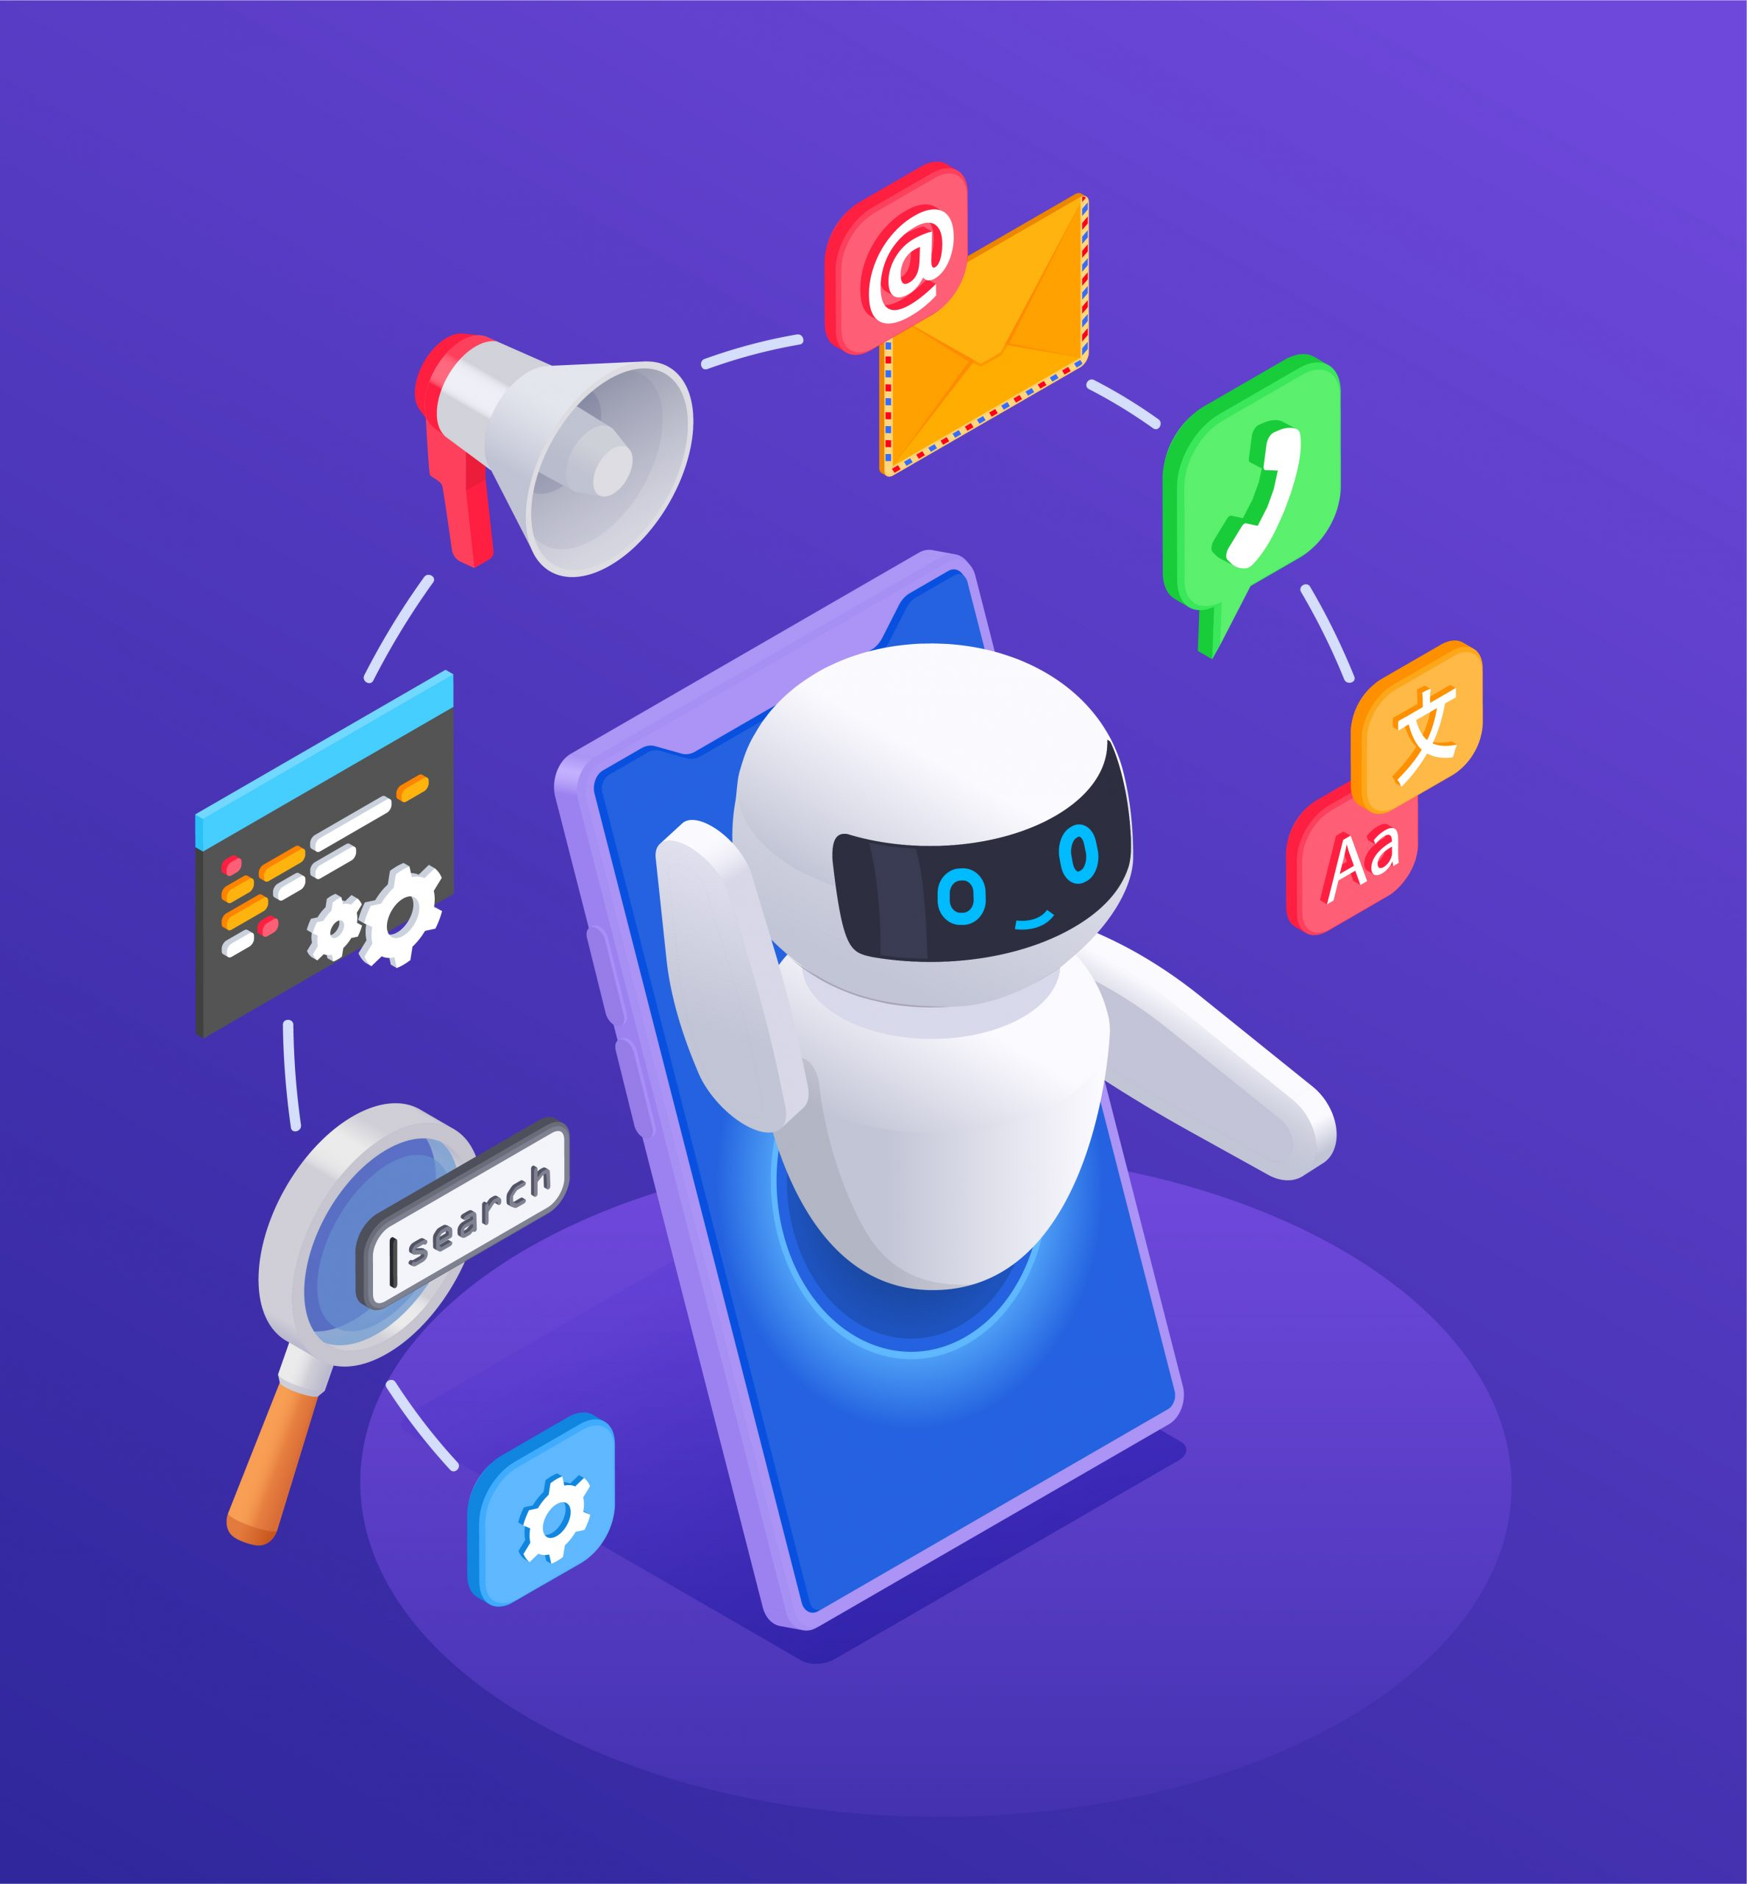

**HOW DO CHATBOTS WORKS?**

There are generally two types of bots: Artificial Intelligence (AI) and Machine Learning (ML) chatbots.

**Rule-based chatbot:**

* + - A rule-based bot can only comprehend a limited range of choice

that it has been programmed.

**AI-based chatbot:**

* + - It is trained using machine-learning algorithms and can understand

opened queries.

**PROBLEM STATEMENT:**

The goal of this project is to design and develop a chatbot using the Python programming language. The chatbot should be able to engage in text-based conversations with users, provide information, answer questions, and perform specific tasks based on user input.

The problem statement before LLMs in chatbots was how to design prompts to collect user self-reported data while maintaining natural conversation flows. The problem with chatbots before LLMs was their reliance on pre-set queries and responses, limiting their flexibility and human-like interaction.

**Design thinking process:**

**Define:**

* Clearly define the problem the chatbot will solve.
* Create user personas and use cases to specify who the chatbot is for and what it will do.

**Prototype:**

* Create a rough, low-fidelity prototype of the chatbot's interface and conversational flow.
* Use wireframes or mockups to visualize the chatbot's design.

**Test:**

* Gather feedback on the prototype by involving potential users.
* Iterate on the design based on the feedback received.

**Develop:**

* Start building the chatbot using Python and relevant frameworks or libraries (e.g., NLTK, spaCy, or Rasa).
* Implement natural language processing (NLP) for understanding and generating text-based conversations.

**PHASES OF DOCUMENT:**

* **Define the Purpose:**

Determine the specific purpose and functionality of your chatbot. Is it for customer support, information retrieval, or entertainment.

* **Gather Data:**

Collect the data your chatbot will need to function effectively, such as FAQs, responses, and user interactions.

* **Choose a Framework or Library:**

Select a Python framework or library for building your chatbot. Popular choices include Chatterbot, NLTK, spaCy, and Rasa.

* **Natural Language Processing (NLP):**

Implement NLP techniques to understand and process user input. Tokenization, stemming, and part-of-speech tagging are common NLP tasks.

* **Training Data:**

Train your chatbot using the gathered data and NLP techniques. Supervised or unsupervised learning methods can be applied, depending on the complexity of your chatbot.

* **Dialog Flow:**

Design the conversation flow and dialog management. Decide how the chatbot should respond to different user inputs.

* **Deployment:**

Deploy the chatbot to a server or platform where it can be accessed by users.

* **Monitoring and Maintenance:**

Continuously monitor the chatbot's performance, address any issues, and keep the knowledge base up to date.

**Nltk program using create a chatbot using python:**

--> Install NLTK if you haven't already:

|  |
| --- |
| pip install nltk |

--> Import necessary libraries and download NLTK data:

|  |
| --- |
| import nltk  from nltk.chat.util import Chat, reflections  nltk.download('punkt') |

* Define your chatbot's responses and patterns. You can add more patterns and responses to make your chatbot more interactive. In this example, I'll create a basic chatbot that responds to greetings and goodbyes.

|  |
| --- |
| # Define chatbot responses  pairs = [  ['hi|hello|hey', ['Hello!', 'Hi there!', 'How can I help you?']],  ['how are you', ["I'm just a computer program, so I don't have feelings, but thanks for asking!"]],  ['goodbye|bye', ['Goodbye!', 'See you later!', 'Have a great day!']],  ]  # Create the chatbot  chatbot = Chat(pairs, reflections) |

* Create a function to interact with the chatbot:

|  |
| --- |
| def chat_with_bot():  print("Hello! I'm your chatbot. You can start a conversation or type 'bye' to exit.") while True:  user_input = input("You: ")  if user_input.lower() == 'bye':  print("Chatbot: Goodbye!")  Break  response = chatbot.respond(user_input)  print("Chatbot:", response) |

* Run the chatbot by calling the **chat_with_bot()** function:

|  |
| --- |
| if __name__ == "__main__":  chat_with_bot() |

**DATA SET TO CREATE CHATBOT:**

Creating a chatbot using Python typically involves working with a dataset that contains pairs of input messages and corresponding output responses. Here's a basic outline of how to describe the dataset.

* **Data Collection:**

Gather a dataset of conversational data. This can be obtained from various sources, such as chat logs, customer support interactions, or by creating your own dataset through user interactions.

* **Data Format:**

Organize your data into a structured format. Each entry in the dataset should have two components: an input message and a corresponding output response. You can use JSON or CSV format.

* **Model Selection:**

Choose a machine learning or deep learning model for your chatbot. Popular choices include Seq2Seq models, transformer-based models like GPT-3, or custom neural networks.

* **Model Training:**

Train your chosen model using the training data. This involves fitting the model to the input-output pairs and optimizing its parameters.

* + **Model Evaluation:**

Assess the performance of your chatbot using the testing data. Metrics like accuracy, BLEU score, or human evaluations can be used to measure its effectiveness.

**CHATBOT DATA PREPROCESSING:**  
 Creating a chatbot using Python involves several data preprocessing steps. Here's a high-level overview of the process:

**Data Collection:**

* Gather the data you'll use to train your chatbot. This can include text conversations, FAQ documents, or any relevant text data.

**Data Cleaning:**

* Remove any irrelevant or redundant information from your dataset.
* Handle missing or null values, if applicable.

**Lemmatization or Stemming:**

* Reduce words to their base or root form to ensure variations of words are treated the same way.

**Data Formatting:**

* Organize your data into a structured format, like a list of questions and answers.
* Label the data appropriately, especially if it's a supervised learning task.

**Data Splitting:**

* Split your dataset into training, validation, and test sets for model training and evaluation.

**Preprocessing Pipeline:**

* Create a preprocessing pipeline that combines all these steps to transform raw text data into a format suitable for training your chatbot model.

**FEATURE EXTRACTION TECHNIQUES:**

Feature extraction is a crucial part of natural language processing (NLP) for chatbots. Here are some common feature extraction techniques when building a chatbot using Python.

**Preprocessing and Tokenization:**

* Cleaning and tokenizing text data is essential.
* Libraries like NLTK and spaCy can assist in text preprocessing.

**Custom Features:**

* You can create custom features based on your specific chatbot's needs.
* These could include features related to user behavior or domain-specific knowledge.

**Part-of-Speech (POS) Tagging:**

* Understanding the grammatical structure of text can be useful.
* spaCy and NLTK offer POS tagging functionalities.

**Word Embeddings:**

* Represent words as dense vectors in a continuous space.
* Pre-trained word embeddings like Word2Vec, GloVe, or using deep learning models like Word2Vec are beneficialy.

**MACHINE LEARNING ALGORITHM:**

To create a chatbot using Python, you can use a variety of machine learning algorithms and libraries. One of the most common approaches is to use a combination of natural language processing (NLP) techniques and machine learning models. Here's a simplified outline of the steps involved:

* **Data Collection**: Gather a dataset of conversation examples that your chatbot will learn from. This dataset should include user inputs and the corresponding chatbot responses.
* **Preprocessing**: Clean and preprocess the text data, which may include tasks like tokenization, lowercasing, and removing stop words.
* **Evaluation**: Evaluate the chatbot's performance using metrics like BLEU score, perplexity, or user satisfaction surveys.
* **Deployment**: Integrate the chatbot into your application or platform. You can create a web interface or integrate it with messaging platforms like Facebook Messenger or Slack.

The choice of algorithm and approach will depend on the complexity of the chatbot's intended use case.

**MODEL TRAINNING:**

Creating a chatbot using Python typically involves several steps, including model training. Here's a high-level overview of the process:

* **Data Collection:** Gather a dataset of conversations or text that your chatbot will be trained on. This data can be in the form of text files, CSVs, or other formats.
* **Preprocessing:** Clean and preprocess the data to remove any noise, format it for training, and tokenize it into sentences or words. You may also need to handle special characters, emojis, and other language-specific elements.
* **Training a Model:** Train your chatbot model using the preprocessed data. The choice of model depends on your chatbot's complexity. You can use rule-based models, retrieval-based models, or generative models like

GPT-3.

**Continuous Learning:** Consider implementing mechanisms for continuous learning and improvement, such as retraining your model with new data or user interactions.

Here's a simple example using the ChatterBot library:

|  |
| --- |
| from chatterbot import ChatBot  from chatterbot.trainers import ChatterBotCorpusTrainer  # Create a chatbot instance  chatbot = ChatBot('MyBot')  # Create a new trainer for the chatbot  trainer = ChatterBotCorpusTrainer(chatbot)  # Train the chatbot on English language data trainer.train('chatterbot.corpus.english')  # Get a response  response = chatbot.get_response('Hello, how are you?')  print(response) |

**Choose a Chatbot Framework:** Decide on the chatbot framework or library you want to use. Some popular options include ChatterBot, NLTK, spaCy, or using deep learning frameworks like TensorFlow or Py Torch.

**EVALUATION METRICS FOR CREATING THE CHATBOT USING PYTHON:**

When evaluating a chatbot created using Python, you can consider various metrics to assess its performance. Here are some common evaluation metrics:

* **User Satisfaction:** Gather user feedback through surveys or ratings to measure how satisfied users are with the chatbot's interactions.
* **Accuracy:** Evaluate the chatbot's ability to provide correct and relevant answers. This can be measured by comparing responses to a set of predefined correct answers.
* **Conversational Flow:** Analyze the chatbot's ability to maintain a coherent and meaningful conversation with users. Look for smooth transitions between topics.
* **Error Rate:** Calculate the rate of errors, misunderstandings, or irrelevant responses in conversations.
* **Security and Privacy: S** Ensure that the chatbot complies with security and privacy standards and evaluate its ability to handle sensitive information.
* **Scalability:** Test the chatbot's ability to handle a growing number of users and maintain performance.

**INNOVATION TECHNIQUES:**

Creating an innovative chatbot using Python involves combining various techniques and technologies. Here are some steps to get you started:

* **Natural Language Processing (NLP):** Implement NLP techniques to understand and generate human-like text. Libraries like NLTK, spaCy, and Transformers (Hugging Face) can be helpful.
* **Machine Learning:** Utilize machine learning algorithms to train your chatbot. You can use frameworks like TensorFlow or PyTorch for this purpose. Consider pre-trained models for faster development.
* **Data Collection:** Gather a diverse dataset of conversations to train your chatbot. You can use publicly available chat datasets or create your own. This is crucial for supervised learning.
* **Testing and Evaluation:** Continuously test and evaluate your chatbot's performance. Consider metrics like accuracy, response time, and user satisfaction.
* **Deployment:** Deploy your chatbot to a server or cloud platform for accessibility. Services like AWS, Azure, or Heroku can be used.
* **Ethical Considerations:** Ensure that your chatbot follows ethical guidelines, respects user privacy, and avoids harmful or biased behavior. Implement content moderation if needed.
* **Continuous Learning:** Keep up with the latest advancements in NLP and AI to update and enhance your chatbot over time.

**MAIN SOURCE CODE FOR CHATBOT:**

|  |
| --- |
| import nltk  from nltk.chat.util import Chat, reflections    # Define some pattern-response pairs  pairs = [  [  r"hi|hello|hey",  ["Hello!", "Hi there!", "Hey! How can I help you today?"]  ],  [  r"what is your name?",  ["I'm just a simple chatbot.", "I don't have a name. You can call me Chatbot."]  ],  [  r"how are you?",  ["I'm just a computer program, so I don't have feelings, but I'm here to assist you."]  ],  [  r"(.*) your name",  ["My name is Chatbot.", "You can call me Chatbot."]  ],  [  r"(.*) help (.*)",  ["I'm here to help. What do you need assistance with?"]  ],  [  r"(.*) programming language is the best",  ["The best programming language depends on your goals. Python is great for beginners, while C++ is powerful for system-level programming. It's important to choose the one that suits your project."]  ],  [  r"tell me a fun fact",  ["Sure! Did you know that honey never spoils? Archaeologists have found pots of honey in ancient Egyptian tombs that are over 3,000 years old and still perfectly edible."]  ],  [  r"who are you?",  ["I'm Chatbot, your virtual assistant. How can I assist you today?"]  ],  [  r"(.*) how old are you",  ["I don't have an age because I'm just a computer program."]  ],  [  r"what is the meaning of life?",  ["The meaning of life is a deep philosophical question that has been pondered for centuries. It's a topic with various interpretations. What are your thoughts on it?"]  ],  [  r"(.*) programming language is the best",  ["The best programming language depends on your goals. Python is great for beginners, while C++ is powerful for system-level programming. It's important to choose the one that suits your project."]  ],  [  r"what can you do?",  ["I can answer questions, tell jokes, provide information, and engage in conversation with you. How can I assist you today?"]  ],  [  r"thanks|thank you",  ["You're welcome! If you have any more questions or need assistance, feel free to ask."]  ],  [  r"(.*) recommend (.*)",  ["I recommend trying a new book, watching a movie, or going for a walk if you're looking for something to do."]  ],  [  r"how does (.*) work",  ["Explaining how %1 works might be quite complex. Could you please specify what exactly you'd like to know about %1?"]  ],  [  r"who is the first programmer in world?",  ["first programmer in world is Ms.Ada Lovelace.","You can call me Chatbot."]  ],    [  r"bye|quit",  ["Goodbye!", "Have a great day!"]  ]  ]    # Create a Chat instance  chatbot = Chat(pairs, reflections)  # Start the conversation  print("Hello! I'm your chatbot. Type 'bye' to exit.")  chatbot.converse() |

**OUTPUT:**

Hello! I'm your chatbot. Type 'bye' to exit.  
>hi  
Hello!  
>hello  
Hi there!  
>hey  
Hi there!  
>what is your name?  
I'm just a simple chatbot.  
>how are you?  
I'm just a computer program, so I don't have feelings, but I'm here to assist you.  
>(.*) your name  
My name is Chatbot.  
>(.*) help (.*)  
I'm here to help. What do you need assistance with?  
>(.*) programming language is the best  
The best programming language depends on your goals. Python is great for beginners, while C++ is powerful for system-level programming. It's important to choose the one that suits your project.  
>tell me a fun fact  
Sure! Did you know that honey never spoils? Archaeologists have found pots of honey in ancient Egyptian tombs that are over 3,000 years old and still perfectly edible.  
>who are you?  
I'm Chatbot, your virtual assistant. How can I assist you today?  
>(.*) how old are you  
I don't have an age because I'm just a computer program.  
>what is the meaning of life?  
The meaning of life is a deep philosophical question that has been pondered for centuries. It's a topic with various interpretations. What are your thoughts on it?  
>(.*) programming language is the best  
The best programming language depends on your goals. Python is great for beginners, while C++ is powerful for system-level programming. It's important to choose the one that suits your project.  
>what can you do?  
I can answer questions, tell jokes, provide information, and engage in conversation with you. How can I assist you today?  
>(.*) recommend (.*)  
I recommend trying a new book, watching a movie, or going for a walk if you're looking for something to do.  
>how does (.*) work  
Explaining how (.*) works might be quite complex. Could you please specify what exactly you'd like to know about (.*)?  
>who is the first programmer in world?  
first programmer in world is Ms.Ada Lovelace.  
>thanks  
You're welcome! If you have any more questions or need assistance, feel free to ask.  
>bye  
Goodbye!  
>quit  
Have a great day!

**PROGRAM EXPLAINATION:**

Importing necessary libraries:

* + **nltk** is imported, which is the Natural Language Toolkit library for natural language processing.
* **Chat** and **reflections** are imported from **nltk.chat.util**. **Chat** is a class that allows you to define pattern-response pairs for the chatbot, and **reflections** is a dictionary of default reflection patterns.
* Defining pattern-response pairs:
* The **pairs** list contains a set of regular expression patterns and corresponding responses. When the user inputs a message that matches one of these patterns, the chatbot will respond with the corresponding response.
* For example, if the user says "hi" or "hello" or "hey," the chatbot will respond with one of the greetings from the response list.
* Creating the chatbot instance:
* **chatbot = Chat(pairs, reflections)** creates an instance of the chatbot with the defined pattern-response pairs and reflections.
* Starting the conversation:
* The program starts a conversation with the user by printing a welcome message: "Hello! I'm your chatbot. Type 'bye' to exit."
* Using **chatbot.converse()**:
* This method initiates the chatbot's conversation loop. It listens to user input and matches it against the defined patterns in the **pairs** list. When a pattern is matched, the chatbot responds with the corresponding response.
* The conversation continues until the user types "bye" or "quit," at which point the chatbot responds with a goodbye message and the program ends.

**CONCLUSION:**

creating a chatbot using Python is an exciting and valuable endeavor. With Python's robust libraries and frameworks like NLTK, spaCy, or TensorFlow, combined with the power of natural language processing, you can develop chatbots that can engage in meaningful conversations, provide information, automate tasks, and enhance user experiences. Remember to consider the design, functionality, and user experience in your development process, and continuously improve your chatbot through user feedback and iterative development. Python's versatility and the vast resources available in the developer community make it an excellent choice for building intelligent chatbots.