**Top Tourist Attractions In Bangladesh :**

Bangladesh is a beautiful country with exotic beaches, hills, forests and other natural areas, coupled with modern facilities. Take a trip in this wonderful country with top 12 famous destinations.

**1. Dhaka: Largest and the most powerful city in Bangladesh**

[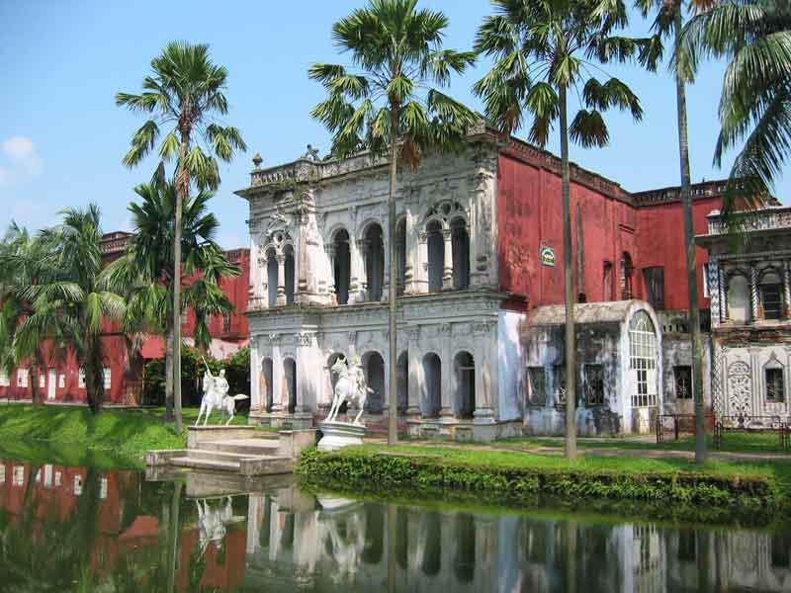](http://cdn.yourarticlelibrary.com/wp-content/uploads/2014/04/wgx_fs.jpg)

Image Courtesy : wikimedia.org/wikipedia/commons/9/94/Paharpur_03.JPG

Bangladesh’s capital city is an important tourist spot for everyone visiting this country, mainly for the historic significance of the places in and around this city.

The most important attractions of Dhaka are the Mughal fort complex “Lalbagh”, palace of Dhaka Nawab families “Ahsan Manzil”, monument remembering the brave warriors fighting and giving their lives for the Bengali language “Shaheed Minar”, and the national assembly of Bangladesh “Jatiya Sangshad”.

**2. Chittagong: Beautiful landscape with kind people**

[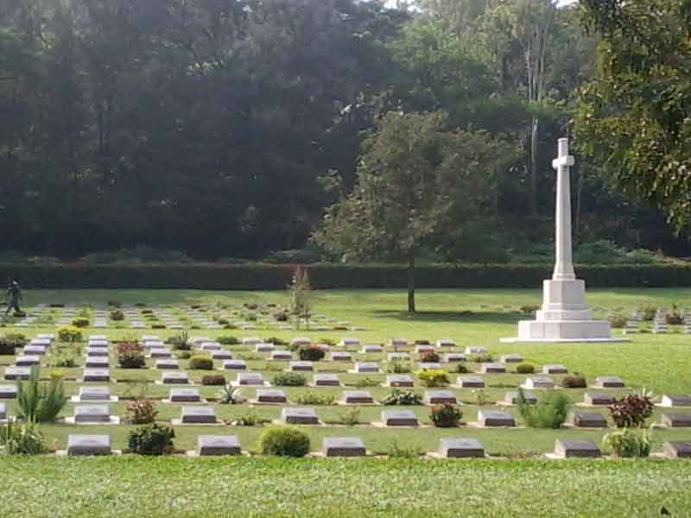](http://cdn.yourarticlelibrary.com/wp-content/uploads/2014/04/wcmtrycth2.jpg)

Image Courtesy : wikimedia.org/wikipedia/commons/9/94/cemetry.JPG

This area is very popular, mainly because of the big number of ethnic groups who are living here together. Tourists from all over the globe travel not just to enjoy the natural beauty of this place, but they also enjoy the unique experience like, dress, food, language and many other aspects of people in Chittagong.

The beaches and lakes in Chittagong are frequently visited by western tourists as they provide a relaxing luxury at an affordable price.

**3. Sylhet: The city of Hazrat Shah Jalal**[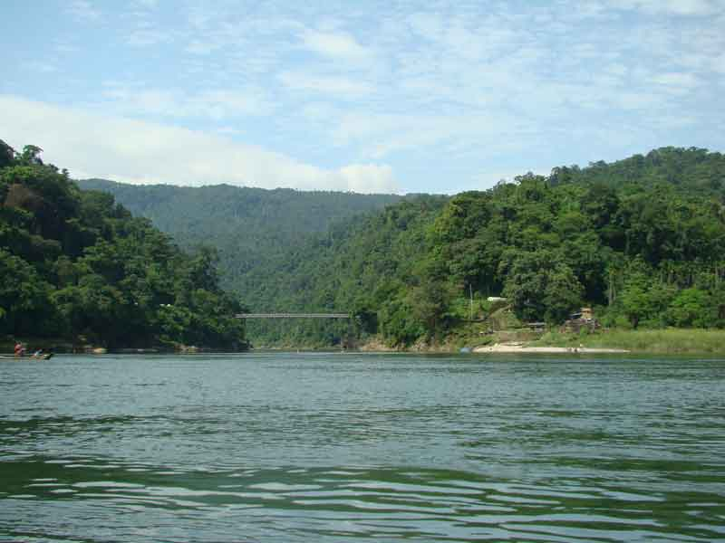](http://cdn.yourarticlelibrary.com/wp-content/uploads/2014/04/Jaflong_Sylhet_Bangladesh_.jpg)

Image Courtesy : wikimedia.org/wikipedia/commons/9/94/jaflong.JPG

A beautiful and modern city, set in the banks of river Surma, Sylhet attracts tourists as it is one of the richest places in Bangladesh. It is easily accessible from anywhere in the globe by road or air.

Sylhet’s important tourist destinations are Kean Bridge, Tamabil Jaflong, Sri Mahalakshmi temple in Joinpur, Sree Mangal, Lawacherra Rain Forest, Madhabkunda, Nazimgargh Resorts, Tilagor, etc.

**4. Khulna: The city of Royal Bengal Tiger**

[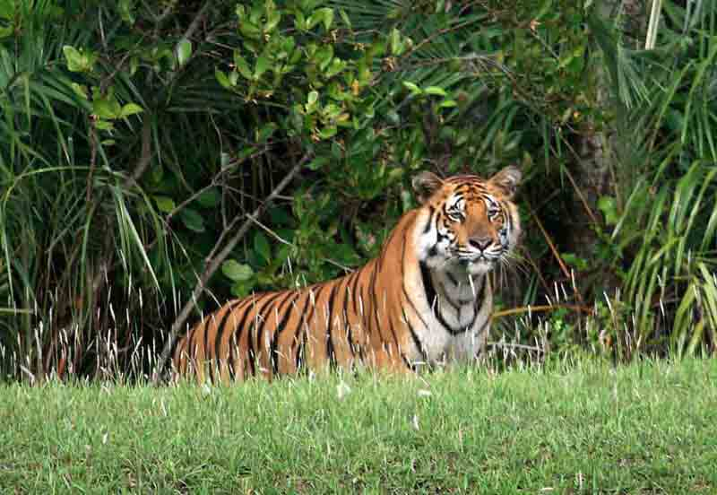](http://cdn.yourarticlelibrary.com/wp-content/uploads/2014/04/sundarban.jpg)

Image Courtesy : wikimedia.org/wikipedia/commons/9/94/sundarban.JPG

Next to Dhaka and Chittagong, this city is the mot favorite to both people looking for jobs and those who are visiting this country as tourists. It has one of the oldest river ports of Bangladesh.

Khulna also provides access to the famous Sundarbans which are world’s largest mangrove forests. This forest is well known for having the Royal Bengal Tigers. In addition to Sundarbans, people also visit Rabindra Complex which is connected to the world famous poet Rabindranath Tagore.

**5. Rangpur: Trade, Business and Tourism hub**

[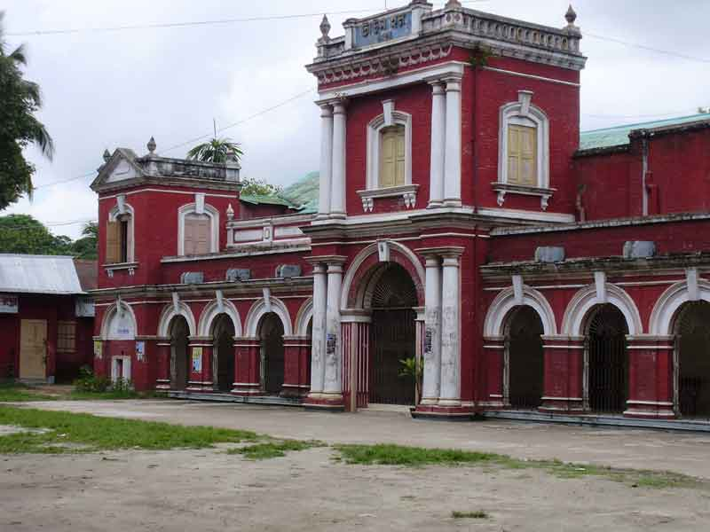](http://cdn.yourarticlelibrary.com/wp-content/uploads/2014/04/Rangpur_town_hall_02.jpg)

Image Courtesy : wikimedia.org/wikipedia/commons/9/94/townhall.JPG

This city has one of the most famous museums in Bangladesh called “Tajhan Rajbari Museum”. It is also simply known as “Rangpur Museum” and provides access to a wide range of things that are related to the history of Bangladesh.

In addition, the city also has number of art objects which are unique. Another museum by name “Begum Rokeya Museum” is also a tourist attraction. Paharpur Buddhist Monastery and Kantanagar temple are also frequently toured by many tourists.

**6. Rajshahi: The city of silk**

[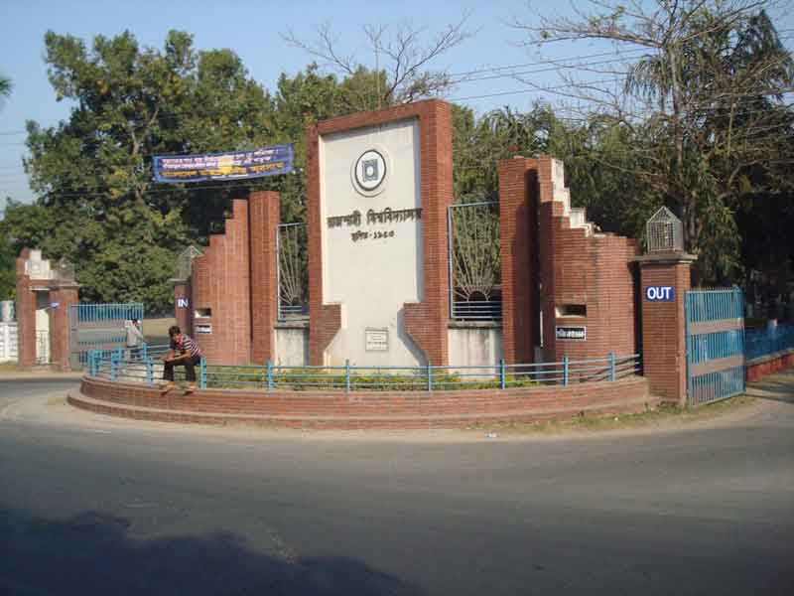](http://cdn.yourarticlelibrary.com/wp-content/uploads/2014/04/20224908.jpg)

Image Courtesy : wikimedia.org/wikipedia/commons/9/94/20224908.JPG

Rajshahi, a city which once produced silk that was sold all over the globe, is now an education hub and tourism center. Even today, tourists are mostly visiting the state bazaars (malls) where specialized silk fabrics are sold. In addition, it also has a large zoo which is very favorite among children.

Barendra Museum is an important tourist destination which has many world famous collections. As this place is suited for growing different kinds of fruits, it has many mango related businesses, which is a remarkable and unique thing about Rajshahi. Another famous fruit to tourists is lichee of Rajshahi.

**7. Mymensingh: The region of Nakshikantha and Moimonsingho Geetika**

[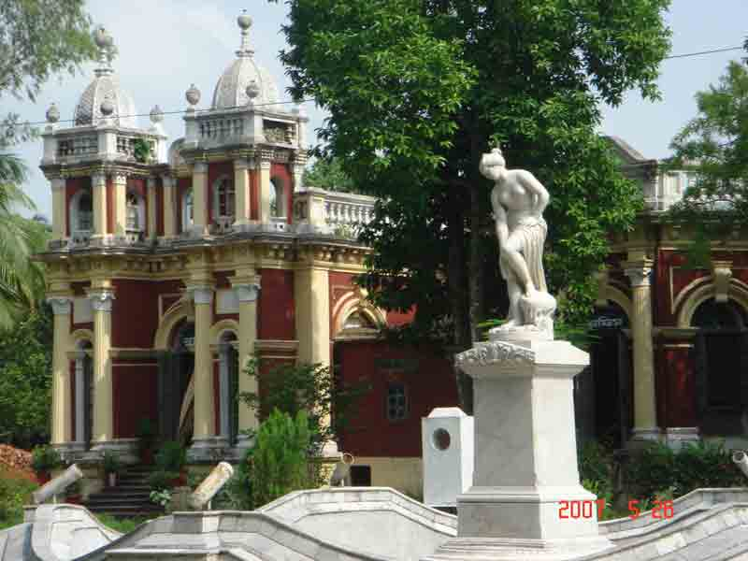](http://cdn.yourarticlelibrary.com/wp-content/uploads/2014/04/Sculpture5_in_TTC_Mymensing.jpg)

Image Courtesy : wikimedia.org/wikipedia/commons/9/94/Sculpture5.JPG

Nakshikantha is the name of a duvet handcrafted by people of Mymensingh, which is very favorite of tourists. In addition, it also has the famous Moimonsingho Geetika, an ancient rural ballad.

The Alexandar Castle in Mymensingh is visited by many tourists, as it has connection with world leaders such as Mahatma Gandhi, Subhash Chandra Bose and many others.

Mymensingh is situated in the banks of the great river of Brahmaputra and tourists can enjoy a scenic boat ride on this which is a unique experience.

**8. Bandarban: The dam of monkeys**

[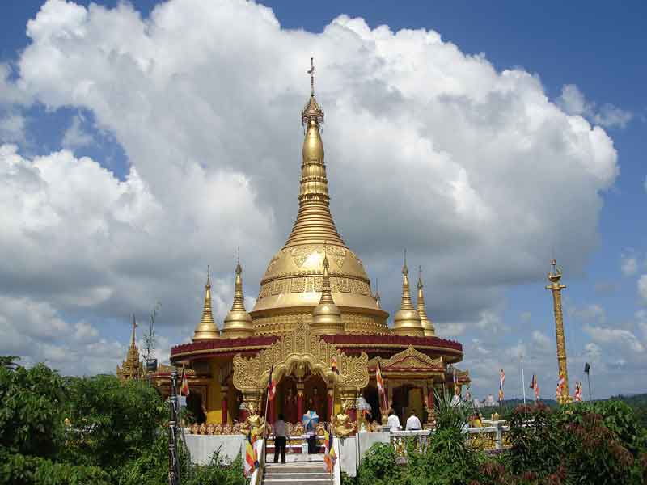](http://cdn.yourarticlelibrary.com/wp-content/uploads/2014/04/Buddha_Dhatu_Zadi01.jpg)

Image Courtesy : wikimedia.org/wikipedia/commons/9/94/Buddha.JPG

This is one of the most beautiful places in Bangladesh, accessible from all major cities. It has a calm lake and Shoilo Propat, a water fall, which are famous destinations of tourists.

There are many Buddhist temples in Bandarban, but Buddha Dhatu Jadi is the most important among them as the second largest statue of Buddha in Bangladesh is here.

**9. Cox’s Bazar: The fishing town with the longest beach**

[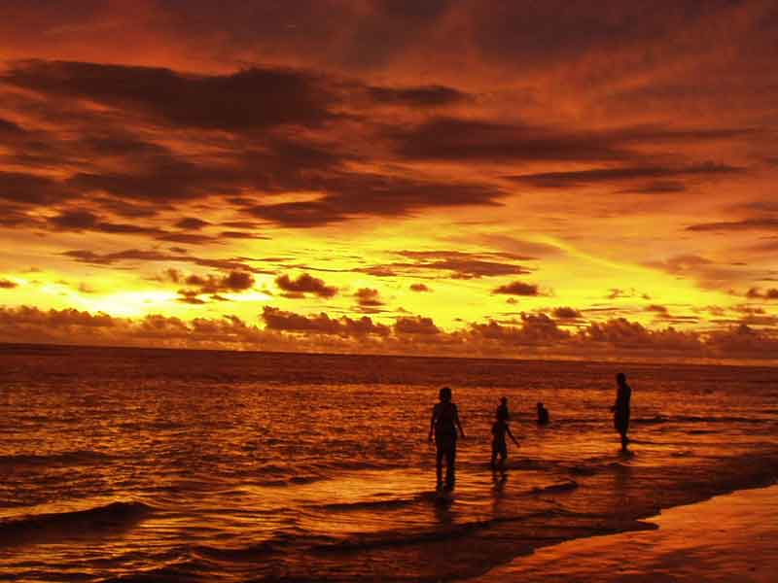](http://cdn.yourarticlelibrary.com/wp-content/uploads/2014/04/coa22.jpg)

Image Courtesy : wikimedia.org/wikipedia/commons/9/94/seabeach.JPG

If you love beaches, Cox’s Bazar is the place to be in Bangladesh. With wonderful, sandy beaches and a fish port, it has a cheering crowd in all seasons. It has the famous Buddhist monastery “Aggmeda Khyang”.

Cox’s Bazar also provides easy access to Chittagong hill tracts and many people interested in adventure tourism visit this place. Tourists should make sure to buy famous handicrafts from a small village called Ramu.

**10. St. Martin’s Island: The coconut Island**

[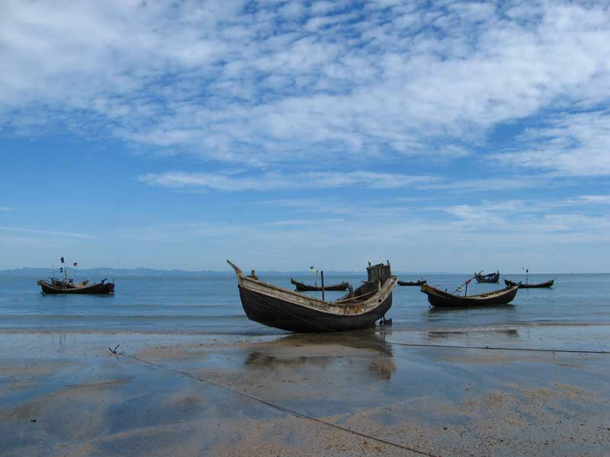](http://cdn.yourarticlelibrary.com/wp-content/uploads/2014/04/Saint-martins-island.jpg)

Image Courtesy : wikimedia.org/wikipedia/commons/9/94/Saint-martin.JPG

Saint Martin’s Island is the only coral island in Bangladesh. As a result, many tourists, who want to enjoy staying in a scenic coral island, come this place. This place has very few inhabitants where tourists are the main population.

There are many shipping companies which run daily trips to this island from neighboring cities. Similarly, establishments are available within this small island to make sure tourists have a comfortable stay.

**11. Durgasagar: A different tourist destination**

You might have seen many places in Bangladesh, but nothing will give the most wonderful experience like, Durgasagar gives. This place is also known as Madhabpasha Dighi which is located near the port of Barisal.

This is actually a large pond, with coconut trees around. It has an island in the center, which is the favorite spot of birds. Around the Dighi, tourists come and spend time picnicking and enjoying this unique site.

**12. Somapura Mahavihara: UNESCO World Heritage Site**

[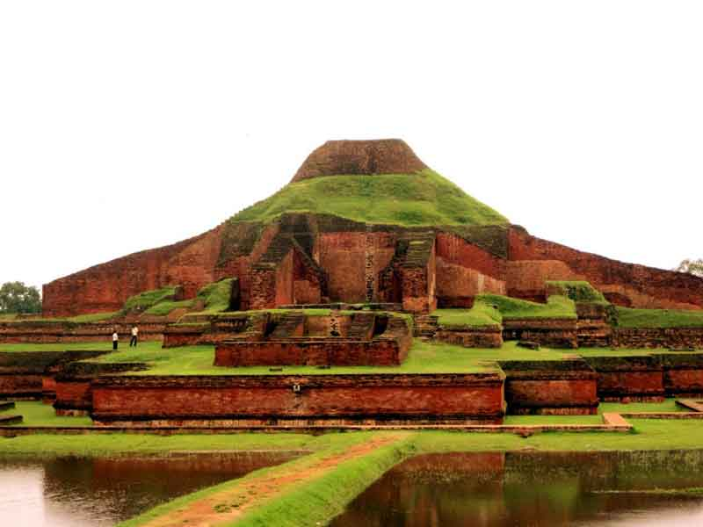](http://cdn.yourarticlelibrary.com/wp-content/uploads/2014/04/38516576.jpg)

most visited destinations of Bangladesh.

|  |
| --- |
| [Bangladesh](http://1.bp.blogspot.com/-IZnS-fk1eys/UpsN-4cCY6I/AAAAAAAARe8/sr0cAjIX9Ac/s400/Sadarghat.jpg) |
| Amazing Bangladesh. |

Bangladesh is the country of beautiful nature because she is full of natural beauties. In Bangladesh there are many attractions for the tourists around Dhaka city, Cox's Bazar, Chittagong, Sylhet, Sundarban etc. Now I writing about good and nice tourism in Bangladesh, for inform to you about very popular top ten tourist spot in this natural country. Every year millions of visitor visiting this 10 place in Bangladesh. Although Bangladesh have many more attractive destination for travelling and travel photography. I were many times visiting those 10 place with my clients, most of them came from outside of Bangladesh. However they was happy for [**visiting Bangladesh**](http://www.bdtourplan.com/2014/01/amazing-yellow-nature-beautiful-bangladesh.html), so I decided to update top 10 must visit place in Bangladesh. But I want showing you more attractions on here for International travelers, all about travel in Bangladesh. Write your useful comments or mail me, If you have any question about tourism in Bangladesh. Or if you want to visit Bangladesh with me, please mail me on: **contact@bdtourplan.com**

|  |
| --- |
| [Cox's Bazar Beach](http://3.bp.blogspot.com/-WtOnlMcoqCM/TEsREUri8VI/AAAAAAAADFY/eyCiVDYRTSE/s400/Cox%27s+Bazar+Beach-2.jpg) |
| Cox's Bazar Beach. |

**13.Cox`s bazar**: cox`s bazar is the world longest sandy sea beach with line of mountain. This beach now hot in the tourism world. Most of the tourist wish to visit cox`s bazar. Cox`s bazar have the hundreds of world class international five star residential hotels.  You can search on Google or see the Wikipedia for more information about unbroken and 155 km longest awesome sea Beach of Bay Of Bengal Sea in Bangladesh. See more about [**beautiful Cox's Bazar**](http://www.bdtourplan.com/2013/04/my-favourite-holiday-destination-in-bangladesh.html) sea beach and others nearest tourist destination.

|  |
| --- |
| [st. martin island](http://3.bp.blogspot.com/-qyFvDjKGpBU/UFwdWW1Df_I/AAAAAAAAGcU/tM5GIn_jY3Q/s400/st.-martin.jpg) |
| Way to St.Martin Island. |

**14.Saint martin**: st. martin island is a another’s coral island in the world. You can drink the fresh coconut juice from st`martin island. Saint martin island famous for coconut tree`s. you can booking tour ticket and hotels from Dhaka.

|  |
| --- |
| [Rangamati](http://4.bp.blogspot.com/-GeDDnXnEFM4/Ti8AdzW4MaI/AAAAAAAADf4/sRTj_ESgXKg/s400/Rangamati.jpg) |
| Hill tracks Rangamati. |

**14.Rangamati**: rangamati is the hill track district in Bangladesh. Many of the people are Buddhist here. This district famous for the sky touching mountain, Water Lake and hanging pool.

|  |
| --- |
| [Khagrachari](http://2.bp.blogspot.com/-3OozKQIUous/TjzSH3M0LOI/AAAAAAAACfE/OmHtOQHXU7E/s400/bd-visit.jpg) |
| **Khagrachari.** |

**15.Khagrachari**: another`s hills district in Bangladesh. Famous for water fall, many of the tourist spot, tea garden, orange garden, hills way road and Hills River.

|  |
| --- |
| [Nilgiri hills Bandarban](http://1.bp.blogspot.com/-gvPz0uiiBg8/TjbpeibYhtI/AAAAAAAACdk/4UBsOUwakN8/s400/Nilgiri-Resort.png) |
| Nilgiri hills Bandarban. |

**16.Bandar ban**: Bandarban is the biggest mountain district in the Chittagong division. Many of the mountain river are located here. You can enjoy deep jungle place in hills.

|  |
| --- |
| [Zia Park Complex, Chittagong](http://3.bp.blogspot.com/-FfZ3qGdyT1Q/UHZuXBds5hI/AAAAAAAAG0s/pp6qgqE-H2A/s400/Zia-Smriti-Complex-park.jpg) |
| Zia Park Complex, Chittagong. |

**17.Chittagong**: Chittagong is a divisional district in Bangladesh. Famous for the fay's lake and Chittagong sea port. This sea port is the main sea port in Bangladesh. potenga sea beach located in Chittagong hill district.

|  |
| --- |
| [Sundarban Mangrove Forest](http://1.bp.blogspot.com/-PvVcTTb-gpQ/TnRbqvYq1NI/AAAAAAAADRY/cFeWdYZmdts/s400/13092011047.jpg) |
| Sundarban Mangrove Forest. |

**18.Sundarban**: sundarban is the world biggest and natural mangrove forest. Located in bank of bay of sea in southern Bangladesh. This forest famous for the royal Bengal tiger. Nice and awesome forest in the world. The world listed this to after the amazon jungle.

|  |
| --- |
| [Ahsan Monzil, Dhaka city](http://4.bp.blogspot.com/-yXFAGUrq0Dg/UCI2nHwWM6I/AAAAAAAAFN4/QAiyVTyI-Mg/s400/Ahsan+Monjil+Dhaka.jpg) |
| Ahsan Monzil, Dhaka city. |

**19.Dhaka**: another biggest city and incident city in the world. Dhaka is a nice city. Many of the foreign visitor like to visit the Dhaka city. Dhaka is the capital of Bangladesh. and biggest city in south Asia.

|  |
| --- |
| [Panam city Dhaka](http://4.bp.blogspot.com/-lK7kyyMkZX4/UBYomKLTVRI/AAAAAAAAFEI/hZbajzOBcTg/s400/Panam+City+Bangladesh.jpg) |
| Panam city Dhaka. |

**20.Panam city**: panam city is the old capital of Bangladesh. but this city is now empty city. o people are live in here. You can visit this city. this cities have a nice museum.

|  |
| --- |
| [Tea Garden in Sylhet](http://2.bp.blogspot.com/-DxTjgkb_r9s/TqQp4kKmVQI/AAAAAAAADKs/xc7ubayp940/s400/0Bangladesh.jpg) |
| Tea Garden in Sylhet. |

**21.Sylhet**: sylhet is a divisional district in Bangladesh. sylhet have the some tourist spot as like Jaflong.

you can`t directly visit Rangamati, khagrachari and Bandarban. If you want to visit this three Districts, then you need a permit from Chittagong DC office. This permission is free and you can get this within half hours.