SCSR4114 Internship-Report


UNIVERSITI TEKNOLOGI MALAYSIA SCHOOL OF COMPUTING,
FACULTY OF ENGINEERING

INDUSTRIAL TRAINING REPORT
Cyber Fraud Revictimization Research under UTM/IASRG
BY
SADIK AL MAHMUD (A20EC4049)
BACHELOR OF COMPUTER SCIENCE
COMPUTER NETWORK AND SECURITY
TRAINING PLACE:
UTM/IASRG Research Context, Faculty of Computing, Universiti Teknologi Malaysia
SUPERVISOR: Assoc. Prof. Ts. Dr. Siti Hajar Othman
TRAINING PERIOD: 09 March 2026 to 24 July 2026
REPORT DATE: 2026

ACKNOWLEDGEMENT
I would like to express my sincere appreciation to my supervisor, Assoc. Prof. Ts. Dr. Siti Hajar Othman, for the guidance, direction, and feedback given throughout my industrial training period. The training gave me the opportunity to work on a cybersecurity-related research project that required reading, evidence checking, report preparation, and practical planning rather than only completing one isolated technical task.
I am also grateful to the Faculty of Computing, Universiti Teknologi Malaysia, and the IASRG research environment for giving me exposure to a research-based workflow in the field of cyber fraud prevention and cybersecurity awareness. Through this placement, I learned how a broad topic can be narrowed into research questions, measurable factors, intervention modules, and future prototype planning.
I would also like to thank my family for their support and encouragement during the training period. Their support helped me continue the work while the report structure, evidence checking, and project direction went through several rounds of review.
Finally, I appreciate everyone who gave advice, comments, or practical help during the preparation of the research materials, logbook, and this industrial training report.

ABSTRACT
This industrial training report describes the work completed during a 20-week training period from 09 March 2026 to 24 July 2026 under a UTM/IASRG research supervision context. The main training work was related to cybersecurity research, specifically cyber fraud revictimization among the public in Malaysia and the planning of a prevention-oriented prototype concept known as ScamShield-MY.
The training was different from a typical company software-development placement because the main work focused on research analysis, evidence handling, report writing, cybersecurity tool exploration, module design, and prototype planning. The project started with broad research on cyber fraud, scam techniques, local reporting initiatives, and repeat victimization. It then moved into literature review work, theory mapping, source verification, and development of a seven-factor framework for cyber fraud revictimization. The framework included overconfidence, social influence, authority impersonation, urgency and fear, emotional grooming, financial pressure, and protective capability. These factors were linked with the Theory of Planned Behavior, Protection Motivation Theory, and Cognitive Appraisal Theory.
During the training, I also explored Wazuh, SOC, SIEM, XDR, and AI-assisted cyber threat intelligence ideas to understand how cybersecurity monitoring and threat analysis could relate to the project. After comparing the technical scope with the research problem, Wazuh was kept as a supporting learning component, while the main project direction focused more on human-centred and behaviour-focused cyber fraud prevention. Later work involved research chapter development, evidence matrix preparation, proof screenshot handling, conceptual figure management, questionnaire and scenario planning, intervention module design, and ScamShield-MY prototype planning.
The main learning outcomes from the training were improvement in research scoping, cybersecurity analysis, academic writing, source verification, documentation, project planning, ethical handling of sensitive scam-related information, and realistic system-design thinking. The training also helped me understand the difference between an official internship report, a daily logbook, and the separate cyber fraud research report. This report therefore focuses on the industrial training experience and the work process, while the cyber fraud research manuscript remains a separate project deliverable.

TABLE OF CONTENTS
Section | Title
Chapter 1 | Introduction
Chapter 2 | Organization and Training Context
Chapter 3 | Specific Details of Project/Training
Chapter 4 | Challenges, Responses, and Learning Outcomes
Chapter 5 | Overall Information of IT/Cybersecurity
Chapter 6 | Conclusion and Recommendation
References | References and Work Materials
Appendices | Supporting Materials

LIST OF TABLES
Table No. | Title
Table 1.1 | Industrial Training Scope
Table 2.1 | Training Resources and Work Materials
Table 3.1 | Summary of Main Training Phases
Table 3.2 | Main Research and Documentation Artifacts
Table 3.3 | Seven-Factor Framework Used During Training
Table 3.4 | Evidence and Proof Handling Method
Table 3.5 | ScamShield-MY Prototype Planning Scope
Table 4.1 | Challenges, Responses, and Learning Outcomes
Table 5.1 | IT and Cybersecurity Concepts Applied During Training
Table 6.1 | Summary of Skills Gained

LIST OF FIGURES
Figure No. | Title
Figure 3.1 | Seven-factor framework artifact prepared for the research work
Figure 3.2 | Conceptual flow artifact for revictimization and recovery
Figure 3.3 | Example of regulator proof screenshot used for evidence handling
Figure 3.4 | Example of verification-tool proof screenshot used for evidence handling

CHAPTER 1: INTRODUCTION
1.1 Introduction
Industrial training is an important part of the Bachelor of Computer Science programme because it allows students to apply university knowledge in a real working environment. In my case, the training was conducted in a research supervision context under UTM/IASRG, with the main work focusing on cybersecurity research, cyber fraud prevention, and cyber fraud revictimization.
The assigned project was titled Study on Identification of Factors and Development of Modules for Methods to Prevent Cyber Fraud Revictimization Problems Among the Public in Malaysia. The title covered several connected areas, so the first part of the training required understanding what cyber fraud revictimization actually means and how it differs from a general cyber fraud awareness topic. Cyber fraud is not only about hacking or malware. Many fraud cases depend on social engineering, fake authority, emotional pressure, urgent threats, attractive financial offers, and limited verification behaviour. Because of that, the training work had to combine cybersecurity knowledge with behavioural research.
The project gradually developed from a general cyber fraud topic into a structured research direction. The work included literature review, local scam evidence collection, theoretical mapping, seven-factor framework development, intervention module planning, proof screenshot handling, and ScamShield-MY prototype concept planning. This report explains that full internship process.
1.2 Training Period and Placement Context
The industrial training period was from 09 March 2026 to 24 July 2026. The placement was conducted differently from a conventional company placement where the student joins a software team or IT support department. The work was performed as supervised research and project-development support under a UTM/IASRG cybersecurity-related research context.
Because of this placement style, the daily work involved reading, comparing sources, preparing structured notes, writing report sections, checking evidence, planning methodology, organizing files, and designing a possible prototype direction. The work still related strongly to Computer Network and Security because it involved phishing, smishing, malicious APKs, SOC/SIEM concepts, cyber threat intelligence, scam detection, online fraud response, and secure reporting practices.
1.3 Objectives of Industrial Training
The objectives of my industrial training were:
1. To apply computer science and cybersecurity knowledge to a supervised research problem.
2. To understand cyber fraud revictimization and the factors that can make users vulnerable after scam exposure or victimization.
3. To improve research reading, source checking, report writing, and technical documentation skills.
4. To explore cybersecurity tools and concepts such as Wazuh, SOC, SIEM, XDR, and cyber threat intelligence.
5. To develop a structured research framework, prevention module direction, and prototype planning idea.
6. To prepare professional documentation through the logbook, research report materials, and this internship report.
1.4 Scope of Training Work
The scope of the training was broad, but it can be grouped into the areas shown in Table 1.1.
Table 1.1: Industrial Training Scope
Scope area | Work performed
Cyber fraud research | Studied scam categories, scam techniques, repeat victimization, local initiatives, and reporting channels
Theory and framework | Reviewed TPB, PMT, Cognitive Appraisal Theory, and seven revictimization factors
Cybersecurity exploration | Studied Wazuh, SOC/SIEM/XDR concepts, AI CTI ideas, phishing, smishing, malicious APKs, and scam detection
Research report development | Drafted and revised chapters, methodology ideas, evidence matrix, references, and module content
Evidence management | Separated official sources, academic sources, news/case evidence, vendor threat evidence, figures, and proof screenshots
Module and prototype planning | Designed prevention-module direction and ScamShield-MY prototype scope
Documentation | Prepared logbook, timeline map, folder organization, report mapping, and this internship report

CHAPTER 2: ORGANIZATION AND TRAINING CONTEXT
2.1 Organization Background
The training was carried out in a UTM/IASRG research context under the Faculty of Computing, Universiti Teknologi Malaysia. Since the placement was research-based, the organization profile is presented differently from a typical company profile with business products, departments, sales activities, and staff numbers. The relevant organization context is the academic and research environment where cybersecurity-related work is supervised, discussed, and developed into structured outputs.
The research environment was suitable for this training because the project required both technical understanding and academic discipline. Cyber fraud prevention is connected to network security, human-centred cybersecurity, digital financial crime, public awareness, threat intelligence, and secure reporting. The work therefore required more than reading articles. It required understanding how evidence, theory, methodology, and a possible prototype could fit together.
2.2 Nature of Work Assigned
The assigned work was research and project-development support for a cyber fraud revictimization study. The main responsibility was to help develop the research direction, gather and organize evidence, prepare report sections, and plan prevention modules. The project also included a technical exploration stage where several cybersecurity tool and system ideas were considered before the project scope was refined.
The work included topic breakdown, cyber fraud and scam-technique review, theory study, Wazuh/SOC and AI CTI exploration, seven-factor framework development, evidence and proof handling, report chapter preparation, and ScamShield-MY prototype planning.
2.3 Supervision and Work Communication
The training followed a supervised research workflow. Tasks were received as broad research directions and then broken into smaller work items. Some work was straightforward, such as collecting source notes or preparing a table. Other parts required refinement because the project scope had to remain aligned with the research aim and the available evidence.
The usual workflow was to receive or identify the task direction, read the available files and guidelines, break the work into smaller sections, search for evidence, draft the required section or artifact, and then check whether the output matched the project scope. This process helped me understand how research work develops through review, comparison, and improvement. Some ideas, such as a full Wazuh SOC-style demo, were useful for technical learning, while scenario-based scam response and ScamShield-MY became more relevant after the research framework became clearer.
2.4 Training Resources and Work Materials
Several types of resources were used during the training. Table 2.1 shows the main resources and how they were used.
Table 2.1: Training Resources and Work Materials
Resource | How it was used
Industrial training report guideline | Used to understand the marking categories for the official internship report
Logbook guideline and template | Used to prepare daily Objective, Activity, and Achievement entries
UTM thesis and paper-writing guidelines | Used to understand academic report structure and chapter flow
Cyber fraud research chapters | Used as the main working manuscript for the research report
Task 2 seven-factor report | Used as the focused deliverable for revictimization factor analysis
Evidence matrix and reference files | Used to track sources, claims, caveats, and research support
Proof screenshot plan | Used to separate real source proof screenshots from conceptual figures
Conceptual figures | Used to explain frameworks, models, and module flow
ScamShield-MY planning notes | Used to convert research findings into a possible prototype direction

2.5 Chapter Summary
This chapter explained the research placement context and the nature of the assigned work. The training centred on cybersecurity research, evidence handling, structured writing, methodology planning, and prototype concept development. This context is important because it explains why the main output of the training was a set of research and planning artifacts rather than a deployed commercial system.

CHAPTER 3: SPECIFIC DETAILS OF PROJECT/TRAINING
3.1 Overview of Training Work
This chapter explains the main work completed during the training period. Since the industrial training report guideline gives the highest weight to specific project and training details, this chapter is written as the main part of the report.
The training work was completed through several connected stages. Each stage helped refine the previous stage, from understanding the assigned topic to preparing research chapters, evidence materials, prevention-module ideas, and prototype planning. This was suitable for a research-based internship because the project direction became clearer through reading, supervisor guidance, scope checking, and comparison of available evidence.
Table 3.1 summarizes the main phases of the training.
Table 3.1: Summary of Main Training Phases
Phase | Period | Main focus | Main output
Phase 1 | March 2026 | Task assignment and initial cyber fraud research | Topic breakdown, scam-type notes, source bank
Phase 2 | Late March to early April 2026 | Wazuh, SOC, SIEM, XDR, and AI CTI feasibility | Feasibility notes and decision to narrow the technical scope
Phase 3 | April to May 2026 | Research report chapter development | Chapter 1 to Chapter 4 drafts and methodology direction
Phase 4 | Late April to May 2026 | Seven-factor framework and Task 2 report | Seven-factor report, measurement ideas, intervention module direction
Phase 5 | May 2026 | Evidence, references, figures, and proof screenshots | Evidence matrix, reference checking, proof-status notes
Phase 6 | June 2026 | ScamShield-MY prototype planning | Hybrid scam detection and revictimization risk concept
Phase 7 | June to July 2026 | Logbook and official internship report preparation | Final logbook structure and internship report draft
3.2 Phase 1: Task Assignment and Initial Cyber Fraud Research
The first stage of the training was to understand the assigned research topic. The phrase "cyber fraud revictimization" was a specific research term, so I had to separate several related ideas: cyber fraud, online scams, scam exposure, victimization, repeat victimization, and revictimization tendency.
The early work included reviewing scam categories such as phishing, smishing, vishing, investment scams, job scams, e-commerce fraud, loan scams, love scams, mule accounts, malicious APK scams, and recovery scams. I also studied public response and reporting initiatives such as NSRC, Semak Mule, Cyber999, banking anti-fraud measures, Securities Commission Malaysia investor tools, and related public warnings.
The main task in this phase was to narrow the research scope properly. If every scam type was described equally, the report would become too general and less focused on revictimization. A better direction was to ask why users may become vulnerable again after prior exposure or victimization. This led to a stronger focus on behaviour, decision-making, reporting delay, shame, recovery scams, and verification capability.
The main learning from this phase was that research scoping matters. A broad title should be converted into research questions, measurable variables, and practical outputs so the report remains clear and useful.
3.3 Phase 2: Wazuh, SOC, SIEM, XDR, and AI CTI Feasibility Exploration
The second stage involved exploring technical cybersecurity directions. Wazuh was studied as an open-source security platform related to endpoint monitoring, log collection, alerting, dashboards, SIEM, XDR, and SOC-style workflows. This exploration helped me understand how cybersecurity teams monitor systems, collect security events, and respond to alerts.
After studying the tool and comparing it with the assigned topic, I found that Wazuh was more suitable as a supporting cybersecurity learning component than as the main project solution. Wazuh is useful for infrastructure monitoring, endpoint visibility, compliance, and security operations. The cyber fraud revictimization project was more focused on public users, scam messages, persuasion, risky compliance, reporting behaviour, and recovery vulnerability.
I also explored AI-assisted cyber threat intelligence ideas. These included using AI to compare scam indicators, summarize threat reports, support source discovery, and classify suspicious scam cues. In the final direction, AI was treated only as support for idea discovery and comparison. It was not treated as a replacement for verified sources or final evidence.
The conclusion of this phase was important: the technical tool should match the purpose of the project. Wazuh remained useful for cybersecurity learning, while the main project direction became more human-centred and focused on scam prevention.
3.4 Phase 3: Research Report Chapter Development
After the scope became clearer, the work shifted to the cyber fraud research report. The report work followed a six-chapter academic structure. Chapter 1 focused on the background, problem statement, aim, research questions, objectives, scope, and contribution. Chapter 2 focused on literature review, cyber fraud types, local scam evidence, behavioural theories, and research gaps. Chapter 3 focused on methodology, respondent groups, instrument design, scenario assessment, ethics, and data analysis. Chapter 4 focused on module design and implementation planning.
This phase required careful revision of the report structure. Some earlier material was useful as background, but the final report needed stronger connection to revictimization, theory, methodology, and module design. I had to keep checking whether each paragraph helped answer the actual research problem.
The strongest direction came from connecting the research to three theories:
1. Theory of Planned Behavior (TPB) - attitude, subjective norms, perceived behavioural control, intention, and behaviour.
2. Protection Motivation Theory (PMT) - perceived severity, perceived vulnerability, response efficacy, self-efficacy, and response cost.
3. Cognitive Appraisal Theory - how people interpret stressful or uncertain situations and choose coping responses.
These theories helped the report move beyond simple awareness. They supported the idea that people may know scams exist but still fail to act safely under pressure.
3.5 Phase 4: Seven-Factor Revictimization Framework
One of the most important outputs of the training was the seven-factor framework. The framework was developed to explain why cyber fraud revictimization can happen and how prevention modules can be designed.
Table 3.3 shows the seven factors used during the training work.
Table 3.3: Seven-Factor Framework Used During Training
Factor | Main idea | Example scam pressure | Prevention direction
Overconfidence | User believes they can detect scams without checking | Familiar-looking message or polished interface | Build verification habits
Social influence | Fake group approval or social proof creates trust | Testimonials, group chats, fake endorsements | Verify even when others appear to approve
Authority impersonation | Scammer pretends to represent a trusted institution | Fake police, bank, tax, regulator, or support call | Verify official claims independently
Urgency and fear | Time pressure reduces careful thinking | Account frozen, legal threat, limited-time offer | Pause before action
Emotional grooming | Trust, shame, hope, or attachment is exploited | Romance scam, parcel scam, fake recovery agent | Reduce shame and seek trusted support
Financial pressure | Reward, need, or loss recovery overrides caution | Investment, loan, job-task, cheap deal, recovery fee | Verify opportunity before payment
Protective capability | User does not know what to do or where to report | Uncertainty after loss or suspicious contact | Train use of reporting and verification channels

The figure below is one of the conceptual artifacts prepared for the research work. It is included here as evidence of the framework-development process, not as a statistical result.
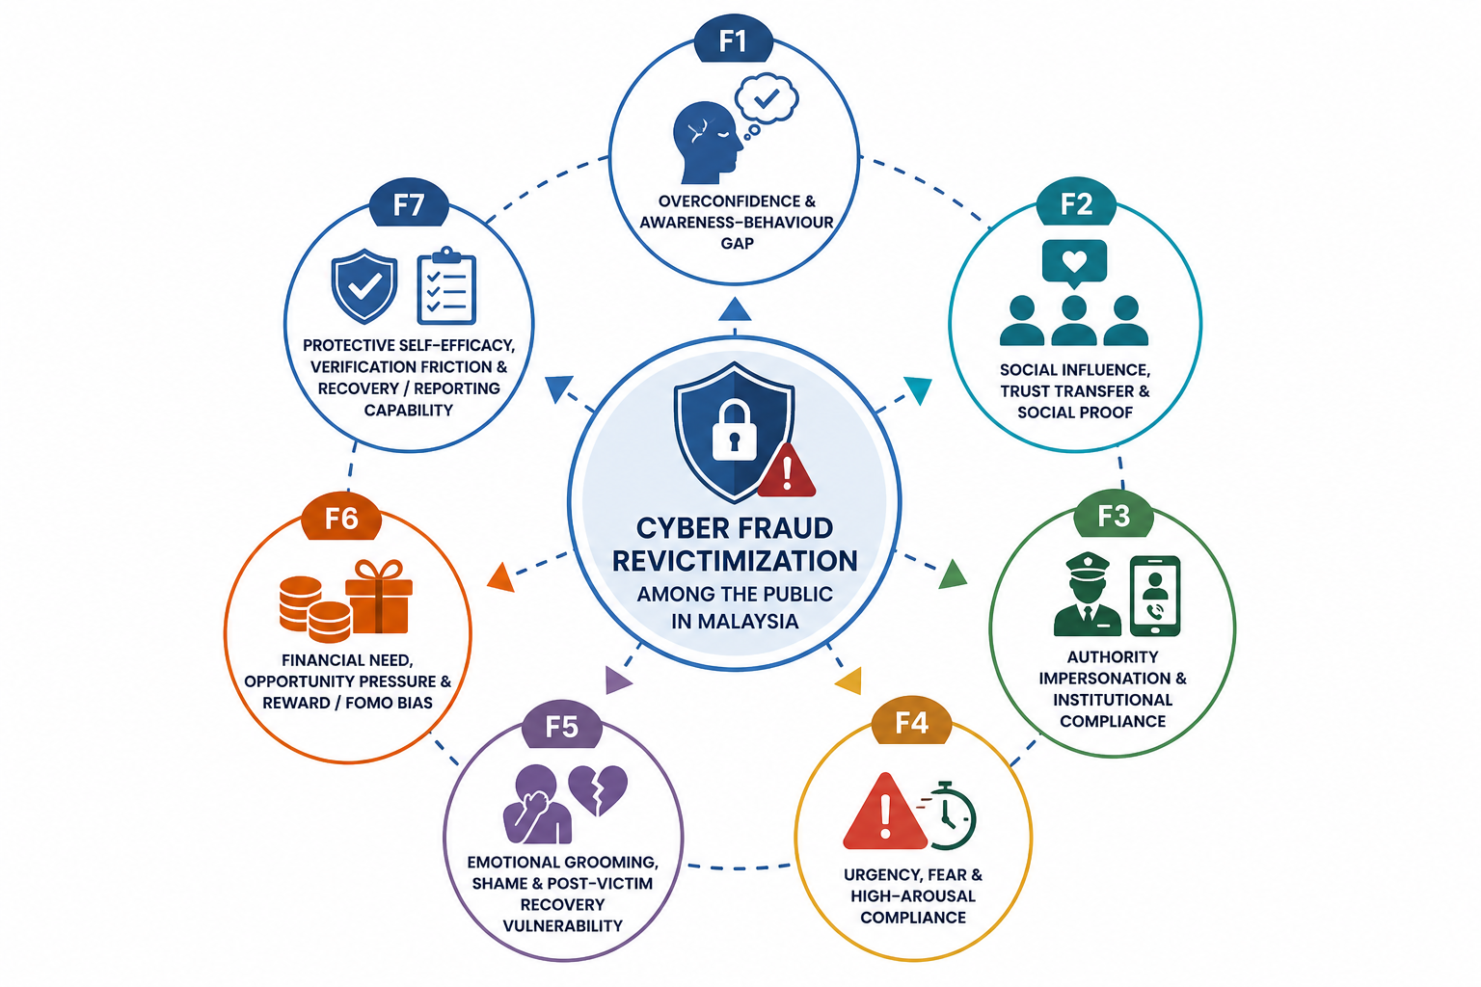
Figure 3.1: Seven-factor framework artifact prepared for the research work.
The seven-factor work was useful because it turned the project into something measurable. Instead of only saying that scams are dangerous, the framework allowed the report to ask what should be measured in a questionnaire, what should be tested in scenarios, and what should be addressed in intervention modules.
The second conceptual artifact below shows the flow from scam exposure to appraisal, behaviour, outcome, and recovery or repeat risk. It helped connect the theory, factors, and module design.
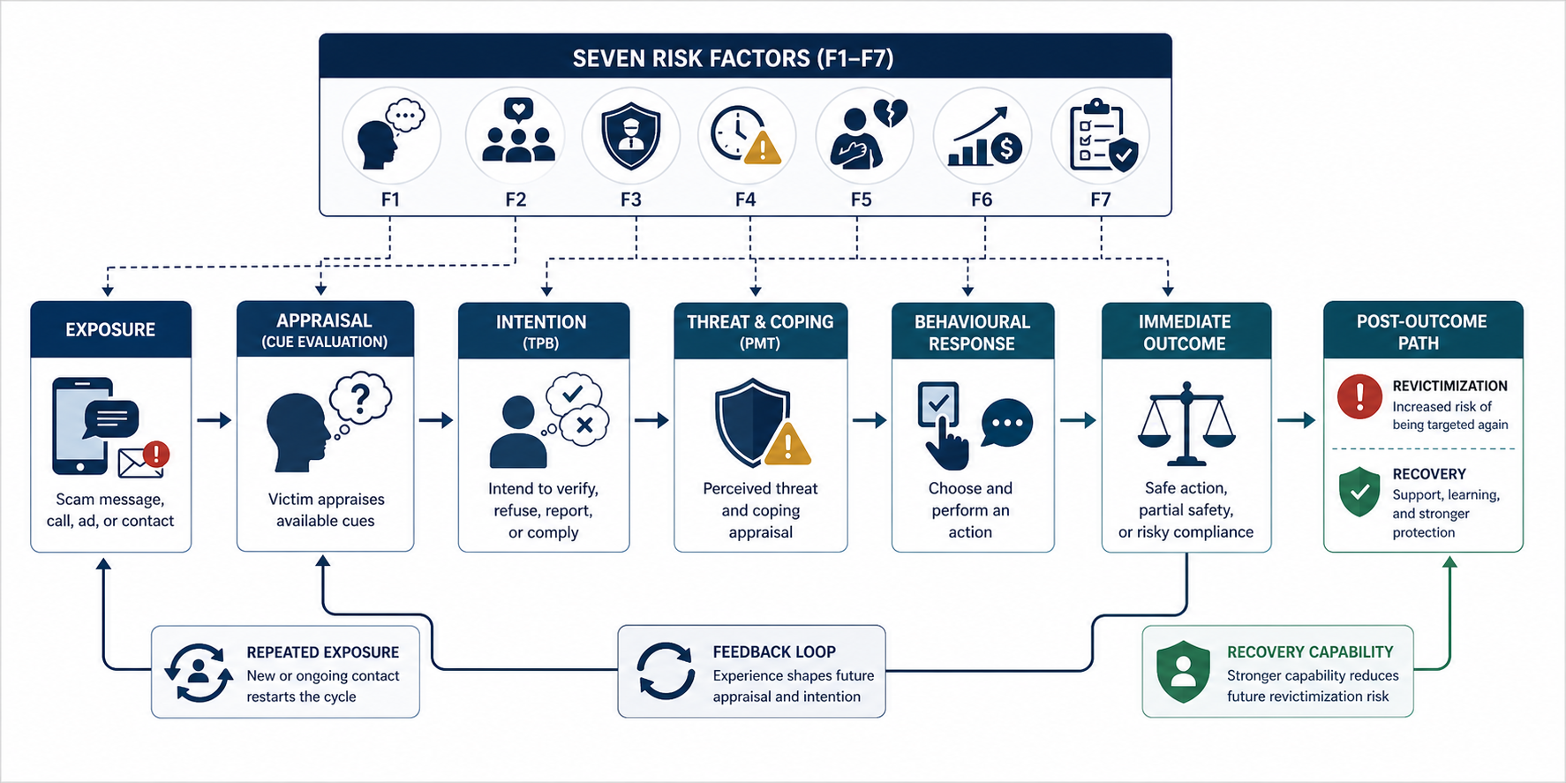
Figure 3.2: Conceptual flow artifact for revictimization and recovery.

3.6 Phase 5: Evidence, References, Figures, and Proof Handling
Evidence handling became one of the most important parts of the work. Cyber fraud research needs reliable sources because different source types support different kinds of claims. Because of that, the sources were separated into categories:
1. Official and regulatory sources.
2. Academic sources.
3. Legal, media, and case sources.
4. Technical threat-intelligence sources.
The evidence matrix recorded what each source supported, which factor it related to, where it could be used in the report, and what caveat should be remembered. This helped prevent overclaiming. For example, Cyber999 reports can support cyber incident reporting trends, but they should not be treated as full national crime totals. Securities Commission Malaysia sources can support investment scam techniques, but they should not represent all scam types.
Another important part of the work was separating conceptual figures from real proof screenshots. Conceptual figures were used to explain ideas. Proof screenshots were used only when a live source page could be captured from a legitimate website. If a source could not be captured because of blocking, cookie panels, or browser errors, that limitation was recorded instead of replacing the proof with a generated image.

Table 3.4 shows the evidence and proof handling method.
Table 3.4: Evidence and Proof Handling Method
Material type | Purpose | Handling rule
Official/regulatory source | Support local scam context, reporting tools, and institutional response | Use for stronger claims where relevant
Academic source | Support theory, behaviour, and victimization factors | Use for research framework and construct support
News/case evidence | Support current examples or public warnings | Use carefully, especially when quoting agencies
Vendor threat intelligence | Support technical mechanisms such as malicious APKs | Use as technical support, not national statistics
Conceptual figure | Explain framework or flow | Label as conceptual, not proof
Proof screenshot | Show live source evidence | Capture only from legitimate pages and record blocked attempts honestly

Figure 3.3 shows an example of a regulator proof screenshot used during evidence handling.
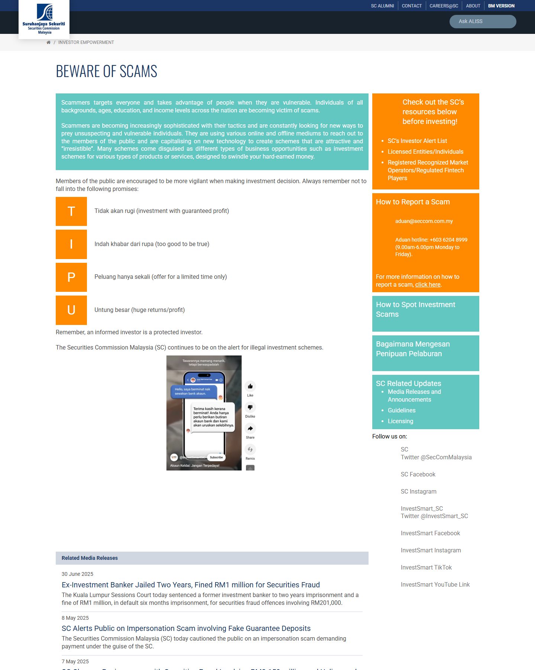
Figure 3.3: Example of regulator proof screenshot used for evidence handling.
Figure 3.4 shows an example of a verification-tool proof screenshot used to support the importance of practical checking capability.
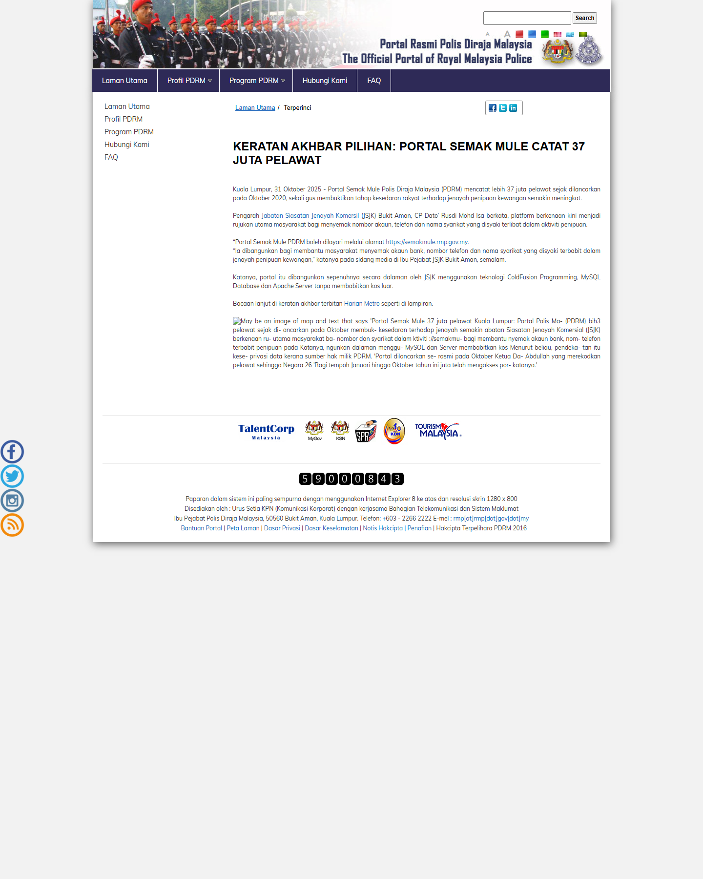
Figure 3.4: Example of verification-tool proof screenshot used for evidence handling.
This phase taught me that research integrity is not only about writing citations. It is also about knowing what a source can and cannot prove. If a screenshot is blocked, the honest action is to record the limitation. If a claim is only supported by a secondary source, it should be written carefully. That habit improved the overall quality of the report.
3.7 Phase 6: ScamShield-MY Prototype Planning
In June, the work shifted toward planning a possible technical artifact called ScamShield-MY. The idea was to connect the research findings with a small cybersecurity prototype concept. The system was not planned as a guaranteed scam detector or commercial product. It was planned as a student-level prototype that could support scam cue explanation, risk scoring, scenario learning, and reporting guidance.
The strongest direction was a hybrid scam detection and revictimization risk analysis system. The prototype could allow a user or researcher to enter suspicious message text, a URL, or a scam scenario. The system could then identify warning cues such as urgency, authority claims, OTP requests, APK installation requests, fake investment claims, emotional grooming, social proof, and recovery-fee promises.
Table 3.5 shows the planned prototype scope.
Table 3.5: ScamShield-MY Prototype Planning Scope
Feature | Purpose | Status during training
Suspicious message input | Allow testing of scam-like text examples | Planned
Optional URL input | Support simple phishing or suspicious-link review | Planned
Scam cue extraction | Detect urgency, authority, financial pressure, APK request, OTP request, social proof, and emotional grooming | Planned
Risk score | Provide a simple low, medium, or high risk explanation | Planned
Explanation panel | Explain why a message or scenario looks risky | Planned
Scenario test | Measure safe, partially safe, or risky user response | Planned
Reporting guidance | Suggest relevant checking or reporting channels | Planned
Researcher dashboard | Summarize test cases, cue patterns, and scenario scores | Future idea

The prototype scope was kept realistic for the internship timeline. Heavy machine learning, live banking integration, real-time threat feeds, and malware analysis were left for possible future work because they would require more time, data access, and safety controls. A smaller rule-based and scenario-based prototype was easier to connect to the seven-factor framework and more suitable for a student-level planning stage.
3.8 Phase 7: Logbook and Official Internship Report Preparation
The final work phase involved organizing the official internship documents. The logbook was refined so that the daily entries showed meaningful variation and reflected the actual progress of the project. Weekends, public holidays, and Hari Raya office closure days were separated from working days. The logbook also marked future-dated entries as planned work where appropriate.
Another important task was separating the official internship report from the cyber fraud research report. The cyber fraud research report is the main project work performed during training. This industrial training report is different. It explains the training experience, the work process, the skills gained, and how the training improved my academic and technical development.
The folder structure was also reorganized so that official internship documents, logbook files, research work, evidence, figures, proofs, and planning notes were separated. This made the project easier to understand and helped keep official documents separate from working research materials.
3.9 Main Research and Documentation Artifacts
Table 3.2 lists the main artifacts prepared or used during the training.
Table 3.2: Main Research and Documentation Artifacts
Artifact | Purpose
Final logbook | Daily record of objectives, activities, achievements, holidays, and planned closing work
Work timeline map | Phase-based summary of the internship work
Chapter 1 to Chapter 6 research files | Main cyber fraud research manuscript structure
Task 2 seven-factor report | Focused report on revictimization factors, measurement, and modules
Evidence matrix | Source, claim, factor, caveat, and report-section tracking
Reference files | Source organization and citation support
Conceptual figures | Visual explanation of frameworks and intervention flow
Proof screenshot plan | Tracking of captured, blocked, and pending proof images
ScamShield-MY planning notes | Prototype concept and feature-scope planning
This internship report | Official report on the training experience

3.10 Chapter Summary
This chapter explained the actual work carried out during the industrial training period. The work developed from topic understanding into structured research, cybersecurity feasibility analysis, seven-factor framework development, evidence management, module planning, prototype planning, and official documentation. The main lesson was that research work improves through review, evidence checking, and gradual refinement of scope.

CHAPTER 4: CHALLENGES, RESPONSES, AND LEARNING OUTCOMES
4.1 Introduction
Every project has challenges, especially when the work involves research, cybersecurity, source verification, and planning. During this training, the main challenges were related to topic scope, source quality, report structure, proof screenshot capture, and the difference between planned work and completed work.
Table 4.1 summarizes the main challenges, responses, and learning outcomes.
Table 4.1: Challenges, Responses, and Learning Outcomes
Challenge | Response applied | Learning outcome
Topic scope needed refinement | Split the work into scam types, theories, factors, methodology, modules, and prototype planning | Good research starts with clear scope control
Source quality needed checking | Prioritized official, regulatory, and academic sources | Source quality matters more than source quantity
Wazuh needed proper positioning | Kept Wazuh as cybersecurity learning and focused the main project on scam prevention | A technical tool should be matched with the research aim
Some proof screenshots could not be captured | Recorded blocked captures honestly and did not replace them with generated images | Evidence limitations must be documented
Report structure needed improvement | Rebuilt the research direction using a six-chapter academic structure | Structure helps prevent repeated or unsupported writing
Some prototype ideas exceeded the internship scope | Reduced ScamShield-MY to a realistic rule-based and scenario-based concept | A smaller prototype can be stronger if it fits the objective
Logbook entries needed natural variation | Revised entries with realistic variation and modest daily achievements | Documentation should reflect real work clearly and honestly

4.2 Scope Clarification
The first major challenge was clarifying the research scope. Cyber fraud can include many different scams, technologies, platforms, and victim situations. If the report tried to cover everything, it would become too general and less useful for the assigned topic.
The solution was to define the core problem as revictimization and repeated vulnerability. This helped the project focus on why a person might still respond unsafely after prior scam exposure or victimization. It also allowed the project to connect scam techniques with theory, questionnaire design, intervention modules, and prototype features.
The learning outcome was that a research topic must be narrowed before it can become useful. A focused report is stronger than a long report that tries to cover too many areas.
4.3 Source Verification and Evidence Quality
Another challenge was source quality. Some sources were useful for general understanding, while others were more suitable for academic or official claims. News articles, vendor blogs, and broad web pages can help explain examples, but they should not carry the main argument unless the claim is properly supported.
The solution was to create an evidence matrix and group sources by role. Official and regulatory sources were used for stronger local context. Academic sources were used for theory and behaviour. News sources were used carefully when they quoted relevant authorities. Vendor threat-intelligence sources were used only for technical mechanism support.
The learning outcome was that evidence should be handled with discipline. It is better to write a careful sentence with a strong source than a strong sentence with unsupported evidence.
4.4 Wazuh Scope Alignment
Wazuh was useful to study because it gave exposure to SOC, SIEM, XDR, endpoint monitoring, dashboards, and alerting. However, the assigned project was mainly about public scam decision-making and revictimization prevention rather than enterprise infrastructure monitoring.
The response was to keep Wazuh as part of cybersecurity learning while keeping the main project direction focused on human-centred scam prevention, scenario-based assessment, and ScamShield-MY prototype planning.
The learning outcome was practical: technical interest must be balanced with project fit. A system or tool is most useful when it supports the actual research question.
4.5 Blocked Proof Captures
Some source pages could not be captured cleanly because of web blocking, cookie panels, or browser limitations. This affected the proof-screenshot work because proof screenshots were useful for visual evidence, but not every source could be captured.
The solution was to document capture status honestly. Captured sources were saved as proof images. Blocked sources were kept as citations but not shown as screenshots. Generated images were not used as proof screenshots.
The learning outcome was research integrity. When a proof capture is blocked, the limitation should be recorded clearly instead of being hidden or replaced with artificial proof.
4.6 Report Refinement
The research report needed refinement so that each section matched the academic chapter flow. Some parts were useful as background, while other parts needed clearer connection to the research questions, methodology, and planned outputs.
The response was to organize the research direction around Chapter 1 to Chapter 6. Chapter 5 was handled carefully as a results structure rather than unsupported findings. Chapter 6 was written as a conclusion based on completed design work and future evaluation needs.
The learning outcome was that academic writing should clearly separate completed work, planned work, and unavailable data.
4.7 Chapter Summary
The main challenges during training helped improve the final direction of the work. The project became clearer after the scope was refined, sources were checked, proof handling was clarified, Wazuh was positioned as supporting learning, and ScamShield-MY was kept as a realistic prototype plan.

CHAPTER 5: OVERALL INFORMATION OF IT/CYBERSECURITY
5.1 Introduction
This chapter explains how the industrial training relates to IT and cybersecurity. Although the placement was research-based, the work was strongly connected to Computer Network and Security because cyber fraud involves digital platforms, malicious links, social engineering, account compromise, reporting systems, scam indicators, security monitoring concepts, and user protection.
5.2 Cybersecurity Relevance of Cyber Fraud Prevention
Cyber fraud prevention is part of cybersecurity because fraudsters exploit both technology and human behaviour. Some scams use phishing websites, malicious APKs, fake login pages, social media accounts, mule accounts, suspicious URLs, or account takeover. Other scams use persuasion through fear, authority, social proof, emotional grooming, or financial pressure.
This means cyber fraud prevention cannot rely only on firewalls, antivirus tools, or banking controls. Users also need safe decision-making routines. The training helped me understand that cybersecurity must include both technical controls and human-centred protection.
5.3 SOC, SIEM, XDR, and Wazuh Learning
Wazuh exploration introduced me to security monitoring ideas. A SOC monitors security events and investigates alerts. SIEM tools collect and correlate logs. XDR extends detection and response across endpoints and other sources. Wazuh supports several of these learning areas through agents, dashboards, alerts, and endpoint monitoring.
Even though Wazuh was not used as the main project solution, the learning was still useful. It helped me see the difference between infrastructure security and public scam prevention. Infrastructure monitoring can detect system events, while cyber fraud revictimization often happens through user decisions before or after technical compromise.
5.4 Cyber Threat Intelligence and Scam Evidence
Cyber threat intelligence is useful because it helps identify threat patterns, scam indicators, malicious techniques, and attacker behaviour. During the training, CTI-style thinking was used to compare scam cues and organize evidence. For example, scam indicators such as suspicious links, APK requests, fake authority claims, limited-time offers, payment redirection, fake testimonials, and recovery-fee demands were treated as clues that could support scenario design and prototype logic.
AI-assisted search was useful at the idea-discovery stage, but final claims still needed verified sources. This was an important boundary. AI can help find directions, summarize possibilities, or compare concepts, but it should not be treated as evidence unless the original source is checked.
5.5 Data Ethics and Sensitive Information
Cyber fraud research can involve sensitive experiences, financial loss, personal embarrassment, and private communication. For that reason, the training included strong attention to ethical handling. The planned questionnaire and prototype should avoid collecting bank credentials, passwords, OTP/TAC codes, IC numbers, account numbers, real scam screenshots, or private chat logs unless formal ethics approval and secure handling are in place.
The ScamShield-MY idea also used fictional but realistic scam scenarios instead of real victim evidence. This reduces privacy risk and avoids teaching harmful details. The goal is to help users recognize danger, not to create better scam examples.
5.6 Responsible Use of AI
AI was treated as a support tool, not as an authority. It could help generate search directions, compare possible project ideas, and organize draft wording. However, the report still needed verified sources, proper citations, and human judgment.
This was especially important for proof images. AI-generated conceptual figures can explain a framework, but they should not be presented as real source screenshots. Live proof screenshots should come from legitimate pages and should be labelled correctly.
5.7 IT and Cybersecurity Concepts Applied
Table 5.1 summarizes the main IT and cybersecurity concepts applied during the training.
Table 5.1: IT and Cybersecurity Concepts Applied During Training
Concept | How it was applied
Phishing and smishing | Studied as common scam channels and scenario categories
Vishing and authority impersonation | Studied through fake police, bank, tax, regulator, and support claims
Malicious APK risk | Studied as a combination of social engineering and technical compromise
SOC/SIEM/XDR | Explored through Wazuh and security monitoring concepts
Cyber threat intelligence | Used to organize scam indicators and source evidence
Human-centred cybersecurity | Applied through behaviour, decision-making, reporting, and recovery routines
Risk scoring | Planned in ScamShield-MY as a cue-based explanation model
Secure reporting | Linked to NSRC, bank hotline, PDRM, Cyber999, Semak Mule, and SC resources
Data privacy | Applied by avoiding collection of sensitive victim data
Technical documentation | Applied through chapters, evidence matrix, logbook, and report writing

5.8 Chapter Summary
The training strengthened my understanding that cybersecurity is not only technical. Cyber fraud prevention requires technical awareness, evidence analysis, behaviour understanding, ethical data handling, and practical reporting knowledge. This is why the internship was useful for a Computer Network and Security student even though the main output was research and planning rather than a fully deployed system.

CHAPTER 6: CONCLUSION AND RECOMMENDATION
6.1 Conclusion
The industrial training provided valuable exposure to cybersecurity research and project planning. The main work focused on cyber fraud revictimization, prevention-module development, evidence handling, and ScamShield-MY prototype planning. During the training, I learned how to move from a broad topic into a clearer research structure supported by theory, local evidence, methodology planning, and practical intervention ideas.
The training also improved my ability to manage research refinement. Source notes had to be checked carefully, proof screenshots had to be handled honestly, prototype ideas had to be kept within scope, and report sections had to be aligned with the actual stage of the research. These experiences helped me become more careful in writing, planning, and evaluating evidence.
Overall, the training helped me develop research discipline, cybersecurity awareness, technical documentation skill, and better judgment about project scope.

6.2 Skills Gained
Table 6.1 summarizes the main skills gained during the training.
Table 6.1: Summary of Skills Gained
Skill | Description
Research scoping | Learned to narrow a broad cybersecurity topic into research questions and factors
Literature review | Improved ability to compare official, academic, news, and technical sources
Cyber fraud analysis | Studied scam types, scam techniques, reporting channels, and revictimization risk
Theory mapping | Connected TPB, PMT, and Cognitive Appraisal Theory to scam behaviour
Evidence management | Built evidence matrix, reference grouping, and proof screenshot notes
Methodology planning | Planned questionnaire, respondent groups, scenarios, ethics, and data analysis
Module design | Developed five prevention modules linked to seven factors
Prototype planning | Planned ScamShield-MY as a realistic student-level cybersecurity prototype concept
Documentation | Prepared logbook, timeline map, file organization, and report draft
Professional judgment | Learned to write carefully, avoid overclaiming, and separate supported points from planned work

6.3 Limitations
The training work also had some clear boundaries. First, the cyber fraud research report did not yet include real survey results at the time this draft was prepared. No survey results are presented in this internship report, so effectiveness claims should only be written after actual data is collected and analysed. Second, some proof screenshots could not be captured because of page blocking or browser limitations. Third, Wazuh was explored as a cybersecurity learning component rather than deployed as the final solution. Fourth, ScamShield-MY remained at the planning and prototype-scope stage, not as a validated commercial system.
These points show the current stage of the project and what should be completed later.
6.4 Recommendations
Several recommendations can be made based on the training:
1. The cyber fraud research report should continue with verified evidence and clear distinction between completed work and planned work.
2. The questionnaire and scenario instrument should be finalized before claiming any result or intervention effectiveness.
3. ScamShield-MY should be developed only after the research framework and scoring logic are stable.
4. Future prototype work should start small, with message cue detection, URL review, risk explanation, scenario scoring, and reporting guidance.
5. The project should avoid collecting sensitive victim data unless ethics approval and secure handling procedures are confirmed.
6. Official internship files, logbook files, and cyber fraud research working files should remain separated so that future work is easier to manage.
6.5 Final Reflection
This industrial training helped me understand that research and development work improves through review, feedback, and careful refinement. A task may begin with a broad idea, and it becomes stronger when the objective, evidence, and project scope are checked properly. Through this training, I learned to think more carefully about cybersecurity issues, evidence, user behaviour, and realistic system planning.

REFERENCES AND WORK MATERIALS
The following materials were used while preparing this internship report and the related training work:
1. Industrial training report assessment guideline, Faculty of Computing, UTM.
2. Daily internship logbook, 09 March 2026 to 24 July 2026.
3. Work timeline map prepared for the internship folder structure.
4. Cyber fraud research chapters stored under the working record folder.
5. Task 2 seven-factor cyber fraud revictimization report.
6. Research evidence matrix and reference files.
7. Proof screenshot plan and captured proof images.
8. UTM thesis and paper-writing guideline materials.
9. CyberSecurity Malaysia / MyCERT incident-report materials used in the research work.
10. Bank Negara Malaysia, National Scam Response Centre, PDRM, Securities Commission Malaysia, and related public cyber fraud response materials used in the research work.
11. Academic theory sources used in the research work, including Theory of Planned Behavior, Protection Motivation Theory, and Cognitive Appraisal Theory.

APPENDICES
Appendix A: Logbook
The final internship logbook is stored separately under:
01_official_internship/02_logbook/2026-06-27_final_logbook.md
Appendix B: Work Timeline Map
The phase-based work timeline map is stored under:
00_project_index/work_timeline_map.md
Appendix C: Research Work Folder
The cyber fraud research work is stored separately under:
02_working_record/03_cyber_fraud_research_report_2026-04_to_2026-06/
Appendix D: Image and Proof Notes
The conceptual figures and proof screenshots used in this draft are work artifacts from the cyber fraud research report folder. In the DOCX draft, these images are included as supporting evidence of the work process, with captions showing whether they are conceptual figures or proof screenshots.
Appendix E: Draft Status Note
This report has been prepared as a draft DOCX for review. The current draft covers the main report assessment areas: report title, abstract, introduction, specific project/training details, overall IT information, conclusion, writing skills, and report format. Before final submission, the student and supervisor details, official placement wording, and any required faculty-specific front matter should be confirmed.

