SCSR4114 Internship-Report


UNIVERSITI TEKNOLOGI MALAYSIA SCHOOL OF COMPUTING,
FACULTY OF ENGINEERING

INDUSTRIAL TRAINING REPORT
Cyber Fraud Revictimization Research under UTM/IASRG
BY
SADIK AL MAHMUD (A20EC4049)
BACHELOR OF COMPUTER SCIENCE
COMPUTER NETWORK AND SECURITY
TRAINING PLACE:
UTM/IASRG Research Context, Faculty of Computing, Universiti Teknologi Malaysia
INDUSTRY SUPERVISOR: Assoc. Prof. Ts. Dr. Siti Hajar Othman
ACADEMIC SUPERVISOR: Ts. Dr. Raja Zahilah Binti Raja Mohd Radz
TRAINING PERIOD: 09 March 2026 to 24 July 2026
REPORT DATE: 2026

ACKNOWLEDGEMENT
I would like to express my sincere appreciation to Assoc. Prof. Ts. Dr. Siti Hajar Othman for her guidance throughout my industrial training. Her direction helped me understand the assigned cybersecurity topic, prepare weekly work, and improve my report writing in a more organized way.
I am also thankful to Universiti Teknologi Malaysia, the Faculty of Computing, and UTM/IASRG for giving me the opportunity to complete my industrial training in a lab environment. The experience allowed me to improve my technical reading, information searching, documentation, and project handling skills.
Finally, I would like to thank my family and everyone who supported me during the training period. Their support helped me complete the internship tasks, logbook, and report preparation.

ABSTRACT
This report describes my industrial training from 09 March 2026 to 24 July 2026 at UTM/IASRG, Faculty of Computing, Universiti Teknologi Malaysia. The work was carried out mainly in the N28 block lab environment under the guidance of Assoc. Prof. Ts. Dr. Siti Hajar Othman.
During the training, my main task was related to cyber fraud revictimization. I studied cyber fraud cases, scam types, latest trends, issues, challenges, and related theories such as the Theory of Planned Behavior, Protection Motivation Theory, and Cognitive Appraisal Theory. I also prepared weekly findings, organized sources, and drafted the early sections of a research paper.
Besides the main cyber fraud work, I also studied Wazuh and SOC-related concepts around the middle stage of the training. This included gathering information, attempting a basic local setup on my laptop, and testing it to understand how security monitoring tools collect and present information. Overall, the training helped me improve my ability to search, understand, organize, and explain cybersecurity information in a proper report format.

ABSTRAK
Laporan ini menerangkan latihan industri saya dari 09 Mac 2026 hingga 24 Julai 2026 di UTM/IASRG, Fakulti Komputeran, Universiti Teknologi Malaysia. Latihan ini dijalankan terutamanya dalam persekitaran makmal di blok N28 di bawah bimbingan Assoc. Prof. Ts. Dr. Siti Hajar Othman.
Sepanjang latihan, tugasan utama saya berkaitan dengan reviktimisasi penipuan siber. Saya mengkaji kes penipuan siber, jenis penipuan, trend terkini, isu, cabaran, dan teori berkaitan seperti Theory of Planned Behavior, Protection Motivation Theory, dan Cognitive Appraisal Theory. Saya juga menyediakan dapatan mingguan, menyusun sumber rujukan, dan menyediakan bahagian awal kertas penyelidikan.
Selain tugasan utama tersebut, saya turut mengkaji konsep Wazuh dan SOC sekitar pertengahan latihan. Tugasan ini melibatkan pencarian maklumat, percubaan pemasangan asas secara tempatan pada komputer riba, dan ujian ringkas untuk memahami cara Wazuh berfungsi sebagai alat pemantauan keselamatan. Secara keseluruhan, latihan ini membantu saya meningkatkan kemahiran mencari, memahami, menyusun, dan menerangkan maklumat keselamatan siber dalam format laporan yang sesuai.

TABLE OF CONTENTS
CHAPTER 1: INTRODUCTION 6
1.1 Introduction of Training Organization 6
1.2 Training Scope 6
1.3 Training Activities 6
1.4 Organization Structure 7
1.5 Practical Training Division Information 7
1.6 Training Program 7
1.7 Conclusion 8
CHAPTER 2: SPECIFIC DETAILS ON PROJECTS / TRAINING 9
2.1 Introduction 9
2.2 Main Project Title 9
2.3 Work Completed 11
2.4 Hardware and Software Used 13
2.5 Knowledge Applied 13
2.6 Challenges 13
2.7 Conclusion 14
CHAPTER 3: OVERALL INFORMATION OF THE INDUSTRIAL TRAINING 15
3.1 Learning Outcomes 15
3.2 Skills Gained 15
3.3 Professional Development 15
3.4 Conclusion 16
CHAPTER 4: CONCLUSION 17
4.1 Overall Achievement 17
4.2 Issues and Challenges During LI 17
4.3 Opinion and Suggestions 17
4.4 Final Conclusion 18
REFERENCES AND WORK MATERIALS 19
APPENDICES 20
Appendix A: Assigned LI Task 20
Appendix B: Research Work Materials 20
Appendix C: Wazuh Notes 20
Appendix D: Internship Documentation 20

CHAPTER 1: INTRODUCTION

1.1 Introduction of Training Organization
Universiti Teknologi Malaysia is a public university that supports learning, research, innovation, and professional development in different fields including computing and technology. My industrial training took place at UTM/IASRG through the Faculty of Computing. The training was related to cybersecurity work, mainly cyber fraud revictimization and supporting security-tool exploration.
During the internship, I worked at UTM in the N28 block lab environment. The work was guided by Assoc. Prof. Ts. Dr. Siti Hajar Othman. Tasks were assigned and improved through reading, discussion, weekly progress preparation, report drafting, and technical study.

1.2 Training Scope
The main scope of the training was to understand the assigned cyber fraud revictimization topic and prepare useful research materials. The assigned title was Study on Identification of Factors and Development of Modules for Methods to Prevent Cyber Fraud Revictimization Problems Among Public in Malaysia. For this stage of the work, the focus was on understanding the topic, collecting information, studying related theories, and preparing early report content.
The training also included a Wazuh-related supporting task around the middle stage of the internship. It helped me understand SIEM, XDR, SOC workflow, and how security monitoring tools collect and show endpoint activity.

1.3 Training Activities
The main activity was analysing the cyber fraud topic. I read materials on cyber fraud crime, scam types, current trends, common techniques, and problems faced by victims. I also studied how repeated victimization can happen when people are exposed to pressure, trust manipulation, fake authority, and weak verification habits.
Another activity was preparing the early research paper materials. I worked on source collection, note organization, weekly findings, and early chapter drafting. The theories studied for the topic included the Theory of Planned Behavior, Protection Motivation Theory, and Cognitive Appraisal Theory.
I also worked on Wazuh for a short technical study. I gathered information about Wazuh, attempted a basic setup on my laptop, and tested the local environment to understand its dashboard, agent concept, alert flow, and monitoring purpose.

1.4 Organization Structure
The organization structure for this report can be stated in a simple way as Universiti Teknologi Malaysia, Faculty of Computing, UTM/IASRG, supervisor, and student intern.
This structure reflects how my work was handled during the training. Task direction came from the supervisor, while the daily work involved reading, analysis, drafting, and documentation.

1.5 Practical Training Division Information
The practical training work was carried out in a lab-based environment at UTM. It involved understanding a cybersecurity topic, preparing research notes, arranging references, writing report sections, and checking whether the information was suitable for the assigned work.
The training also helped me practise self-management. Some days were used mainly for reading, some days for arranging notes, some days for rewriting report sections, and some days for checking smaller issues such as references and formatting.

1.6 Training Program
The training program was arranged around the assigned cyber fraud topic and related cybersecurity tasks. The main work included topic understanding, information gathering, theory reading, weekly progress preparation, and early research paper drafting.
Around the middle stage of the training, I also worked on Wazuh and SOC-related learning. The task focused on information gathering and local laptop testing, and it helped me understand how security monitoring tools can support cybersecurity operations.

1.7 Conclusion
This chapter introduced the training place, work environment, training scope, and main activities completed during the internship. The main focus was cyber fraud revictimization research, supported by a smaller Wazuh study for technical understanding.

CHAPTER 2: SPECIFIC DETAILS ON PROJECTS / TRAINING

2.1 Introduction
This chapter explains the main work completed during the industrial training period. The main project was the cyber fraud revictimization topic assigned by the supervisor. The work required reading, searching for suitable information, preparing weekly findings, and drafting early research paper sections.
The training also included Wazuh as a supporting task. It was useful for understanding practical cybersecurity monitoring, while the main training direction remained the cyber fraud research work.

2.2 Main Project Title
The main assigned project title was Study on Identification of Factors and Development of Modules for Methods to Prevent Cyber Fraud Revictimization Problems Among Public in Malaysia. The topic focused on understanding why people may become victims again after being exposed to cyber fraud and what factors may influence safer online behaviour.
The project required both cybersecurity understanding and behavioural understanding. Many scams depend on trust, urgency, social influence, fear, and poor verification habits, so the topic needed to be studied from both sides.

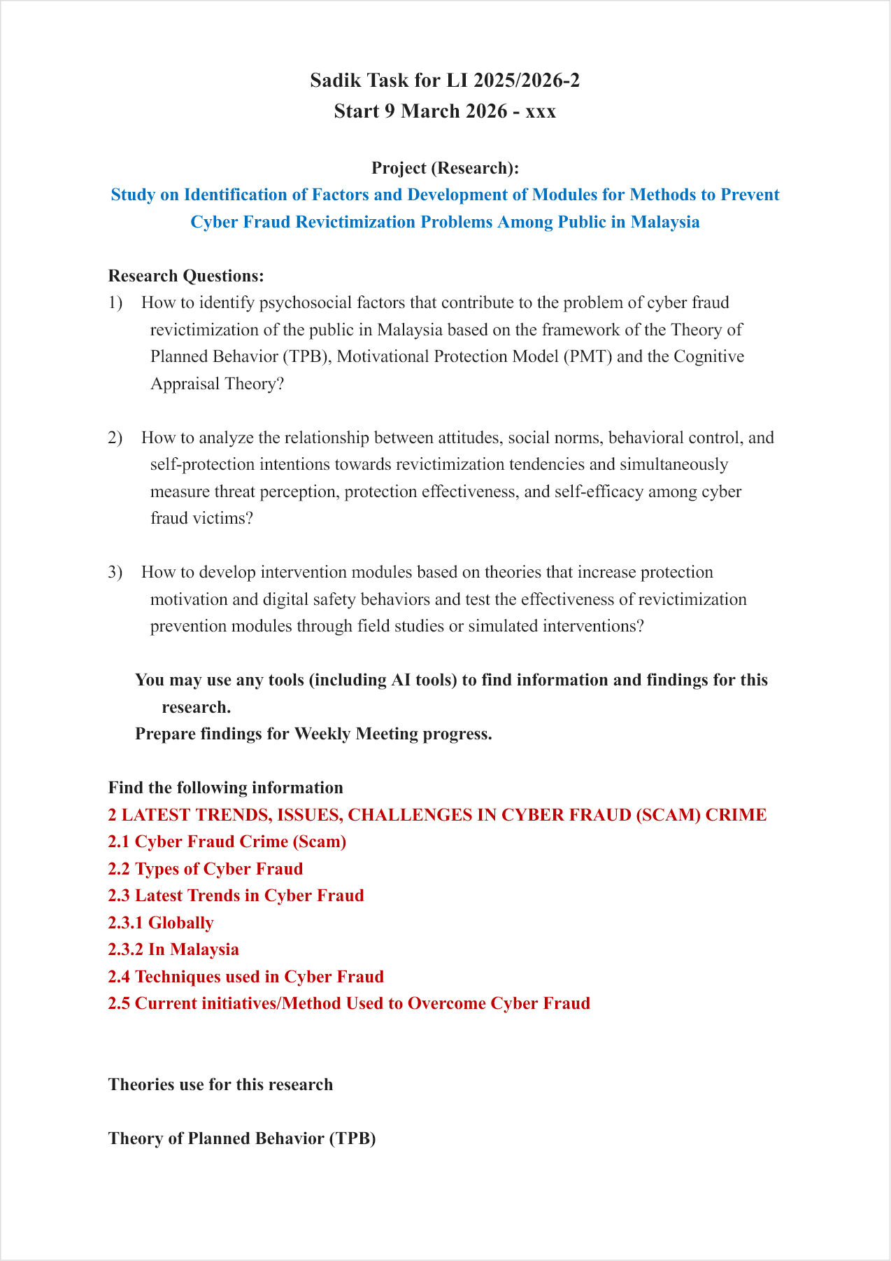
Figure 1: Initial LI task document for the assigned cyber fraud research topic.

2.3 Work Completed
During the training, I studied cyber fraud analysis and information gathering. This included scam crime, scam types, latest trends, issues, challenges, and common techniques used by scammers.
I also prepared early research paper materials. I arranged sources, compared information, prepared weekly progress findings, and drafted early sections related to the problem background, theory, and research direction. The work helped me understand how a broad topic becomes clearer after the sources and arguments are organized properly.
For the Wazuh task, I gathered information about Wazuh, SIEM, XDR, SOC, and endpoint monitoring. I also attempted a local setup on my laptop and tested the basic environment to understand how the system works.

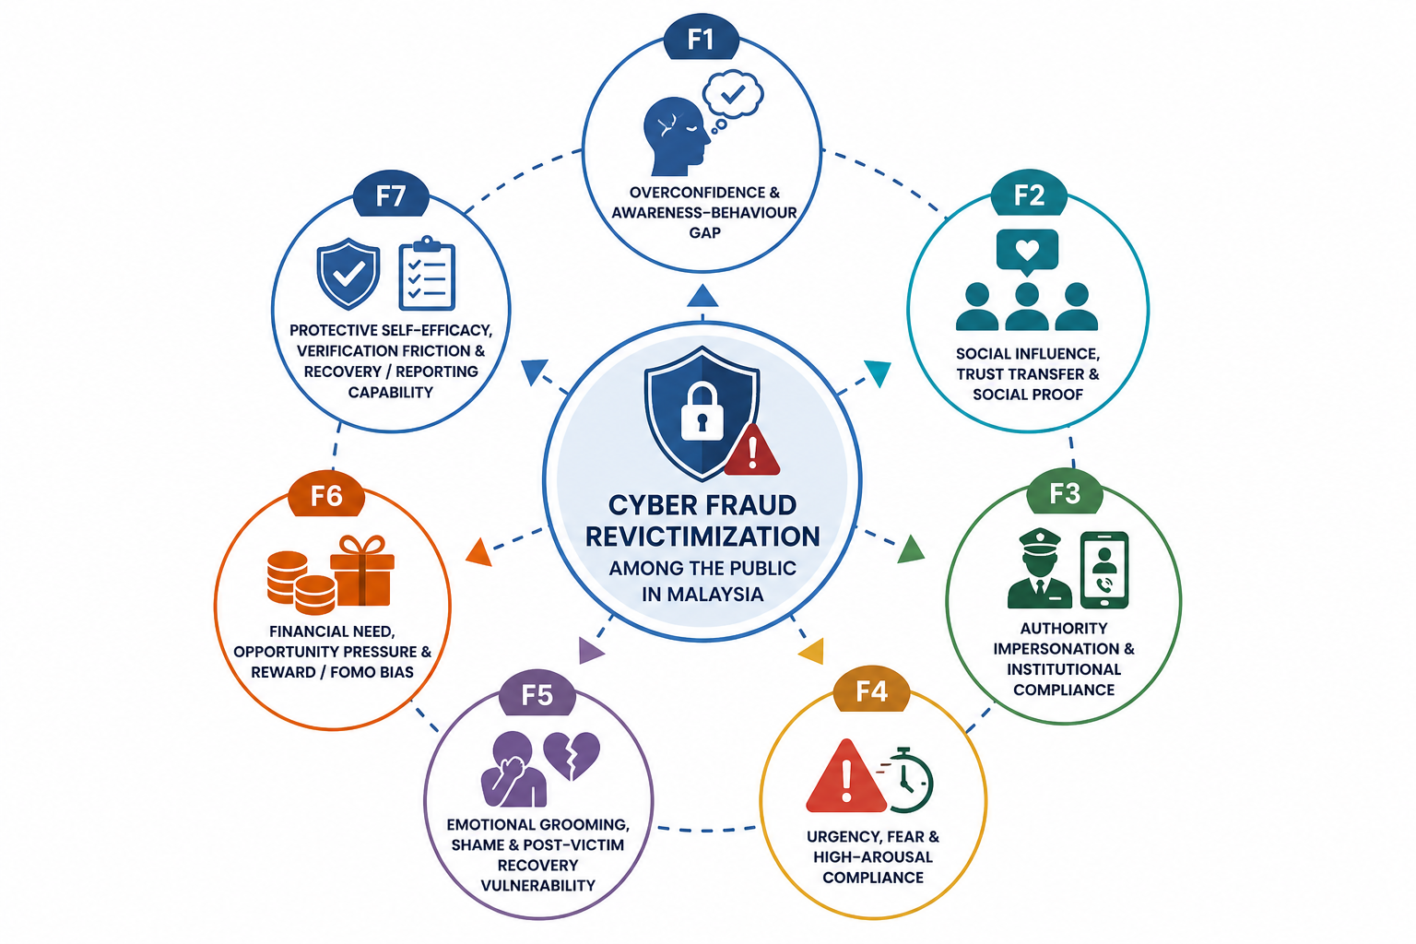
Figure 2: Cyber fraud revictimization factor framework used during topic analysis.

2.4 Hardware and Software Used
The main hardware used during the training was my laptop. The main software and materials used included web browsers, Microsoft Word, Markdown files, spreadsheet-style notes, Wazuh documentation, Wazuh setup files, academic papers, official reports, and cybersecurity references.
AI-assisted tools were used only as support for idea searching, comparison, and drafting. The information still needed to be checked and arranged properly before being used in the report.

2.5 Knowledge Applied
The training applied knowledge from computer network and security, cybersecurity awareness, technical reading, and report writing. The cyber fraud work helped me understand scam techniques, victim-related issues, and the importance of reliable sources.
The Wazuh task helped me connect the training with SOC, SIEM, XDR, endpoint monitoring, and alert concepts. It also gave me experience in learning a tool through documentation and basic testing.

2.6 Challenges
One challenge was that cyber fraud is a broad topic. At the beginning, many materials were related to general scam awareness, but not all of them were suitable for the assigned topic. I managed this by focusing on cyber fraud revictimization, victim behaviour, protection intention, and theory-related sources.
Another challenge was arranging the report materials clearly. Some information was useful as background only, while some was more suitable for the main discussion. I managed this by separating notes, references, and draft sections.
For Wazuh, the main challenge was understanding the different components and how they communicate. I handled this by reading the documentation, doing basic setup, and testing what could be done in my laptop environment.

2.7 Conclusion
The project and training tasks improved my understanding of cyber fraud research, source checking, report drafting, and cybersecurity monitoring tools. The main output was early research work on the cyber fraud topic, supported by Wazuh study and basic local testing.

CHAPTER 3: OVERALL INFORMATION OF THE INDUSTRIAL TRAINING

3.1 Learning Outcomes
The industrial training gave me experience in handling an assigned cybersecurity topic in a real work setting. I learned that research work needs continuous reading, comparison, rewriting, and checking before the content becomes useful for a report.
From the technical side, I learned about cyber fraud, scam methods, SOC workflow, SIEM, XDR, and Wazuh. From the report-writing side, I learned how to arrange sources, prepare weekly findings, and write in a more organized way.

3.2 Skills Gained
The main skills gained during the training were information searching, source selection, summarising, technical reading, report writing, and documentation. I also improved my ability to manage files and prepare work in a clearer structure.
The training helped me understand that not every day has the same type of progress. Some days were used for reading, some for testing, some for rewriting, and some for checking small details. This made the work feel more realistic and helped me manage the overall progress better.

3.3 Professional Development
This training helped me explain technical work in a clearer and more accurate way. For the Wazuh task, I analysed how Wazuh works, studied the purpose of related SOC and SIEM tools, and understood how these tools collect logs, show alerts, and support security monitoring.
The training also helped me develop better documentation habits. I learned to separate research notes, references, report drafts, Wazuh notes, logbook materials, and official internship documents.

3.4 Conclusion
Overall, the industrial training improved my technical and documentation skills. It gave me experience in cyber fraud research, Wazuh/SOC learning, weekly progress preparation, and formal report writing.

CHAPTER 4: CONCLUSION

4.1 Overall Achievement
The industrial training allowed me to complete useful work under UTM/IASRG. The main achievement was progressing the cyber fraud revictimization topic from initial understanding to organized notes, theory reading, weekly findings, and early research paper drafting.
I also gained supporting technical knowledge through Wazuh and SOC-related study. This helped me connect the research topic with practical cybersecurity monitoring concepts.

4.2 Issues and Challenges During LI
The main issue during the training was managing a broad cybersecurity topic. Cyber fraud includes many scam types, methods, victim issues, and prevention efforts. To handle this, I focused on the assigned revictimization topic and arranged the materials step by step.
Another challenge was source quality. Some sources were useful for examples, but not strong enough for main report content. I managed this by comparing sources and keeping stronger materials for the main writing.

4.3 Opinion and Suggestions
In my opinion, this industrial training was useful because it gave me experience in both cybersecurity research and technical exploration. The work improved my ability to understand a problem, search for reliable information, prepare findings, and organize a report.
The training also showed me the importance of writing only what was actually done. This helped make the report more accurate, especially for the Wazuh task and the early research paper work.

4.4 Final Conclusion
In conclusion, the industrial training helped me apply computer network and security knowledge in a practical environment. I gained experience in cyber fraud research, report drafting, Wazuh/SOC study, basic local testing, source organization, and internship documentation. These skills are useful for future work related to cybersecurity and technical reporting.

REFERENCES AND WORK MATERIALS
This report was prepared based on the internship task document, weekly progress work, cyber fraud research notes, Wazuh analysis notes, early research paper drafts, reference files, logbook preparation, and official internship report guidelines.

APPENDICES

Appendix A: Assigned LI Task
The main assigned task was the cyber fraud revictimization topic under UTM/IASRG.

Appendix B: Research Work Materials
The research work materials include topic notes, source lists, theory notes, early report sections, and weekly progress findings.

Appendix C: Wazuh Notes
The Wazuh notes record the supporting study on Wazuh, SOC, SIEM, XDR, basic local setup, and technical understanding.

Appendix D: Internship Documentation
The internship documentation includes the final logbook, organized internship files, and this industrial training report draft.

