Task 2 Report: Seven Factors of Cyber Fraud Revictimization Among the Public in Malaysia
Prepared from the seven-factor cyber fraud revictimization framework for Malaysia
Table of Contents
1. Introduction 3
2. Summary of the Seven Factors 3
2.1 How the Factors Work Together 5
3. Factor 1: Overconfidence and Awareness-Behaviour Gap 6
Suggested measurement items 8
Suggested intervention focus 8
Detailed report discussion 8
4. Factor 2: Social Influence, Trust Transfer, and Social Proof 10
Suggested measurement items 11
Suggested intervention focus 11
Detailed report discussion 11
5. Factor 3: Authority Impersonation and Institutional Compliance 12
Suggested measurement items 13
Suggested intervention focus 13
Detailed report discussion 13
6. Factor 4: Urgency, Fear, and High-Arousal Compliance 15
Suggested measurement items 16
Suggested intervention focus 16
Detailed report discussion 16
7. Factor 5: Emotional Grooming, Shame, and Post-Victim Recovery Vulnerability 17
Suggested measurement items 18
Suggested intervention focus 18
Detailed report discussion 18
8. Factor 6: Financial Need, Opportunity Pressure, and Reward/FOMO Bias 20
Suggested measurement items 21
Suggested intervention focus 21
Detailed report discussion 21
9. Factor 7: Protective Self-Efficacy, Verification Friction, and Recovery/Reporting Capability 22
Suggested measurement items 22
Suggested intervention focus 23
Detailed report discussion 23
10. Integrated Discussion 24
10.1 Relationship Between the Seven Factors and the Intervention Modules 24
10.2 Suggested Conceptual Flow for the Report 25
11. Suggested Measurement and Scenario Design 25
11.1 Suggested Questionnaire Structure 26
11.2 Suggested Scenario Scoring Table 27
12. Suggested Intervention Module Mapping 27
13. Conclusion 27
References 29

Introduction

Cyber fraud revictimization is an important issue in Malaysia because many scams do not succeed only through technical hacking. In many cases, victims are persuaded to click links, install applications, share sensitive information, transfer money, trust fake authorities, or continue communication with fraudulent actors. This means cyber fraud must be understood as both a cybersecurity issue and a behavioral decision-making issue.
In this report, cyber fraud revictimization refers to repeated vulnerability after a person has already experienced or encountered cyber fraud. It may include repeated financial loss, repeated scam exposure, repeated risky compliance, delayed reporting after a scam, recovery-scam targeting, or continued vulnerability caused by shame, confusion, low self-confidence, or poor knowledge of reporting channels.
The seven factors below are used as the main framework for understanding why members of the public in Malaysia may become vulnerable to cyber fraud again. These factors are connected to three theory foundations:
Theory of Planned Behavior (TPB), which explains how attitude, subjective norms, and perceived behavioural control shape protective intention (Ajzen, 1991).
Protection Motivation Theory (PMT), which explains how threat appraisal and coping appraisal influence protective behaviour (Rogers, 1975; Rogers, 1983).
Cognitive Appraisal Theory, which explains how people interpret stressful or uncertain situations and decide how to cope (Lazarus and Folkman, 1984; Folkman et al., 1986).

Malaysia-specific evidence supports this direction. CyberSecurity Malaysia reported that fraud was the dominant Cyber999 incident category in Q4 2024 and Q1 2025, showing that fraud remains a major reported cyber incident category in Malaysia (CyberSecurity Malaysia, 2025a; CyberSecurity Malaysia, 2025b). Bank Negara Malaysia also reported the launch of the National Fraud Portal in September 2024 to improve suspected fraud transaction identification and mule-account identification (Bank Negara Malaysia, 2025). These sources show that Malaysia has active response systems, but public behaviour remains important because many scams depend on users acting under pressure.

Concept of the 7 factors
The seven factors should be read as a connected process rather than as seven isolated causes. In a real scam, several factors may appear at the same time. For example, a fake investment scam may begin with social proof in a Telegram group, use a fake licensed-entity claim to create authority, add a limited-time offer to create urgency, and finally ask the victim to deposit money into an unrelated account. If the person does not know how to check the SC Investment Checker or Semak Mule, protective self-efficacy becomes the final weakness that allows the scam to proceed.
The same process can also continue after the first scam. After a person loses money, shame and fear may prevent reporting. The victim may then receive a fake recovery message that claims the money can be recovered for a fee. At this stage, emotional vulnerability, authority impersonation, urgency, financial pressure, and low reporting capability can combine to create revictimization.
Factor ID | Factor category | Main Malaysia scam cues | Main theory link | Main prevention focus
F1 | Overconfidence and awareness-behaviour gap | Familiar links, fake bank messages, delivery links, government aid messages | TPB, PMT, Cognitive Appraisal Theory | Separate awareness from actual safe behaviour
F2 | Social influence, trust transfer, and social proof | Telegram groups, WhatsApp agents, fake testimonials, celebrity images | TPB and Cognitive Appraisal Theory | Verify even when information comes from familiar or popular sources
F3 | Authority impersonation and institutional compliance | PDRM, BNM, LHDN, MCMC, SC, NSRC, banks, courts | TPB, PMT, Cognitive Appraisal Theory | Verify official claims independently
F4 | Urgency, fear, and high-arousal compliance | Frozen account, arrest threat, tax warning, limited-time offer | PMT and Cognitive Appraisal Theory | Pause before acting under pressure
F5 | Emotional grooming, shame, and recovery vulnerability | Love scam, parcel scam, recovery scam, fake investigator | TPB and Cognitive Appraisal Theory | Reduce shame and improve help-seeking
F6 | Financial need, opportunity pressure, and reward/FOMO bias | Investment profit, job task, loan fee, e-commerce offer, QR/e-wallet payment | TPB, PMT, Cognitive Appraisal Theory | Verify financial opportunities before payment
F7 | Protective self-efficacy, verification friction, and reporting capability | Not knowing NSRC 997, Semak Mule, Cyber999, bank hotline, SC checks | TPB and PMT | Build practical verification and reporting ability

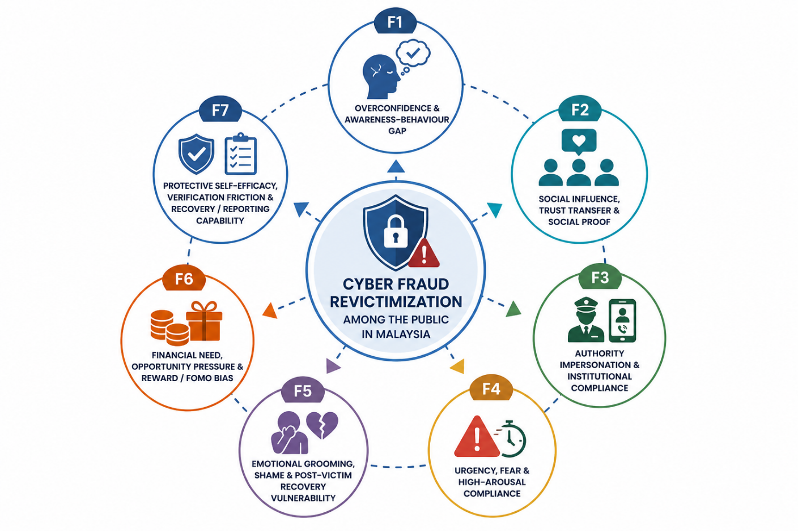
Figure 1: Seven-factor framework for cyber fraud revictimization.

Stage in scam process | Related factors | What happens to the victim | Safer response needed
First contact | F1, F2, F3 | Message, call, advertisement, or contact appears familiar, social, or official | Slow down and identify the source
Persuasion | F2, F3, F4, F5, F6 | Scammer creates trust, fear, urgency, emotional pressure, or reward expectation | Reappraise the situation as potentially suspicious
Decision point | F1, F4, F6, F7 | Victim decides whether to click, pay, install, share, or continue communicating | Pause, verify independently, and refuse unsafe instructions
After incident | F5, F7 | Victim may feel shame, confusion, or uncertainty about reporting | Report quickly, preserve evidence, and seek trusted support
Repeat targeting | F3, F5, F6, F7 | Fake recovery agents, fake support accounts, or new offers may appear | Avoid recovery fees and use official channels only

This process view is important for the research because revictimization is not caused by one simple mistake. It can result from repeated exposure, emotional state, social context, perceived authority, financial pressure, and lack of practical recovery skills.

Factor 1: Overconfidence and Awareness-Behaviour Gap

Overconfidence occurs when a person believes they can detect scams easily without checking other sources. This is dangerous because cyber fraud often uses realistic messages, familiar logos, professional-looking interfaces, and normal daily routines. A person may know that scams exist but still click a fake link because it looks familiar, or they may ignore a warning because the amount involved seems small.
This factor is important in Malaysia because cyber fraud exposure often happens through routine digital channels such as online banking, e-wallets, delivery services, government-aid messages, social media, and e-commerce platforms. CyberSecurity Malaysia's Q1 2025 report identified local phishing themes such as government aid scams, fake promotions, traffic summons scams, subscription impersonation, bank and e-wallet smishing, and delivery-related messages (CyberSecurity Malaysia, 2025b). These scams work partly because they appear normal and familiar.
Academic evidence also supports the importance of overconfidence. Balakrishnan, Ahhmed and Basheer (2025) found that overconfidence significantly predicted online fraud victimization among Malaysian adults (Balakrishnan et al., 2025). This means awareness alone is not enough. A person can understand the general idea of scams but still behave unsafely in a realistic situation.
From the TPB perspective, overconfidence weakens the attitude toward verification because the person believes checking is unnecessary. From the PMT perspective, verification may feel like a response cost because it takes time or effort. From the Cognitive Appraisal Theory perspective, the person may appraise a scam cue as safe because it looks familiar.
For the study, this factor should be measured by separating knowledge from behaviour. Respondents should not only be asked whether they know about scams. They should also be tested through scenario tasks, such as fake delivery links, fake bank messages, fake government-aid forms, or fake e-wallet alerts.
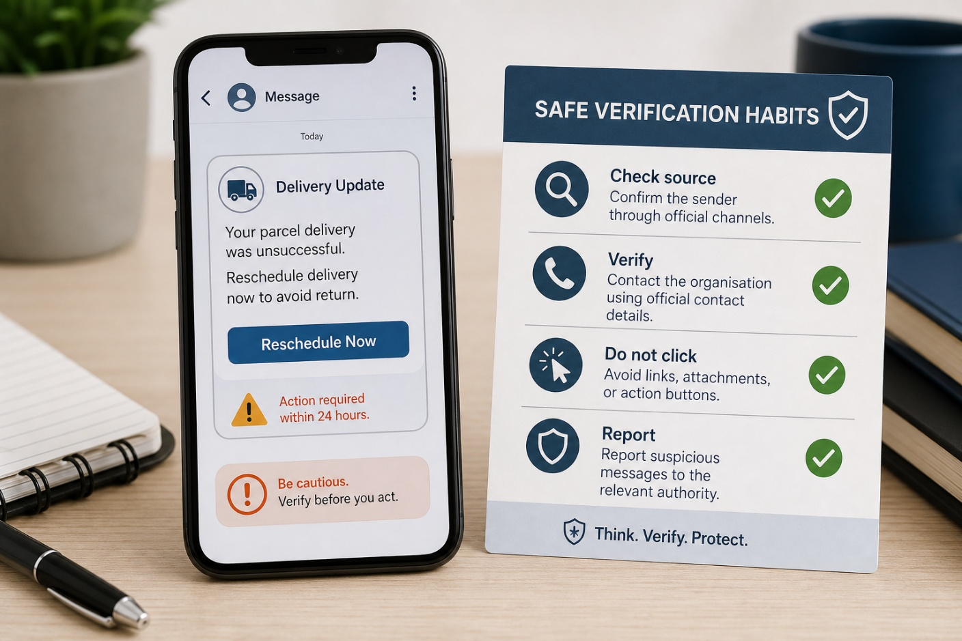
Figure 2: Example of awareness-behaviour gap in familiar digital messages.

Suggested measurement items
I can usually tell whether an online message is genuine without checking another source.
I do not need to verify small payment requests if the message looks familiar.
Scam warnings are mostly useful for people who are less digitally experienced than me.

Suggested intervention focus
The intervention should teach that verification is not a sign of ignorance. It is a responsible safety habit. Participants should practise checking suspicious links, messages, and payment requests through official channels instead of relying only on personal judgement.

Detailed report discussion
Overconfidence is not the same as digital literacy. A person may use online banking, e-wallets, social media, and shopping platforms every day, but that experience can sometimes create false confidence. The person may believe that because they have avoided scams before, they can continue to identify scams without formal checking. This is risky because scam messages are designed to look ordinary. They may imitate bank layouts, delivery tracking pages, traffic summons notices, government-aid forms, or subscription renewals.
In a revictimization context, overconfidence can become stronger after an attempted scam that did not succeed. A person may think, "I already know how scams work", and this belief may reduce future caution. Prior victims may also become selectively confident: they may be careful with the scam type that harmed them before, but less careful with a different scam type. For example, a person previously affected by an e-commerce scam may still trust a fake authority call or fake investment advertisement.
The research should therefore avoid treating awareness as the same thing as safety. A respondent may correctly define phishing but still choose a risky option in a scenario. This is why scenario-based scoring is essential. The study should compare self-rated awareness against actual safe-response scores.

Report element | How F1 should be used
Literature review | Explain that awareness alone does not eliminate cyber fraud risk, using Malaysian online fraud evidence
Methodology | Include overconfidence items and compare them with scenario performance
Scenario design | Use familiar-looking links, small payment requests, delivery messages, and e-wallet alerts
Module design | Train verification as a normal habit, not as a sign of low digital skill
Evaluation | Check whether post-test participants verify more often even when the message looks familiar

Factor 2: Social Influence, Trust Transfer, and Social Proof
Social influence becomes a revictimization factor when a person trusts an online offer, message, or request because it appears to be supported by other people. Scammers often borrow credibility from friends, family contacts, group chats, fake testimonials, social media comments, celebrity images, agents, or community recommendations. This creates trust transfer, where the victim trusts the scam because the source appears familiar or socially approved.
This factor is especially relevant to investment scams and malicious APK scams. Securities Commission Malaysia warns that investment scams commonly use social media platforms, fake testimonials, celebrity or prominent-personality endorsement, WhatsApp groups, Telegram groups, and clone entities to appear legitimate (Securities Commission Malaysia, n.d.). Kaspersky also reported malicious APK activity in Malaysia and Brunei where scam messages could spread through messenger-style contexts and potentially appear to come from trusted contacts (Kaspersky, 2025).
Balakrishnan et al. (2025) found that social influence significantly predicted online fraud victimization among Malaysian adults. This supports the need to measure social proof and trust transfer as more than a general communication issue. A person may trust a Telegram investment group because many members claim to have earned profit, or they may open a file because it appears to come from a known contact.
From the TPB perspective, social influence is linked to subjective norms. People may feel that an action is acceptable because others seem to approve it. From Cognitive Appraisal Theory, social familiarity can make a suspicious message appear legitimate. This is why social proof can reduce careful thinking and weaken verification.
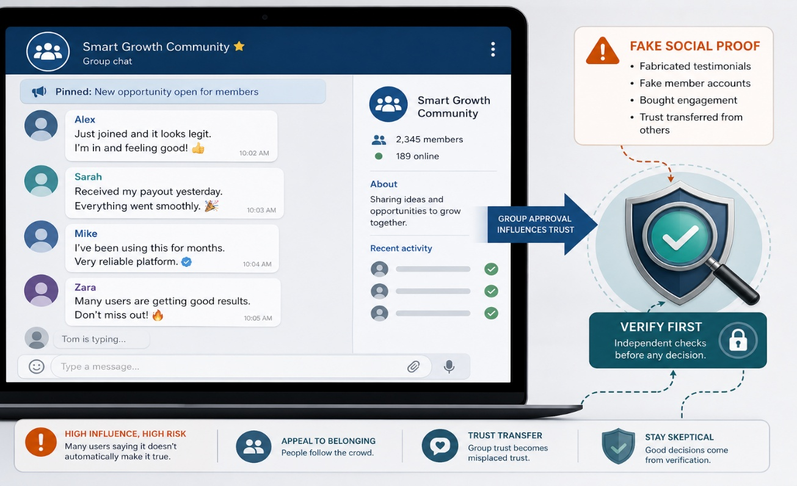
Figure 3: Social proof and trust transfer in online scam environments.

Suggested measurement items
I am more likely to trust an online offer if many people in a group say it works.
I would consider an investment opportunity if it is recommended by someone I know online.
If a familiar contact sends an attachment, I am less likely to verify it.

Suggested intervention focus
The intervention should teach that social proof can be fabricated. Participants should verify offers even when they come from friends, groups, agents, testimonials, or familiar contacts. The module should also explain the difference between harmful scam social proof and helpful protective social support.

Detailed report discussion
Social influence can be protective or harmful. It is protective when family members, friends, colleagues, or community members encourage verification and reporting. It is harmful when scammers create fake social proof that makes risky behaviour seem normal. This distinction is important because the study should not treat all social influence as negative. The goal is to reduce scammer-created social proof while strengthening genuine protective support.
In Malaysia, social proof is especially visible in investment and job-task scams. Scammers may create Telegram or WhatsApp groups where many accounts appear to show profit, payment receipts, testimonials, or screenshots. These groups create the impression that many people have already benefited. A victim may then feel safer because the opportunity appears socially validated. Similar trust transfer can happen when a malicious APK is sent through a familiar contact whose account may already be compromised.
Social proof can also affect revictimization after a first loss. A prior victim may join online groups looking for help, recovery, or new income opportunities. Scammers can use these groups to introduce fake recovery services or new investment schemes. The victim's desire for reassurance and community can be exploited.

Social influence type | Safe or risky? | Example | Research implication
Family member encouraging verification | Protective | Asking a parent or sibling before transferring money | Measure trusted support as a protective behaviour
Telegram group showing fake profit | Risky | Many users claim they earned money from a scheme | Measure fake social proof and group pressure
Friend sends APK file | Risky if not verified | Contact may be compromised | Scenario should test verification even for familiar contacts
Community warning about scam | Protective | Sharing official scam alert | Intervention should promote safe social norms
Recovery group asking for fees | Risky | Fake agents offer to recover money | Connect F2 with F5 recovery vulnerability

Image suggestion: use a visual showing the difference between "protective social support" and "fake social proof". This can be a two-column diagram with safe support on one side and scam group pressure on the other.

Factor 3: Authority Impersonation and Institutional Compliance
Authority impersonation occurs when scammers pretend to represent trusted institutions. In Malaysia, scammers may impersonate PDRM, BNM, LHDN, MCMC, SC, NSRC, banks, courts, delivery services, or other official bodies. This technique works because people may feel pressure to obey institutions, especially when the message involves legal action, tax issues, account freezing, money laundering, or investigation.
CyberSecurity Malaysia's Q1 2025 report identified vishing cases involving impersonation of police, LHDN, MCMC, banks, companies, and CyberSecurity Malaysia (CyberSecurity Malaysia, 2025b). Securities Commission Malaysia also reports clone-firm scams where fraudsters misuse legitimate names, fake documents, agents, and false credentials (Securities Commission Malaysia, 2022). Bernama reported a PDRM warning about fake Facebook accounts using NSRC's name and image, where PDRM stated that NSRC receives calls through 997 and does not contact individuals by phone or WhatsApp (Bernama, 2025a).
Authority impersonation is closely connected to revictimization because prior victims may be especially vulnerable to fake recovery channels, fake investigators, fake lawyers, or fake support accounts. A person who has already lost money may want urgent help and may trust an official-looking recovery offer.
From the TPB perspective, perceived institutional norms can make compliance feel expected. From the PMT perspective, legal or financial threats increase perceived severity. From Cognitive Appraisal Theory, authority cues may cause the victim to appraise the situation as a real official threat rather than a possible scam.

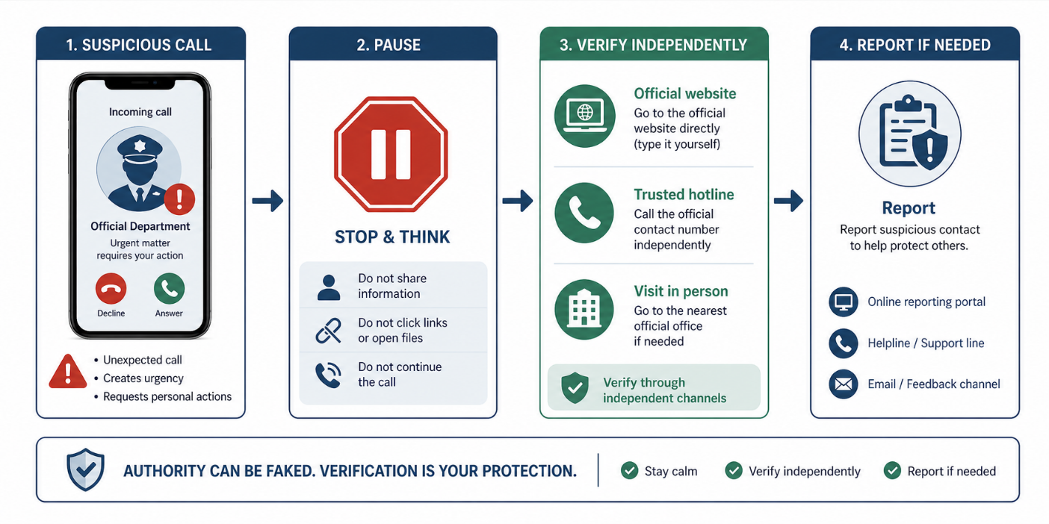
Figure 4: Authority impersonation and safe independent verification.

Suggested measurement items
If a caller claims to be from an enforcement agency, I feel pressured to follow instructions quickly.
I know how to independently verify whether a call from PDRM, BNM, LHDN, MCMC, SC, or NSRC is genuine.
I would hesitate to end a call from someone claiming to be an officer.

Suggested intervention focus
The intervention should teach that official claims must be verified through independently sourced contact details. Participants should not call numbers, click links, or follow instructions supplied by the suspicious caller or sender. Fake NSRC and recovery-support channels should be included because they directly relate to revictimization risk.

Detailed report discussion
Authority impersonation is powerful because many people are trained to respect official institutions. A caller who claims to be from PDRM, BNM, LHDN, MCMC, a bank, a court, or NSRC may create immediate pressure. The victim may feel that ending the call is rude, illegal, or dangerous. This is exactly what the scammer wants: the victim remains inside the scammer's communication channel instead of verifying independently.
Authority scams often include technical-sounding or legal-sounding language. A victim may be told that their identity was used for money laundering, their account is linked to crime, their tax record has a problem, their phone line will be blocked, or their bank account must be protected. The details may be false, but the institutional language creates fear and compliance.
For prior victims, fake authority can become even more dangerous. A scammer may pretend to be an investigator, lawyer, recovery officer, bank officer, or NSRC representative. The victim may want help so badly that they trust the fake official. This is why authority impersonation must be connected to recovery-scam education.
Authority claim | Why it is persuasive | Safe verification principle
Police or court case | Creates fear of arrest or legal action | End the call and verify through official published channels
BNM or bank safe account | Creates fear of losing money | No legitimate authority asks users to transfer to unknown safe accounts
LHDN tax issue | Creates fear of penalties | Verify through official LHDN channels, not caller-supplied links
MCMC line blocking | Creates fear of service loss | Check with official service provider or agency channel
NSRC recovery help | Exploits prior victim's need for help | NSRC receives calls through 997; avoid fake social media accounts

Image suggestion: use a flowchart titled "If an authority contacts you". The safe flow should be: stop communication, do not share information, search official contact independently, verify, then report if suspicious.

Factor 4: Urgency, Fear, and High-Arousal Compliance
Urgency and fear are used to reduce thinking time. Scammers may say that an account will be frozen, a police case has been opened, a tax penalty must be paid, an investment slot will close soon, or a transfer must be made immediately. These messages create high emotional arousal. When a person is afraid or rushed, they may comply before verifying.
This factor is visible in Malaysian scam cues. CyberSecurity Malaysia's Q1 2025 report identified threats of legal action, account suspension, overdue payments, and similar vishing or phishing themes (CyberSecurity Malaysia, 2025b). Securities Commission Malaysia also warns that investment scams may use limited-time opportunities to pressure people into acting quickly (Securities Commission Malaysia, n.d.). The Ministry of Finance Malaysia reported that NSRC had received many scam-related calls, which shows that rapid response is part of Malaysia's scam response environment (Ministry of Finance Malaysia, 2024).
From the PMT perspective, urgency and fear increase perceived severity. However, if the person has low self-efficacy or does not know what to do, fear may lead to panic or unsafe compliance. From Cognitive Appraisal Theory, the person may appraise the situation as an urgent danger and believe there is no time to verify. From TPB, the intention to verify can collapse when time pressure feels stronger than normal safety habits.
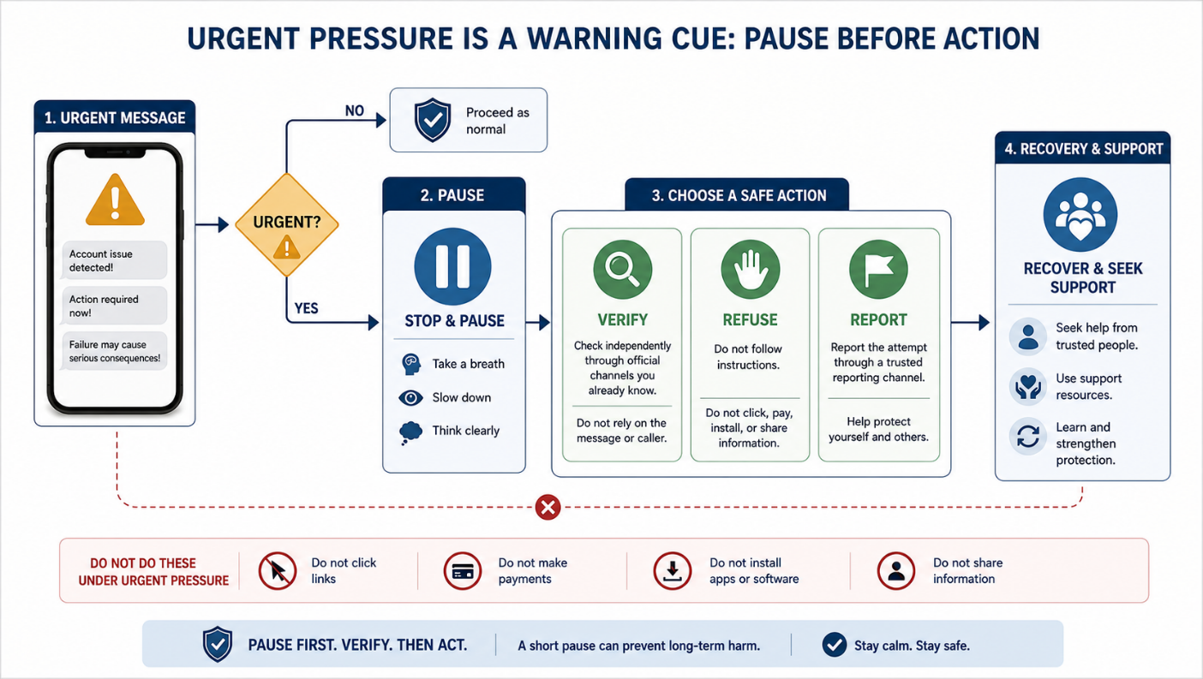
Figure 5: Urgency as a warning cue and the pause-before-action routine.

Suggested measurement items
When a message says urgent action is needed, I find it difficult to pause.
I am confident I can end a threatening call and verify through official channels.
Fear of legal or financial consequences makes me more likely to follow instructions.

Suggested intervention focus
The first trained action should be "pause". Participants should learn that urgency itself is a scam cue. The module should include short refusal scripts and a simple response routine: pause, verify, refuse, report, and recover.

Detailed report discussion
Urgency changes the way people think. When people are frightened or rushed, they may rely on quick emotional judgement instead of careful verification. Scammers use this by creating deadlines, threats, countdowns, or instructions that must be followed immediately. The victim may feel that checking is too slow, even when checking is exactly what is needed.
Urgency can appear in both fear-based and reward-based scams. Fear-based urgency includes arrest threats, frozen accounts, legal action, tax penalties, and suspicious transaction alerts. Reward-based urgency includes limited-time investment slots, flash discounts, early-bird job opportunities, or "last chance" loan approval. In both cases, the scammer tries to make verification feel costly.
In revictimization, urgency can be intensified by a previous loss. A victim who already lost money may panic when told that more money can be lost, or may rush to pay a recovery fee because they fear losing the chance to recover funds. This means urgency should be measured not only as a scam cue but also as an emotional response.
Urgency pattern | Example scam message | Likely risky response | Safer trained response
Legal threat | "You are linked to money laundering. Act now." | Stay on call and follow instructions | End call and verify independently
Account threat | "Your bank account will be frozen." | Click link or disclose details | Open official banking app or call official hotline
Payment deadline | "Pay today or face penalty." | Pay through supplied link | Check official portal directly
Investment deadline | "This profit slot closes in 10 minutes." | Deposit quickly | Verify entity through SC resources
Recovery deadline | "Pay now to recover your lost money." | Pay recovery fee | Refuse fee and report official channel

Image suggestion: use a decision-tree image that begins with the question "Is the message urgent?" and routes the reader to "Pause first" before any action.

Factor 5: Emotional Grooming, Shame, and Post-Victim Recovery Vulnerability
Emotional grooming happens when scammers build trust, attachment, obligation, secrecy, or emotional dependence. This is common in love scams, parcel scams, pig-butchering scams, and recovery scams. After victimization, shame and self-blame can make victims avoid reporting or avoid telling family and friends. This can increase revictimization risk because victims may remain isolated and may become vulnerable to fake recovery services.
Malaysian love scam evidence supports the importance of emotional grooming. Alavi et al. (2018) studied love scam victims in Selangor and identified factors such as sweet talk, socializing, easy internet access, self-pressure, fake profiles, false promises, parcel narratives, and tax-agency impersonation (Alavi et al., 2018). CyberSecurity Malaysia's Q1 2025 report also listed love and parcel scams as fraud sub-categories (CyberSecurity Malaysia, 2025b).
This factor is highly relevant to revictimization. A prior victim may feel embarrassed and avoid reporting. Another scammer may then approach them as a fake investigator, fake lawyer, fake NSRC account, or recovery agent. Bernama's report on fake NSRC Facebook accounts shows that recovery or support infrastructure can itself be impersonated (Bernama, 2025a).
From Cognitive Appraisal Theory, grooming changes the person's appraisal from "stranger risk" to "trusted relationship". From TPB, shame and social norms affect help-seeking and reporting intention. From PMT, high response cost, such as embarrassment or confusion, reduces recovery action.
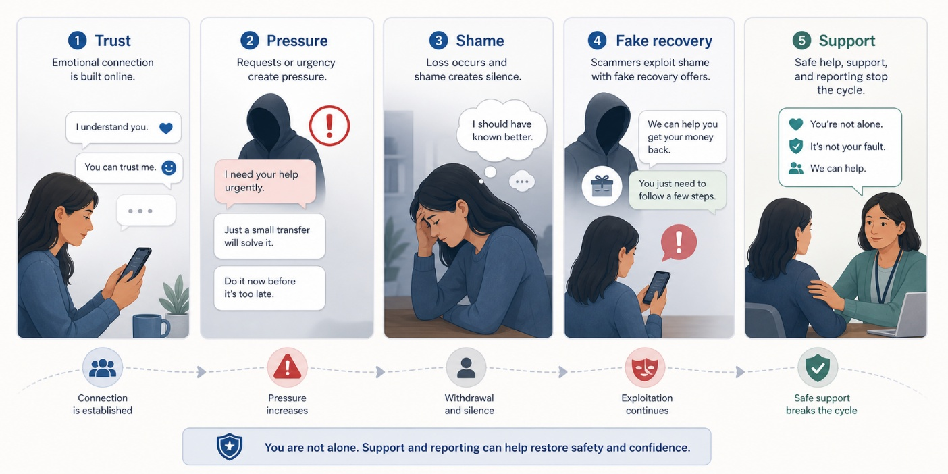
Figure 6: Emotional grooming and post-victim recovery vulnerability.

Suggested measurement items
I would feel embarrassed to tell family or authorities if I lost money to a scam.
After being scammed, I would be tempted to pay someone who claims they can recover my money.
I find it difficult to refuse financial requests from someone I trust emotionally.

Suggested intervention focus
The intervention must include shame reduction, trusted-contact routines, reporting guidance, recovery-scam warnings, evidence preservation, and emotional support. Prior victims should be taught that fraud is a structured manipulation process and that seeking help quickly is a protective action.

Detailed report discussion
Emotional grooming is different from one-time phishing because it can develop over days, weeks, or months. The scammer may build trust gradually, create a sense of intimacy, ask for secrecy, and introduce financial requests only after emotional dependence has formed. In love scams and parcel scams, the victim may believe they are helping someone they care about. In pig-butchering style scams, emotional trust may later be redirected into fake investment platforms.
Shame becomes a second layer of harm after the scam. Victims may feel embarrassed, foolish, guilty, or afraid of being judged. This can delay reporting and reduce support-seeking. Delayed reporting matters because quick action can sometimes help banks or response centres reduce further harm. Shame can also make victims more isolated, and isolation can make recovery scams more persuasive.
Recovery scams are directly linked to revictimization. A fake recovery agent may claim that the victim's money can be retrieved for a fee. A fake lawyer or investigator may ask for "processing", "tax", "clearance", or "case" fees. A fake support account may use the name or logo of a real agency. The victim may comply because the message gives hope after loss.

Emotional/recovery risk | How it appears | Why it increases revictimization | Protective response
Groomed trust | Online partner requests money | Victim sees the scammer as trusted | Consult trusted person before payment
Secrecy | "Do not tell your family" | Victim becomes isolated | Treat secrecy as a warning sign
Shame | Victim avoids reporting | Delays help and learning | Normalize reporting and support-seeking
Recovery promise | "We can recover funds for a fee" | Hope after loss overrides caution | Refuse fees and verify official channels
Self-blame | "I should have known better" | Lowers self-efficacy | Reframe scam as manipulation, then teach action steps

Image suggestion: use a staged diagram showing grooming, payment request, shame, recovery scam, and safe recovery actions. Keep the tone respectful and avoid victim-blaming visuals.

Factor 6: Financial Need, Opportunity Pressure, and Reward/FOMO Bias
Financial need and opportunity pressure make scams attractive. A person may be more willing to take risks when they need money, want to recover previous losses, fear missing out on profit, or believe an offer is available for a limited time. This factor appears in investment scams, job-task scams, loan scams, e-commerce bargains, e-wallet payment redirection, QR scams, and crypto-related offers.
Securities Commission Malaysia warns that investment scams often promise high returns with little or no risk, use social media platforms, request deposits into personal or unrelated bank accounts, frame offers as limited-time opportunities, ask for extra taxes or fees, use fake testimonials, and impersonate legitimate entities (Securities Commission Malaysia, n.d.). SC's clone-firm findings also show the use of social media advertisements, agents, WhatsApp chats, mule accounts, and possible large flows to masterminds (Securities Commission Malaysia, 2022). SC's Annual Report 2025 also identified suspicious URLs, Telegram accounts, corporate mule accounts, e-wallet channels, and crypto-related suspicious URLs in the investment scam environment (Securities Commission Malaysia, 2026).
This factor contributes to revictimization because a prior victim may want to recover money quickly. The desire to replace a loss may make high-return offers or recovery-payment requests more attractive. A person may continue paying "tax", "unlock", "processing", or "task" fees because they hope the next payment will recover previous losses.
From the TPB perspective, a positive attitude toward quick gain can weaken protective intention. From PMT, the perceived reward competes with perceived threat. From Cognitive Appraisal Theory, the person may appraise the situation as an opportunity rather than a danger.
Figure 7: Financial opportunity pressure and reward-based scam cues.

Suggested measurement items
I am willing to act quickly if an online offer looks profitable.
I may skip verification if an investment opportunity is available for a limited time.
Financial pressure makes online loan, job, or investment offers more attractive.

Suggested intervention focus
The intervention should include investment, job, loan, e-commerce, e-wallet, QR payment, and crypto-related scenarios. Participants should practise checking SC Investment Checker, SC Investor Alert List, Semak Mule, and official company or platform information before making any payment.

Detailed report discussion
Financial pressure can make risky offers feel reasonable. Someone who needs money may be attracted to a fast loan, easy job, cheap goods, investment profit, task commission, crypto return, or e-wallet reward. The scam may not look like a threat at first. It may look like a solution to a financial problem.
Reward/FOMO bias is powerful because the victim may fear losing a rare opportunity. Scammers use phrases such as "limited slot", "today only", "guaranteed return", "VIP group", "unlock fee", "tax payment", or "complete this task to withdraw". These phrases make verification feel like a delay that could cause the victim to miss the reward.
This factor is closely connected to revictimization. After a first loss, a victim may want to recover money quickly. That desire can make new investment schemes, job offers, or recovery-fee claims more attractive. A person may continue paying because they believe one more payment will unlock the promised return.
Scam type | Financial pressure used | Warning sign | Verification action
Investment scam | High return with little or no risk | Guaranteed profit, fake testimonials, unrelated account | Check SC Investment Checker and Investor Alert List
Job-task scam | Easy income from simple tasks | Pay to unlock task or withdraw commission | Verify employer and refuse upfront payments
Loan scam | Fast approval for people in need | Processing fee before loan release | Verify licensed provider and avoid upfront fees
E-commerce scam | Cheap goods or urgent sale | Seller pushes direct transfer outside platform | Check seller, platform protection, and Semak Mule
Recovery scam | Promise to recover previous loss | Fee before recovery | Refuse and report through official channels

Image suggestion: use an image showing a "too good to be true" offer passing through three checks: source, payment account, and official registry.

Factor 7: Protective Self-Efficacy, Verification Friction, and Recovery/Reporting Capability
Protective self-efficacy refers to a person's confidence in performing protective actions. Even when a person knows that cyber fraud is dangerous, they may still fail to act safely if they do not know what to do, doubt that reporting will help, feel embarrassed, or find the process confusing. This is called verification friction or reporting friction.
Malaysia has several important verification and reporting tools. Cyber999 is a national point of contact for reporting and responding to computer security incidents (CyberSecurity Malaysia, 2026). Semak Mule allows the public to check suspicious bank accounts, phone numbers, and company names linked to financial fraud, and PDRM reported that the portal had more than 37 million visitors since October 2020 (Royal Malaysia Police, 2025). NSRC 997 provides a coordinated scam response channel, and the Ministry of Finance Malaysia reported major call activity and blocked suspicious transactions through coordinated response (Ministry of Finance Malaysia, 2024). Securities Commission Malaysia advises investors to use SC Investment Checker and deal only with licensed or registered entities (Securities Commission Malaysia, n.d.).
The problem is not only whether these tools exist. The real issue is whether the public knows which tool to use, when to use it, and how to act quickly. A person may know the name "Semak Mule" but not use it before transferring money. A victim may know NSRC exists but delay reporting because of shame. A person may search online for help and find a fake support account.
From PMT, self-efficacy and response efficacy are central. A person must believe they can perform the action and that the action can reduce harm. From TPB, perceived behavioural control affects intention and behaviour. From Cognitive Appraisal Theory, secondary appraisal depends on whether the person can identify realistic coping options.
[Insert Figure 8 here: Suggested image of Malaysian verification and reporting channels with matching scam situations.]
Figure 8: Verification and reporting capability for cyber fraud prevention.

Suggested measurement items
I know exactly what to do in the first 24 hours after a scam transfer.
I can check whether a bank account, phone number, or company name has scam reports.
I know where to verify whether an investment entity is licensed.
I believe reporting quickly can reduce harm.

Suggested intervention focus
The intervention should teach tool use, not only tool names. Participants should practise choosing the correct channel:
Bank hotline and NSRC 997 for active or recent scam transfers.
Semak Mule for suspicious bank accounts, phone numbers, and company names.
Cyber999/MyCERT for malicious links, malicious APKs, and cyber incidents.
SC Investment Checker and Investor Alert List for investment-related claims.
PDRM report for formal crime reporting and investigation record.
Platform reporting for fake profiles, marketplace listings, or fraudulent accounts.

Detailed report discussion
Protective self-efficacy is the practical side of cyber fraud prevention. A person may have high awareness and still fail if they do not know what to do. For example, a respondent may know that investment scams exist but not know how to check whether an entity is licensed. A prior victim may know they should report but not know whether to contact the bank, NSRC, PDRM, Cyber999, SC, or the platform first.
Verification friction includes anything that makes safe action feel difficult. It may be lack of knowledge, confusion between agencies, embarrassment, fear of being blamed, uncertainty about what evidence to preserve, or difficulty finding the correct official channel. Scammers exploit this friction by keeping the victim inside the scammer's own channel and by providing fake links or phone numbers.
The study should therefore test tool-use capability directly. Respondents should be given short situations and asked to choose the correct channel. This is more useful than simply asking whether they have heard of NSRC, Semak Mule, Cyber999, or SC Investment Checker.
Situation | Correct first action | Why
Money was just transferred to a suspected scammer | Contact bank hotline and NSRC 997 quickly | Speed may help block or trace funds
A seller gives an unfamiliar bank account or phone number | Check Semak Mule before payment | It may show prior scam reports
A website asks the user to install an APK | Refuse installation and report as cyber incident if needed | APK files can enable technical compromise
An investment group claims to be licensed | Check SC Investment Checker and Investor Alert List | Investment legitimacy must be verified independently
A fake profile or marketplace listing is found | Report to platform and relevant official channel if loss occurred | Reduces further exposure and preserves reporting trail

Image suggestion: use a simple channel-matching chart. The image should match scam situations to the correct Malaysian tool or authority.

Integrated Discussion
The seven factors should not be treated as separate personality traits. They are connected parts of a revictimization process. A scam may begin with a familiar message, use social proof to create trust, add authority to increase compliance, use urgency to reduce checking, create emotional or financial pressure, and finally exploit the victim's lack of confidence in reporting or recovery.
For example, a fake investment scam may use a Telegram group to create social proof, use fake SC-related language to create authority, promise high returns to trigger FOMO, and pressure the victim to deposit quickly into an unrelated account. If the person does not know how to check SC Investment Checker or Semak Mule, F7 becomes part of the risk. If the person loses money and later receives a recovery offer, F5 becomes part of the revictimization risk.
Therefore, the study should measure both psychological factors and practical capability. It is not enough to ask whether people are aware of scams. The study should test whether respondents can recognise scam cues, pause under pressure, verify independently, choose the correct reporting channel, preserve evidence, and avoid recovery scams.

Relationship Between the Seven Factors and the Intervention Modules
The intervention should be designed so that every factor is addressed by at least one module. Some factors require knowledge, but most require practice. For example, F1 requires scenario practice because overconfident respondents may already know scam definitions. F3 and F4 require role-play or decision-tree practice because authority and urgency are experienced emotionally. F5 requires careful language because the intervention must reduce shame without blaming the victim. F7 requires hands-on channel-matching activities because tool-use ability cannot be assumed.
Factor | Main weakness | Best intervention method | Expected improvement
F1 | Awareness does not become safe action | Familiar-message scenario practice | More independent verification
F2 | Fake social proof creates false trust | Group/testimonial analysis | Less trust in fabricated proof
F3 | Official-sounding claims trigger compliance | Authority-call role-play | More independent official verification
F4 | Fear and urgency reduce thinking time | Pause-and-refuse scripts | Lower risky compliance under pressure
F5 | Shame and emotional trust reduce help-seeking | Recovery and support routine | Faster reporting and lower recovery-scam risk
F6 | Financial opportunity overrides caution | Investment/job/loan verification tasks | More checking before payment
F7 | User does not know what to do | Tool-use channel matching | Higher reporting and verification capability

SUGGESTIONS

Suggested Conceptual Flow for the Report
The research report can explain the seven factors using the following flow:
1. Cyber fraud exposure begins through a message, call, advertisement, social contact, platform listing, or application request.
2. The victim appraises the situation using available cues, such as familiarity, authority, urgency, social proof, emotional connection, or financial opportunity.
3. TPB constructs influence whether the victim intends to verify, refuse, report, or comply.
4. PMT constructs influence whether the victim feels threatened and whether they believe protective action will work.
5. Cognitive Appraisal Theory explains whether the victim reappraises the scam cue or accepts the scammer's framing.
6. The behavioural outcome becomes safe action, partial safety, or risky compliance.
7. After a victimization event, shame, recovery pressure, repeated contact, and reporting capability determine whether revictimization risk increases or decreases.
[Insert Figure 9 here: Suggested conceptual flow diagram from scam exposure to appraisal, intention, behaviour, and revictimization outcome.]
Figure 9: Suggested conceptual flow for the seven-factor revictimization model.

Suggested Measurement and Scenario Design
The questionnaire should classify respondents into four groups:
Prior victims: people who have already experienced cyber fraud victimization.
Repeat victims: people who experienced more than one victimization event.
Attempted-scam exposed non-victims: people who encountered scam attempts but did not experience confirmed loss.
No-known-exposure respondents: people who do not recall scam exposure.
Scenario tasks should include:
Fake PDRM, LHDN, BNM, MCMC, SC, NSRC, or bank call.
Fake bank, e-wallet, delivery, traffic summons, or government-aid smishing link.
Telegram or social media investment offer.
Job-task or loan-fee scam.
Love or parcel scam.
Malicious APK request.
Fake recovery agent or fake support account.
Each scenario should be scored separately:
Safe response: respondent pauses, verifies independently, refuses unsafe instructions, reports correctly, or seeks trusted support.
Partially safe response: respondent delays action or asks someone, but still remains exposed to the scammer.
Risky compliance: respondent clicks, pays, transfers, installs, shares credentials, follows secrecy instructions, or contacts fake support.

Suggested Questionnaire Structure
The questionnaire should be organised clearly so that respondents can answer without confusion. Sensitive questions about victimization should appear after the general digital-use questions, not at the very beginning. This helps respondents understand the study before answering personal experience items.
Section | Content | Purpose
A | Demographic profile | Understand respondent background
B | Digital platform exposure | Identify online banking, e-wallet, e-commerce, messaging, and social media use
C | Cyber fraud exposure and victimization history | Classify prior victims, repeat victims, attempted-scam targets, and no-known-exposure respondents
D | Seven-factor items | Measure F1 to F7
E | TPB, PMT, and appraisal items | Measure theoretical constructs
F | Scenario tasks | Test actual response under Malaysia-specific scam cues
G | Tool-use capability | Test correct use of NSRC, Semak Mule, Cyber999, bank hotline, PDRM, and SC tools
H | Intervention feedback | Measure usefulness and pre/post improvement

Suggested Scenario Scoring Table
Score | Response category | Meaning | Example
2 | Safe response | Respondent refuses unsafe action and verifies or reports through the correct channel | Ends fake PDRM call and checks official channel
1 | Partially safe response | Respondent delays or asks someone but still remains in contact with scammer or uses unclear verification | Asks the caller for proof instead of ending the call
0 | Risky compliance | Respondent follows scammer instruction | Transfers money, clicks link, installs APK, pays recovery fee

The scoring should be analysed separately from confidence. A respondent who says they are confident but chooses a risky response should be treated as an awareness-behaviour gap. This directly supports the measurement of F1 and F7.

Suggested Intervention Module Mapping
Module | Main purpose | Factors covered
Module 1: Cyber Fraud and Revictimization Awareness | Explain Malaysian scam types, prior victimization, and repeated vulnerability | F1, F3, F5, F6, F7
Module 2: Scam Cue Detection and Cognitive Reappraisal | Train recognition of authority, urgency, social proof, emotional grooming, reward, and technical cues | F1, F2, F3, F4, F5, F6
Module 3: Threat and Coping Appraisal Strengthening | Balance realistic threat awareness with confidence in protective actions | F4, F6, F7
Module 4: Verification, Reporting, and Protective Action Routine | Teach practical use of Malaysian verification and reporting channels | F1, F3, F4, F6, F7
Module 5: Recovery, Shame Reduction, Social Support, and Revictimization Resistance | Support prior victims and prevent recovery-scam targeting | F2, F3, F5, F7

Conclusion
Cyber fraud revictimization among the public in Malaysia is not only a technical problem. It is also a behavioural, emotional, social, financial, and practical-response problem. The seven-factor framework explains how people may remain vulnerable even after they know scams exist or after they have already experienced a scam.
The most important conclusion is that prevention must move beyond general awareness. A strong intervention should train people to pause, verify, refuse, report, and recover. It should also teach practical use of Malaysian tools such as NSRC 997, bank hotlines, Semak Mule, Cyber999/MyCERT, PDRM reporting, platform reporting, and SC Investment Checker. For prior victims, the intervention must also address shame, recovery scams, repeated contact, and trusted support.
This seven-factor framework can therefore support the questionnaire design, scenario assessment, intervention module development, and final evaluation of the research project.

References
Ajzen, I. (1991) 'The theory of planned behavior', Organizational Behavior and Human Decision Processes, 50(2), pp. 179-211.
Alavi, K. et al. (2018) 'Love Scam di Selangor: Satu Penerokaan terhadap Modus Operandi Jenayah Siber ke atas Wanita Profesional', Jurnal Pembangunan Sosial, 21, pp. 105-122. Available at: https://e-journal.uum.edu.my/index.php/jps/article/view/jps.21.2018.11558 (Accessed: 20 May 2026).
Balakrishnan, V., Ahhmed, U. and Basheer, F. (2025) 'Personal, environmental and behavioral predictors associated with online fraud victimization among adults', PLOS ONE, 20(1), e0317232. Available at: https://journals.plos.org/plosone/article?id=10.1371%2Fjournal.pone.0317232 (Accessed: 20 May 2026).
Bank Negara Malaysia (2025) 'Bank Negara Malaysia publishes Annual Report 2024, Economic and Monetary Review 2024 and Financial Stability Review for Second Half 2024'. Available at: https://www.investmalaysia.gov.my/resources/latest-announcements/bank-negara-malaysia-publishes-annual-report-2024-economic-and-monetary-review-2024-and-financial-stability-review-for-second-half-2024/ (Accessed: 20 May 2026).
Bernama (2025a) 'PDRM detects fake Facebook accounts using NSRC's name'. Available at: https://www.bernama.com/en/news.php/news.php?id=2463516 (Accessed: 20 May 2026).
CyberSecurity Malaysia (2025a) 'MyCERT Cyber Incident Quarterly Summary Report Q4 2024'. Available at: https://www.cybersecurity.my/portal-main/advisories-details/e14a3424-f7d4-11ef-9a4c-005056812d51 (Accessed: 20 May 2026).
CyberSecurity Malaysia (2025b) 'MyCERT Cyber Incident Quarterly Summary Report Q1 2025'. Available at: https://www.cybersecurity.my/portal-main/advisories-details/93c2ce07-468d-11f0-a5d3-0050568c1b65 (Accessed: 20 May 2026).
CyberSecurity Malaysia (2026) 'Cyber999 Cyber Incident Response Center overview'. Available at: https://www.cybersecurity.my/portal-main/services/cyber999-overview (Accessed: 20 May 2026).
Folkman, S., Lazarus, R.S., Dunkel-Schetter, C., DeLongis, A. and Gruen, R.J. (1986) 'Dynamics of a stressful encounter: Cognitive appraisal, coping, and encounter outcomes', Journal of Personality and Social Psychology, 50(5), pp. 992-1003.
Kaspersky (2025) 'Beware of stealers disguised as wedding invitations'. Available at: https://www.kaspersky.com/blog/tria-stealer-wedding-scam/52958/ (Accessed: 20 May 2026).
Lazarus, R.S. and Folkman, S. (1984) Stress, Appraisal, and Coping. New York: Springer.
Ministry of Finance Malaysia (2024) 'National Scam Response Centre logs over 122,000 fraud calls since 2022, MOF'. Available at: https://www.mof.gov.my/portal/en/news/press-citations/national-scam-response-centre-logs-over-122-000-fraud-calls-since-2022-mof (Accessed: 20 May 2026).
Rogers, R.W. (1975) 'A protection motivation theory of fear appeals and attitude change', The Journal of Psychology, 91(1), pp. 93-114.
Rogers, R.W. (1983) 'Cognitive and physiological processes in fear appeals and attitude change: A revised theory of protection motivation', in Cacioppo, J. and Petty, R. (eds.) Social Psychophysiology. New York: Guilford Press.
Royal Malaysia Police (2025) 'Portal Semak Mule catat 37 juta pelawat'. Available at: https://www.rmp.gov.my/news-detail/2025/11/03/keratan-akhbar-pilihan-portal-semak-mule-catat-37-juta-pelawat (Accessed: 20 May 2026).
Securities Commission Malaysia (n.d.) 'Beware of scams'. Available at: https://www.sc.com.my/investor-empowerment/scam (Accessed: 20 May 2026).
Securities Commission Malaysia (2022) 'SC discloses findings on clone firm scams'. Available at: https://www.sc.com.my/resources/media/media-release/sc-discloses-findings-on-clone-firm-scams%20 (Accessed: 20 May 2026).
Securities Commission Malaysia (2026) Annual Report 2025, Part 2 Regulatory Performance and Outcomes. Available at: https://www.sc.com.my/api/documentms/download.ashx?id=cacdc196-ba4f-4cd0-95fe-2973b99f057a (Accessed: 20 May 2026).

