Training-free Enhancement of SDXL: An Empirical Comparison of FreeU and Perturbed-Attention Guidance
Oct 23, 2026 · @miumiu

Abstract
Training-free guidance and feature-reweighting methods promise better text-to-image samples without retraining the model. We compare four settings built on the same pretrained SDXL model: the base model, SDXL + FreeU, SDXL + Perturbed-Attention Guidance (PAG), and FreeU and PAG combined, plus a reimplementation of the recent DUNE refiner. Using 150 stratified MS-COCO captions, fixed seeds and identical sampling settings, we generate 1,000 images on an NVIDIA A40 and evaluate them with CLIPScore, image similarity to the base output, inference cost, and a blind ranking study in which three raters judged 60 prompts each.
Three findings stand out. First, the automatic metric and human judgement disagree: PAG lowers CLIPScore by 0.56 (p = 0.002) yet has the best human mean rank (2.04 of 4) and is chosen as worst in only 5% of judgements. Second, PAG's benefit is structural: it roughly halves the rate of structure and limb errors (54% to 26%) at the cost of 47% more inference time. Third, the two methods do not compose: FreeU's saturation is amplified when combined with PAG, so 82% of judgements flag over-saturation and the combination ranks last (3.05). Inter-rater agreement is low (Fleiss' κ = 0.105), which limits how strongly the human results generalise. Our DUNE reimplementation is the most conservative setting: it adds no cost and keeps images closest to the base model (CLIP image similarity 0.983), but its changes are too small to show a measurable benefit in our setting.

1 Introduction
Latent diffusion models such as SDXL [1, 2] now produce photorealistic 1024×1024 images from short text prompts, but their samples still contain characteristic errors: extra limbs, merged objects, duplicated instances and incoherent layouts. Fixing these by retraining is expensive and out of reach for most users. A family of training-free methods instead modifies the sampling process or the network's internal features at inference time, leaving the weights untouched. Two well-known examples are FreeU [3], which reweights the U-Net's backbone and skip-connection features, and Perturbed-Attention Guidance (PAG) [4], which steers each denoising step away from a deliberately degraded prediction.
Both methods are attractive because they are cheap to try, but their papers report results under each method's own protocol. It is not obvious how they compare on the same model and prompts, what they cost, or whether combining them helps. We therefore ask five questions:
- Do FreeU and PAG improve the subjective visual quality of SDXL?
- Do they improve semantic alignment between image and prompt?
- What do they cost in inference time and memory?
- For which kinds of prompts does each method help?
- How do their hyper-parameters affect the results?
Our contributions are a controlled comparison of four settings on 150 COCO captions with fixed seeds, extended with a reimplementation of the 2026 DUNE refiner [11]; an evaluation that combines CLIPScore and image similarity to the base output with a blind four-way human ranking and failure-mode tags; and the finding that the automatic metric and human judgement rank the methods differently, together with an explanation of why. All code, prompts, ratings and analysis scripts are released with the report.

2 Methods
Both methods act only at inference time and leave the model weights unchanged, but they intervene in different places: FreeU changes how the U-Net combines its internal features, while PAG changes the direction of each sampling step (Figure 1).
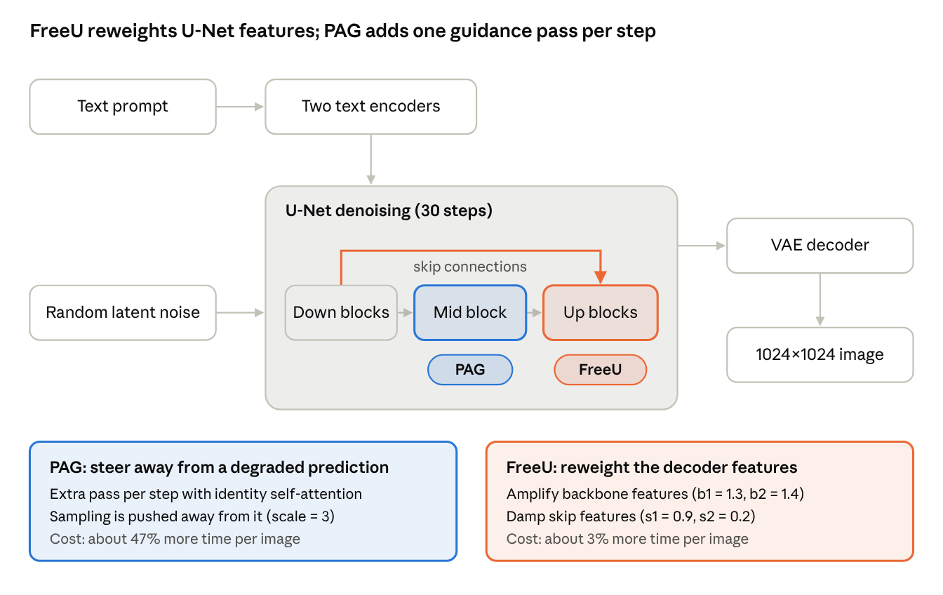
Figure 1. The SDXL sampling pipeline and where FreeU and PAG act.
Figure 1. The SDXL sampling pipeline and where FreeU (orange) and PAG (blue) act.

2.1 SDXL
SDXL [1] is a latent diffusion model [2]: a VAE compresses a 1024×1024 image into a 128×128 latent, and a U-Net, conditioned on two text encoders, iteratively denoises a random latent over a fixed number of steps before the VAE decodes it. Each step uses classifier-free guidance [6], which extrapolates from an unconditional prediction ε(x) towards the text-conditional prediction ε(x, c) with guidance scale w:
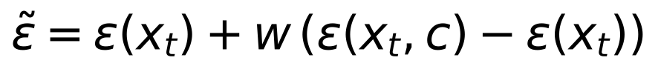

2.2 FreeU
FreeU [3] starts from the observation that, in the U-Net decoder, backbone features mainly carry low-frequency content such as layout and semantics, whereas skip connections feed high-frequency detail from the encoder. When skip features dominate, the denoiser can neglect the backbone and produce structural errors. FreeU therefore scales the backbone features of the first two decoder stages by factors b1, b2 > 1 and attenuates the low-frequency part of the corresponding skip features by s1, s2 < 1. The operation is a few element-wise multiplications and a Fourier filter, so its cost is negligible.

2.3 Perturbed-Attention Guidance
PAG [4] builds a deliberately degraded prediction by replacing the self-attention map in selected U-Net layers with the identity matrix, which removes the long-range structure the attention would otherwise impose. Like classifier-free guidance, it then extrapolates away from this degraded prediction ε̂(x, c) with scale s:
Intuitively, the model is shown a version of its own prediction with broken structure and told to move away from it. The perturbed prediction requires an additional U-Net forward pass per step, which is why PAG adds roughly half of the inference time when combined with classifier-free guidance.

2.4 Combining FreeU and PAG
Because FreeU modifies the network and PAG modifies the sampler, the two can be applied together without conflict: FreeU's reweighting is active in every forward pass, including PAG's perturbed one. We test the combination with each method at its default strength, to see whether their benefits add up.

2.5 DUNE (our reimplementation)
DUNE [11] is a training-free refiner proposed in 2026 that also targets structural defects. During the first 40% of sampling steps it monitors the U-Net bottleneck activation hₜ (1280×32×32 in SDXL), normalised as zₜ = −hₜ / σₜ, and keeps an exponential moving average z̄ with γ = 0.7. Entries whose log-ratio deviation Δ = log|zₜ / z̄| exceeds its 90th percentile are treated as anomalous and rescaled by κ·nₜ, where nₜ is the absolute channel-wise mean of hₜ and κ = 0.3:
The paper releases no code, so we implemented DUNE as a forward hook on the SDXL mid block. Where the paper is ambiguous we chose: the percentile is computed per image over all C×H×W entries; σₜ = √(1 − ᾱₜ); the moving average is updated with the unsuppressed zₜ; suppression starts after 3 warm-up steps and stops at 40% of the steps. Following the formula literally, the factor κ·nₜ averaged 0.54 in our logged run but exceeded 1 for about 14% of channels (up to about 4), so a minority of flagged entries are amplified rather than shrunk; the paper does not discuss this case.

3 Experimental Setup
All five settings share one pipeline, one prompt set and one seed per prompt, so the only difference between them is the component under study.
Prompts. We sample 150 captions from the MS-COCO 2017 validation set [5], one caption per image, stratified into five categories of 30 each: person, animal, indoor, outdoor and multi-object (at least two distinct object nouns). A fixed 50-prompt subset, balanced across categories, is used for the hyper-parameter studies. Each prompt is assigned a fixed random seed that is reused for every setting.
Generation. We use SDXL Base 1.0 without the refiner at 1024×1024, 30 Euler steps and classifier-free guidance scale 5.0 [6], in fp16, with Diffusers 0.39 [9] and PyTorch 2.14 on one NVIDIA A40 (46 GB) of a shared Slurm cluster. The main study generates 150 images for each of the five settings; the hyper-parameter studies add 250 images on the subset, for 1,000 images in total.
Setting | FreeU (b1, b2, s1, s2) | PAG scale / layer | DUNE (κ, γ, p)
SDXL | off | 0 | off
SDXL + FreeU | 1.3, 1.4, 0.9, 0.2 | 0 | off
SDXL + PAG | off | 3.0 / mid | off
SDXL + FreeU + PAG | 1.3, 1.4, 0.9, 0.2 | 3.0 / mid | off
SDXL + DUNE | off | 0 | 0.3, 0.7, 0.9
The FreeU values are the authors' recommended SDXL setting; PAG scale 3.0 on the mid block follows the Diffusers default; the DUNE values are the paper's SDXL setting.
Automatic metrics. CLIPScore [7] is computed as 100 × the cosine similarity between CLIP [10] ViT-L/14 image and text embeddings. We report the mean with a 95% bootstrap confidence interval and compare each method with the base model using a paired Wilcoxon signed-rank test. We do not report FID, which is unreliable at 150 samples. Generation time is measured per image after a warm-up call, with CUDA synchronisation, and peak memory with torch.cuda.max_memory_allocated.
Similarity to the base image. Following [11], we also compute the cosine similarity between the CLIP image embeddings of each image and of the SDXL image generated from the same prompt and seed. It measures how far a method moves the sample away from the base model's output, independently of the caption.
Blind human study. We randomly draw 60 of the 150 prompts. For each prompt the four images are shuffled into slots A–D with a hidden key, and each of three raters (the authors) independently selects the best and the worst image, or marks the four as indistinguishable. Raters may also tag any image with failure types: missing object, structure/limb error, duplicated object, over-saturation/artifact, or mismatch with the description. Best and worst choices give each image a rank (best = 1, worst = 4, the other two tied at 2.5), from which we derive mean ranks and pairwise win rates (ties excluded, two-sided sign test). Agreement on the best choice is measured with Fleiss' κ [8]. Ratings were collected through a small self-hosted web page that saves each choice as it is made.

4 Experiments and Analysis
Table 1 summarises the main comparison on all 150 prompts (CLIPScore and cost) and the 60 blindly rated prompts (human ranking).
Table 1. Main results. CLIPScore: mean with 95% bootstrap CI and paired Wilcoxon p-value against SDXL. Human: mean rank among the four images (1 = best, 4 = worst) and the share of 180 judgements in which the setting was chosen as best or worst. DUNE was added after the blind study and is evaluated with automatic metrics only.
Setting | CLIPScore [95% CI] | p vs SDXL | Time / image | Rel. time | Peak mem. | Mean rank ↓ | Best | Worst
SDXL | 26.56 [26.07, 27.06] | — | 6.40 s | 1.00× | 10.49 GB | 2.38 | 30% | 22%
SDXL + FreeU | 26.40 [25.82, 26.96] | 0.33 | 6.58 s | 1.03× | 10.49 GB | 2.52 | 15% | 17%
SDXL + PAG | 26.00 [25.48, 26.50] | 0.002 | 9.41 s | 1.47× | 10.49 GB | 2.04 | 36% | 5%
SDXL + FreeU + PAG | 25.96 [25.41, 26.53] | 0.005 | 9.60 s | 1.50× | 10.49 GB | 3.05 | 6% | 42%
SDXL + DUNE | 26.52 [26.04, 27.00] | 0.74 | 6.43 s | 1.00× | 10.50 GB | not rated | — | —

4.1 Automatic metric versus human judgement
The automatic metric and the raters order the methods differently (Figure 2). On CLIPScore no enhancement beats the base model: FreeU is indistinguishable from it (−0.16, p = 0.33), while PAG and the combination are slightly but significantly lower (−0.56 and −0.60). Human raters instead place PAG first, the base model second, FreeU third and the combination last. The cost column makes the trade-off explicit: the method humans prefer costs about 1.5× the inference time, whereas FreeU is almost free but brings no visible gain. Peak memory is identical at batch size 1.
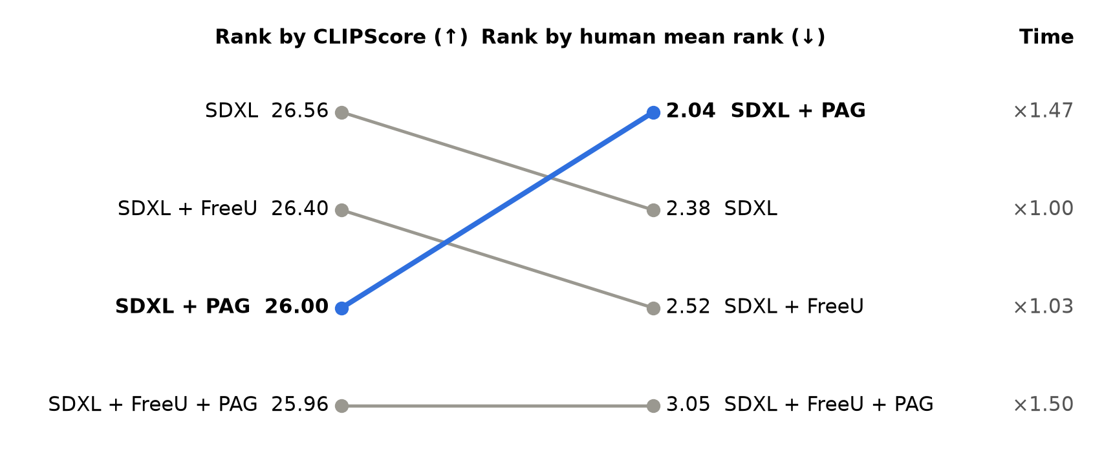
Figure 2. Ranking by CLIPScore (left) and by human mean rank (right), with inference time relative to SDXL. PAG moves from third to first.

4.2 Human preference
PAG is the most reliable setting rather than the most spectacular one: it is chosen as best in 36% of judgements, close to the base model's 30%, but as worst in only 5% (Figure 3). Pairwise, with ties excluded, PAG beats FreeU in 71% of comparisons (p < 0.001) and the combination in 88% (p < 0.001); against the base model it wins 57%, which is not significant (p = 0.12). The base model beats the combination in 65% of comparisons (p < 0.001) and FreeU in 58% (p = 0.07).
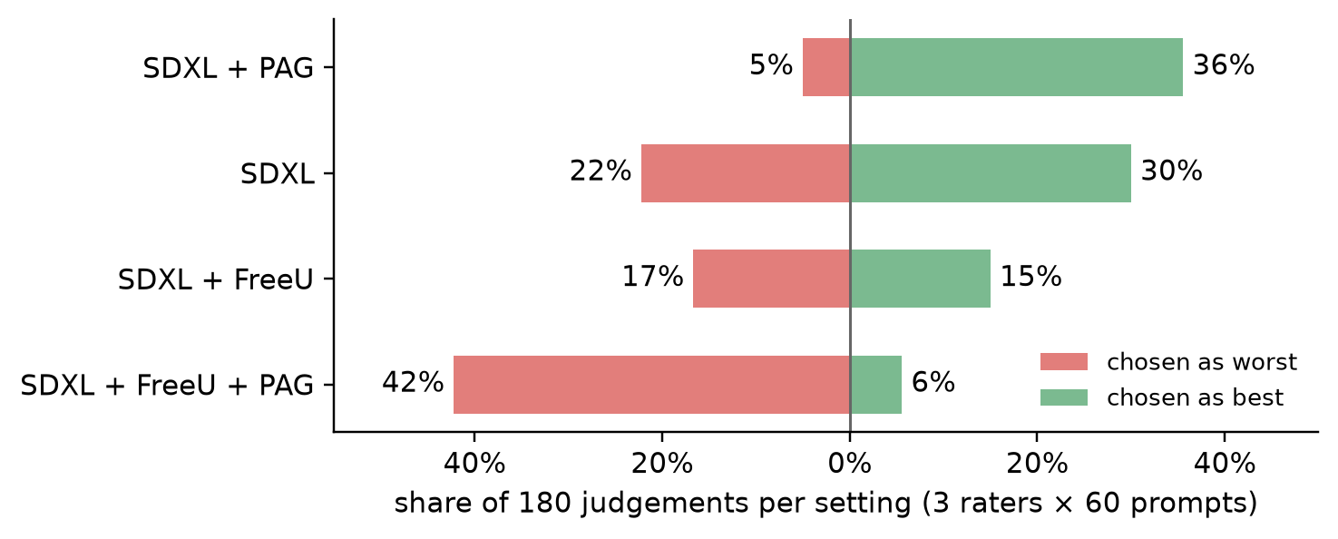
Figure 3. Share of judgements in which each setting was chosen as best (right) or worst (left); 25 of 180 judgements marked the four images as indistinguishable.
Agreement between raters is low. Fleiss' κ for the best choice is 0.105, and individual preferences diverge: one rater chose the base model as best on 58% of prompts, another chose PAG on 58%, and the third marked 32% of prompts as indistinguishable. The pooled ranking should therefore be read as a trend.

4.3 Failure modes
The failure tags explain the ranking (Figure 4). The base model's dominant failure is structural: 54% of its judgements carry a structure or limb error tag. Both enhancements cut this to 26–30%. FreeU, however, raises over-saturation from 7% to 50%, and combining it with PAG raises it to 82%, which is why the combination is chosen as worst so often. The remaining three tags vary by less than 4 percentage points across settings, so neither method changes what is drawn, only how well it is drawn.
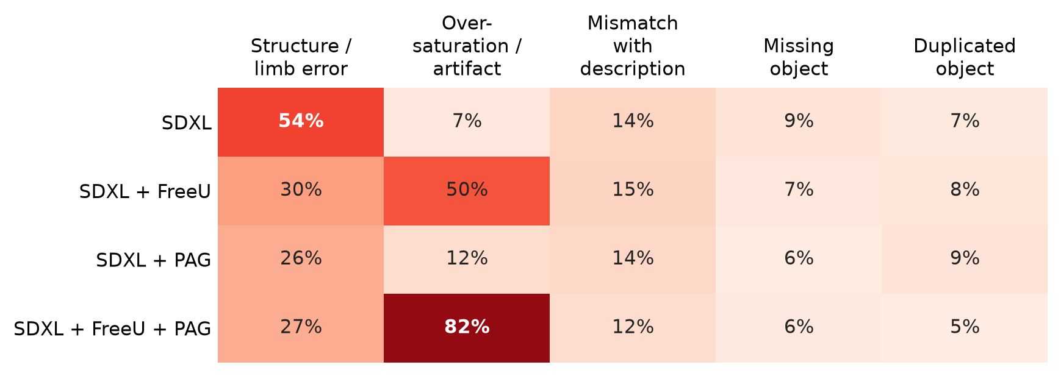
Figure 4. Share of judgements carrying each failure tag (180 judgements per setting).

4.4 Results by prompt category
PAG ranks first in the indoor, outdoor and multi-object categories, ties the base model on person prompts, and is narrowly behind it on animals (Figure 5). FreeU helps indoor scenes markedly (2.89 to 2.06) but hurts animal prompts (1.86 to 2.86). The combination is last in every category. Each category contains only 9–15 rated prompts, so these differences are indicative only.
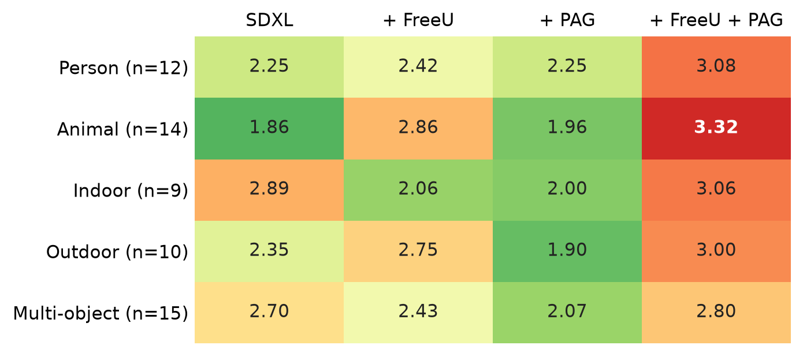
Figure 5. Human mean rank by prompt category (lower is better); n is the number of rated prompts.

4.5 Hyper-parameter study
On the 50-prompt subset no hyper-parameter setting changes CLIPScore significantly (Figure 6). Raising the PAG scale lowers CLIPScore monotonically from 26.57 (off) to 25.78 at scale 5 (−0.79, p = 0.054), while the comparison grids show progressively cleaner structure; inference time stays at about 1.47× for every scale. The three FreeU strengths (weak: 1.1/1.2/0.95/0.6; default; strong: 1.5/1.6/0.7/0.1) differ by less than 0.1 in CLIPScore, and stronger settings mainly add saturation. Moving PAG from the mid block to the first up block gives 26.16 against 26.17, so the choice of layer matters little here.
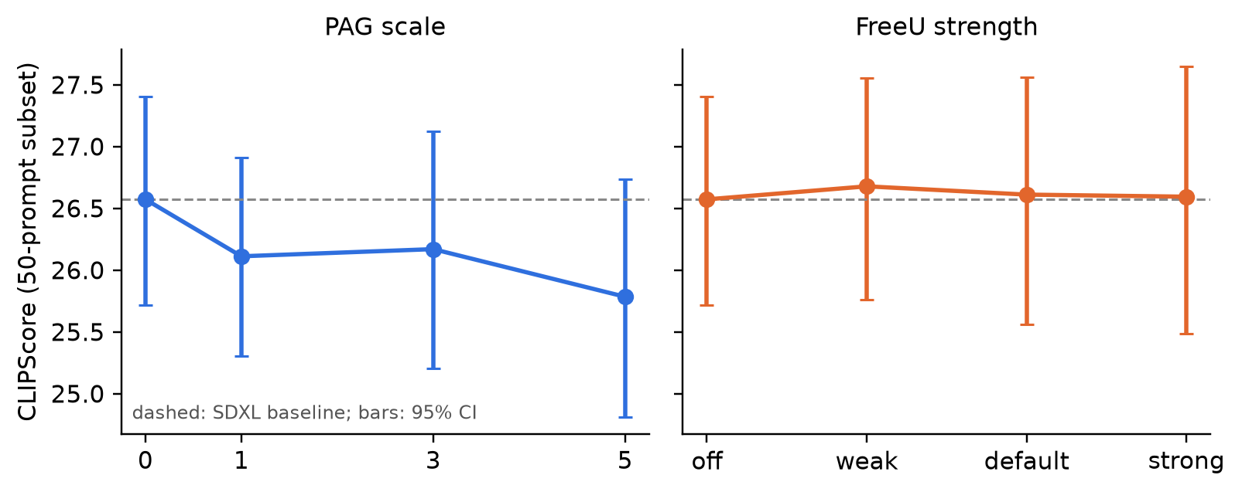
Figure 6. CLIPScore on the 50-prompt subset as a function of PAG scale and FreeU strength, with 95% bootstrap confidence intervals; dashed line: SDXL.

4.6 Qualitative cases
Figures 7 and 8 show cases selected automatically from the human rankings; each row uses the same prompt and seed. Scenes with two instances of the same animal are where PAG helps most: the base model and FreeU fuse bodies or add legs, while PAG separates the animals cleanly and keeps natural colour; the combination is also structurally sound but visibly over-saturated.
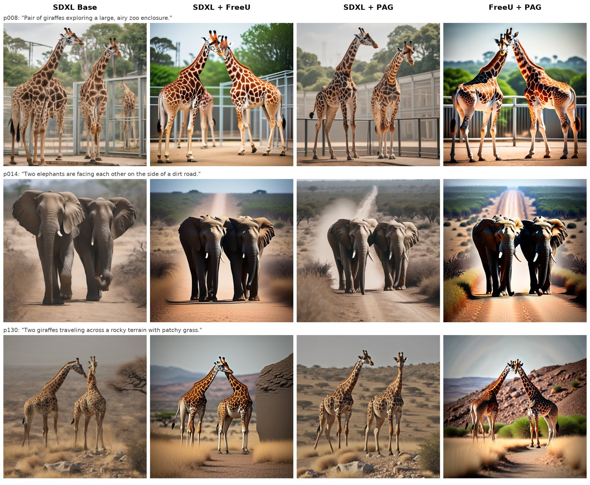
Figure 7. Cases where PAG is clearly preferred (p008, p014, p130). Columns: SDXL, + FreeU, + PAG, + FreeU + PAG.
None of the methods repairs semantic errors. For “A white car and a white bus parked parallel from one another” every setting draws either a car–bus hybrid or only the bus, and the frog in p063 is missing everywhere (the original COCO caption misspells “frog” as “from”).
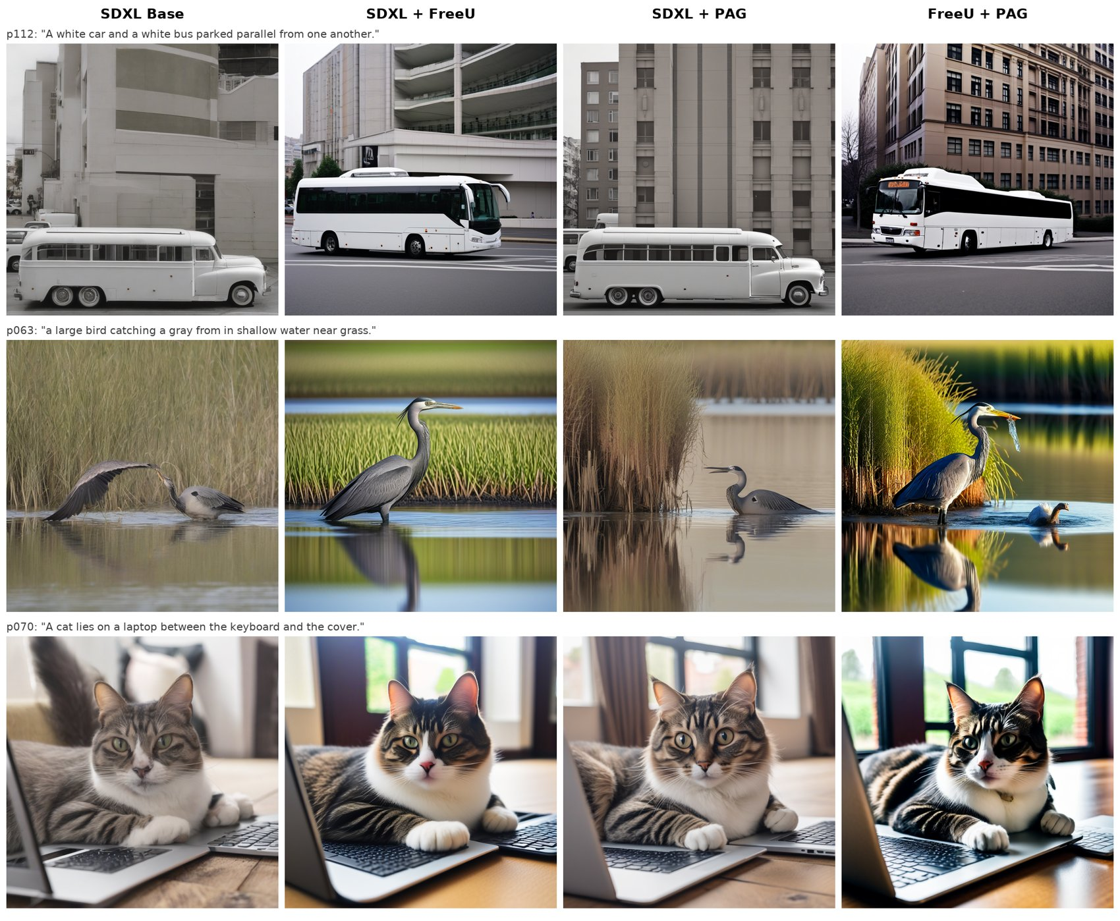
Figure 8. Cases where all enhancements fail (p112, p063, p070).

4.7 DUNE and similarity to the base image
We add DUNE as a fifth setting on all 150 prompts and measure, for every setting, the CLIP image similarity to the SDXL image with the same prompt and seed (Figure 9). DUNE changes the image least by a wide margin (0.983, against 0.889 for PAG, 0.869 for FreeU and 0.833 for the combination), adds no measurable cost (6.43 s per image, 1.00×) and leaves CLIPScore unchanged (26.52, −0.04, p = 0.74). The ordering of the other methods matches the DUNE paper on SDXL (FreeU 0.781, PAG 0.821, DUNE 0.925); our absolute values are higher, plausibly because of the different number of steps and CLIP backbone. Similarity also falls steadily as the PAG scale or FreeU strength increases, which quantifies how far each setting departs from the base sample. The setting that departs most, the combination, is also the one raters liked least.
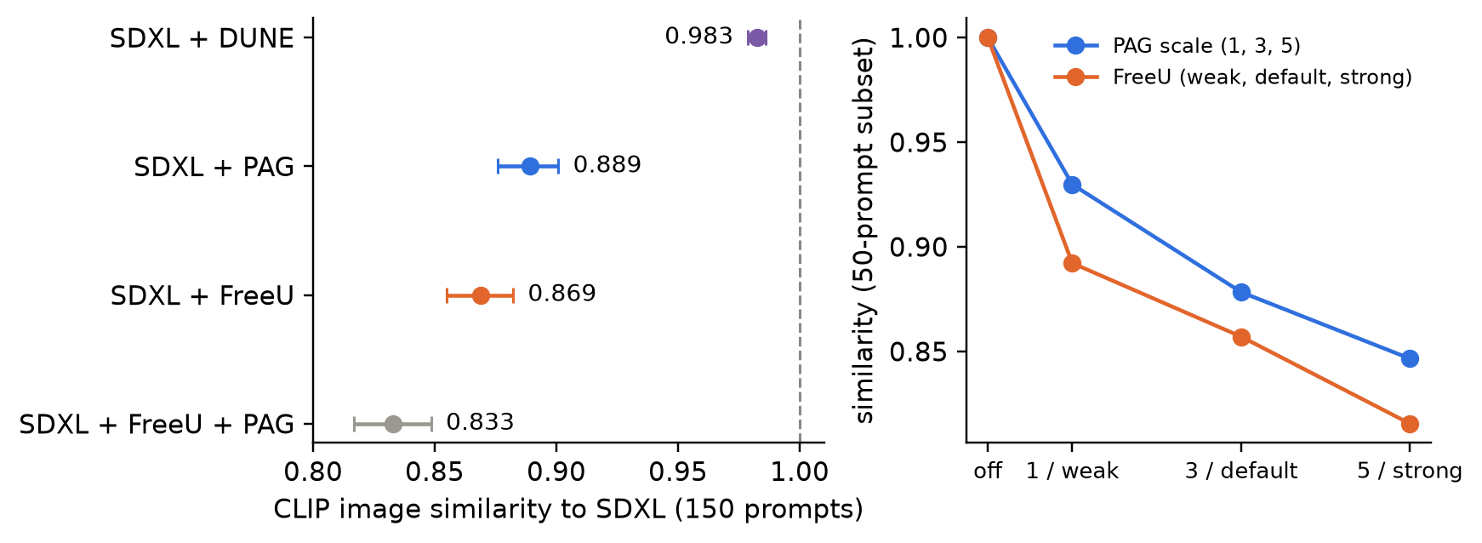
Figure 9. Left: CLIP image similarity to the SDXL image for each setting (150 prompts, 95% CI). Right: similarity on the 50-prompt subset as PAG scale and FreeU strength increase.
Because DUNE was not part of the blind study, we inspect the four prompts on which it changes the image most (Figure 10). Even there it keeps composition and colour; the changes are local and not always improvements: in p047 it turns one clock into a row of clocks, a new duplication error, and in p139 it removes the cars from the street. Within our setting we therefore cannot confirm the large reduction in anatomical defects reported in [11]; testing that claim would need human ratings or the HADM detector [12] used in that paper.
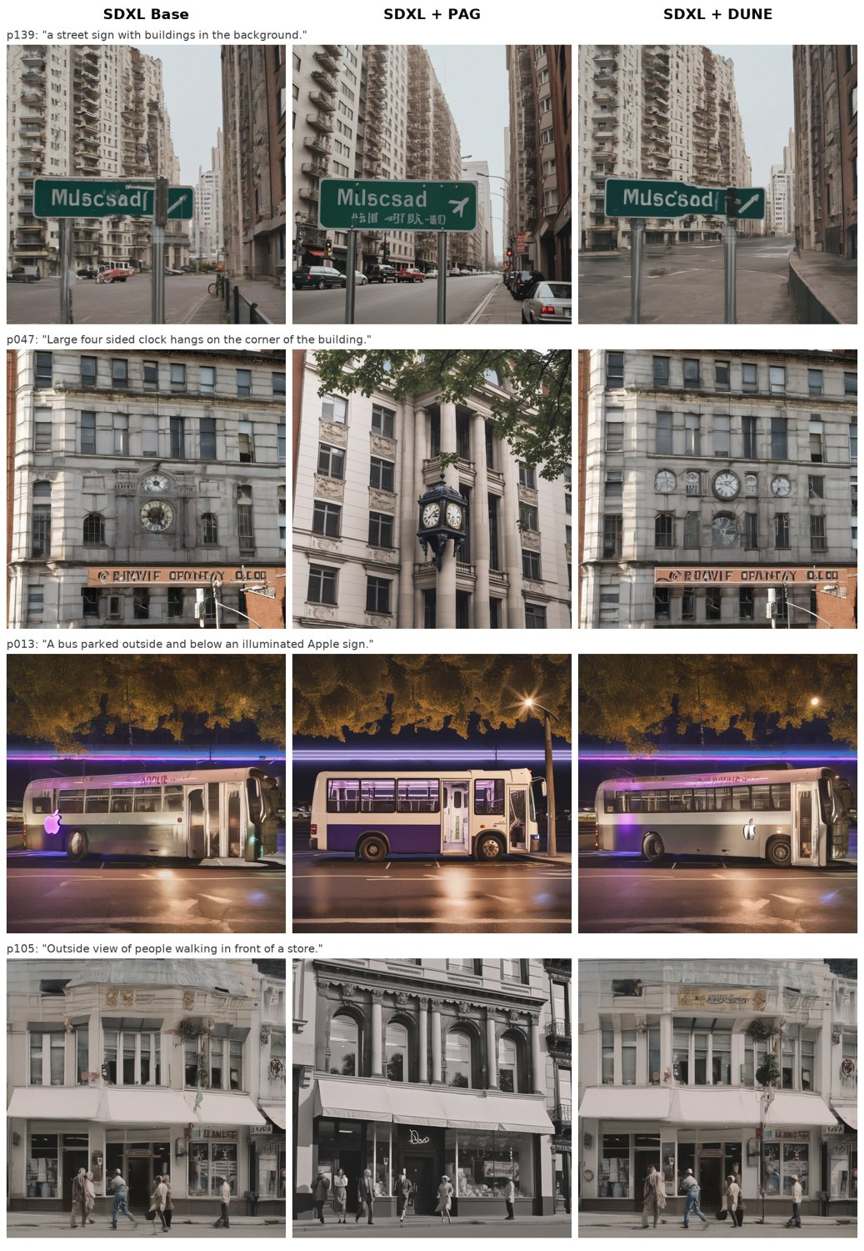
Figure 10. Prompts on which DUNE departs most from SDXL (p139, p047, p013, p105). Columns: SDXL, + PAG, + DUNE.

5 Discussion and Limitations
Why the metric and the raters disagree. CLIPScore measures whether the concepts named in the caption are present, so an image with a fused pair of giraffes and an image with two well-formed giraffes can score alike. PAG changes structure far more than content: the mismatch tag rate is flat across settings (12–15%), while structure errors halve. A metric that is blind to structure therefore cannot see PAG's main effect, and its small drop in CLIPScore may reflect PAG's tendency to produce cleaner but less cluttered scenes. Studies of training-free guidance should pair embedding-based metrics with human or structure-aware evaluation.
Why the combination fails. FreeU amplifies backbone features, which raises contrast and saturation; PAG pushes each step away from a structurally degraded prediction, which also sharpens the image. Applied together with their individual default strengths, the two effects stack and overshoot. The combination may work with weaker settings, which we did not tune.
Limitations.
- Human study. Three raters, all authors, with low agreement (κ = 0.105). One rater preferred the base model on 58% of prompts, another preferred PAG on 58%, and the third marked 32% of prompts as indistinguishable. The pooled ranking is therefore a trend, not a settled preference; more independent raters and shared rating guidelines would strengthen it.
- Prompt set. 150 short COCO captions; long, compositional or artistic prompts may behave differently, and per-category results rest on 9–15 rated prompts each.
- One sampling configuration. All results use 30 Euler steps and CFG 5.0; the best FreeU and PAG settings may change with these.
- Memory. Peak memory was measured at batch size 1, where weights and VAE decoding dominate; PAG's extra forward pass would show at larger batches.
- Metric coverage. We did not use learned preference models or VQA-based alignment metrics, which might track human judgement better than CLIPScore.
- DUNE. Our DUNE results come from a reimplementation of an unreviewed preprint without released code, using the interpretation choices listed in Section 2.5, and DUNE was evaluated with automatic metrics only, not in the blind study.

6 Conclusion and Future Work
We compared FreeU, PAG and their combination on a single SDXL pipeline with fixed prompts and seeds. Our answers to the five research questions:
- Visual quality. PAG improves it most reliably (mean rank 2.04 vs 2.38, worst-choice rate 5% vs 22%), although its head-to-head win over the base model is not significant (57%, p = 0.12). FreeU does not improve it, and the combination makes it worse.
- Semantic alignment. None of the methods improves CLIPScore; PAG and the combination reduce it slightly but significantly.
- Cost. FreeU is essentially free (+3% time); PAG and the combination add about 50% inference time; peak memory is unchanged at batch size 1.
- Prompt types. PAG ranks first or ties for first in four of five categories; FreeU helps indoor scenes but hurts animal prompts.
- Hyper-parameters. Larger PAG scales lower CLIPScore while visibly improving structure; FreeU's strength has little effect on CLIPScore but raises saturation; the PAG layer choice matters little.
Beyond FreeU and PAG, our reimplementation of DUNE [11] is the most conservative of the methods: it adds no inference cost, leaves CLIPScore unchanged and keeps images closest to the base sample (similarity 0.983), but in our setting its changes were too small and too mixed to show a clear benefit.
In short, training-free enhancement is not a free lunch: each method trades structure, colour and speed against one another, and the methods should not be stacked naively. Future work should repeat the study with more independent raters, structure-aware metrics such as the HADM detector [12], preference-based metrics, a human study that includes DUNE, harder prompt sets, and a joint search over the strengths of the combined methods.

References
- D. Podell, Z. English, K. Lacey, A. Blattmann, T. Dockhorn, J. Müller, J. Penna, R. Rombach. SDXL: Improving Latent Diffusion Models for High-Resolution Image Synthesis. ICLR, 2024.
- R. Rombach, A. Blattmann, D. Lorenz, P. Esser, B. Ommer. High-Resolution Image Synthesis with Latent Diffusion Models. CVPR, 2022.
- C. Si, Z. Huang, Y. Jiang, Z. Liu. FreeU: Free Lunch in Diffusion U-Net. CVPR, 2024.
- D. Ahn, H. Cho, J. Min, W. Jang, J. Kim, S. Kim, H. H. Park, K. H. Jin, S. Kim. Self-Rectifying Diffusion Sampling with Perturbed-Attention Guidance. ECCV, 2024.
- T.-Y. Lin, M. Maire, S. Belongie, J. Hays, P. Perona, D. Ramanan, P. Dollár, C. L. Zitnick. Microsoft COCO: Common Objects in Context. ECCV, 2014.
- J. Ho, T. Salimans. Classifier-Free Diffusion Guidance. NeurIPS Workshop on Deep Generative Models and Downstream Applications, 2021.
- J. Hessel, A. Holtzman, M. Forbes, R. Le Bras, Y. Choi. CLIPScore: A Reference-free Evaluation Metric for Image Captioning. EMNLP, 2021.
- J. L. Fleiss. Measuring Nominal Scale Agreement among Many Raters. Psychological Bulletin, 76(5):378–382, 1971.
- P. von Platen et al. Diffusers: State-of-the-art Diffusion Models. GitHub repository, 2022.
- A. Radford et al. Learning Transferable Visual Models from Natural Language Supervision. ICML, 2021.
- H. Lim, M. Lee, W. Chang, J. Choi. Unified Backbone Refinement for Diffusion Models via Internal-Latent Analysis. arXiv:2607.09753, 2026.
- K. Wang et al. Detecting Human Artifacts from Text-to-Image Models. arXiv:2411.13842, 2024.

Member Contributions
Replace the bracketed names and adjust the split to match what each member actually did.
Member | Code and experiments | Report | Presentation
[Name A] | Cluster setup, generation pipeline, timing and memory logging, main runs | Section 3 (Experimental Setup), cost analysis | Background, SDXL, experimental setup
[Name B] | FreeU runs and hyper-parameter study, CLIPScore, statistical analysis | Sections 2.2, 4.1, 4.5 (FreeU part) | FreeU, main results
[Name C] | PAG runs and ablations, blind-evaluation tool, rating collection, case selection | Sections 2.3, 4.2–4.4, 4.6 | PAG, failure cases, conclusion
All three members took part in the blind human evaluation, and wrote the Introduction and Conclusion together.

