EPIC EVENTS
Technical architecture and security
Command-line CRM - Python, Peewee, SQLite, Typer, JWT, Sentry and Pytest

Automated tests | 156
Failures | 0
Total coverage | 77%
JWT coverage | 96%
OpenClassrooms Project P12 - July 2026

Contents
1. Validation summary
2. Architecture overview
3. Database schema
4. JWT authentication and authorization
5. Security and Sentry monitoring
6. Testing strategy and coverage
7. Installation and demonstration
8. Final repository verification

1. Validation summary
Epic Events implements a layered architecture, a relational SQLite database, JWT authentication, authorization based on role, ownership and assignment, least privilege, Sentry monitoring, and an automated test suite.
- 156 tests passed, 0 failures.
- 77% total coverage; 96% for src/core/jwt_auth.py.
- 4 unit tests, 143 integration tests, and 9 functional tests.
- In-memory isolated SQLite test database and temporary JWT test files.
- Secrets, local token, local database, and generated reports excluded from Git.
- Controlled demonstration event successfully received by Sentry.
Metric | Value
Tests | 156
Failures | 0
Total coverage | 77%
JWT coverage | 96%

2. Architecture overview

2.1 Purpose
The CRM is used by management, sales, and support departments. The architecture separates terminal interaction, authentication session management, business rules, persistence, and monitoring.
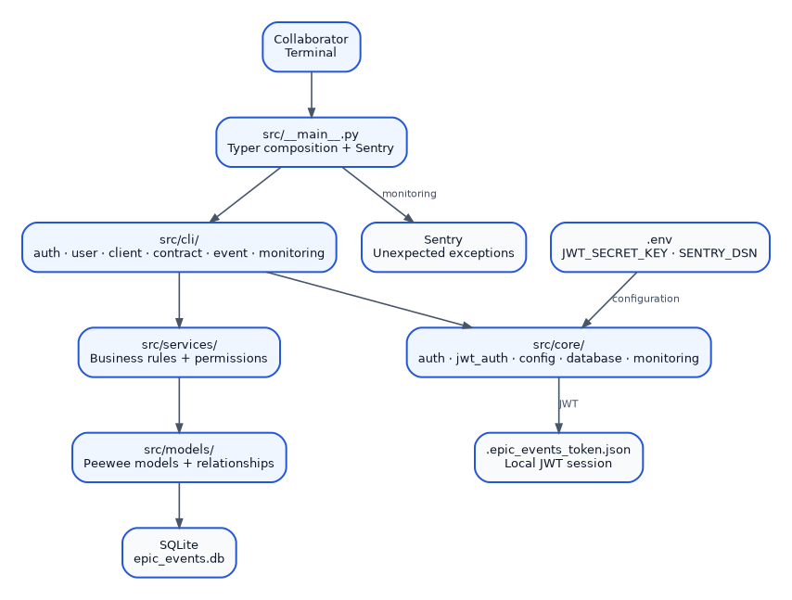
Figure 1 - Current layered architecture

2.2 Layer responsibilities
Component | Responsibility
src/__main__.py | Composes Typer groups, initializes Sentry, and catches unexpected exceptions.
src/cli/ | Collects arguments, displays results, and converts business errors into CLI responses.
src/core/auth.py | Verifies bcrypt credentials and exposes generic department checks.
src/core/jwt_auth.py | Creates, signs, validates, loads, stores, and deletes JWTs.
src/services/ | Enforces permissions, ownership, assignment, and business validation.
src/models/ | Defines the Peewee schema and relationships.
src/utils/ | Initializes the database and the first management account.
Sentry | Receives unexpected technical exceptions and the controlled demonstration.

2.3 Project structure
src/
├── __main__.py
├── cli/
│ ├── auth.py client.py common.py
│ ├── contract.py event.py monitoring.py user.py
├── core/
│ ├── auth.py config.py database.py
│ ├── jwt_auth.py monitoring.py
├── models/
├── services/
└── utils/
├── create_db.py
└── create_user.py
The entry point no longer contains business rules. Commands are grouped by domain with app.add_typer and the application runs with python -m src.

2.4 Protected command flow
Figure 2 - Authentication followed by authorization

3. Database schema

3.1 SQLite and Peewee choice
SQLite fits a local command-line application: no database server is required and installation remains reproducible. Peewee provides model-based schema definitions, foreign keys, and parameterized queries.
- Foreign keys enabled through the foreign_keys pragma.
- RESTRICT protects referenced clients, contracts, and sales collaborators.
- SET NULL preserves an event when its support reference is removed.
- Logical account deactivation preserves CRM history.
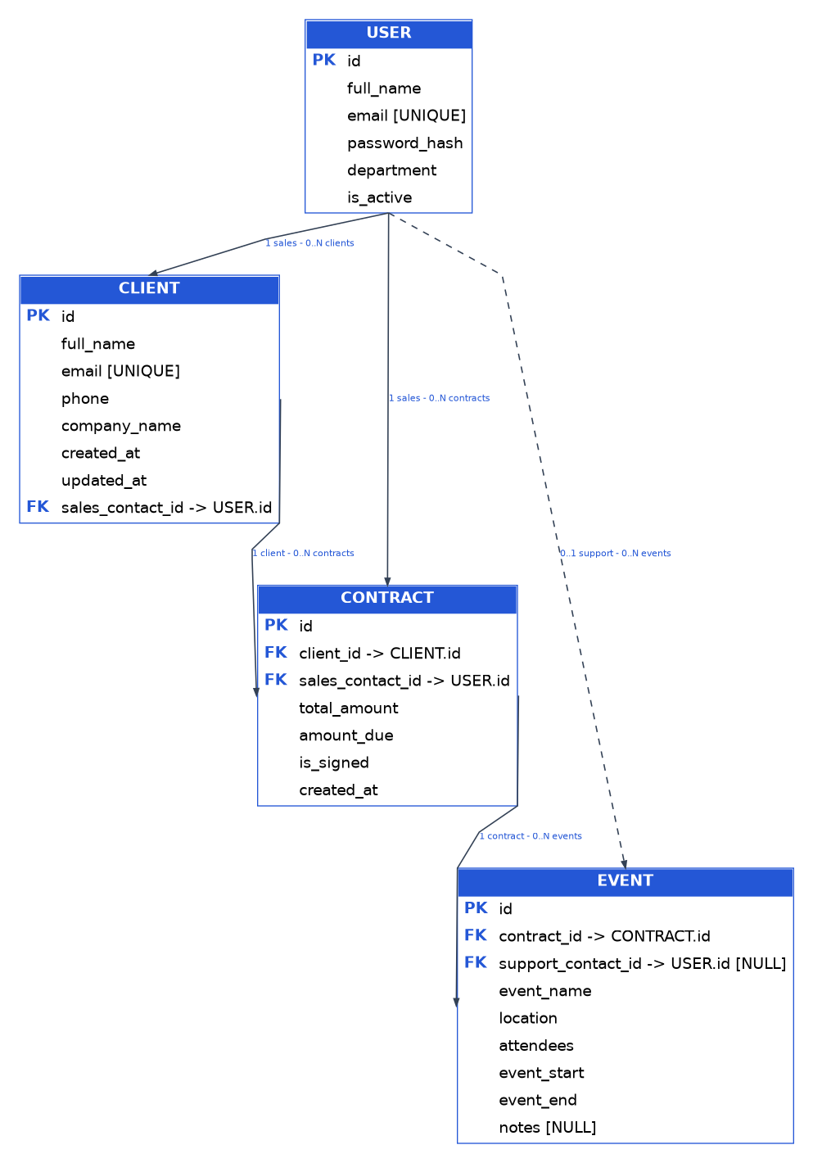
Figure 3 - Final entity relationship diagram

3.2 Tables

users
Field | Type | Constraint | Purpose
id | Integer | Primary key | Collaborator identifier
full_name | Varchar(255) | Required | Display name
email | Varchar(255) | Unique, required | Login identifier
password_hash | Varchar(255) | Required | Bcrypt hash
department | Varchar(50) | Required | MANAGEMENT, COMMERCIAL, SUPPORT
is_active | Boolean | Default true | Logical status

clients
Field | Type | Constraint | Purpose
id | Integer | Primary key | Client identifier
full_name | Varchar(255) | Required | Name
email | Varchar(255) | Unique, required | Email
phone | Varchar(30) | Required | Phone
company_name | Varchar(255) | Required | Company
created_at | Datetime | Automatic | First contact
updated_at | Datetime | Updated | Last contact
sales_contact_id | Integer | FK users, RESTRICT | Responsible sales

contracts
Field | Type | Constraint | Purpose
id | Integer | Primary key | Contract identifier
client_id | Integer | FK clients, RESTRICT | Client
sales_contact_id | Integer | FK users, RESTRICT | Sales contact
total_amount | Decimal(10,2) | Positive | Total
amount_due | Decimal(10,2) | 0 to total | Remaining amount
is_signed | Boolean | Default false | Signature
created_at | Datetime | Automatic | Creation

events
Field | Type | Constraint | Purpose
id | Integer | Primary key | Event identifier
contract_id | Integer | FK contracts, RESTRICT | Contract
support_contact_id | Integer | Nullable FK users, SET NULL | Support
event_name | Varchar(255) | Required | Name
location | Varchar(255) | Required | Venue
attendees | Integer | Greater than zero | Attendees
event_start | Datetime | Required | Start
event_end | Datetime | After start | End
notes | Text | Nullable | Notes

3.3 Relationship logic
- One sales collaborator may manage multiple clients and contracts.
- One client may have multiple contracts.
- The contract stores the sales contact associated with the client.
- One contract may cover multiple events.
- An event may be unassigned or have one support collaborator; one support collaborator may manage multiple events.

4. JWT authentication and authorization

4.1 Login and session
The collaborator provides an email to auth login and enters the password through a hidden prompt. After bcrypt verification, the application creates an HS256-signed JWT valid for 60 minutes and stores it in .epic_events_token.json.
JWT payload
{
"sub": "<user_id>",
"email": "<user_email>",
"department": "<department>",
"iat": "<issued_at>",
"exp": "<expiration>"
}
The token is session evidence, not the final permission source. For every protected command, the user is reloaded from SQLite and the account must still exist and be active.

4.2 Authentication versus authorization
Concept | Question | Implementation
Authentication | Who is the collaborator? | bcrypt + JWT + SQLite reload
Authorization | May they perform the action? | require_permission + ownership + assignment in services

4.3 Permission matrix
Operation | Management | Sales | Support
Read clients, contracts, and events | Yes | Yes | Yes
Create / update / deactivate collaborator | Yes | No | No
Create client | No | Yes | No
Update client | No | Own clients | No
Create contract | Yes | No | No
Update contract | All | Own-client contracts | No
Filter unsigned / unpaid contracts | No | Yes | No
Create event | No | Own client + signed contract | No
List events without support | Yes | No | No
Assign support | Yes | No | No
List / update assigned events | No | No | Own assignments
Trigger Sentry test | Yes | No | No

4.4 Deactivation and existing sessions
Functional collaborator deletion is logical deactivation. Related records are preserved. Even when an unexpired token still exists, the SQLite reload immediately rejects a deactivated or deleted account.

5. Security and Sentry monitoring
Risk | Control
Exposed password | Hidden prompt, bcrypt hash, and no password in command history.
Forged or expired token | HS256 signature, exp validation, and invalid-JWT rejection.
Revoked account | User reload and is_active check for every command.
SQL injection | Parameterized Peewee queries; no SQL concatenated with input.
Privilege escalation | Service-layer authorization by role, ownership, and assignment.
Committed secret | Exclusion of .env, JWT_SECRET_KEY, token, local DB, and reports.
Monitoring leak | send_default_pii=False and include_local_variables=False.

5.1 Secret configuration
.env
JWT_SECRET_KEY=<long random secret>
SENTRY_DSN=<optional Sentry DSN>
SENTRY_ENVIRONMENT=development
The JWT secret and real DSN are never stored in source code. .env and .epic_events_token.json are ignored by Git.

5.2 Sentry architecture
src/__main__.py -> initialize_sentry()
Expected business error
-> explicit CLI message
Unexpected technical exception
-> capture_application_exception()
-> Sentry event ID
Controlled demonstration
python -m src monitoring test-sentry
The demonstration command is management-only. Without a DSN it stops with an explicit message; with a valid DSN it sends a controlled RuntimeError and returns the Sentry identifier.

5.3 Accepted limits of the local JWT design
- The token is a local bearer token: the operating system must protect the file.
- There is no central revocation list or refresh token.
- These limits fit the scope of a local CLI CRM with short expiration and SQLite revalidation.

6. Testing strategy and coverage

6.1 Organization
tests/
├── unit/
│ └── test_monitoring.py
├── integration/
│ ├── test_auth.py
│ ├── test_client_service.py
│ ├── test_contract_service.py
│ ├── test_database.py
│ ├── test_event_service.py
│ ├── test_jwt_auth.py
│ └── test_user_service.py
└── functional/
└── test_cli.py
Category | Scope | Result
Unit | Monitoring isolated with mocks | 4
Integration | Auth, JWT, services, models, in-memory SQLite | 143
Functional | Public CLI with CliRunner | 9
Total | Complete suite | 156 / 0 failures

6.2 Validated coverage
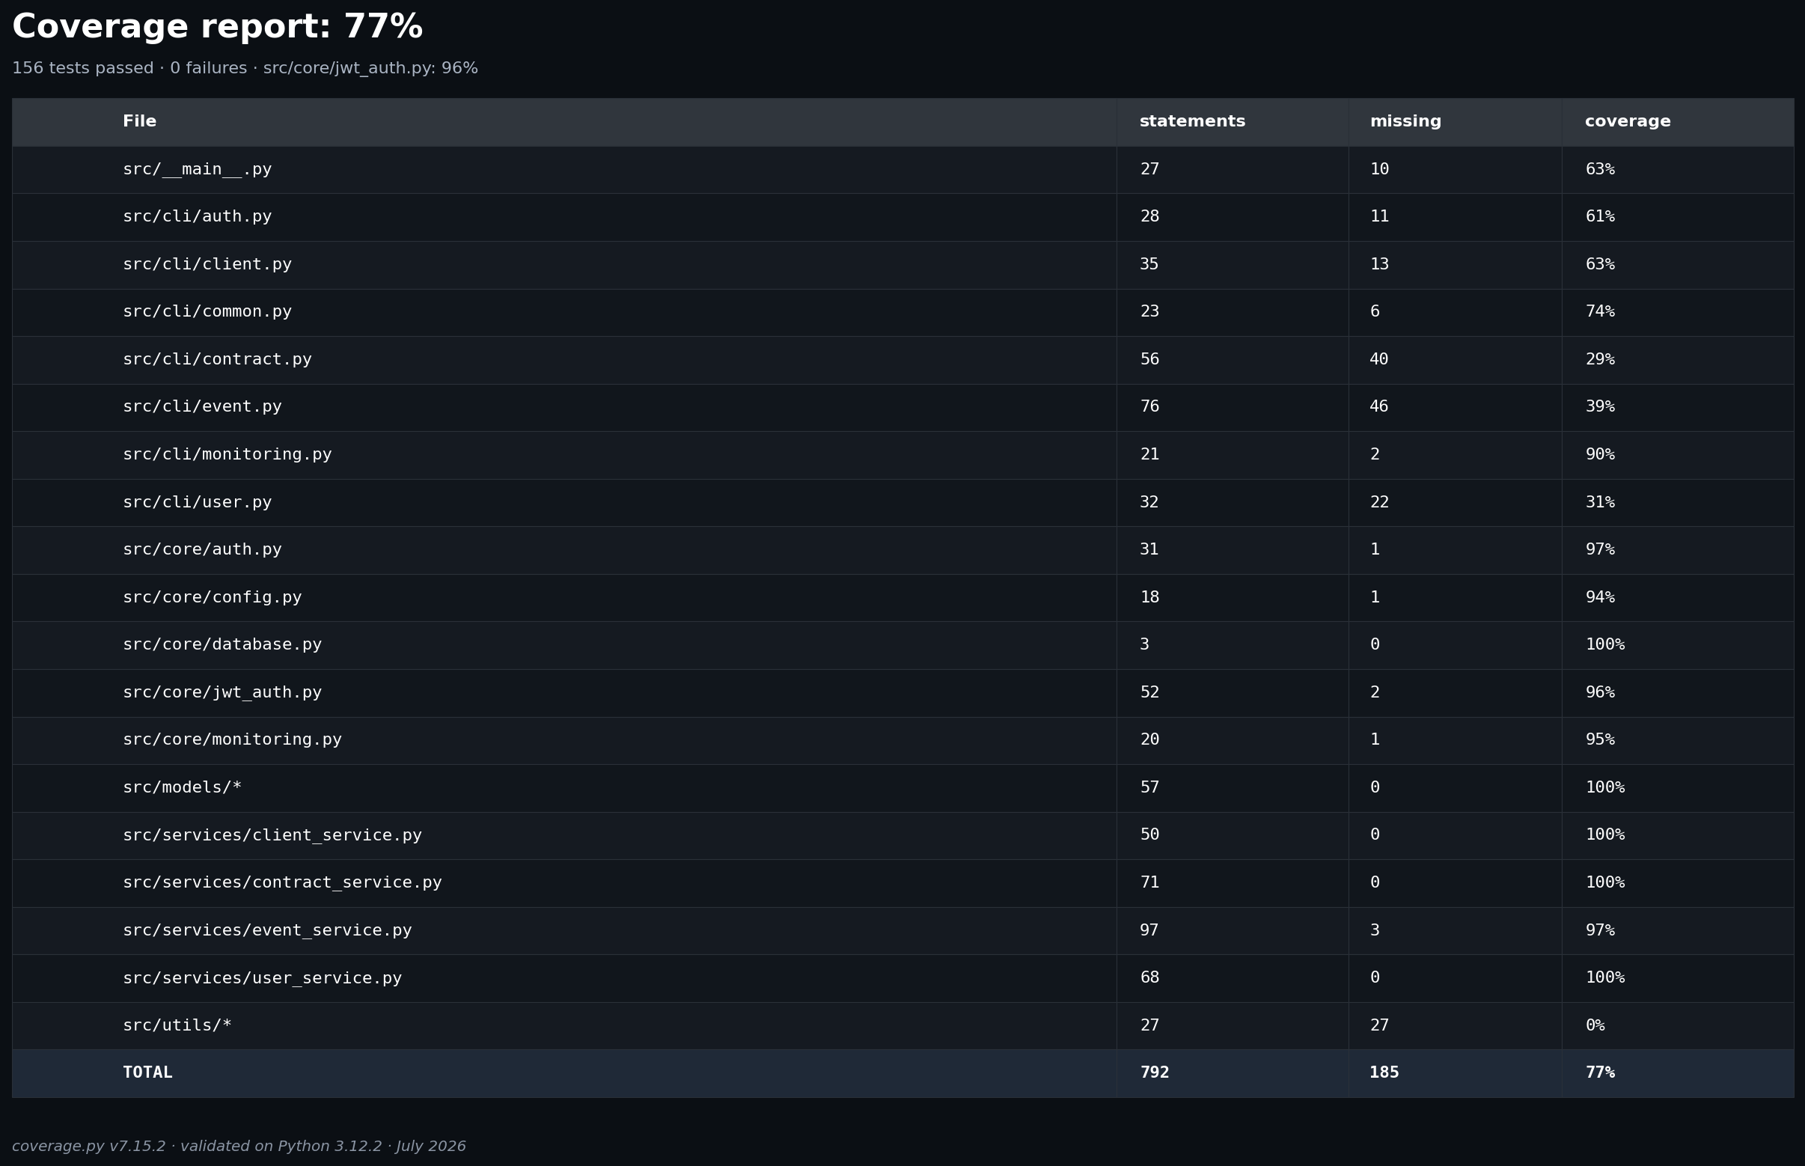
Figure 4 - Updated coverage report
Component | Coverage
Models | 100%
Client service | 100%
Contract service | 100%
User service | 100%
Event service | 97%
Bcrypt authentication | 97%
JWT engine | 96%
Monitoring | 95%
Total | 77%

Initialization utilities remain at 0% because they are executed as installation tools; business services and security modules retain high coverage.

6.3 Validation commands
python -m pytest -q
python -m pytest tests/unit -v
python -m pytest tests/integration -v
python -m pytest tests/functional -v
python -m pytest --cov=src --cov-report=term-missing --cov-report=html

7. Installation and demonstration

7.1 Clean environment installation
git clone https://github.com/AlNocquet/OC-Projet12-EpicEvents.git
cd OC-Projet12-EpicEvents
python -m venv venv
.\venv\Scripts\Activate.ps1
python -m pip install --upgrade pip
python -m pip install -r requirements.txt
Copy-Item .env.example .env
python -c "import secrets; print(secrets.token_urlsafe(48))"
# Paste the generated value into JWT_SECRET_KEY
python -m src.utils.create_db
python -m src.utils.create_user "Morgan Manager" manager@epicevents.com
python -m src --help

7.2 Authentication workflow
python -m src auth login manager@epicevents.com
python -m src auth check-management
python -m src client list
python -m src auth logout
After login, business commands no longer require the email or password. The token expires after 60 minutes or is removed on logout.

7.3 Suggested ten-minute demonstration
Step | Demonstration | Point explained
1 | Architecture and schema | Packages, responsibilities, PK/FK, SQLite, and Peewee.
2 | JWT login | Hidden prompt, bcrypt, local token, expiration, and logout.
3 | Management | Create collaborator and contract; assign support.
4 | Sales | Create client, filters, owned contract, signed event.
5 | Support | List and update assigned events.
6 | Security | Least privilege, Peewee parameters, secrets, deactivation.
7 | Tests | 156 tests, 77% total, 96% JWT.
8 | Sentry | Controlled exception visible in the dashboard.

8. Final repository verification
git status --short
git log --oneline --decorate --graph --all
git ls-files .env .epic_events_token.json epic_events.db
python -m pytest -q
python -m pytest --cov=src --cov-report=term-missing
- Clean working tree.
- No secret, JWT token, or local database tracked by Git.
- Reproducible French and English README files.
- Relationship diagram, ADRs, journals, and UML files present.
- Reproducible complete test suite and coverage report.

Conclusion
The current architecture satisfies the CRM functional, technical, and security requirements. It provides a usable JWT session, authorization still grounded in SQLite state, least-privilege permissions, Sentry monitoring, a documented relational schema, and automated validation through 156 tests.

