CIS 427: Programming Assignment 1:
A Multi-Threaded Web Server
Al Salt Al Bahri

How we Designed the code:
Single-thread server:
Picture 1
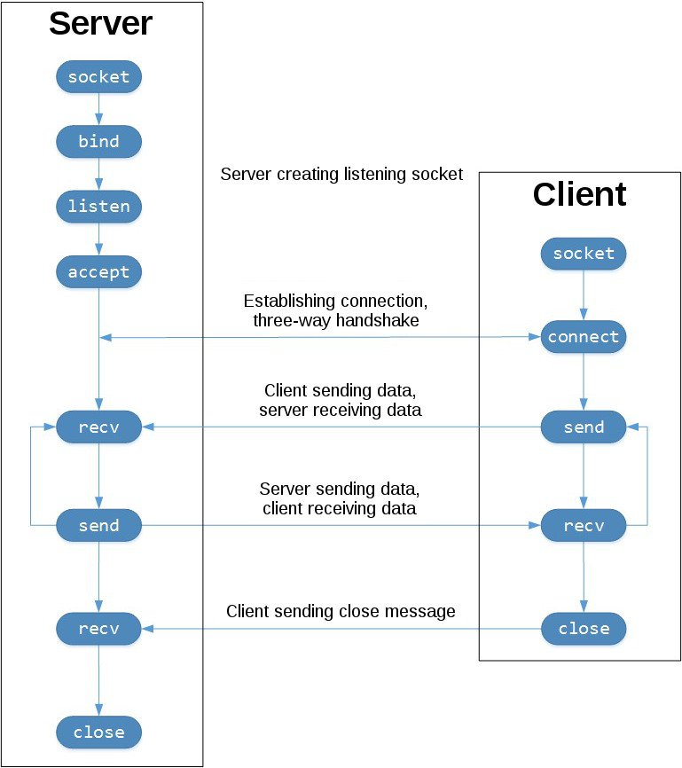

This pictures shows us the Socket calls and the data flow for TCP connection. The left column represents the server and how it works with the right column which in our is case is the browser. The client has to establish a connection to the server and start a three-way handshake. And then the client can send the request and the server will respond to each request respectively. The Server is listening through a port that we specified in the code. The client will send a query to the server, which in this case is the file name “index.html” . When the client sends the query to the server, the server will read the file and send it back to the client.
Screenshot 1:
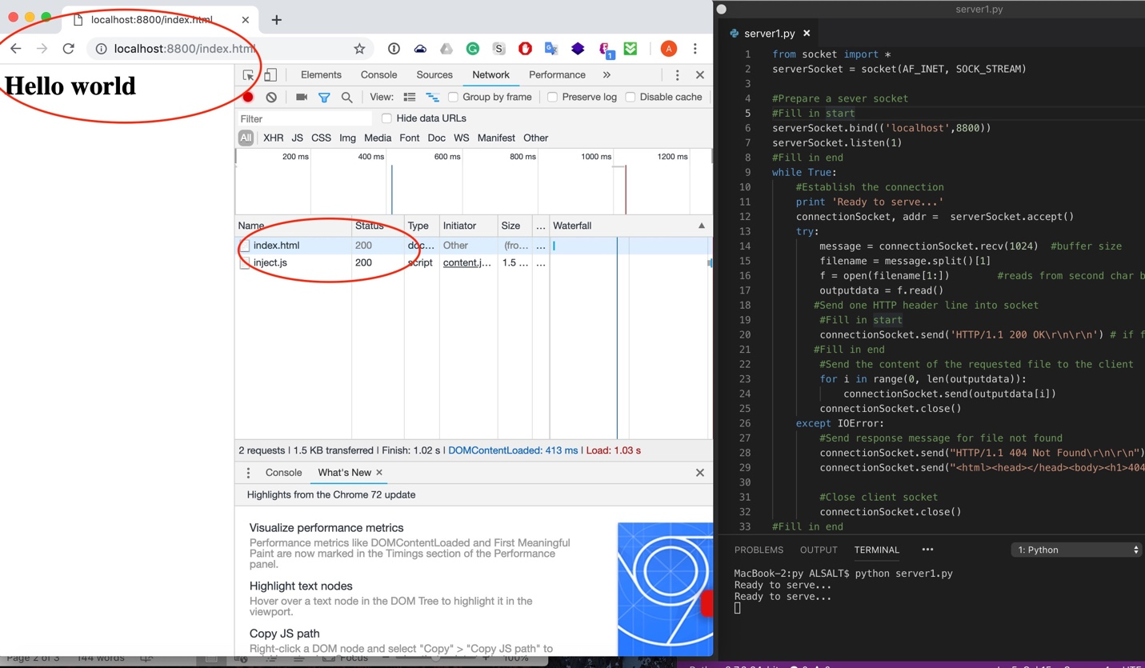

The screenshot above shows that the user requested a file that is available so it outputs the file on the screen. Also, the status code is 200 which means the request has succeeded.

Screenshot 2:
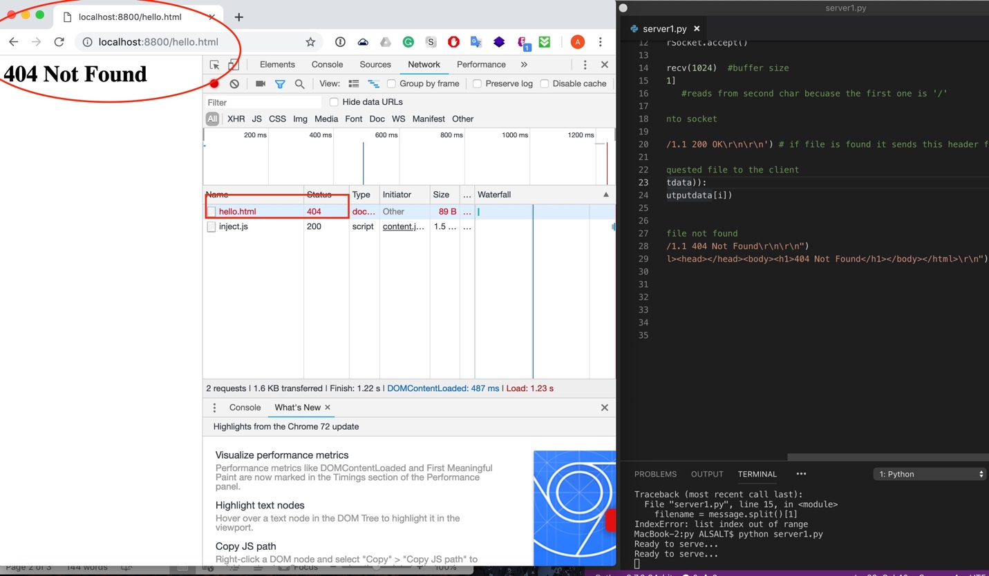
screenshot 2 shows that the user requested a file that is not available. Therefore a 404 not found message is showing. Also, the status code is 404 which indicates that the client was able to communicate with the server but the server could not fine the requested file.

Multi-Threaded server:
A multi-Threaded server handles multiple requests simultaneously. The TCP connection will be set up through another port and serves the client request in a separate thread. So each thread will handle each request/response pair. Threading.Lock() has two states. It’s either locked or unlocked and the functions acquire() and release() are used to lock and unlock the state. Before starting a new thread you need to lock the lock object by calling the method acquire, so the serve reserves that thread for one TCP connection only, and unlock the lock after the TCP connection is closed so the thread can be used for another TCP connection.

Screenshot 3:
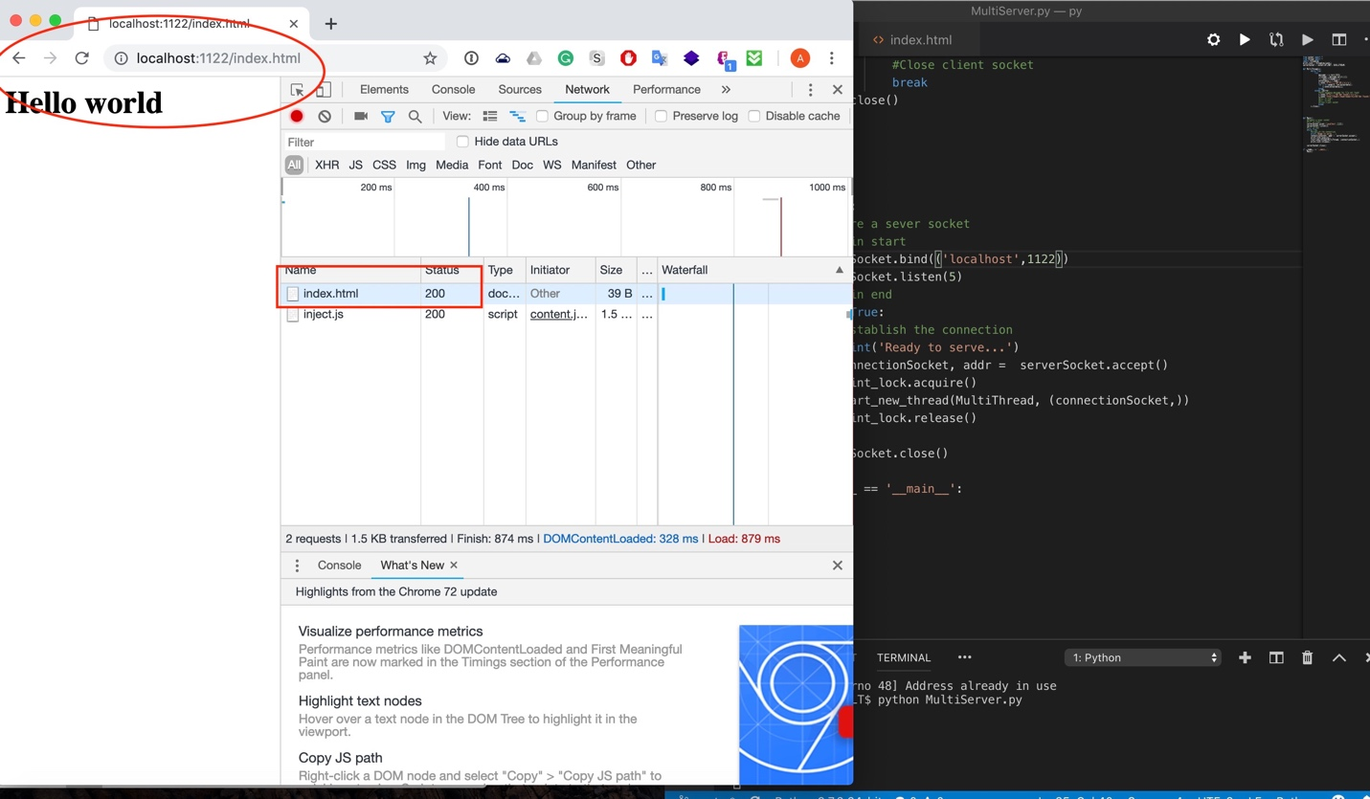
Again, this screenshot shows us the multi-threaded server responding to the client when an available file is requested by the client.

Screenshot 4: 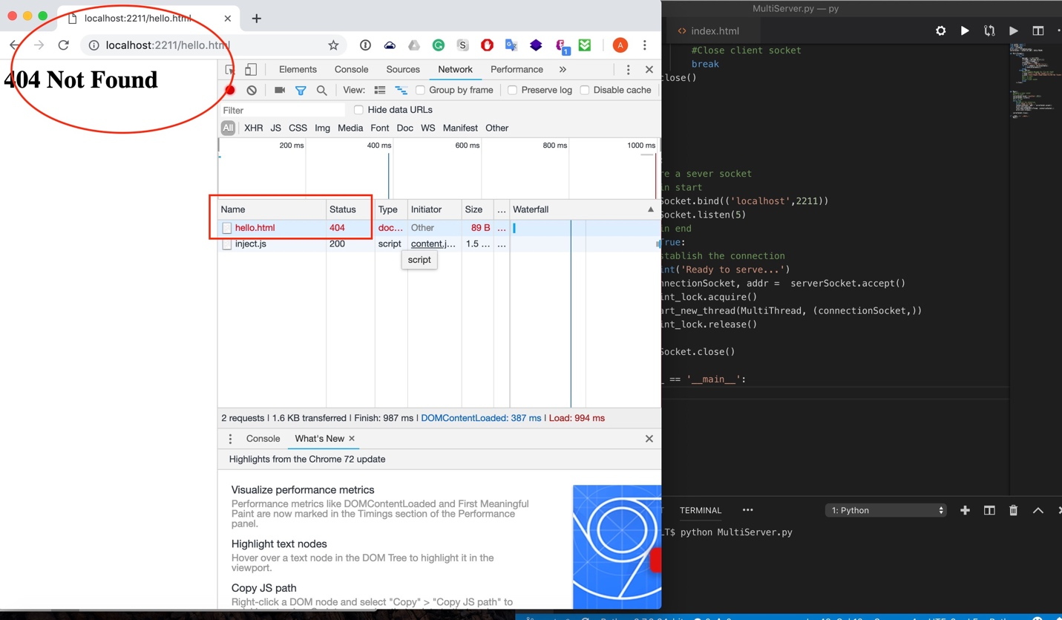
Screenshot 4 shows us the status and the message 404 showing when the server could not find the file.

