### Introduction

Welcome!

This is a study of individual decision-making and behavior. The money you earn will be paid to you in cash at the end of this experiment.

This experiment has 4 parts. For each part, we will give you instructions just before it begins. Your choices in one part of the experiment will not affect what happens in any other part. Each part proceeds in rounds. There will be 10 rounds in total. We expect that most participants would be able to complete the experiment in about 30 minutes. The experiment will end with a short questionnaire.

At the end of the experiment, we will draw one of the rounds at random as the **Payment Round.** Each round of the experiment is equally likely to be drawn. Only the decision that you made in that Payment Round will determine your final payoff. Hence you should make every decision as if it is the one that counts, because it might be!

At the start of the experiment, you will be given $25, so with the show up fee included you will have $30 in total. The choices you make within the experiment will determine how much of this amount you may lose. It is impossible to lose more than $25, so your earnings in the worst-case scenario will be exactly your show-up fee of $5.

You are not allowed to talk during the study. If you have any questions, please raise your hand and we will come and answer your questions privately. Please

do not use cell phones or other electronic devices until after the study is over. If we do find you using your cell phone or other electronic devices, the rules of the study require us to withhold your completion payment.

Often during this study, you will be shown information or asked to make decisions. After doing so, remember to click the button that says "Continue". The experiment will not proceed until you click that button.

**Task 1: Blind Protection Instructions**

## *Task 1: Protection Decision*

The first part of the experiment has 6 rounds. In each round, you will make the Protection Decision as described below. Please note that after the instruction screen, there will be a short quiz to make sure you understand the experiment. Please read the instructions carefully.

At the beginning of each round, the computer will randomly draw a ball from the box, which contains white and black balls. The number of balls of each color can vary between rounds. We will not tell you which ball has been selected by the computer, but you will know the number of balls of each color as in the picture below.

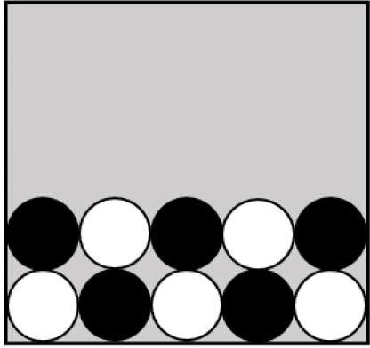

In each round you must decide whether to buy ***Protection. Protection*** costs

$5. If you do not buy ***Protection,*** you lose $20 of your starting money if the Ball is Black, but you do not lose anything if the Ball is White. This means that your earnings will be:

* $30-$5=$25 if you buy protection and the ball is White
* $30-$5=$25 if you buy protection and the ball is Black
* $30-$0=$30 if you do not buy protection and the ball is White
* $30-$20=$10 if you do not buy protection and the ball is Black

We would like to ask you a few questions to check your understanding of this task. Please feel free to go back to the instructions if needed.

If the computer selects a black ball and the round is the Payment Round, which of the following is true?

**0** My earnings in this experiment is $10 whether or not I buy Protection

**0** My earnings in this experiment is $10 if I don't buy Protection

**0** My earnings in this experiment is $30 if I don't buy Protection

**0** None of the above

If the computer selects a white ball and the round is the Payment Round, which of the following is true?

**0** My earnings in this experiment is $10 whether or not I buy Protection

**0** My earnings in this experiment is $10 if I don't buy Protection

**0** My earnings in this experiment is $30 if I don't buy Protection

**0** None of the above

In any given round, what is the chance that the computer selects a black ball?

0 10%

0 20%

0 50%

0 The chance can vary between rounds and depends on the composition of the Box

Thank you for answering our questions! All of your answers are correct.

Thank you for answering our questions! Unfortunately, some of your answers are incorrect:

### Question: If the computer selects a black ball and the round is the Payment Round, which of the following is true?

*You will receive $10 as earnings in this experiment (with show up fee) if you don't buy Protection, because drawing* a *black ball without Protection reduces*

*your payoff by $20. However, if you buy Protection, your payoff will be $25 regardless of the ball color.*

### Question: If the computer selects a white ball and the round is the Payment Round, which of the following is true?

*You will receive the full $30 if you don't buy Protection, because drawing* a *white ball never reduces your payoff. However, if you buy Protection, your payoff will be $25 regardless of the ball color.*

### Question: In any given round, what is the chance that the computer selects a black ball?

*The chance can vary between rounds. In the beginning of each round you will see the box with black and white balls. The chance of drawing* a *black ball is equal to the proportion of black balls in the box.*

### Blind Protection: rounds

***Round NaN***

The Box contains undefined

Based on my information, I decide to:

**0** not buy Protection in this round

**0** buy Protection for $5 in this round

You chose to undefined in this round. You will learn your payoff only if this round is selected as the Payment Round.

### Task 2: Informed Protection Task Instructions

***Task 2: Informed Protection Task***

The second part of the experiment has 6 rounds. Please note that after the instruction screen, there will be a short quiz to make sure you understand the experiment before you can continue to the first round. Please read the instructions carefully.

As in the first part, the computer is going to randomly select one ball from the Box with white and black balls. The computer will show you the contents of the Box but will not tell you the color of the selected ball.

**Within each round, you would receive a hint about the ball's color from a gremlin.** There are three types of gremlins: an honest gremlin always tells the true color of the Ball, a black-swamp gremlin always says that the Ball is black and a white-swamp gremlin always says that the Ball is white. This is how they look:

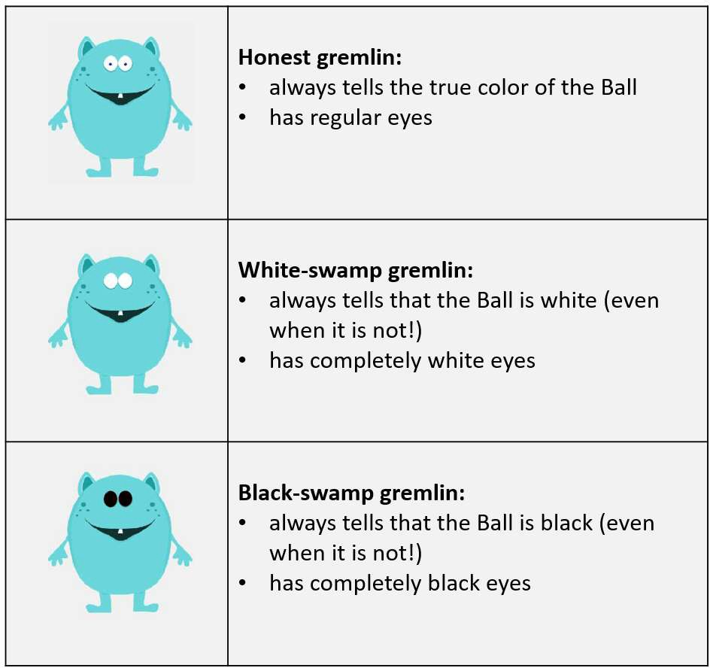

The hints of white-swamp and black-swamp gremlins do not depend on the color of the selected ball. A white-swamp gremlin always says that the Ball is white and would never say that the Ball is black; a black-swamp gremlin always says that the Ball is black and would never say that the Ball is white. Their hints can be correct only by accident.

Suppose, for example, that the Ball is black. Then an honest gremlin would say that the Ball is black. A white-swamp gremlin would say that the Ball is white. A black-swamp gremlin would say that the Ball is black.

On the other hand, if the Ball is white, then an honest gremlin would say that it is white. A white-swamp gremlin would say that it is white. A black-swamp gremlin would say that it is black. Remember that gremlins are just pre-coded computer algorithms and do not intentionally try to help or harm you.

The computer picks the hinting gremlin randomly from a group of gremlins of different types, where each individual gremlin is equally likely to be selected. You will be informed of the mixture of gremlins in this group (similar to the figure below), but you do not know which gremlin is giving the hint.

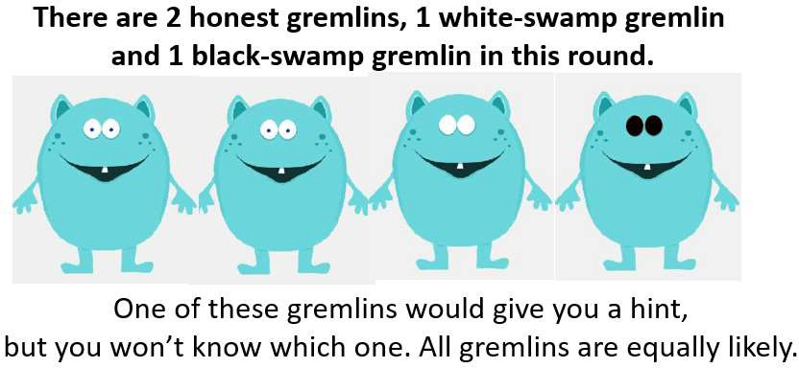

The group of gremlins from which the computer selects the hinting gremlin can change from round to round. For example, in one round, you might have two honest gremlins and one white-swamp gremlin in the group. In another round, you might have three honest gremlins and two black-swamp gremlins. You will see the group's composition before making your decisions.

There are two possible hints: either the gremlin says "The Ball is white!" or it says "The Ball is black!". We would like to know whether or not you would buy protection for each of these possible hints. That is, if the hint you receive from a gremlin randomly selected from that group says the Ball is white, would you buy protection? If the hint you receive says that the Ball is black, would you buy protection?

You will need to figure out on your own how likely it is that the hint is true given the group's composition. For example, if all the gremlins are honest, any hint

from a randomly drawn gremlin is true. If all the gremlins are white-swamp or all are black-swamp, then their hints give no information. Most often though, your group will include both honest and dishonest gremlins.

As before, protection costs $5. If you do not buy Protection, you lose $20 of your starting money if the Ball is Black, but you would not lose anything if the Ball is White. This means your earnings will be:

* $30-$5=$25 if you **buy protection** and the Ball is **White**
* $30-$5=$25 if you **buy protection** and the Ball is **Black**
* $30-$0=$30 if you **do not buy protection** and the Ball is **White**
* $30-$20=$10 if you **do not buy protection** and the Ball is **Black**

After you tell us your decision for each possible hint, the computer will draw a ball. Then it will record a hint from one randomly chosen gremlin from the group. If the gremlin says that the Ball is white, the computer will implement the choice you made for that hint. If the gremlin says that the Ball is black, the computer will implement the choice you made for that hint. The flow chart below illustrates what happens in each round. You should make your choice for each of two possible hints carefully because either one may determine your payoff if this round is chosen for payment.

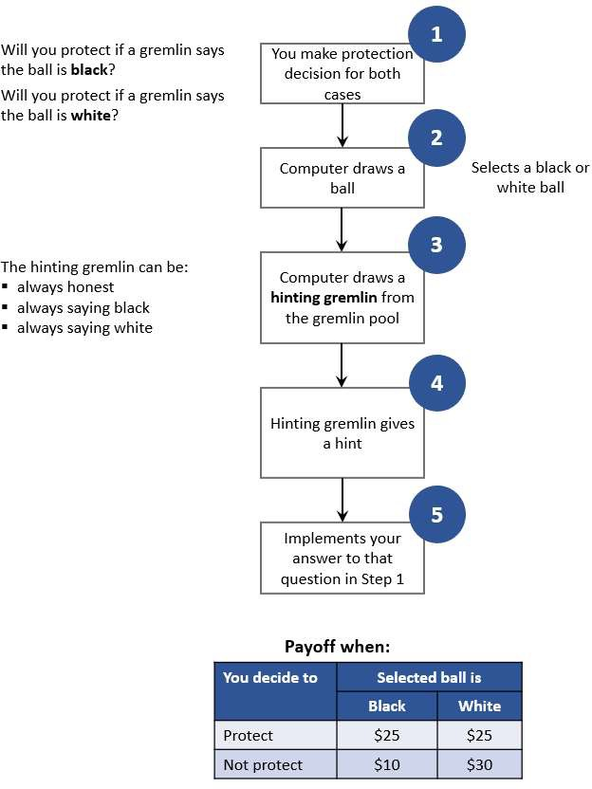

We would like to ask you five quick questions to check your understanding and clear any remaining confusion.

Suppose that the ball is black. What would a white-swamp gremlin say?

Q That the ball is black

0 That the ball is white

Suppose that the ball is white. What would a white-swamp gremlin say?

Q That the ball is black

0 That the ball is white

Suppose that the ball is black. What would a black-swamp gremlin say?

Q That the ball is black

0 That the ball is white

If a white-swamp gremlin says that the Ball is white, that means:

0 The Ball is white

Q The Ball is black

0 The Ball can be of either color

0 This will never happen

If a black-swamp gremlin says that the Ball is white, that means:

0 The Ball is white

Q The Ball is black

0 The ball can be of either color

0 This will never happen

Thank you for answering our questions! All of your answers are correct.

Thank you for answering our questions! Some of your answers are incorrect. It is important that you understand the instructions before you make your choices, so please read our additional explanations for the questions you missed. We might ask you a few more questions afterwards to make sure that there is no confusion.

### Question: Suppose that the ball is black. What would a white-swamp gremlin say?

*It would say that the ball is white. The white-swamp gremlin always says that the ball is white regardless of its actual color.*

### Question: Suppose that the ball is white. What would a white-swamp gremlin say?

*It would say that the ball is white. The white-swamp gremlin always says that the ball is white regardless of its actual color. In this case, it means that its hint is true, but only by chance.*

### Question: Suppose that the ball is black. What would a black-swamp gremlin say?

*It would say that the ball is black. The black-swamp gremlin always says that the ball is black regardless of its actual color. In this case, it means that its hint*

*is true, but only by chance. If the ball were to be white, the gremlin would still falsely state that it is black.*

### Question: If a white-swamp gremlin says that the Ball is white, that means:

*It means that the ball can be of either color. Remember that* a *white-swamp gremlin always says that the ball is white, so their hint does not give any new information.*

### Question: If a black-swamp gremlin says that the Ball is white, that means:

*This will never happen. Remember that* a *black-swamp gremlin always says that the ball is black.*

Remember that there are only three types of gremlins. An honest gremlin always says the true color, a white-swamp gremlin always says that the ball is white (whether it is actually white or not) and a black-swamp gremlin always says that the ball is black (whether it is actually black or not).

Next, we will ask you three more questions.

Suppose that the ball is white. What would a black-swamp gremlin say?

Q That the ball is black

0 That the ball is white

If a black-swamp gremlin says that the Ball is white, that means:

0 The Ball is white

Q The Ball is black

0 This will never happen

0 The Ball can be of either color

If a black-swamp gremlin says that the Ball is black, that means:

0 The Ball is white

Q The Ball is black

0 The Ball can be of either color

0 This will never happen

### Informed Protection: rounds

The Box contains

If a gremlin says that the Ball is white, I will:

**0** not buy Protection in this round

**0** buy Protection for $5 in this round

If a gremlin says that the Ball is black, I will:

**0** not buy Protection in this round

**0** buy Protection for $5 in this round

You chose to if the gremlin says that the Ball is white and to if the gremlin says that the Ball is black. You would learn your payoff if this round is selected as the

Payment Round.

**Task 3: Belief Elicitation**

## *Task 3: Measuring Chances*

In this part of the experiment, you will estimate the chance that the Ball is black based on gremlin's hints. We will first show you: 1) the box with white and black balls and 2) the group of gremlins. Imagine that the computer then randomly picks one ball from the box and one gremlin out of this group who will give you a hint. We will ask you two questions:

1. If this gremlin says that the Ball is white, what do you think are the chances that the Ball is white?
2. If this gremlin says that the Ball is black, what do you think are the chances that the Ball is black?

Your estimate each time will be a percentage between 0 and 100. To illustrate how this works, suppose that all the gremlins in the group are honest. It means that their hints are always true: if a gremlin says that the Ball is white, there is exactly 0% chance of it being black. If a gremlin says that the Ball is black, there is exactly 100% chance that the Ball is black. And the chance that the gremlin says it is Black is exactly the chance that is is Black or the proportion of black balls in the box. This case is very easy, but in most cases, the group of gremlins will include some white-swamp and/or black-swamp gremlins. You should take into account the number of white and black balls and the proportions of each type of gremlin in your group when estimating the chances.

Your payoff depends on the accuracy of your answers. All you have to understand in this task is that you make more money if your guess is closer to

the actual probability of the event given your information. You make the most money if your guess is exactly equal to the actual probability of the event. For example, you want to predict the chances that the ball is black if the gremlin says that it is black. If the actual probability is 10% and you choose 20%, you payoff will be $30 with probability 90% and $10 with probability 10%. If you choose 50% instead, your payoff will be $30 with the probability of about 60%>. As you can see, you can win if your estimate is very imprecise, but chances are higher for a more accurate estimate. The next two paragraphs lay out the details of how the payoff is calculated, and you are welcome to read these details.

If any round of this task is chosen as the Payment Round, the computer would, first, draw a ball at random from the Box. Then it would record a hint from one randomly chosen gremlin from the group. Finally, it will draw one random lottery with chances between 0 and 100.

This computer will then calculate your payment based both on the hint, the actual ball color and this random lottery. This is easier to understand through an example. Suppose, that the gremlin hints that the Ball is white and you estimate that the Ball is indeed white with probability 85%. If a computer draws a lottery with chances of 85% and above, then you lose $20 if the Ball is white. If the computer draws a lottery with chances lower than 85%, then you would lose

$20 with the chance specified in the lottery.

### Belief Elicitation: rounds

The Box contains

Here are the gremlins giving you hints in this round:

**Suppose that one of the gremlins says that the Ball is white.** What do you think is the chance that the Ball is actually **white?** Please estimate to the best of your ability and make your selection on the slider below:

Impossible Completely certain

0 10 20 30 40 50 60 70 80 90 100

Chance (%) that the Ball is white



**Suppose that one of the gremlins says that the Ball is black.** What do you think is the chance that the Ball is actually **black?** Please estimate to the best of your ability and make your selection on the slider below:

Impossible Completely certain

0 10 20 30 40 50 60 70 80 90 100

Chance (%) that the Ball is black

This concludes the round. You will see the outcome only if this round is selected as the Payment Round in the end of the experiment.

**Task 4: Value**

## *Task 4: Value*

Were gremlins helpful for you? How much would you pay for their hints if given an opportunity?

In this task, you can buy a hint before making a protection decision. As before, the hint will come from a gremlin which is randomly selected from a group of gremlins of different types. We will show you the group composition, but not the type of the hinting gremlin.

After seeing the group of gremlins, please think about the prices you are willing to pay for the hint. You will then select all acceptable prices by filling a table

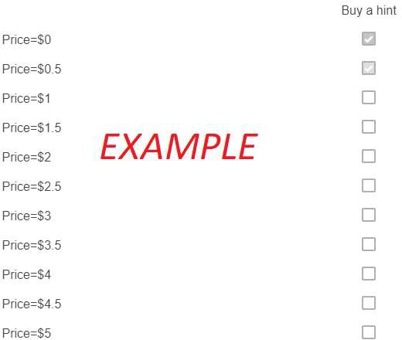

such as this:

In this table, you select all the prices which you are willing to pay to receive a hint. For example, if you are willing to pay no more than $0.5, then the first and the second rows in the table should be selected as shown in the example above. If you are willing to pay no more than $3, all the rows from the first to the seventh one should be selected. For your convenience, you just need to select the maximum price you are willing to pay for the hint and the system will

automatically select all prices lower than that chosen price. You can always unselect the prices by clicking on their checkboxes.

In each round, you will have a different group of gremlins. There are also six rounds in this part of the experiment. You will also have to answer a short quiz before proceeding to the rounds to make sure you understand the experiment. Please read the instructions carefully.

**Payoff Calculation.** If this the Payment Round, the computer will randomly select one of the prices from the Table. If you chose to buy a hint at this price, you would go through one round of the Informed Protection Task. You will make a Protection decision after receiving a hint from the gremlin. We will subtract the selected price from your payoff in that round. Note, that the price you are paying does not affect the hint's quality.

If you opted not to buy a hint at this price, you would go through one round of the Blind Protection task. In other words, you would make a Protection decision without a hint.



For example, suppose that you fill the table as shown above and this round is the Payment Round. If the computer randomly selects price $0.5 (the second line), you will pay $0.5 and go through one round of the **Informed Protection:** you will receive a hint from one of the gremlins and then choose to protect or not. Your payoff would be equal to what you would have received from the Informed Protection round minus the price of the hint. In this example, if you do not protect, then your payoff will be $30-$0.5=$29.5 if the Ball is white and ($30-$20)-$0.5=$9.5 if the Ball is black. If you decide to protect, your payoff will be ($30-$5)-$0.5=$24.5 for any color of the Selected Ball.

If, for example, the computer randomly selects $1 (line 3) instead of $0.5, you will go through one Blind Protection round and this round would determine your payoff. You will neither pay $1 nor receive a hint, because you did not want to pay this price for a hint based on your selections in the Table. The computer

would calculate your payoff in the same way as in the Part 1 of the experiment (Blind Protection).

**Suggestions.** You should consider the composition of gremlins when selecting the prices to pay. For example, you might have only white-swamp gremlins in the group. Because white-swamp gremlins always say that the Ball is white, their hints are worthless, and most people would not pay anything for them. On another hand, a hint from a group of honest gremlins is more valuable because it tells you the Ball's color with certainty.

It is always in your best interest to select all the prices below or equal to your maximum price. Suppose, for example, that you want to pay any price up to $3 for a hint from a certain group of gremlins. If you do not select the price of $2 and this price is randomly chosen by the Computer, you would have to make the protection decision without a hint even though you prefer to pay $2 to get one.

On another hand, if you select the price of $5, you might have to pay $5 which is $2 more than the maximum price you are willing to pay.

Please answer the couple of quick questions to make sure that you are ready for our final task. These questions refer to the following table:

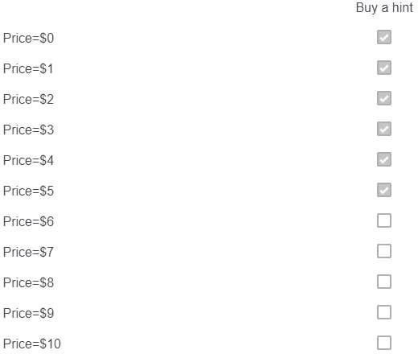

Suppose that another player with different prices and different gremlins (Anna) has filled the table as shown above. If this task is chosen as the Payment Round, then:

**0** Anna will pay $5 and have another round of Informed Protection where she will make a protection decision after receiving a hint

**0** Anna will have one round of Blind Protection where she will make a protection decision without a hint

0 Anna will go through Informed Protection if the computer randomly selects a price less than $5

**0** Anna will go through Informed Protection if the computer randomly selects a hint price greater than $5

Suppose that another player with different prices and different gremlins (Anna) has filled the table as shown above. If this task is chosen as the Payment Round and the computer randomly selects Price=$2, then:

**0** Anna will have one round of Blind Protection with payoff equal to the payoff from the additional round

**0** Anna will have one round of Blind Protection with payoff equal to the payoff from the additional round minus $2

**0** Anna will have one round of Informed Protection with payoff equal to the payoff from the additional round minus $2

**0** Anna will have one round of Informed Protection and her payoff will equal to the payoff from the additional round

Thank you for answering our questions! All of your answers are correct.

Thank you for answering our questions! Some of your answers are incorrect. It is important that you understand the instructions before you make your choices, so please read our additional explanations for the questions you missed. We might ask you a few more questions afterwards to make sure that there is no confusion.



### Question: Suppose that another player with different prices and different gremlins (Anna) has filled the table as shown above. If this task is chosen as the Payment Round, then

*She will go through one additional Informed Protection round only if the computer draws the price less or equal to $5, because she indicated to buy* a *hint only for those prices.*

### Question: Suppose that another player with different prices and different gremlins (Anna) has filled the table as shown above. If this task is chosen

**as the Payment Round and the computer randomly selects Price=$2, then**

*Anna will have one round of Informed Protection with payoff equal to the payoff from the additional round minus $2. The table indicates that she is willing to pay*

*$2 to receive* a *hint,* so *she will receive* a *hint and then make* a *protection decision. The computer will then subtract the price of $2 from her payoff.*

The active option was ${e://Field/option_a}. History is ${e://Field/History}.

### Value: rounds

The Box contains

Please look at the composition of the box and the group of gremlins above. Which prices would you accept to pay to receive a hint? Please select all such prices in the table below:

Buy a hint

Price=$0 □

Price=$0.5 □

Price=$1 □

Price=$1.5 □

Price=$2 □

Price=$2.5 □

Price=$3 □

Price=$3.5 □

Price=$4 □

Price=$4.5 □

Price=$5

Buy a hint

□

The active option was . History is .

### Payoff Calculation

We use this round to create fake history.

The computer has selected round NaN of task NaN (undefined) to calculate the payoff. undefined

### Additional Blind Protection Round

***Additional Blind Protection Round***

### The next round will determine your final payoff. In this round, you will do the protection task (the first task of the experiment). We reproduce the instructions for the first task below for your convenience, but you can skip them if you still remember the rules.

At the beginning of each round, the computer will randomly draw a ball from the box, which contains undefined We will not tell you which ball has been selected by the computer.

In each round you decide to buy or not to buy ***Protection. Protection*** costs $5. If you do not buy ***Protection,*** you would lose $20 of your starting money if the

Ball is black, but you would not lose anything if the Ball is white. This means that your earnings will be:

* $30-$5=$25 if you buy protection and the Ball is white
* $30-$5=$25 if you buy protection and the Ball is black
* $30-$0=$30 if you do not buy protection and the Ball is white
* $30-$20=$10 if you do not buy protection and the Ball is black

Based on my information, I decide to:

**0** not buy Protection in this round

**0** buy Protection for $5 in this round

You chose to in this round. The Selected Ball was undefined. You would receive a payoff of **Starting Money - Protection Cost - Loss = NaN - NaN - NaN** = **NaN USD.**

### Additional Informed Protection Round

***Additional Informed Protection Task***

### This round of the experiment will determine your final payoff. The rules of this round follow the rules of the Informed Protection Task (Task 2 of the experiment). In this round, you can get one hint from one of the gremlins before making the Protection Decision. We reproduce the instructions for the Informed Protection Task below for your convenience. You can skip these instructions if you still remember them.

As in the first part, the computer is going to select one ball from the Box with undefined You will not know the color of the selected ball until after you make the decision.

**At the beginning of each round, one gremlin would give you a hint about the Ball color.** There are three types of gremlins: an honest gremlin would always tell the true color of the Ball, a black-swamp gremlin would always tell that the Ball is black and a white-swamp gremlin would always say that the Ball is white. This is how they look like:

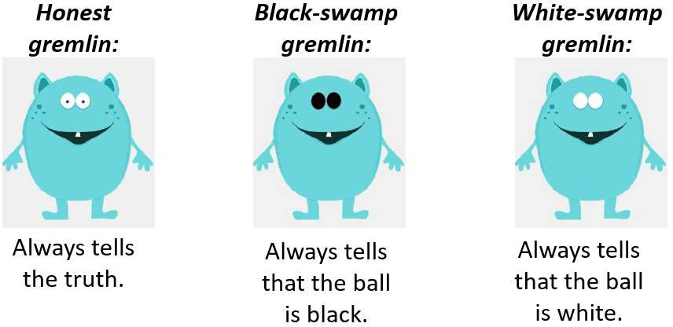

Remember that gremlins are just pre-coded computer algorithms and do not intentionally try to help or harm you.

***Additional Round***

The Box contains

 

Based on my information, I decide to:

0 not buy Protection in this round

**0** buy Protection for $5 in this round

You chose to in this round. The Ball was . You would receive a payoff of **Starting Money - Price of the Hint - Protection Cost - Loss** = - **NaN** - - = **USD.**

### Final Payoff Calculation 2

This concludes the main experiment tasks. Your payoff is ${e://Field/fpayoff} (with the show-up fee included). Next, we will ask you to fill out a short questionnaire.

**Feedback**

## *Experiment Feedback*

We are almost finished! As this is one of the first runs of the experiment, we would like to ask a few questions in order to improve it. First, we are going to ask whether you agree or disagree with several statements about particular tasks. Reminder:

* Task 1 (Blind Protection): you decide to protect or not without seeing a hint
* Task 2 (Informed Protection): you decide to protect or not after seeing a hint
* Task 3 (Measuring Chances): you use sliders to select chances
* Task 4 (Value): you choose between paying to have an Informed Protection round instead of a Blind Protection round

I understood the instructions

|  |  |
| --- | --- |
| Agree | Disagree |
| 0 | 0 |
| 0 | 0 |
| 0 | 0 |
| 0 | 0 |

Task 1 (Blind Protection)

Task 2 (Informed Protection)

Task 3 (Measuring Chances)

Task 4 (Value)

I understood how my choices affected the payoff in

Agree Disagree

Task 1 (Blind Protection)

0

0

Task 2 (Informed Protection)

0

0

Task 3 (Measuring Chances)

0

0

Task 4 (Value) 0 0

I could figure out the best choice in each round of

Agree Disagree

Task 1 (Blind Protection)

0 0

Task 2 (Informed Protection)

0 0

Task 3 (Measuring Chances)

0 0

Agree Disagree

Task 4 (Value) 0 0

Finally, just a few open response questions:

Which task did you find the most confusing?

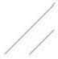

Please explain the strategy you used for Task 2 (Informed Protection)? This is the task in which you see a hint and then decide to protect or not.

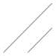

Please explain the strategy you used in Task 3 (Measuring Chances)? This is the task in which you use sliders.

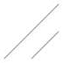

Do you see any ways to improve the experiment?

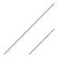

Anything else you would like to say about the experiment?

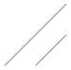

**Final Task: Survey**

## *Background Information*

Finally, we would like to ask you a few personal questions. We appreciate if you answer them truthfully so that we get a better understanding of our results. The responses would not be connected back to you.

What gender are you?

Female

# 0

Male

# 0

Other

# 0

In what year were you born?

Year

***V***

What is the highest degree or level of school you have completed?

*(If currently enrolled, mark the previous grade or highest grade received.)*

0 No schooling completed

**0** Grades 1-12, no high school diploma

0 High school diploma or GED

**0** Some college, but no degree

**0** Associate or bachelor's degree

**0** Graduate or professional degree (master's, MD, Phd)

Have you taken any statistics or probability theory classes?

**0** Yes

Q No

**0** Currently taking a class

Powered by Qualtrics