Vamos a reurrir a la pagina:

<https://material.io/>

Componentes de la tarea:

* App Bar: Top
* Banners
* Buttons
* Cards

# App bars: top

Control: Como funciona y para qué sirve (Intro and Usage)

Distintos formatos del control (Types)

Para que se utiliza cada tipo (Types)

Anatomia del control (Anatomy)

Enlace a la página web

# App bars: top

# Banners

# Buttons

# Buttons: floating action button

# Cards

# Checkboxes

# Chips

# Data Tables

# Dialogs

## Usage

A dialog is a type of modal window that appears in front of app content to provide critical information or ask for a decision. Dialogs disable all app functionality when they appear, and remain on screen until confirmed, dismissed, or a required action has been taken.

Dialogs are purposefully interruptive, so they should be used sparingly.

## Principles

*Focused*

Dialogs focus user attention to ensure their content is addressed.

*Direct*

Dialogs should be direct in communicating information and dedicated to completing a task.

*Helpful*

Dialogs should appear in response to a user task or an action, with relevant or contextual information.

## Types

We have 4 different types of dialogs.

Type 1: Alert Dialog

Alert dialogs interrupt users with urgent information, details, or actions.

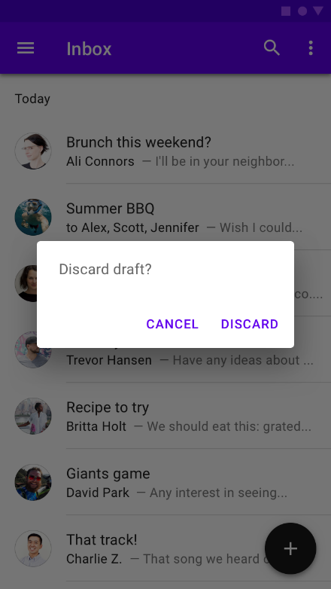

#### Simple dialog

Simple dialogs display a list of items that take immediate effect when selected.

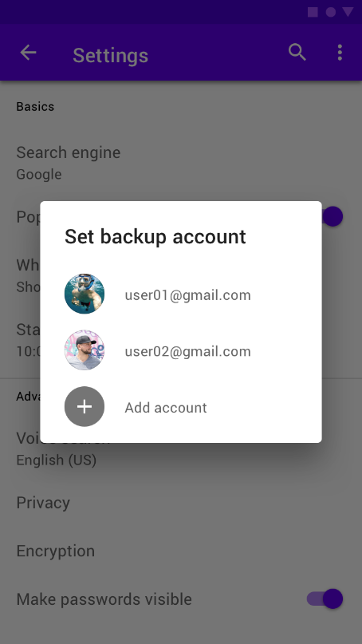

#### Confirmation dialog

Confirmation dialogs require users to confirm a choice before the dialog is dismissed.

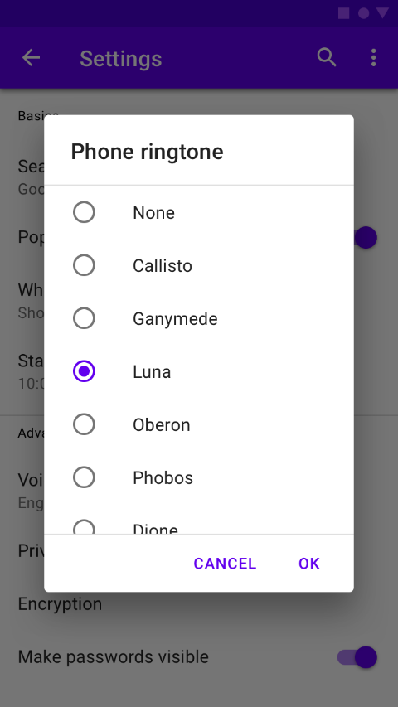

#### Full-screen dialog

Full-screen dialogs fill the entire screen, containing actions that require a series of tasks to complete.

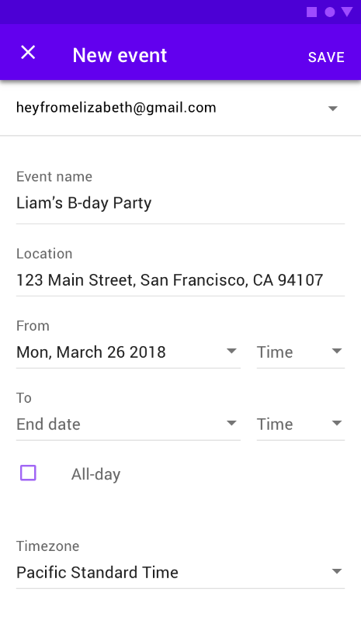

## Anatomy

1. Container
2. Title (optional)
3. Supporting text
4. Buttons
5. Scrim

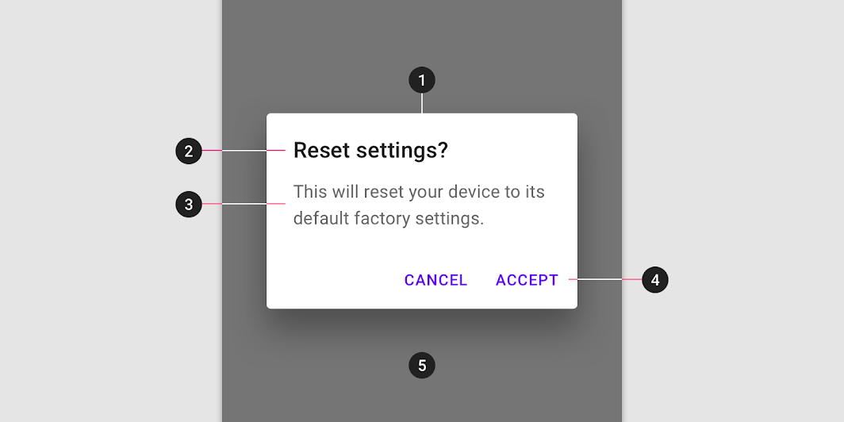

# Image Lists

# Lists

# Menus

# Nagivation drawer

# Progress Indicators

# Radio Buttons

# Sliders

# Text fields

# Tooltips