Weekly Report

# 16/05/2022 & 23/05/2022

BOUDEMIA ALA EDDINE

TEAM CHEN

# Goal:

* Extract mutational signatures operational at CO-HO regions
* Extract mutations co-occurring on R-loop regions

# Procedure:

1. Extraction of CO-HO regions was described in the previous report; I just ran SigProfiler to extract the signatures.
2. To define the mutations co-occurring on R-loops region:
   1. I start by using liftover on the MCF7 data to change the coordinates from hg19 to hg38.
   2. Merge overlapping R-loops.
   3. Run binary search to find the coordinates of the R-loop where the mutation has occurred.
   4. Create a dataframe where each row has the R-loop coordinates and the mutations mapping to it.
   5. Compute the middle point of each R-loop and deduce it from the End and Starting points which will center all the R-loops to 0. (Is it necessary to scale all the R-loops to the same size?)
   6. Separate also based on TSS and TTS in a way that if R-loop overlap with TSS or TTS it will be considered, and TSS/TTS regions are always of size +/-3kb
   7. Plot histograms

# Results:

## Signatures:

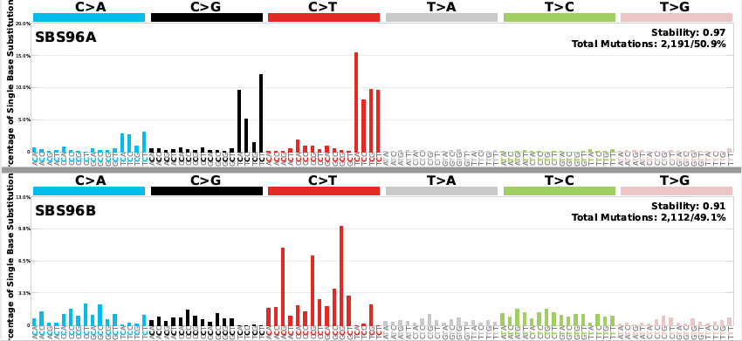

Figure 1 Mutational signatures extracted from convergent regions

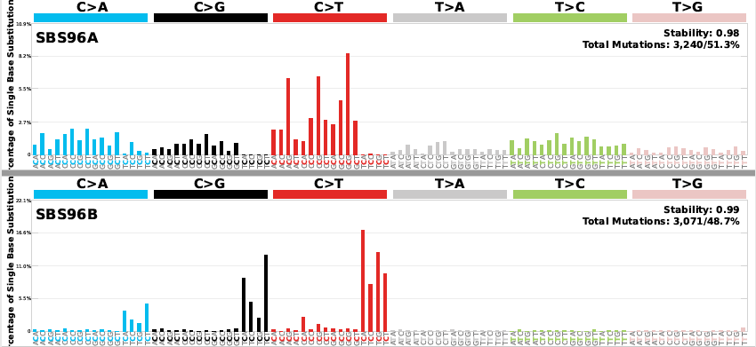

Figure 2 Mutational signatures extracted from co-directional regions

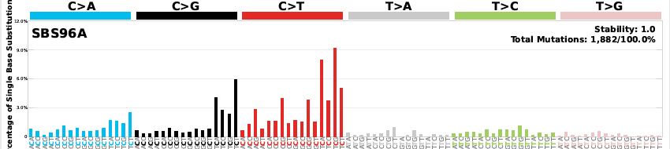

Figure Mutational signatures extracted from divergent regions

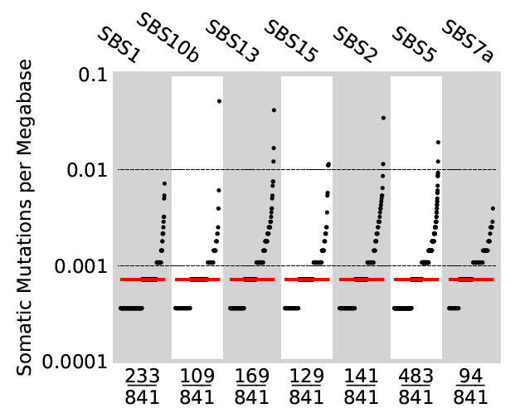

Figure 4 Activities of COSMIC signatures in convergent regions

SBS10b mutations at exonuclease domain of POLE

SBS13 and SBS2 APOBEC

SBS7a UV light

SBS15 defective mismatch repair

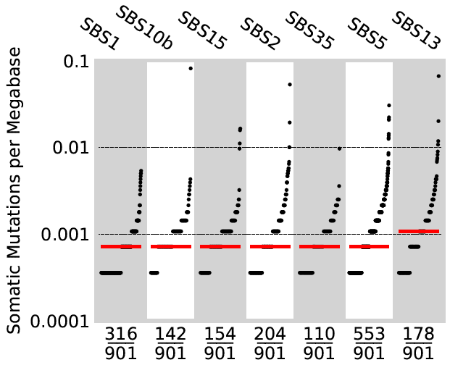

Figure 5 Activities of COSMIC signatures in co-directional regions

SBS35 platinum chemotherapy

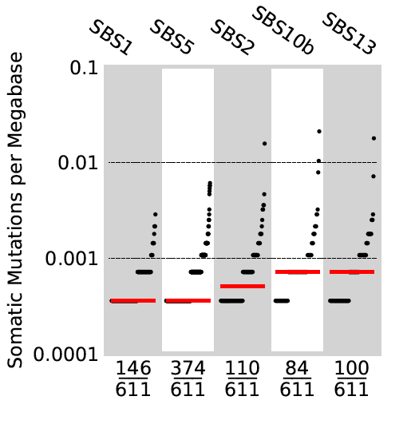

Figure Activities of mutational signatures at divergent regions

## R-loops :

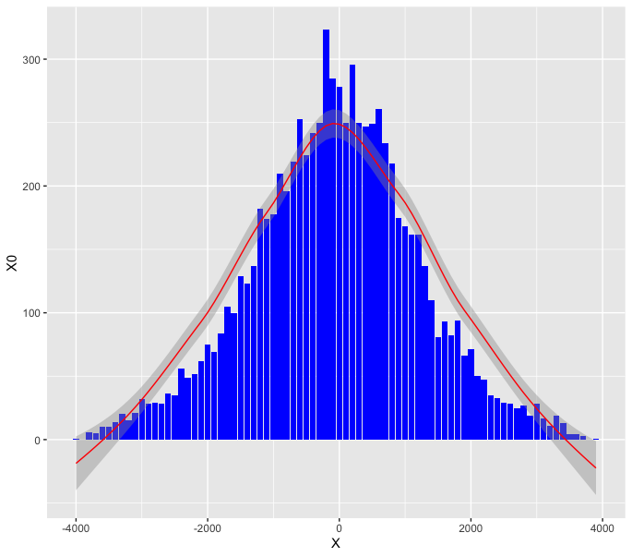

Figure 7 Mutations co-occurring with R-loops from control MCF7

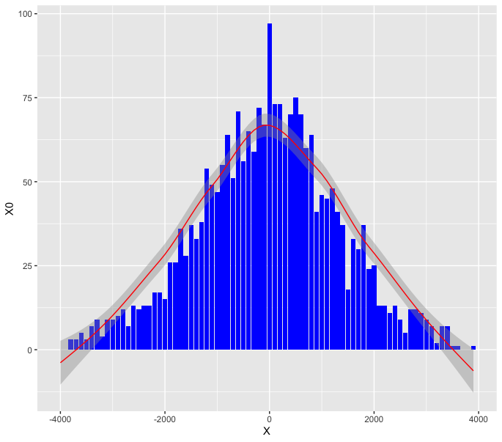

Figure 8 Mutations co-occurring with R-loops close to TSS

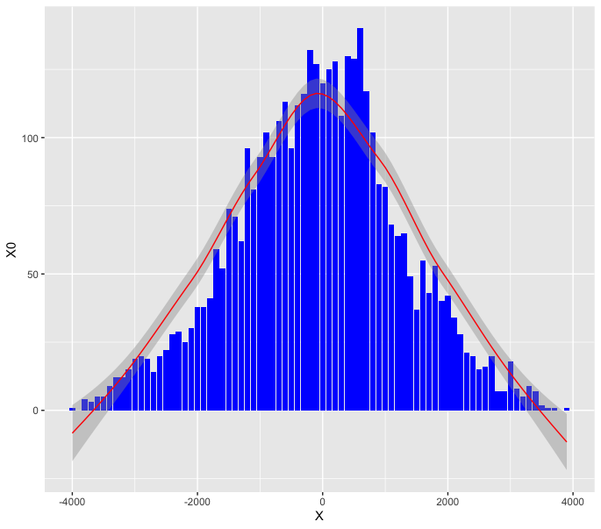

Figure 9 Mutations co-occurring with R-loops close to TTS

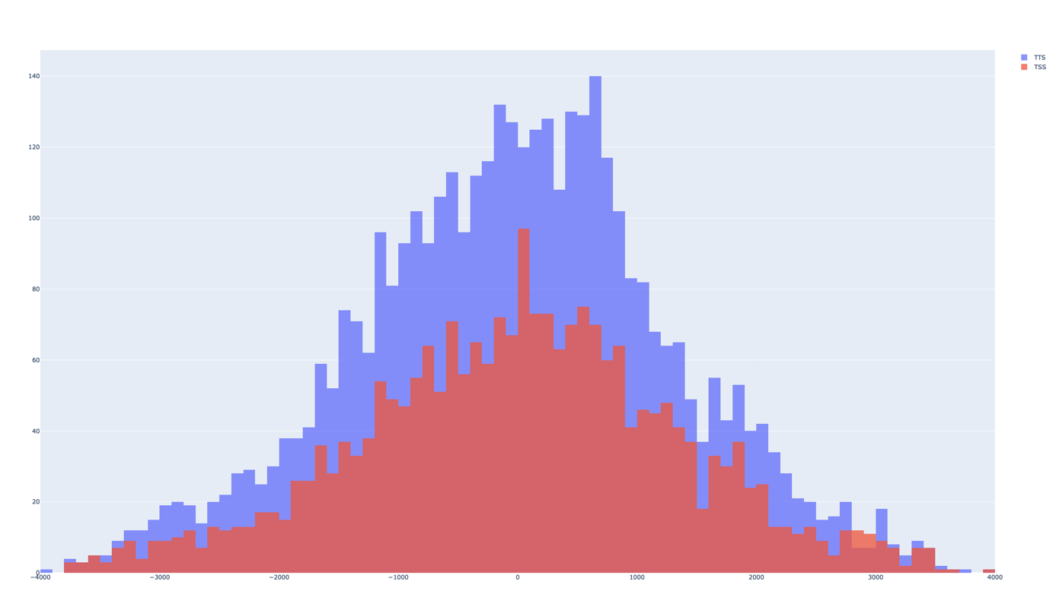

Figure Number of mutations co-occurring with R-loops close to TTS (purple) and TSS(red)

**Note: In MCF-7 treated with E2 for 2h the number of mutations increases but the difference is not huge and when treated for 24h the number of mutations decreases compared to 2h treatment.**