Weekly Report

# 07/06/2022

BOUDEMIA ALA EDDINE

TEAM CHEN

# Goal:

* Extended analysis of mutations co-localizing with R-loops with regard to active and inactive genes

# Results:

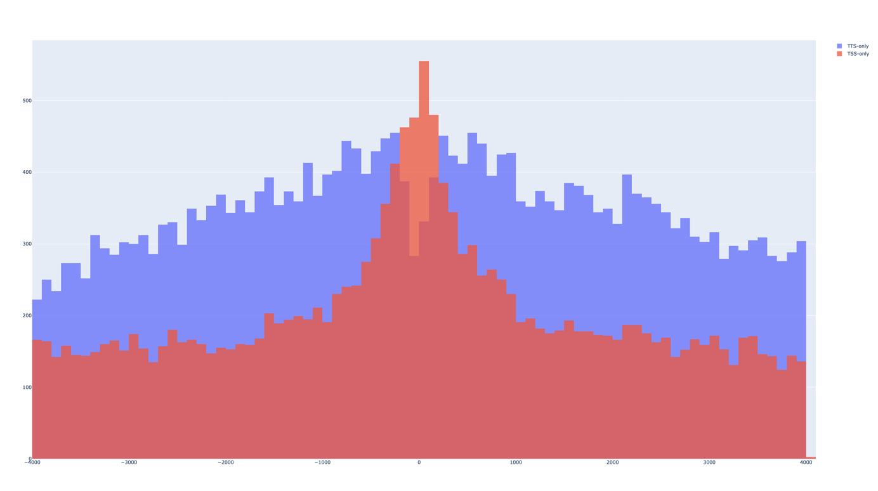

Figure 1 Initial observation without descrimination between active and inactive

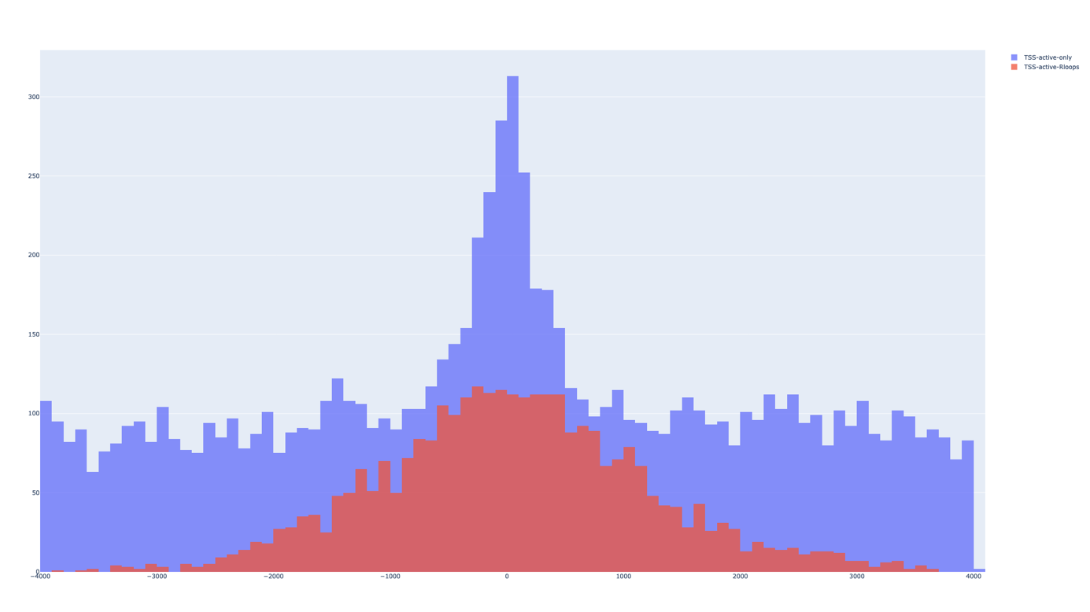

Figure 2 Mutations around TSS of active genes (purple) Mutations with R-loops around TSS of active genes (red)

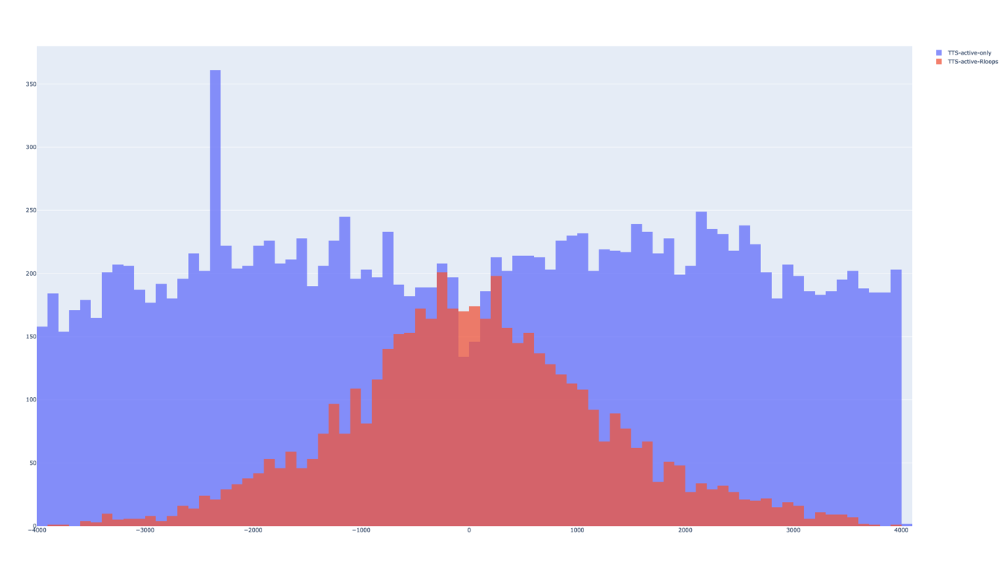

Figure 3 Mutations around TTS of active genes (purple) and Rloops around TTS of active genes (red)

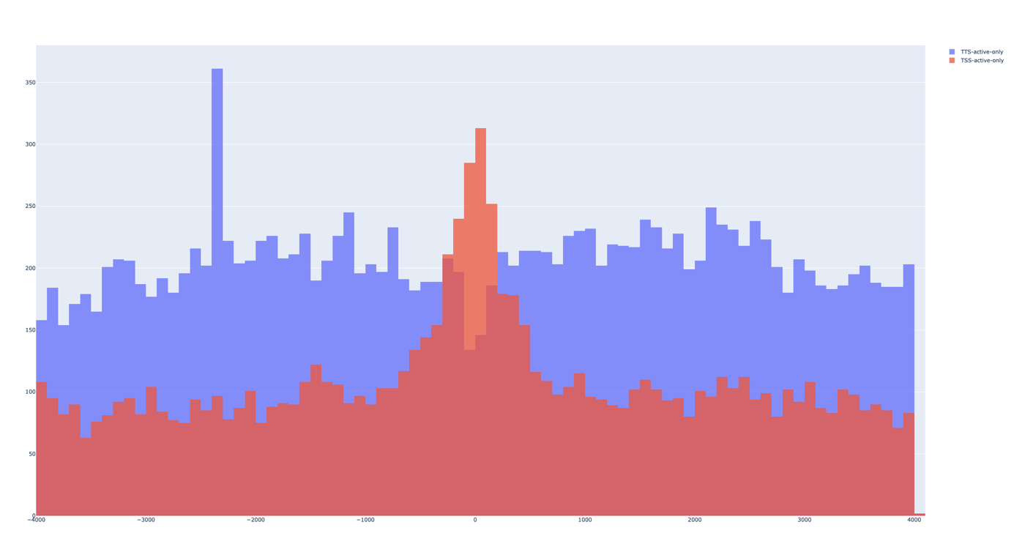

Figure 4 Mutations around TSS (red) and TTS (purple) of active genes

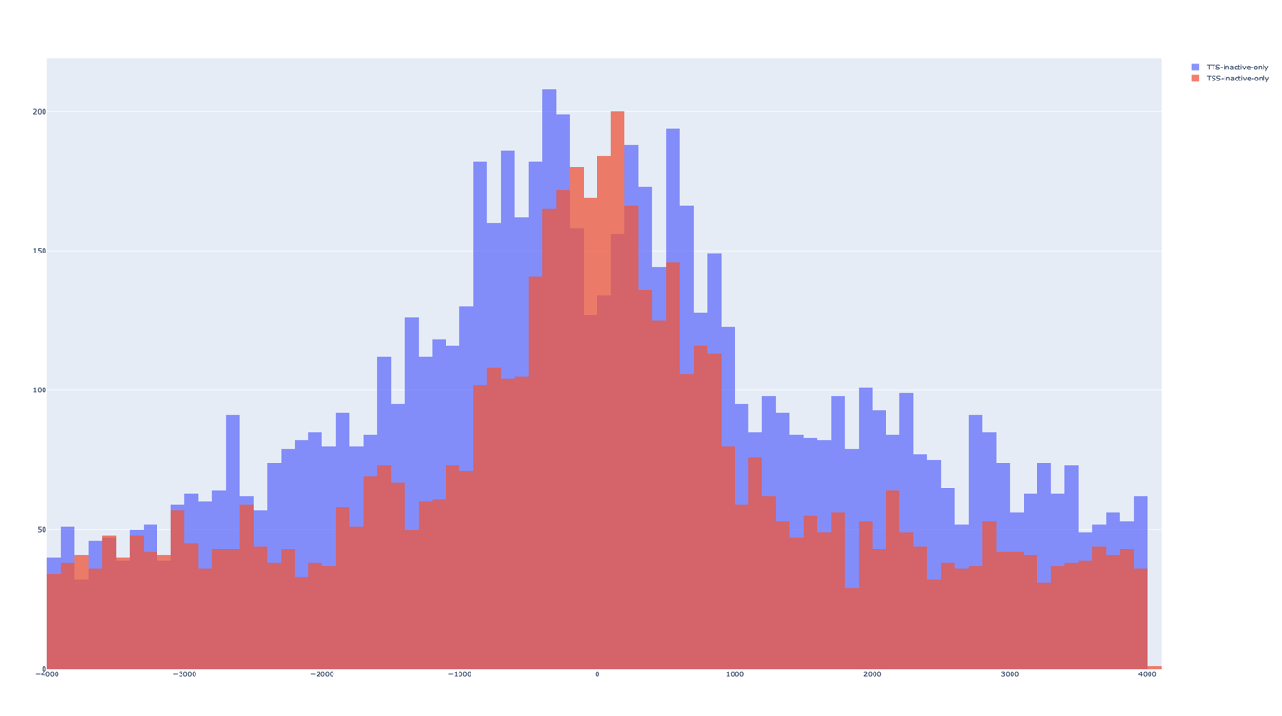

Figure 5 Mutations around TSS (red) and TTS (purple) of inactive genes

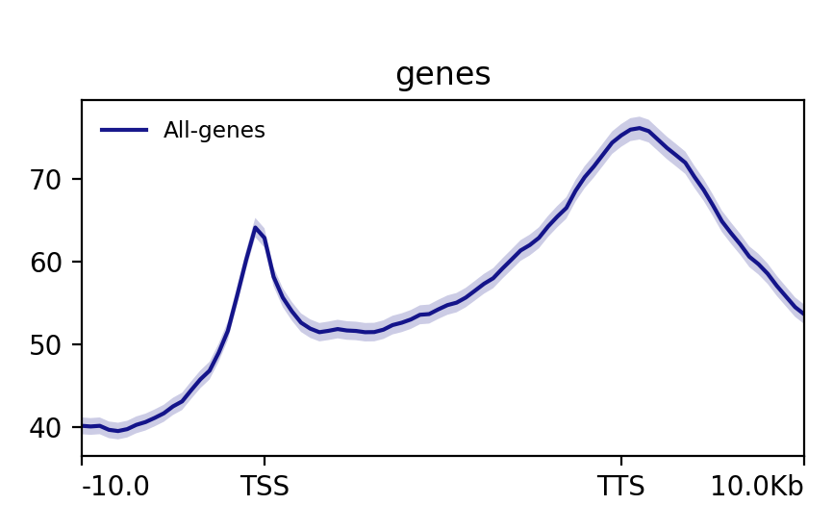

Figure All genes

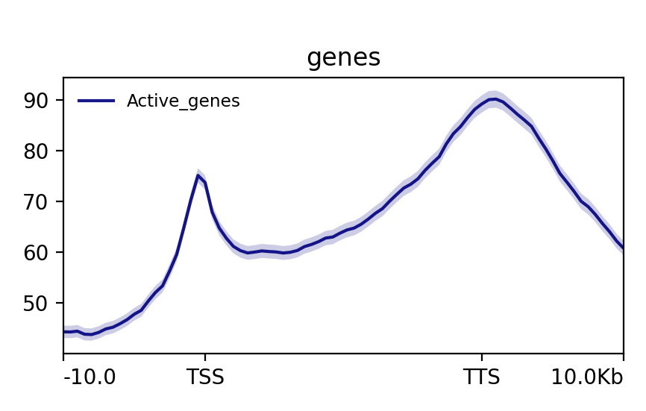

Figure Active genes 12261

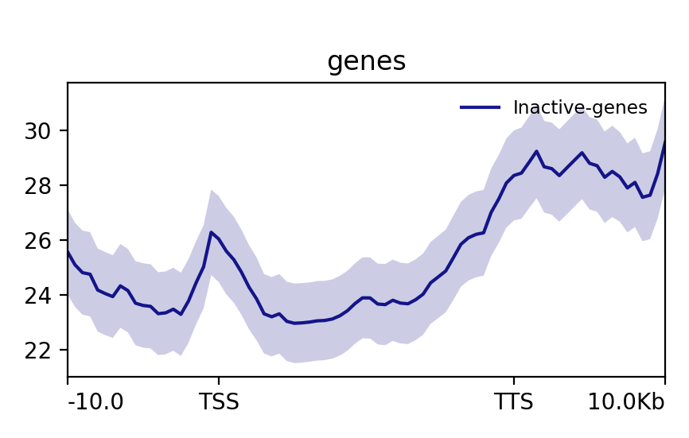

Figure Inactive genes