Weekly Report

# 30/05/2022

BOUDEMIA ALA EDDINE

TEAM CHEN

# Goal:

* Extract mutational signatures at R-loops

# Results:

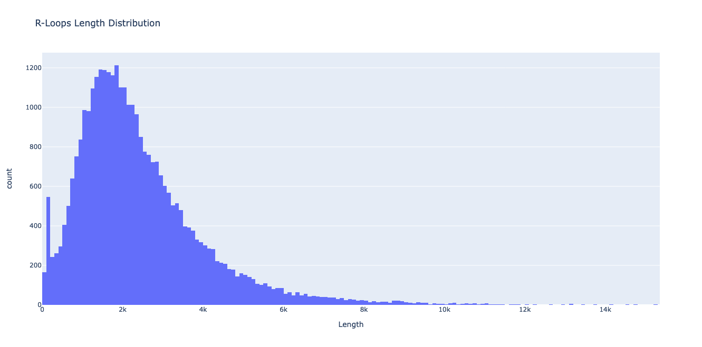

Figure 1 Distribution of R-loops sizes

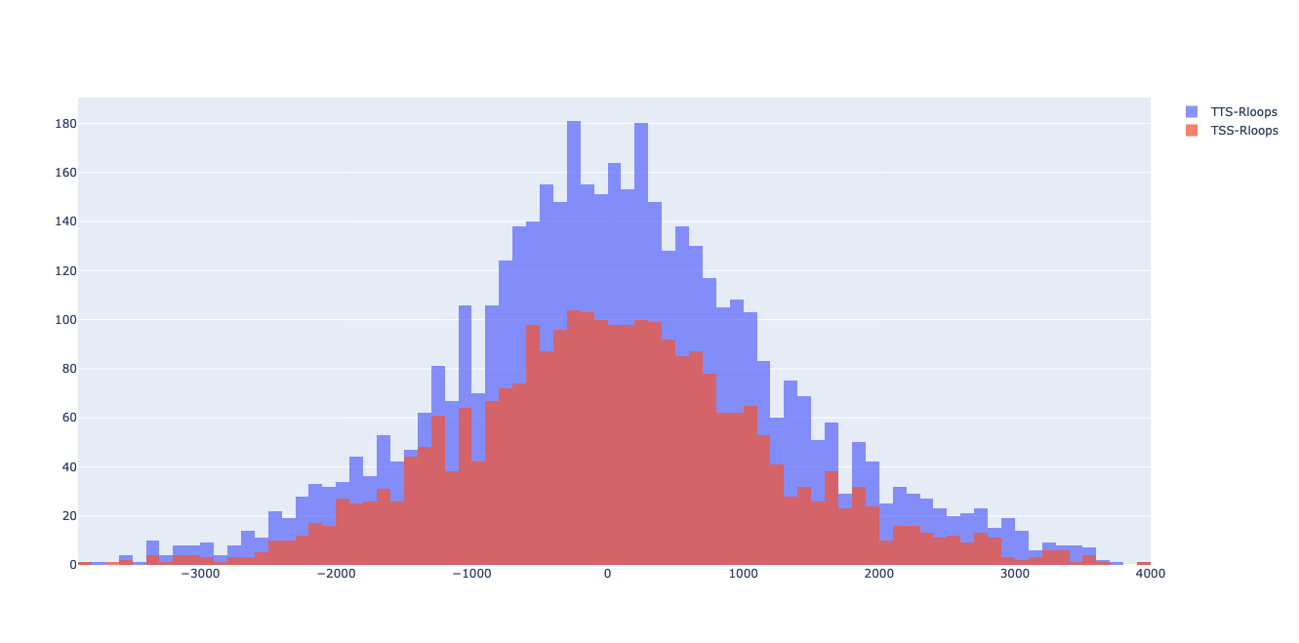

Figure 2 Mutations co-occurring with R-loops at TSS (red) and TTS (purple)

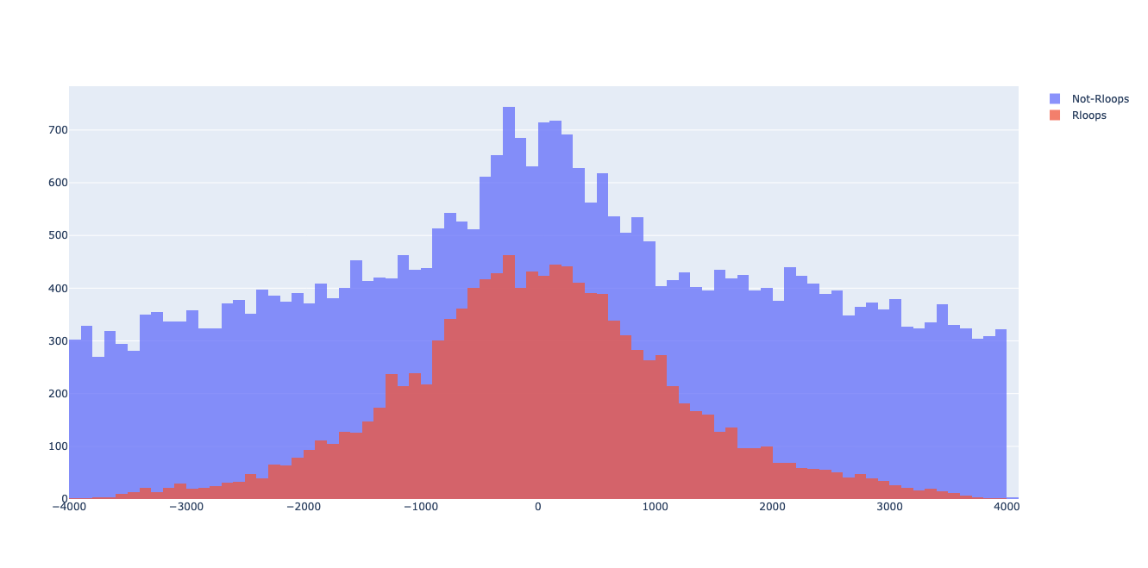

Figure 3 Mutations co-occurring with R-loops (red) compared to mutations outside of R-loops (purple)

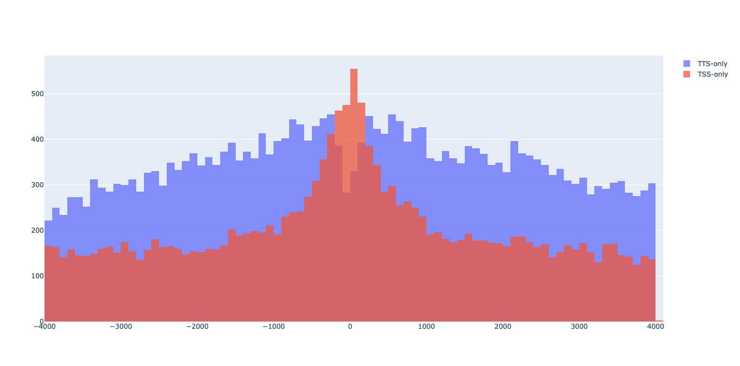

Figure 4 Mutations occurring outside of R-loops at TSS (red) and TTS (purple)

Interesting that at TSS position 0 there are more mutations while at TTS there is a drop almost to half the mutations.

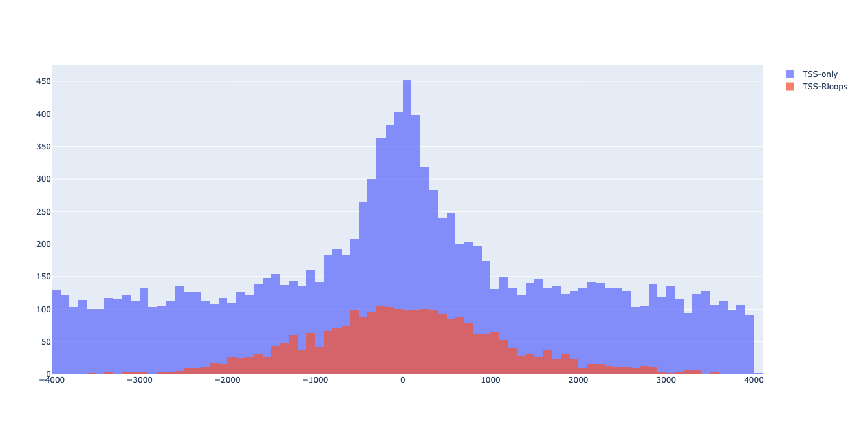

Figure 5 Mutations co-occurring with R-loops at TSS (red) and mutations occurring outside of R-loops at TSS (purple)

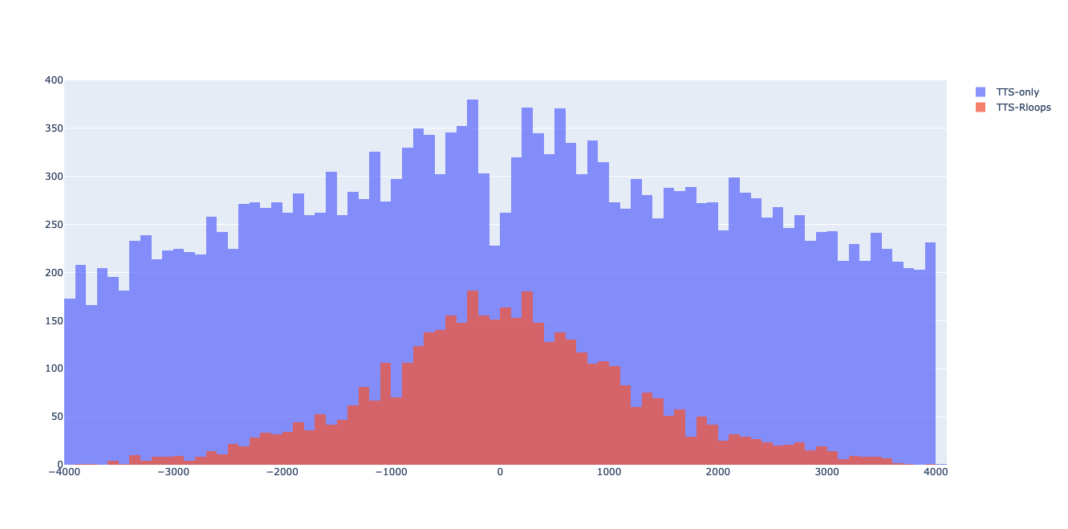

Figure 6 Mutations co-occurring with R-loops at TTS (red) and mutations occurring outside of R-loops at TTS (purple)

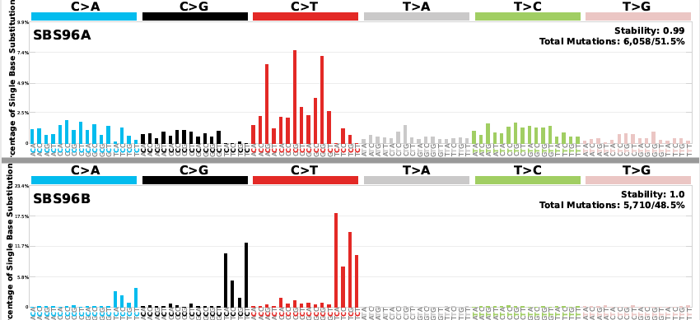

Figure 7 Mutational Signatures Extracted From R-loops regions

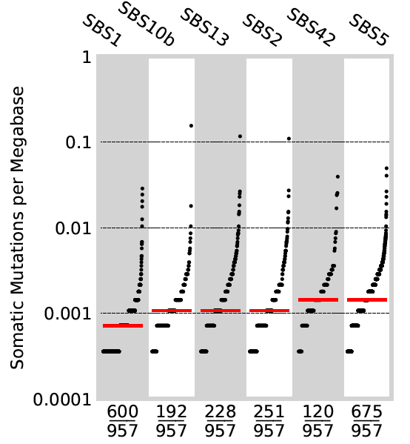

Figure 8 Activities of the signatures when decomposed to COSMIC signatures

Table 1 Kruskal test

|  |  |  |  |  |  |  |
| --- | --- | --- | --- | --- | --- | --- |
| SigA | SigB | Mean A | Mean B | H-statistic | P-value | Decision |
| SBS2 | SBS13 | 1,82 | 1,92 | 0,84 | 0,36 | Rank medians similar |
| SBS10b | SBS13 | 1,32 | 1,92 | 5,06 | 0,024 |

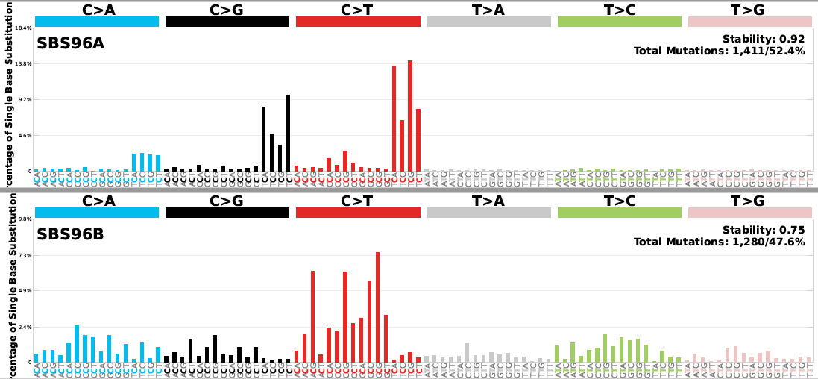

Figure 9 Signatures extracted from TSS regions corresponding to R-loops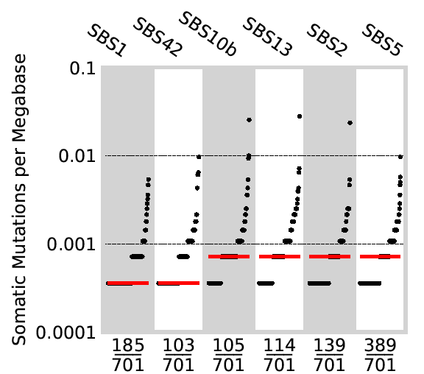

Figure 10 Activities of the signatures when decomposed to COSMIC signatures

Table 2 Kruskal test

|  |  |  |  |  |  |  |
| --- | --- | --- | --- | --- | --- | --- |
| SigA | SigB | Mean A | Mean B | H-statistic | P-value | Decision |
| SBS2 | SBS13 | 0,54 | 0,6 | 2,096 | 0,14 | Rank medians similar |
| SBS10b | SBS13 | 0,54 | 0,6 | 0,5 | 0,48 |
| SBS10b | SBS42 | 0,54 | 0,4 | 0,11 | 0,73 |
| SBS13 | SBS42 | 0,6 | 0,4 | 1,08 | 0,3 |

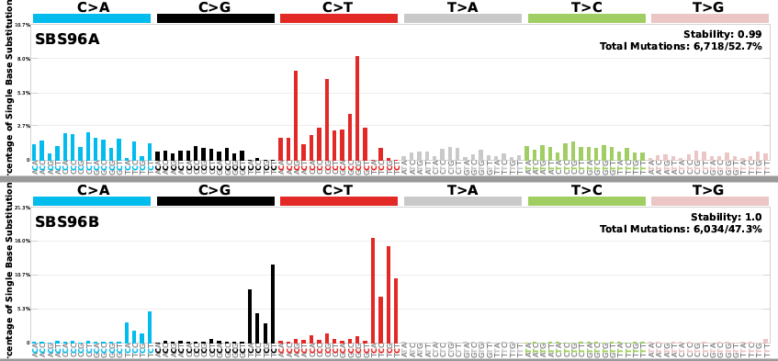

Figure 11 Signatures extracted from TSS regions outside of R-loops

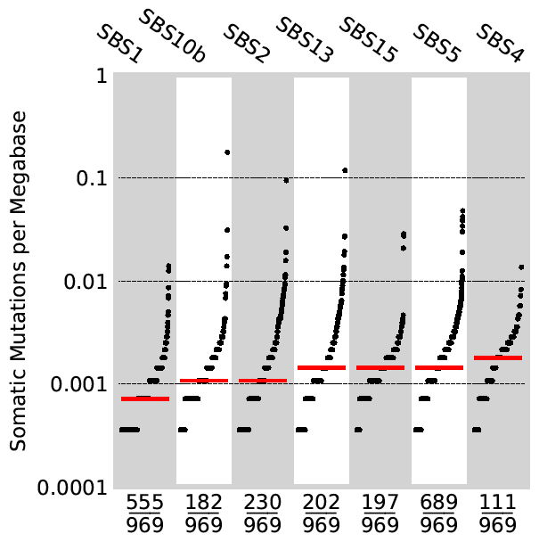

Figure 12 Activities of the signatures when decomposed to COSMIC signatures

Table Kruskal test

|  |  |  |  |  |  |  |
| --- | --- | --- | --- | --- | --- | --- |
| SigA | SigB | Mean A | Mean B | H-statistic | P-value | Decision |
| SBS2 | SBS13 | 1,73 | 1,78 | 1,77 | 0,18 | Rank medians similar |
| SBS2 | SBS15 | 1,73 | 1,05 | 2,61 | 0,10 |
| SBS10b | SBS13 | 1,48 | 1,78 | 1,65 | 0,20 |
| SBS10b | SBS15 | 1,48 | 1,05 | 1,04 | 0,3 |
| SBS13 | SBS15 | 1,78 | 1,05 | 0,087 | 0,77 |

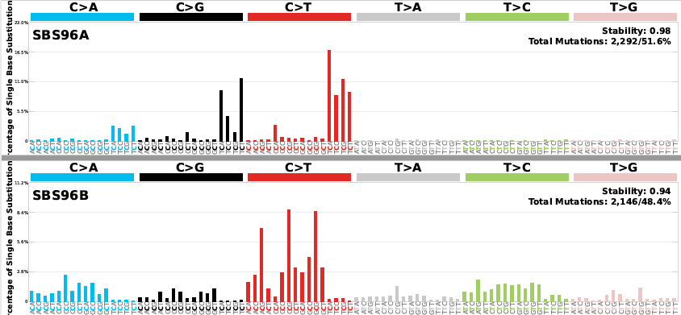

Figure 13 Signatures extracted from R-loops at TTS regions

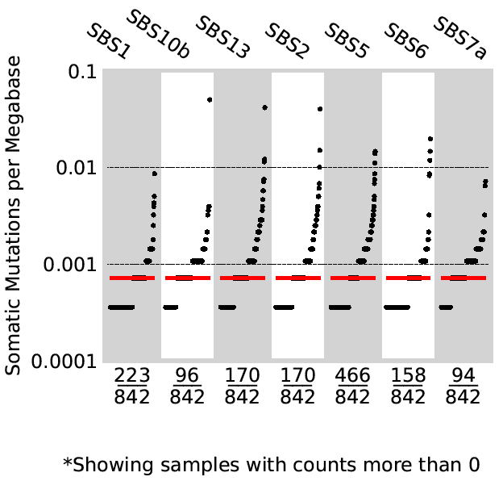

Figure 14 Activities of the signatures when decomposed to COSMIC signatures

Table Kruskal test

|  |  |  |  |  |  |  |
| --- | --- | --- | --- | --- | --- | --- |
| SigA | SigB | Mean A | Mean B | H-statistic | P-value | Decision |
| SBS2 | SBS6 | 0,79 | 0,54 | 1,14 | 0,28 | Rank medians similar |
| SBS2 | SBS13 | 0,79 | 0,85 | 0,0197 | 0,88 |
| SBS6 | SBS13 | 0,54 | 0,85 | 1,479 | 0,2239 |

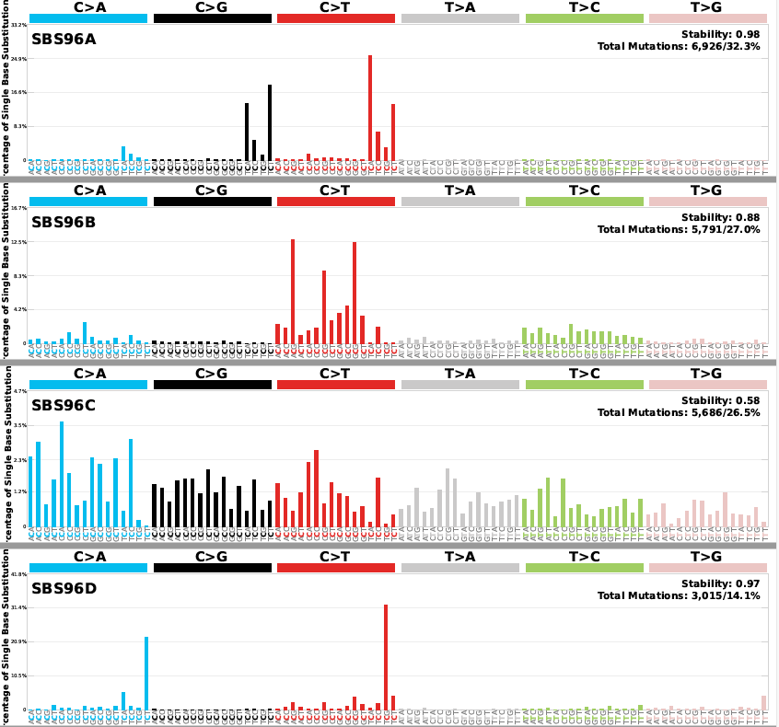

Figure 15 Signatures extracted from TTS outside of R-loops

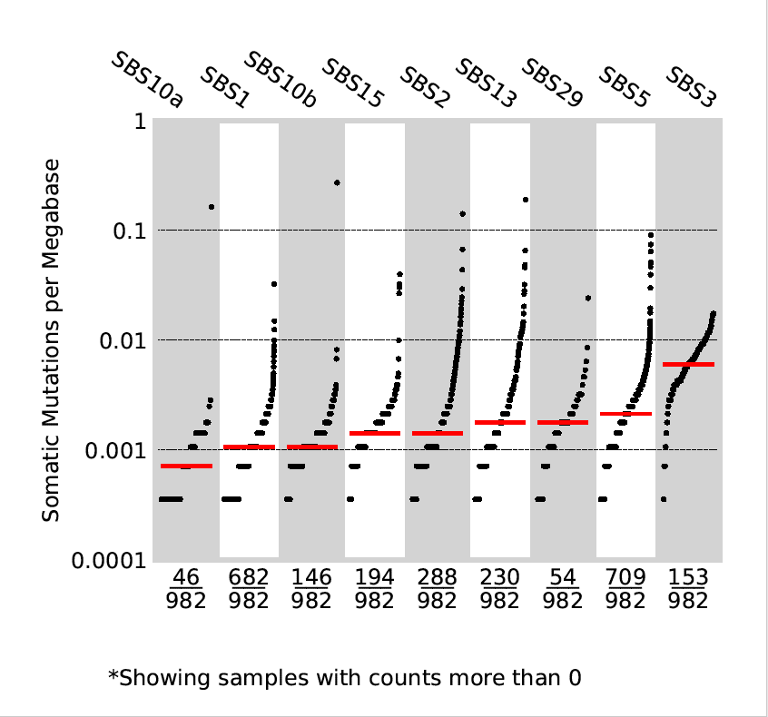

Figure 16 Activities of the signatures when decomposed to COSMIC signatures

Table Kruskal Test

|  |  |  |  |  |  |  |
| --- | --- | --- | --- | --- | --- | --- |
| SigA | SigB | Mean A | Mean B | H-statistic | P-value | Decision |
| SBS3 | SBS10b | 2,89 | 1,34 | 2,76 | 0,096 | Rank medians similar |
| SBS3 | SBS15 | 2,89 | 1,337 | 0,994 | 0,32 |
| SBS10b | SBS29 | 0,58 | 0,377 | 0,9115 | 0,3397 |

Table 6 Kruskal Test between signatures of TSS and TTS R-loops

|  |  |  |  |  |  |  |
| --- | --- | --- | --- | --- | --- | --- |
| TSS-DRIP | TTS-DRIP | Mean TSS | Mean TTS | H-statistic | P-value | Decision |
| SBS1 | SBS1 | 0,516 | 0,554 | 0,097 | 0,754 | Rank medians similar |
| SBS2 | SBS2 | 0,542 | 0,794 | 0,189 | 0,663 |
| SBS5 | SBS5 | 1,234 | 1,739 | 1,972 | 0,160 |

Table 7 Kruskal Test between signatures of TSS and TTS outside of R-loops

|  |  |  |  |  |  |  |
| --- | --- | --- | --- | --- | --- | --- |
| TSS | TTS | Mean TSS | Mean TTS | H-statistic | P-value | Decision |
| SBS13 | SBS13 | 1,78 | 3,16 | 3,22 | 0,072 | Rank medians similar |
| SBS15 | SBS15 | 1,05 | 1,33 | 0,006 | 0,935 |