**Problem:**

Cross-section drawings in Civil 3D do not display vertical labels based on code sets for reference axes for offset or more lanes.

The labels are displayed on the straight sections of the corridor/axis.  
  
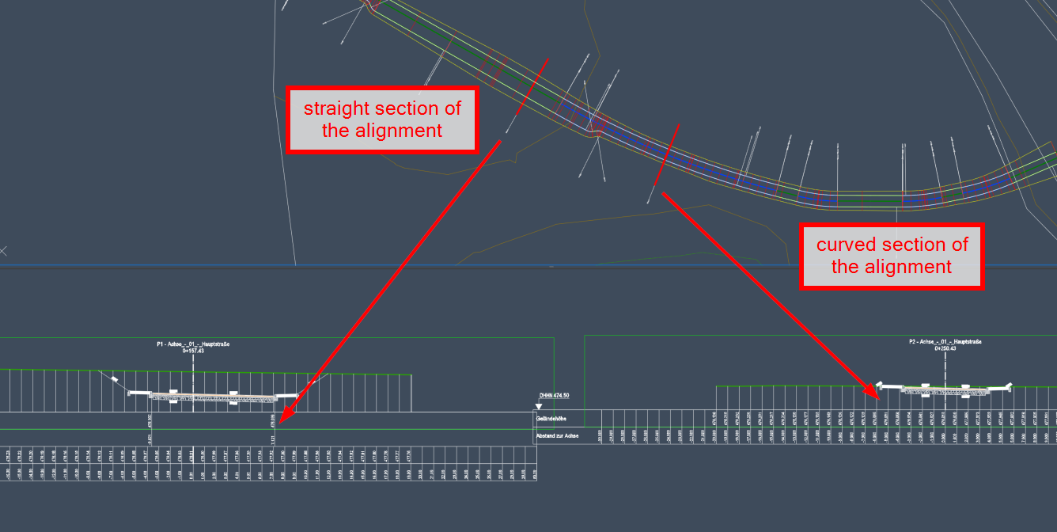

**Causes :**

Product limitation : cross-section drawing labels are only displayed if the tab is orthogonal.

In curves, the offset axis or the axis of the second corridor is not orthogonal.

**Solution :**

There are possible workarounds.

1. A second corridor in the sectional view : How to add offset reference axes with labels to a cross-section drawing in Civil 3D
2. Using reference axes for offset in the same corridor : Corridor labels in the cross-section drawing do not work with additional base lines in the corridor