A highly motivated software engineering student seeking an internship in a dynamic and challenging environment where I can apply my skills and knowledge to real world projects.

Tunisia, carthage

+21628719397

alamdalla11@gmail.com

**EDUCATION**

**CONTACT**

**PROFILE**

**AlaMdalla**

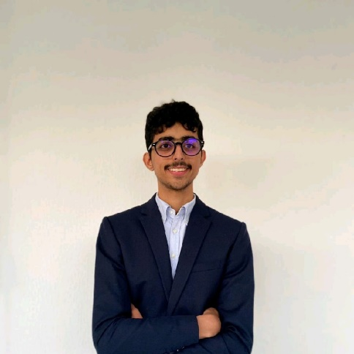

Baccalaureate (Mathematics) 2020-2021  
Carthage Byrsa  
  
Software Engineer (2nd year) 2021-2023  
Esprit: The Private Higher School of Engineering and Technology

**TECHNICAL SKILLS**

391-mail4.png

•Programming Languages: HTML, CSS, PHP

JavaScript, C++, C

• Database Management: MySQL

• Version Control Systems: Git

• Adobe Photoshop, Adobe Premiere Pro,

Adobe illustrator, After effects

067-phone.png

**EXPERIENCE**

001-home.png

202-sphere.png

**Summer Intern**

Tunisair

During my experience in the network branch in Tunisaire, I gained knowledge in Cisco systems, expanding my skills in networking and learning about Cisco technologies.

alaeddinecv.000webhostapp.com

**HOBBIES**

016-camera.png

Music

Photography

018-music.png