**PROFILE**

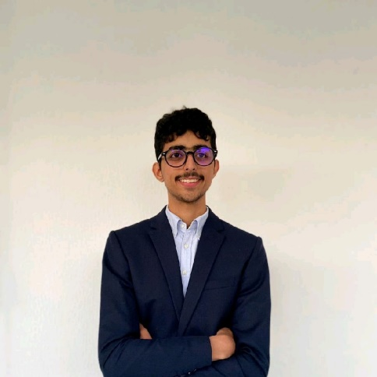

**Alaeddine Mdalla**

**EDUCATION**

Software Engineer (2nd year) 2021-2023  
Esprit: The Private Higher School of Engineering and Technology

Baccalaureate (Mathematics) 2020-2021  
Carthage Byrsa

A highly motivated software engineer student seeking an internship in a dynamic and challenging environment where I can apply my skills and knowledge to real world projects.

**TECHNICAL SKILLS**

**CONTACT**

067-phone.png391-mail4.png

•Programming Languages: HTML, CSS, PHP

JavaScript, C++, C

• Database Management: MySQL

• Version Control Systems: Git

• Adobe Photoshop, Adobe Premiere Pro,

Adobe illustrator, After effects

+21628719397

alamdalla11@gmail.com

001-home.png

Tunisia, carthage

202-sphere.png

**EXPERIENCE**

alaeddinecv.000webhostapp.com

202-sphere.png

github.com/AlaMdalla

**Summer Intern**

August 2022

Tunisair

During my experience in the network branch in Tunisair, I gained knowledge in Cisco systems, expanding my skills in networking and learning about Cisco technologies.

**HOBBIES**

018-music.png016-camera.png

Music

Photography

**Projets**

**The time jumper**

2D game with SDL 1.2 is a C library for coding graphical applications, while Photoshop is used for editing pictures

**Avanti**

I developed a website using Bootstrap, HTML,Api, CSS, JavaScript, PHP, and MySQL, combining the power of these technologies to create a visually appealing and dynamic web experience with database functionality