**Ala’Younis**

## Personal information:

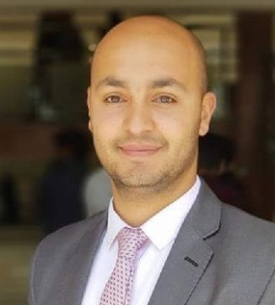

Name: Ala’ Khaled Mahmoud Younis

Nationality: Jordanian

Date of Birth: 26/4/1996

Place of Birth: Amman, Jordan.

Marital status: Single

## Objective:

Developer looking for a position, where I can learn new technologies, And sharpen my skill in problem solving.

## Experience:

1. **B12 Company, Gathering requirements.**
2. **User Interface Testing, June2018.**

## Education:

**Bachelor of Software Engineering**

**AL ZAYTOONAH UNIVERSITY OF JORDAN, Degree: Very Good.**

## Courses:

* **Web designing and development**

1. HTML,CSS, JAVASCRIPT,BOOTSTRAP, Aptech institute computer education Bangalore, India.

* **English Language Course**, Valuepoint Academy, India.

1. **English: Very good**

* **Programming in C# and Unity, English language, and Soft Skills by Al Hussein Technical University, April 2019 .**

## Skills

* Gathering requirements.
* Problem solving.
* Communication skills.
* Hard Worker.
* Team working.

## Contact Details:

**Email:** alaa10younis@gmail.com

**Address:** Al Mouqabalayn, Amman Jordan

**Phone :**00962 795109199