**Name :** Alaa Ayman Hassan Ali Mohamed

**B.N./** 196

**Topic :** Artificial intelligence

**Github-link :** <https://github.com/Alaa-2001-art/ECE001>

**Github- page** **(published website) :** <https://alaa-2001-art.github.io/ECE001/>

**Application Brief :** we use Artificial intelligence because it has many benefits and we will talk about it from SIRI to self-driving cars, artificial intelligence (AI) is progressing rapidly. While science fiction often portrays AI as robots with human-like characteristics, AI can encompass anything from Google’s search algorithms to IBM’s Watson to autonomous weapons. Artificial intelligence today is properly known as narrow AI (or weak AI), in that it is designed to perform a narrow task (e.g. only facial recognition or only internet searches or only driving a car). However, the long-term goal of many researchers is to create general AI (AGI or strong AI). While narrow AI may outperform humans at whatever its specific task is, like playing chess or solving equations, AGI would outperform humans at nearly every cognitive task.

And nowadays Artificial intelligence is safe as in the near term, the goal of keeping AI’s impact on society beneficial motivates research in many areas, from economics and law to technical topics such as verification, validity, security and control. Whereas it may be little more than a minor nuisance if your laptop crashes or gets hacked, it becomes all the more important that an AI system does what you want it to do if it controls your car, your airplane, your pacemaker, your automated trading system or your power grid. Another short-term challenge is preventing a devastating arms race in lethal autonomous weapons.

**Screenshots :** 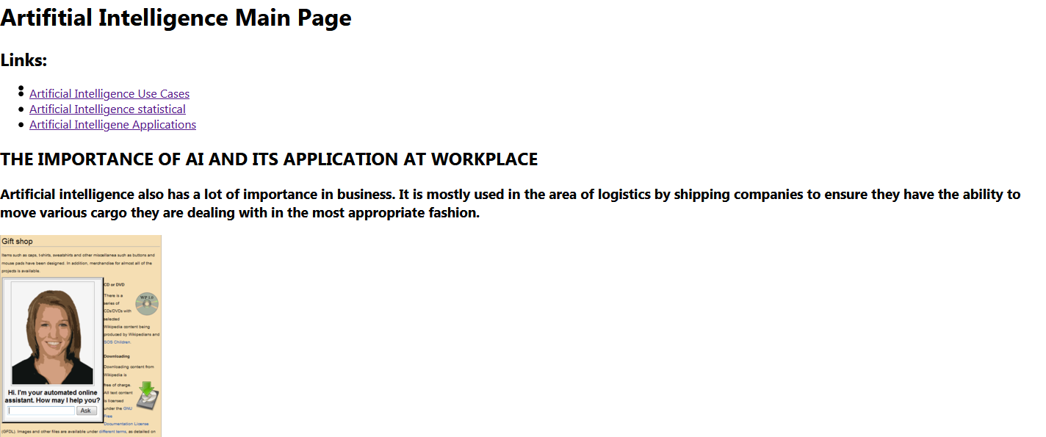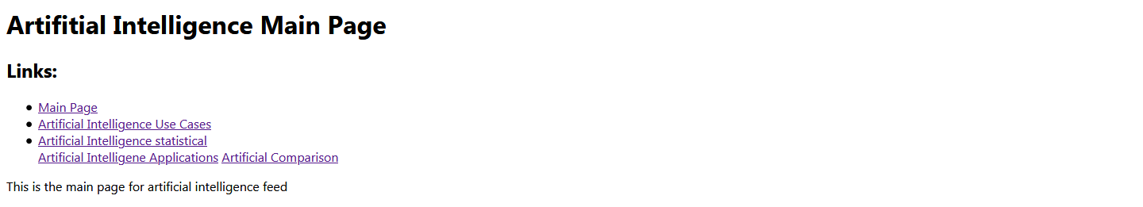

**Source code :** 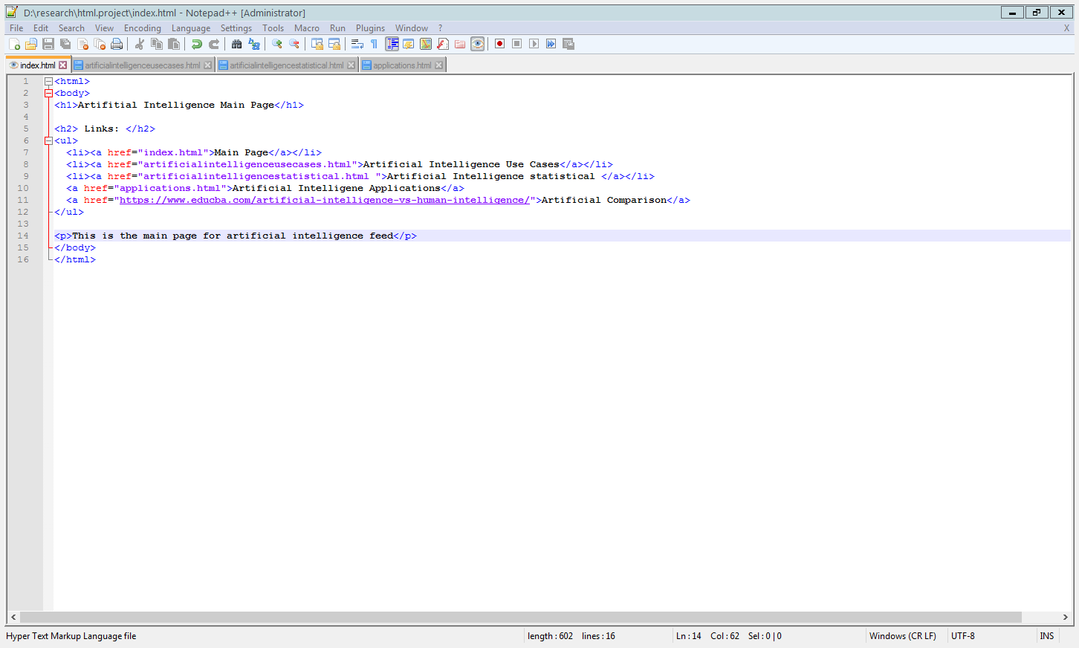

**References:**

* Ryszard S. Michalski, John R. AndersonComputer ScienceSymbolic computation1984
* J. CopelandComputer Science1993
* Fadillah Ismail1 , Adnan Ali Hassan al Hosaini2 ,Chan Shiau Wei3 , Rumaizah Ruslan4 , Khadijah Maulad Bahrol5 1,2,3,4,5Faculty of Technology Management and Business, University Tun Hussein Onn Malaysia