Task Day1 Bash

1. Task Search
2. **change file lp to mylp**

* **use while loop**

awk  -F : '

BEGIN{i=1;}

{

  i=1;

  while(i<=NF){

    #1 ,2 ,3 $1 $2 $3

    if($i == "lp"){

      $i="mylp"

    }

    i=i+1

  }

  print $0  #i=8

}' /etc/passwd

* **use gsub**

awk  -F : '

{

  #gsub(/\blp\b/,"mylp")

gsub(/lp/,"mylp")     # gsub(/ \b filenameold \b /, "filenamenewchange")

  print $0

}' /etc/passwd

1. **Valriable outside awk to show inside awk**

* **use -v**

myvar="hello"

awk  -v var="$myvar" 'BEGIN

{

  print "the variable is :",var

}'   #output=>the variable is : hello

* **use ENVIRON**

export myvar="hello"

awk 'BEGIN

{

  print "the variable is :",ENVIRON["myvar"]

}'   #output=>the variable is : hello

* **use echo/cat**

myvar="hello"

echo "any data here " | awk '{

  print "the variable is :",v

}'

v="$myvar"

 #output=>the variable is : hello

* **use “ or ‘**

myvar="hello"

awk '{

  print "the variable is :","'"$myvar"'"

}'

 #output=>the variable is : hello

1. Task pdf
2. **Using sed utility**
3. **Display the lines that contain the word “lp” in /etc/passwd file.**

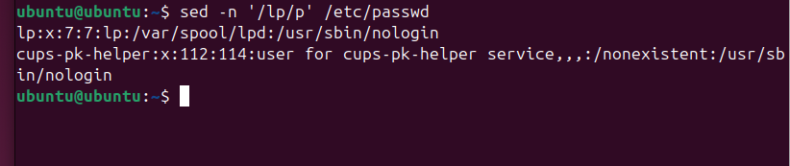

1. **Display /etc/passwd file except the third line.**

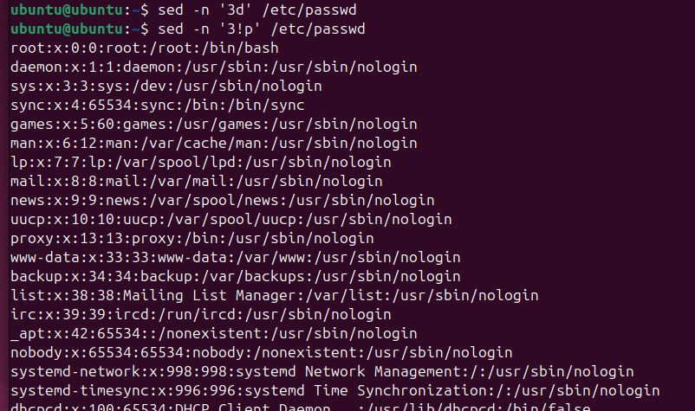

1. **Display /etc/passwd file except the last line.**

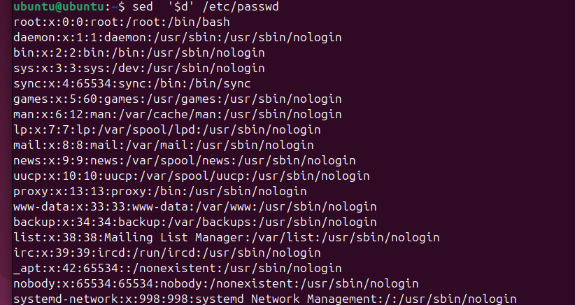

1. **Display /etc/passwd file except the lines that contain the word “lp”.**

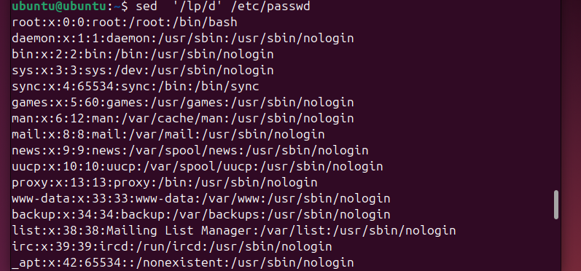

1. **Substitute all the words that contain “lp” with “mylp” in /etc/passwd file.**

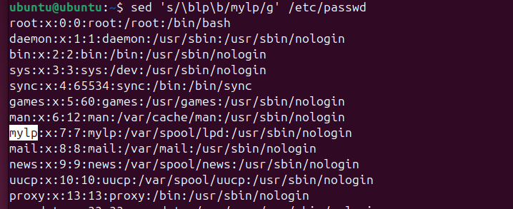

1. **Using awk utility**
2. **Print full name (comment) of all users in the system.**

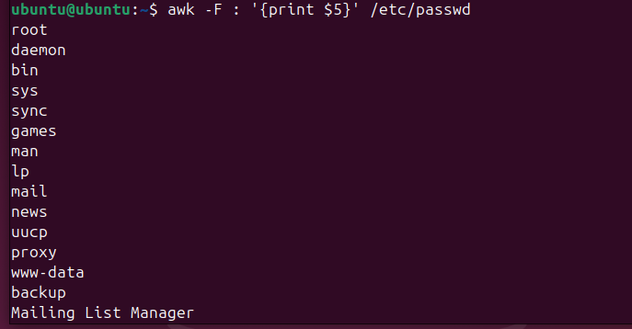

1. **Print login, full name (comment) and home directory of all users.( Print each line preceded by a line number)**

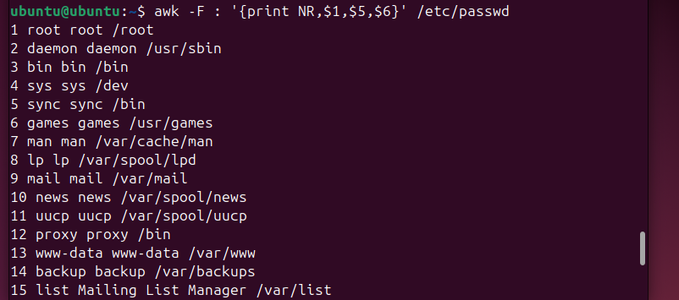

1. **Print login, uid and full name (comment) of those uid is greater than 500**

* **Using if**

awk  -F : '{

if($3>500)

{

print $1,$3,$5

}

}'  /etc/passwd

* **Without if**

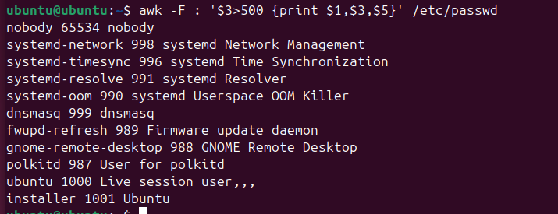

1. **Print login, uid and full name (comment) of those uid is exactly 500**

* **Using if**

awk  -F : '{

if($3==500)

{

print $1,$3,$5

}

}'  /etc/passwd

* **Without if**

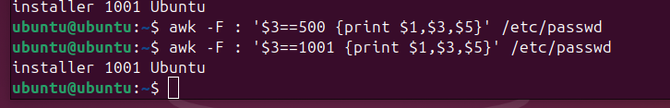

1. **Print line from 5 to 15 from /etc/passwd**

* **Using if**

awk  -F : '{

if(NR>=5 && NR<=15)

{

print $0

}

}'  /etc/passwd

* **Without if**

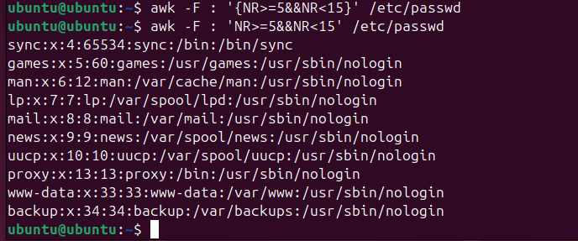

1. **Change lp to mylp**

* **Using while**

awk  -F : '

BEGIN{i=1;}

{

  i=1;

  while(i<=NF){

    if($i == "lp"){

      $i="mylp"

    }

    i=i+1

  }

  print $0

}' /etc/passwd

* **Without while**

awk  -F : '

{

  gsub(/lp/,"mylp")

  print $0

}' /etc/passwd

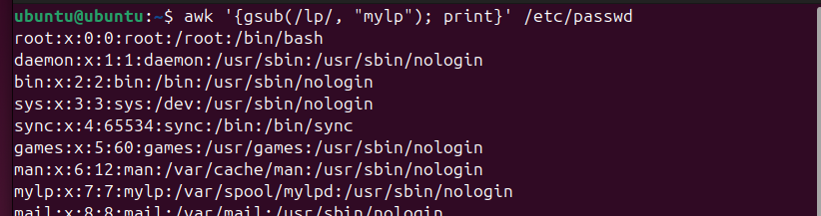

1. **Print all information about greatest uid.**

* **Using if**

awk 'BEGIN { FS=":";max=0;line='';print "start"}

{

if($3>max)

{ max=$3

line=$0

}

}

END {print line ,"End"}'  /etc/passwd

**8- Get the sum of all accounts id’s.**

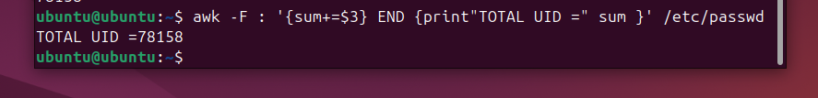

Bonus

* **Get the sum of accounts id’s that has the same group.**

awk -F: '{

    if ($4 in sumuid)

        sumuid[$4] += $3;

    else

        sumuid[$4] = $3;

}

END {

    for (gid in sumuid) {

        print "groupid=", gid, "Total sumuid=", sumuid[gid];

    }

}' /etc/passwd

