**Connections**

**Components:**

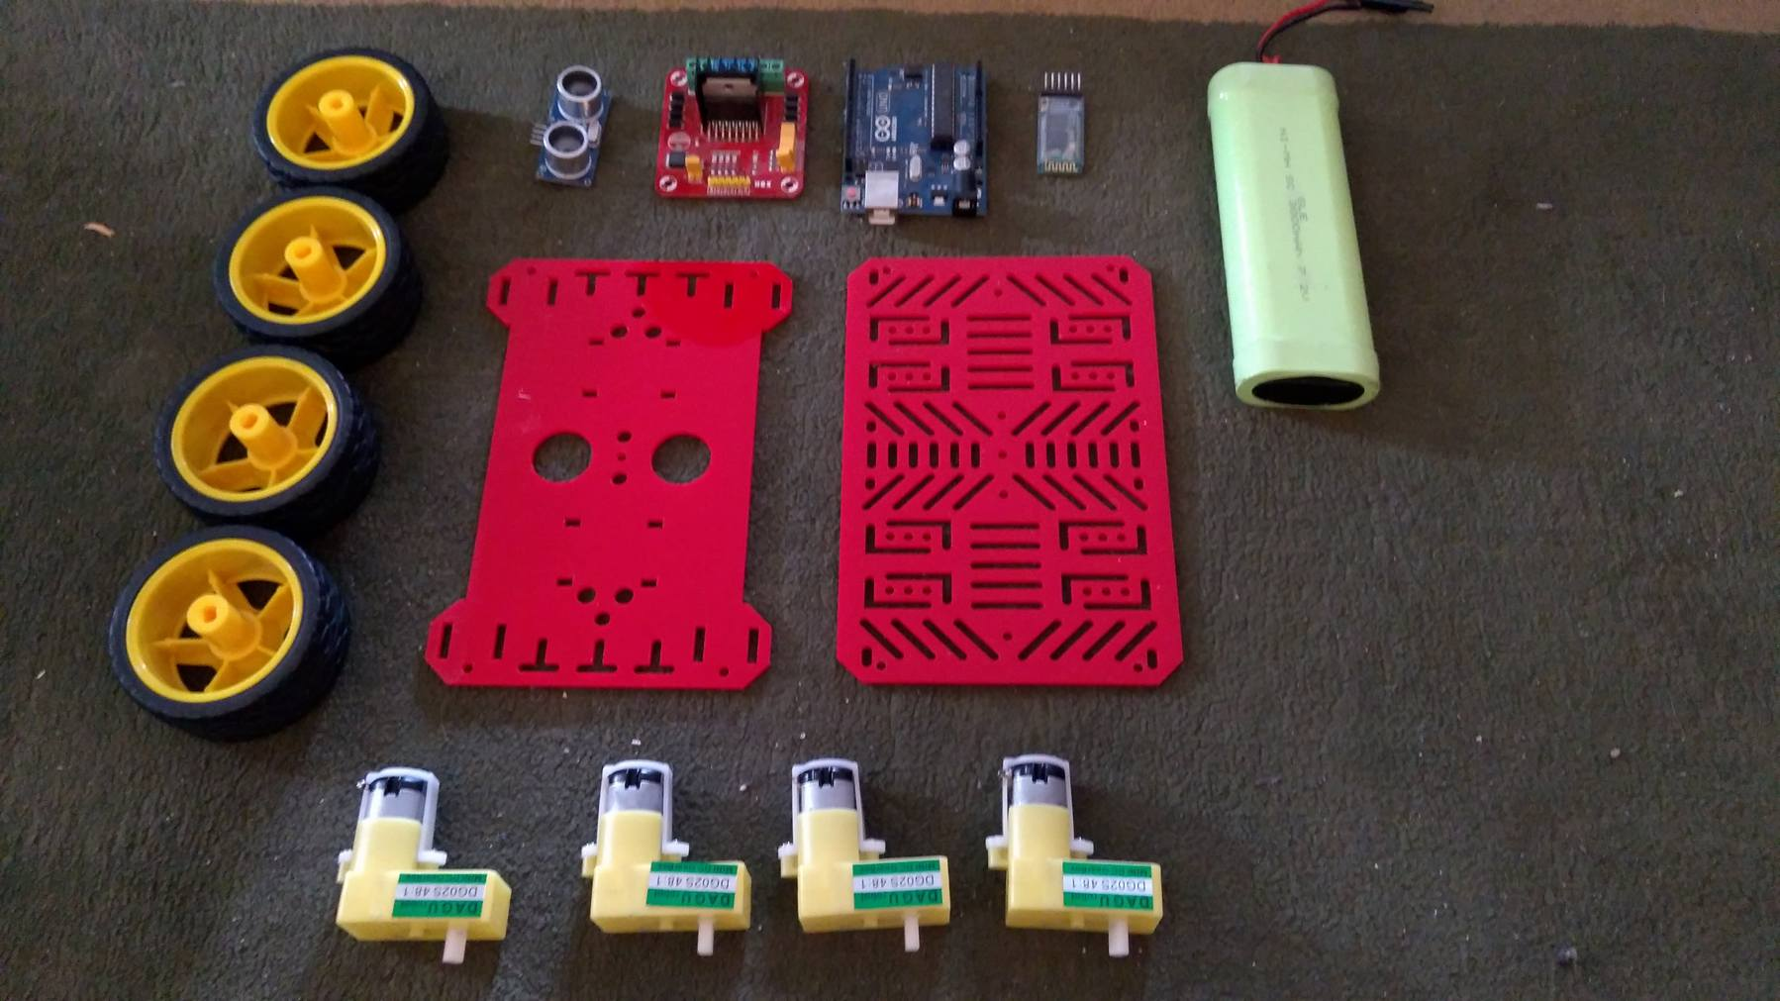

1. Motor Drive:

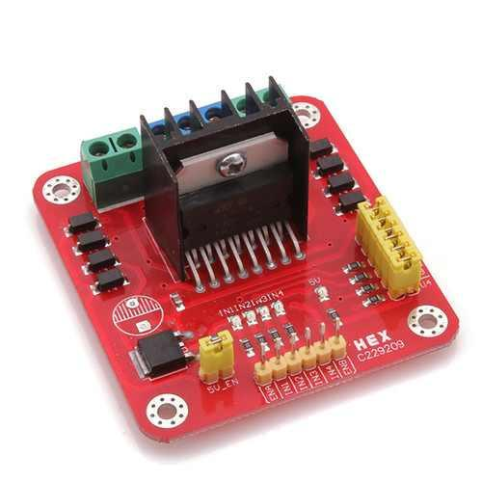

Motor A:

ENA 🡪 pin 9

IN1 🡪 pin 6

IN2 🡪 pin 7

Motor B:

ENB 🡪 pin 10

IN3 🡪 pin 11

IN4 🡪 pin12

1. Ultrasonic:

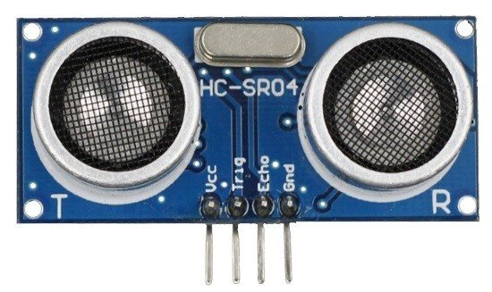

Echo 🡪 pin 3

Trig 🡪 pin 5

1. Bluetooth Module (HC-05):

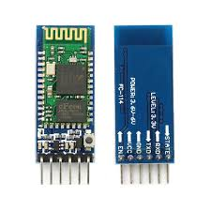

Rx 🡪 Tx

Tx 🡪 Rx

State 🡪 pin 2

1. Line Follower:

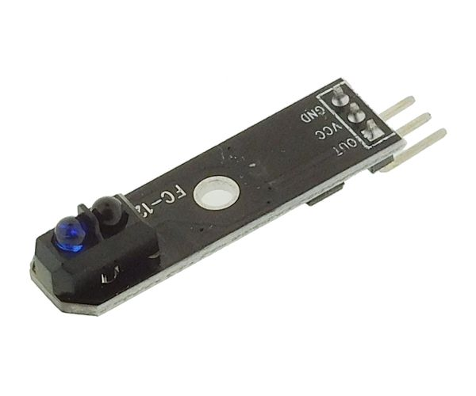

Sensor 1 (Center):

Out 🡪 pin 8

Sensor 2 (Right):

Out 🡪 pin 4

Sensor 3 (Left):

Out 🡪 pin 13