AdminLinux_Task6

Section 1:
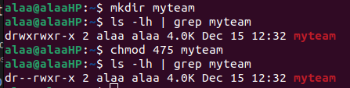
1.

2. & 3.
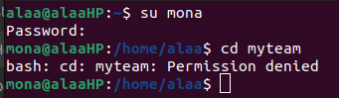

4.
a.
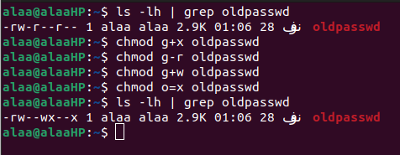

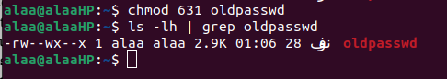

b.
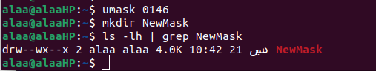

c. The maximum permissions a file can have by default when first created is 666, while the maximum permissions a directory can have is 777.

d.
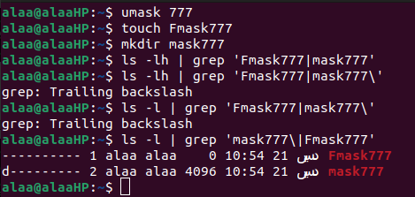

e. Neither the owner of the file/directory nor the sudors can access the file/folder, but they can open the file using text editors but can’t save the changes unless they use force flag like :wq!For example.
But they can’t read the file/directory, or execute them. However, the root can read and execute the file/directory, but can’t write to them.
The owner trying to write in the file:
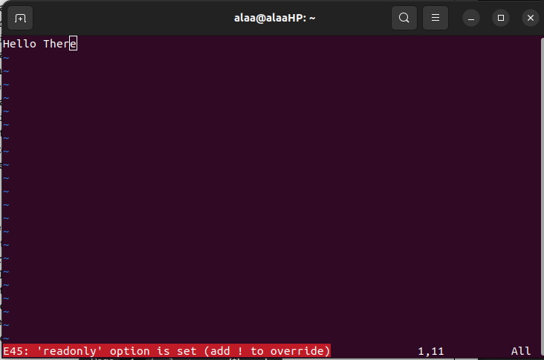
The root trying to write in the file:
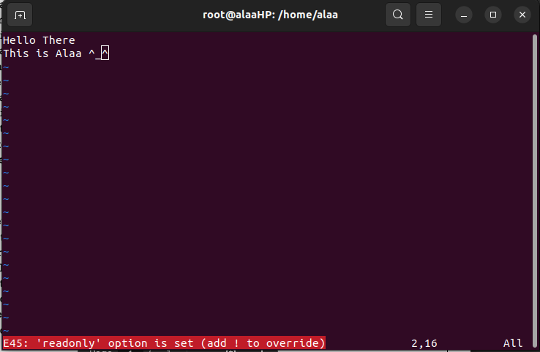
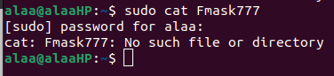

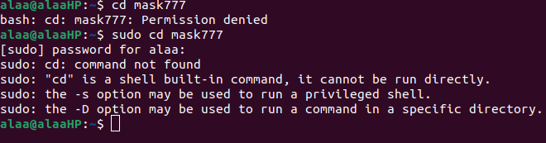
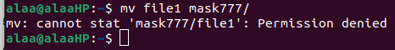

The root reading and executing the file:
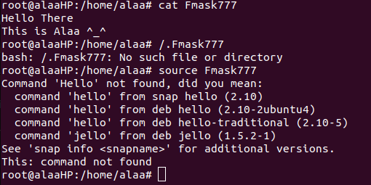

5.
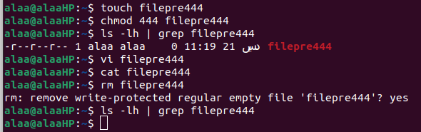
I can’t edit the file or remove it, because it is protected and I have no permissions for doing this.
However I can do it in another way.

6. The executing permission of the file allows to execute the content of the file, while executing permission of a directory allows to change the working directory to this directory or pass through it, it also allows to look at extended information on files in the directory (bu using ls -l).

Section 2:
1.
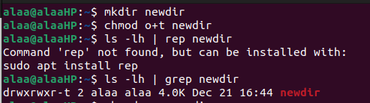

2.
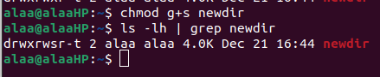

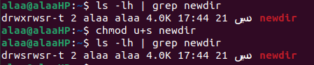

3.
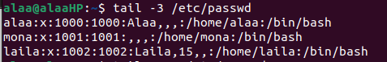

4.
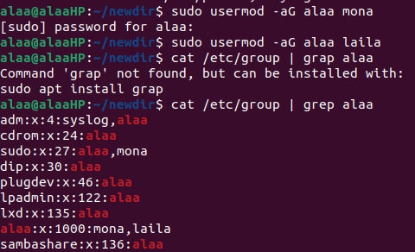

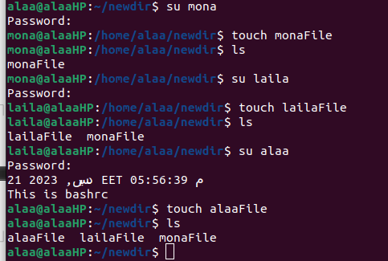

5. & 6.
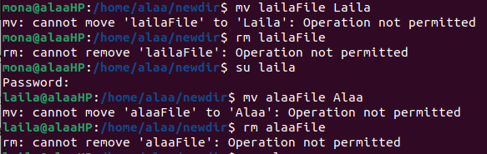
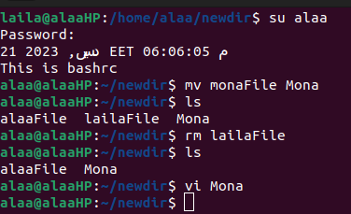

7.
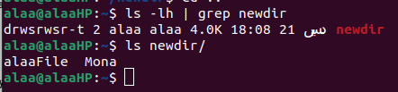

List the permission passwd command has and explain why it has S
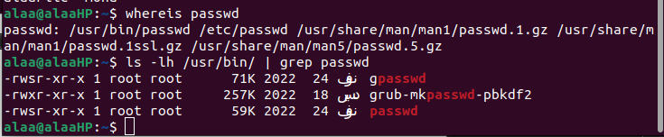
The s in the permissions of the command passwd refers to the setuid special command, which used to allow any user to execute the file as the owner of the file. This permission is used here to allow all the users to run this command as the owner which is the root here.

