AdminLinux_Task5
Section 2

Q1:
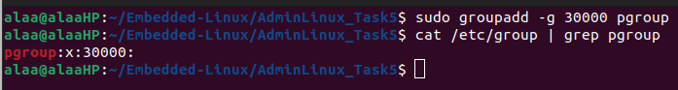
Q2:
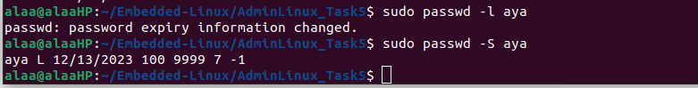
L is for Locked.

Q3:
Q4:
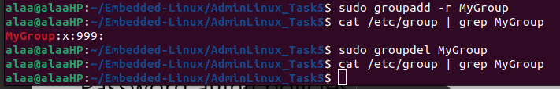
Q5:
useradd:
It is a low-level, portable command available on all Linux distributions. It requires various options to add and set up an active user account, and allows changing default values for the user creation process. After creating the user with the useradd command without using any options with it, the user then requires additional setup with the passwd command to use the account.

adduser:
It is a higher-level (high-level wrapper written in Perl and is a front-end for useradd) and not available on all Linux distributions. Running this command creates an active user account on the system. It creates a home directory, adds the default shell as Bash, and prompts the user to enter a password to unlock the account.

However, the command doesn’t provide much control over the user creation details
