AdminLinux_Task3
Section 2:
Q1:

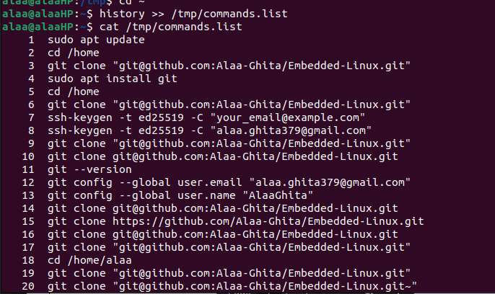

Q2:

The .profile file has been edited, but the changes didn’t appear.

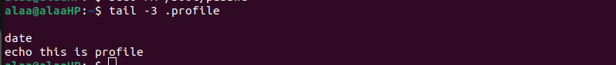

Q3:
The wc command shows the number of lines, words, characters, or bytes in a file or an output of another command.


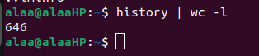

Q4:
a. It shows the content of filename2 only.

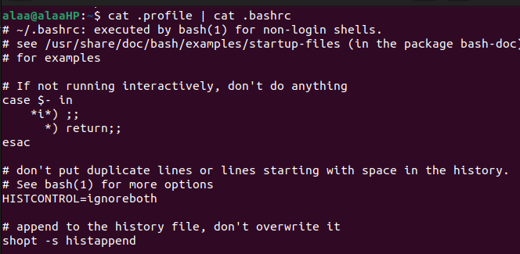

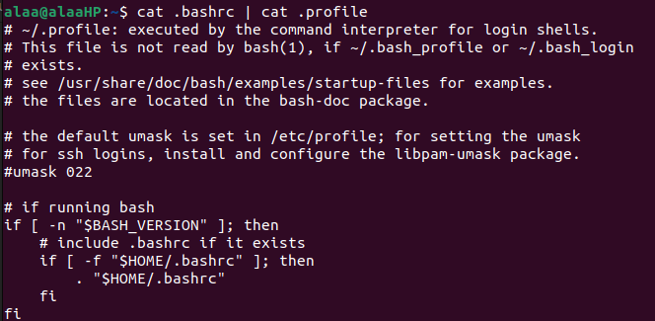

b. Only the rm command will execute and remove the file
c. It only displays the number 1, because ls is used to list the content of a directory not a file, and /etc/passwd is a file so it displays the directory this file only, which is in one line.
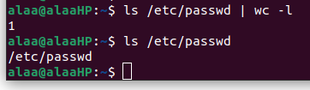

Q5:
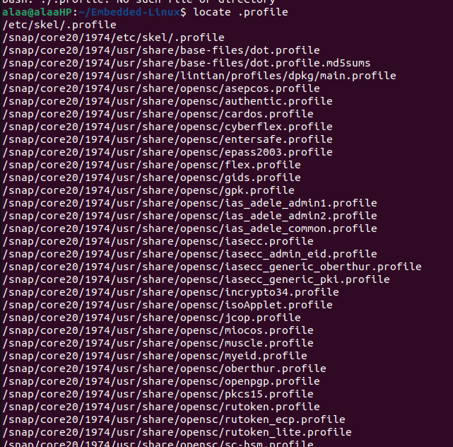

Q6:

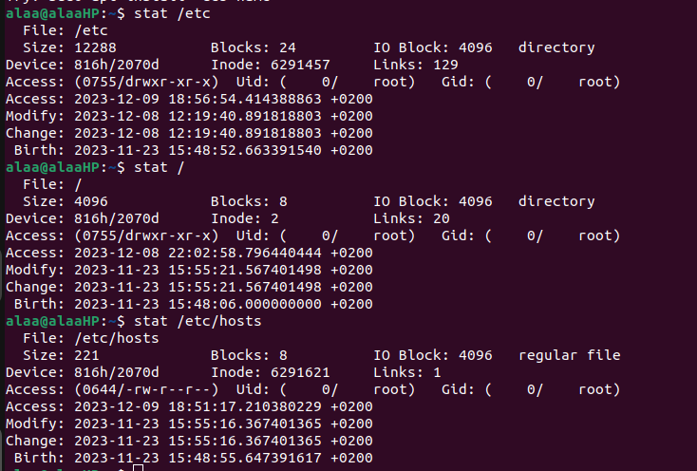
Q7:

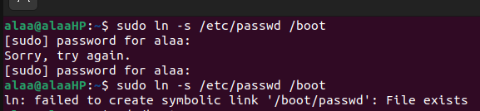
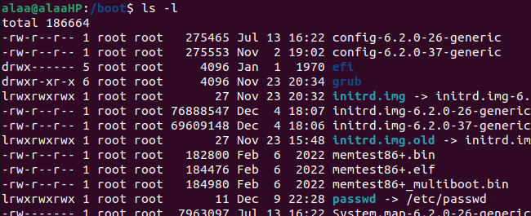

Q8:
No, operation not permitted. But can make it using sudo.
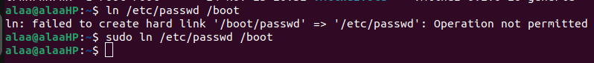
Q9:
(In progress ...)

