Script exercise exam G3

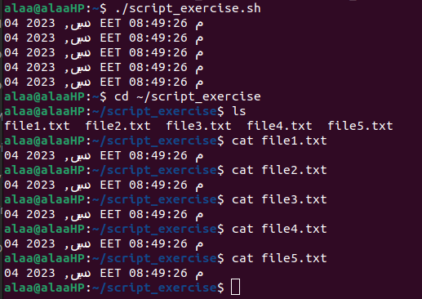
The output of running the script file:

