Embedded Linux Task1

Static linking:
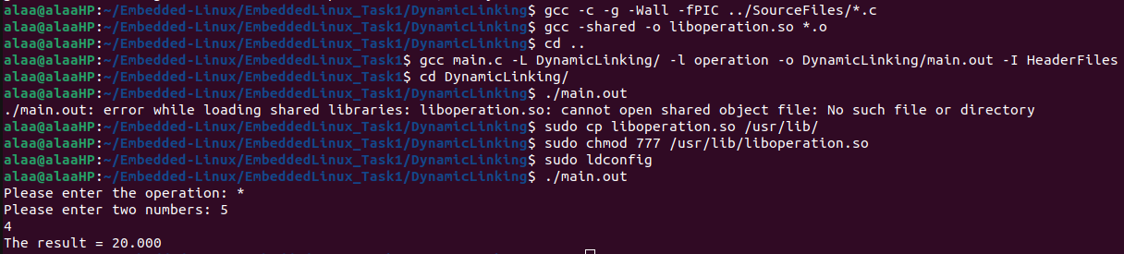
Dynamic linking:

Differences:
using ldd command:
ldd with the elf file that was dynamically linked shows the libraries that the files uses. While with the elf file that was statically linked it simply displays that the file is not dynamic.
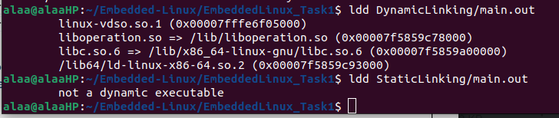
Using file command:
It simply shows if the elf file is dynamically or statically linked along with other information.
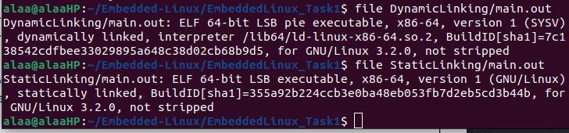
Using objdump command:
In the dynamic linking there are some variables that are undefined, while in the static linking all the variable are absolute.

