Admin Linux Task2

Q1:4:

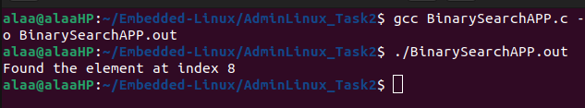

Q2:
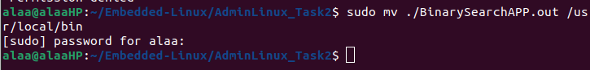
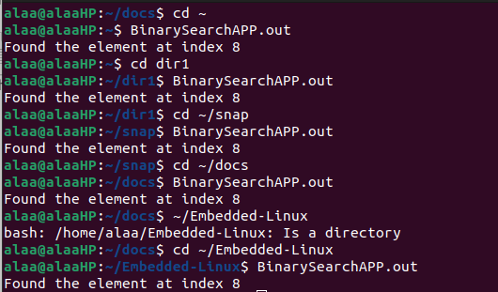

usr/local/bin contains the executable programs that are not managed by a distribution package. And this directory is assigned in the PATH global variable which lists directories where executable programs are located.
