Na2na2a

1.
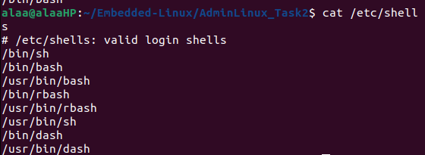
2.
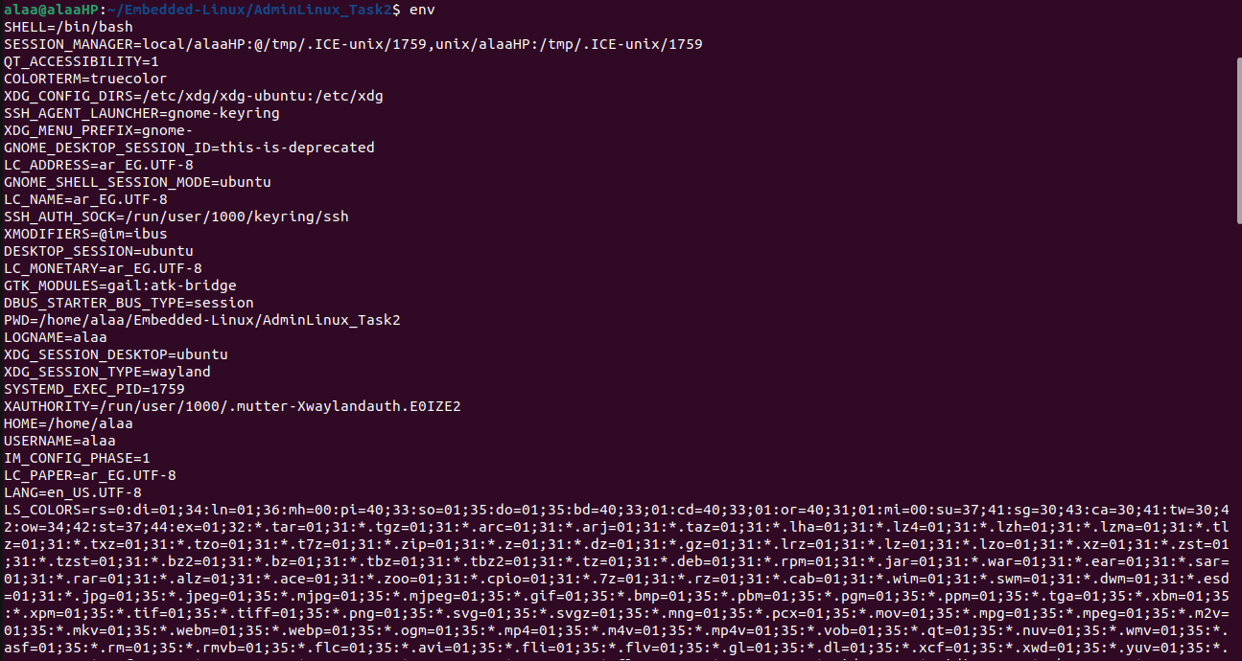
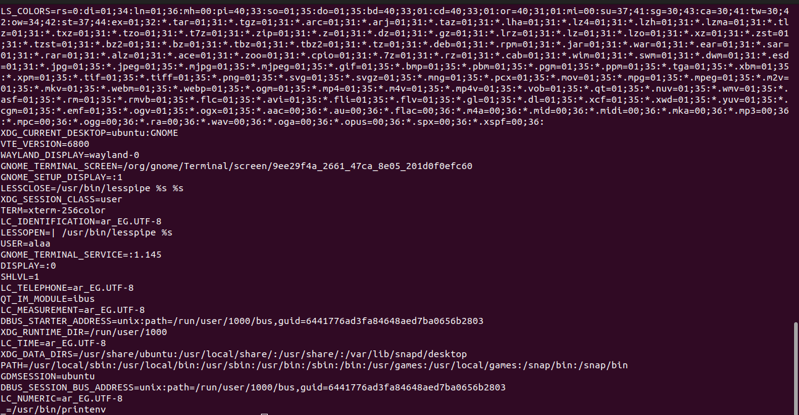

3.
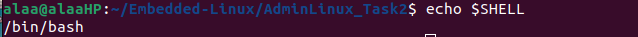

4.
The backward slash is used to connect the current line to the next line, thus allow to write command in more then one line.

5.

