Embedded Linux Task 1

Q1:
Linux Distributions:
1-ubuntu
2-Red Hat
3-dedbian

Q2:
man command:
It is a system-wide documentation system that provides short reference manuals (pages) for individual commands, API functions, concepts, configuration file syntax, file formats and is organized in sections (1 for user commands, 2 for system calls...). That's the traditional Unix documentation system.

Q3:
The difference between rm and rmdir:
rm:
rm removes each specified file. By default, it does not remove directories.

rmdir:
Remove the DIRECTORY(ies), if ther are empty.

Q4:

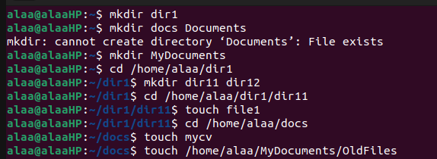

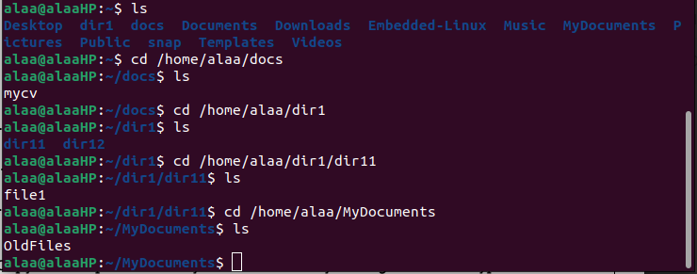

a. Couldn’t remove the directory because it is not empty. To remove a non empty directory we use “rm -r” command.
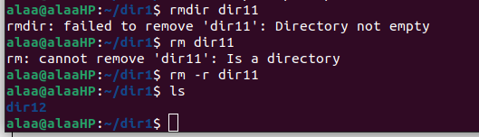

b. The “OldFiles” file couldn’t be removed because “rmdir -p” is used for directories only.

C. The absolute path:
home/user/docs/mycv
The relative path:
docs/mycv

Q5:

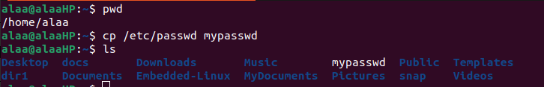

Q6:
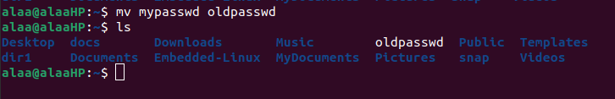

Q7:
- cd
- cd ~
- cd $HOME
- cd home/user
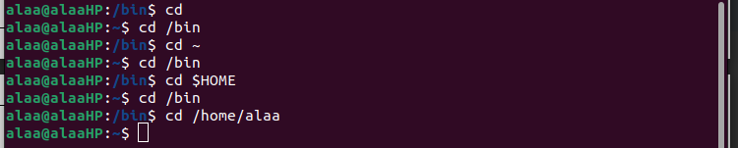

Q8:

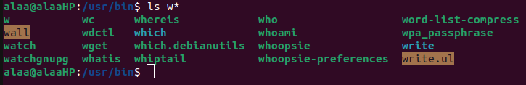

Q9:
Command type is used to display information about command type.

Q10:
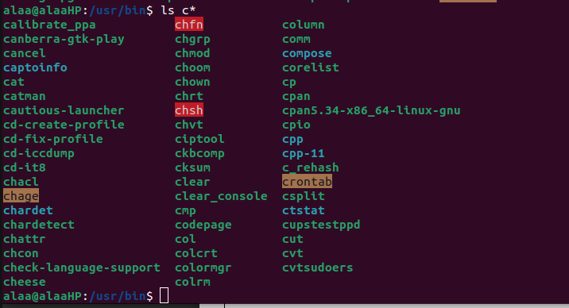

Q11:

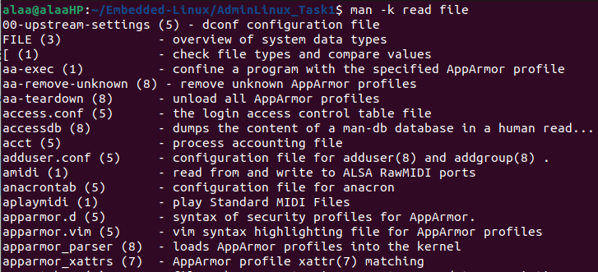
Q12:

Search the manual age names and descriptions

