**Research Project**

**Name:** Alaa Mostafa Arafa Afifi Lasheen

**B.N:** 200

**Date**: 31/5/2020

**Topic:** Artificial Intelligence

**GitHub Link:** <https://github.com/Alaa-Lasheen/ece001>

**GitHub Pages:** https://alaa-lasheen.github.io/ece001/

*Artificial Intelligence*

Artificial Intelligence (AI) in computer science is called machine intelligence, It is intelligence demonstrated through machines, in comparison to the natural intelligence displayed by human beings and animals.

Leading AI textbooks define the field as the studying of "intelligent agents": any device that perceives its environment and takes moves that maximize its chance of successfully achieving its goals. Colloquially, the term "artificial intelligence" is regularly used to describe machines (computers) that mimic "cognitive" functions that human beings associate with the human mind, such as: learning and problem solving.

*The applications of Artificial Intelligence*

Artificial Intelligence has different applications. AI is making our life more comfortable and faster. It is becoming necessary for today's time because it can solve complicated problems with an efficient way in: Business, Healthcare, Autonomous vehicles, Education, and robotics. Humanoid Robots are best examples for AI in robotics, these days the intelligent Humanoid robot named as Erica and Sophia has been evolved which behave like humans.

AI in the future may be work as a personal virtual tutor for students, to be able to be accessible easily at anytime and anyplace. AI may be very beneficial to solve complicated universe problems. AI technology may be useful for understanding the universe inclusive of the way it works, origin, and so on.

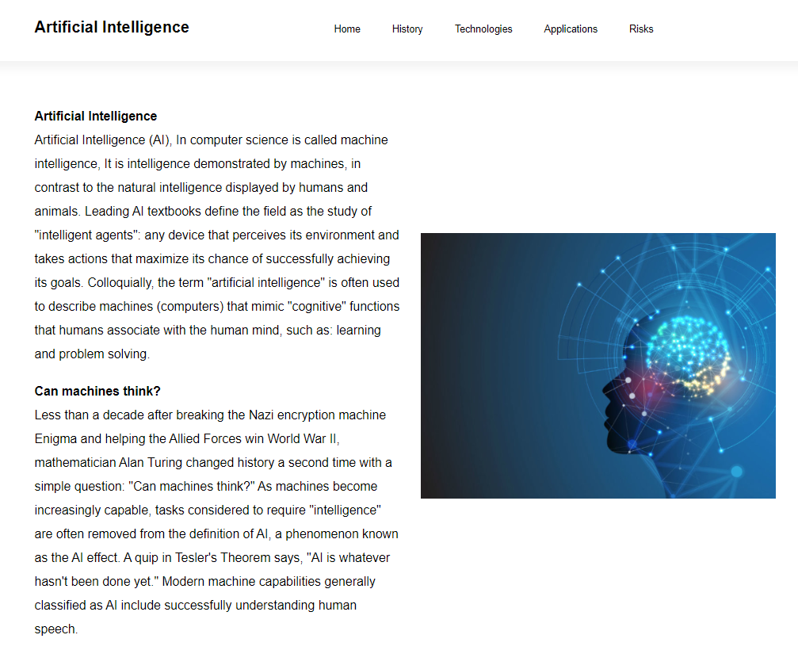***Screenshots:***

***Source Code:***

