## Gallery Instructions:

## 

You can either draw a new image by choosing ‘Paint Brush’ from ‘File’ menu and save it on your desktop or using an existing image by adding it to your Gallery.

* **How can I add a new image?**

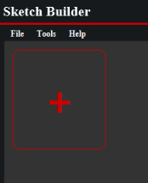

Option 1: Click the add button, and choose one or more image that you want to add from the open dialog, then press ok.

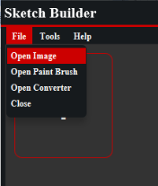

Option 2: Choose ‘Open Image’ from ‘File’ menu, and choose one or more image that you want to add from the open dialog, then press ok.

* **How can I modify an image?**

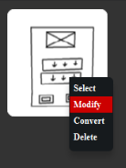

Option 1: You can press ‘Right click’ on the image you want to modify and press ‘Modify’ or select the images you want to modify if they are more than one by pressing ‘Right click’ on everyone and choose ‘select’ then press ‘Right click’ again to choose ‘Modify Selected’, and it/they will be opened on the Paint Brush to edit.

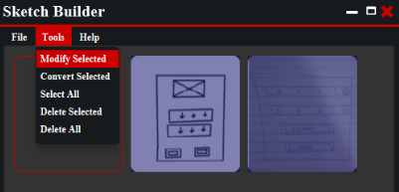

Option 2: Select one or more image you want to modify by pressing ‘Right click’ on it/them and choose ‘select’, then choose ‘Modify Selected’ from ‘Tools’ menu, and it/they will be opened on the Paint Brush to edit.

* **How can I delete an image?**

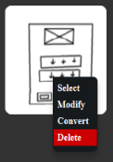

Option 1: You can press ‘Right click’ on the image you want to delete and press ‘Delete’ or select the images you want to delete if they are more than one by pressing ‘Right click’ on everyone and choose ‘select’ then press ‘Right click’ again to choose ‘Delete Selected’.

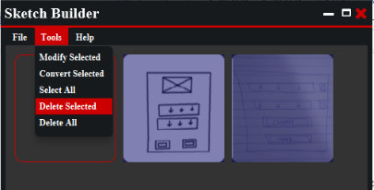

Option 2: Select one or more image you want to delete by pressing ‘Right click’ on it/them and choose ‘select’, and then choose ‘Delete Selected’ from ‘Tools’ menu.

* **How can I convert an image?**

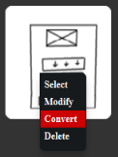

Option 1: You can press ‘Right click’ on the image you want to convert and press ‘Convert’ or select the images you want to convert if they are more than one by pressing ‘Right click’ on everyone and choose ‘select’ then press ‘Right click’ again to choose ‘Convert Selected’.

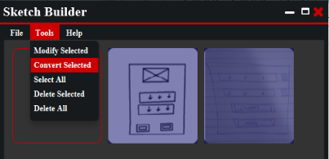

Option 2: Select one or more image you want to convert by pressing ‘Right click’ on it/them and choose ‘select’, and then choose ‘Convert Selected’ from ‘Tools’ menu.

Option 3: Choose ‘Open Converter’ from ‘File’ menu

**Convertor Instruction:**

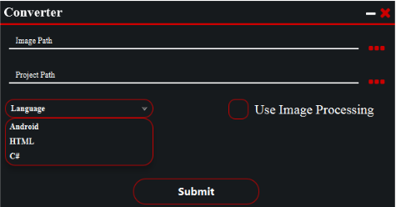

1

2

4

3

5

1. Insert ‘Image Path’ by choosing the one or more image you want to convert from its/their location.

2. Insert ‘Project Path’ by choosing the location you want to save coding file at.

3. Choose the language you want to convert into.

4. Check it if you want to increase the accuracy, but also it would take a little more time.

5. Press ‘Submit’ to start the converting.

The converted file will be ready to use at the location you chose.

**Paint Brush Instructions:**

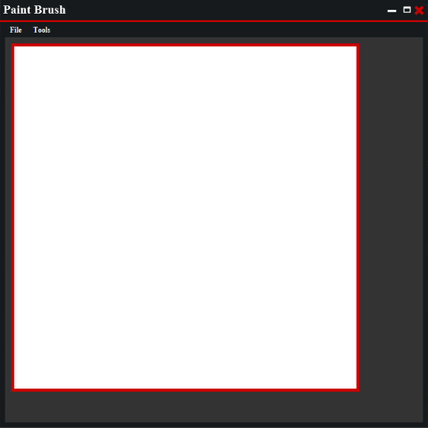

* **How can I save my drawn image?**

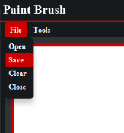

Choose ‘save’ from ‘File’ menu, choose the location you want and press ok.

* **How can I modify an image?**

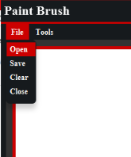

Choose ‘Open’ from ‘File’ menu, choose the image you want to modify and press ok.

**To make it easier for you:**

**In Gallery:**

* You can select all the images in your gallery by choosing ‘Select All’ from ‘Tools’ menu.
* You can delete all the images in your gallery by choosing ‘Delete All’ from ‘Tools’ menu.
* You can view any image by double click it.

**In Paint Brush:**

* You can resize your sketch by grabbing its borders.