**MySQL Labs**

**MySQL (Day1):**

| **1** | **Create a database called grades** |
| --- | --- |
|  | **create database grades;**  **use grades;** |
| **2** | **Create the following tables in the grades database:** |
|  | **create table students**  **-> (student_id int primary key,**  **-> student_name varchar(100) not null,**  **-> email varchar(50),**  **-> tel varchar(20) );**  **create table courses**  **-> (course_id int primary key,**  **-> course_name varchar(100) not null,**  **-> credit_hour int );**  **create table student_courses**  **-> (course_id int,**  **-> student_id int,**  **-> grade int,**  **-> reg_date date);** |
| **3** | **Modify the students table to allow for longer Student names (150 char)**  **Confirm your modification.** |
|  | **alter table students modify student_name char(150) not null;**  **desc students;** |
| **4** | **Add constraint to force unique email for each student** |
|  | **alter table students modify email varchar(50) unique;** |
| **5** | **Get Time, Date, Current user, MySQL Version using prompt?** |
|  | **select now();**  **select user();**  **select @@version;** |
| **6** | **Add gender column for the students table. It holds two value (male or female)** |
|  | **alter table students add gender varchar(10),add constraint check_gender check(gender in ('Female','Male'));** |
| **7** | **Add birth_date column for the students table.** |
|  | **alter table students add birth_date date;** |
| **8** | **Drop the student_name column and replace it with first name and last name.** |
|  | **alter table students drop column student_name;**  **alter table students add column(first_name varchar(20),last_name varchar(20) );** |

**Part II**

**Populate your tables with the following records:**

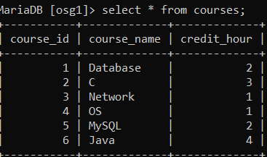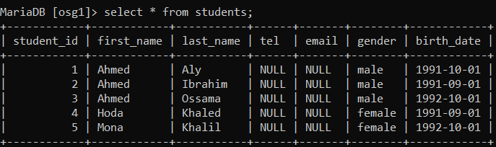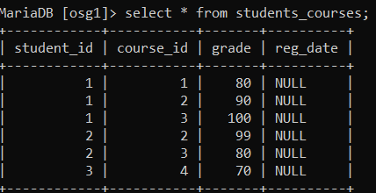

| **1** | **Display all students’ information.** |
| --- | --- |
|  | **select * from students;** |
| **2** | **Display male students only.** |
|  | **select * from students where gender = 'male';** |
| **3** | **Display the number of female students.** |
|  | **select count(case when gender ='female' then 1 end) as 'number of females' from students;** |
| **4** | **Display the students’ data for the students who are born before 1992-10-01.** |
|  | **select * from students where birth_date<=cast('1992-10-01' as date);** |
| **5** | **Display the students’ data for the students who are born after 1991-10-01.** |
|  | **select * from students where birth_date>=cast('1991-10-01' as date);** |