Lab 2

1. Configure apache to use Worker MPM

check mpm enabled module :

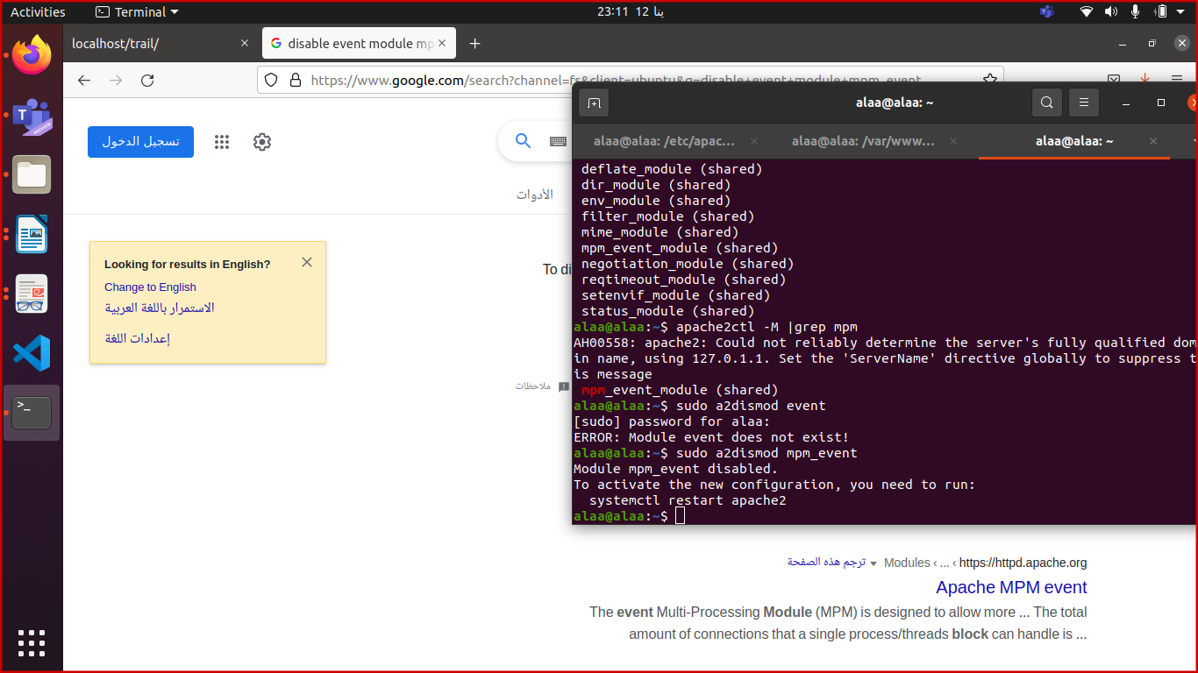

disable event module

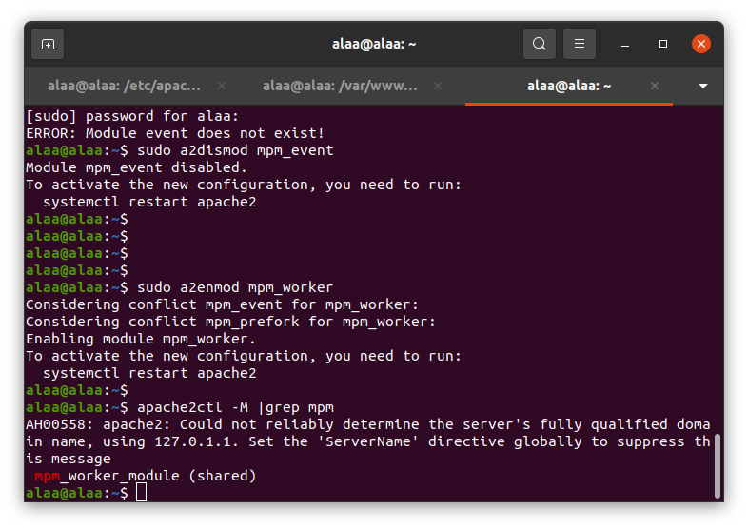

enable worker module :



check if it was enabled ?



2. Check the status of rewrite_mod and enable it if it is enabled.

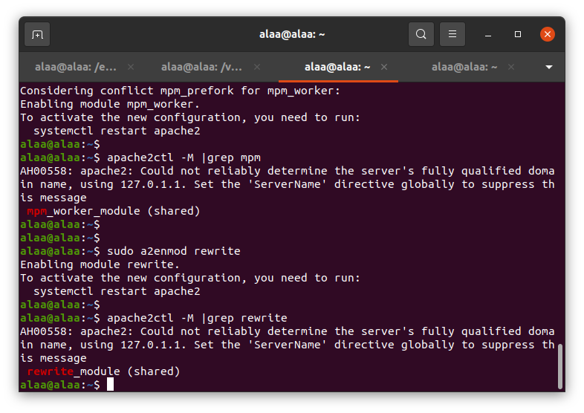

3. Write RewriteCond and RewiteRules for:

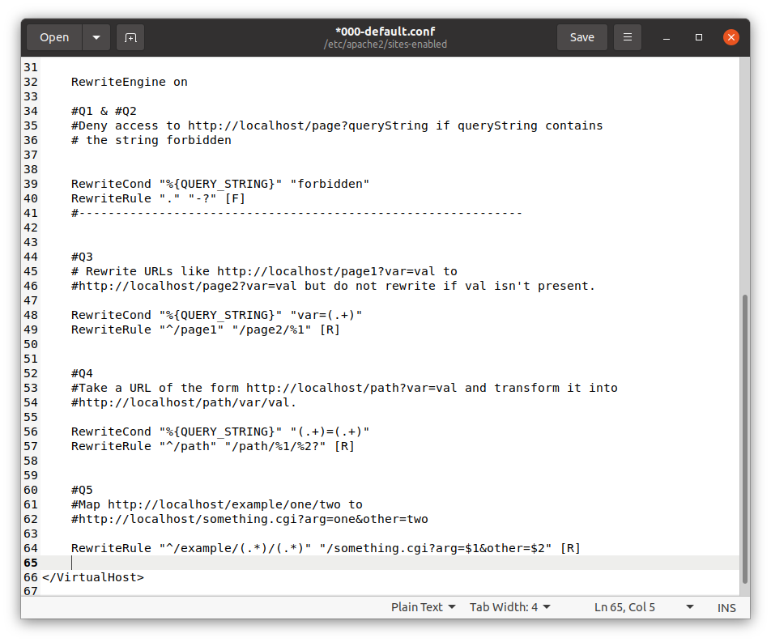

Run :

a. Deny access to http://localhost/page?queryString if queryString contains

the string forbidden.

b. Remove the Query String

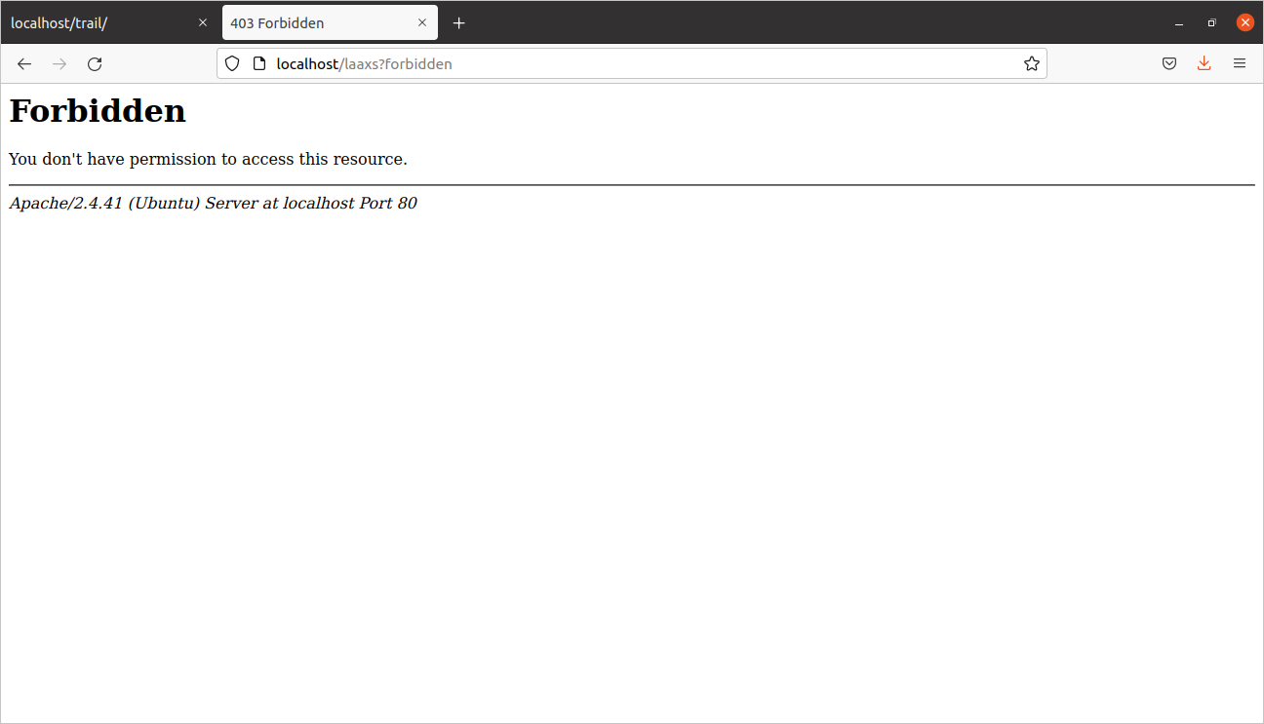

c. Rewrite URLs like http://localhost/page1?var=val to

http://localhost/page2?var=val but do not rewrite if val isn't present.

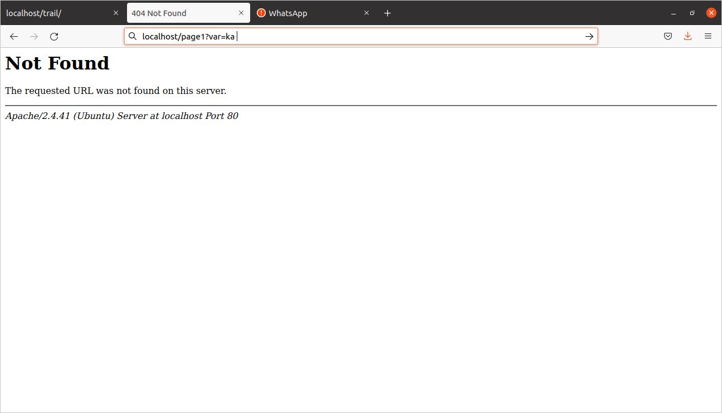

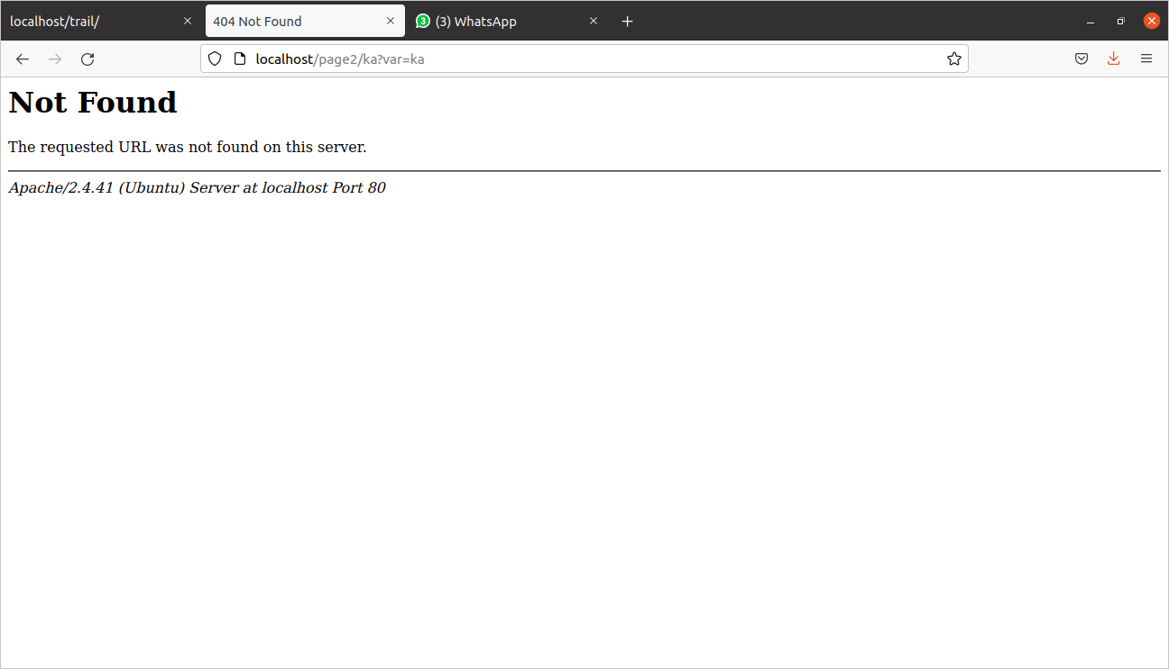

D. Take a URL of the form http://localhost/path?var=val and transform it into <http://localhost/path/var/val>.

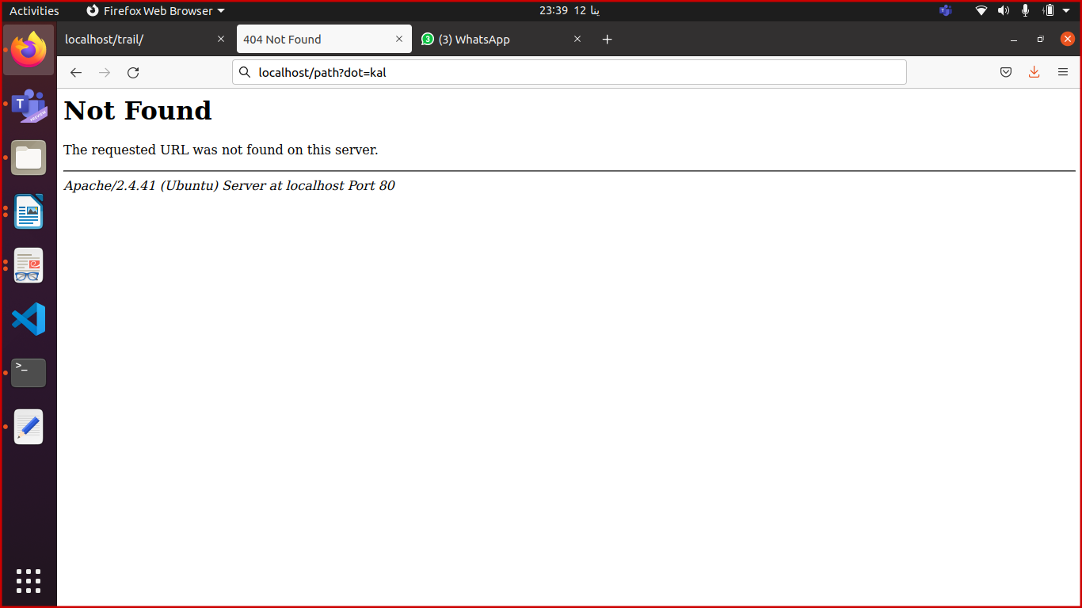

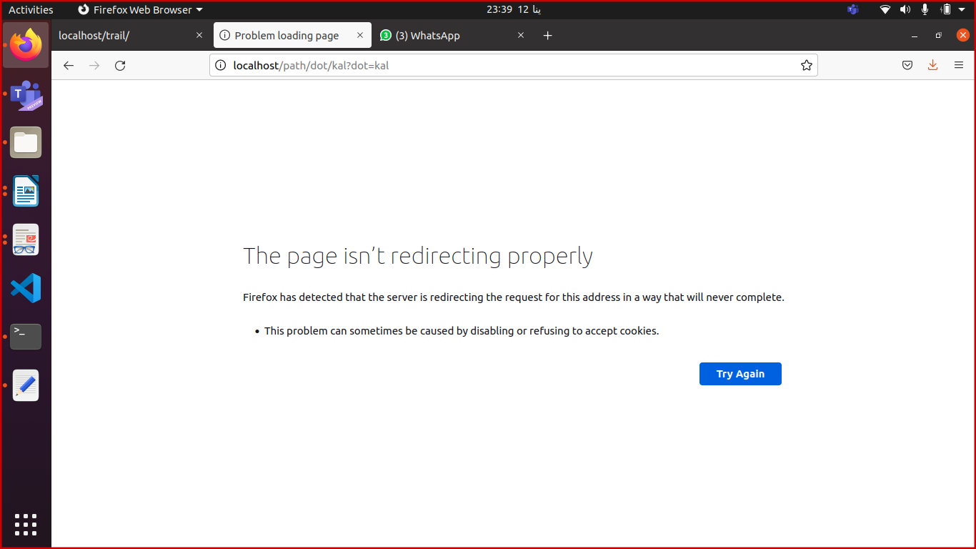

e. Map http://localhost/example/one/two to

http://localhost/something.cgi?arg=one&other=two

