Lab 1
1. Introduction
2. Plan phase
2.1 System Description
2.2 Problem statement
2.3 Benefits of the system
2.4 Solution methodology
2.5 Environment

Lab 2
1.6 Requirement analysis
1.6.1 Stakeholders/users of the system
1.6.2 Requirements elicitation techniques
1.6.2.1 Interviewing

Lab 3
1.6.2.2 Questionnaire
1.6.1 System Gathered Function
1.6.2 Functional Requirements
1.6.3 Non-functional Requirements

Lab 4
3.1 Use Case diagrams

Lab 5
1. Analysis phase part
3.2 entity-relationship diagram (ERD)
3.3 Sequence diagrams

Lab 6

Lab 7


Kingdom of Saudi Arabia - Ministry of Higher Education - University of Hail -
College of Computer Science and Engineering - Department of Computer
Science and Software Engineering (CSSE)

Software Engineering

Lab 1
System description:
Planning events is simplified by providing diverse features and tools that enable users to manage all aspects of their wedding, starting from guest lists and invitations, all the way to vendor management and budget tracking،Its location is in Al-Naqra neighborhood,The store has a website to order fromThe project consists of renting tables for newborns, graduates, andwedding receptions at prices suitable for everyone
Problem statement:
1-Problem: You may have difficulty coordinating the various activities of the party and managing time effectively. Solution: Create a detailed schedule that outlines the expected activities for the party and the duration of each activity. Take into account the time needed for preparation before the party starts. 2-Problem: The client postponed the event and did not inform the staff Solution: Set a support number for the customer to call in the event of a sudden delay
Benefits of the system :
The site includes a comprehensive set of organizing tools from the first step to the last Such as choosing the ceremony location, organizing the ceremony, and coordinating the venueThe customer can also specify his budget and show what suits him according to the budget He also helps the bride choose her hairdresser, makeup, and dress. An application to facilitate a couple's wedding 2-Guest Management 3-Inspiration and Ideas
Environment:
IOS and Android

Lab 2
- 1.6 Requirement analysis :
.1 User Registration and Profiles:
•Users should be able to create an account and securely log in - Each user should have a profile where they can manage their -
personal information, such as names, contact details, and wedding date
:Wedding Checklist and Timeline 2.
Provide a comprehensive checklist of tasks and milestones that -
•need to be completed during the wedding planning process •Allow users to set deadlines and receive reminders for each task -
Display a visual timeline that shows the progress of their planning -
:Vendor Directory and Recommendations 3. Maintain a directory of wedding vendors, including venues, -
photographers, caterers, florists, etc
Allow users to search and filter vendors based on location, services - •offered, pricing, and reviews
Provide recommendations and ratings based on user reviews and -
•experiences
:Budget Management 4.
•Enable users to set a wedding budget and track expenses -
.Categorize expenses, such as venue, catering, decorations, etc - •Provide visual representations of budget allocations and expenses –
- 1.6.1 Stakeholders /users of the System Stakeholders:
The following are examples from project stakeholders:
Project leader- Project team members-
The top managemen-
Project clients- Resource managers-
Executives-
Product user group- Stakeholders are interested in the success
of the project
Stakeholders are important because they
can influence the project positively or negatively-1.6.2.1 INTERVIEWING:
What are the appropriate prices for organizing a wedding?
?Who are the first customers for discounts
?What are the latest wedding trends for this season
?What do you need to organize the party

Lab 3
1.6.1 System Gathered Function:
1. Wedding Vendor Directory: A comprehensive directory of wedding vendors such as
venues, photographers, florists, caterers, DJs, and more. Users can search for vendors based
on location, services, availability, and reviews.
2. Wedding Planning Tools: Online tools and resources to help couples plan their wedding.
This may include budget calculators, guest list managers, seating arrangement planners,
checklist generators, and timeline trackers.
3. Inspiration and Ideas: Curated galleries and collections of wedding themes, décor ideas,
dresses, hairstyles, and other inspiration to help couples visualize and plan their wedding.
4. Real Wedding Stories: Showcasing real weddings with photos, stories, and tips from
couples who have already tied the knot. This can provide inspiration and insights into various
wedding styles and themes.
5. RSVP Management: A feature that allows couples to send online invitations and manage
RSVPs from their guests. This can simplify the process of tracking guest responses and
communicating wedding details.
6. Wedding Registry: Integration with online wedding registries, allowing couples to create
and manage their gift registry, making it easier for guests to select and purchase gifts.
7. Community and Forums: Online forums or communities where couples can connect with
other brides, grooms, and wedding professionals to share experiences, ask questions, and
seek advice.
8. Wedding Blog: A regularly updated blog featuring articles on wedding planning, trends,
tips, and expert advice. This can be a valuable resource for couples looking for guidance
throughout the wedding planning process.
9. Vendor Reviews and Ratings: A platform where couples can read and leave reviews and
ratings for wedding vendors they have worked with, helping future couples make informed
decisions.
10. Wedding Website Builder: A tool that allows couples to create their own personalized
wedding website, where they can share event details, photos, stories, and other information
with their guests.
11. Budget Tracker: A tool to help couples set and manage their wedding budget, track
expenses, and receive alerts if they are exceeding their planned budget.
These are just some of the functions that a wedding planning website may offer. The specific
features and functionalities can vary, so it's important to explore different platforms to find
the one that best suits your needs
1.6.2 Functional Requirements:
1- Login:
Input: username and password
Processing: Verify information Log in and verify your account
Output: Notification of the result of successful login or login failure
:Sign Up-2
.input: Username and password to create a new account
.Processing: Verify that the username is not repeated and create a new account
Output: A notification that the account creation was successful or a failure message if the
account .creation process was not successful
Wedding planning tools-3
input: Online tools and resources to help couples plan their wedding
.Processing: Browse resources such as budget calculators, guest list managers, and seating
charts Output: The ceremony report, including a specific and appropriate budget for the
party owners .and others
Wedding Vendor Directory-4
input: Comprehensive wedding vendor directory such as venues, photographers, florists and
more .
. Processing: Users find several sites that may be suitable for them
Output: Verify and confirm data
Create a new Event-5
. input: Details of the ceremony, including location, photographers and decor .Processing:
Save the details of the new ceremony and implement it
Output: Notification of the successful establishment of the ceremony or notification of the
failure . of the ceremony
View available Event-6
.input: Specific event for management such as party number
.Processing: View the details of the specific event and allow deletion or modification Output:
A notification that the Event was managed successfully or an error message if there was .an
error in the process
Assign Service providers-7
.Input: A specific event to appoint service providers for
Processing: View the details of the party and the details of the party presenters and their
.appointment
Output: Notification of successful assignment of providers to the party or an error message if
.there was an error in the process
1.6.3 Non-functional Requirement:
1. Performance: The website should be responsive and provide fast loading times to ensure a
smooth browsing experience for users. It should be able to handle high traffic volumes,
especially during peak wedding planning seasons.
2. Scalability: The website should be designed to scale and accommodate increasing usage
and data as the user base grows. It should be able to handle a large number of concurrent
users and vendors without significant performance degradation.
3. Security: The website should implement appropriate security measures to protect user
data, including personal information, payment details, and any other sensitive information. It
should use encryption and secure protocols to ensure data privacy and prevent
unauthorized access.
4. Reliability: The website should be available and accessible to users consistently. It should
have a robust infrastructure and backup mechanisms to prevent data loss and minimize
downtime. Regular maintenance and updates should be performed without causing
extended service disruptions.
5. Usability and User Experience: The website should have an intuitive and user-friendly
interface, making it easy for users to navigate, search for vendors, and access the desired
information. It should be visually appealing, with clear and concise content.
6. Compatibility: The website should be compatible with different web browsers, operating
systems, and devices (e.g., desktops, laptops, tablets, and mobile phones) to ensure a
seamless experience across various platforms.
7. Accessibility: The website should comply with accessibility standards to ensure that users
with disabilities can access and use the website effectively. This includes providing
alternative text for images, keyboard navigation options, and proper heading structures.
8. Localization and Internationalization: The website should support multiple languages,
currencies, and date/time formats to cater to a diverse user base, especially if the website
targets an international audience.
9. Performance Monitoring and Analytics: The website should have mechanisms in place to
monitor its performance, track user behavior, and gather analytics data. This information can
be used to identify and address any performance issues, improve user experience, and make
data-driven decisions.
10. Compliance: The website should adhere to relevant legal and regulatory requirements,
such as data protection laws, privacy policies, and accessibility guidelines. Questionnaira:
Do you think this is the right place for the store?
- Yes
- no
- somewhat
Do you need an application for the store?
- Yes
- no
- somewhat
Do you think the app will attack you faster?
- Yes
- somewhat
- no
Do you think you will need more than one employee?
- Yes
- no
- somewhat
What do you think of the store's decor?
- amazing
- Good
- Improvement is preferred
1. Do you prefer using a wedding planning application or do you prefer traditional planning?
a) Yes, I prefer using a wedding planning application.
b) No, I prefer traditional planning.
2. Do you prefer an outdoor or indoor wedding?
a) Outdoor.
b) Indoor.
c) No specific preference.
3. Do you want to arrange for professional photography and videography services for the
wedding?
a) Yes, I prefer professional photography and videography services.
b) No, I'm not interested in this service.
4. What is your total budget for the wedding?
a) Less than 50,000
b) 50,000-75,000.
c) 75,00”-1000,000
d) More than 100,000.
5.Do you prefer to have a wedding planner or do you want to plan everything yourself?
a) I prefer to hire a wedding planner.
b) I prefer to plan everything myself.
c) I'm open to either option.
Lab 4
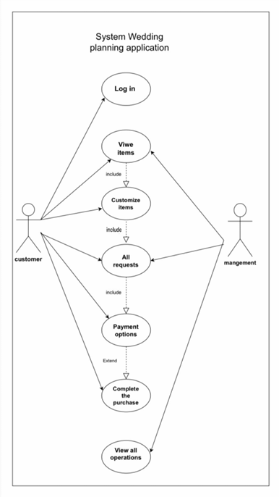
Lab 5
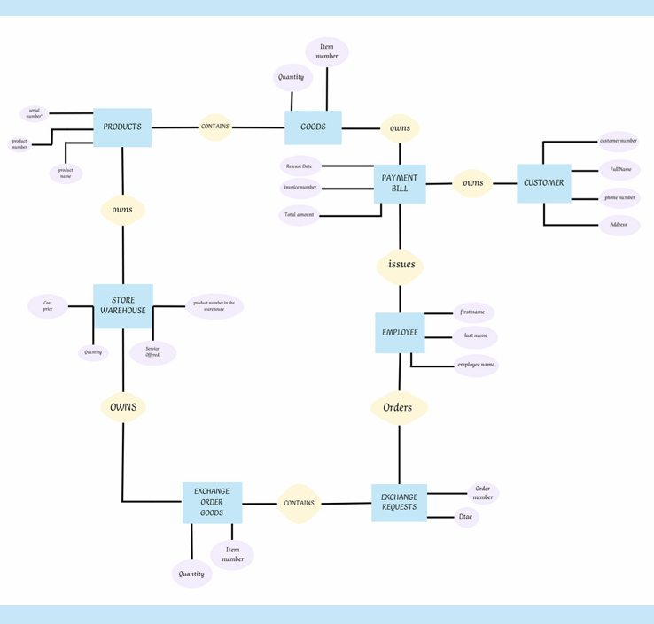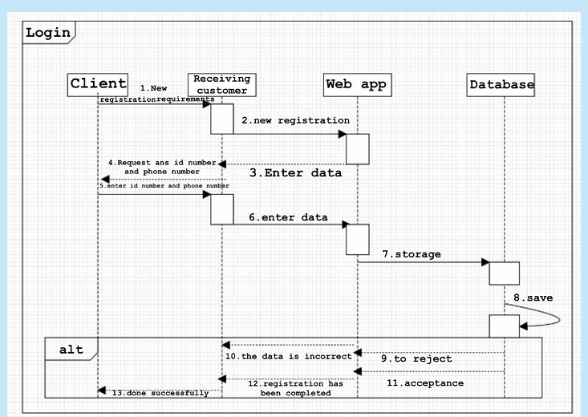
Lab 6
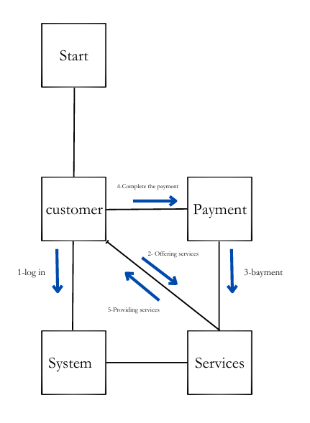
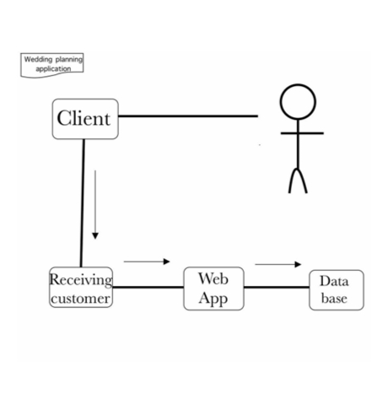
Lab 7

