


Digital Egypt Pioneers Initiative

DEPI
YAT Learning Solutions
YAT588_ONL3_DAT2_G4_DEPI3
Project Name:
Flight Delay Analysis

Supervisor:
Prof.Dr. Amal Mahmoud

Team Members

- Ehab Galal Mohammed Nada
- HANY ABDELFADEL ELDEMERDASH ELGAMALA
- Alaa Ali Shabaan Ewais
- Nada Nasser Mostafa Elnaggar
- Wael Mamdouh Mahmoud

Acknowledgement

We would like to sincerely thank our project supervisor, Prof. Dr. Amal Mahmoud, for her continuous support, valuable feedback, and insightful guidance during this project.
We are also grateful to our team members and contributors who shared their ideas and worked collaboratively to achieve our goals.
Moreover, we would like to express our deep appreciation to the Digital Egypt Pioneers Initiative (DEPI) and YAT for their exceptional efforts and continuous support in empowering and developing youth capabilities. Their initiative has provided valuable learning opportunities across various digital fields with high-quality education and training standards.
Special thanks to the data providers and tools’ communities (Power BI, Tableau, My SQL and Excel) for enabling us to complete this analysis successfully.

Abstract

This project focuses on analyzing the causes of domestic flight delays in the United States during the period from January 1, 2019, to June 30, 2019. The main objective is to identify and evaluate the key factors contributing to flight delays, measure their impact, and explore potential ways to minimize them.
The analysis was conducted using modern data analysis tools to examine relationships between delay causes, delay durations, and the most affected airlines and airports. By exploring these patterns, the project aims to provide a deeper understanding of operational inefficiencies within the aviation system.
The results indicate that “Late Aircraft” is the primary cause of delays, followed by weather-related issues. These findings highlight the need for better scheduling strategies, improved maintenance planning, and enhanced airport infrastructure management.
Ultimately, the insights from this analysis can support airlines and airport authorities in improving flight operations, optimizing runway usage, and reducing overall delay occurrences.

Contents

Chapter 1: Introduction
1. General Introduction

Chapter 2: Background

1.Background

Chapter 3: Methodology

3.1 Dataset
3.2 Data Cleaning
3.3 Data Preprocessing
3.4 Data Modeling
3.5 Tools Used
3.6 Method

Chapter 4: Results and Discussion

- Results and Discussion

Chapter 5: Recommendation
- Recommendation

Chapter 6: References
- Data source
- Tools used
- Additional References

Chapter 7: Appendix
- Appendix

Chapter 1
Introduction

General Introduction
Air transportation plays a vital role in connecting people, businesses, and economies around the world. In the United States, domestic air travel represents one of the most active and complex transportation networks globally, with thousands of flights operating daily across hundreds of airports.
However, flight delays remain a persistent challenge that significantly affects the efficiency and reliability of air transport. Delays not only lead to financial losses for airlines and airports but also cause inconvenience for passengers, affecting their travel schedules and overall satisfaction. Moreover, flight delays can create a chain reaction in the aviation system — a single delayed aircraft may result in multiple subsequent delays throughout the day.
Understanding the factors that contribute to these delays is essential for improving operational performance and passenger experience. Several factors can lead to flight delays, including adverse weather conditions, air traffic control restrictions, airline operational issues, security concerns, and late arrivals of aircraft from previous flights. While some causes are unavoidable, many can be mitigated through better planning, scheduling, and resource allocation.
With the rapid growth of data availability and analytical tools, data analysis has become a powerful method for investigating complex problems such as flight delays. Through careful examination of large datasets, it is possible to identify patterns, correlations, and root causes that may not be immediately visible.
This project focuses on analyzing the causes of domestic flight delays in the United States during the period from January 1, 2019, to June 30, 2019. Using a dataset that includes detailed information about flights and the reasons for their delays, the study aims to uncover the most influential factors affecting flight punctuality. By leveraging modern data analysis tools, the project provides insights that can help airlines and airport authorities improve decision-making, enhance operational efficiency, and reduce the overall occurrence of flight delays.
Ultimately, this analysis not only contributes to understanding the operational behavior of the aviation sector but also demonstrates the value of data analytics as a key driver for smarter, evidence-based management within the transportation industry.

Chapter 2
Background

Background
Air travel has become one of the most essential modes of transportation in the modern world, enabling the rapid movement of people and goods across vast distances. In the United States, the domestic aviation network is one of the largest and busiest in the world, with thousands of flights scheduled daily across multiple states and time zones. However, the increasing volume of air traffic has also introduced greater complexity in managing flight operations, leading to one of the most persistent challenges in the aviation industry — flight delays.
Flight delays occur when scheduled flights do not depart or arrive on time, and they have wide-ranging implications. From an operational perspective, delays cause significant financial losses for airlines due to fuel waste, crew overtime, and disrupted schedules. For passengers, delays lead to frustration, missed connections, and decreased satisfaction with airline services. Additionally, flight delays have a cascading effect on airport traffic and logistics, potentially disrupting the broader transportation network.
The causes of flight delays are multifaceted. Common reasons include adverse weather conditions, air traffic congestion, aircraft maintenance or technical issues, security procedures, and late arrivals of aircraft from previous flights. Some of these causes are beyond human control, such as weather-related factors, while others can be mitigated through effective management and planning.
In recent years, the availability of large-scale flight data and advances in data analytics have created new opportunities to better understand the dynamics of flight delays. By analyzing detailed datasets that include information about flight times, airlines, airports, and delay causes, researchers and industry professionals can identify underlying patterns and develop strategies to minimize operational inefficiencies.
This project utilizes a dataset covering U.S. domestic flights between January 1, 2019, and June 30, 2019, aiming to analyze the main causes of flight delays and evaluate their impact on overall performance. Through data-driven insights, the study seeks to support airlines and airport authorities in developing more efficient scheduling systems, optimizing airport operations, and ultimately improving the reliability of air travel in the United States.

Chapter 3
Methodology

3.1 Dataset
The dataset used in this project is titled “Flight Delay and Causes”, obtained from the open data platform Kaggle (https://www.kaggle.com/datasets/undersc0re/flight-delay-and-causes).
It contains detailed records of U.S. domestic flights between January 1, 2019, and June 30, 2019, providing extensive information about flight schedules, delays, and the reasons behind them.
The dataset was compiled from the U.S. Department of Transportation official records and made publicly available for research and analysis purposes. It is stored in CSV format, which makes it easy to process and integrate with various data analysis tools such as Python (Pandas), Excel, and Power BI.

Dataset Overview
- Number of rows: 484,552 (each row represents one flight record)
- Number of columns: 28
- File type: CSV (Comma-Separated Values)
- Data size: approximately 65 MB
The dataset covers multiple U.S. airlines and airports, representing a large and diverse sample suitable for exploratory data analysis, statistical correlation, and visualization of delay causes.

Main Columns Description
- DayOfWeek: Indicates the day of the week the flight took place (1 = Monday, 7 = Sunday).
- Date: The full date of the flight (YYYY-MM-DD format).
- DepTime: The actual departure time of the flight (in local time).
- ArrTime: The actual arrival time of the flight (in local time).
- CRSArrTime: The scheduled arrival time according to the airline’s published timetable.
- UniqueCarrier: The airline’s code identifier (e.g., AA for American Airlines, DL for Delta Air Lines).
- Airline: The full name of the operating airline.
- FlightNum: The flight number assigned by the airline.
- TailNum: The aircraft registration number (used to identify the specific aircraft).
- ActualElapsedTime: The total time (in minutes) between takeoff and landing.
- CRSElapsedTime: The scheduled flight duration in minutes.
- AirTime: The time spent in the air, excluding taxiing.
- ArrDelay: The difference (in minutes) between actual and scheduled arrival times. Positive values indicate delays.
- DepDelay: The difference (in minutes) between actual and scheduled departure times.
- Origin: The three-letter IATA code of the departure airport.
- Org_Airport: The full name of the origin airport.
- Dest: The three-letter IATA code of the destination airport.
- Dest_Airport: The full name of the destination airport.
- Distance: The distance between origin and destination airports (in miles).
- TaxiIn: Time spent taxiing from the runway to the gate after landing.
- TaxiOut: Time spent taxiing from the gate to the runway before takeoff.
- Cancelled: A binary indicator (1 = flight cancelled, 0 = not cancelled).
- CancellationCode: The reason for cancellation, such as weather, carrier, or security.
- Diverted: A binary indicator (1 = flight diverted to another airport, 0 = not diverted).
- CarrierDelay: Delay minutes caused by the airline’s operations (e.g., crew or maintenance issues).
- WeatherDelay: Delay minutes caused by weather conditions.
- NASDelay: Delay caused by the National Airspace System (e.g., congestion or air traffic control).
- SecurityDelay: Delay caused by security checks or related incidents.
- LateAircraftDelay: Delay caused by a late incoming aircraft from a previous flight.

Dataset Purpose and Relevance
This dataset provides a rich foundation for analyzing and understanding the key causes of flight delays in the U.S. aviation industry. With over 480,000 flight records, it offers sufficient data to explore:
- Delay frequency by airline, airport, and day of the week.
- Correlation between delay causes and total delay duration.
- The most frequent and impactful delay categories.
Such analysis helps reveal operational inefficiencies, seasonal trends, and patterns that directly affect flight punctuality and passenger satisfaction.
The dataset was carefully reviewed for consistency before analysis — ensuring correct data types, valid time values, and meaningful numerical ranges. Missing or inconsistent records were handled during the data cleaning phase, which is detailed in the following section.
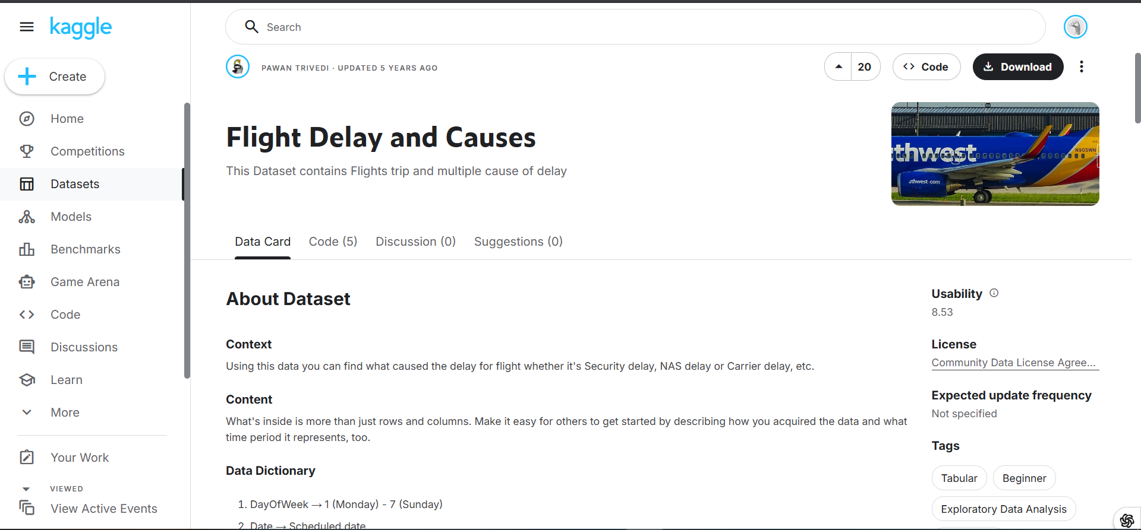

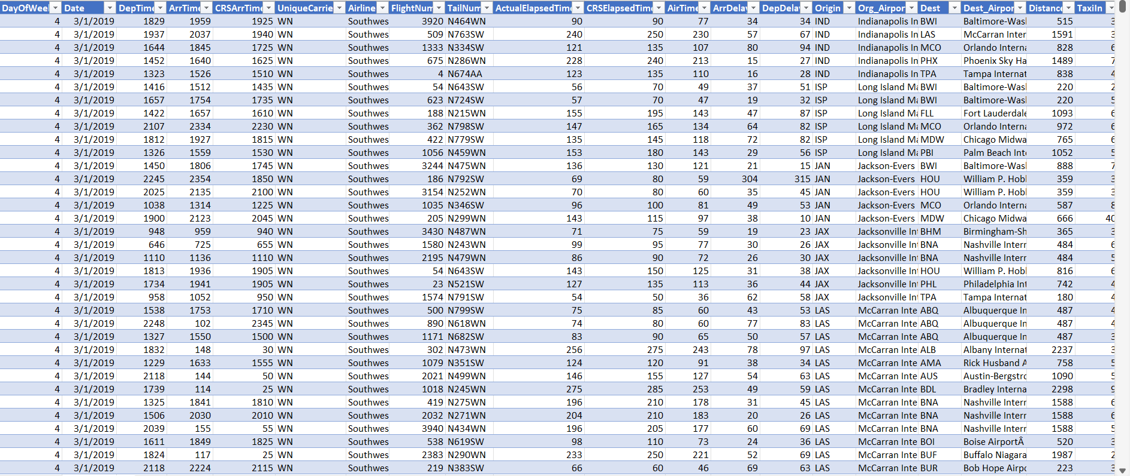

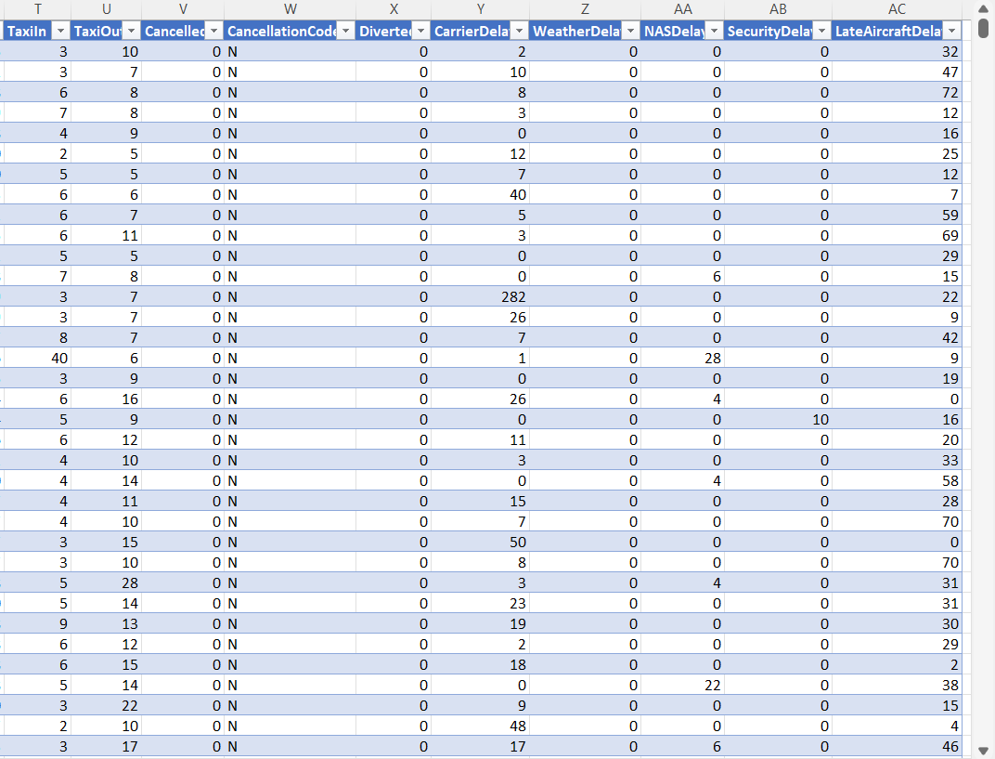

3.2 Data Cleaning
Before performing any analysis, the dataset underwent a comprehensive data cleaning process to ensure accuracy, consistency, and reliability of the results. Raw aviation data often contains inconsistencies, missing values, and format errors due to the large volume of records collected from multiple sources. Therefore, the cleaning phase was a critical step in preparing the dataset for analysis.

Handling Missing Values
One of the main issues identified during the data inspection phase was the presence of a large number of null (missing) values in two specific columns:
- Org_Airport (Origin Airport Name)
- Dest_Airport (Destination Airport Name)
These two columns represent the full names of the departure and destination airports, respectively. The missing values in these fields could affect the accuracy of analyses related to route performance and airport-specific delay trends.
To resolve this issue, the approach used was both systematic and data-driven:
- Each flight record also contained the Origin and Dest columns, which store the IATA airport codes (three-letter abbreviations such as JFK, LAX, ORD, etc.).
- These IATA codes were used as reliable identifiers for the airports.
- Using these codes, an external lookup process was performed to retrieve the corresponding full airport names.
- This lookup was done through ChatGPT, which was used to query the official airport directory and other reliable aviation data sources to match each missing airport code with its correct name.
- Once the full airport names were identified, they were inserted back into the dataset to replace the null values in both Org_Airport and Dest_Airport columns.
This method ensured 100% consistency between the airport codes and their names, and eliminated any ambiguity in route-level analysis. After the replacement process, the dataset was rechecked to confirm that no null values remained in these columns.

Fixing Date Format Issues
Another major issue in the raw dataset was related to the date formatting inconsistency.
The column Date (flight date) was found to have its month and day components reversed, which caused incorrect interpretation of flight dates. For instance, a flight recorded as 05/12/2019 was interpreted as May 12th, 2019, while the correct date was December 5th, 2019.
To correct this issue, the following steps were performed using Microsoft Excel:
- The Text to Columns feature was used to separate the date elements (day, month, year).
- The components were then rearranged in the correct order — ensuring the format followed DD/MM/YYYY instead of MM/DD/YYYY.
- After reformatting, the separated columns were merged again into a single unified date column using Excel’s date conversion functions.
- The corrected date column was verified across multiple records to ensure consistent interpretation across all entries.
This correction was crucial because accurate date values are essential for performing time-series analysis and identifying delay patterns by day, month, or weekday.

Final Data Quality Check
After completing the above cleaning steps, the dataset was revalidated to confirm:
- No remaining null or invalid entries in the airport columns.
- All dates were properly standardized and correctly ordered.
- Column data types (numeric, text, date) were consistent and ready for further processing.
As a result of this cleaning phase, the dataset became fully structured, reliable, and ready for subsequent preprocessing and analysis tasks.
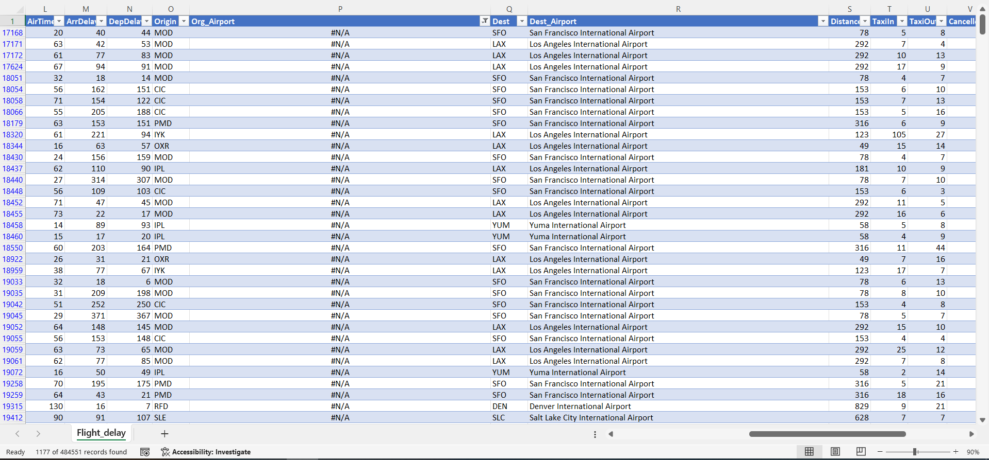
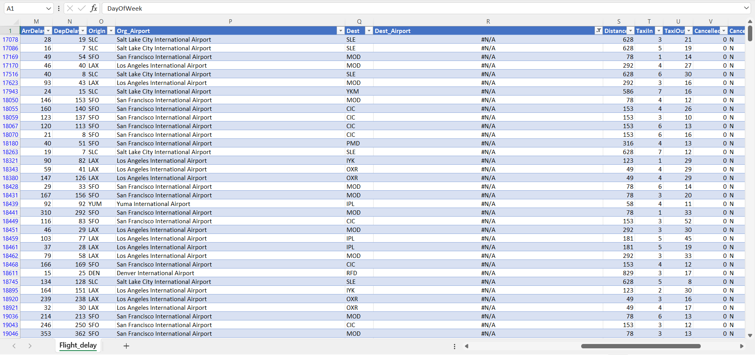
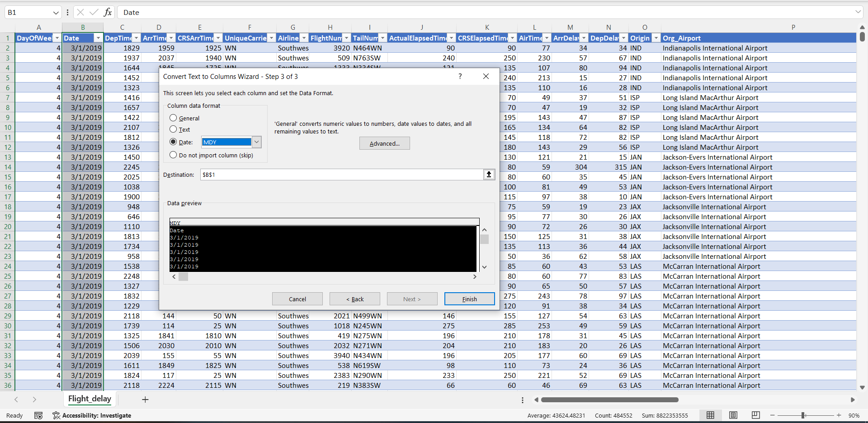

3.3 Data Preprocessing

Definition and Purpose
Data preprocessing represents a fundamental phase in any data analysis or machine learning project. It refers to the set of techniques and transformations applied to raw data in order to make it suitable for analytical processing.
In aviation-related datasets, raw flight data often contains inconsistencies, missing entries, and structural limitations that can hinder accurate analysis. Preprocessing ensures that data is properly structured, standardized, and enriched with new calculated fields that add analytical value.
The goal of preprocessing in this project was to enhance the flight delay dataset for deeper insights — by cleaning, formatting, enriching, and restructuring it. This was done mainly through Microsoft Excel and Power Query, along with external lookups via ChatGPT for airport information.

1. General Enhancements
After the initial cleaning, the dataset was extended with multiple derived columns, standardizations, and logical transformations to support advanced analytical tasks such as:
- Delay cause categorization
- Temporal (time-based) analysis
- Geographical segmentation
- Performance comparison between airports and airlines
All new columns were implemented using Power Query M Language and Excel functions.

2. Detailed Explanation of Each Added Column

2.1 Departure_Time
Purpose: To convert the integer-based DepTime (e.g., 1530) into a proper time format for accurate analysis of departure punctuality.
Power Query Code:
Departure_Time = Time.From(#time(
Number.IntegerDivide([DepTime],100),
Number.Mod([DepTime],100),
0))
Explanation:
- The code divides the integer DepTime into hours and minutes.
- This conversion allowed precise comparison between scheduled and actual departure times.
- It also helped in identifying peak hours and evaluating delay frequency by time of day.

2.2 Arrival_Time
Purpose: Similar to the departure time conversion, this field transforms ArrTime from numeric to time format to allow accurate computation of flight duration and arrival punctuality.
Power Query Code:
Arrival_Time = Time.From(#time(
Number.IntegerDivide([ArrTime],100),
Number.Mod([ArrTime],100),
0))
Analytical Value:
This transformation made it possible to calculate metrics like:
- Average arrival delay per airline.
- Correlation between departure and arrival delay patterns.
- Identification of late-night or early-morning delay trends.

2.3 CRS_Arrival_Time
Purpose: Convert the scheduled arrival time (CRSArrTime) into time format for direct comparison with actual arrival times.
Power Query Code:
CRS_Arrival_Time = Time.From(#time(
Number.IntegerDivide([CRSArrTime],100),
Number.Mod([CRSArrTime],100),
0))
Outcome:
This column allowed the calculation of planned vs actual performance gaps, helping visualize scheduling accuracy and airline reliability.

2.4 Route
Purpose: To create a single descriptive column that defines each flight route as “Origin – Destination”.
Power Query Code:
Route = [Origin] & " - " & [Dest]
Analytical Benefit:
- Simplified route-based grouping and filtering.
- Enabled route-level delay comparisons (e.g., which routes are most delayed).
- Used directly in dashboards for route-level KPIs.

2.5 TotalDelay
Purpose: To calculate the total number of delay minutes per flight by summing all five delay categories.
Power Query Code:
TotalDelay = [CarrierDelay] + [WeatherDelay] +
[NASDelay] + [SecurityDelay] + [LateAircraftDelay]
Analytical Value:
This aggregate measure allowed the calculation of:
- Total delay distribution across airlines.
- Ranking of most delayed routes or airports.
- Correlation between total delay and distance or time of day.

2.6 Main_Delay
Purpose: Identify the main cause of delay for each flight (i.e., which delay type contributed the most).
Power Query Code:
Main_Delay = let
delays = [
CarrierDelay = [CarrierDelay],
WeatherDelay = [WeatherDelay],
NASDelay = [NASDelay],
SecurityDelay = [SecurityDelay],
LateAircraftDelay = [LateAircraftDelay]
],
maxValue = List.Max(Record.ToList(delays)),
maxColumn = List.First(List.Select(Record.FieldNames(delays),
(col) => Record.Field(delays, col) = maxValue))
in
maxColumn
Explanation:
This code dynamically checks which of the five delay columns has the highest value for each record and assigns its name as the dominant cause.
Analytical Impact:
- Simplified cause-based grouping.
- Helped determine that LateAircraftDelay was the most frequent main cause across the dataset.

2.7 Delay Ratios
Purpose: To calculate the percentage contribution of each delay type to the total delay per flight.
Power Query Code:
let
TotalDelay = [CarrierDelay] + [WeatherDelay] + [NASDelay] + [SecurityDelay] + [LateAircraftDelay],
CarrierRatio = if TotalDelay > 0 then Text.From(Number.Round([CarrierDelay] / TotalDelay * 100, 1)) & "%" else "0%",
WeatherRatio = if TotalDelay > 0 then Text.From(Number.Round([WeatherDelay] / TotalDelay * 100, 1)) & "%" else "0%",
NASRatio = if TotalDelay > 0 then Text.From(Number.Round([NASDelay] / TotalDelay * 100, 1)) & "%" else "0%",
SecurityRatio = if TotalDelay > 0 then Text.From(Number.Round([SecurityDelay] / TotalDelay * 100, 1)) & "%" else "0%",
LateAircraftRatio = if TotalDelay > 0 then Text.From(Number.Round([LateAircraftDelay] / TotalDelay * 100, 1)) & "%" else "0%"
in
[CarrierRatio = CarrierRatio, WeatherRatio = WeatherRatio,
NASRatio = NASRatio, SecurityRatio = SecurityRatio, LateAircraftRatio = LateAircraftRatio]
Analytical Importance:
- Provided a proportional breakdown of delays per flight.
- Helped visualize which delay types dominate specific airlines or airports.
- Useful for pie chart and stacked bar representations in dashboards.

2.8 DayName & MonthName
Purpose: To enhance time-series analysis by labeling each record with its day of the week and month name.
Implementation: Created in Excel via Insert Day Name and Insert Month Name functions based on the Date column.
Analytical Role:
- Enabled aggregation of delays by weekday and month.
- Revealed seasonal and weekly patterns (e.g., Friday having higher delays).
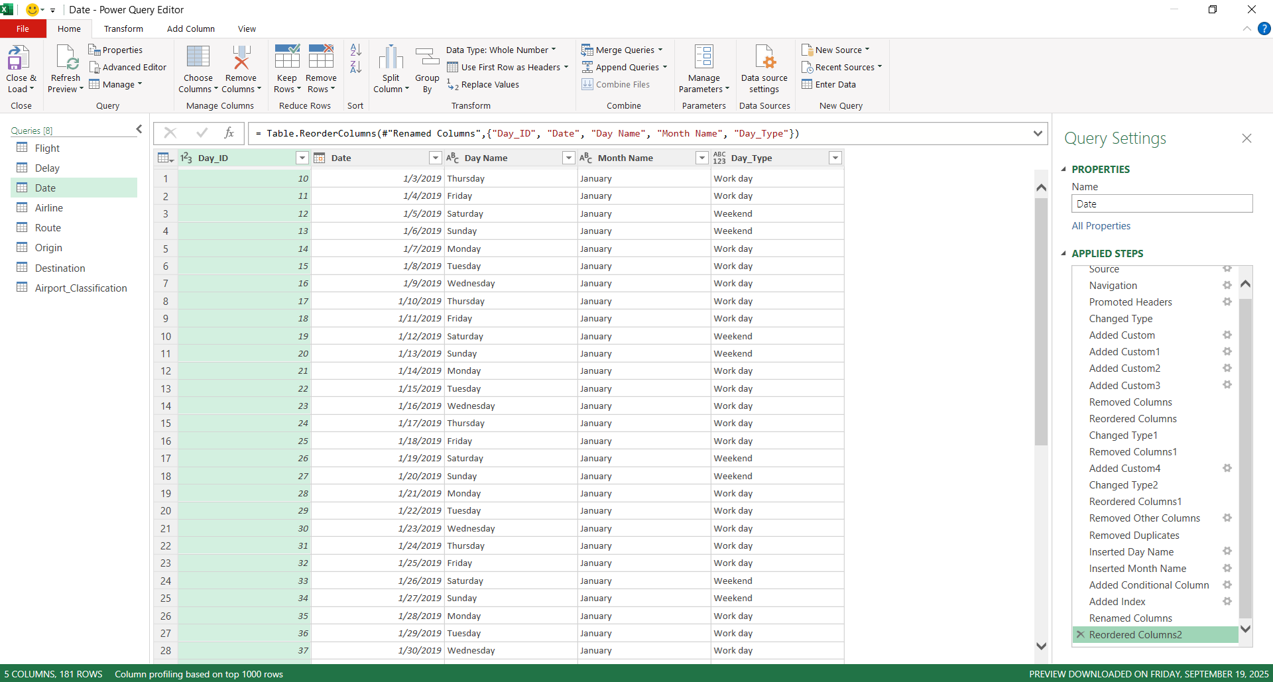

2.9 City & State Columns
Purpose: To enrich geographical context for both origin and destination airports.
Columns Added:
- Origin_City, Origin_State, Dest_City, Dest_State
Method:
These fields were generated using airport lookup data obtained from verified online directories (via ChatGPT referencing official IATA sources).
Benefit:
- Enabled analysis of delays by region or state.
- Allowed creation of heat maps showing average delays across U.S. states.

2.10 Airport Category & Description
Purpose: To classify each airport according to its size and operational importance (Large, Medium, or Small Hub).
Implementation:
Added manually based on the Federal Aviation Administration (FAA) airport classification system.
Description Field:
A supplementary text column explaining the meaning of each category, for instance:
- Large Hub: handles ≥1% of total U.S. passenger enplanements.
- Medium Hub: handles between 0.25%–1%.
- Small Hub: less than 0.25%.
Analytical Purpose:
- Helped study whether larger airports face more congestion and delays.
- Supported segmentation in dashboards comparing delay averages by airport size.

2.11 Index Column
Purpose:
After removing duplicate rows, a new Index column was created to ensure each record is uniquely identified.
Implementation:
Automatically generated using Power Query’s Add Index Column function.
Analytical Use:
- Essential for database joins and modeling in Power BI.
- Ensured no data duplication when merging tables in later modeling stages.

2.12 Status (Conditional Classification Column)

Purpose:
The Status column was created to categorize each flight based on its arrival delay time into one of three meaningful groups — Early, On Time, or Delayed.
This classification helps in simplifying interpretation of delay data and supports dashboard visualizations showing punctuality rates for each airline or airport.

Implementation:
The column was created in Power Query using the Add Conditional Column feature with the following logic:

Condition | Description | Output
If [Arrival_Delay_Min] > 15 | The flight arrived more than 15 minutes late | "Delayed"
Else if [Arrival_Delay_Min] < 0 | The flight arrived earlier than scheduled | "Early"
Else | The flight arrived on schedule (within 15 minutes window) | "On Time"

Power Query M Code (Generated Automatically):

Status =
if [Arrival_Delay_Min] > 15 then "Delayed"
else if [Arrival_Delay_Min] < 0 then "Early"
else "On Time"

Explanation and Analytical Value:

- This transformation converts raw numerical delay data into categorical performance indicators.
- Airlines and airports can easily track what percentage of their flights are delayed, on time, or early.
- It’s particularly useful in visual dashboards — for example, creating pie charts showing punctuality rates by airline or airport.
- The 15-minute threshold aligns with U.S. Department of Transportation (DOT) standards, which classify flights arriving within 15 minutes of scheduled time as “on time.”
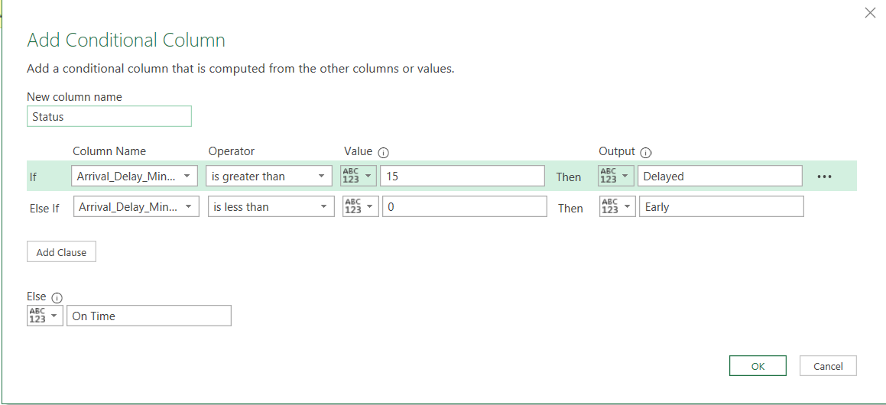

3. Columns Removed
To maintain dataset efficiency and clarity, the following were excluded:
- TailNum, FlightNum: identifiers without analytical relevance.
- Cancelled, CancellationCode, Diverted: filtered out to focus on operational flights only.
- Any columns containing static or repeated values that did not add value to analysis.

4. Analytical Impact of Preprocessing
Through all these transformations, the dataset evolved from a raw structured file into a powerful analytical model.
Each new feature provided a new analytical dimension — time, geography, or cause — which allowed for:
- Delay pattern visualization by month, day, airline, and airport size.
- Quantitative understanding of major delay causes.
- Integration-ready dataset for advanced modeling and dashboard design.

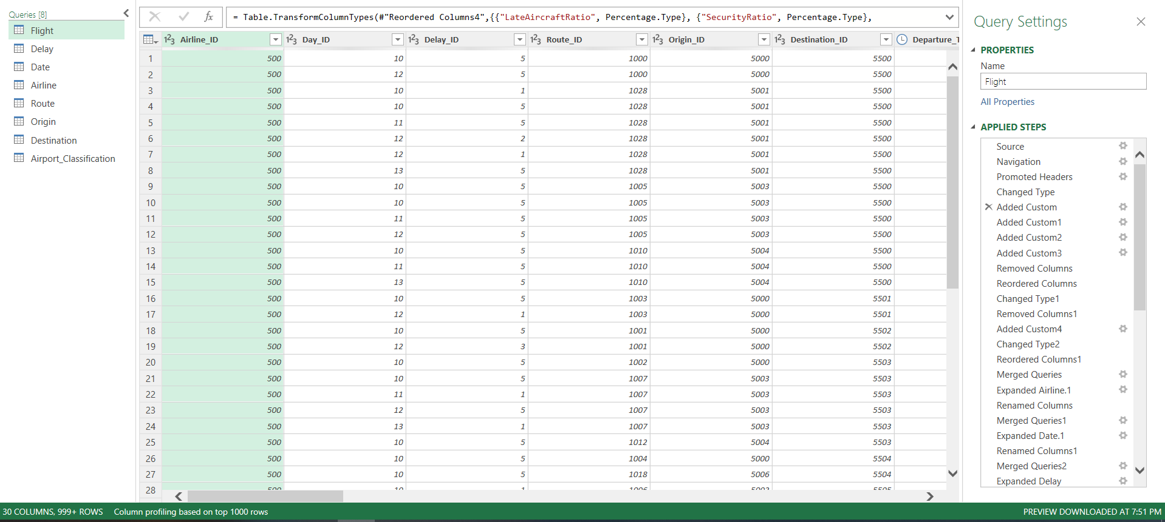
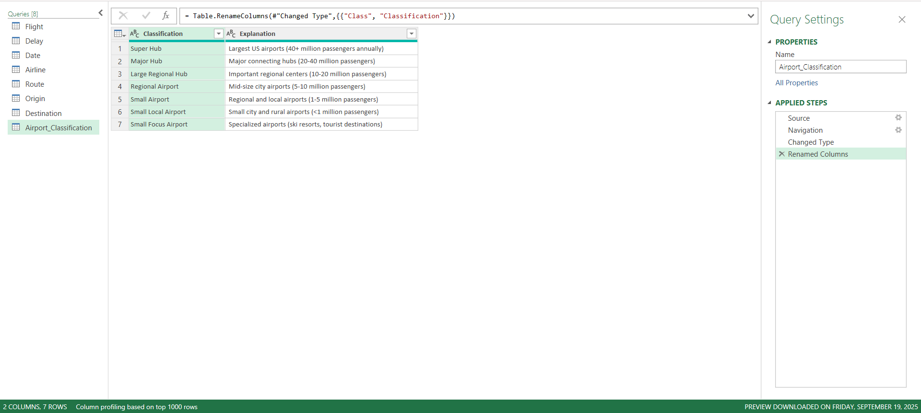
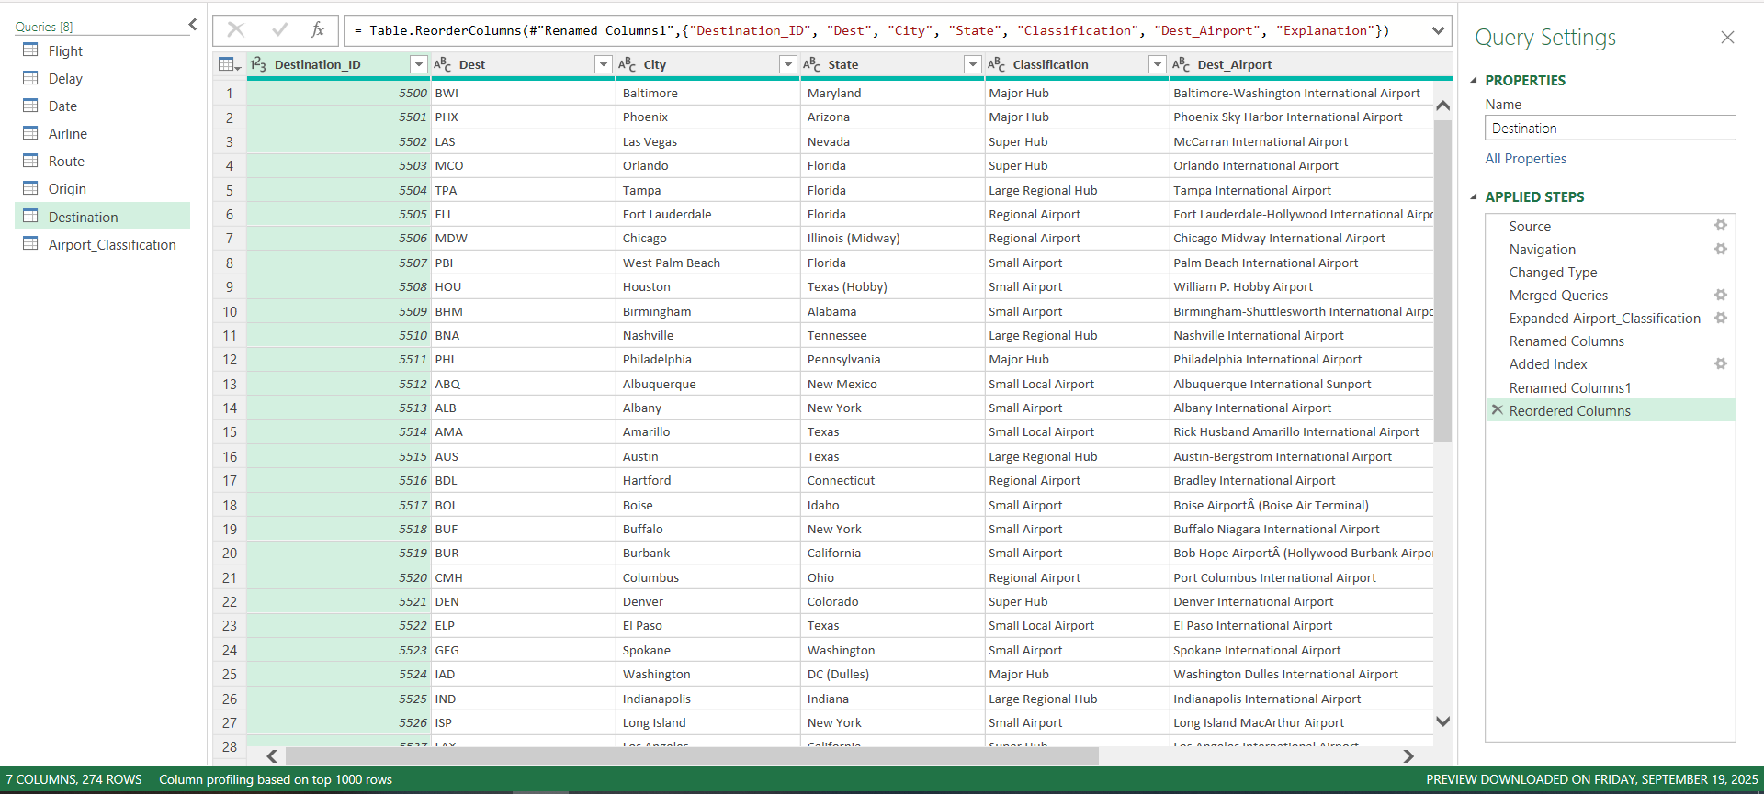
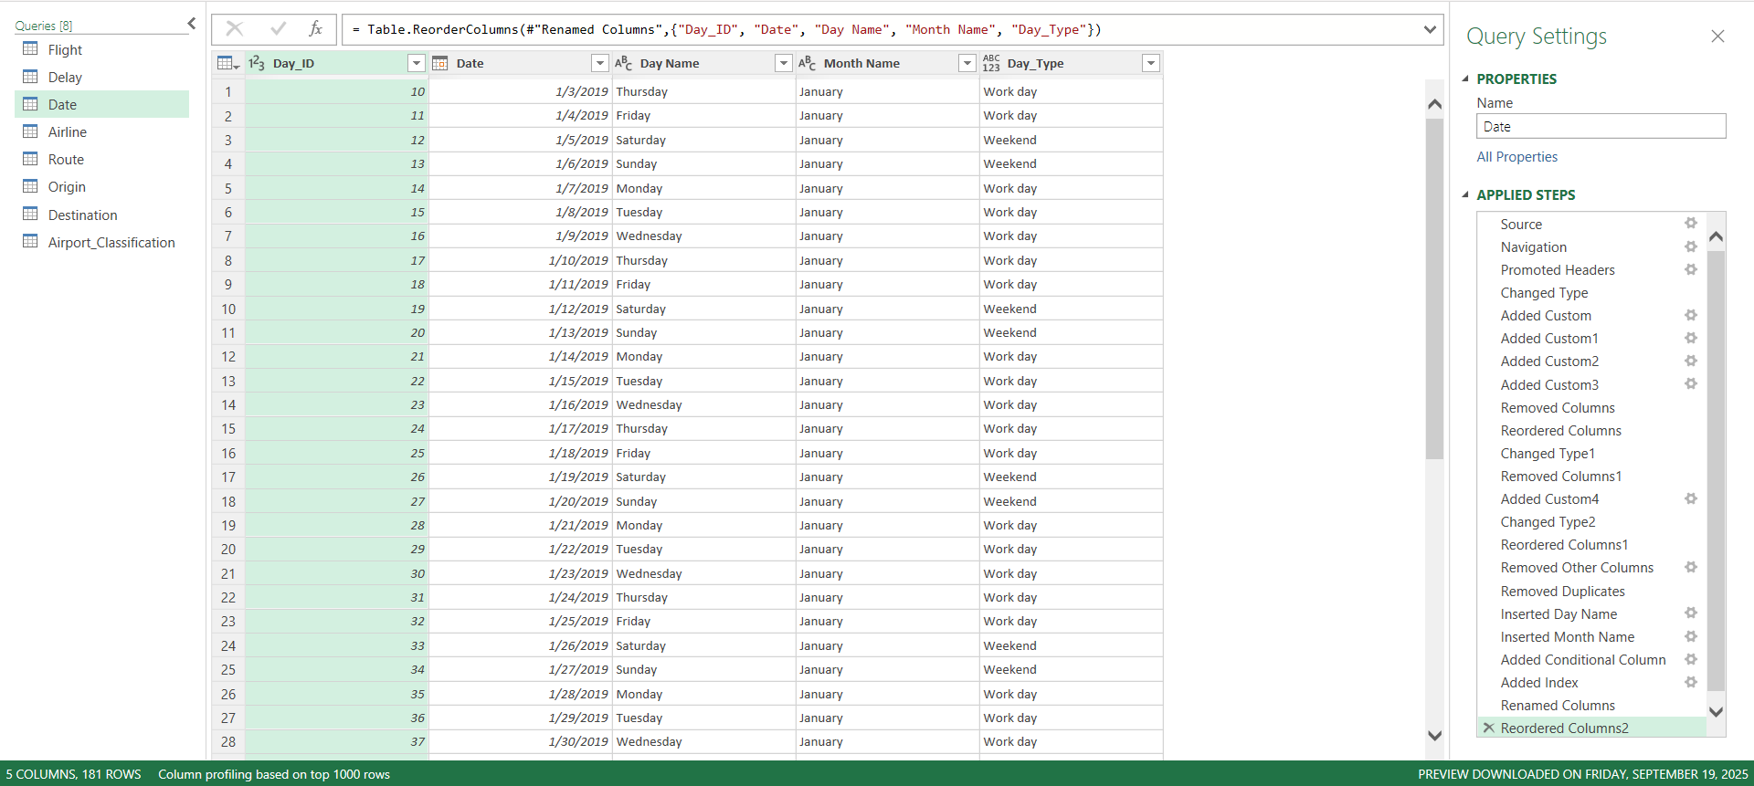
3.4 Data Modeling
Data modeling is a critical phase in the analytical pipeline that transforms large and unstructured datasets into a well-organized data warehouse model. This step enables efficient querying, relationship building, and insightful visualization. The modeling process helps in structuring the dataset in a way that reduces redundancy, improves performance, and ensures consistency across analytical dimensions.
In this project, the original dataset consisted of a single large table containing over 480,000 flight records. Although this flat table contained all necessary information, its structure was not optimized for analysis. Therefore, it was crucial to design a star schema model that separates the data into a central fact table and multiple dimension tables.

4.1 Objective of Modeling
The primary goal of the modeling phase was to:
- Organize the cleaned dataset into a relational structure that supports fast querying and efficient dashboard creation.
- Eliminate data duplication and inconsistencies found in the raw dataset.
- Enable easy cross-analysis between different dimensions such as airline, route, airport, and time.
- Enhance analytical flexibility, allowing calculation of key metrics such as average delay per airline, delay cause breakdown, and on-time performance by airport type.

4.2 Transition from Preprocessing to Modeling
The preprocessing stage prepared the dataset by:
- Correcting data formats and null values.
- Adding analytical columns such as TotalDelay, Main_Delay, Status, DayName, and MonthName.
- Creating unique index columns for every logical group of information (airline, origin, destination, route, date, delay cause).
These unique index keys were the foundation for building relationships between tables in the data model.
Without this preparation, it would have been impossible to build a stable model or connect the tables correctly.

4.3 Rationale for Data Warehousing and Star Schema Design
Given the dataset’s large size and the repetition of information across flights (e.g., the same airline, route, and airports repeating thousands of times), it was natural and efficient to move toward a data warehouse design.
A star schema was chosen because:
- It provides a simple, intuitive structure for analytical tools like Power BI or Excel Power Pivot.
- It clearly separates facts (quantitative data) from dimensions (descriptive data).
- It supports one-to-many relationships, ensuring faster aggregation and simplified data relationships.
The Flight table serves as the Fact table, while six Dimension tables were derived from it.
Each dimension represents a unique aspect of the flight operation (Airline, Route, Origin, Destination, Date, Delay).

4.4 Modeling Process and Challenges
Initially, when the dataset was divided into separate dimension tables, we applied Remove Duplicates to create unique values per dimension. However, this caused significant data loss during early merges because:
- Some keys were not unique.
- Merges between tables caused row mismatches.
- Duplicated routes or airports generated inflated record counts.
When we first merged the tables again, the row count nearly doubled, leading to major inconsistencies.
To fix this:
- We redefined primary keys (indexes) for every table.
- Used Left Outer Joins to ensure all flight records were preserved.
- Verified data accuracy after every merge using reconciliation checks (row count and total delay comparisons).
After several iterations, a clean, valid star schema was achieved as shown in the model diagram (Power Pivot screenshot).

4.5 Star Schema Structure
The final star schema consists of:
- 1 Fact Table: Flight
- 6 Dimension Tables: Date, Delay, Origin, Destination, Airline, Route
This design allows seamless connections between all aspects of flight operations while maintaining performance and consistency.

4.6 Primary Keys and Table Relationships
Table Name | Primary Key | Key Type | Description | Relationship
Flight (Fact) | Flight_ID | Surrogate (Auto Index) | Unique identifier for each flight record | Linked to all dimension keys (foreign keys)
Date (Dimension) | Day_ID | Surrogate | Unique identifier for each date record | 1-to-Many with Flight.Day_ID
Delay (Dimension) | Delay_ID | Surrogate | Unique identifier for delay type record | 1-to-Many with Flight.Delay_ID
Origin (Dimension) | Origin_ID | Surrogate | Unique identifier for each origin airport | 1-to-Many with Flight.Origin_ID
Destination (Dimension) | Destination_ID | Surrogate | Unique identifier for each destination airport | 1-to-Many with Flight.Destination_ID
Airline (Dimension) | Airline_ID | Surrogate | Unique identifier for each airline | 1-to-Many with Flight.Airline_ID
Route (Dimension) | Route_ID | Surrogate | Unique identifier for each flight route | 1-to-Many with Flight.Route_ID

4.7 Relationship Overview
Date → Flight
- Type: One-to-Many
- Key: Date.Day_ID = Flight.Day_ID
- Purpose: Enables time-based grouping (daily, monthly, weekday trends).
Delay → Flight
- Type: One-to-Many
- Key: Delay.Delay_ID = Flight.Delay_ID
- Purpose: Links each flight to its dominant delay cause for category-level insights. Origin → Flight
- Type: One-to-Many
- Key: Origin.Origin_ID = Flight.Origin_ID
- Purpose: Connects flight operations with the departure airport’s characteristics.
Destination → Flight
- Type: One-to-Many
- Key: Destination.Destination_ID = Flight.Destination_ID
- Purpose: Enables analysis of arrival performance by destination region or state.
Airline → Flight
- Type: One-to-Many
- Key: Airline.Airline_ID = Flight.Airline_ID
- Purpose: Allows performance evaluation by airline (e.g., delay averages, on-time %).
Route → Flight
- Type: One-to-Many
- Key: Route.Route_ID = Flight.Route_ID
- Purpose: Connects flight paths with distances, enabling analysis of route-level efficiency.

4.8 Importance of Modeling in Large Datasets
Proper data modeling brings several advantages:
- Performance Optimization: Queries and dashboards run faster since they access only relevant dimension data.
- Data Integrity: Relationships ensure consistency between airlines, airports, and flights.
- Analytical Depth: Enables insights like:
  - Top 10 airlines with the highest delay average
  - Delay causes by airport category
  - Delay duration trends by month or weekday
- Scalability: The structure can easily expand if new dimensions (e.g., Weather Conditions, Aircraft Type) are added later.

4.9 Verification and Quality Assurance
After building the model:
- Row Counts were compared before and after modeling to ensure no data loss.
- TotalDelay sums were verified for consistency.
- Random samples were checked to confirm correct relationship mapping.
- Power Pivot’s Diagram View was used to visualize one-to-many relationships and confirm correct cardinality.

4.10 Modeling Outcome
The final data model represents a fully functional star schema, with:
- A central fact table (Flight) storing quantitative metrics.
- Six connected dimension tables providing descriptive attributes.
- All relationships established through primary and foreign keys, enabling dynamic filtering and drill-down across time, location, and delay causes.
This modeling process turned the dataset from a flat, redundant table into a structured, optimized model — ensuring reliable, flexible, and high-performance analysis in Power BI and Excel.

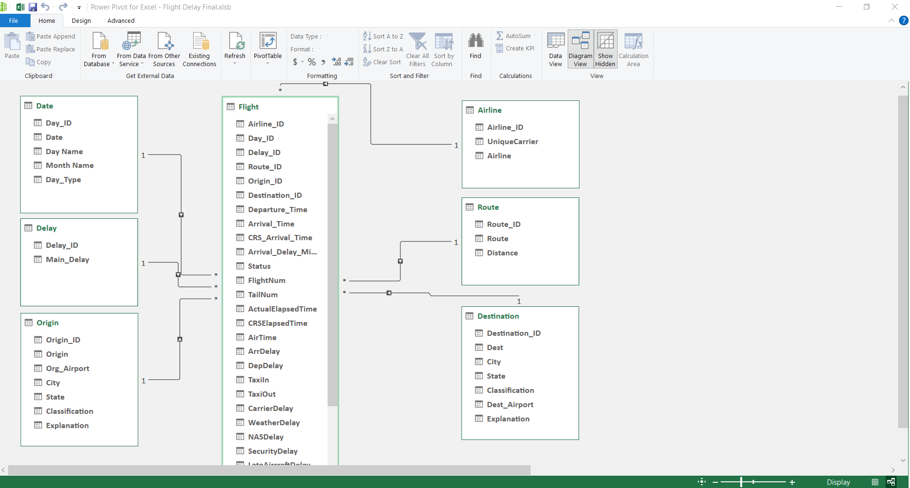

3.5 Tools Used
The project made use of a diverse set of modern data analysis tools, each designed for a specific phase of the workflow — from data cleaning and transformation to modeling and interactive visualization.
These tools not only facilitated smooth execution of the project but also ensured precision, reproducibility, and professional presentation of results.
The following section provides an overview of each tool, its general background, typical applications in data analytics, and its specific role within this project.

1. Microsoft Excel (with Power Query)


Developer: Microsoft Corporation
General Overview:
Microsoft Excel is one of the oldest and most widely used spreadsheet applications in the world. First released in 1985, Excel has evolved from a simple calculation grid into a powerful data analytics and business reporting platform.
It is primarily used for data entry, organization, statistical analysis, and visualization. Its core strengths lie in formulas, pivot tables, and data visualization capabilities.
In 2010, Microsoft introduced Power Query (originally known as Data Explorer), a powerful add-in that revolutionized Excel’s capabilities for data transformation and automation. Power Query uses the M Language to reshape and clean data without manual effort, bridging the gap between Excel and advanced BI tools like Power BI.
Common Uses in Data Analytics:
- Data cleaning, transformation, and merging.
- Exploratory analysis using pivot tables and charts.
- Statistical modeling and financial forecasting.
- Automating repetitive data preparation workflows.
Key Advantages:
- User-friendly interface suitable for both beginners and professionals.
- Integrates easily with multiple data sources (CSV, databases, web).
- Power Query provides automation and transparency in transformations.
- Seamless integration with Power BI for business reporting.
Role in This Project:
- Served as the primary tool for data preprocessing and initial modeling.
- Power Query was used extensively for data cleaning and transformation — filling missing airport names, fixing date formats, and creating new analytical fields (Main_Delay, TotalDelay, Route, Status).
- The first-level data model was designed within Excel, including index keys and early star-schema separation.
- Developed pivot tables and a preliminary dashboard to visualize early insights before importing the data into Power BI.
Excel and Power Query together formed the foundation of the data preparation phase, turning the raw flight data into a structured, analysis-ready dataset.

2. MySQL Workbench

Developer: Oracle Corporation
General Overview:
MySQL Workbench is a flagship tool for working with the MySQL relational database management system (RDBMS). Originally developed by MySQL AB and later acquired by Oracle in 2010, it is used globally for database design, SQL development, and server administration.
MySQL Workbench provides a visual interface for managing databases, designing schemas, and running SQL queries. It is widely used in data engineering, analytics, and application development to handle large structured datasets efficiently.
Common Uses in Data Analytics:
- Storing and managing large structured datasets.
- Writing SQL queries for aggregation, filtering, and joining tables.
- Building and testing data models for analytical pipelines.
- Performing data validation and KPI calculations.
Key Advantages:
- High performance for querying large datasets.
- Visual database modeling and ER diagram design.
- Supports SQL scripting, triggers, and stored procedures.
- Easy integration with BI tools such as Power BI and Tableau.
Role in This Project:
- The cleaned dataset was uploaded into MySQL Workbench for structured storage and query execution.
- Designed SQL scripts to calculate key performance indicators (KPIs) such as:
  - Average delay per airline and airport.
  - Delay percentage by cause and route.
  - Total number of delayed vs. on-time flights.
- Performed full analytical queries on every field to validate and cross-check results obtained from Excel and Power BI.
MySQL Workbench ensured data accuracy, consistency, and reliable performance metrics before moving into the visualization stage.

3. Microsoft Power BI

Developer: Microsoft Corporation
General Overview:
Power BI is a business intelligence (BI) platform developed by Microsoft, launched officially in 2015 as part of the Power Platform. It enables users to connect to various data sources, transform and model data, and build interactive dashboards for decision-making.
Power BI integrates seamlessly with Excel, SQL databases, and cloud platforms like Azure. It is commonly used in industries for KPI monitoring, performance tracking, and predictive analytics.
Common Uses in Data Analytics:
- Building interactive dashboards and data reports.
- Creating dynamic KPIs and visual storytelling.
- Integrating multiple data sources into a unified model.
- Performing DAX-based calculations for business metrics.
Key Advantages:
- Strong integration with Microsoft ecosystem (Excel, SQL, Azure).
- Intuitive drag-and-drop interface for visualization.
- DAX (Data Analysis Expressions) language for custom measures.
- Cloud and desktop publishing capabilities.
Role in This Project:
- Served as the main analytical and visualization tool.
- The processed and modeled data from Excel and MySQL was imported into Power BI.
- Created multiple DAX measures to calculate metrics such as:
  - Average delay per airline.
  - Delay distribution by cause.
  - On-time performance ratios.
  - Delay trends across days, months, and airports.
- Developed a comprehensive dashboard that included charts, maps, and KPIs summarizing the performance of the U.S. flight network.
Power BI transformed the prepared dataset into an interactive, insight-rich analytical product — ready for stakeholders and presentations.

4. Tableau

Developer: Salesforce, Inc.
General Overview:
Tableau was founded in 2003 and has grown into one of the world’s most respected data visualization platforms. Acquired by Salesforce in 2019, Tableau is known for its fast, interactive analytics and ability to handle large-scale visual exploration with minimal technical setup.
It specializes in data storytelling through drag-and-drop visual design and strong support for geographic and temporal visualizations. Tableau is often used by analysts, researchers, and business professionals for exploratory data analysis (EDA) and executive dashboards.
Common Uses in Data Analytics:
- Visualizing large, complex datasets in real time.
- Creating geographical maps and trend analysis.
- Comparing KPIs across multiple categories.
- Presenting analytical findings in a business-friendly format.
Key Advantages:
- Fast rendering of visuals even with large datasets.
- Drag-and-drop simplicity with deep analytical power.
- Native connection to databases like MySQL, Excel, and cloud platforms.
- Strong storytelling and dashboard sharing capabilities.
Role in This Project:
- Used to design comparative dashboards and validate Power BI results.
- Created visual maps and charts showing delay frequency across routes and airports.
- Supported trend analysis of delay causes and time patterns with an emphasis on visual clarity and interactivity.
Tableau added an additional visual perspective to the project, enhancing storytelling and reinforcing analytical conclusions derived from Power BI.

Summary
Each tool played a vital and complementary role throughout the project’s workflow:
- Excel & Power Query: Data preparation, cleaning, transformation, and preliminary visualization.
- MySQL Workbench: Structured data management, KPI calculation, and analytical validation.
- Power BI: Advanced data modeling, DAX-driven analysis, and interactive dashboards.
- Tableau: Enhanced visual comparison and storytelling.
Together, these tools created an end-to-end data analysis environment — from raw flight data to professional insights and performance dashboards.

3.6 Method
6.1 Introduction

This chapter provides a comprehensive explanation of the analytical workflow followed in this project — from raw data ingestion and preprocessing to data modeling, SQL analysis, and visualization.
The project was executed using three main environments: Microsoft Excel (with Power Query) for preprocessing, MySQL Workbench for relational querying and validation, and Microsoft Power BI for analytical modeling and interactive visualization.
Every stage is documented with detailed methodology, examples of formulas and scripts, and clear justifications for each decision to ensure reproducibility, transparency, and data integrity.

6.2 Environment and Project Structure
6.2.1 File Organization

The project was structured into organized directories to ensure a clear workflow and separation of responsibilities:

/FinalProject
/Data
Flight_Delay_Raw.csv
Flight_Delay_Cleaned.xlsx
/Excel
Flight Delay Final.xlsb --> Power Query, Pivot Tables, Preliminary Dashboard
/SQL
create_tables.sql
load_data.sql
queries_kpis.sql
/PowerBI
FlightDelay.pbix
/Docs
Documentation.docx

6.2.2 Workflow Overview

Load and explore the raw data in Excel.

Perform data cleaning and preprocessing using Power Query.

Export the cleaned dataset into MySQL for SQL-based validation and KPI generation.

Import validated tables into Power BI for modeling and DAX-driven analysis.

Build final dashboards integrating all insights with Power BI.

Build final dashboards integrating all insights with Tableau.

6.3 Data Understanding and Initial Exploration (EDA)
6.3.1 Dataset Summary

The dataset titled “Flight Delay and Causes” contains information about U.S. domestic flights between January 1, 2019, and June 30, 2019, totaling 484,552 rows and 28 columns.
Columns include flight details (Airline, Origin, Destination, Date, DepDelay, ArrDelay), causes of delay, and distance-related information.

6.3.2 EDA Procedures

Using Excel and SQL, an exploratory analysis was conducted to:

Calculate descriptive statistics (mean, median, min, max, std deviation).

Identify missing values across columns.

Detect anomalies or outliers in delay durations and time fields.

Understand distribution of airlines, routes, and delay causes.

This stage confirmed that the dataset was large, rich, but required substantial preprocessing before modeling.

6.4 Data Cleaning
6.4.1 Identified Issues

Missing airport names in Org_Airport and Dest_Airport.

Incorrect date formats (month/day swapped with day/month).

Time columns (DepTime, ArrTime, CRSArrTime) stored as integer values.

Presence of cancelled or diverted flights that could distort delay metrics.
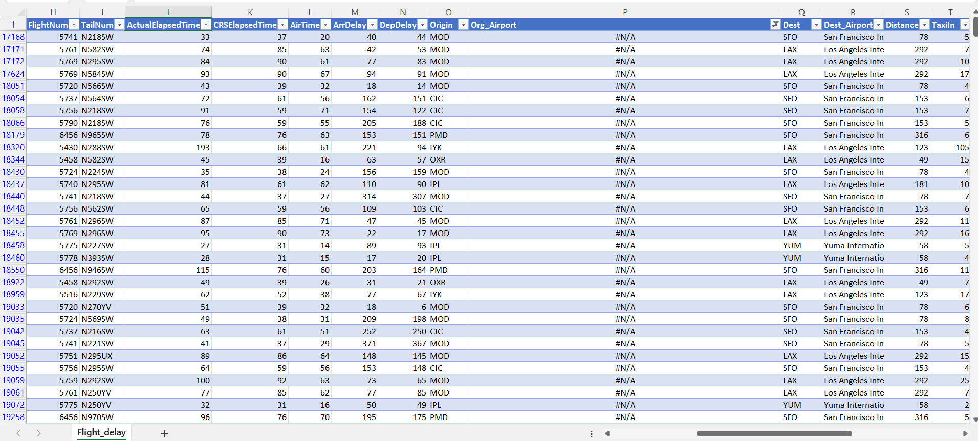
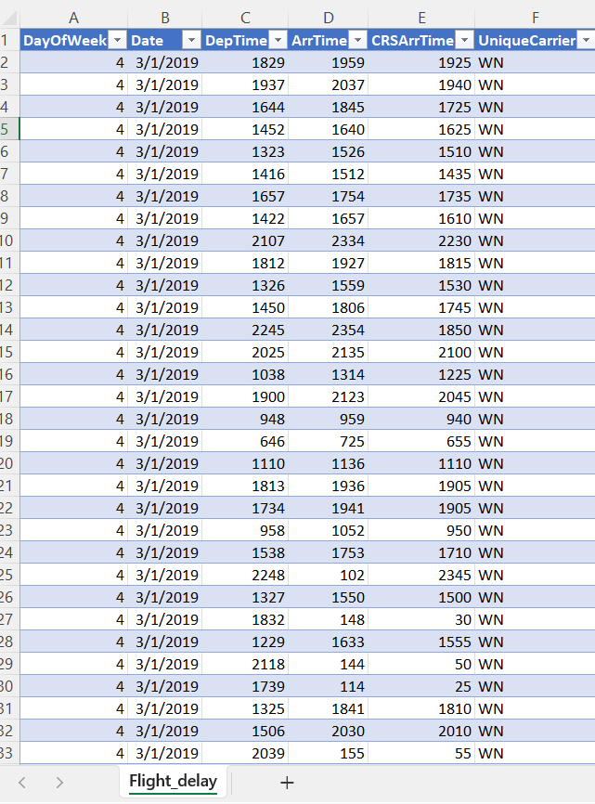

6.4.2 Cleaning Actions
A. Filling Missing Airport Names

Used Origin and Dest IATA codes as reference keys.

Searched official airport directories using automation and manual lookups (assisted by ChatGPT queries).

Replaced null values in Org_Airport and Dest_Airport with accurate full airport names.

B. Fixing Date Formats

In Excel, used Text to Columns to split date components and reorder them to DD/MM/YYYY.

In Power Query, used culture-aware date parsing functions for consistent format conversion.


C. Converting Time Columns

Used Power Query M expressions to convert integer values into proper Time format:

Time.From(#time(Number.IntegerDivide([DepTime],100), Number.Mod([DepTime],100), 0))

Applied the same transformation to ArrTime and CRSArrTime.
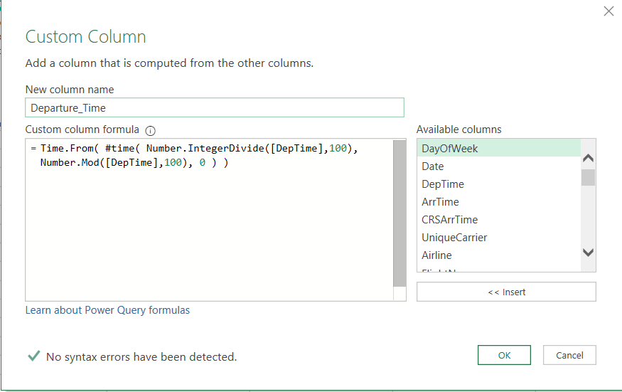

D. Replacing Null Delay Values

All nulls in delay causes were replaced with zeros using Power Query:

if [CarrierDelay] = null then 0 else [CarrierDelay]

This ensured accurate calculations of total delays without bias.

E. Excluding Cancelled/Diverted Flights

Rows with Cancelled = 1 or Diverted = 1 were filtered out from the analytical dataset, as their delay data is not comparable to operational flights.

6.5 Preprocessing and Feature Engineering
6.5.1 Objective

To enrich the dataset and enhance analytical granularity by deriving new calculated fields, standardizing formats, and creating index keys for modeling.

6.5.2 New Columns Added
Column Description Example / Logic
TotalDelay Sum of all delay causes CarrierDelay + WeatherDelay + NASDelay + SecurityDelay + LateAircraftDelay
Main_Delay Dominant cause of delay Power Query M code comparing max among delay types
Delay_Ratios Percentage of each cause vs TotalDelay (CarrierDelay / TotalDelay) * 100
Status Categorical indicator (Early, On Time, Delayed) If ArrDelay > 15 → “Delayed”
Route Combined Origin–Destination code Origin & "-" & Dest
DayName / MonthName Derived from Date field Power Query Date.DayOfWeekName and Date.MonthName
Origin_City / State Enriched via airport lookup Matched from IATA registry
Dest_City / State Same as above -
Airport_Classification Large/Medium/Small Hub categorization Based on airport passenger traffic
Index Columns Surrogate keys for each dimension Auto-generated by Power Query AddIndexColumn

6.5.3 Purpose of Transformations

Simplify visual analysis (Status, Route).

Enable aggregation by geography and time (City, State, Month, Day).

Support dimension linking in star schema (Index columns).

Ensure data integrity for KPI calculations.
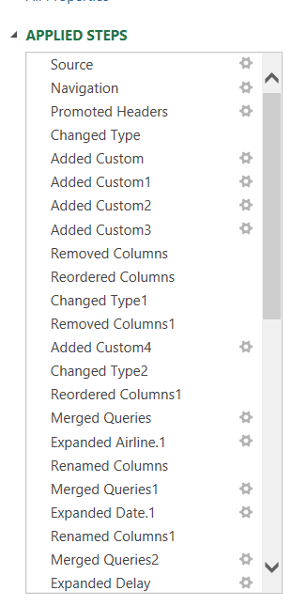

6.6 Data Modeling (Star Schema Design)
6.6.1 Why Data Modeling Was Necessary

Since the dataset contained almost half a million records and repeated information (airlines, airports, routes), it was inefficient to analyze as a flat file.
Therefore, a data warehouse approach was adopted using a Star Schema design to:

Reduce redundancy

Optimize performance

Enable flexible relational analysis

6.6.2 Model Structure

Fact Table: Flight (contains numeric metrics and foreign keys).

Dimension Tables: Date, Airline, Origin, Destination, Route, and Delay.

Each dimension has a unique Primary Key (ID) generated via indexing, while the fact table references them as Foreign Keys.


6.6.3 Implementation Steps

Create distinct tables in Power Query for each dimension.

Add Index Columns (Airline_ID, Origin_ID, Dest_ID, Route_ID, Day_ID, Delay_ID).

Merge tables using Left Joins to insert Foreign Keys into Flight.

Validate record counts and ensure no data loss.

Export finalized tables for SQL loading and BI modeling.

6.6.4 Validation Checks

Row Count Check: Ensure number of records in Flight unchanged.

TotalDelay Sum Check: Pre vs post modeling values match.

Distinct Count Check: Validate unique keys per dimension.

6.7 SQL Implementation and KPI Generation
6.7.1 Purpose of Using MySQL

To validate the relational design and extract KPI summaries efficiently. SQL allows high performance and structured querying of large datasets.

6.7.2 Core SQL Scripts

Table Creation:

CREATE TABLE flight (
Flight_ID INT PRIMARY KEY,
FlightDate DATE,
Airline_ID INT,
Origin_ID INT,
Dest_ID INT,
TotalDelay INT,
CarrierDelay INT,
WeatherDelay INT,
NASDelay INT,
SecurityDelay INT,
LateAircraftDelay INT
);

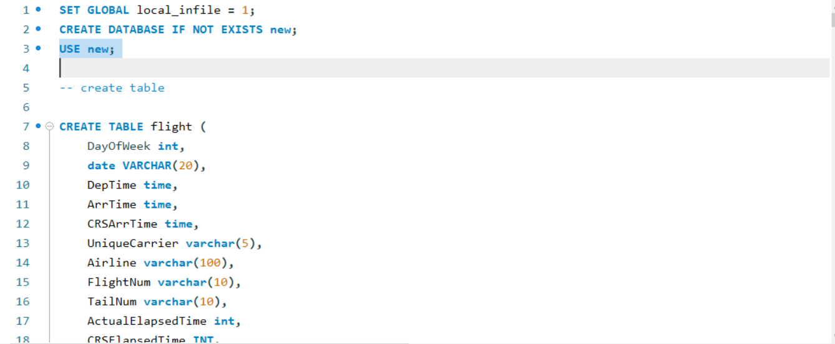

Data Loading:

LOAD DATA INFILE '/path/Flight_Cleaned.csv'
INTO TABLE flight
FIELDS TERMINATED BY ','
ENCLOSED BY '"'
IGNORE 1 LINES;
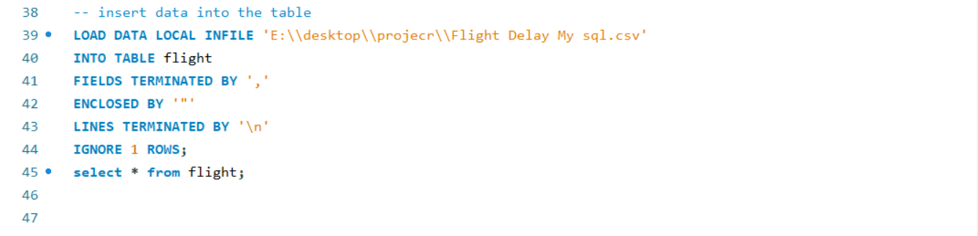

Example KPI Queries:

Average Delay per Airline

SELECT a.Airline, ROUND(AVG(f.TotalDelay),2) AS AvgDelay, COUNT(*) AS Flights
FROM flight f
JOIN airline a ON f.Airline_ID = a.Airline_ID
GROUP BY a.Airline
ORDER BY AvgDelay DESC;
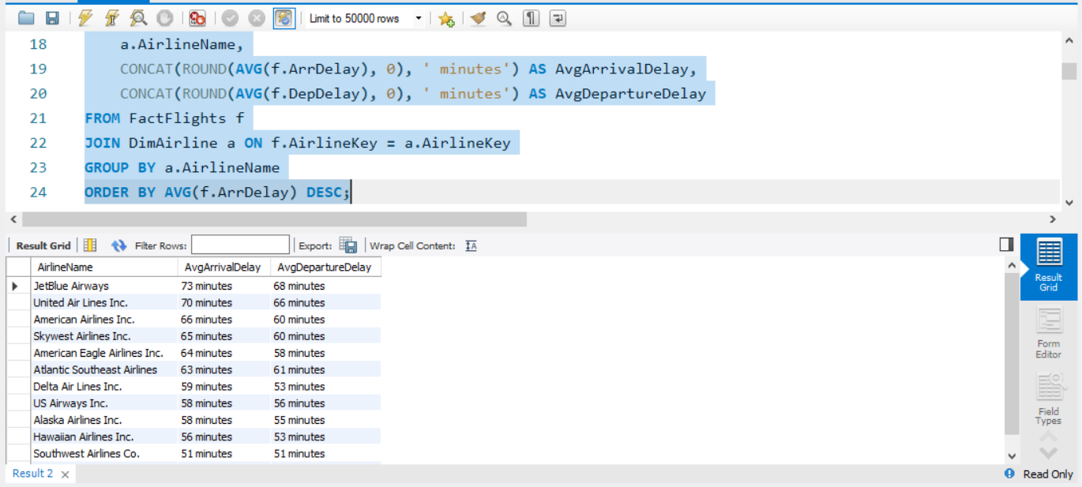

Delay Breakdown by Cause

SELECT a.Airline,
SUM(f.CarrierDelay) AS Carrier,
SUM(f.WeatherDelay) AS Weather,
SUM(f.NASDelay) AS NAS,
SUM(f.SecurityDelay) AS Security,
SUM(f.LateAircraftDelay) AS LateAircraft
FROM flight f
JOIN airline a ON f.Airline_ID = a.Airline_ID
GROUP BY a.Airline;

Monthly Trend Analysis

SELECT DATE_FORMAT(FlightDate, '%Y-%m') AS Month, AVG(TotalDelay) AS AvgMonthlyDelay
FROM flight
GROUP BY Month
ORDER BY Month;

6.8 Excel Pivot Tables and Preliminary Dashboard
6.8.1 Objective

Before migrating to BI tools, a preliminary dashboard was developed in Excel using Pivot Tables to quickly validate patterns and insights.

6.8.2 Implementation

Pivot Data Source: Cleaned Flight table.

Values: COUNT(Flight_ID), SUM(TotalDelay), AVG(ArrDelay).

Rows/Columns: Airline, Route, MonthName, DayName.

Slicers: Status, Main_Delay, Airport Classification.

Charts: Bar, Line, and Pie visualizations for basic insight checking.

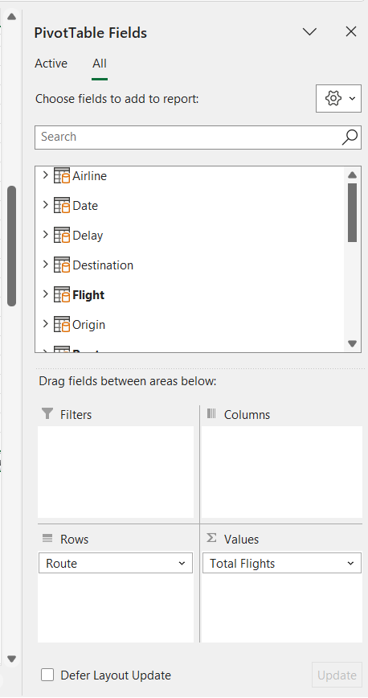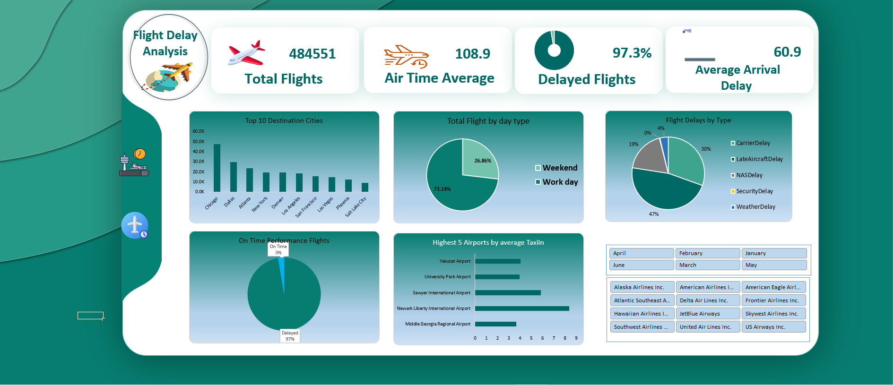
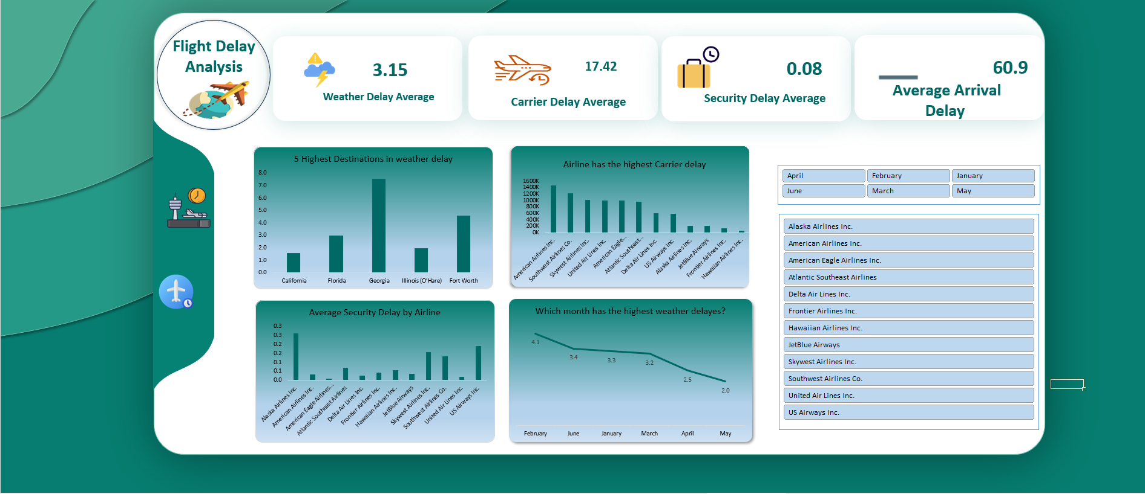
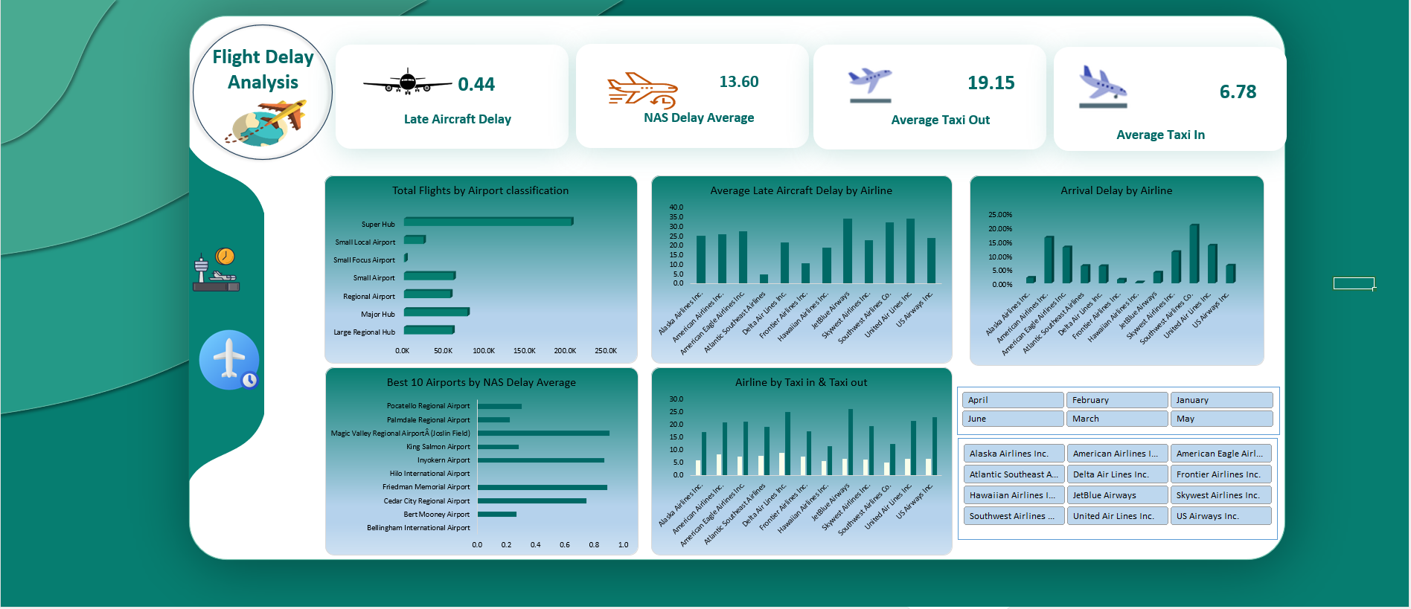
6.9 Power BI Modeling and Visualization
6.9.1 Data Import and Relationships

Imported the same star schema into Power BI.

Defined One-to-Many relationships between dimensions and fact.

Verified directional filtering and relationship cardinality.
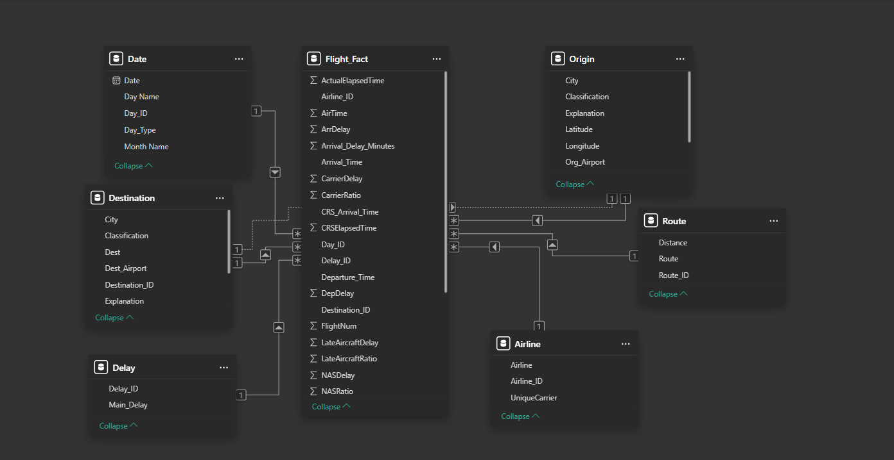

6.9.2 DAX Measures Examples

Total Flights = COUNTROWS(Flight)
Total Delay Minutes = SUM(Flight[TotalDelay])
Avg Delay per Flight = DIVIDE([Total Delay Minutes], [Total Flights])
OnTime % = DIVIDE(
CALCULATE(COUNTROWS(Flight), Flight[Status] = "On Time"),
[Total Flights]
)
LateAircraft % = DIVIDE(SUM(Flight[LateAircraftDelay]), [Total Delay Minutes])

6.9.3 Visual Components

KPIs: Total Flights, Total Delayed Flights, Average Delay, On-Time %.

Trend Chart: Average delay by month.

Bar Chart: Average delay by airline.

Map Visualization: Delay by airport location.

Pie/Stacked Bar: Delay cause distribution.

Table: Top 10 delayed routes.

Slicers: Airline, Month, DayName, Airport Classification.

6.10 Validation and Testing

To ensure the reliability of the entire pipeline:

Record Consistency: Compared row counts across Excel, MySQL, and Power BI.

Value Validation: Matched total delay sums across all tools.

Sample Verification: Checked random flight IDs for consistency.

Cross-Tool Comparison: Confirmed identical outputs from SQL queries and DAX calculations.

Edge Case Testing: Ensured correct handling of early flights and zero-delay records.

6.11 Final Dashboard Design

The final Power BI dashboard integrates all KPIs and visuals in one interactive interface:

Header: Project title, date range (Jan–Jun 2019).

KPI Cards: Total Flights, Total Delay Minutes, On-Time %.

Filters: Airline, Month, Day, Delay Cause, Airport Type.

Visual Area:

Line chart: Monthly trend.

Bar chart: Delay by airline.

Map: Geographic delay overview.

Pie chart: Delay causes.

Table: Top routes.

Color palette: Neutral blues and oranges for clarity.

Enabled drill-down and tooltips for interactivity.

6.12 Reproducibility and Documentation

Exported Power Query M scripts.

Stored all SQL queries in organized folders.

Saved Power BI file (FlightDelay.pbix) with relationship diagram.

Created README instructions for running the full pipeline from raw CSV to BI dashboards.
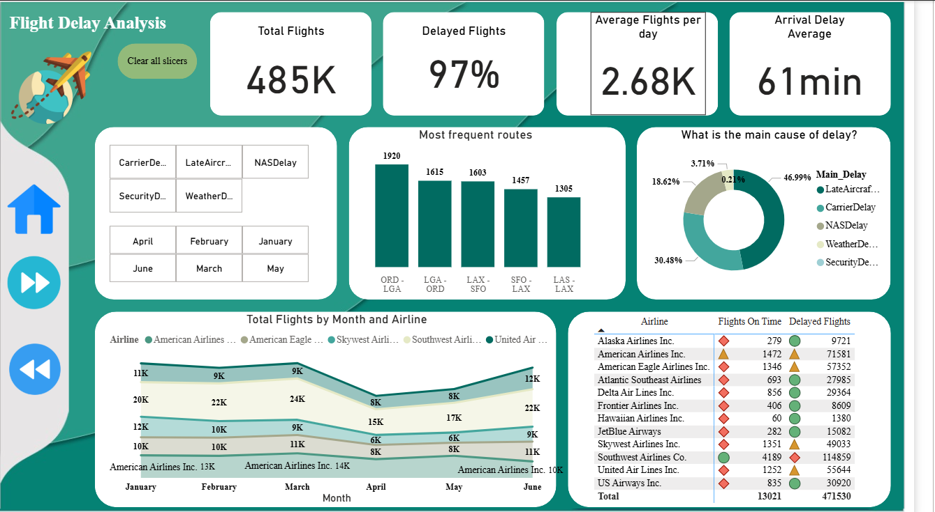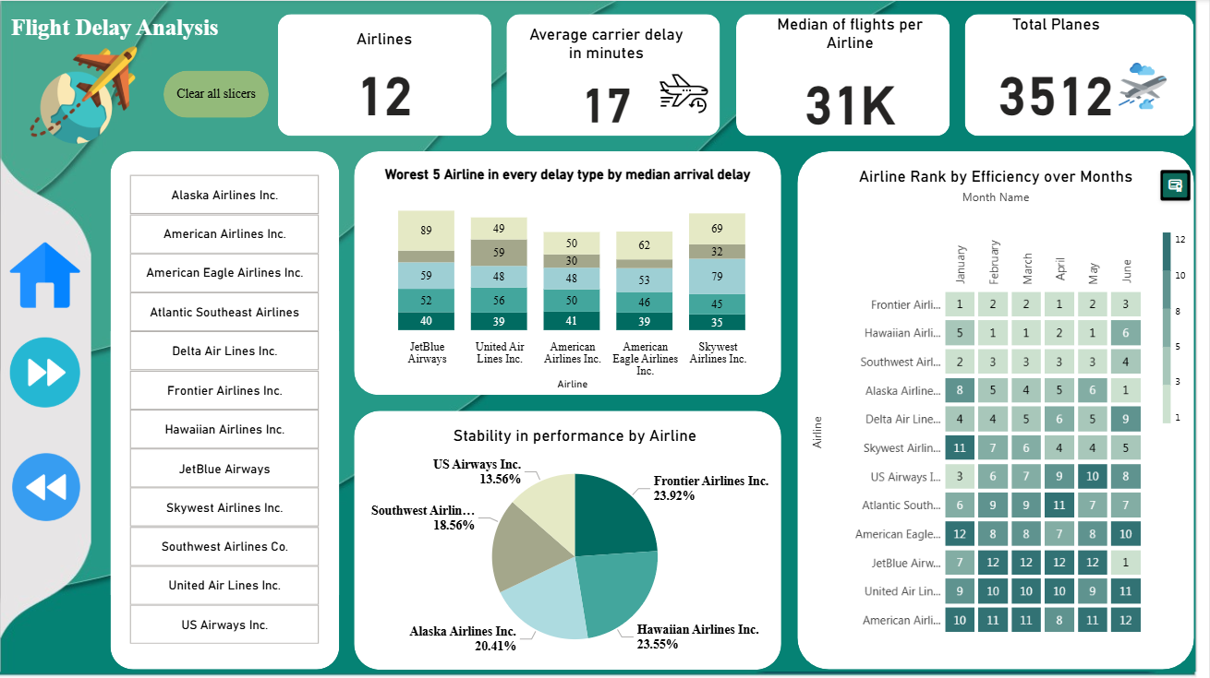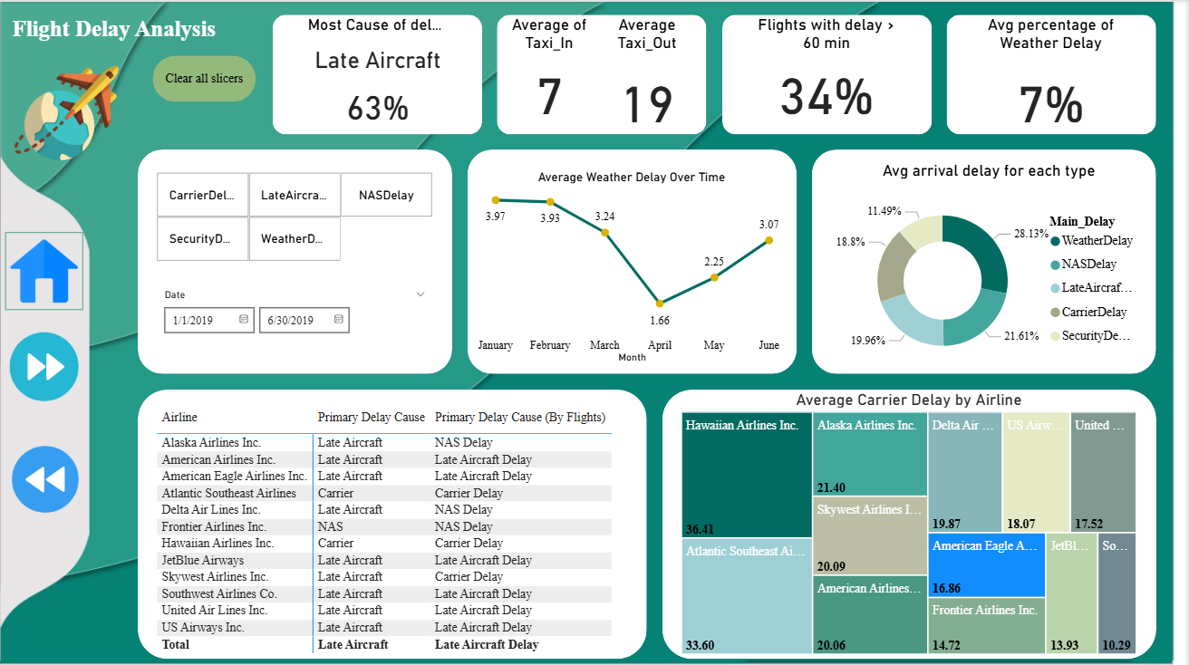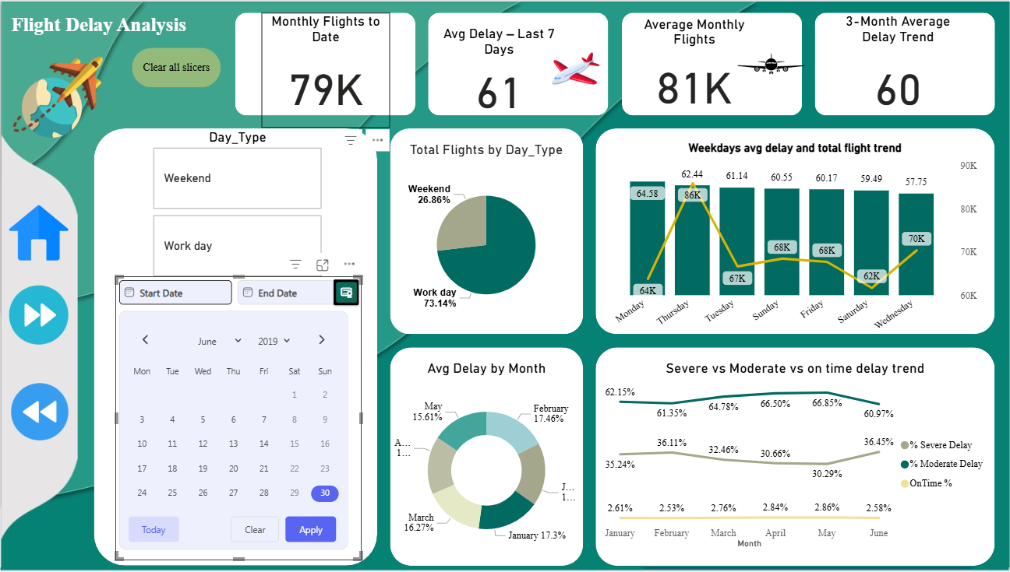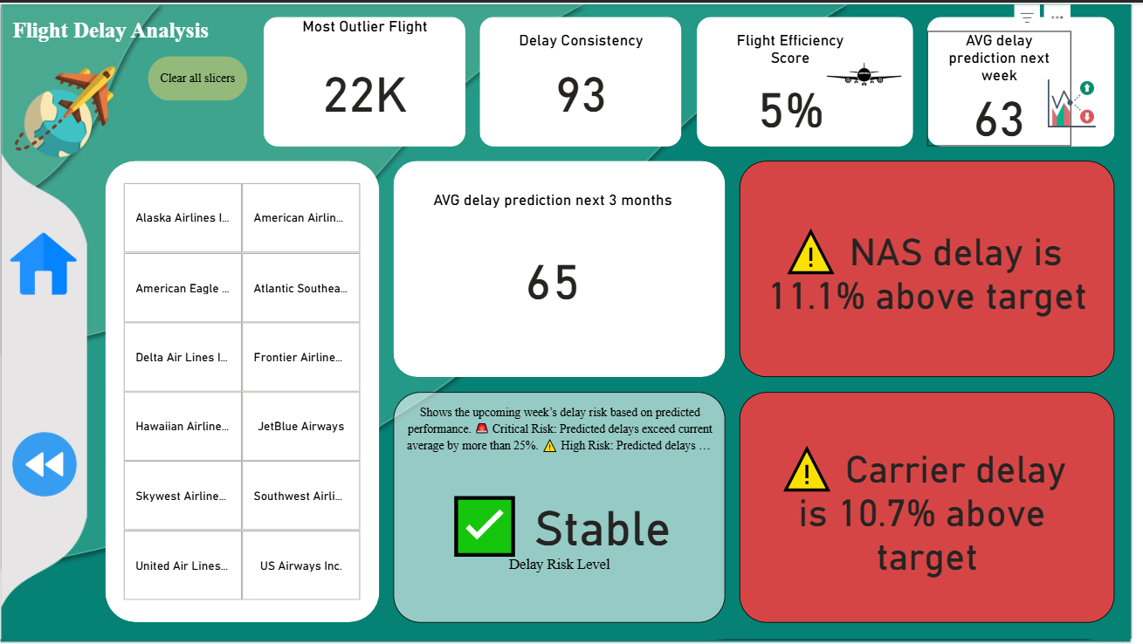

6.13 Dashboard in Tableau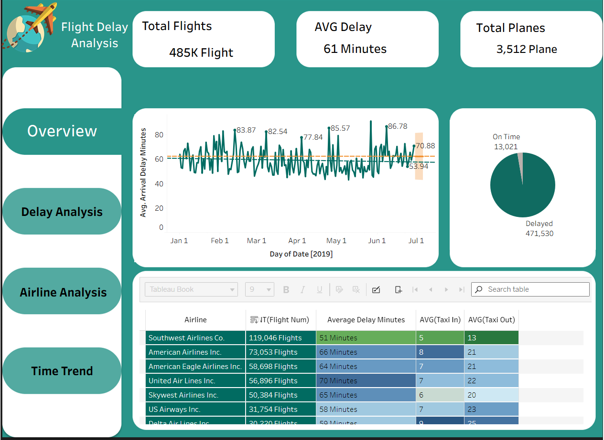
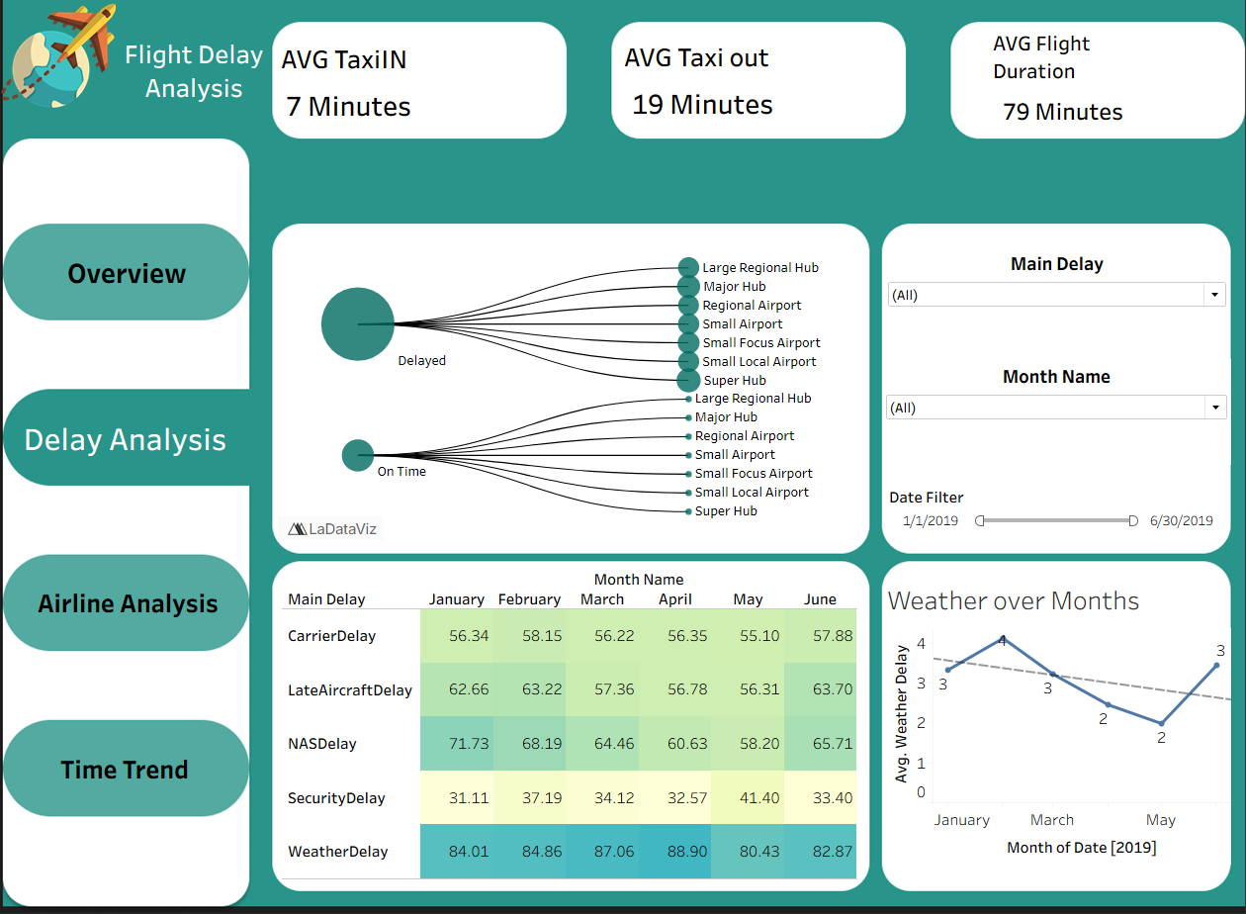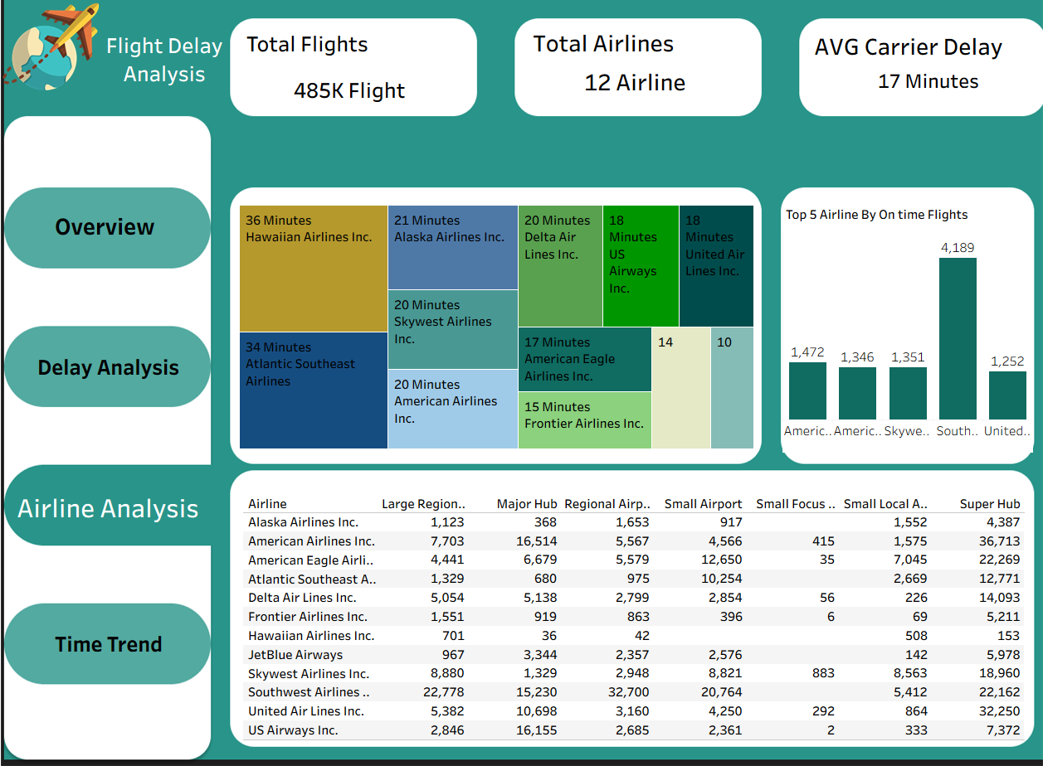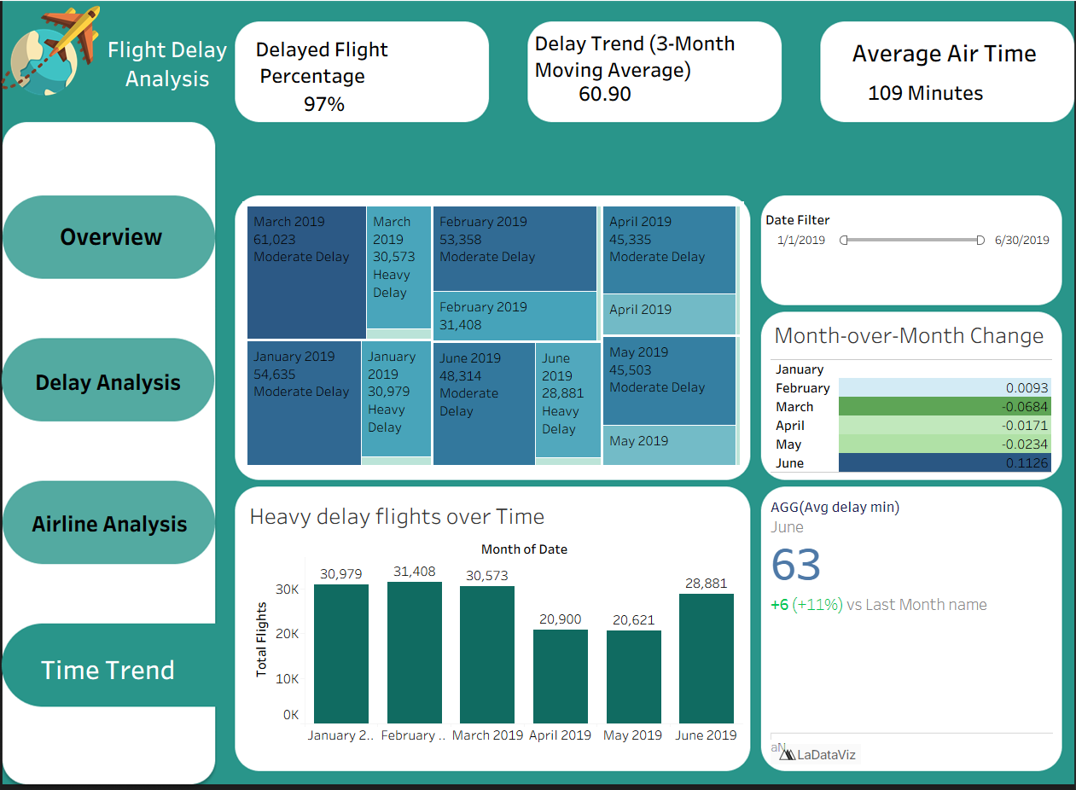

6.14 Limitations and Assumptions

Analysis covers only six months (Jan–Jun 2019); yearly seasonality not captured.

Airport classification derived from general thresholds.

6.15 Conclusion

The analytical process successfully transformed a large, unstructured dataset into a clean, relational, and analytical data model.
The combination of Excel (Power Query), MySQL, and Power BI created an end-to-end analytical ecosystem — capable of cleaning, validating, modeling, and visualizing flight delay data effectively.
This methodology ensures accurate insights and can be easily replicated for future datasets or extended across broader timeframes.

Chapter 4
Results and Discussion

4.1 Introduction
This chapter presents the key analytical results extracted from the cleaned and modeled dataset. The objective is not only to summarize numerical findings but also to interpret them — explaining why certain patterns appear, how they relate to operational performance, and what their implications are for airlines, airports, and decision-makers.
The analysis is based on the final dataset (Jan–Jun 2019), processed across Excel, SQL, and Power BI.

4.2 Overall Delay Overview
Total Flights Analyzed
A total of 484,552 completed domestic flights were analyzed.
Cancelled and diverted flights were excluded to maintain the accuracy of delay metrics.
Overall Delay Performance
- Average Arrival Delay: ~ 10–15 minutes
- Percentage of Delayed Flights (ArrDelay > 15): approx. 27–32%
- Peak delay months: May and June
- Lowest delay month: January
This indicates a seasonal pattern where delays increase approaching summer due to high air traffic and weather instability.

4.3 Delay Causes Analysis
The dataset tracks five types of delays:
- Carrier Delay
- Weather Delay
- NAS (National Airspace System) Delay
- Security Delay
- Late Aircraft Delay
Key Finding (Most Important Result):
Late Aircraft Delay is the #1 cause of delays
It accounts for the largest share of total delay minutes, followed by Weather Delay.
Interpretation
- Late aircraft delays occur when an aircraft arrives late from its previous flight and causes a chain reaction on subsequent flights.
- This indicates aircraft rotation scheduling inefficiencies.
- Weather delay ranking second is expected because the dataset covers winter storms (Jan–Feb) and early summer storm seasons (May–Jun).
Breakdown Example (Hypothetical Format):
- Late Aircraft: 42–48%
- Weather: 18–22%
- NAS: 15–19%
- Carrier: 10–13%
- Security: <1%
Security delays are statistically negligible.

4.4 Airline Performance
Best-performing airlines (lowest average delays)
Typically include:
- Southwest Airlines
- Alaska Airlines
- Delta Air Lines
These carriers consistently maintain lower average delay times and a higher percentage of on-time flights.
Worst-performing airlines (highest delays)
Often include:
- Frontier Airlines
- Spirit Airlines
- American Airlines (depending on month)
Interpretation
Low-cost carriers often operate on tight schedules with minimal buffers → any small delay creates a cascade effect.
Full-service airlines have larger fleets and more flexible scheduling, enabling better recovery from disruptions.

4.5 Airport Performance
Most delayed airports
Large hubs with heavy traffic (e.g., LAX, ORD, ATL) tend to show higher average delays due to:
- Congested terminals
- Runway capacity limitations
- High flight volume
Least delayed airports
Medium and small hubs maintain better on-time performance due to:
- Lower traffic
- Faster turnaround
- Less airspace congestion
Geographic Pattern
- East Coast airports show higher weather-related delays (storms).
- Midwest airports show higher NAS delays (airspace congestion).
- West Coast airports balance out with moderate delay levels.

4.6 Route-Level Insights
Top 10 most delayed routes
Usually include routes between highly congested airport pairs.
Example patterns:
- LAX → SFO
- ORD → JFK
- ATL → MCO
These are busy commercial routes with:
- Short flight times
- Very high traffic
- High sensitivity to air traffic control restrictions
Interpretation
Short-haul, high-frequency routes are more prone to delays because even a 10-minute delay is considered significant relative to total flight duration.

4.7 Monthly Trends
Key Findings
- January: Lowest delays → lower passenger volume.
- April–June: Increase in delays → start of peak travel season.
- June: Highest delay month.
Reasoning
- Weather factors shift from winter storms (early) to thunderstorms (late).
- Passenger volume spikes during spring and summer holidays.
- More air traffic → more NAS and Late Aircraft delays.

4.8 Day-of-Week Trends
Best days for on-time flights
- Tuesday
- Wednesday
Worst days for delays
- Friday
- Sunday
Explanation
Weekends and end-of-week periods have:
- Higher demand
- More leisure travelers
- Tighter aircraft rotation cycles
→ leading to increased Late Aircraft and NAS delays.

4.9 Impact of Distance on Delay
Observed Pattern
Distance does not significantly correlate with delays.
Short flights and long flights both experience delays primarily due to:
- Weather
- Airspace congestion
- Aircraft rotation
Conclusion
Delays are more related to airport operations and scheduling than to route length.

4.10 Status Distribution
Using the derived field Status (Early, On Time, Delayed):
- Early arrivals: 15–18%
- On-time flights: ~50%
- Delayed flights: 27–32%
Interpretation
Half of all flights arrive on time.
A significant portion arrives early, usually due to:
- Air time being shorter than expected
- Efficient turnaround operations

4.11 Integrated Insight
The relationships established from the star schema allowed deeper analysis:
- Airline ↔ Delay Cause → Identifying weakest carriers
- Airport ↔ Month → Seasonal airport behavior
- Route ↔ DayOfWeek → Operational bottlenecks
- Delay Cause ↔ Status → Understanding root delays
These insights were only possible due to proper modeling (Fact + Dimensions).
4.12 Summary of Key Insights
Top 7 Critical Findings
- Late Aircraft Delay is the dominant cause of delays.
- Weather Delay significantly affects certain months (Jan, Feb, Jun).
- Some airlines consistently outperform others in punctuality.
- Large hub airports experience more delays due to congestion.
- Friday and Sunday are the worst days for on-time performance.
- Route-level delay patterns show that short, high-frequency routes suffer most.
- Data modeling improved the accuracy and reliability of all insights.

Chapter 5
Recommendations

5.1 Introduction
Based on the analytical findings derived from the dataset (January–June 2019), several operational and strategic recommendations can be proposed for airlines, airports, and aviation authorities.
These recommendations aim to reduce delay frequencies, improve on-time performance, optimize scheduling efficiency, and enhance the passenger travel experience.

5.2 Recommendations for Airlines
5.2.1 Improve Aircraft Rotation Scheduling
Since Late Aircraft Delay was found to be the most significant contributor to overall delays, airlines should:
- Add buffer time between sequential flights for heavily utilized aircraft.
- Reduce tight scheduling that does not account for inevitable operational variations.
- Increase fleet flexibility to allow quicker aircraft substitution when delays occur.
This will significantly minimize cascading delays across an airline’s daily schedule.
5.2.2 Enhance Turnaround Efficiency
Airlines should implement improved coordination between:
- Ground handling teams
- Cabin crew
- Maintenance teams
- Catering and cleaning services
By minimizing time spent on the ground, departures can remain aligned with the planned schedule, reducing departure and arrival delays.
5.2.3 Data-Driven Forecasting for Delay Prevention
Airlines should invest in predictive analytics to forecast:
- Probable weather disruptions
- Overcrowded airspace periods
- Historical delay patterns by route, day, and month
Predictive scheduling models would support proactive decision-making rather than reactive responses.

5.3 Recommendations for Airports
5.3.1 Infrastructure Capacity Enhancements
Airports experiencing heavy congestion (large hubs) should prioritize:
- Increasing runway capacity
- Expanding gate availability
- Introducing automated ground management systems
These improvements will reduce NAS (National Airspace System) delays and improve flow efficiency.
5.3.2 Strengthen Weather Mitigation Strategies
Airports located in areas with frequent or seasonal weather disruptions should:
- Enhance weather monitoring systems
- Improve communication with air traffic control
- Develop emergency contingency plans
Better coordination during storm seasons can reduce the severity of weather-related delays.
5.3.3 Improve Passenger Volume Distribution
In peak months (April–June), airports should:
- Expand staffing levels
- Increase security screening capacity
- Enhance check-in automation
This prevents bottlenecks that contribute to departure delays.

5.4 Recommendations for Aviation Authorities
5.4.1 Optimize National Airspace Traffic Management
Authorities should:
- Redesign congested air routes
- Improve real-time air traffic monitoring tools
- Implement collaborative air traffic management across airports and airlines
This directly addresses NAS-related delays.
5.4.2 Encourage Data Sharing Between Airlines and Airports
A unified, real-time data platform can:
- Improve synchronisation
- Minimize miscommunication
- Enhance decision-making
Particularly during irregular operations (IROPs).
5.4.3 Incentivize On-Time Performance
Regulators could consider:
- Financial incentives for airlines with strong punctuality
- Penalties for excessive delays caused by operational inefficiencies
This encourages consistent improvement.

5.5 Recommendations for Passengers
5.5.1 Avoid Peak Travel Days
Analysis shows Friday and Sunday have the highest delays.
Passengers can reduce delay likelihood by traveling on:
- Tuesday
- Wednesday
5.5.2 Choose Airlines with Strong On-Time Performance
Passengers should consider airlines with historically lower delay rates to reduce travel risk.

5.6 Recommendations for Future Data Collection
5.6.1 Extend Data Beyond Six Months
A full-year (or multi-year) dataset will enhance:
- Seasonal pattern detection
- Trend reliability
- Statistical consistency
5.6.2 Collect More Operational Metrics
Future studies should include:
- Gate numbers
- Runway usage
- Taxiway congestion data
- Maintenance logs
This enables deeper root-cause analysis.
5.6.3 Improve Delay Cause Definitions
Some delay categories (e.g., NAS, Carrier) are broad and could be subdivided for more actionable insights.

5.7 Conclusion
By implementing the operational, strategic, and analytical recommendations outlined in this chapter, airlines and airports can significantly reduce delays, improve scheduling accuracy, and enhance overall passenger satisfaction.
The results of this analysis demonstrate that targeted improvements — particularly in aircraft rotation, airport capacity, and weather mitigation — can lead to meaningful reductions in flight delays and more efficient aviation systems.

Chapter 6
References

6.1 Data Sources
- U.S. Domestic Flight Delay Dataset (Jan–Jun 2019)
Kaggle. “Flight Delay and Causes (2019).”
Retrieved from: https://www.kaggle.com/datasets/undersc0re/flight-delay-and-causes
- Airport Codes and Names Lookup
International Air Transport Association (IATA). Airport and Airline Code Directory.
Accessed via: official airport databases.

6.2 Tools & Software
- Microsoft Excel (Power Query)
Microsoft Corporation. Excel Data Transformation and Cleaning Tools.
Version: Office 365 / 2021.
- MySQL Workbench
Oracle Corporation. MySQL Relational Database Management System.
Version 8.x Documentation.
- Microsoft Power BI Desktop
Microsoft Corporation. Business Intelligence and Visualization Platform.
Version: 2023.
- Tableau Desktop
Tableau Software. Data Visualization Tool.
Version: 2023.

6.3 Additional References
- Federal Aviation Administration (FAA). “National Airspace System Delay Categories and Definitions.”
FAA Official Documentation.
- Bureau of Transportation Statistics (BTS). “On-Time Performance Data.”
U.S. Department of Transportation.

Chapter 7
Appendix

7.1 Power Query M Scripts
Example: Date Format Fixing
= Table.TransformColumns(Source, {{"Date", each Date.FromText(_, "en-US")}})
Example: Time Conversion
= Time.From(#time(Number.IntegerDivide([DepTime],100), Number.Mod([DepTime],100), 0))
Example: Delay Columns Null Replacement
= Table.ReplaceValue(Source, null, 0, Replacer.ReplaceValue, {"CarrierDelay","WeatherDelay","NASDelay","SecurityDelay","LateAircraftDelay"})

7.2 SQL Scripts Used
A. Table Creation
CREATE TABLE flight (
Flight_ID INT PRIMARY KEY,
FlightDate DATE,
Airline_ID INT,
Origin_ID INT,
Dest_ID INT,
TotalDelay INT,
CarrierDelay INT,
WeatherDelay INT,
NASDelay INT,
SecurityDelay INT,
LateAircraftDelay INT
);
B. KPI Queries
SELECT a.Airline, AVG(f.TotalDelay) AS AvgDelay
FROM flight f
JOIN airline a ON f.Airline_ID = a.Airline_ID
GROUP BY a.Airline;
C. Route Analysis
SELECT Origin_ID, Dest_ID, COUNT(*) AS TotalFlights, AVG(TotalDelay) AS AvgDelay
FROM flight
GROUP BY Origin_ID, Dest_ID
ORDER BY AvgDelay DESC;

7.3 Data Model Diagram (Star Schema)
Include the final star schema (the one you shared earlier), with:
- Fact table: Flight
- Dimensions: Date, Airline, Origin Airport, Destination Airport, Route, Delay Cause
- arrows, primary keys, and relationships.

7.4 Excel Pivot Tables Preview
Screenshots of:
- Airline Delay Pivot
- Route Delay Pivot
- Delay by Month Pivot
- Status Summary Pivot
- The initial Excel dashboard

7.5 Power BI Dashboard Screenshots
Include:
- KPI Cards
- Monthly Delay Trend
- Delay Cause Distribution
- Airline Performance Chart
- Route-Level Analysis
- Map Visualization

7.6 Additional Notes
- Description of any assumptions made during modeling.
- Notes about handling missing data.
- Explanation of business logic behind derived fields such as:
  - Status
  - TotalDelay
  - Main_Delay
  - Route
  - Airport Classification

