Text-Based Emotion Classification Using NLP and Machine Learning
Abstract
This research focuses on enhancing text-based emotion classification through advanced preprocessing and data balancing techniques. The proposed approach integrates Natural Language Processing (NLP) with supervised machine learning algorithms. Enhancements include the use of spaCy-based text preprocessing and Synthetic Minority Oversampling Technique (SMOTE) to address class imbalance. Experimental results demonstrate improved classification performance across multiple evaluation metrics, with notable accuracy and recall for underrepresented emotion classes.
1. Introduction
Social media platforms generate vast amounts of text data, providing an opportunity to analyze and classify emotions for applications such as sentiment analysis, mental health monitoring, and customer feedback analysis. Despite its potential, text-based emotion recognition faces challenges due to imbalanced datasets and noise in textual data. To address these issues, this study introduces advanced preprocessing and data balancing techniques, building on previous methodologies.
2. Related Work
Existing studies have primarily relied on traditional preprocessing techniques and manual balancing approaches. Emotion classification models, such as Support Vector Machines (SVM), Random Forests, and Decision Trees, have demonstrated varying levels of accuracy. However, these models often struggle with imbalanced datasets and noisy textual data. Recent advancements in NLP and data augmentation, such as SMOTE, present opportunities to overcome these limitations.
3. Methodology
3.1 Dataset Collection
The study uses the "Emotion in Text" dataset from Kaggle, containing six emotion classes: Anger, Fear, Joy, Love, Sadness, and Surprise. The dataset includes 21,459 samples, with significant class imbalances.
3.2 Preprocessing
Advanced text preprocessing is implemented using spaCy, focusing on:
- Tokenization and lemmatization.
- Removal of stop words and punctuation.
- Conversion of text to lowercase.
Code Implementation:
import spacy
nlp = spacy.load('en_core_web_sm')

def preprocess(text):
doc = nlp(text)
filtered_tokens = [token.lemma_ for token in doc if not token.is_stop and not token.is_punct]
return " ".join(filtered_tokens)
3.3 Data Balancing with SMOTE
To address class imbalance, SMOTE is applied to the preprocessed dataset:
- Synthetic samples are generated for underrepresented classes.
- Ensures balanced representation across all emotion classes.
Code Implementation:
from imblearn.over_sampling import SMOTE
from sklearn.model_selection import train_test_split

smote = SMOTE(sampling_strategy='all')
X_sm, y_sm = smote.fit_resample(x_vec, y)
X_train, X_test, y_train, y_test = train_test_split(X_sm, y_sm, test_size=0.2, random_state=42)
After explaining the impact of SMOTE:
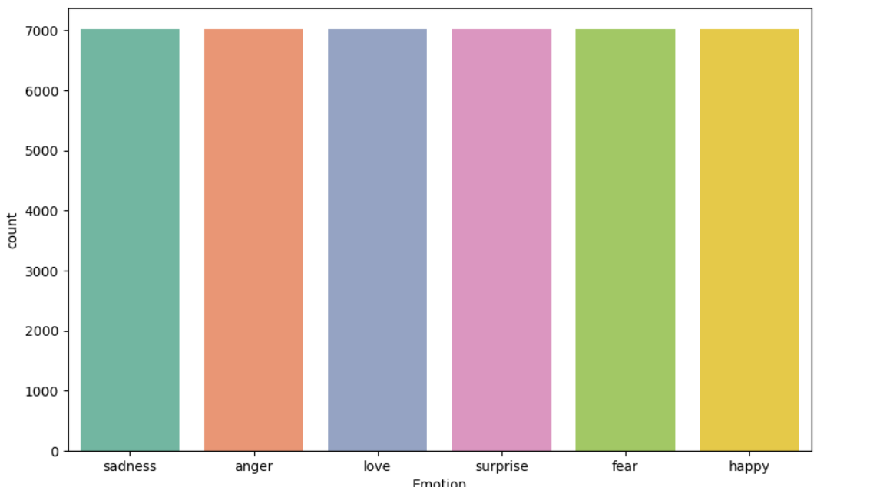
3.4 Model Development
Three machine learning algorithms are evaluated:
- Random Forest (RF)
- Linear Support Vector Machine (Linear SVM)
- Decision Tree Classifier (DTC)
Data is vectorized using TfidfVectorizer and split into training and testing sets. Models are evaluated using metrics such as accuracy, precision, recall, and F1-score.
4. Results and Discussion
4.1 Preprocessing Impact
The inclusion of spaCy-based preprocessing significantly reduced noise and improved the representational quality of text data, leading to enhanced model performance.
4.2 Data Balancing Impact
SMOTE balanced the dataset, resulting in improved recall and F1-scores for underrepresented classes. The average accuracy across all models increased
4.3 Model Performance
Model | Accuracy | Precision | Recall | F1-Score
Random Forest | 88.63 | 0.89 | 0.89 | 0.89
Linear SVM | 94.27 | 0.94 | 0.94 | 0.94
Decision Tree | 87 | 0.85 | 0.84 | 0.85
Linear SVM achieved the highest accuracy and overall performance, making it the most suitable model for deployment.
5.EvaluationMetrics
5.1 Linear SVM Confusion Matrix
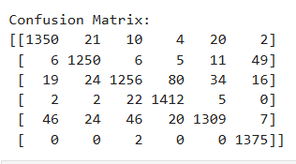
Classification Report
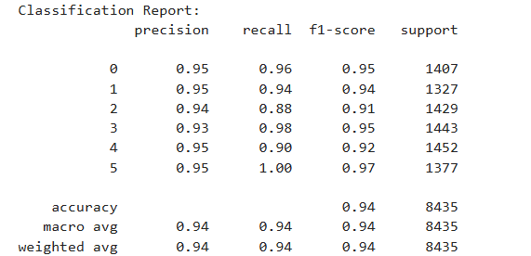
5.2 Decision Tree Classifier Confusion Matrix
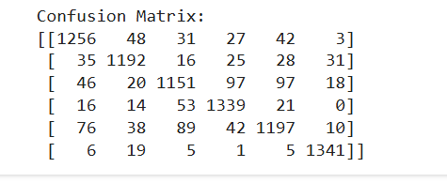
Classification Report
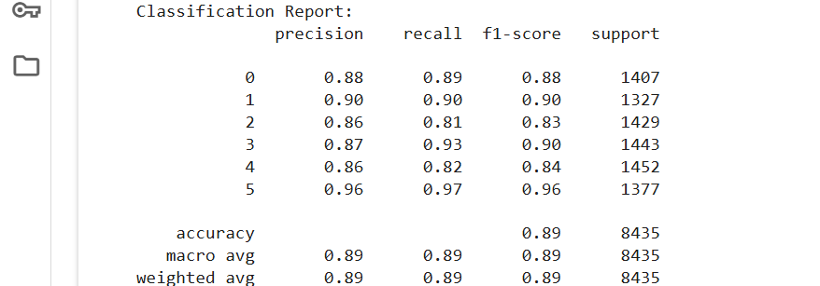
5.3 Random Forest Confusion Matrix
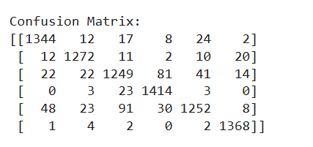
Classification Report
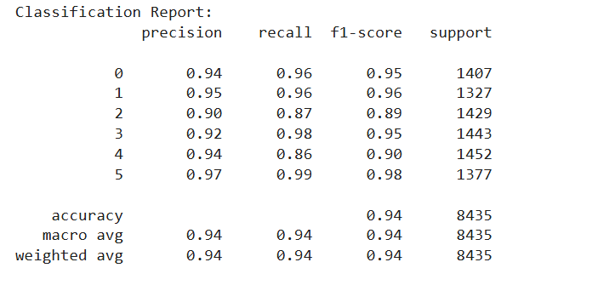
6. Conclusion
This study demonstrates that combining advanced preprocessing techniques with data balancing significantly improves the performance of text-based emotion classification models. Future work includes exploring deep learning approaches and applying these techniques to multilingual datasets.

