**University of Palestine**

**Facility of applied engineering and urban planning**

**Software Engineering Department**

**Home Trend   
(Application & Web Page)**

**Submitted by:**

**Basel Midhat Mohaisen.**

**Ziad Talal Abo Alkamar.**

**Mohammed zoheir Almadani.**

**Nedaa Hatem Ahmed.**

**Saja Fayez Radwan.**

**Abeer Ahmed Salim.**

**Supervised by:**

**Dr. Abed El-Hamid Zoughbor.**

**2021**

Table of Contents

Contents

1 CHAPTER 1: INTRODUCTION 7

1.1 Introduction 7

1.2 Background 7

1.3 Problem Statement 2

1.4 Project Motivation 3

1.5 Problem Question 3

1.6 Goals & Objectives 4

1.7 Project Scope and Limitations 5

1.8 Contributions 5

1.9 Conclusion 6

1 CHAPTER 2: LITERATURE REVIEW 7

2.1 Introduction 7

2.2 E-commerce (electronic commerce) 7

2.3 Techniques used 8

2.3.1 Design Techniques 8

2.3.1.1 Adobe XD 8

2.3.1.2 Draw.io 8

2.3.1.3 EdrawMax 8

2.3.1.4 Photoshop 9

2.3.2 Flutter Techniques 9

2.3.2.1 IntelliJ IDEA 9

2.3.2.2 Firebase 9

2.3.2.3 Services 10

2.3.2.3.1 Firebase Authentication 10

2.3.2.3.2 Firebase Cloud Firestore 10

2.3.2.3.3 Firebase Storage 10

2.3.2.4 Xcode 10

2.3.3 Web Techniques 11

2.3.3.1 Laravel 11

2.3.3.2 PHP 11

2.3.3.3 MySQL 11

2.3.3.4 Visual Studio Code 12

2.3.3.5 XAMPP 12

2.3.3.6 HTML5 12

2.3.3.7 CSS3 13

2.3.3.8 Bootstrap (Front-end Framework) 13

2.3.4 Communication Techniques 13

2.3.4.1 Zoom 13

2.3.4.2 GitHub 13

2.3.4.3 WhatsApp 14

2.4 Related works 15

2.4.1 Houzz app & website 15

2.4.1.1 Overview 15

2.4.1.2 Advantages 16

2.4.1.3 Disadvantages 16

2.4.2 Atheth 17

2.4.2.1 Overview 17

2.4.2.2 Advantages 18

2.4.2.3 Disadvantages 18

2.4.3 موقع قمتي 19

2.4.3.1 Overview 19

2.4.3.2 Advantages 20

2.4.3.3 Disadvantages 20

2.4.4 Comparison 20

2.5 Conclusion 21

1 CHAPTER 3: PROJECT METHODOLOGY 22

3.1 Introduction 22

3.2 Agile Model 22

3.3 Principles behind the Agile Manifesto [46]: 23

3.4 Agile benefits 24

3.5 Reasons for Choosing this Model 24

3.6 Iterative #1 Phase: 25

3.6.1 Requirement analysis: 25

3.6.2 Design 26

3.6.3 Development 27

3.6.4 Testing 27

3.6.5 Deployment 28

3.7 Gant Chart 28

3.8 Conclusion 30

References 31

List of Figures

Figure 1-2 Adobe XD 9

Figure 2-2 Draw.io 9

Figure 3-2 EdrawMax 9

Figure 4-2 Photoshop 10

Figure 5-2 Flutter 10

Figure 6-2 IntelliJ IDEA 10

Figure 7-2 Firebase 10

Figure 8-2 Xcode 11

Figure 9-2 Laravel 11

Figure 10-2 PHP 12

Figure 11-2 MySQL 12

Figure 12-2 Visual Studio Code 12

Figure 13-2 XAMPP 13

Figure 14-2 HTML5 13

Figure 15-2 CSS3 13

Figure 16-2 Bootstrap 14

Figure 17-2 Zoom 14

Figure 18-2 GitHub 14

Figure 19-2 WhatsApp 15

Figure 20-2 Houzz App 16

Figure 21-2 Houzz Homepage 17

Figure 22-2 Atheth Homepage 18

Figure 23-2 Atheth Homepage 18

Figure 24-2 Qimmati Homepage 20

Figure 25-2 Qimmati Homepage 20

Figure 26-3 Agile Phase 23

Figure 27- 3 Agile Model Phase 26

Figure 28-3 Requirements Analysis 27

Figure 29-3 Home Trend Gantt chart 32

List of Tables

Table 2-2 Similar Systems Comparison 22

Table 3-3 Home Trend Proses Scheduling 30



***CHAPTER 1  
Table of Content:***

**1.1 Introduction**

**1.2 Background**

**1.3 Problem Statement**

**1.4 Problem Motivation**

**1.5 Problem Question**

**1.6 Goals & Objectives**

**1.7 Project Scope and Limitations**

**1.8 Contributions**

**1.9 Conclusion**

# CHAPTER 1: INTRODUCTION

## Introduction

This chapter provides readers, stakeholders, and developers with information about this project by introducing the project idea and a statement of the project's objectives, motivations, and contribution to the project. It focuses on clarifying the problem, how to solve this problem, and the scope and limitations of this solution.

## Background

At the moment, there may be no one without a smartphone. With the Internet, smartphones have changed many aspects of life, such as education, health, entertainment, transportation, and many other areas, and turned the world into a small village, and the time to search and explore things is lost to save time and effort as well as shopping.

Smart device applications are categorized according to the tasks and functions they perform into several categories, including shopping classification.

E-commerce applications are applications for online shopping and doing business. Businesses and merchants can sell their products and enable them to reach as many consumers as possible, crossing geographical boundaries like never before. In addition, it enables seniors to access the largest variety of products through these applications.

We see a large and noticeable trend in the twentieth century towards e-commerce applications targeting different age groups and cultural and material levels. This led to stimulating investment to build e-commerce sites and promote through them because they save time and effort and reach companies and traders to sell their products and reach the largest possible number of consumers crossing geographical boundaries as never before. In addition, it enables seniors to access the largest variety of products through these applications.

Due to the spread of the current epidemic and the limited daily shopping through shops and the need to access electronic stores with the lack of the appropriate time and place for shopping, and the massive overcrowding of shops during the permitted periods of movement, facing difficulty in transporting furniture properly to homes.

People want to get designs and have their own ideas about them in the light of consulting specialists in interior design. And also the interior designers' accumulation work without benefiting from it and their experience in this field.

The solution to this problem was to create an application and a website to reduce congestion and save time and effort for customers, and the idea drew attention because it facilitated people's lives, reduced congestion and saved effort, and fit with their financial budgets and the proposals in the exhibition. Many applications are similar to this one, but this one is easy to use and handle and has a creative design for setting standards.

In this study, we have presented a Home Trend application and website to provide remote electronic service to display the exhibition furniture in a wonderful marketing way, especially that the application provides convenience for buyers, sellers, and visitors, in general, to browse the contents of the store without the need to go to the exhibition and display the contents in a very realistic way, and they can also sell their old used furniture For the store, facilitating financial matters and the possibility of paying in cash or electronic cards and providing the service of delivering products to the home of the buyer or seller, in addition to the possibility for the visitor to browse around the clock and not be bound by a specific time or place, and to provide direct communication between the customer and consultants specialized in furniture.

Also, the user can request local manufacture of a specific design or specifications with the possibility of consulting furniture specialists for free or communicating with interior designers and paying a fee for external consultation. The interior designers have been allocated the first Arab platform inside the Gaza Strip, which is based on the idea of freelancer sites by presenting their designs and projects and providing external consultations to customers in return for a fee.

## Problem Statement

Due to the increase in the number of shops and markets in general, and the lack of those shops for used furniture, we find the scarcity of international products in the local markets.

Also, the spread of the Coronavirus in the Gaza Strip is the main reason, the speed of transmission of the disease, the commitment of people to quarantine, and their lack of movement from one place to another, Low usage of credit cards so the customer cannot use them in some online stores.  
The presence of old furniture in homes without benefiting from it, the need to furnish the homes according to the appropriate financial budgets, also the difficulty of getting products to the customer quickly and easily so that the furniture is not damaged.

Therefore, we found that we need an application, and website that helps customers to reach the local and international markets easily and conveniently, and to enable the customer to visit the application at any time and from anywhere without restrictions and give him complete freedom of choice, in addition to the possibility of selling old furniture and immediate delivery of furniture in a manner suitable for homes, and the provision of direct communication between the client and consultants specialized in furniture, And the customer can order his own design and manufacture it locally according to the specifications he wants. We offer a platform like a freelancer platform where interior designers can showcase and promote their own designs and provide external consultations to clients for a fee.

## Project Motivation

E-commerce facilitated the process of promoting products, services, and information using the Internet, which has spread widely. Sales and purchases are carried out through it and are accessible to all groups at present.

But what has become clear is that people, especially the people in the Gaza Strip, use social media to a large extent, making them partial e-commerce platforms to promote and sell their goods and exclusive to gain more users, which leads to the tendency of most users to subscribe to as many services as possible, and with many pages Which offers various goods to users, these services accumulate and users leave to follow them over time.

With the frequent use of social media applications, which are mainly for social media in advertisements and promotion of various types of services, the user will feel uncomfortable in following them and his inability to follow what is renewed in them continuously and immediately, so most of them will eventually stop subscribing to those pages, which will direct the users’ attention to using Separate applications or websites that specialize in their products.

## Problem Question

Regarding the problem statement, this research aims to verify the following:

1. What does the application, and website offer?
2. Who are the users?
3. What kinds of application, and website products?
4. What is the payment mechanism??
5. What are the available prices?
6. How to get the products?
7. Can I get advice and tips?
8. Can I order my own design according to certain specifications?
9. Can I, as a specialist in interior design, offer my designs and provide consultations for a fee?

## Goals & Objectives

The main goal of the project is to create a link between the customer and the store through the application, and website without the need for personal presence.

The sub-goals are:

* 1. The application provides the following users:

1. Allow the customer to browse the store and get different information about the products.
2. Enable the customer to purchase new or used furniture.
3. Enable the customer to sell his used furniture.
   1. Provide cash or card payment and save time and effort for the customer.
   2. Give integrated solutions that include supplying different types of furniture as per client requirements.
   3. Purchasing the product that fits the customer's budget and allows the customer to compare price and quality.
   4. The application enables fast delivery of furniture without damage to it.
   5. 7. The possibility of the customer to communicate with consultants specialized in furniture for free.
   6. The customer is provided with the local manufacturing service, so the customer requests his own design according to certain specifications.
   7. The interior designer has been allocated a platform that serves as the idea of freelancer sites to present their designs and projects, and they can provide external consultations to customers in return for a fee.

## Project Scope and Limitations

Home Trend applications and websites focus on a specific geographical area, which is the Gaza Strip in general, and on people interested in furniture.

The study aims mainly to facilitate the display of the contents of the store electronically, and it includes a variety of furniture such as furniture, furnishings, lighting, etc., enabling the user to buy new or used furniture, and also enabling him to sell his old furniture, if any, and the ability to pay either in cash Or by card with the availability of home delivery of furniture. The user can order his design according to certain specifications. Also, interior designers can present their own designs and providing external consultations to clients in return for a fee.

Home Trend is an app and website's first version currently, but newer versions will be developed in the future.

Developed Home Trend is currently available for mobile platforms such as Android and IOS.

It will be completely free for this version and will remain that way until it is settled on the optimized version.

The system has limits, as the presence of the Internet is essential to open the application; External consultations will be between the customer and the interior designer through another application and will not take place through the website page or the application itself. We will focus on providing the best possible experience within the domain because it will be the first system to provide this service, especially since the promoters tend to display their products through social media pages.

## Contributions

1. Home Trend is an application and website easy to use.
2. It takes into account the provision of all the needs that the customer needs when buying furniture.
3. Providing very high-quality replicas of the existing furniture.
4. The ability of the customer to buy new furniture or used furniture suitable for his financial budget.
5. The ability of the customer to sell his used furniture and benefit from its financial value.
6. It gives space for interior designers to display their own designs through their own profiles.
7. Purchases are either by cash or card payment.
8. Users can see all kinds of furniture and know all prices.
9. Reduce user time and effort; He can move between the contents of the store without the need to visit the store.
10. The presence of communication between the client and consultants specializing in furniture for free.
11. The user can request local manufacture of a design with specific specifications.
12. Providing consultations to the client by furniture consultants free of charge.
13. Allows the user to communicate with the available interior designers and obtain their advice in return for payment of a fee.
14. Easily provide home delivery.
15. While there are a large number of people heading towards social media to provide and promote products, which provides the function of buying and selling similar to our project, but we are distinguished by the presence of a special application and website only for the store that is characterized by ease of use, credibility, transparency and other advantages. Thus, it provides an environment of convenient and comfortable options for the customer in terms of material aspects and new and modern contents.

## Conclusion

In this chapter, the idea of ​​the project was presented; the project's goals, motives, and contribution to this project were presented, the problem related to thinking about this project, how to solve this problem, and the scope and limitations of this solution.

In short, Home Trend is a mobile application that enables the owner of a furniture showroom to display his new and used products in an easy, fast, and inexpensive way, thus allowing customers to see everything in the store. Our application mainly serves customers, so they browse the contents of the store without having to go to it, they can order furniture electronically and pay on delivery, either by cash or by card. They can also sell their old furniture and order home delivery.



***CHAPTER 2  
Table of Content:***

**2.1 Introduction**

**2.2 E-commerce (Electronic Commerce)**

**2.3 Techniques Used**

**2.4 Related Works**

**2.5 Conclusion**

# CHAPTER 2: LITERATURE REVIEW

## Introduction

This chapter provides an overview of previous research and gives a demonstration of the relevant literature describing prior work and similar systems in the field which followed with a discussion on what others have done what they have achieved, and limitations of their work. If they exist, it also adds a section, which shows the technology choices that were used to build Home Trend and the reasons for those choices. Finally shows a summarize comparison between the business model and the similar system that currently exist in the business market.

## E-commerce (Electronic Commerce)

E-commerce (electronic commerce) is the activity of electronically buying or selling products on online services or over the Internet [1].

Whereas e-business refers to all aspects of operating an online business, e-commerce refers specifically to the transaction of goods and services [2].

Every time individuals and companies are buying or selling products and services online they’re engaging in e-commerce. The term e-commerce also encompasses other activities including online auctions, internet banking, payment gateways, and online ticketing. [3]

The history of e-commerce begins with the first-ever online sale: on August 11, 1994, a man sold a CD by the band Sting to his friend through his website NetMarket, an American retail platform. This is the first example of a consumer purchasing a product from a business through the World Wide Web—or “e-commerce” as we commonly knows it today [4].

In the last decade, the widespread use of e-commerce platforms such as Amazon and eBay has contributed to substantial growth in online retail. In 2007, e-commerce accounted for 5.1% of total retail sales; in 2019, e-commerce made up 16.0% [5].

Modern electronic commerce typically uses the World Wide Web for at least one part of the transaction's life cycle although it may also use other technologies such as e-mail [6] [7].

Finally, E-commerce can be a substitute for brick-and-mortar stores, though some businesses choose to maintain both.

Almost anything can be purchased through e-commerce today [8].

## Techniques used

These tools and techniques were practically used in our application as they helped us to complete the practical side of the project accurately and quickly.

### Design Techniques

It is the graphical user interface builderused in Home Trend System.

### Adobe XD

Is a vector-based user experience design tool for web apps and mobile apps, developed and published by Adobe Inc. It is available for macOS and Windows, although there are versions for iOS and Android to help preview the result of work directly on mobile devices. XD supports website wireframing and creating click-through prototypes [9].

Figure -2 Adobe XD

### draw.io DiagramsDraw.io

Is a free diagramming application that allows users to create and share diagrams within a web browser, the online tool works with G Suite/Google Drive and Dropbox, and is deeply integrated and audit-friendly in Atlassian's Confluence and Jira products. Users can also work on diagrams offline and save locally using draw.io’s desktop app for macOS, Windows and Linux [10].

Figure -2 Draw.io

### Wondershare EdrawMax 10.5.0 Crack &amp; License Key Free DownloadEdrawMax

EdrawMax is 2D business technical diagramming software which help create flowcharts, organizational charts, mind map, network diagrams, floor plans, workflow diagrams, business charts, and engineering diagrams. The current version, EdrawMax 10.5.0 was released in March 2020 for Microsoft Windows, macOS, and Linux [11].

Figure -2 EdrawMax

### Photoshopupload.wikimedia.org/wikipedia/commons/thumb/a/...

Is a popular image changing software package, It is widely used by photographers for photo editing (fixing colors, reducing noise, adding effects, fixing brightness/contrast) and by graphic designers and Web designers to create and change images for web pages [12].

Figure -2 Photoshop

### Flutter Techniques

Google-flutter-logo.svgFlutter is Google’s open source technology for creating mobile, desktop, and web apps with a single codebase. Unlike other popular solutions, Flutter is not a framework or library; it’s a complete SDK – software development kit [13].

Figure -2 Flutter

### IntelliJ IDEA

Is an **Integrated Development Environment (IDE)** for JVM languages designed to maximize developer productivity. It does the routine and repetitive tasks for you by providing clever code completion, static code analysis, and refactorings, and lets you focus on the bright side of software development, making it not only productive but also an enjoyable experience [14].

Figure -2 IntelliJ IDEA

### Firebase

Is a mobile and web application development platform developed by Firebase, Inc. in 2011, then acquired by Google in 2014. As of March 2020, the Firebase platform has 19 products, which are used by more than 1.5 million apps [15].

Figure -2 Firebase

### Firebase Services

### Firebase Authentication

Firebase Authentication is a service that can authenticate users using only client-side code. It supports social login providers Facebook, GitHub, Twitter and Google as well as other service providers like Google Play Games, Apple, Yahoo, and Microsoft [16].

### Firebase Cloud Firestore

Cloud Firestore is a flexible, scalable database for mobile, web, and server development from Firebase and Google Cloud. Like Firebase Real-time Database, it keeps your data in sync across client apps through real-time listeners and offers offline support for mobile and web so you can build responsive apps that work regardless of network latency or Internet connectivity. Cloud Firestore also offers seamless integration with other Firebase and Google Cloud products, including Cloud Functions [17].

### Firebase Storage

Firebase Storage provides secure file uploads and downloads for Firebase apps, regardless of network quality [18].

### Xcode

Is Apple's integrated development environment (IDE) for macOS, used to develop software for macOS, iOS, iPadOS, watchOS, and tvOS. It was first released in 2003 the latest stable release is version 12.5, released on April 26, 2021, and is available via the Mac App Store free of charge for macOS Big Sur users. Registered developers can download preview releases and prior versions of the suite through the Apple Developer website. Xcode includes Command Line Tools (CLT), which enable UNIX-style development via the Terminal app in macOS [19].

Figure -2 Xcode

### Web Techniques

It is the Web builderused in Home Trend System.

### Agile web development with Laravel 5.7 -Laravel

It is a free, open-source, web framework, created by Taylor Otwell and intended for the development of web applications following the model–view–controller (MVC) architectural pattern and based on Symfony. Some of the features of Laravel are a modular packaging system with a dedicated dependency manager, different ways for accessing relational databases, utilities that aid in application deployment and maintenance, and its orientation toward syntactic sugar [20] [21] [22] [23].

Figure -2 Laravel

### PHP

It is an open source language developed by a team of volunteers under a PHP license. It supports object-oriented programming and has a very similar syntax to C, in addition to running on multiple operating systems such as Linux and Windows. Theme, keyboard shortcuts, preferences, and installs extensions that add additional functionality [24]. 13

Figure -2 PHP

### MySQL

It is an open-source relational database management system (RDBMS).[5][6] Its name is a combination of “My”, the name of co-founder Michael Widenius’s daughter, [25] and “SQL”, the abbreviation for Structured Query Language. A relational database organizes data into one or more data tables in which data types may be related to each other; these relations help structure the data. SQL is a language programmers use to create, modify and extract data from the relational database, as well as control user access to the database. In addition to relational databases and SQL, an RDBMS like MySQL works with an operating system to implement a relational database in a computer’s storage system, manages users, allows for network access and facilitates testing database integrity and creation of backups [26].

Figure -2 MySQL

### Visual Studio Code - WikipediaVisual Studio Code

It is a free source-code editor made by Microsoft for Windows, Linux and MacOS. Features include support for debugging, syntax highlighting, intelligent code completion, snippets, code refactoring, and embedded Git. Users can change the theme, keyboard shortcuts, preferences, and install extensions that add additional functionality [27].

Figure -2 Visual Studio Code

### XAMPP - WikipediaXAMPP

It is a free and open-source cross-platform web server solution stack package developed by Apache Friends, [28] consisting mainly of the Apache HTTP Server, MariaDB database, and interpreters for scripts written in the PHP and Perl programming languages. [29] [30]Since most actual web server deployments use the same components as XAMPP, it makes transitioning from a local test server to a live server possible.

Figure -2 XAMPP

XAMPP’s ease of deployment means a WAMP or LAMP stack can be installed quickly and simply on an operating system by a developer, with the advantage that common add-in applications such as WordPress and Joomla! Can also be installed with similar ease using Bitnami [31].

### HTML5

The Hypertext Markup Language or HTML is the standard markup language for documents designed to be displayed in a web browser. It can be assisted by technologies such as Cascading Style Sheets (CSS) and scripting languages such as JavaScript.

Web browsers receive HTML documents from a web server or from local storage and render the documents into multimedia web pages. HTML describes the structure of a web page semantically and originally included cues for the appearance of the document [32].

Figure -2 HTML5

### CSS3

Cascading Style Sheets (CSS) is a style sheet language used for describing the presentation of a document written in a markup language such as HTML. [33] CSS is a cornerstone technology of the World Wide Web, alongside HTML and JavaScript. [34]

CSS is designed to enable the separation of presentation and content, including layout, colors, and fonts. [35] This separation can improve content accessibility, provide more flexibility and control in the specification of presentation characteristics, enable multiple web pages to share formatting by specifying the relevant CSS in a separate. [36].

Figure -2 CSS3

### Bootstrap (front-end framework) - WikipediaBootstrap (Front-end Framework)

It is a free and open-source CSS framework directed at responsive, mobile-first front-end web development. It contains CSS- and (optionally) JavaScript-based design templates for typography, forms, buttons, navigation, and other interface components [37].

Figure -2 Bootstrap

### Communication Techniques

### zoom-logo - GymnasiumZoom

Is an American communications technology company headquartered in San Jose, California, It provides video telephony and online chat services through a cloud-based peer-to-peer software platform and is used for teleconferencing, telecommuting, distance education, and social relations [38].

Figure -2 Zoom

### موقع جاحظ | ما هو موقع GitHub ولماذا يستخدم » موقع جاحظGitHub

Is a United States-based global company that provides hosting for software development and version control using Git. It has been a subsidiary of Microsoft since 2018. It offers the distributed version control and source code management (SCM) functionality of Git, plus its own features [39].

Figure -2 GitHub

### رسالة من فريق عمل الـ واتس اب - مجتمع مراسلونWhatsApp

WhatsApp Messenger, or simply WhatsApp, is an American freeware, cross-platform centralized messaging and voice-over-IP service owned by Facebook, Inc. It allows users to send text messages and voice messages, make voice and video calls, and share images, documents, user locations, and other content [40].

Figure -2 WhatsApp

## 

## Related works

## Houzz app & website

## Overview

Houzz is the official app from the site of the same name. Houzz is one of the leading names in decorating, design, and home improvement improvements. In the app, you'll find millions of HD pictures with ideas for decorating every room in the house, from the living room to your kids' room, and even the bathroom [41].

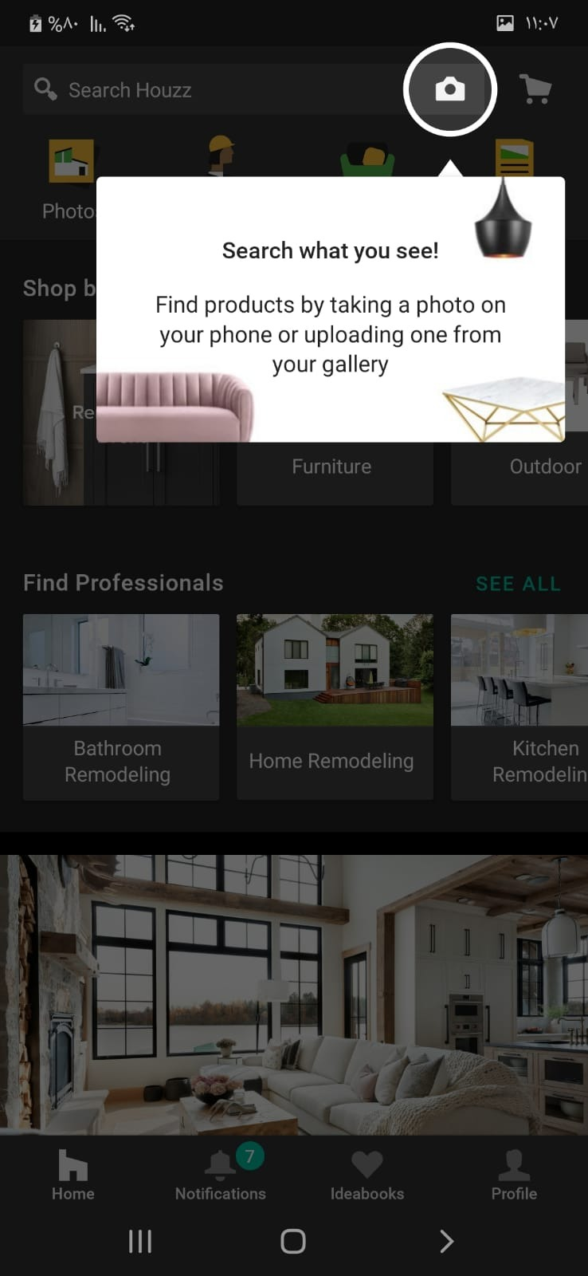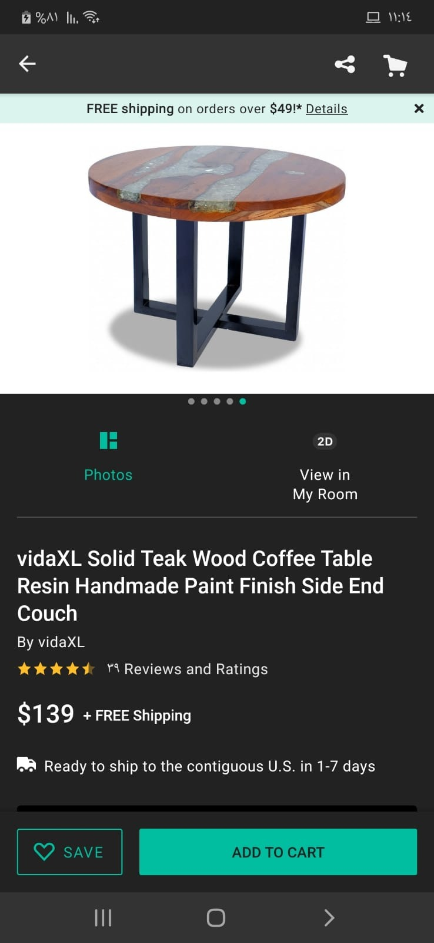

Figure 20-2 Houzz App

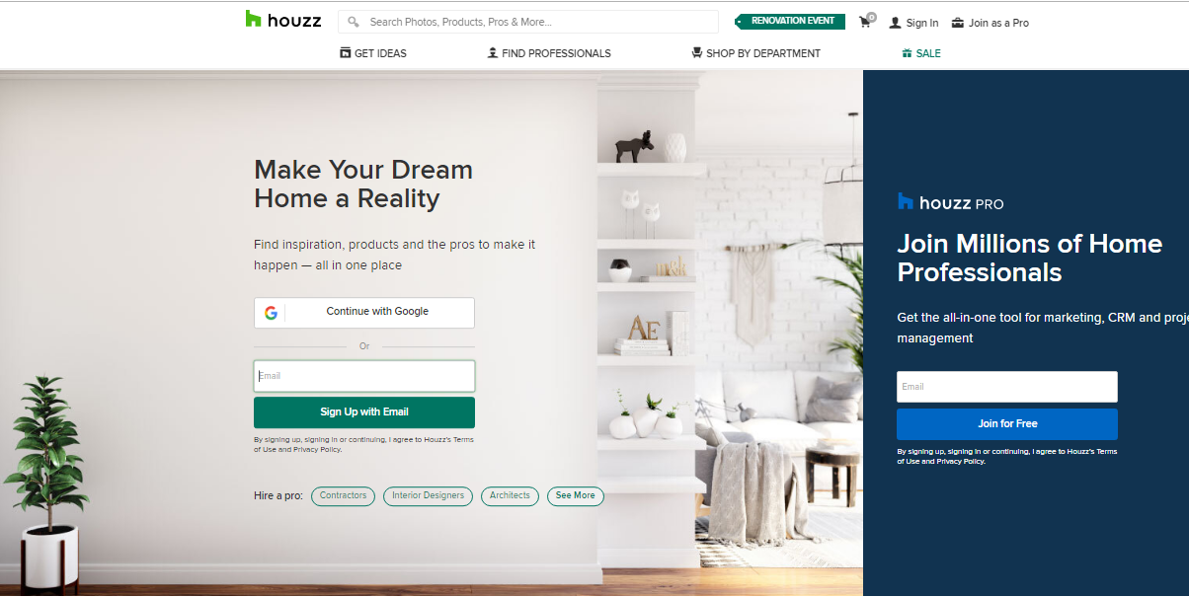

Figure 21-2 Houzz Homepage

## Advantages

These are the major advantages that Houzz provides:

* Website application is available.
* Supports English language.
* Furniture specialist.
* Some of the furniture and things you see in the pictures can be purchased directly.
* There is a special section for interior designers so that a consultation can be taken from them for a fee.
* The application supports Android and IOS phones.
* Delivery service is available.

## Disadvantages

These are some of the disadvantages that affect Houzz:

* Difficulty understanding the user interface of the application and the website (due to the frequent movement within it).
* It does not support the Arabic language.
* Selling new furniture only.
* Used furniture cannot be purchased from the customer.
* The user cannot order local manufacture of a specific design or specification.
* Frequent sending of promotional messages to your e-mail even after logging out or uninstalling the application.
* There is no cash on delivery.

## Atheth

## Overview

It is a website that provides everything related to the home from furniture to home accessories, through which you can browse hundreds of international brands specialized in home furnishings and luxuries, and it provides the largest number of choices in home furnishings, accessories and decorations that guarantee saving time and effort [42].

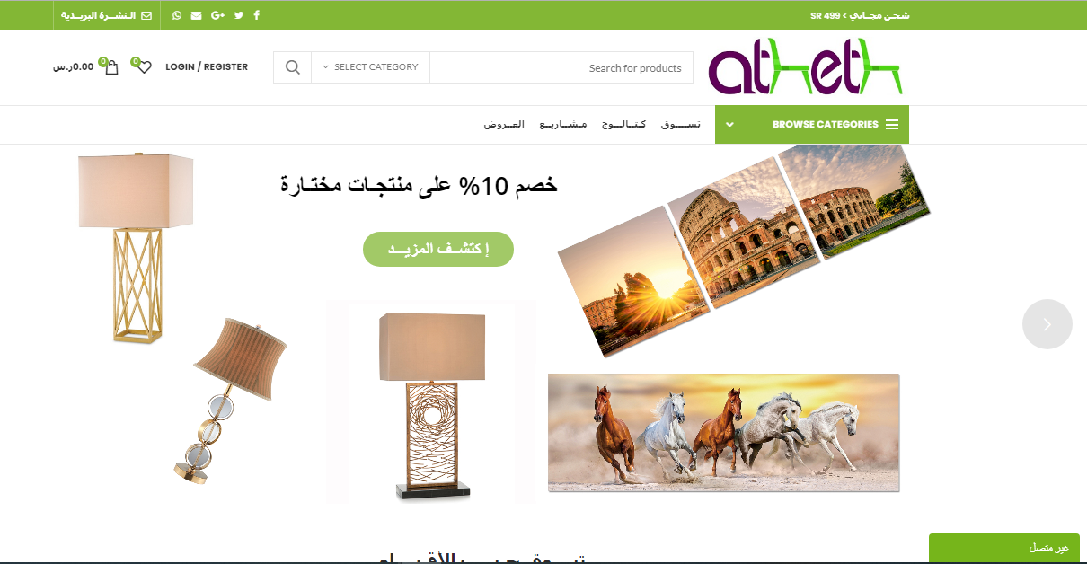

Figure 22-2 Atheth Homepage

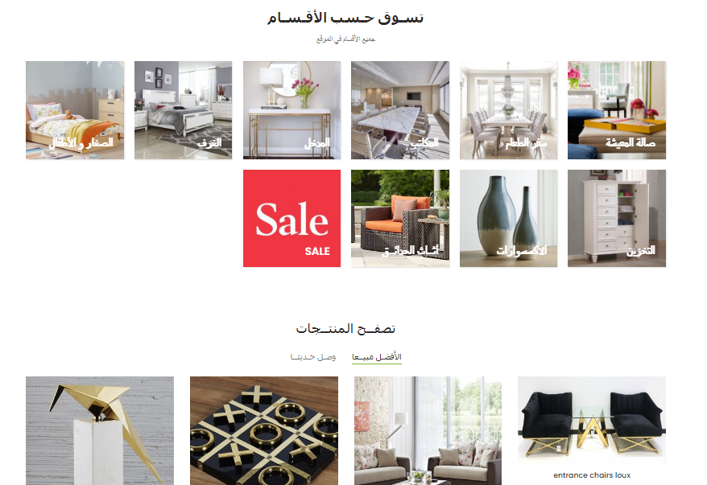

Figure 23-2 Atheth Homepage

## Advantages

These are the major advantages that Atheth provides:

* The site is easy to use
* Supports Arabic language
* Specialist in furniture.
* Delivery service is available.

## Disadvantages

These are some of the disadvantages that affect Atheth:

* The application is only available for download in Saudi Arabia and cannot be browsed from outside
* It does not support the English language.
* Selling new furniture only.
* Used furniture cannot be purchased from the customer.
* The user cannot order local manufacture of a specific design or specification.
* There is no special platform for interior designers to present their designs and provide their consultations for a fee.
* It does not provide the service of communicating with interior designers.
* Delivery and shipping only within the Kingdom of Saudi Arabia.
* It does not support iOS phones.
* It does not support the English language.

## موقع قمتي

## Overview

Qimmati is a Saudi company based in Dammam. Qimmati platform is in the field of commercial shopping and we are distinguished by the availability of products in Saudi Arabia. Fast delivery to the entire Kingdom [43].

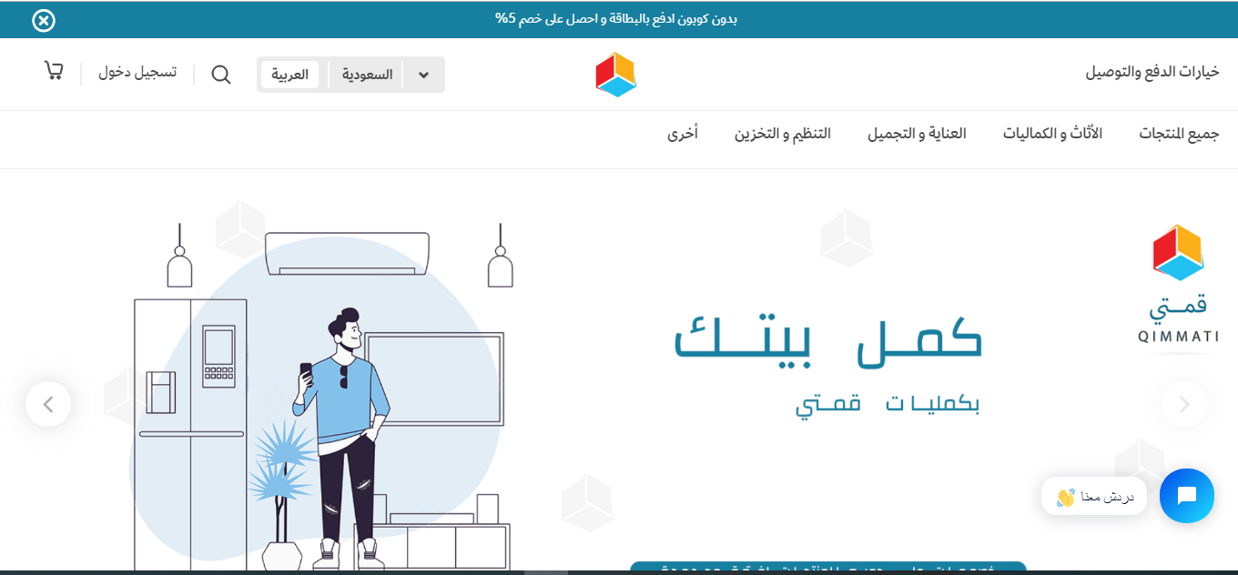

Figure 24-2 Qimmati Homepage



Figure 25-2 Qimmati Homepage

## Advantages

These are the major advantages that قمتي provides:

* Easy to use.
* Supports the Arabic language.
* Delivery service is available.

## Disadvantages

These are some of the disadvantages that affect قمتي:

* Website and no app.
* It is not specialized in furniture and contains many other products such as devices, phones, and other care products.
* Selling new furniture only.
* Used furniture cannot be purchased from the customer.
* Not adding new products through customer recommendations.
* The user cannot order local manufacture of a specific design or specification.
* There is no platform for interior designers to present their designs and provide their consultations for a fee.
* Does not allow service to communicate with interior designers.
* Unavailability of products from outside Saudi Arabia (unavailability of international goods).
* There is no cash on delivery.
* It does not support the English language.
* There is no cash on delivery.

## Comparison

This table below shows the most significant features of Home Trend comparing to the similar systems that were already been presented.

|  |  |  |  |  |
| --- | --- | --- | --- | --- |
| **Features** | **Houzz** | **Atheth** | **قمتي** | **Home Trend** |
| **Application** | **✔** | ✖ | ✖ | **✔** |
| **Web Application** | **✔** | **✔** | **✔** | **✔** |
| **Support English lang.** | **✔** | ✖ | ✖ | **✔** |
| **Support Arabic lang.** | ✖ | **✔** | **✔** | **✔** |
| **Furniture specialist only** | **✔** | **✔** | ✖ | **✔** |
| **Sell used furniture** | ✖ | ✖ | ✖ | **✔** |
| **Buy used furniture** | ✖ | ✖ | ✖ | **✔** |
| **Interior designers** | **✔** | ✖ | ✖ | **✔** |
| **Cash payment** | ✖ | ✖ | **✔** | **✔** |
| **Card payment** | **✔** | **✔** | **✔** | **✔** |
| **local manufacturing order** | ✖ | ✖ | ✖ | **✔** |
| **External consultation for interior designers for a fee** | **✔** | ✖ | ✖ | **✔** |

Table 2-2 Similar Systems Comparison

## Conclusion

In this chapter, we talk about a discussion of previous research, the techniques that were used in building Home Trend

, a brief analysis of some similar systems for the project, their advantages, and disadvantages, and building a comparison table between these applications to present the most important characteristics of Home Trend in particular.



***CHAPTER 3  
Table of Content:***

**3.1 Introduction**

**3.2 Agile Model**

**3.3 Principles Behind The Agile Manifesto**

**3.4 Agile Benefits**

**3.5 Reasons For Choosing This Model**

**3.6 Iterative #1 Phase:**

**3.7 Gant Chart**

**3.8 Conclusion**

# CHAPTER 3: PROJECT METHODOLOGY

## Introduction

The success of a software development project depends largely on the process model used. This chapter emphasizes the need to use the appropriate model as the application to be developed; therefore, the agile methodology was chosen.

This chapter provides an overview of the chosen approach, the twelve principles, their benefits, the reasons for choosing this methodology, and finally a detailed explanation of the project's stages and life cycle.

Finally, a Gantt chart was added, which is a graphic technique to illustrate the project schedule.

## Agile Model

It is a software development method where the complete product is divided into staged products, the product is designed, implemented, and tested, and the product develops sequentially (more features and advantages are added at each stage) until the product is completed. It involves both development and maintenance. A product is defined as finished when it meets all of its requirements.

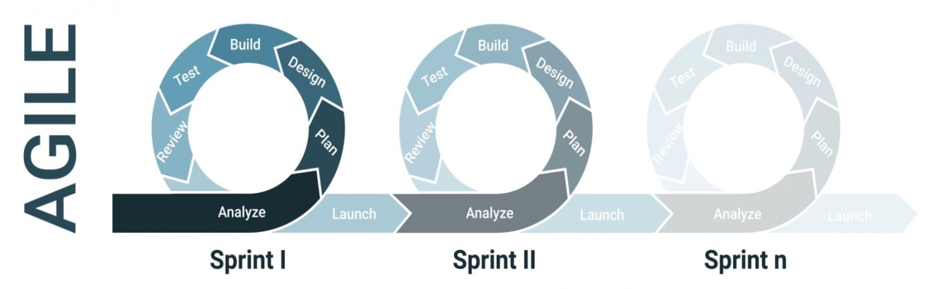

Figure 26-3 Agile Phase

The basic idea behind this method is to develop a system through an iterative approach to software development." This focus on iterative development enables teams to respond quickly to change. You begin to create a product step-by-step so that feedback from the customer can be combined at different stages of the process to ensure that what is produced is still what is needed." [44]

This innovative methodology ensures that the project team can consistently deliver tangible products without being delayed by changes and new and evolving requirements. Agile is primarily focused on customer engagement and includes frequent progress reviews with both the project team and the client.

The Agile method is completely different from the traditional methods, it focuses on certain characteristics, which are implemented in a short time and presented to the customer (the customer), here the customer (the customer) can see more how his idea was implemented, and we can see his reaction when seeing the product, if there are modifications or changes we can easily and quickly make, and then move on to a next feature until the project is fully built [45].

In general, customers cannot express their idea and what they want exactly from the beginning. They have an idea, an explanation of their idea and how to imagine the software, but it remains unclear how to implement this idea and the characteristics they want until they see a tangible product with their own eyes, to be able to evaluate whether this is what they want or not.

In this methodology, there is no need to wait for all modules to be developed and integrated. Because it offers real primary products during successive periods of time to the customer and he can try and evaluate them and give his feedback for modifications or existing errors, and therefore it is easy to bypass them because

It was discovered in an early period of work, and the progress to the next step is more steadily and the completion of the next version is based on the effective product developed and used in the first version with the addition of some features and characteristics according to the customer's requirements until the project is completed.

## Principles behind the Agile Manifesto [46]:

1. Our highest priority is to satisfy the customer through early and continuous delivery of valuable software.
2. Welcome changing requirements, even late in development. Agile processes harness change for the customer’s competitive advantage.
3. Deliver working software frequently, from a couple of weeks to a couple of months, with a preference to the shorter timescale.
4. Business people and developers must work together daily throughout the project.
5. Build projects around motivated individuals. Give them the environment and support they need, and trust them to get the job done.
6. The most efficient and effective method of conveying information to and within a development team is face-to-face conversation.
7. Working software is the primary measure of progress.
8. Agile processes promote sustainable development. The sponsors, developers, and users should be able to maintain a constant pace indefinitely.
9. Continuous attention to technical excellence and good design enhances agility.
10. Simplicity–the art of maximizing the amount of work not done–is essential.
11. The best architectures, requirements, and designs emerge from self-organizing teams.
12. At regular intervals, the team reflects on how to become more effective, then tunes and adjusts its behavior accordingly.

## Agile benefits

**There are many benefits of agile approach** [47]**:**

* **Quick Feedback**: By delivering a small feature, you have the chance to get feedback after each iteration and hence improve your product in next iteration. Customer has the transparency of functionality that is being implemented. He can easily review things and suggest changes.
* **Customer Involvement**: Customer does not have to wait for long time to see the output. He remains engaged with the product during each iteration and has the visibility of the product.
* **Change Management**: Change management is easier as updating things after a small iteration is cheap as compared to updating the product after providing complete functionality.
* **Team Motivation**: Teams feel more productive as they are delivering something quite often and get response on their delivery.

## Reasons for Choosing this Model

The agile model can create business programs quickly and early in the life cycle of the program. It also helps mitigate the impact of issuing a completely new system at once.

The main reason for choosing this model is due to the importance of including the client within the project established from the beginning of its stages; to avoid unwanted errors early and, make adjustments according to the requirements and vision of the client first and also our time is limited.

After serious research and consultation, we found that the agile model is the solution to this particular problem. As we mentioned earlier, the first version in this methodology is basically an effective and usable base product where the basic requirements have been addressed and additional features will be added in the next version.

Based on that, we will only work on the release and after we present it as the first official version of the project, taking into account that it will be a tested version with all the basic and necessary features, it is effective and usable. In future works, a development plan for the next releases will be made after reviewing all feedback from users of the first version s. Thus in each release, more features and functions are added and the core product is updated. This allows partial use of the product and avoids long development time.

## Iterative #1 Phase:

In the agile approach used to model the existing system, the developer divides the functions into different classes. By implementing iterative stages, the functional categories of the system are improved with each successive release of products until all functional categories are covered. The ultimate goal of this model is to provide the user with a system with comprehensive functionality.

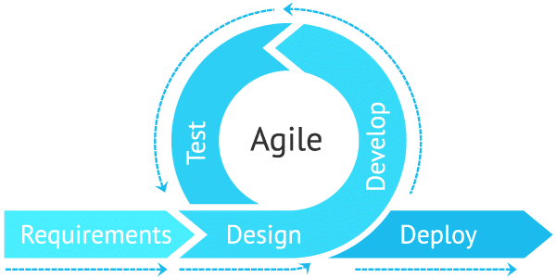

Figure 27- 3 Agile Model Phase

### **Requirement analysis:**

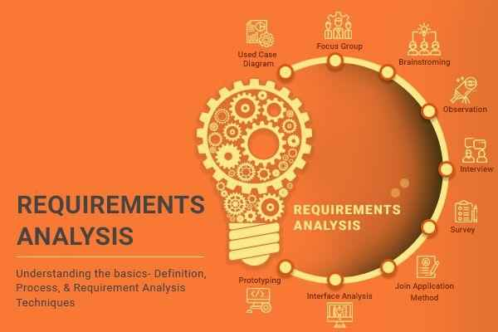The requirements analysis stage is the first stage in the project, but before starting this stage, the problem on which the project is based must be defined and defined. We focus at this stage on identifying the needs or conditions to meet the product or project, so we see that the most difficult part in building the software system is Defining precisely what we will build, these requirements determine the health of the system; Therefore the requirements must be documented, executable, measurable, testable, traceable, related to specific business needs or opportunities, and defined with a level of detail sufficient to design the system.

Figure -3 Requirements Analysis

**In our project**, the requirements were collected by collecting data and information from meetings between the work team and consulting with each other about the needs and services. The team was divided into two groups, one representing the customers and the other the developers, so the customer group gave their ideas that they see from the customer’s view, and the developer group discussed these ideas and expressed their opinion from the developer’s view and again we reversed the groups, this led to the diversity and development of ideas because they represent different points of view with the possibility of realizing these ideas and applying them programmatically. We also searched for applications that provide similar services. We searched for other distinctive ways that were not presented to benefit customers in the future.

### Design

The design process in the agile model is an iterative approach. It is a sequential process:

Understand, research, sketch, design, prototype, test, refine. The iterative design process starts from the first stage to the last stage. The output is then analyzed, and multiple iterations are made to improve it further.

This method allows designers to improve iterations of the product design and solve important problems according to the user experience to achieve customer satisfaction and away from designing products in an ill-considered way that will not adequately meet the needs of users.

**In our project**, during the first iteration, we assembled the team. We presented the requirements that were created in the previous stage. We discussed among ourselves how to address these requirements and suggested the necessary tools to achieve this project and what would contain technical specifications to be applied during the implementation of the system. This stage includes a set of diagrams and models such as database schema and user interface design; it is the outcome of what has been reached from the analysis of requirements, and the application of the ideas and needs of the customer to determine whether this is what he wants or there are modifications or changes at this early stage.

### Development

This stage includes bringing preliminary requirements documents to present a work program based on the analyzed requirements. Code is written and design documents are converted into actual software within the software development process. This stage is considered to be the longest of the Software development life cycle stages as it is the backbone of the entire process. The product is undergoing many improvements but at this point, there are not many changes between iterations.

**In our project**, at this stage and after confirming the components of the project, we started with the actual coding and development of the project based on the models designed in the design stage. The development process falls under two parts: the front-end code and then the back-end code are added to it; thus the system works with the logic associated with the design. Various tools and different techniques were used to develop this project, among which we briefly mention the design and programming techniques in the Application Filters language, Laravel Web Language, and other related technologies to work within these programming environments.

### Testing

The primary goal of this stage is to ensure that the product does not contain any bugs and is compatible with everything else the developers have written before. Tests are conducted to verify the code and to ensure that the solution is in line with business objectives.

Agile testing can start at the beginning of a project with continuous integration between development and testing. Agile testing methodology is not sequential (meaning it is only executed after the coding phase) but it is continuous [48].

**In our project**, the agile methodology naturally provides customer feedback periodically and continuously due to its existence from the beginning of the system construction stages. Therefore, all previous stages included the presence of the customer during the establishment of the system, so there was a series of tests to ensure that the code works correctly and that all work objectives and requirements have been achieved according to what the customer wants, so the test was not kept for a single and subsequent stage.

### Deployment

This is the last stage of the software development lifecycle that puts the product into production. After being tested by the project team, the product is ready for commissioning. This means that the product is ready for use in a real environment by all end users of the product, and additional iterations provide updates to eliminate bugs and introduce new features.

This stage is also called the soft opening stage because it publishes the final product or service to a focus group as part of the pilot deployment to understand its operation and specifications [49].

**In our project**, after making sure that the project is valid, has passed the testing and modification stages, and meets the requirements, the application and website will be published on the servers and made available to customers for a demo, and later users can provide their feedback and suggestions on modifications or improvements, based on users' opinions we will provide iterations Additional to update the current program, solve errors if any, and introduce new features in future versions

## Gant Chart

A Gantt chart, commonly used in project management, is one of the most popular and useful ways of showing activities (tasks or events) displayed against time [50].

The horizontal bar chart visually represents the progression of a project plan over time. Most Gantt charts show you the status of each step in the project, as well as the stakeholders [51].

Each activity is represented by a bar; the position and length of the bar reflects the start date, duration and end date of the activity [50].

## Proses Scheduling:

|  |  |  |  |
| --- | --- | --- | --- |
| **#** |  | **Tasks** | **Days** |
| **1** | **Communication** | Status Meetings | 2 |
| Define a communication mechanism | 1 |
| **2** | **Preparations** | Brainstorming and giving ideas for projects | 2 |
| Discuss ideas and choose one | 2 |
| Researching for related issues | 5 |
| Researching and gathering of information | 4 |
| Initial mention of needs | 3 |
| Searching for new features | 3 |
| **3** | **Introduction** | Writing background, problem statement, motivation | 2 |
| Writing problem question, objectives, scope ,contributions | 2 |
| Meeting to discuss the first chapter | 1 |
| **4** | **Literature review** | Discuss and listing techniques used with brief description | 7 |
| Discuss related works with brief description , advantages, disadvantages and comparison | 7 |
| Meeting to discuss the second chapter | 1 |
| **5** | **Project methodology** | Discussing the types of Methodology and adopting one | 2 |
| Discuss and talking about Agile methodology | 2 |
| Writing information, principle, benefits, reasons of Agile | 3 |
| Discussing and dropping the Agile stages | 5 |
| Gather and draw the contents of Gantt chart | 2 |
| Meeting to discuss the third chapter | 1 |
| **6** | **Requirements analysis** | Check realistic of requirements | 2 |
| Define and setting Functional requirements | 10 |
| Define and setting Non-Functional requirements | 5 |
| Requirements Analysis | 2 |
| Phase documentation | 5 |
| **7** | **Design** | Requirement specification &UML diagrams development | 10 |
| User interface design for app | 7 |
| User interface design for web | 8 |
| Logical database | 5 |
| Phase documentation | 3 |
| **8** | **Development** | Application Coding | 45 |
| Website Coding | 45 |
| Phase documentation | 3 |
| **9** | **Testing** | Unit testing | 5 |
| Test plan | 5 |
| Test cases | 5 |
| Phase documentation | 3 |
| **10** | **Deployment** | Reviewing hosting options | 4 |
| Install Software first version | 2 |
| Setting support & Feedback methods | 5 |
| Phase documentation | 3 |
| **11** | **Final** | Check system function | 4 |
| Setting future works | 2 |
| Finalizing documentation file | 4 |

Table 3-3 Home Trend Proses Scheduling

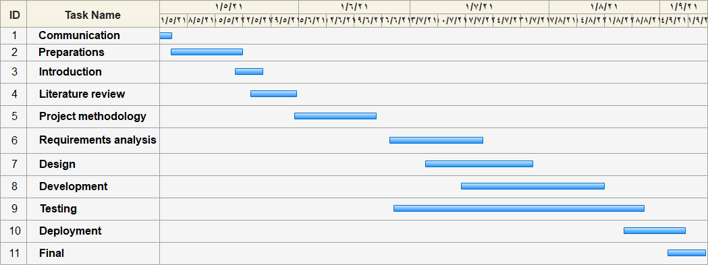

Figure -3 Home Trend Gantt chart

## 

## Conclusion

In this chapter, we are talking about the Agile model which is our choice for our software development methodology, where a model is analyzed, designed, tested, and implemented iteratively. We also address the twelve principles, the benefits of agile, and the reasons for choosing this methodology, and finally a detailed explanation of the project phases and its life cycle, in addition, the chapter provides an overview of the stages we went through to develop Home Trend system. Also, we added a Gantt chart to manage project elements and indicate the start and end date of each element.

# References

|  |  |
| --- | --- |
| [1] | [Online]. Available: https://en.wikipedia.org/wiki/E-commerce. |
| [2] | [Online]. Available: https://www.shopify.com/encyclopedia/what-is-ecommerce. |
| [3] | [Online]. Available: https://ecommerceguide.com/guides/what-is-ecommerce/. |
| [4] | [Online]. Available: https://www.shopify.com/encyclopedia/what-is-ecommerce. |
| [5] | [Online]. Available: https://searchcio.techtarget.com/definition/e-commerce. |
| [6] | [Online]. Available: https://en.wikipedia.org/wiki/E-commerce. |
| [7] | "Retail e-commerce sales CAGR forecast in selected countries from 2016 to 2021". Statista. October 2016". |
| [8] | [Online]. Available: https://www.investopedia.com/terms/e/ecommerce.asp. |
| [9] | [Online]. Available: https://en.wikipedia.org/wiki/Adobe_XD. |
| [10] | [Online]. Available: https://www.jetbrains.com/help/idea/discover-intellij-idea.html. |
| [11] | [Online]. Available: https://www.edrawsoft.com/. |
| [12] | [Online]. Available: https://simple.wikipedia.org/wiki/Adobe_Photoshop. |
| [13] | [Online]. Available: https://www.altexsoft.com/blog/engineering/pros-and-cons-of-flutter-app-development/. |
| [14] | [Online]. Available: https://www.jetbrains.com/help/idea/discover-intellij-idea.html. |
| [15] | [Online]. Available: https://en.wikipedia.org/wiki/Firebase. |
| [16] | [Online]. Available: https://firebase.google.com/docs/auth. |
| [17] | [Online]. Available: https://firebase.google.com/docs/firestore. |
| [18] | [Online]. Available: https://sodocumentation.net/firebase/topic/4281/storage. |
| [19] | [Online]. Available: https://en.wikipedia.org/wiki/Xcode. |
| [20] | Daniel Gafitescu (June 6, 2013). "Goodbye CodeIgniter, Hello Laravel". sitepoint.com. Retrieved December 21, 2013.. |
| [21] | Martin Bean (April 2015). Laravel 5 Essentials. Packt. ISBN 978-1785283017.. |
| [22] | "Laravel Documentation (versions 3.0–3.2.14)". three.laravel.com. Archived from the original. |
| [23] | [Online]. Available: https://en.wikipedia.org/wiki/Laravel#cite_note-sitepoint-4. |
| [24] | [Online]. Available: https://en.wikipedia.org/wiki/XAMPP. |
| [25] | History of MySQL. |
| [26] | [Online]. Available: https://en.wikipedia.org/wiki/MySQL#cite_ref-6. |
| [27] | [Online]. Available: https://snyk.io/lp/debugging-snyk-code-checker/?utm_medium=Paid-Search&utm_source=google&utm_campaign=nb_snyk-code&utm_content=bug&utm_term=code%20debugging&gclid=CjwKCAjwiLGGBhAqEiwAgq3q_qcGm_v1w0Z1l3pHox0S8l1z52CGFqa7M9AsJZfv-MmSjzWutSEkNBoCJgwQAvD_BwE. |
| [28] | *Interview with Kai Seidler from the XAMPP project.* [Interview]. |
| [29] | "New XAMPP with MariaDB". |
| [30] | "An easy to install Apache distribution containing MySQL, PHP, and Perl". |
| [31] | [Online]. Available: https://en.wikipedia.org/wiki/XAMPP. |
| [32] | [Online]. Available: https://en.wikipedia.org/wiki/HTML. |
| [33] | "CSS developer guide". |
| [34] | Flanagan, David. JavaScript – The definitive guide (6 ed.). p. 1. JavaScript is part of the triad of technologies that all Web developers must learn: HTML to specify the content of web pages, CSS to specify the presentation of web pages, and JavaScript to. |
| [35] | "What is CSS?". |
| [36] | [Online]. Available: https://en.wikipedia.org/wiki/CSS. |
| [37] | [Online]. Available: https://en.wikipedia.org/wiki/Bootstrap. |
| [38] | [Online]. Available: https://en.wikipedia.org/wiki/Zoom_Video_Communications. |
| [39] | [Online]. Available: https://en.wikipedia.org/wiki/GitHub. |
| [40] | [Online]. Available: https://en.wikipedia.org/wiki/WhatsApp. |
| [41] | [Online]. Available: https://www.houzz.com/. |
| [42] | [Online]. Available: https://atheth.com/. |
| [43] | [Online]. Available: https://qimmati.com/. |
| [44] | [Online]. Available: https://www.exin.com/agile-scrum/getting-to-grips-with-agile-basic-concepts-explained/. |
| [45] | [Online]. Available: https://www.alefstartup.com/blog/2018/10/18/%D9%85%D8%A7-%D9%87%D9%8A-%D8%A7%D9%84%D8%A2%D8%AC%D8%A7%D9%8A%D9%84-Agile-%D8%A3%D9%88-%D8%A7%D9%84%D9%85%D9%86%D9%87%D8%AC%D9%8A%D8%A9-%D8%A7%D9%84%D8%B1%D8%B4%D9%8A%D9%82%D8%A9-%D9%81%D9%8A-%D8%A5%D8%AF%D8%A7. |
| [46] | [Online]. Available: https://www.agilealliance.org/agile101/12-principles-behind-the-agile-manifesto/. |
| [47] | [Online]. Available: https://uxdesign.cc/agile-design-process-24be92018ad2. |
| [48] | [Online]. Available: http://blog.click2cloud.net/?p=1154. |
| [49] | [Online]. Available: https://agile-design-architecture.com/blog-details/20/A-beginners-guide-to-the-concept-of-Agile-Framework. |
| [50] | [Online]. Available: https://www.gantt.com/. |
| [51] | [Online]. Available: https://miro.com/templates/gantt-chart/?utm_source%3Dgoogle%26utm_medium%3Dcpc%26utm_campaign%3DS|GOO|NB|Tier2|ALL-EN|Core%26utm_adgroup=dsa%26utm_custom%3D12123522200%26utm_content%3D492751716479%26utm_term%3D%26matchtype=b%26device=c%26location=2275&gcl. |