**Snippets for the implemented code**

**Uart-packet.sv**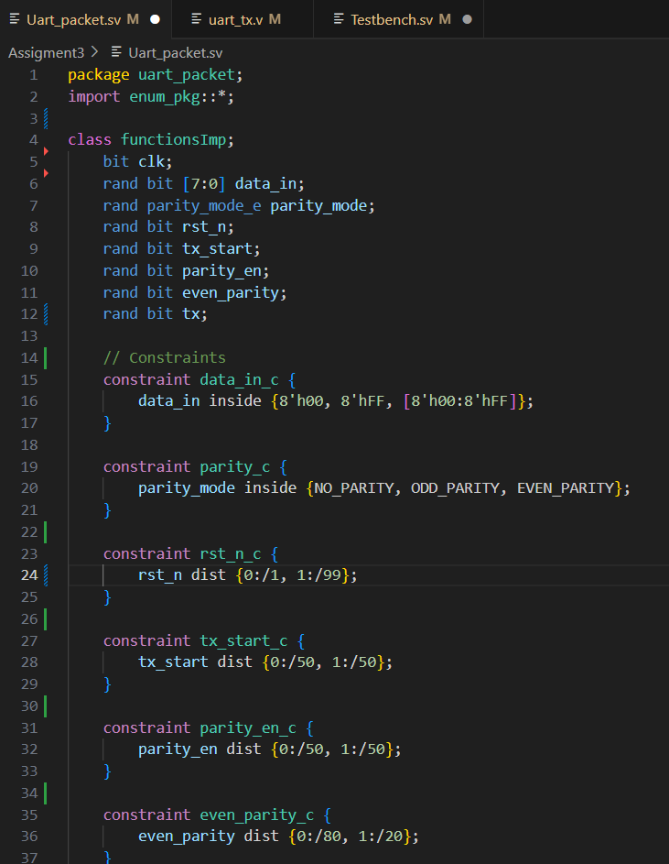

**TestBensh.sv**

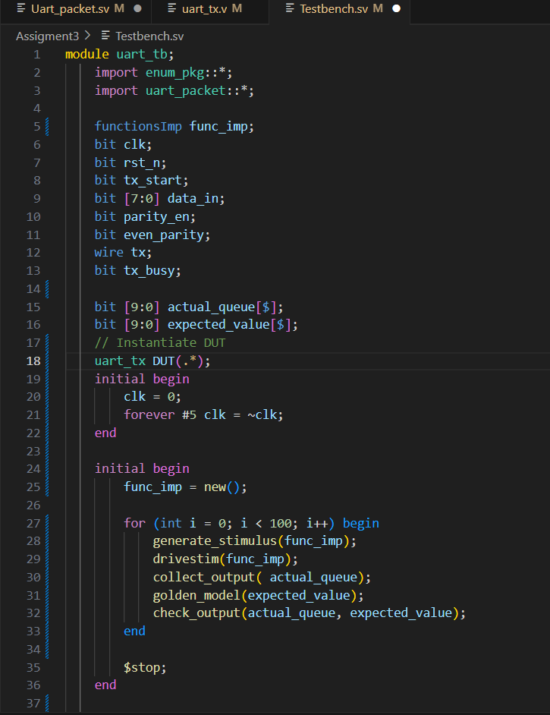

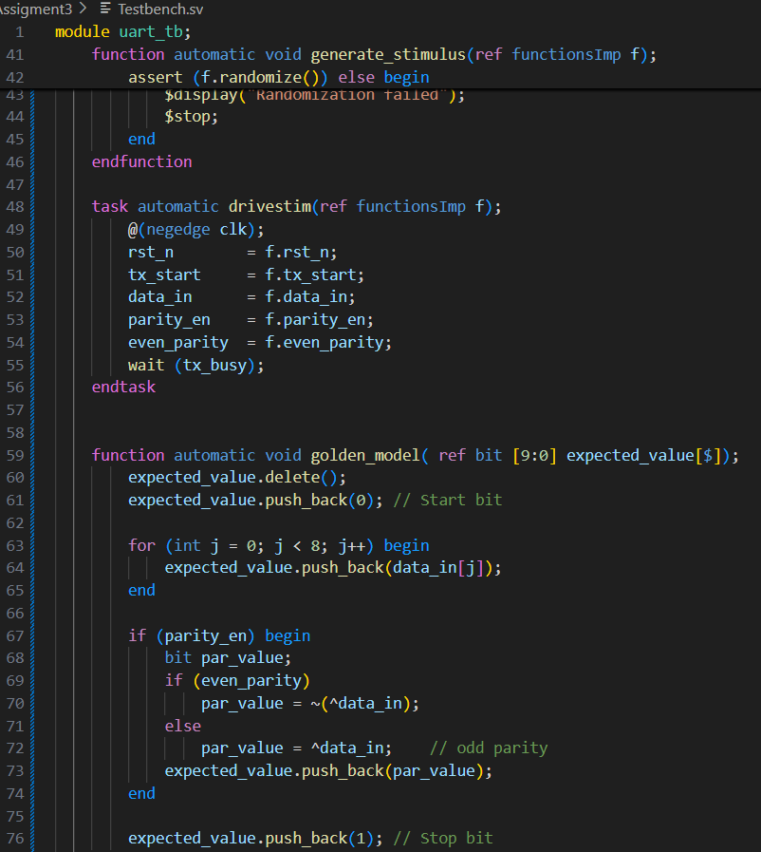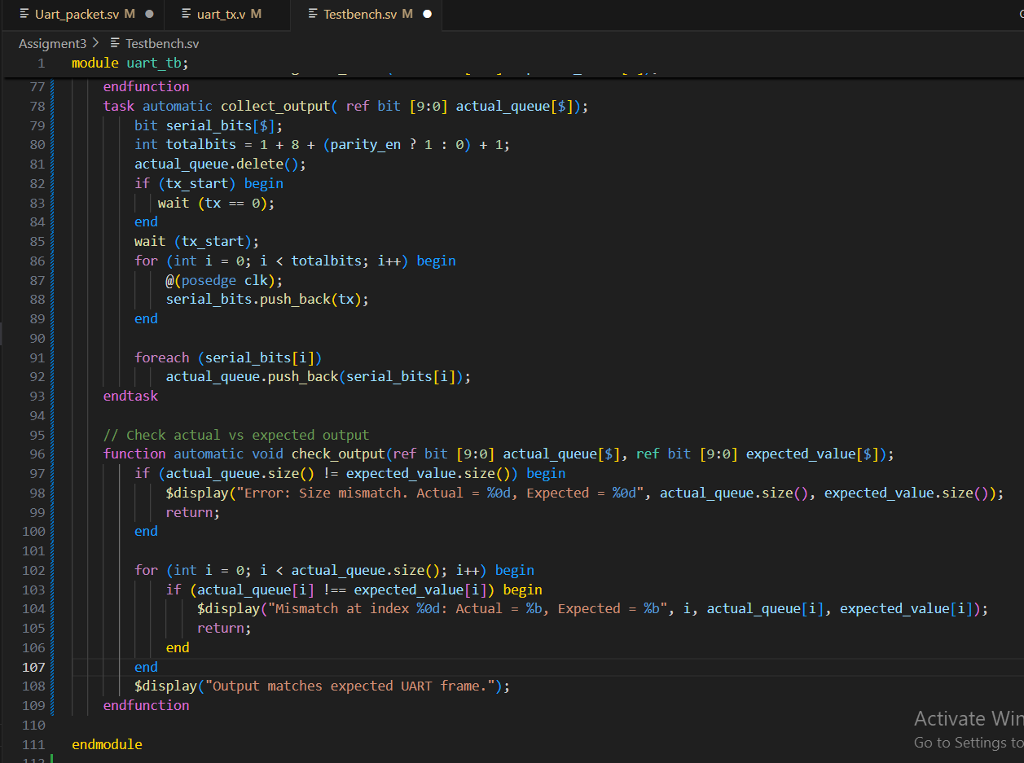

**Snippet for the waveform shows the different testcases.**

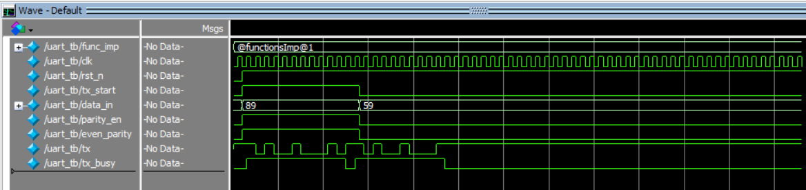

**Snippets for the logs show the all printed values.**

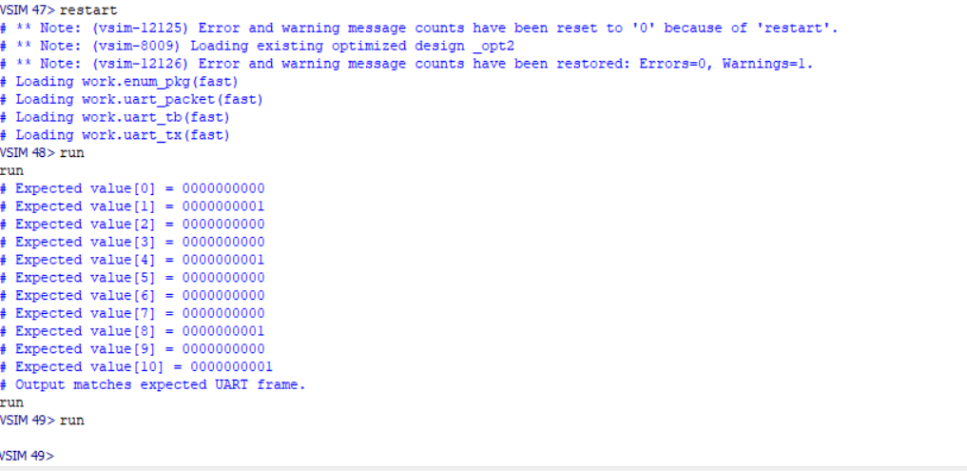

**Snippet for Do file you have used for automating the process**

