Cairo University  
Faculty of Computers and Information



**CS251**

**Software Engineering I**

Software Requirements Specifications

Team Names

Alaa Ihab Abd El-wahab

Mahmoud Fareed Ezz Elden

Mohamed Hesham Elden Emam

Month & Year

Contents

Instructions 3

Team 3

Document Purpose and Audience 3

Introduction 3

Software Purpose 3

Software Scope 4

Definitions, acronyms, and abbreviations 4

Requirements 4

Functional Requirements 4

Non Functional Requirements 4

System Models 5

Use Case Model 5

Use Case Tables 5

Ownership Report 6

# 

# Team

|  |  |  |  |
| --- | --- | --- | --- |
| **ID** | **Name** | **Email** | **Mobile** |
| 20140174 | Alaa Ihab Abd El-wahab | [Alaa.ihab.ali1996@gmail.com](mailto:Alaa.ihab.ali1996@gmail.com) | 01010954702 |
| 20140252 | Mahmoud Fareed Ezz Elden | mody.xin2015@gmail.com | 01011801689 |
| 20140242 | Mohamed Hesham Elden Emam | mohammed_hesham42@hotmail.com | 01123859302 |

# Introduction

## Software Purpose

* This Software is to make a useful learning system which makes us able to teach students in the best learning way.

## Software Scope

* An educational platform for playing games which help students to understand science in a good way to enhance the education process in schools, platform will be applications in a website written in java programming language divided into categories for each science.

# System Requirements

**Functional requirements**

**Teacher**

* **Create account**
* **Sign in**
* **Create games**
* **Log out**
* **View profile**
* **Replay to comment**
* **Edit profile**

**Student**

* **Create account**
* **Sign in**
* **Play game**
* **Rate game**
* **Save achievements**
* **Log out**
* **View profile**
* **Add comment**
* **Edit profile**
* **Check ranking list**

**Nonfunctional requirements**

|  |  |
| --- | --- |
| **Reliability** | **Make sure that the content of the game is reliable** |
| **Availability** | **Make a backup for website because if the the site is failed to load so we can change the ip host of the site** |
| **performance** | **The complexity of the function is optimized so the response of the web site is fast** |
| **supportability** | **Enhance the web site by taking reviews from users.** |

# System Models

## Use Case Model

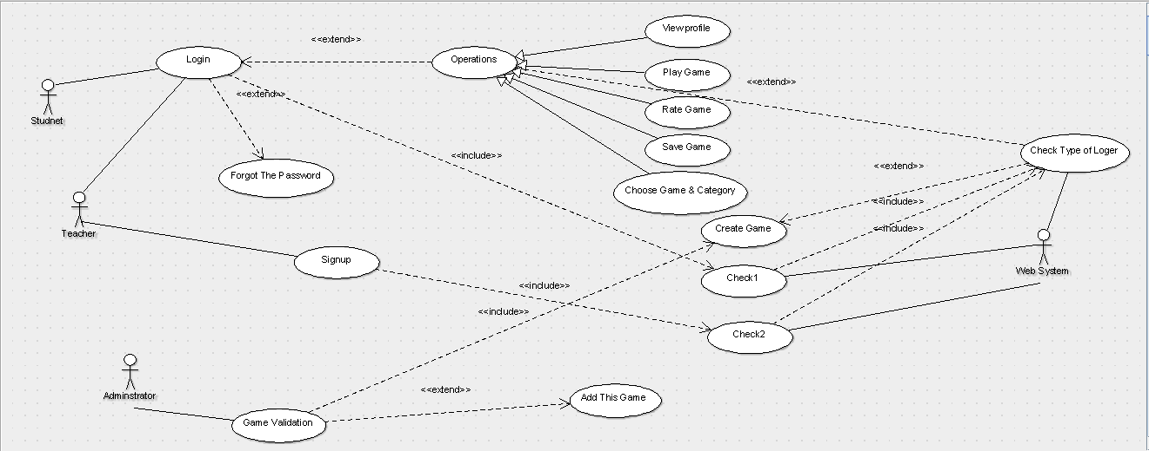

## Use Case Tables

|  |  |  |
| --- | --- | --- |
| Use Case ID: | 0001 | |
| Use Case Name: | **Forget password** | |
| Actors: | Student | |
| Pre-conditions: | if the user forget the password of an account | |
| Post-conditions: | User will receive a message of code to change the password | |
| Flow of events: | **User Action** | **System Action** |
| 1- press forget my password |  |
|  | 2- will ask him some questions to assure that this user is own this account |
| 3- answer questions |  |
|  | 4- will send a message to him |
| Exceptions: | **User Action** | **System Action** |
| 1- Wrong answer for questions |  |
|  | 2- Try again |
| Includes: |  | |
| Notes and Issues: |  | |

|  |  |  |
| --- | --- | --- |
| Use Case ID: | 0002 | |
| Use Case Name: | **View profile** | |
| Actors: | Teacher / Student | |
| Pre-conditions: | User login | |
| Post-conditions: | Logout | |
| Flow of events: | **User Action** | **System Action** |
| 1-User push "Profile" button. |  |
|  |  | 2-System display user's profile |
| Includes: |  | |
| Notes and Issues: |  | |

|  |  |  |
| --- | --- | --- |
| Use Case ID: | 0003 | |
| Use Case Name: | **CREATE ACCOUNT** | |
| Actors: | Student | |
| Pre-conditions: | the web site is open and student press button create account | |
| Post-conditions: | student logged out from web site | |
| Flow of events: | **User Action** | **System Action** |
| 1- press button create account |  |
|  | 2- will display empty form to fill it about his/her personal information. |
| 3- user will fill the form and press submit button |  |
|  | 4- The system will display the categories and games. |
| Exceptions: | **User Action** | **System Action** |
| 1- The use enters the same username of someone else or Wrong password. |  |
|  | 2- System print try again message. |
| Includes: |  | |
| Notes and Issues: |  | |

|  |  |  |
| --- | --- | --- |
| Use Case ID: | 0004 | |
| Use Case Name: | **Login Student** | |
| Actors: | Student | |
| Pre-conditions: | Going to the url of web site and press button student | |
| Post-conditions: | Student logged in | |
| Flow of events: | **User Action** | **System Action** |
| 1- will enter the user name and password and press login button |  |
|  | 2- check the validation of the user name and password  If everything is correct the system will display the web page. |
| Exceptions: | **User Action** | **System Action** |
| 1- User enters an incorrect username or password or both are incorrect |  |
|  | 2- System show a message that invalid username or password. |
| Includes: |  | |
| Notes and Issues: |  | |

|  |  |  |
| --- | --- | --- |
| Use Case ID: | 0005 | |
| Use Case Name: | **Choose game** | |
| Actors: | Student | |
| Pre-conditions: | Student logged in. | |
| Post-conditions: | Student will play the game | |
| Flow of events: | **User Action** | **System Action** |
| 1- User will choose the game and category. |  |
|  | 2- System will display the game. |

|  |  |  |
| --- | --- | --- |
| Use Case ID: | 0006 | |
| Use Case Name: | **Play game** | |
| Actors: | Student | |
| Pre-conditions: | Student logged in and chooses the game and category. | |
| Post-conditions: | Student logged out or exit the game. | |
| Flow of events: | **User Action** | **System Action** |
| 1- User will play the game corresponding to rules of play. |  |
|  | 2- System will evaluate the user doing and responses for it. |

|  |  |  |
| --- | --- | --- |
| Use Case ID: | 0007 | |
| Use Case Name: | **Save achievements** | |
| Actors: | Student | |
| Pre-conditions: | Student logged in and makes changes of some information or playing a game and wants to save the progress. | |
| Post-conditions: | student logged out. | |
| Flow of events: | **User Action** | **System Action** |
| 1- Student press button Save achievements. |  |
|  | 2- System will save the changes that the use do |

|  |  |  |
| --- | --- | --- |
| Use Case ID: | 0008 | |
| Use Case Name: | **Rate the game** | |
| Actors: | Student | |
| Pre-conditions: | Logged in ,playing some game or not | |
| Post-conditions: | Student logged in | |
| Flow of events: | **User Action** | **System Action** |
| 1- press rate button. |  |
|  | 2- will display 5 chooses  Excellent ,very good , good, normal, boring |
| 3-will choose the rate and press ok. |  |
|  | 4-will save the rate. |
| Exceptions: | **User Action** | **System Action** |
| Enter the rate button and doesn't choose any thing and press ok. |  |

|  |  |  |
| --- | --- | --- |
| Use Case ID: | 0009 | |
| Use Case Name: | **Replay to comment** | |
| Actors: | Teacher | |
| Pre-conditions: | Student commented | |
| Flow of events: | **User Action** | **System Action** |
| 1-Teacher push "replay" button |  |
|  |  | 2- display replay area |
|  | 3- Write replay and push submission button |  |

|  |  |  |
| --- | --- | --- |
| Use Case ID: | 0010 | |
| Use Case Name: | Add comment | |
| Actors: | Student | |
| Pre-conditions: | Choose game | |
| Flow of events: | **User Action** | **System Action** |
| 1- Click in comment area and write his comment. |  |
|  | 2- display the submission button |
| 3- Push submission button |  |
|  | 4- display message "comment submitted successfully" |
| Includes: |  | |
| Notes and Issues: |  | |

|  |  |  |
| --- | --- | --- |
| Use Case ID: | 0011 | |
| Use Case Name: | login | |
| Actors: | Teacher | |
| Pre-conditions: | Enter User name and password | |
| Flow of events: | **User Action** | **System Action** |
| 1- Teacher enter username and password then submit. |  |
|  | 2- Information sent to database of the website. |
|  | 3-Confirm that values are correct. |
| Exceptions: | **User Action** | **System Action** |
| 1- Values are wrong. |  |
|  | 2- send back error message “invalid username or password “ |

|  |  |  |
| --- | --- | --- |
| Use Case ID: | 0012 | |
| Use Case Name: | Creating game | |
| Actors: | Teacher | |
| Pre-conditions: | Press create game button | |
| Flow of events: | **User Action** | **System Action** |
| 1- Teacher press create game |  |
|  | 2- System show up his category type |
| 3-Inserts game questions |  |
|  | 4- Confirming the game and put it in it’s category. |
| Exceptions: | **User Action** | **System Action** |
| 1- Teacher didn't insert questions |  |
|  | 2- send back "please insert your game questions" |