###### **journalThumbnail_tr_TRAlaa AlMarawi**

**Formal languages and Automata theory Project Report**

**Regular Expressions**

* A wep page to explain Regex:
* General introduction to Regex & regex characters tables

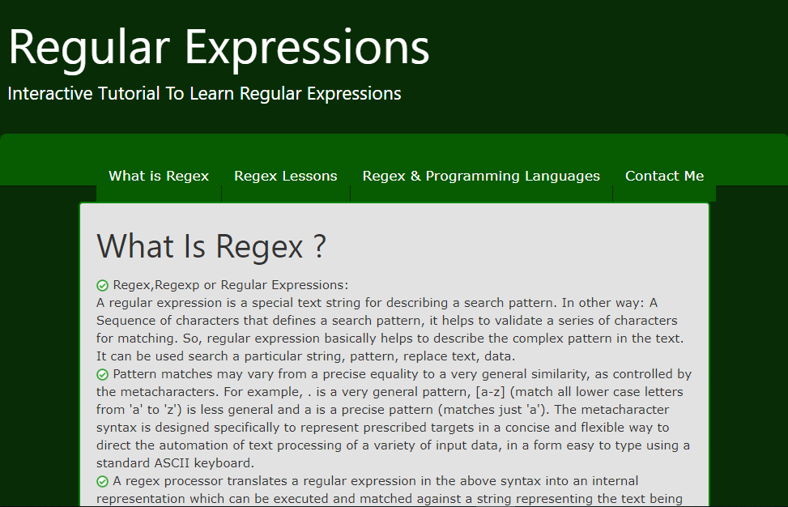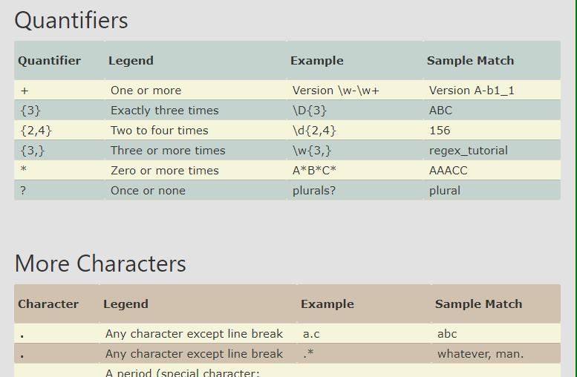

* Regex learning with interactive Exercises with answers and progress bar for lessons

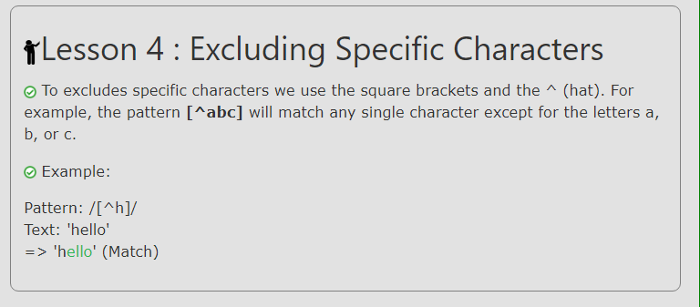

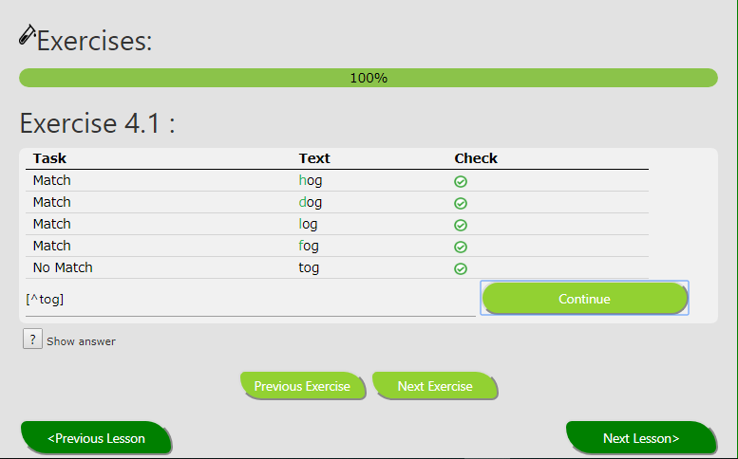

* Regex & programming languages (js, java, python)
* Responsive screen
* References & contanct info