Question1_image

Q1: result.txt image:

Errors.txt image:

Show this file in home:

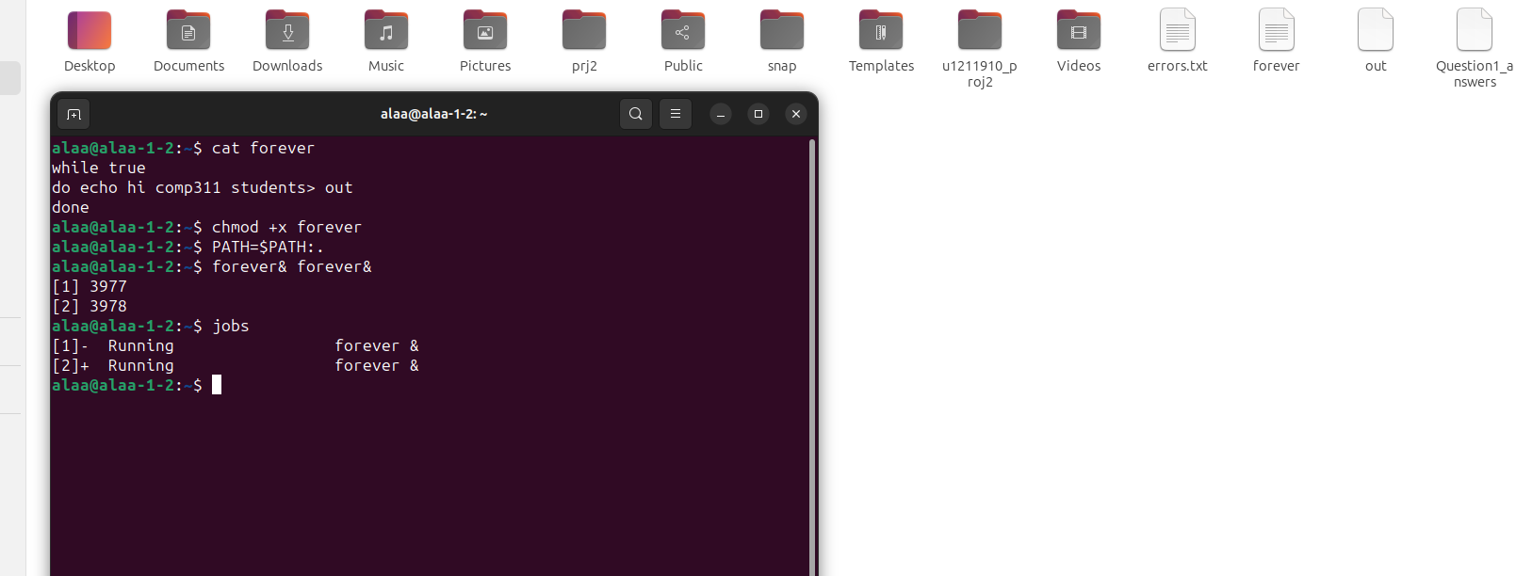Q3

Q4)

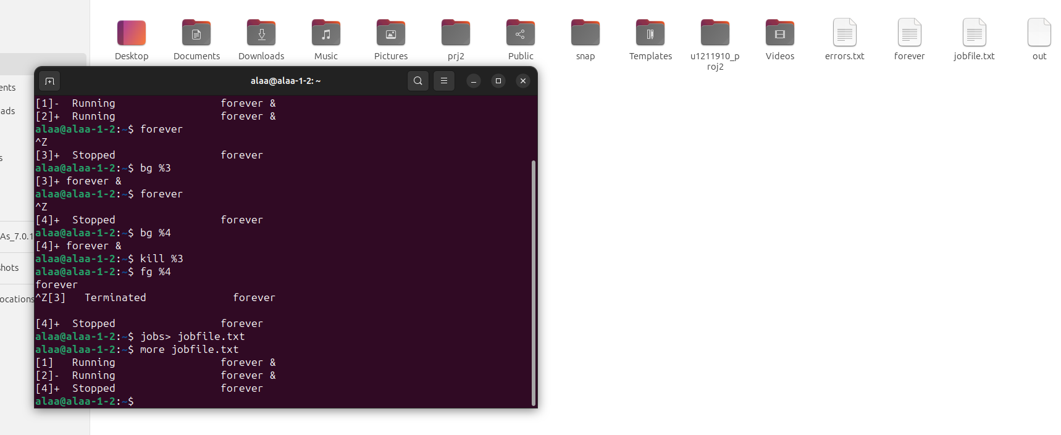

Q5)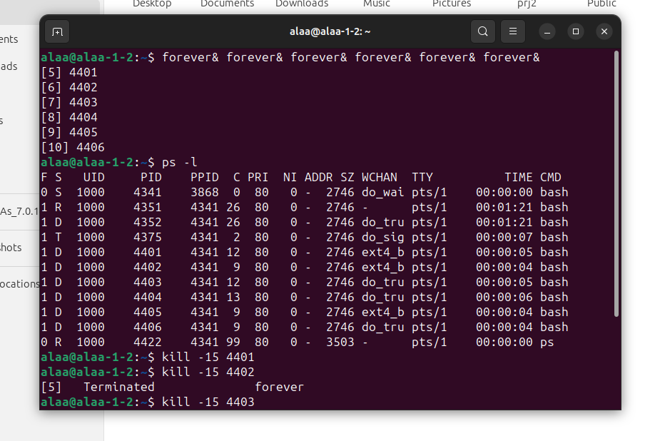

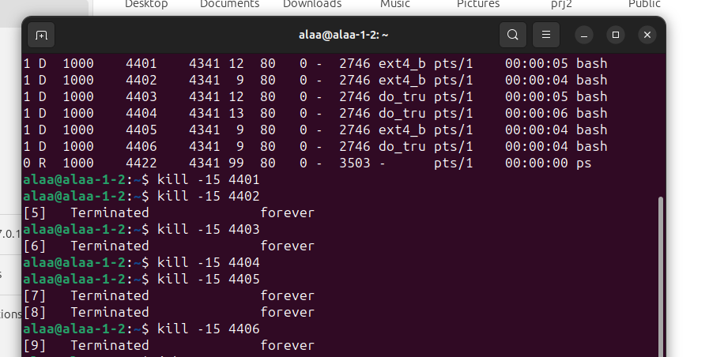

Q6&7)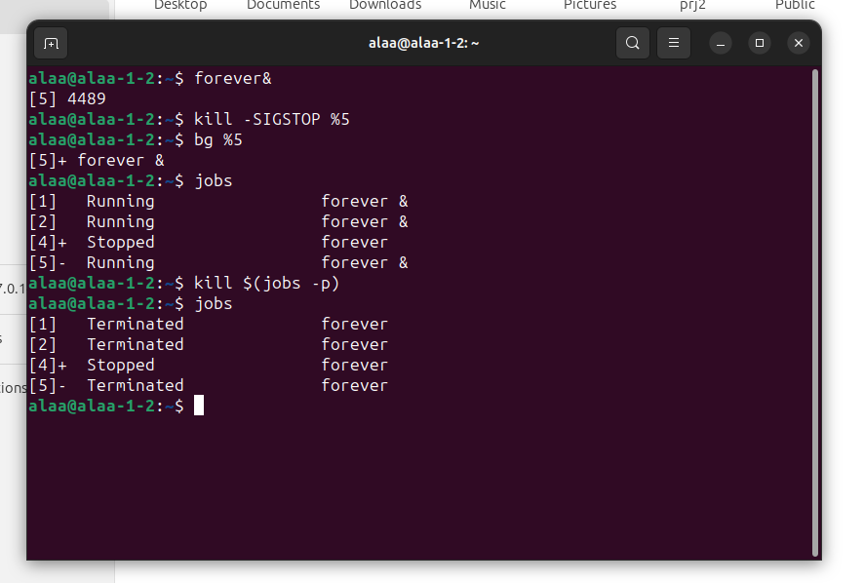

Q8)

Q9)