Question2_image

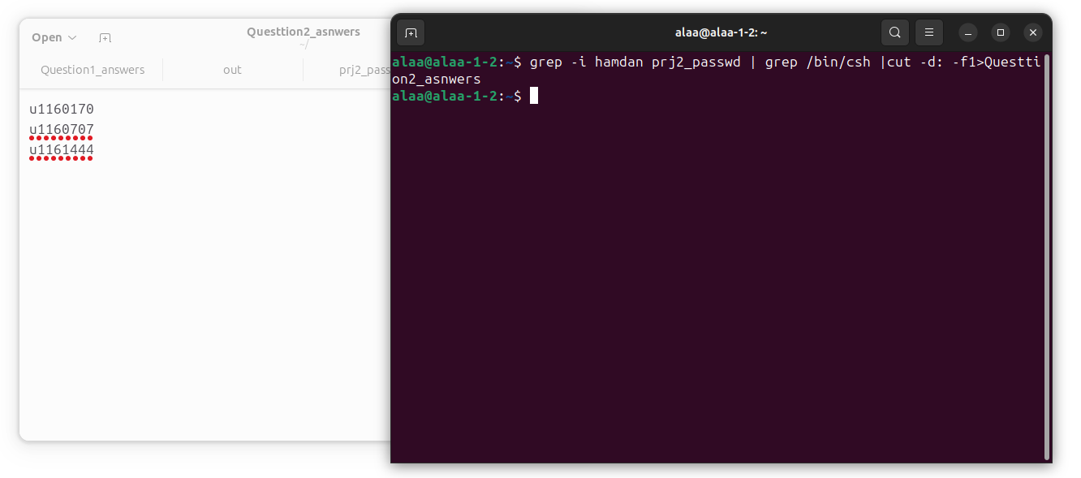Q1)

Q2)

Q3)

Q4)

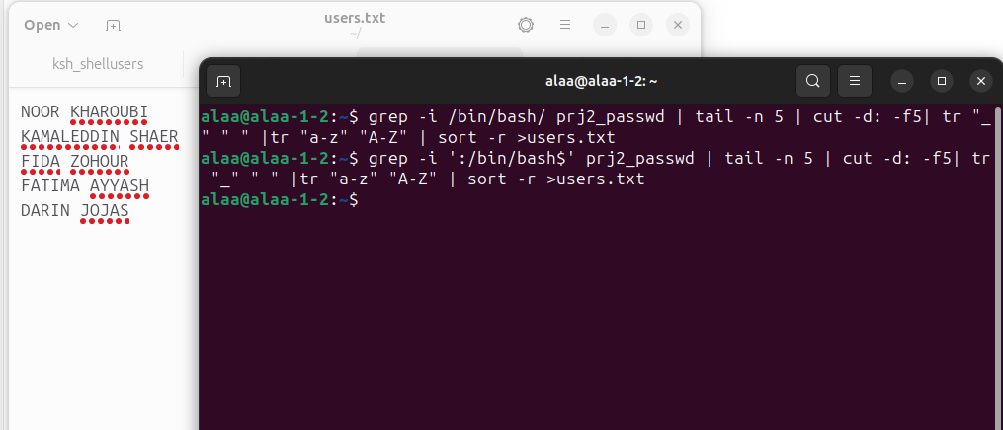

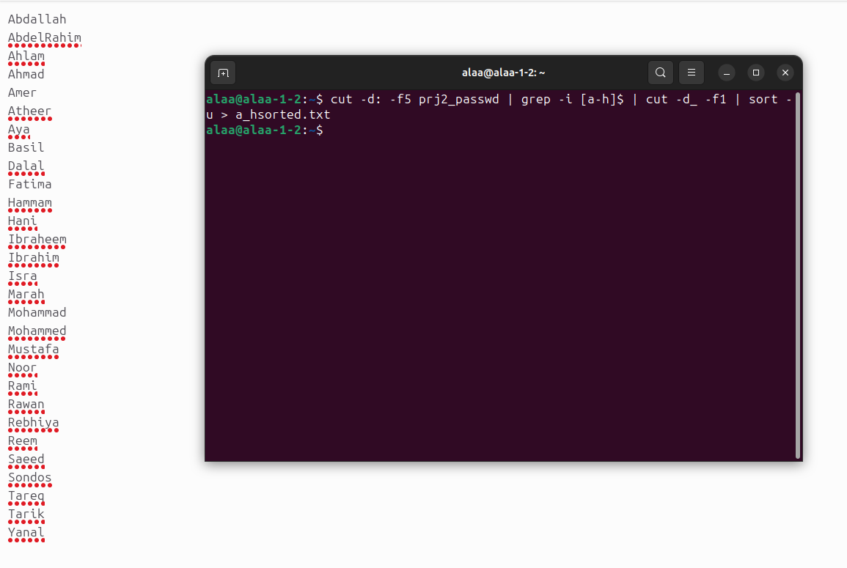Q5):

Q6):

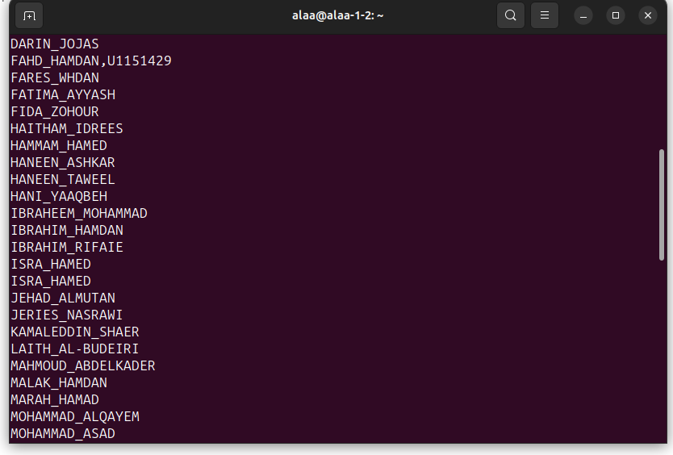

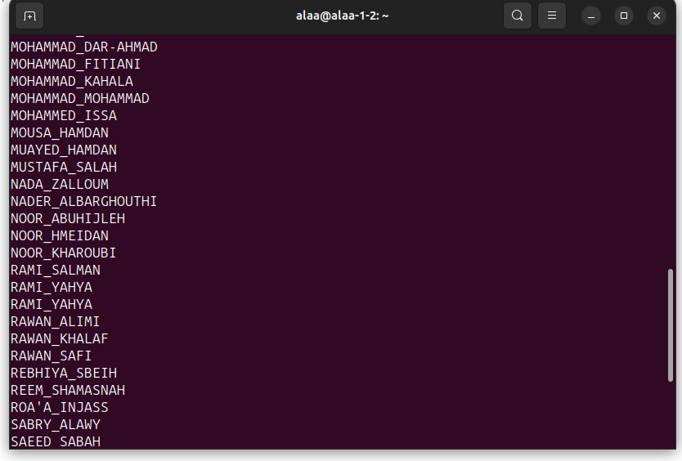

Q7)

Q8):

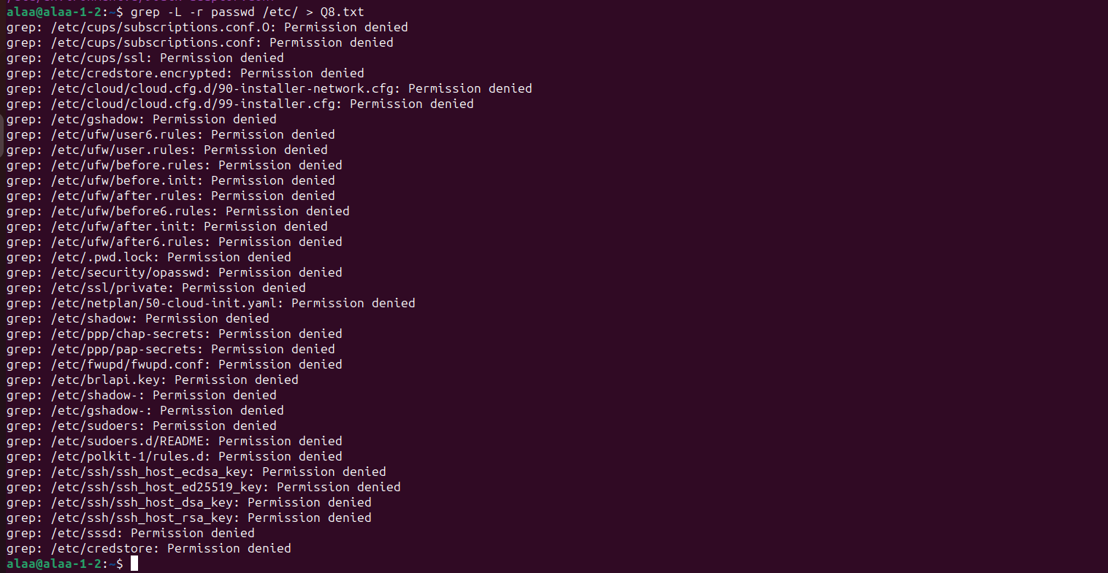

Q9):

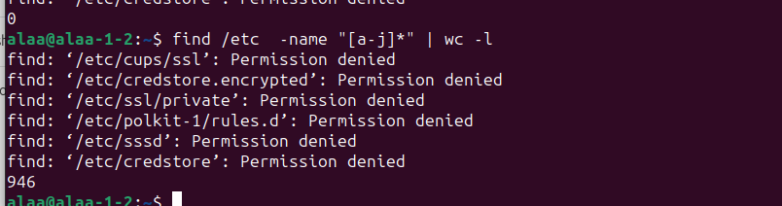

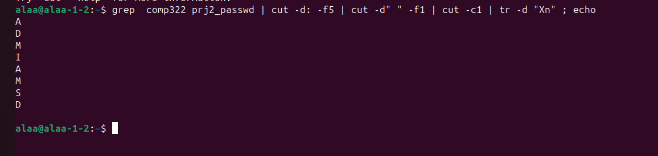Q10):