# Extracting-tables-from-emails

Extracting the second tables on all the emails and creating a csv file for them using python pandas library

The email is sent with the below format as you can see we need the second table not the first

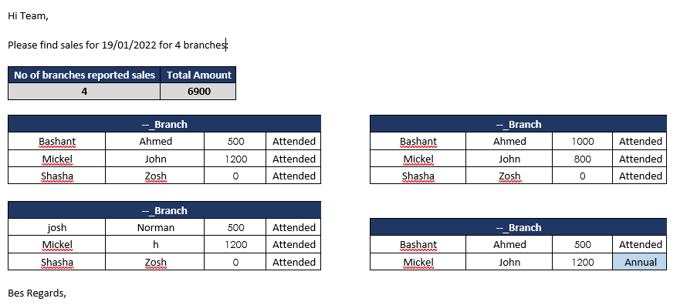

We save the email on Mails folder and apply the code. U will have csv file with the name of the email having the below format

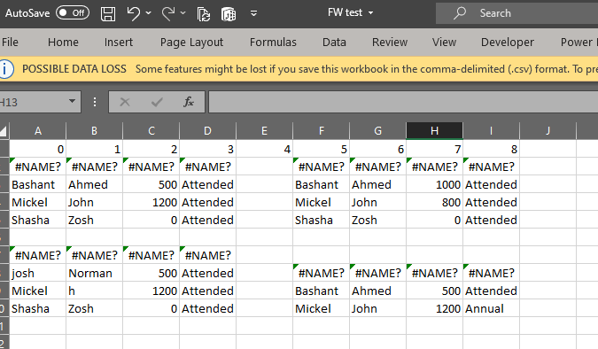

I’m still missing how I can make the sheet as only 4 columns without the need for doing manually.