 **Indoor Navigation System**

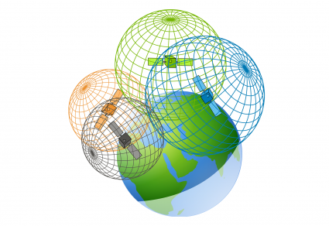In outdoor environments, the determination of an object's position is happened through the Global Satellite Navigation System.

However, in an indoor environment, we still need to define a positioning system **standard** that can be applied in different contexts.

**What is an Indoor Navigation System?**

An indoor navigation system is a technology that helps people navigate within indoor environments where GPS signals may be unavailable.

**What is Needed for Positioning Individuals for Navigate them?**

1. **Map of the Indoor Environment:** These maps should include only the layout of the space and also key features such as rooms, hallways,
2. **Objects (Sensors):** These objects collecting data and determine the user's location within the indoor environment. This could include Wi-Fi access points, Bluetooth beacons, or other sensor devices.

**Our main idea solution is:**

* using WIFI access points as a sensor throughout the building.
* create a detailed map with the coordinates of each single point.
* Build a dataset that has the coordinates of each point with signal strength of nearby access point.

**User scenario:** when user want to determine his location it just send the signal strength to the system which it can compared it with the coordinates in database

While components of the indoor environment are variables which is can effect of the stored signal strength that causes **Accuracy** goes down.

So, we eliminated the Variable components to maintain the **Accuracy** by:

Make it more dynamically.

* Instead of scan coordinates of the all area we just determine the **reference points** which is that will never been change.
* Relate our **access points** only with any of reference points.
* Record this reference points with the signal strength in dataset

Now, our main components are **fixed.** But there is a **gap between the stored point.**

using dynamic located technique will solve that like **Trilateration algorithm.**

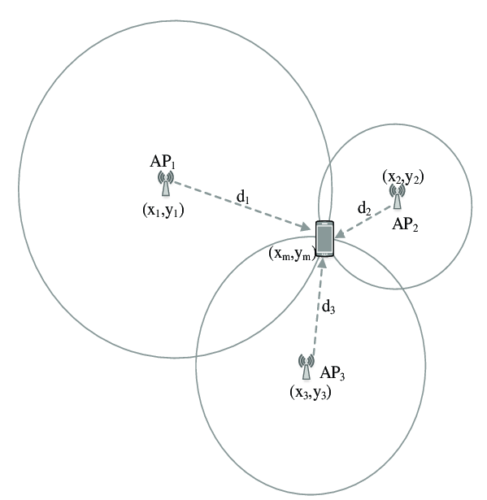measuring **distance** with TOF, TOA depends on speed and time.