**Name: Alaa Shaaban Hussien Ali Shatat**

**ID: 1700271**

**Section: 1**

**Subject: Distributed Systems- Assignment 1**

**Submitted to: DR. Gamal A. Ebrahim**

**Cairo 2021**

# 

# Introduction:

In our system we basically have three nodes or we can call it tiers: the drivers, the computers, and the servers. The servers send the recommendations to the computers, where they, in turn, send these recommendations to the drivers in the streets.

## Answer

1. Mobile Agent is a running code and data that can travel from a network to another, in our distributed system we can say that the computers are transferring the readings of the sensors to the server and the driver’s Request to the Server, and ask for recommendations. In return they send the recommendations to the driver as it took it from the server.

**The scenario:**

* 1. The driver wants to go somewhere.
  2. He will send to the Computer “intermediate node”.
  3. The computer send the reading and the destination to the server.
  4. The server can make the recommendations based on the readings.
  5. The server sends back the recommendations to the computer.
  6. The computers in return send these recommendations to the driver.

1. Screenshots

The sequence: first run the server, then run the computer class, and finally run the client class.

* The client Class “Driver”

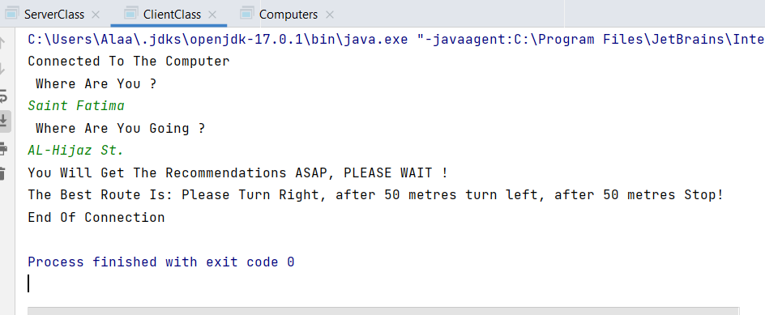

* The Computer Class

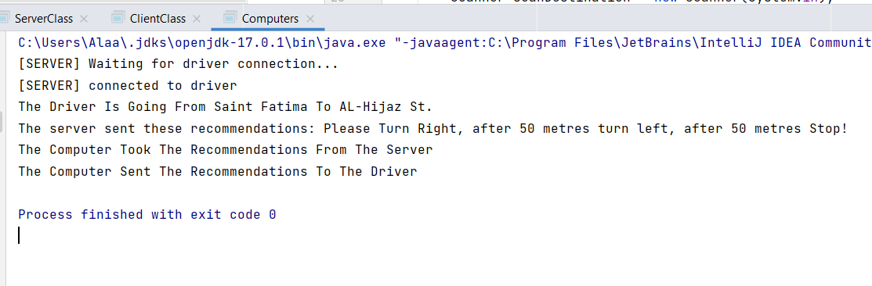

* The Server Class

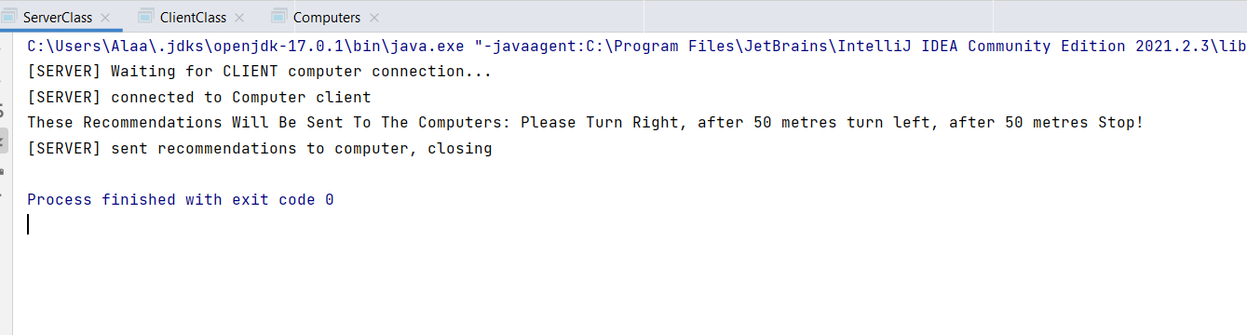

Samples from another Example:

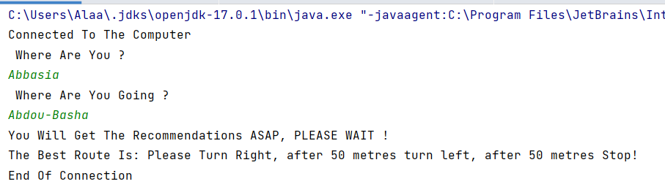

1. The ALP diagram:

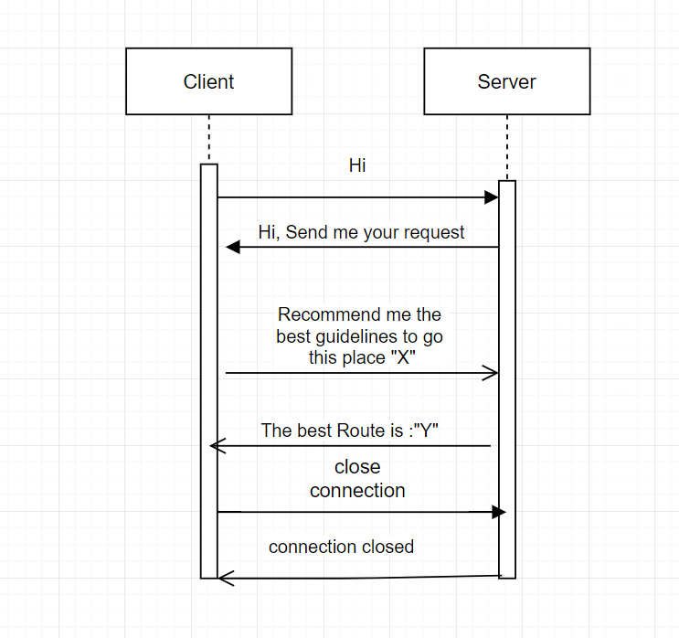

1. Multithreaded Screenshots:

Multi-threading is used in this point so multiple clients can be served at the same time.

Samples from Examples:

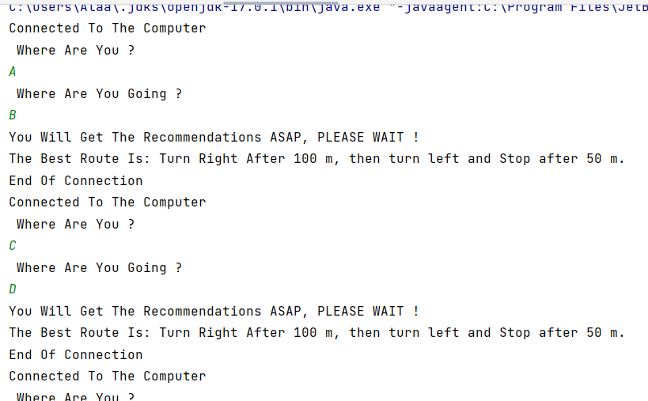

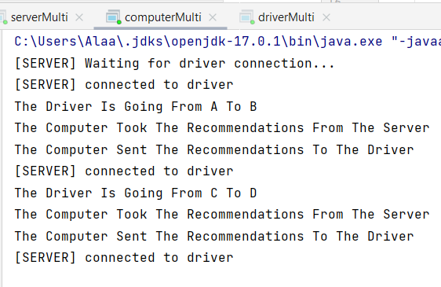

# Working Files:

* GitHub Repository Link:

<https://github.com/AlaaShatat/Monitoring-System>

* The README.txt file: <https://drive.google.com/drive/folders/1AOOvU9op6GNLOmgrlcP9o4KS8G3_9O0L?usp=sharing>

**Note:** You can find in the Repository the README.txt file and all the working files including the source Code.