Api documentation link : https://www.api-football.com/documentation-v3#tag/Fixtures/operation/get-fixtures-headtohead


- Introduction
- Authentication
- Architecture
- Logos / Images
- Sample Scripts
- Changelog
- Integrations
  - CDN
  - Databases Solutions
- Widgets
  - Widgets
- Endpoints
  - Timezone
  - Countries
  - Leagues
  - Teams
  - Venues
  - Standings
  - Fixtures
    - getRounds
    - getFixtures
    - getHead To Head
    - getStatistics
    - getEvents
    - getLineups
    - getPlayers statistics
  - Injuries
  - Predictions
  - Coachs
  - Players
  - Transfers
  - Trophies
  - Sidelined
  - Odds (In-Play)
  - Odds (Pre-Match)
API docs by Redocly

API-FOOTBALL (3.9.3)
support: https://dashboard.api-football.comURL: https://www.api-football.com

Introduction
Welcome to Api-Football! You can use our API to access all API endpoints, which can get information about Football Leagues & Cups.
We have language bindings in C, C#, cURL, Dart, Go, Java, Javascript, NodeJs, Objective-c, OCaml, Php, PowerShell, Python, Ruby, Shell and Swift! You can view code examples in the dark area to the right, and you can switch the programming language of the examples with the tabs in the top right.
The update frequency indicated in the documentation is given as an indication and may vary for certain competitions.

Authentication
We uses API keys to allow access to the API. You can register a new API key in our dashboard.
API-SPORTS : https://v3.football.api-sports.io/
Our API expects for the API key to be included in all API requests to the server in a header that looks like the following:
Make sure to replace XxXxXxXxXxXxXxXxXxXxXxXx with your API key.
REQUESTS HEADERS & CORS
The API is configured to work only with GET requests and allows only the headers listed below:
- x-apisports-key
If you make non-GET requests or add headers that are not in the list, you will receive an error from the API.
Some frameworks (especially in JS, nodeJS..) automatically add extra headers, you have to make sure to remove them in order to get a response from the API.

API-SPORTS Account
If you decided to subscribe directly on our site, you have a dashboard at your disposal at the following url: dashboard
It allows you to:
- To follow your consumption in real time
- Manage your subscription and change it if necessary
- Check the status of our servers
- Test all endpoints without writing a line of code.
You can also consult all this information directly through the API by calling the endpoint status.
This call does not count against the daily quota.
get("https://v3.football.api-sports.io/status");

// response
{
"get": "status",
"parameters": [],
"errors": [],
"results": 1,
"response": {
"account": {
"firstname": "xxxx",
"lastname": "XXXXXX",
"email": "xxx@xxx.com"
},
"subscription": {
"plan": "Free",
"end": "2020-04-10T23:24:27+00:00",
"active": true
},
"requests": {
"current": 12,
"limit_day": 100
}
}
}

Headers sent as response
When consuming our API, you will always receive the following headers appended to the response:
- x-ratelimit-requests-limit: The number of requests allocated per day according to your subscription.
- x-ratelimit-requests-remaining: The number of remaining requests per day according to your subscription.
- X-RateLimit-Limit: Maximum number of API calls per minute.
- X-RateLimit-Remaining: Number of API calls remaining before reaching the limit per minute.

Rate Limiting Policy
If you exceed your allowed request rate per minute, either through continuous excessive usage or by generating abnormal traffic spikes, your access may be temporarily or permanently blocked by our firewall without prior notice. This ensures service stability and fair usage for all customers.

Dashboard
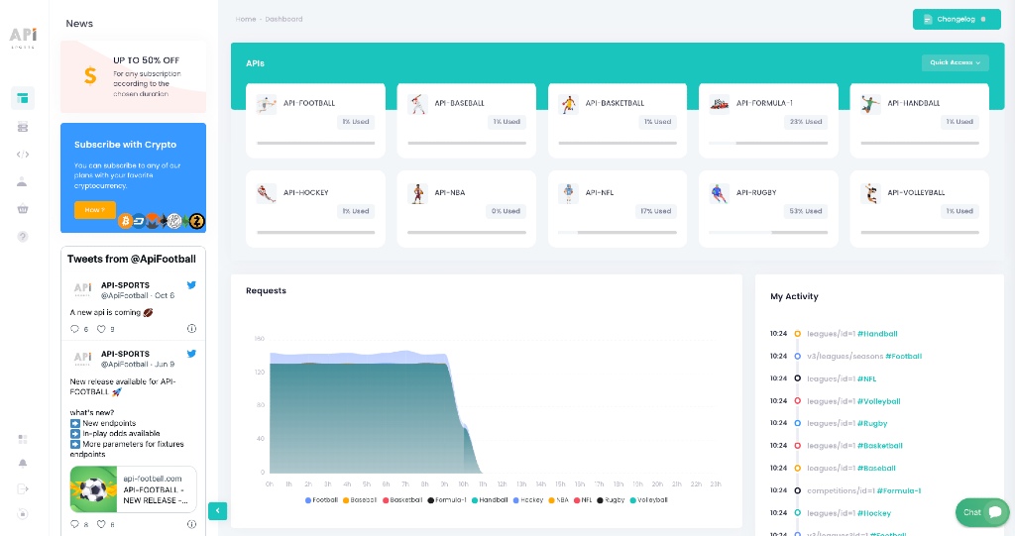

Requests
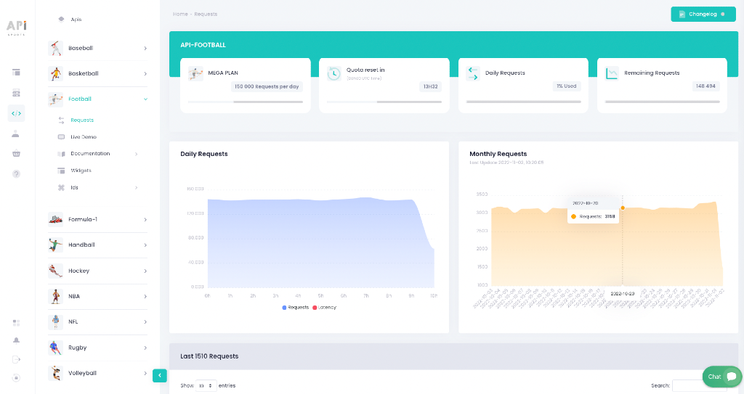

Live tester
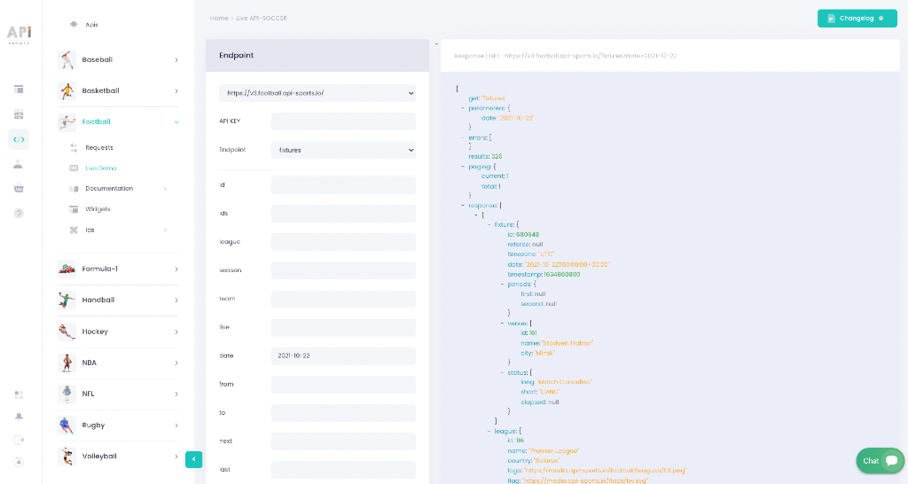

Architecture
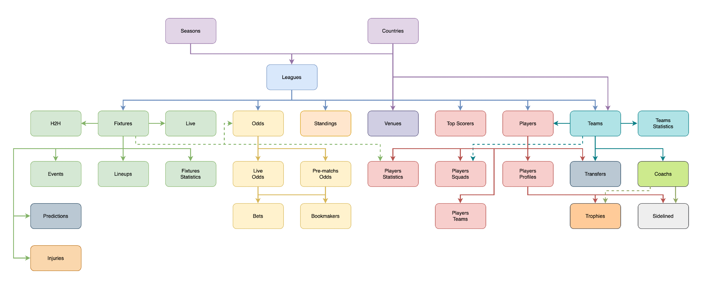

Logos / Images
Calls to logos/images do not count towards your daily quota and are provided for free. However these calls are subject to a rate per second & minute, it is recommended to save this data on your side in order not to slow down or impact the user experience of your application or website. For this you can use CDNs such as bunny.net.
We have a tutorial available here, which explains how to set up your own media system with BunnyCDN.
Logos, images and trademarks delivered through the API are provided solely for identification and descriptive purposes (e.g., identifying leagues, teams, players or venues). We does not own any of these visual assets, and no intellectual property rights are claimed over them. Some images or data may be subject to intellectual property or trademark rights held by third parties (including but not limited to leagues, federations, or clubs). The use of such content in your applications, websites, or products may require additional authorization or licensing from the respective rights holders. You are fully responsible for ensuring that your usage of any logos, images, or branded content complies with applicable laws in your country or the countries where your services are made available. We are not affiliated with, sponsored by, or endorsed by any sports league, federation, or brand featured in the data provided.

Sample Scripts
Here are some examples of how the API is used in the main development languages.
You have to replace {endpoint} by the real name of the endpoint you want to call, like leagues or fixtures for example. In all the sample scripts we will use the leagues endpoint as example.
Also you will have to replace XxXxXxXxXxXxXxXxXxXxXx with your API-KEY provided in the dashboard.

C
libcurl
CURL *curl;
CURLcode res;
curl = curl_easy_init();
if(curl) {
curl_easy_setopt(curl, CURLOPT_CUSTOMREQUEST, "GET");
curl_easy_setopt(curl, CURLOPT_URL, "https://v3.football.api-sports.io/leagues");
curl_easy_setopt(curl, CURLOPT_FOLLOWLOCATION, 1L);
curl_easy_setopt(curl, CURLOPT_DEFAULT_PROTOCOL, "https");
struct curl_slist *headers = NULL;
headers = curl_slist_append(headers, "x-apisports-key: XxXxXxXxXxXxXxXxXxXxXxXx");
curl_easy_setopt(curl, CURLOPT_HTTPHEADER, headers);
res = curl_easy_perform(curl);
}
curl_easy_cleanup(curl);

C#
RestSharp
var client = new RestClient("https://v3.football.api-sports.io/leagues");
client.Timeout = -1;
var request = new RestRequest(Method.GET);
request.AddHeader("x-apisports-key", "XxXxXxXxXxXxXxXxXxXxXxXx");
IRestResponse response = client.Execute(request);
Console.WriteLine(response.Content);

cURL
Curl
curl --request GET \
--url https://v3.football.api-sports.io/leagues \
--header 'x-apisports-key: XxXxXxXxXxXxXxXxXxXxXxXx'

Dart
http
var headers = {
'x-apisports-key': 'XxXxXxXxXxXxXxXxXxXxXxXx',
};
var request = http.Request('GET', Uri.parse('https://v3.football.api-sports.io/leagues'));

request.headers.addAll(headers);

http.StreamedResponse response = await request.send();

if (response.statusCode == 200) {
print(await response.stream.bytesToString());
}
else {
print(response.reasonPhrase);
}

Go
Native
package main

import (
"fmt"
"net/http"
"io/ioutil"
)

func main() {

url := "https://v3.football.api-sports.io/leagues"
method := "GET"

client := &http.Client {
}
req, err := http.NewRequest(method, url, nil)

if err != nil {
fmt.Println(err)
return
}
req.Header.Add("x-apisports-key", "XxXxXxXxXxXxXxXxXxXxXxXx")

res, err := client.Do(req)
if err != nil {
fmt.Println(err)
return
}
defer res.Body.Close()

body, err := ioutil.ReadAll(res.Body)
if err != nil {
fmt.Println(err)
return
}
fmt.Println(string(body))
}

Java
OkHttp
var myHeaders = new Headers();
myHeaders.append("x-apisports-key", "XxXxXxXxXxXxXxXxXxXxXxXx");

var requestOptions = {
method: 'GET',
headers: myHeaders,
redirect: 'follow'
};
Unirest
Unirest.setTimeouts(0, 0);
HttpResponse<String> response = Unirest.get("https://v3.football.api-sports.io/leagues")
.header("x-apisports-key", "XxXxXxXxXxXxXxXxXxXxXxXx")
.asString();

Javascript
Fetch
var myHeaders = new Headers();
myHeaders.append("x-apisports-key", "XxXxXxXxXxXxXxXxXxXxXxXx");

var requestOptions = {
method: 'GET',
headers: myHeaders,
redirect: 'follow'
};

fetch("https://v3.football.api-sports.io/leagues", requestOptions)
.then(response => response.text())
.then(result => console.log(result))
.catch(error => console.log('error', error));
jQuery
var settings = {
"url": "https://v3.football.api-sports.io/leagues",
"method": "GET",
"timeout": 0,
"headers": {
"x-apisports-key": "XxXxXxXxXxXxXxXxXxXxXxXx",
},
};

$.ajax(settings).done(function (response) {
console.log(response);
});
XHR
var xhr = new XMLHttpRequest();
xhr.withCredentials = true;

xhr.addEventListener("readystatechange", function() {
if(this.readyState === 4) {
console.log(this.responseText);
}
});

xhr.open("GET", "https://v3.football.api-sports.io/leagues");
xhr.setRequestHeader("x-apisports-key", "XxXxXxXxXxXxXxXxXxXxXxXx");

xhr.send();

NodeJs
Axios
var axios = require('axios');

var config = {
method: 'get',
url: 'https://v3.football.api-sports.io/leagues',
headers: {
'x-apisports-key': 'XxXxXxXxXxXxXxXxXxXxXxXx',
}
};

axios(config)
.then(function (response) {
console.log(JSON.stringify(response.data));
})
.catch(function (error) {
console.log(error);
});
Native
var https = require('follow-redirects').https;
var fs = require('fs');

var options = {
'method': 'GET',
'hostname': 'v3.football.api-sports.io',
'path': '/leagues',
'headers': {
'x-apisports-key': 'XxXxXxXxXxXxXxXxXxXxXxXx',
},
'maxRedirects': 20
};

var req = https.request(options, function (res) {
var chunks = [];

res.on("data", function (chunk) {
chunks.push(chunk);
});

res.on("end", function (chunk) {
var body = Buffer.concat(chunks);
console.log(body.toString());
});

res.on("error", function (error) {
console.error(error);
});
});

req.end();
Requests
var request = require('request');
var options = {
'method': 'GET',
'url': 'https://v3.football.api-sports.io/leagues',
'headers': {
'x-apisports-key': 'XxXxXxXxXxXxXxXxXxXxXxXx',
}
};
request(options, function (error, response) {
if (error) throw new Error(error);
console.log(response.body);
});
Unirest
var unirest = require('unirest');
var req = unirest('GET', 'https://v3.football.api-sports.io/leagues')
.headers({
'x-apisports-key': 'XxXxXxXxXxXxXxXxXxXxXxXx',
})
.end(function (res) {
if (res.error) throw new Error(res.error);
console.log(res.raw_body);
});

Objective-c
NSURLSession
#import <Foundation/Foundation.h>

dispatch_semaphore_t sema = dispatch_semaphore_create(0);

NSMutableURLRequest *request = [NSMutableURLRequest requestWithURL:[NSURL URLWithString:@"https://v3.football.api-sports.io/leagues"]
cachePolicy:NSURLRequestUseProtocolCachePolicy
timeoutInterval:10.0];
NSDictionary *headers = @{
@"x-apisports-key": @"XxXxXxXxXxXxXxXxXxXxXxXx",
};

[request setAllHTTPHeaderFields:headers];

[request setHTTPMethod:@"GET"];

NSURLSession *session = [NSURLSession sharedSession];
NSURLSessionDataTask *dataTask = [session dataTaskWithRequest:request
completionHandler:^(NSData *data, NSURLResponse *response, NSError *error) {
if (error) {
NSLog(@"%@", error);
dispatch_semaphore_signal(sema);
} else {
NSHTTPURLResponse *httpResponse = (NSHTTPURLResponse *) response;
NSError *parseError = nil;
NSDictionary *responseDictionary = [NSJSONSerialization JSONObjectWithData:data options:0 error:&parseError];
NSLog(@"%@",responseDictionary);
dispatch_semaphore_signal(sema);
}
}];
[dataTask resume];
dispatch_semaphore_wait(sema, DISPATCH_TIME_FOREVER);

OCaml
Cohttp
open Lwt
open Cohttp
open Cohttp_lwt_unix

let reqBody =
let uri = Uri.of_string "https://v3.football.api-sports.io/leagues" in
let headers = Header.init ()
|> fun h -> Header.add h "x-apisports-key" "XxXxXxXxXxXxXxXxXxXxXxXx"
in
Client.call ~headers `GET uri >>= fun (_resp, body) ->
body |> Cohttp_lwt.Body.to_string >|= fun body -> body

let () =
let respBody = Lwt_main.run reqBody in
print_endline (respBody)

Php
cURL
$curl = curl_init();

curl_setopt_array($curl, array(
CURLOPT_URL => 'https://v3.football.api-sports.io/leagues',
CURLOPT_RETURNTRANSFER => true,
CURLOPT_ENCODING => '',
CURLOPT_MAXREDIRS => 10,
CURLOPT_TIMEOUT => 0,
CURLOPT_FOLLOWLOCATION => true,
CURLOPT_HTTP_VERSION => CURL_HTTP_VERSION_1_1,
CURLOPT_CUSTOMREQUEST => 'GET',
CURLOPT_HTTPHEADER => array(
'x-apisports-key: XxXxXxXxXxXxXxXxXxXxXxXx',
),
));

$response = curl_exec($curl);

curl_close($curl);
echo $response;
Request2
<?php
require_once 'HTTP/Request2.php';
$request = new HTTP_Request2();
$request->setUrl('https://v3.football.api-sports.io/leagues');
$request->setMethod(HTTP_Request2::METHOD_GET);
$request->setConfig(array(
'follow_redirects' => TRUE
));
$request->setHeader(array(
'x-apisports-key' => 'XxXxXxXxXxXxXxXxXxXxXxXx',
));
try {
$response = $request->send();
if ($response->getStatus() == 200) {
echo $response->getBody();
}
else {
echo 'Unexpected HTTP status: ' . $response->getStatus() . ' ' .
$response->getReasonPhrase();
}
}
catch(HTTP_Request2_Exception $e) {
echo 'Error: ' . $e->getMessage();
}
Http
$client = new http\Client;
$request = new http\Client\Request;
$request->setRequestUrl('https://v3.football.api-sports.io/leagues');
$request->setRequestMethod('GET');
$request->setHeaders(array(
'x-apisports-key' => 'XxXxXxXxXxXxXxXxXxXxXxXx'
));
$client->enqueue($request)->send();
$response = $client->getResponse();
echo $response->getBody();

PowerShell
RestMethod
$headers = New-Object "System.Collections.Generic.Dictionary[[String],[String]]"
$headers.Add("x-apisports-key", "XxXxXxXxXxXxXxXxXxXxXxXx")

$response = Invoke-RestMethod 'https://v3.football.api-sports.io/leagues' -Method 'GET' -Headers $headers
$response | ConvertTo-Json

Python
http.client
import http.client

conn = http.client.HTTPSConnection("v3.football.api-sports.io")

headers = {
'x-apisports-key': "XxXxXxXxXxXxXxXxXxXxXxXx"
}

conn.request("GET", "/leagues", headers=headers)

res = conn.getresponse()
data = res.read()

print(data.decode("utf-8"))
Requests
url = "https://v3.football.api-sports.io/leagues"

payload={}
headers = {
'x-apisports-key': 'XxXxXxXxXxXxXxXxXxXxXxXx',
}

response = requests.request("GET", url, headers=headers, data=payload)

print(response.text)

Ruby
Net::HTTP
require 'uri'
require 'net/http'
require 'openssl'

url = URI("https://v3.football.api-sports.io/leagues")

http = Net::HTTP.new(url.host, url.port)
http.use_ssl = true
http.verify_mode = OpenSSL::SSL::VERIFY_NONE

request = Net::HTTP::Get.new(url)
request["x-apisports-key"] = 'XxXxXxXxXxXxXxXxXxXxXxXx'

response = http.request(request)
puts response.read_body

Shell
Httpie
http --follow --timeout 3600 GET 'https://v3.football.api-sports.io/leagues' \
x-apisports-key:'XxXxXxXxXxXxXxXxXxXxXxXx' \
wget
wget --no-check-certificate --quiet \
--method GET \
--timeout=0 \
--header 'x-apisports-key: XxXxXxXxXxXxXxXxXxXxXxXx' \
'https://v3.football.api-sports.io/leagues'

Swift
URLSession
import Foundation
#if canImport(FoundationNetworking)
import FoundationNetworking
#endif

var semaphore = DispatchSemaphore (value: 0)

var request = URLRequest(url: URL(string: "https://v3.football.api-sports.io/leagues")!,timeoutInterval: Double.infinity)
request.addValue("XxXxXxXxXxXxXxXxXxXxXxXx", forHTTPHeaderField: "x-apisports-key")

request.httpMethod = "GET"

let task = URLSession.shared.dataTask(with: request) { data, response, error in
guard let data = data else {
print(String(describing: error))
semaphore.signal()
return
}
print(String(data: data, encoding: .utf8)!)
semaphore.signal()
}

task.resume()
semaphore.wait()

Changelog

3.9.3
- Add endpoint players/profiles that returns the list of all available players
- Add endpoint players/teams that returns the list of teams and seasons in which the player played during his career
- Endpoint fixtures
  - Add field extra that returns the additional time played in a half
  - Add field standings indicating whether the fixture's competition covers standings (True | False)
- Endpoint fixtures/rounds
  - Add the dates parameter that allows to retrieve the dates of each round in the response
- Endpoint fixtures/statistics
  - Add the half parameter that allows to retrieve the halftime statistics in the response
- Endpoint injuries
  - Add the ids parameter that allows to retrieve data from several fixtures in one call
- Endpoint teams/statistics, more statistics added
  - Goals Over
  - Goals Under
- Endpoint sidelined
  - Add the players and coachs parameters that allows to retrieve data from several players/coachs in one call
- Endpoint trophies
  - Add the players and coachs parameters that allows to retrieve data from several players/coachs in one call

3.9.2
- Endpoint odds
  - Add endpoint odds/live
  - Add endpoint odds/live/bets
- Endpoint teams
  - Add parameter code
  - Add parameter venue
  - Add endpoint teams/countries
- Endpoint fixtures
  - Add the ids parameter that allows to retrieve data from several fixtures including events, lineups, statistics and players in one Api call
  - Add the Possibility to add several status for the status parameter
  - Add parameter venue
- Endpoint fixtures/headtohead
  - Add the Possibility to add several status for the status parameter
  - Add parameter venue

3.8.1
- Add endpoint injuries
- Add endpoint players/squads
- Add endpoint players/topassists
- Add endpoint players/topyellowcards
- Add endpoint players/topredcards
- Endpoint fixtures/lineups
  - Add players positions on the grid
  - Add players' jerseys colors
- Endpoint fixtures/events
  - add VAR events
- Endpoint teams
  - Add tri-code
- Endpoint teams/statistics, more statistics added
  - Scoring minute
  - Cards per minute
  - Most played formation
  - Penalty statistics
- Add Coaches Photos

CDN

Optimizing Sports Websites with BunnyCDN
BunnyCDN is a Content Delivery Network (CDN) that delivers a global content distribution experience. With strategically positioned servers, BunnyCDN ensures swift and reliable delivery of static content, optimizing website performance with features like intelligent image optimization, sophisticated caching, and advanced security measures.
Unlocking Media Delivery Excellence with BunnyCDN:
- Quick Configuration: Set up your media CDN in just 5 minutes. Define cache times, customize your domain – it's that simple.
- Global Accessibility: Leverage BunnyCDN's expansive server network for swift and dependable content delivery worldwide.
- Customized Configuration: Tailor caching, define cache times, and implement CORS headers to create an efficient and seamless user experience.
- Own Your Domain: Personalize your media delivery with your domain, enhancing your brand's online presence.
- Robust Security: BunnyCDN integrates advanced security features, guaranteeing a secure environment for delivering your content.
- Responsive Performance: Experience responsive performance without the need for prior media downloads. Discover the capabilities of BunnyCDN for optimized media delivery.
A tutorial is available here on our blog to help you configure it.

Databases Solutions

Enhance Your Data Management with Aiven
Integrating databases into your application can greatly enhance data management and storage. If you're looking for high-performing, flexible, and secure database solutions, we recommend checking out Aiven.
Aiven is a cloud platform that offers a range of managed database services, including relational databases, NoSQL databases, streaming data processing systems, and much more. Their offerings include PostgreSQL, MySQL, Cassandra, Redis, Kafka, and many other databases, all with simplified management, high availability, and advanced security.
Moreover, Aiven provides a free tier to get started, along with testing credits to explore their offerings. This opportunity allows you to evaluate their platform and determine if it meets your needs.
One particularly attractive feature of Aiven is that they work with multiple cloud providers, including Google Cloud, Amazon Web Services (AWS), Microsoft Azure, DigitalOcean, and more. This means you have the flexibility to choose the best cloud infrastructure for your project.
In terms of reliability, Aiven is committed to providing a 99.99% Service Level Agreement (SLA), ensuring continuous and highly available service.
- To test their services, visit this page.
- If you're a developer, explore their DEV center for technical information.
- Check out Aiven's documentation for detailed information on their services and features.
By integrating Aiven with our API, you can efficiently store, manage, and analyze your data while taking advantage of their cloud database solutions' flexibility and scalability.

Real-Time Data Management with Firebase
When you're looking for a real-time data management solution for your application, Firebase's Realtime Database is a powerful choice. Explore how Firebase can enhance real-time data management for your application.
Firebase's Realtime Database offers a cloud-based real-time database that synchronizes data in real-time across users and devices. This makes it an ideal choice for applications that require instant data updates.
Why Choose Firebase's Realtime Database?
- Real-Time Data: Firebase allows you to store real-time data, meaning that updates are instantly propagated to all connected users.
- Easy Synchronization: Data is automatically synchronized across all devices, providing a consistent and real-time user experience.
- Built-In Security: Firebase offers flexible security rules to control data access and ensure privacy.
- Simplified Integration: Firebase's Realtime Database easily integrates with other Firebase services, simplifying backend management.
Helpful Links:
- Explore Firebase's Realtime Database: Discover the features and advantages of Firebase's Realtime Database for efficient real-time data management.
- Firebase's Realtime Database Documentation: Refer to the comprehensive documentation for Firebase's Realtime Database for a smooth integration.
A tutorial describing each step is available on our blog here.

Widgets
API-SPORTS widgets allow you to easily display dynamic sports data on your website.
They are designed to be:
- Ultra-modular: each component is autonomous
- Customisable: language, theme, content, behaviour
- Easy to integrate: no framework required, a simple HTML tag is all you need
They use request from your API-SPORTS account and work with all plans, including the free plan.
Find all the documentation on widgets here
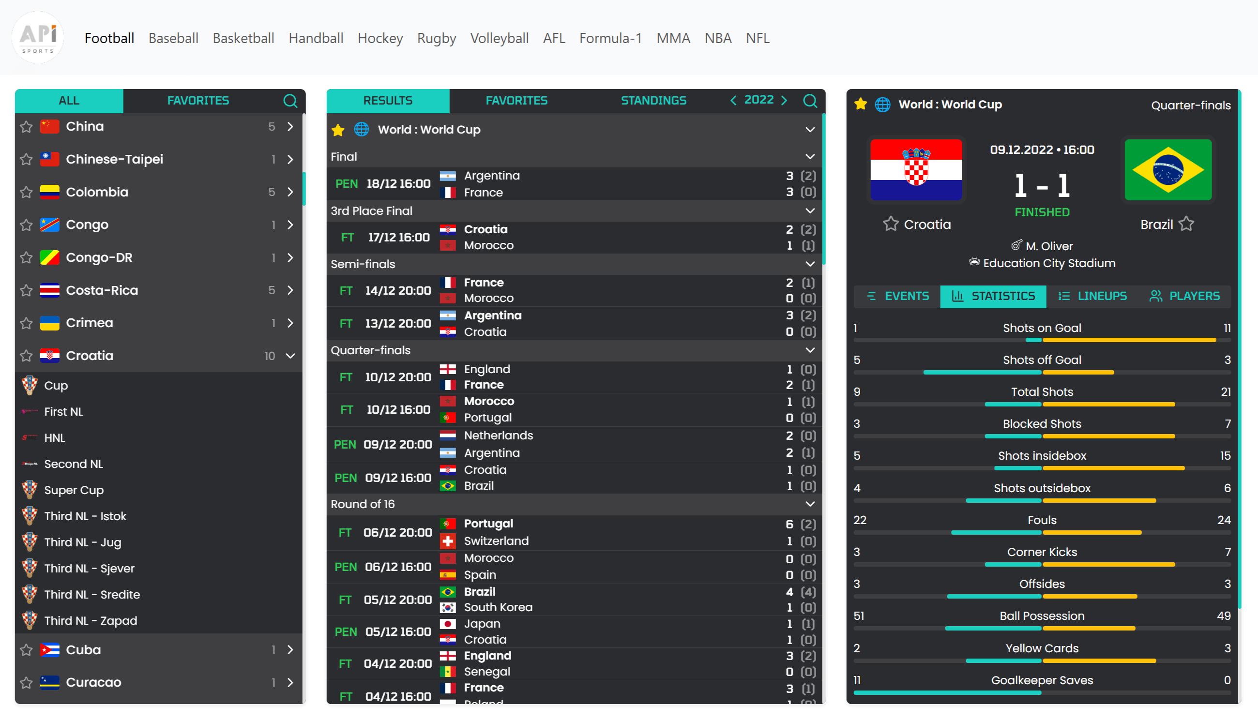

Security
Our widgets use your account's API-KEY, which must be specified in the data-key attribute of your widget configuration.
When using these widgets it is important to be aware that your API-KEY will be visible to the users of your site, it is possible to protect yourself from this by allowing only the desired domains or IP in our dashboard. This way no one else can use your API-KEY for you. If you have already set up your widget and have not activated this option, you can reset your API-KEY and activate this option after.
You can further enhance security by completely hiding your API-KEY from the source code by following this tutorial.

Caching Data
By using Widgets, each visit to a page on your website triggers one or more API requests to retrieve data. Without a caching system, your daily quota can be reached very quickly.
Example: If a page triggers a single API request per visitor and you receive 80 visits to that page in one minute, this results in 80 API requests. Over a full day, that can add up to 115 200 requests.
By implementing a caching system, even with a very short duration, such as 60 seconds, you can drastically reduce the number of requests. The first visit will trigger an API request, but the response will then be cached for the next 60 seconds. This means that if 80 visitors access the same page within that time frame, only the first request will reach the API, while the next 79 will be served directly from the cache.
With this system in place, you reduce usage from 115 200 requests per day to just 1 440.
A full tutorial is available here, explaining step by step how to set up an effective caching system.

Debugging
If the widget does not display the requested information, it is possible to set the data-show-errors tag to true to display error messages directly in the widget and in the console. This can be due to several things like : (Non-exhaustive list)
- You have reached your daily number of requests
- Tags are incorrectly filled in
- Your API-KEY is incorrect

All available widgets
Below is a list of all available widgets:
- games → list of matches
- game → details of a match
- team → team profile
- player → player profile
- standings → league table
- league → schedule
- leagues → list of all leagues
- h2h → historical head-to-head
- races, race, driver → Formula 1
- fights, fight, fighter → MMA
Each widget adapts automatically based on the selected sport.

Before You Begin

Dynamic targeting
Some widgets, such as games, can dynamically open other widgets like game, standings, player, and more.
This interaction is enabled using the data-target-* attributes.
These attributes allow you to define where the opened widget should be rendered:
- modal → renders the widget inside a modal.
- CSS selector (#id or .class) → injects the widget into a specific HTML element on the page.
These targeting options are available for:
General sports widgets (Football, Basketball, etc.):
- data-target-game
- data-target-standings
- data-target-team
- data-target-player
- data-target-league
Formula 1 specific:
- data-target-race
- data-target-ranking
- data-target-driver
MMA specific:
- data-target-fight
- data-target-fighter
Target a container by ID
<api-sports-widget data-type="games"></api-sports-widget>

<div id="details"></div>

<api-sports-widget
data-type="config"
data-key="Your-Api-Key-Here"
data-sport="football"
data-target-game="#details"
></api-sports-widget>
Target using modal
<api-sports-widget data-type="games"></api-sports-widget>

<api-sports-widget
data-type="config"
data-key="Your-Api-Key-Here"
data-sport="football"
data-target-game="modal"
></api-sports-widget>

Language
The data-lang attribute allows you to easily switch the interface language of all widgets.

Available languages:
- en (English)
- fr (French)
- es (Spanish)
- it (Italian)
Example usage
<api-sports-widget
data-type="config"
data-key="Your-Api-Key"
data-sport="football"
data-lang="en"
data-custom-lang="https://yourdomain.com/lang/en.json"
></api-sports-widget>
Example
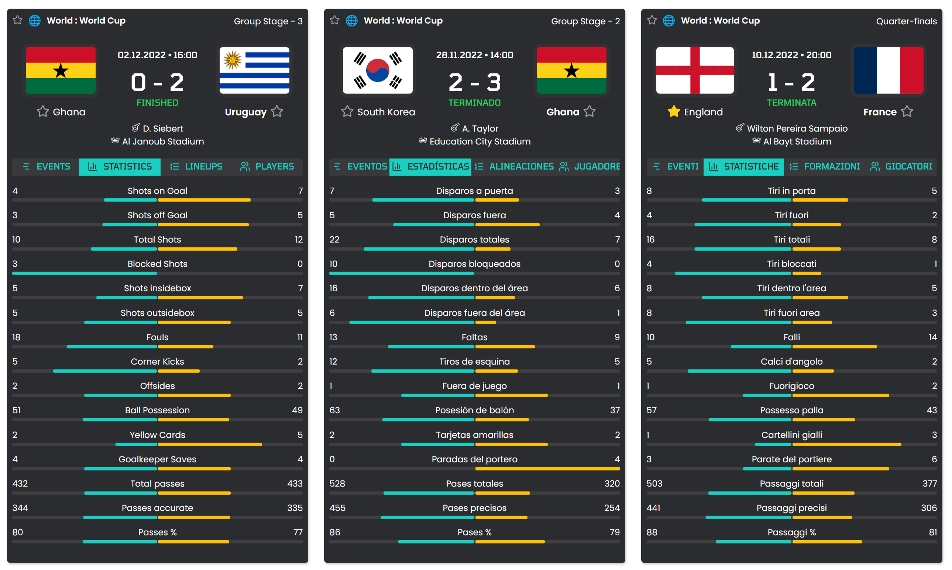

Custom translations:
For complete control over wording, you can load your own translation file using data-custom-lang.
This file must be a valid JSON object following the internal key structure.
You can download the translation file here.
It allows you to:
- Override specific labels
- Translate missing terms
- Adapt terminology to your audience
Example JSON format:
{
"all": "All",
"live": "Now Live",
"finished": "Completed",
"scheduled": "Coming Up",
"favorites": "Favorites",
}
You can use data-lang and data-custom-lang together.
If a key is defined in both, the custom file will take priority.
Exemple for custom translation
<api-sports-widget data-type="games" data-target-game="modal"></api-sports-widget>

<api-sports-widget
data-type="config"
data-key="Your-Api-Key-Here"
data-sport="football"
data-lang="custom"
data-custom-lang="https://yourdomain.com/lang/custom.json"
></api-sports-widget>
You have a tutorial available here

Predefined themes
Four built-in themes are available by default. You can set them using the data-theme attribute on any widget.
- white (default)
- grey
- dark
- blue
Each theme adjusts background colors, text colors, button styles, borders, and more.
White
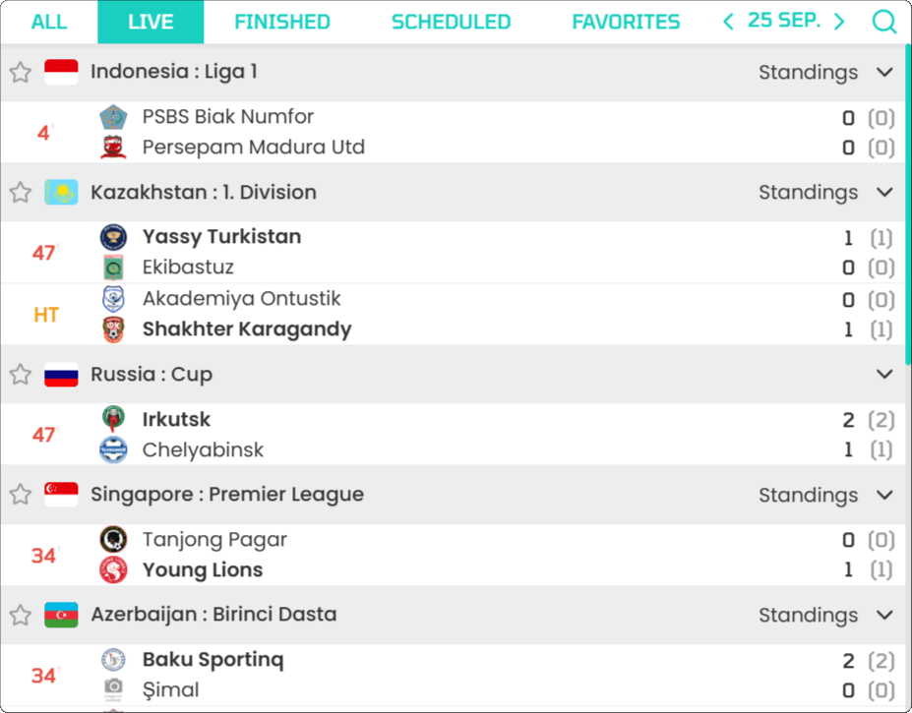Grey
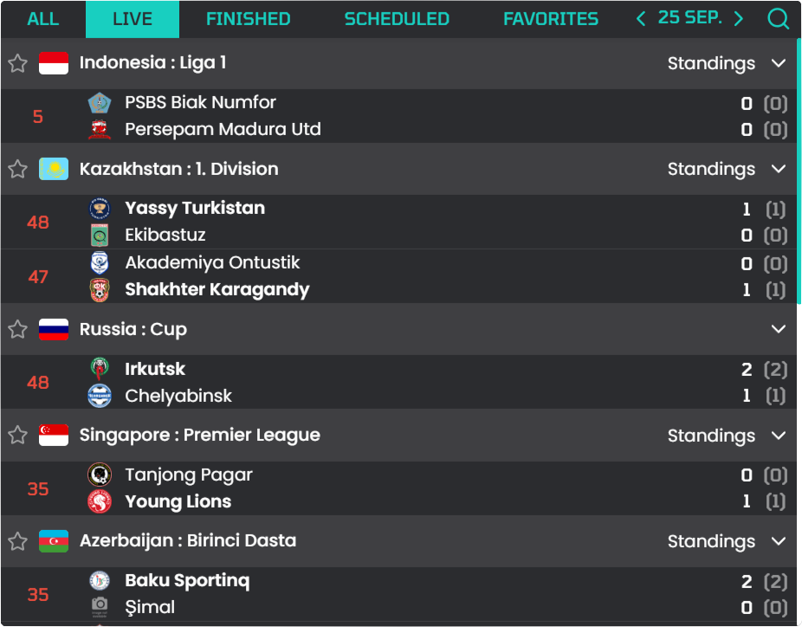
Dark
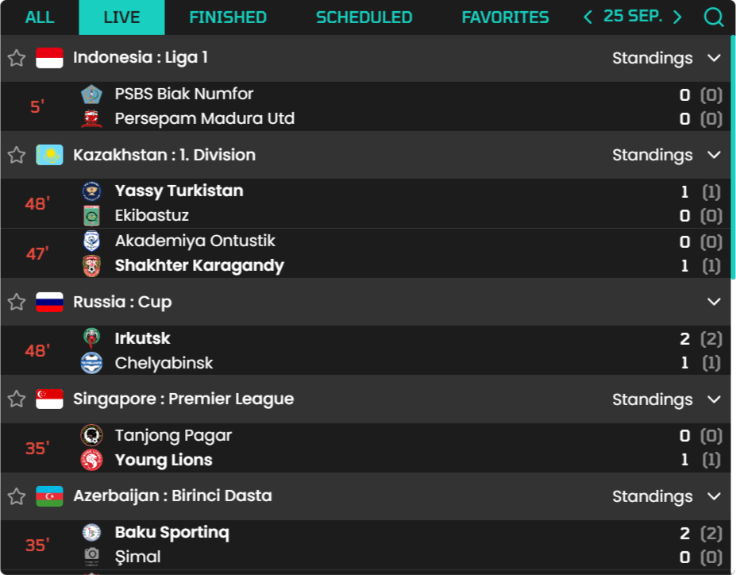Blue
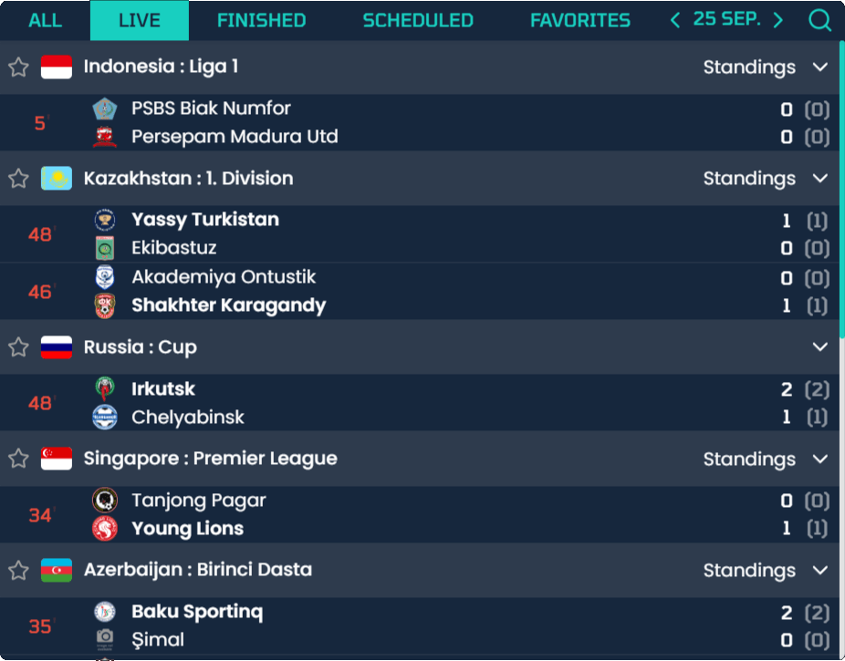

Custom theme
You can override the default styles by creating your own CSS theme using the data-theme attribute and custom variable declarations.
Example:
api-sports-widget[data-theme="MyTheme"] {
--primary-color: #18cfc0;
--success-color: #2ecc58;
--warning-color: #f39c12;
--danger-color: #e74c3c;
--light-color: #898989;

--home-color: var(--primary-color);
--away-color: #ffc107;

--text-color: #333;
--text-color-info: #333;

--background-color: #fff;

--primary-font-size: 0.72rem;
--secondary-font-size: 0.75rem;
--button-font-size: 0.8rem;
--title-font-size: 0.9rem;

--header-text-transform: uppercase;
--button-text-transform: uppercase;
--title-text-transform: uppercase;

--border: 1px solid #95959530;
--game-height: 2.3rem;
--league-height: 2.35rem;

--score-size: 2.25rem;
--flag-size: 22px;
--teams-logo-size: 18px;
--teams-logo-size-xl: 5rem;
--hover: rgba(200, 200, 200, 0.15);
}
<api-sports-widget data-type="games"></api-sports-widget>

<div id="game-container"></div>

<api-sports-widget
data-type="config"
data-key="Your-Api-Key-Here"
data-sport="football"
data-theme="MyTheme"
></api-sports-widget>
Find all the documentation on widgets here

Timezone

Timezone
Get the list of available timezone to be used in the fixtures endpoint.
This endpoint does not require any parameters.
Update Frequency : This endpoint contains all the existing timezone, it is not updated.
Recommended Calls : 1 call when you need.

header Parameters
x-apisports-key  required | string  Your Api-Key

Responses
200
OK
204
No Content
499
Time Out
500
Internal Server Error
get/timezone

Request samples
- Php
- Python
- Node
- JavaScript
- Curl
- Ruby
Copy
$client = new http\Client;
$request = new http\Client\Request;

$request->setRequestUrl('https://v3.football.api-sports.io/timezone');
$request->setRequestMethod('GET');
$request->setHeaders(array(
'x-apisports-key' => 'XxXxXxXxXxXxXxXxXxXxXxXx'
));

$client->enqueue($request)->send();
$response = $client->getResponse();

echo $response->getBody();

Response samples
- 200
- 204
- 499
- 500
Content type
application/json
Copy
Expand allCollapse all
{
- "get": "timezone",
- "parameters": [ ],
- "errors": [ ],
- "results": 425,
- "paging": {
  - "current": 1,
  - "total": 1
},
- "response": [
  - "Africa/Abidjan",
  - "Africa/Accra",
  - "Africa/Addis_Ababa",
  - "Africa/Algiers",
  - "Africa/Asmara"
]
}

Countries

Countries
Get the list of available countries for the leagues endpoint.
The name and code fields can be used in other endpoints as filters.
To get the flag of a country you have to call the following url: https://media.api-sports.io/flags/{country_code}.svg
Examples available in Request samples "Use Cases".
All the parameters of this endpoint can be used together.
Update Frequency : This endpoint is updated each time a new league from a country not covered by the API is added.
Recommended Calls : 1 call per day.

query Parameters
name | string  The name of the country
code | string [ 2 .. 6 ] characters FR, GB-ENG, IT…  The Alpha code of the country
search | string = 3 characters  The name of the country

header Parameters
x-apisports-key  required | string  Your Api-Key

Responses
200
OK
204
No Content
499
Time Out
500
Internal Server Error
get/countries

Request samples
- Use Cases
- Php
- Python
- Node
- JavaScript
- Curl
- Ruby
Copy
// Get all available countries across all {seasons} and competitions
get("https://v3.football.api-sports.io/countries");

// Get all available countries from one country {name}
get("https://v3.football.api-sports.io/countries?name=england");

// Get all available countries from one country {code}
get("https://v3.football.api-sports.io/countries?code=fr");

// Allows you to search for a countries in relation to a country {name}
get("https://v3.football.api-sports.io/countries?search=engl");

Response samples
- 200
- 204
- 499
- 500
Content type
application/json
Copy
Expand allCollapse all
{
- "get": "countries",
- "parameters": {
  - "name": "england"
},
- "errors": [ ],
- "results": 1,
- "paging": {
  - "current": 1,
  - "total": 1
},
- "response": [
  - {}
]
}

Leagues

Leagues
Get the list of available leagues and cups.
The league id are unique in the API and leagues keep it across all seasons
To get the logo of a competition you have to call the following url: https://media.api-sports.io/football/leagues/{league_id}.png
This endpoint also returns the coverage of each competition, which makes it possible to know what is available for that league or cup.
The values returned by the coverage indicate the data available at the moment you call the API, so for a competition that has not yet started, it is normal to have all the features set to False. This will be updated once the competition has started.
You can find all the leagues ids on our Dashboard.
Example :
"coverage": {
"fixtures": {
"events": true,
"lineups": true,
"statistics_fixtures": false,
"statistics_players": false
},
"standings": true,
"players": true,
"top_scorers": true,
"top_assists": true,
"top_cards": true,
"injuries": true,
"predictions": true,
"odds": false
}
In this example we can deduce that the competition does not have the following features: statistics_fixtures, statistics_players, odds because it is set to False.
The coverage of a competition can vary from season to season and values set to True do not guarantee 100% data availability.
Some competitions, such as the friendlies, are exceptions to the coverage indicated in the leagues endpoint, and the data available may differ depending on the match, including livescore, events, lineups, statistics and players.
Competitions are automatically renewed by the API when a new season is available. There may be a delay between the announcement of the official calendar and the availability of data in the API.
For Cup competitions, fixtures are automatically added when the two participating teams are known. For example if the current phase is the 8th final, the quarter final will be added once the teams playing this phase are known.
Examples available in Request samples "Use Cases".
Most of the parameters of this endpoint can be used together.
Update Frequency : This endpoint is updated several times a day.
Recommended Calls : 1 call per hour.

query Parameters
id | integer  The id of the league
name | string  The name of the league
country | string  The country name of the league
code | string [ 2 .. 6 ] characters FR, GB-ENG, IT…  The Alpha code of the country
season | integer = 4 characters YYYY  The season of the league
team | integer  The id of the team
type | string  Enum: "league" "cup"  The type of the league
current | string Return the list of active seasons or the las...Show pattern  Enum: "true" "false"  The state of the league
search | string >= 3 characters  The name or the country of the league
last | integer <= 2 characters  The X last leagues/cups added in the API

header Parameters
x-apisports-key  required | string  Your Api-Key

Responses
200
OK
204
No Content
499
Time Out
500
Internal Server Error
get/leagues

Request samples
- Use Cases
- Php
- Python
- Node
- JavaScript
- Curl
- Ruby
Copy
// Allows to retrieve all the seasons available for a league/cup
get("https://v3.football.api-sports.io/leagues?id=39");

// Get all leagues from one league {name}
get("https://v3.football.api-sports.io/leagues?name=premier league");

// Get all leagues from one {country}
// You can find the available {country} by using the endpoint country
get("https://v3.football.api-sports.io/leagues?country=england");

// Get all leagues from one country {code} (GB, FR, IT etc..)
// You can find the available country {code} by using the endpoint country
get("https://v3.football.api-sports.io/leagues?code=gb");

// Get all leagues from one {season}
// You can find the available {season} by using the endpoint seasons
get("https://v3.football.api-sports.io/leagues?season=2019");

// Get one league from one league {id} & {season}
get("https://v3.football.api-sports.io/leagues?season=2019&id=39");

// Get all leagues in which the {team} has played at least one match
get("https://v3.football.api-sports.io/leagues?team=33");

// Allows you to search for a league in relation to a league {name} or {country}
get("https://v3.football.api-sports.io/leagues?search=premier league");
get("https://v3.football.api-sports.io/leagues?search=England");

// Get all leagues from one {type}
get("https://v3.football.api-sports.io/leagues?type=league");

// Get all leagues where the season is in progress or not
get("https://v3.football.api-sports.io/leagues?current=true");

// Get the last 99 leagues or cups added to the API
get("https://v3.football.api-sports.io/leagues?last=99");

// It’s possible to make requests by mixing the available parameters
get("https://v3.football.api-sports.io/leagues?season=2019&country=england&type=league");
get("https://v3.football.api-sports.io/leagues?team=85&season=2019");
get("https://v3.football.api-sports.io/leagues?id=61¤t=true&type=league");

Response samples
- 200
- 204
- 499
- 500
Content type
application/json
Copy
Expand allCollapse all
{
- "get": "leagues",
- "parameters": {
  - "id": "39"
},
- "errors": [ ],
- "results": 1,
- "paging": {
  - "current": 1,
  - "total": 1
},
- "response": [
  - {}
]
}

Seasons
Get the list of available seasons.
All seasons are only 4-digit keys, so for a league whose season is 2018-2019 like the English Premier League (EPL), the 2018-2019 season in the API will be 2018.
All seasons can be used in other endpoints as filters.
This endpoint does not require any parameters.
Update Frequency : This endpoint is updated each time a new league is added.
Recommended Calls : 1 call per day.

header Parameters
x-apisports-key  required | string  Your Api-Key

Responses
200
OK
204
No Content
499
Time Out
500
Internal Server Error
get/leagues/seasons

Request samples
- Php
- Python
- Node
- JavaScript
- Curl
- Ruby
Copy
$client = new http\Client;
$request = new http\Client\Request;

$request->setRequestUrl('https://v3.football.api-sports.io/leagues/seasons');
$request->setRequestMethod('GET');
$request->setHeaders(array(
'x-apisports-key' => 'XxXxXxXxXxXxXxXxXxXxXxXx'
));

$client->enqueue($request)->send();
$response = $client->getResponse();

echo $response->getBody();

Response samples
- 200
- 204
- 499
- 500
Content type
application/json
Copy
Expand allCollapse all
{
- "get": "leagues/seasons",
- "parameters": [ ],
- "errors": [ ],
- "results": 12,
- "paging": {
  - "current": 1,
  - "total": 1
},
- "response": [
  - 2008,
  - 2010,
  - 2011,
  - 2012,
  - 2013,
  - 2014,
  - 2015,
  - 2016,
  - 2017,
  - 2018,
  - 2019,
  - 2020
]
}

Teams

Teams information
Get the list of available teams.
The team id are unique in the API and teams keep it among all the leagues/cups in which they participate.
To get the logo of a team you have to call the following url: https://media.api-sports.io/football/teams/{team_id}.png
You can find all the teams ids on our Dashboard.
Examples available in Request samples "Use Cases".
All the parameters of this endpoint can be used together.
This endpoint requires at least one parameter.
Update Frequency : This endpoint is updated several times a week.
Recommended Calls : 1 call per day.
Tutorials :
- HOW TO GET ALL TEAMS AND PLAYERS FROM A LEAGUE ID

query Parameters
id | integer  The id of the team
name | string  The name of the team
league | integer  The id of the league
season | integer = 4 characters YYYY  The season of the league
country | string  The country name of the team
code | string = 3 characters  The code of the team
venue | integer  The id of the venue
search | string >= 3 characters  The name or the country name of the team

header Parameters
x-apisports-key  required | string  Your Api-Key

Responses
200
OK
204
No Content
499
Time Out
500
Internal Server Error
get/teams

Request samples
- Use Cases
- Php
- Python
- Node
- JavaScript
- Curl
- Ruby
Copy
// Get one team from one team {id}
get("https://v3.football.api-sports.io/teams?id=33");

// Get one team from one team {name}
get("https://v3.football.api-sports.io/teams?name=manchester united");

// Get all teams from one {league} & {season}
get("https://v3.football.api-sports.io/teams?league=39&season=2019");

// Get teams from one team {country}
get("https://v3.football.api-sports.io/teams?country=england");

// Get teams from one team {code}
get("https://v3.football.api-sports.io/teams?code=FRA");

// Get teams from one venue {id}
get("https://v3.football.api-sports.io/teams?venue=789");

// Allows you to search for a team in relation to a team {name} or {country}
get("https://v3.football.api-sports.io/teams?search=manches");
get("https://v3.football.api-sports.io/teams?search=England");

Response samples
- 200
- 204
- 499
- 500
Content type
application/json
Copy
Expand allCollapse all
{
- "get": "teams",
- "parameters": {
  - "id": "33"
},
- "errors": [ ],
- "results": 1,
- "paging": {
  - "current": 1,
  - "total": 1
},
- "response": [
  - {}
]
}

Teams statistics
Returns the statistics of a team in relation to a given competition and season.
It is possible to add the date parameter to calculate statistics from the beginning of the season to the given date. By default the API returns the statistics of all games played by the team for the competition and the season.
Update Frequency : This endpoint is updated twice a day.
Recommended Calls : 1 call per day for the teams who have at least one fixture during the day otherwise 1 call per week.
Here is an example of what can be achieved
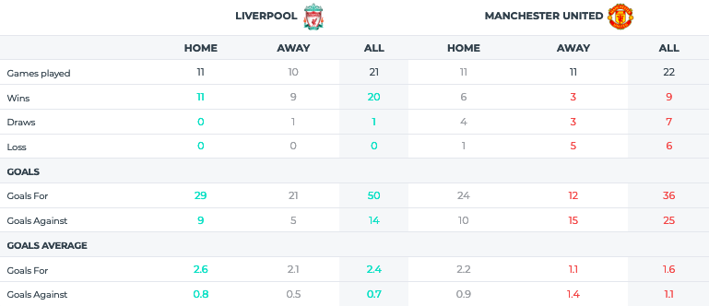

query Parameters
league  required | integer  The id of the league
season  required | integer = 4 characters YYYY  The season of the league
team  required | integer  The id of the team
date | stringYYYY-MM-DD  The limit date

header Parameters
x-apisports-key  required | string  Your Api-Key

Responses
200
OK
204
No Content
499
Time Out
500
Internal Server Error
get/teams/statistics

Request samples
- Use Cases
- Php
- Python
- Node
- JavaScript
- Curl
- Ruby
Copy
// Get all statistics for a {team} in a {league} & {season}
get("https://v3.football.api-sports.io/teams/statistics?league=39&team=33&season=2019");

//Get all statistics for a {team} in a {league} & {season} with a end {date}
get("https://v3.football.api-sports.io/teams/statistics?league=39&team=33&season=2019&date=2019-10-08");

Response samples
- 200
- 204
- 499
- 500
Content type
application/json
Copy
Expand allCollapse all
{
- "get": "teams/statistics",
- "parameters": {
  - "league": "39",
  - "season": "2019",
  - "team": "33"
},
- "errors": [ ],
- "results": 11,
- "paging": {
  - "current": 1,
  - "total": 1
},
- "response": {
  - "league": {},
  - "team": {},
  - "form": "WDLDWLDLDWLWDDWWDLWWLWLLDWWDWDWWWWDWDW",
  - "fixtures": {},
  - "goals": {},
  - "biggest": {},
  - "clean_sheet": {},
  - "failed_to_score": {},
  - "penalty": {},
  - "lineups": [],
  - "cards": {}
}
}

Teams seasons
Get the list of seasons available for a team.
Examples available in Request samples "Use Cases".
This endpoint requires at least one parameter.
Update Frequency : This endpoint is updated several times a week.
Recommended Calls : 1 call per day.

query Parameters
team  required | integer  The id of the team

header Parameters
x-apisports-key  required | string  Your Api-Key

Responses
200
OK
204
No Content
499
Time Out
500
Internal Server Error
get/teams/seasons

Request samples
- Use Cases
- Php
- Python
- Node
- JavaScript
- Curl
- Ruby
Copy
// Get all seasons available for a team from one team {id}
get("https://v3.football.api-sports.io/teams/seasons?team=33");

Response samples
- 200
- 204
- 499
- 500
Content type
application/json
Copy
Expand allCollapse all
{
- "get": "teams/seasons",
- "parameters": {
  - "team": "33"
},
- "errors": [ ],
- "results": 1,
- "paging": {
  - "current": 1,
  - "total": 1
},
- "response": [
  - 2010,
  - 2011,
  - 2012,
  - 2013,
  - 2014,
  - 2015,
  - 2016,
  - 2017,
  - 2018,
  - 2019,
  - 2020,
  - 2021
]
}

Teams countries
Get the list of countries available for the teams endpoint.
Update Frequency : This endpoint is updated several times a week.
Recommended Calls : 1 call per day.

header Parameters
x-apisports-key  required | string  Your Api-Key

Responses
200
OK
204
No Content
499
Time Out
500
Internal Server Error
get/teams/countries

Request samples
- Use Cases
- Php
- Python
- Node
- JavaScript
- Curl
- Ruby
Copy
// Get all countries available for the teams endpoints
get("https://v3.football.api-sports.io/teams/countries");

Response samples
- 200
- 204
- 499
- 500
Content type
application/json
Copy
Expand allCollapse all
{
- "get": "teams/countries",
- "parameters": [ ],
- "errors": [ ],
- "results": 258,
- "paging": {
  - "current": 1,
  - "total": 1
},
- "response": [
  - {}
]
}

Venues

Venues
Get the list of available venues.
The venue id are unique in the API.
To get the image of a venue you have to call the following url: https://media.api-sports.io/football/venues/{venue_id}.png
Examples available in Request samples "Use Cases".
All the parameters of this endpoint can be used together.
This endpoint requires at least one parameter.
Update Frequency : This endpoint is updated several times a week.
Recommended Calls : 1 call per day.

query Parameters
id | integer  The id of the venue
name | string  The name of the venue
city | string  The city of the venue
country | string  The country name of the venue
search | string >= 3 characters  The name, city or the country of the venue

header Parameters
x-apisports-key  required | string  Your Api-Key

Responses
200
OK
204
No Content
499
Time Out
500
Internal Server Error
get/venues

Request samples
- Use Cases
- Php
- Python
- Node
- JavaScript
- Curl
- Ruby
Copy
// Get one venue from venue {id}
get("https://v3.football.api-sports.io/venues?id=556");

// Get one venue from venue {name}
get("https://v3.football.api-sports.io/venues?name=Old Trafford");

// Get all venues from {city}
get("https://v3.football.api-sports.io/venues?city=manchester");

// Get venues from {country}
get("https://v3.football.api-sports.io/venues?country=england");

// Allows you to search for a venues in relation to a venue {name}, {city} or {country}
get("https://v3.football.api-sports.io/venues?search=trafford");
get("https://v3.football.api-sports.io/venues?search=manches");
get("https://v3.football.api-sports.io/venues?search=England");

Response samples
- 200
- 204
- 499
- 500
Content type
application/json
Copy
Expand allCollapse all
{
- "get": "venues",
- "parameters": {
  - "id": "556"
},
- "errors": [ ],
- "results": 1,
- "paging": {
  - "current": 1,
  - "total": 1
},
- "response": [
  - {}
]
}

Standings

Standings
Get the standings for a league or a team.
Return a table of one or more rankings according to the league / cup.
Some competitions have several rankings in a year, group phase, opening ranking, closing ranking etc…
Examples available in Request samples "Use Cases".
Most of the parameters of this endpoint can be used together.
Update Frequency : This endpoint is updated every hour.
Recommended Calls : 1 call per hour for the leagues or teams who have at least one fixture in progress otherwise 1 call per day.
Tutorials :
- HOW TO GET STANDINGS FOR ALL CURRENT SEASONS

query Parameters
league | integer  The id of the league
season  required | integer = 4 characters YYYY  The season of the league
team | integer  The id of the team

header Parameters
x-apisports-key  required | string  Your Api-Key

Responses
200
OK
204
No Content
499
Time Out
500
Internal Server Error
get/standings

Request samples
- Use Cases
- Php
- Python
- Node
- JavaScript
- Curl
- Ruby
Copy
// Get all Standings from one {league} & {season}
get("https://v3.football.api-sports.io/standings?league=39&season=2019");

// Get all Standings from one {league} & {season} & {team}
get("https://v3.football.api-sports.io/standings?league=39&team=33&season=2019");

// Get all Standings from one {team} & {season}
get("https://v3.football.api-sports.io/standings?team=33&season=2019");

Response samples
- 200
- 204
- 499
- 500
Content type
application/json
Copy
Expand allCollapse all
{
- "get": "standings",
- "parameters": {
  - "league": "39",
  - "season": "2019"
},
- "errors": [ ],
- "results": 1,
- "paging": {
  - "current": 1,
  - "total": 1
},
- "response": [
  - {}
]
}

Fixtures

Rounds
Get the rounds for a league or a cup.
The round can be used in endpoint fixtures as filters
Examples available in Request samples "Use Cases".
Update Frequency : This endpoint is updated every day.
Recommended Calls : 1 call per day.

query Parameters
league  required | integer  The id of the league
season  required | integer = 4 characters YYYY  The season of the league
current | boolean  Enum: "true" "false"  The current round only
dates | boolean  Default: false  Enum: "true" "false"  Add the dates of each round in the response
timezone | string  A valid timezone from the endpoint Timezone

header Parameters
x-apisports-key  required | string  Your Api-Key

Responses
200
OK
204
No Content
499
Time Out
500
Internal Server Error
get/fixtures/rounds

Request samples
- Use Cases
- Php
- Python
- Node
- JavaScript
- Curl
- Ruby
Copy
// Get all available rounds from one {league} & {season}
get("https://v3.football.api-sports.io/fixtures/rounds?league=39&season=2019");

// Get all available rounds from one {league} & {season} With the dates of each round
get("https://v3.football.api-sports.io/fixtures/rounds?league=39&season=2019&dates=true");

// Get current round from one {league} & {season}
get("https://v3.football.api-sports.io/fixtures/rounds?league=39&season=2019&current=true");

Response samples
- 200
- 204
- 499
- 500
Content type
application/json
Example
Default
Copy
Expand allCollapse all
{
- "get": "fixtures/rounds",
- "parameters": {
  - "league": "39",
  - "season": "2019"
},
- "errors": [ ],
- "results": 38,
- "paging": {
  - "current": 1,
  - "total": 1
},
- "response": [
  - "Regular Season - 1",
  - "Regular Season - 2",
  - "Regular Season - 3",
  - "Regular Season - 4",
  - "Regular Season - 5",
  - "Regular Season - 6",
  - "Regular Season - 7",
  - "Regular Season - 8",
  - "Regular Season - 9",
  - "Regular Season - 10",
  - "Regular Season - 11",
  - "Regular Season - 12",
  - "Regular Season - 13",
  - "Regular Season - 14",
  - "Regular Season - 15",
  - "Regular Season - 16",
  - "Regular Season - 17",
  - "Regular Season - 18",
  - "Regular Season - 18",
  - "Regular Season - 19",
  - "Regular Season - 20",
  - "Regular Season - 21",
  - "Regular Season - 22",
  - "Regular Season - 23",
  - "Regular Season - 24",
  - "Regular Season - 25",
  - "Regular Season - 26",
  - "Regular Season - 27",
  - "Regular Season - 28",
  - "Regular Season - 29",
  - "Regular Season - 30",
  - "Regular Season - 31",
  - "Regular Season - 32",
  - "Regular Season - 33",
  - "Regular Season - 34",
  - "Regular Season - 35",
  - "Regular Season - 36",
  - "Regular Season - 37",
  - "Regular Season - 38"
]
}

Fixtures
For all requests to fixtures you can add the query parameter timezone to your request in order to retrieve the list of matches in the time zone of your choice like “Europe/London“
To know the list of available time zones you have to use the endpoint timezone.
Available fixtures status
SHORT | LONG | TYPE | DESCRIPTION
TBD | Time To Be Defined | Scheduled | Scheduled but date and time are not known
NS | Not Started | Scheduled
1H | First Half, Kick Off | In Play | First half in play
HT | Halftime | In Play | Finished in the regular time
2H | Second Half, 2nd Half Started | In Play | Second half in play
ET | Extra Time | In Play | Extra time in play
BT | Break Time | In Play | Break during extra time
P | Penalty In Progress | In Play | Penaly played after extra time
SUSP | Match Suspended | In Play | Suspended by referee's decision, may be rescheduled another day
INT | Match Interrupted | In Play | Interrupted by referee's decision, should resume in a few minutes
FT | Match Finished | Finished | Finished in the regular time
AET | Match Finished | Finished | Finished after extra time without going to the penalty shootout
PEN | Match Finished | Finished | Finished after the penalty shootout
PST | Match Postponed | Postponed | Postponed to another day, once the new date and time is known the status will change to Not Started
CANC | Match Cancelled | Cancelled | Cancelled, match will not be played
ABD | Match Abandoned | Abandoned | Abandoned for various reasons (Bad Weather, Safety, Floodlights, Playing Staff Or Referees), Can be rescheduled or not, it depends on the competition
AWD | Technical Loss | Not Played
WO | WalkOver | Not Played | Victory by forfeit or absence of competitor
LIVE | In Progress | In Play | Used in very rare cases. It indicates a fixture in progress but the data indicating the half-time or elapsed time are not available
Fixtures with the status TBD may indicate an incorrect fixture date or time because the fixture date or time is not yet known or final. Fixtures with this status are checked and updated daily. The same applies to fixtures with the status PST, CANC.
The fixtures ids are unique and specific to each fixture. In no case an ID will change.
Not all competitions have livescore available and only have final result. In this case, the status remains in NS and will be updated in the minutes/hours following the match (this can take up to 48 hours, depending on the competition).
Although the data is updated every 15 seconds, depending on the competition there may be a delay between reality and the availability of data in the API.
Update Frequency : This endpoint is updated every 15 seconds.
Recommended Calls : 1 call per minute for the leagues, teams, fixtures who have at least one fixture in progress otherwise 1 call per day.
Here are several examples of what can be achieved
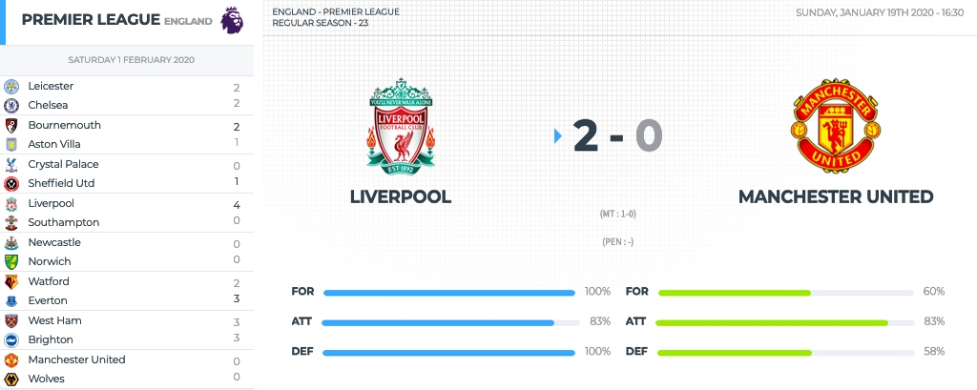

query Parameters
id | integer  Value: "id"  The id of the fixture
ids | stringMaximum of 20 fixtures ids  Value: "id-id-id"  One or more fixture ids
live | string  Enum: "all" "id-id"  All or several leagues ids
date | stringYYYY-MM-DD  A valid date
league | integer  The id of the league
season | integer = 4 characters YYYY  The season of the league
team | integer  The id of the team
last | integer <= 2 characters  For the X last fixtures
next | integer <= 2 characters  For the X next fixtures
from | stringYYYY-MM-DD  A valid date
to | stringYYYY-MM-DD  A valid date
round | string  The round of the fixture
status | string  Enum: "NS" "NS-PST-FT"  One or more fixture status short
venue | integer  The venue id of the fixture
timezone | string  A valid timezone from the endpoint Timezone

header Parameters
x-apisports-key  required | string  Your Api-Key

Responses
200
OK
204
No Content
499
Time Out
500
Internal Server Error
get/fixtures

Request samples
- Use Cases
- Php
- Python
- Node
- JavaScript
- Curl
- Ruby
Copy
// Get fixture from one fixture {id}
// In this request events, lineups, statistics fixture and players fixture are returned in the response
get("https://v3.football.api-sports.io/fixtures?id=215662");

// Get fixture from severals fixtures {ids}
// In this request events, lineups, statistics fixture and players fixture are returned in the response
get("https://v3.football.api-sports.io/fixtures?ids=215662-215663-215664-215665-215666-215667");

// Get all available fixtures in play
// In this request events are returned in the response
get("https://v3.football.api-sports.io/fixtures?live=all");

// Get all available fixtures in play filter by several {league}
// In this request events are returned in the response
get("https://v3.football.api-sports.io/fixtures?live=39-61-48");

// Get all available fixtures from one {league} & {season}
get("https://v3.football.api-sports.io/fixtures?league=39&season=2019");

// Get all available fixtures from one {date}
get("https://v3.football.api-sports.io/fixtures?date=2019-10-22");

// Get next X available fixtures
get("https://v3.football.api-sports.io/fixtures?next=15");

// Get last X available fixtures
get("https://v3.football.api-sports.io/fixtures?last=15");

// It’s possible to make requests by mixing the available parameters
get("https://v3.football.api-sports.io/fixtures?date=2020-01-30&league=61&season=2019");
get("https://v3.football.api-sports.io/fixtures?league=61&next=10");
get("https://v3.football.api-sports.io/fixtures?venue=358&next=10");
get("https://v3.football.api-sports.io/fixtures?league=61&last=10&status=ft");
get("https://v3.football.api-sports.io/fixtures?team=85&last=10&timezone=Europe/london");
get("https://v3.football.api-sports.io/fixtures?team=85&season=2019&from=2019-07-01&to=2020-10-31");
get("https://v3.football.api-sports.io/fixtures?league=61&season=2019&from=2019-07-01&to=2020-10-31&timezone=Europe/london");
get("https://v3.football.api-sports.io/fixtures?league=61&season=2019&round=Regular Season - 1");

Response samples
- 200
- 204
- 499
- 500
Content type
application/json
Copy
Expand allCollapse all
{
- "get": "fixtures",
- "parameters": {
  - "live": "all"
},
- "errors": [ ],
- "results": 4,
- "paging": {
  - "current": 1,
  - "total": 1
},
- "response": [
  - {}
]
}

Head To Head
Get heads to heads between two teams.
Update Frequency : This endpoint is updated every 15 seconds.
Recommended Calls : 1 call per minute for the leagues, teams, fixtures who have at least one fixture in progress otherwise 1 call per day.
Here is an example of what can be achieved
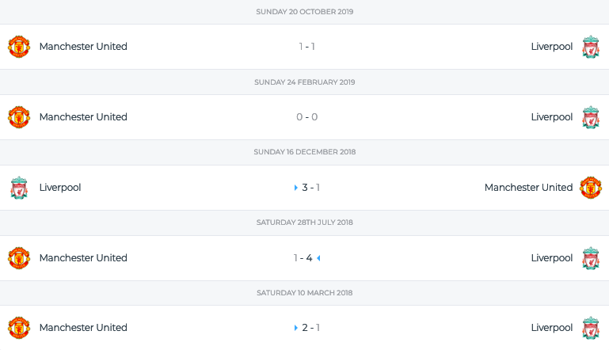

query Parameters
h2h  required | stringID-ID  The ids of the teams
date | stringYYYY-MM-DD
league | integer  The id of the league
season | integer = 4 characters YYYY  The season of the league
last | integer  For the X last fixtures
next | integer  For the X next fixtures
from | stringYYYY-MM-DD
to | stringYYYY-MM-DD
status | string  Enum: "NS" "NS-PST-FT"  One or more fixture status short
venue | integer  The venue id of the fixture
timezone | string  A valid timezone from the endpoint Timezone

header Parameters
x-apisports-key  required | string  Your Api-Key

Responses
200
OK
204
No Content
499
Time Out
500
Internal Server Error
get/fixtures/headtohead

Request samples
- Use Cases
- Php
- Python
- Node
- JavaScript
- Curl
- Ruby
Copy
// Get all head to head between two {team}
get("https://v3.football.api-sports.io/fixtures/headtohead?h2h=33-34");

// It’s possible to make requests by mixing the available parameters
get("https://v3.football.api-sports.io/fixtures/headtohead?h2h=33-34");
get("https://v3.football.api-sports.io/fixtures/headtohead?h2h=33-34&status=ns");
get("https://v3.football.api-sports.io/fixtures/headtohead?h2h=33-34&from=2019-10-01&to=2019-10-31");
get("https://v3.football.api-sports.io/fixtures/headtohead?date=2019-10-22&h2h=33-34");
get("https://v3.football.api-sports.io/fixtures/headtohead?league=39&season=2019&h2h=33-34&last=5");
get("https://v3.football.api-sports.io/fixtures/headtohead?league=39&season=2019&h2h=33-34&next=10&from=2019-10-01&to=2019-10-31");
get("https://v3.football.api-sports.io/fixtures/headtohead?league=39&season=2019&h2h=33-34&last=5&timezone=Europe/London");

Response samples
- 200
- 204
- 499
- 500
Content type
application/json
Copy
Expand allCollapse all
{
- "get": "fixtures/headtohead",
- "parameters": {
  - "h2h": "33-34",
  - "last": "1"
},
- "errors": [ ],
- "results": 1,
- "paging": {
  - "current": 1,
  - "total": 1
},
- "response": [
  - {}
]
}

Statistics
Get the statistics for one fixture.
Available statistics
- Shots on Goal
- Shots off Goal
- Shots insidebox
- Shots outsidebox
- Total Shots
- Blocked Shots
- Fouls
- Corner Kicks
- Offsides
- Ball Possession
- Yellow Cards
- Red Cards
- Goalkeeper Saves
- Total passes
- Passes accurate
- Passes %
Update Frequency : This endpoint is updated every minute.
Recommended Calls : 1 call every minute for the teams or fixtures who have at least one fixture in progress otherwise 1 call per day.
Here is an example of what can be achieved


query Parameters
fixture  required | integer  The id of the fixture
team | integer  The id of the team
type | string  The type of statistics
half | boolean  Default: false  Enum: "true" "false"  Add the halftime statistics in the response Data start from 2024 season for half parameter

header Parameters
x-apisports-key  required | string  Your Api-Key

Responses
200
OK
204
No Content
499
Time Out
500
Internal Server Error
get/fixtures/statistics

Request samples
- Use Cases
- Php
- Python
- Node
- JavaScript
- Curl
- Ruby
Copy
// Get all available statistics from one {fixture}
get("https://v3.football.api-sports.io/fixtures/statistics?fixture=215662");

// Get all available statistics from one {fixture} with Fulltime, First & Second Half data
get("https://v3.football.api-sports.io/fixtures/statistics?fixture=215662&half=true");

// Get all available statistics from one {fixture} & {type}
get("https://v3.football.api-sports.io/fixtures/statistics?fixture=215662&type=Total Shots");

// Get all available statistics from one {fixture} & {team}
get("https://v3.football.api-sports.io/fixtures/statistics?fixture=215662&team=463");

Response samples
- 200
- 204
- 499
- 500
Content type
application/json
Example
Default
Copy
Expand allCollapse all
{
- "get": "fixtures/statistics",
- "parameters": {
  - "team": "463",
  - "fixture": "215662"
},
- "errors": [ ],
- "results": 1,
- "paging": {
  - "current": 1,
  - "total": 1
},
- "response": [
  - {}
]
}

Events
Get the events from a fixture.
Available events
TYPE
Goal | Normal Goal | Own Goal | Penalty | Missed Penalty
Card | Yellow Card | Red card
Subst | Substitution [1, 2, 3...]
Var | Goal cancelled | Penalty confirmed
- VAR events are available from the 2020-2021 season.
Update Frequency : This endpoint is updated every 15 seconds.
Recommended Calls : 1 call per minute for the fixtures in progress otherwise 1 call per day.
You can also retrieve all the events of the fixtures in progress with to the endpoint fixtures?live=all
Here is an example of what can be achieved
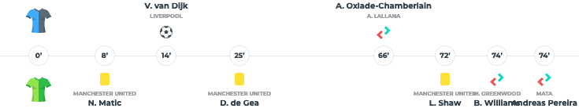

query Parameters
fixture  required | integer  The id of the fixture
team | integer  The id of the team
player | integer  The id of the player
type | string  The type

header Parameters
x-apisports-key  required | string  Your Api-Key

Responses
200
OK
204
No Content
499
Time Out
500
Internal Server Error
get/fixtures/events

Request samples
- Use Cases
- Php
- Python
- Node
- JavaScript
- Curl
- Ruby
Copy
// Get all available events from one {fixture}
get("https://v3.football.api-sports.io/fixtures/events?fixture=215662");

// Get all available events from one {fixture} & {team}
get("https://v3.football.api-sports.io/fixtures/events?fixture=215662&team=463");

// Get all available events from one {fixture} & {player}
get("https://v3.football.api-sports.io/fixtures/events?fixture=215662&player=35845");

// Get all available events from one {fixture} & {type}
get("https://v3.football.api-sports.io/fixtures/events?fixture=215662&type=card");

// It’s possible to make requests by mixing the available parameters
get("https://v3.football.api-sports.io/fixtures/events?fixture=215662&player=35845&type=card");
get("https://v3.football.api-sports.io/fixtures/events?fixture=215662&team=463&type=goal&player=35845");

Response samples
- 200
- 204
- 499
- 500
Content type
application/json
Copy
Expand allCollapse all
{
- "get": "fixtures/events",
- "parameters": {
  - "fixture": "215662"
},
- "errors": [ ],
- "results": 18,
- "paging": {
  - "current": 1,
  - "total": 1
},
- "response": [
  - {},
  - {},
  - {},
  - {},
  - {},
  - {},
  - {},
  - {},
  - {},
  - {},
  - {},
  - {},
  - {},
  - {},
  - {},
  - {},
  - {},
  - {}
]
}

Lineups
Get the lineups for a fixture.
Lineups are available between 20 and 40 minutes before the fixture when the competition covers this feature. You can check this with the endpoint leagues and the coverage field.
It's possible that for some competitions the lineups are not available before the fixture, in this case, they are updated and available after the match with a variable delay depending on the competition.
Available datas
- Formation
- Coach
- Start XI
- Substitutes
Players' positions on the grid *
X = row and Y = column (X:Y)
Line 1 X being the one of the goal and then for each line this number is incremented. The column Y will go from left to right, and incremented for each player of the line.
* As a new feature, some irregularities may occur, do not hesitate to report them on our public Roadmap
Update Frequency : This endpoint is updated every 15 minutes.
Recommended Calls : 1 call every 15 minutes for the fixtures in progress otherwise 1 call per day.
Here are several examples of what can be done
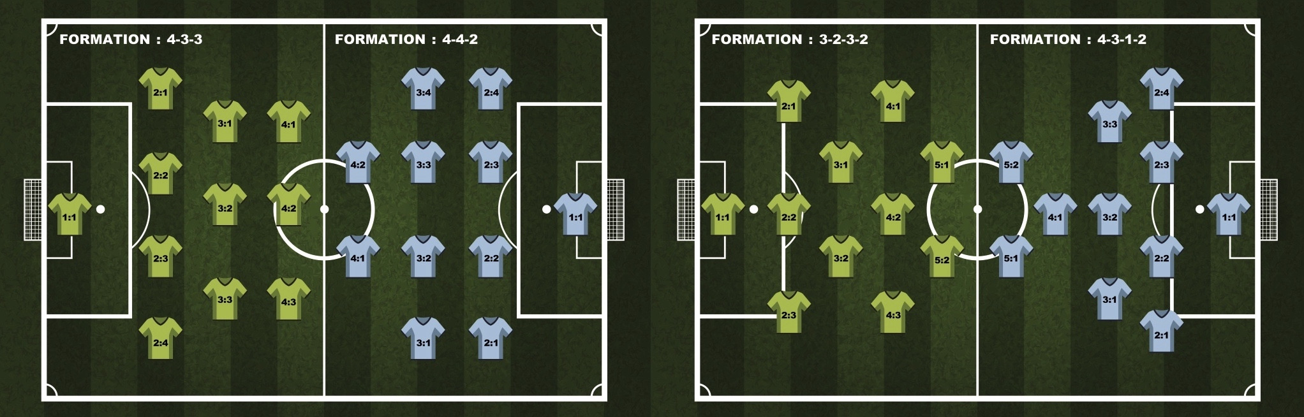
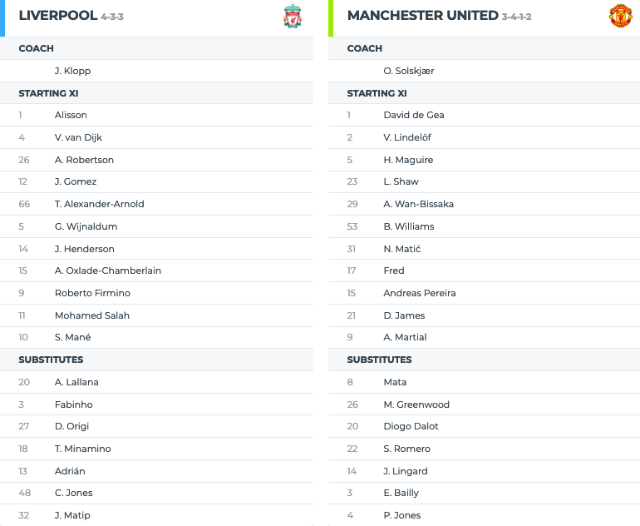

query Parameters
fixture  required | integer  The id of the fixture
team | integer  The id of the team
player | integer  The id of the player
type | string  The type

header Parameters
x-apisports-key  required | string  Your Api-Key

Responses
200
OK
204
No Content
499
Time Out
500
Internal Server Error
get/fixtures/lineups

Request samples
- Use Cases
- Php
- Python
- Node
- JavaScript
- Curl
- Ruby
Copy
// Get all available lineups from one {fixture}
get("https://v3.football.api-sports.io/fixtures/lineups?fixture=592872");

// Get all available lineups from one {fixture} & {team}
get("https://v3.football.api-sports.io/fixtures/lineups?fixture=592872&team=50");

// Get all available lineups from one {fixture} & {player}
get("https://v3.football.api-sports.io/fixtures/lineups?fixture=215662&player=35845");

// Get all available lineups from one {fixture} & {type}
get("https://v3.football.api-sports.io/fixtures/lineups?fixture=215662&type=startXI");

// It’s possible to make requests by mixing the available parameters
get("https://v3.football.api-sports.io/fixtures/lineups?fixture=215662&player=35845&type=startXI");
get("https://v3.football.api-sports.io/fixtures/lineups?fixture=215662&team=463&type=startXI&player=35845");

Response samples
- 200
- 204
- 499
- 500
Content type
application/json
Copy
Expand allCollapse all
{
- "get": "fixtures/lineups",
- "parameters": {
  - "fixture": "592872"
},
- "errors": [ ],
- "results": 2,
- "paging": {
  - "current": 1,
  - "total": 1
},
- "response": [
  - {},
  - {}
]
}

Players statistics
Get the players statistics from one fixture.
Update Frequency : This endpoint is updated every minute.
Recommended Calls : 1 call every minute for the fixtures in progress otherwise 1 call per day.

query Parameters
fixture  required | integer  The id of the fixture
team | integer  The id of the team

header Parameters
x-apisports-key  required | string  Your Api-Key

Responses
200
OK
204
No Content
499
Time Out
500
Internal Server Error
get/fixtures/players

Request samples
- Use Cases
- Php
- Python
- Node
- JavaScript
- Curl
- Ruby
Copy
// Get all available players statistics from one {fixture}
get("https://v3.football.api-sports.io/fixtures/players?fixture=169080");

// Get all available players statistics from one {fixture} & {team}
get("https://v3.football.api-sports.io/fixtures/players?fixture=169080&team=2284");

Response samples
- 200
- 204
- 499
- 500
Content type
application/json
Copy
Expand allCollapse all
{
- "get": "fixtures/players",
- "parameters": {
  - "fixture": "169080"
},
- "errors": [ ],
- "results": 2,
- "paging": {
  - "current": 1,
  - "total": 1
},
- "response": [
  - {}
]
}

Injuries

Injuries
Get the list of players not participating in the fixtures for various reasons such as suspended, injured for example.
Being a new endpoint, the data is only available from April 2021.
There are two types:
- Missing Fixture : The player will not play the fixture.
- Questionable : The information is not yet 100% sure, the player may eventually play the fixture.
Examples available in Request samples "Use Cases".
All the parameters of this endpoint can be used together.
This endpoint requires at least one parameter.
Update Frequency : This endpoint is updated every 4 hours.
Recommended Calls : 1 call per day.

query Parameters
league | integer  The id of the league
season | integer = 4 characters YYYY  The season of the league, required with league, team and player parameters
fixture | integer  The id of the fixture
team | integer  The id of the team
player | integer  The id of the player
date | stringYYYY-MM-DD  A valid date
ids | stringMaximum of 20 fixtures ids  Value: "id-id-id"  One or more fixture ids
timezone | string  A valid timezone from the endpoint Timezone

header Parameters
x-apisports-key  required | string  Your Api-Key

Responses
200
OK
204
No Content
499
Time Out
500
Internal Server Error
get/injuries

Request samples
- Use Cases
- Php
- Python
- Node
- JavaScript
- Curl
- Ruby
Copy
// Get all available injuries from one {league} & {season}
get("https://v3.football.api-sports.io/injuries?league=2&season=2020");

// Get all available injuries from one {fixture}
get("https://v3.football.api-sports.io/injuries?fixture=686314");

// Get all available injuries from severals fixtures {ids}
get("https://v3.football.api-sports.io/injuries?ids=686314-686315-686316-686317-686318-686319-686320");

// Get all available injuries from one {team} & {season}
get("https://v3.football.api-sports.io/injuries?team=85&season=2020");

// Get all available injuries from one {player} & {season}
get("https://v3.football.api-sports.io/injuries?player=865&season=2020");

// Get all available injuries from one {date}
get("https://v3.football.api-sports.io/injuries?date=2021-04-07");

// It’s possible to make requests by mixing the available parameters
get("https://v3.football.api-sports.io/injuries?league=2&season=2020&team=85");
get("https://v3.football.api-sports.io/injuries?league=2&season=2020&player=865");
get("https://v3.football.api-sports.io/injuries?date=2021-04-07&timezone=Europe/London&team=85");
get("https://v3.football.api-sports.io/injuries?date=2021-04-07&league=61");

Response samples
- 200
- 204
- 499
- 500
Content type
application/json
Copy
Expand allCollapse all
{
- "get": "injuries",
- "parameters": {
  - "fixture": "686314"
},
- "errors": [ ],
- "results": 13,
- "paging": {
  - "current": 1,
  - "total": 1
},
- "response": [
  - {},
  - {},
  - {},
  - {},
  - {},
  - {},
  - {},
  - {},
  - {},
  - {},
  - {},
  - {},
  - {}
]
}

Predictions

Predictions
Get predictions about a fixture.
The predictions are made using several algorithms including the poisson distribution, comparison of team statistics, last matches, players etc…
Bookmakers odds are not used to make these predictions
Also provides some comparative statistics between teams
Available Predictions
- Match winner : Id of the team that can potentially win the fixture
- Win or Draw : If True indicates that the designated team can win or draw
- Under / Over : -1.5 / -2.5 / -3.5 / -4.5 / +1.5 / +2.5 / +3.5 / +4.5 *
- Goals Home : -1.5 / -2.5 / -3.5 / -4.5 *
- Goals Away -1.5 / -2.5 / -3.5 / -4.5 *
- Advice (Ex : Deportivo Santani or draws and -3.5 goals)
* -1.5 means that there will be a maximum of 1.5 goals in the fixture, i.e : 1 goal
Update Frequency : This endpoint is updated every hour.
Recommended Calls : 1 call per hour for the fixtures in progress otherwise 1 call per day.
Here is an example of what can be achieved
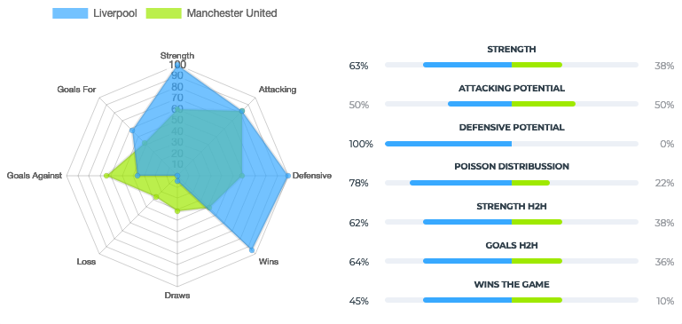

query Parameters
fixture  required | integer  The id of the fixture

header Parameters
x-apisports-key  required | string  Your Api-Key

Responses
200
OK
204
No Content
499
Time Out
500
Internal Server Error
get/predictions

Request samples
- Use Cases
- Php
- Python
- Node
- JavaScript
- Curl
- Ruby
Copy
// Get all available predictions from one {fixture}
get("https://v3.football.api-sports.io/predictions?fixture=198772");

Response samples
- 200
- 204
- 499
- 500
Content type
application/json
Copy
Expand allCollapse all
{
- "get": "predictions",
- "parameters": {
  - "fixture": "198772"
},
- "errors": [ ],
- "results": 1,
- "paging": {
  - "current": 1,
  - "total": 1
},
- "response": [
  - {}
]
}

Coachs

Coachs
Get all the information about the coachs and their careers.
To get the photo of a coach you have to call the following url: https://media.api-sports.io/football/coachs/{coach_id}.png
Update Frequency : This endpoint is updated every day.
Recommended Calls : 1 call per day.

query Parameters
id | integer  The id of the coach
team | integer  The id of the team
search | string >= 3 characters  The name of the coach

header Parameters
x-apisports-key  required | string  Your Api-Key

Responses
200
OK
204
No Content
499
Time Out
500
Internal Server Error
get/coachs

Request samples
- Use Cases
- Php
- Python
- Node
- JavaScript
- Curl
- Ruby
Copy
// Get coachs from one coach {id}
get("https://v3.football.api-sports.io/coachs?id=1");

// Get coachs from one {team}
get("https://v3.football.api-sports.io/coachs?team=33");

// Allows you to search for a coach in relation to a coach {name}
get("https://v3.football.api-sports.io/coachs?search=Klopp");

Response samples
- 200
- 204
- 499
- 500
Content type
application/json
Copy
Expand allCollapse all
{
- "get": "coachs",
- "parameters": {
  - "team": "85"
},
- "errors": [ ],
- "results": 1,
- "paging": {
  - "current": 1,
  - "total": 1
},
- "response": [
  - {}
]
}

Players

Seasons
Get all available seasons for players statistics.
Update Frequency : This endpoint is updated every day.
Recommended Calls : 1 call per day.

query Parameters
player | integer  The id of the player

header Parameters
x-apisports-key  required | string  Your Api-Key

Responses
200
OK
204
No Content
499
Time Out
500
Internal Server Error
get/players/seasons

Request samples
- Use Cases
- Php
- Python
- Node
- JavaScript
- Curl
- Ruby
Copy
// Get all seasons available for players endpoint
get("https://v3.football.api-sports.io/players/seasons");

// Get all seasons available for a player {id}
get("https://v3.football.api-sports.io/players/seasons?player=276");

Response samples
- 200
- 204
- 499
- 500
Content type
application/json
Copy
Expand allCollapse all
{
- "get": "players/seasons",
- "parameters": [ ],
- "errors": [ ],
- "results": 35,
- "paging": {
  - "current": 1,
  - "total": 1
},
- "response": [
  - 1966,
  - 1982,
  - 1986,
  - 1990,
  - 1991,
  - 1992,
  - 1993,
  - 1994,
  - 1995,
  - 1996,
  - 1997,
  - 1998,
  - 1999,
  - 2000,
  - 2001,
  - 2002,
  - 2003,
  - 2004,
  - 2005,
  - 2006,
  - 2007,
  - 2008,
  - 2009,
  - 2010,
  - 2011,
  - 2012,
  - 2013,
  - 2014,
  - 2015,
  - 2016,
  - 2017,
  - 2018,
  - 2019,
  - 2020,
  - 2022
]
}

Profiles
Returns the list of all available players.
It is possible to call this endpoint without parameters, but you will need to use the pagination to get all available players.
To get the photo of a player you have to call the following url: https://media.api-sports.io/football/players/{player_id}.png
This endpoint uses a pagination system, you can navigate between the different pages with to the page parameter.
Pagination : 250 results per page.
Update Frequency : This endpoint is updated several times a week.
Recommended Calls : 1 call per week.

query Parameters
player | integer  The id of the player
search | string >= 4 characters  The lastname of the player
page | integer  Default: 1  Use for the pagination

header Parameters
x-apisports-key  required | string  Your Api-Key

Responses
200
OK
204
No Content
499
Time Out
500
Internal Server Error
get/players/profiles

Request samples
- Use Cases
- Php
- Python
- Node
- JavaScript
- Curl
- Ruby
Copy
// Get data from one {player}
get("https://v3.football.api-sports.io/players/profiles?player=276");

// Allows you to search for a player in relation to a player {lastname}
get("https://v3.football.api-sports.io/players/profiles?search=ney");

// Get all available Players (limited to 250 results, use the pagination for next ones)
get("https://v3.football.api-sports.io/players/profiles");
get("https://v3.football.api-sports.io/players/profiles?page=2");
get("https://v3.football.api-sports.io/players/profiles?page=3");

Response samples
- 200
- 204
- 499
- 500
Content type
application/json
Copy
Expand allCollapse all
{
- "get": "players/profiles",
- "parameters": {
  - "player": "276"
},
- "errors": [ ],
- "results": 1,
- "paging": {
  - "current": 1,
  - "total": 1
},
- "response": [
  - {}
]
}

Statistics
Get players statistics.
This endpoint returns the players for whom the profile and statistics data are available. Note that it is possible that a player has statistics for 2 teams in the same season in case of transfers.
The statistics are calculated according to the team id, league id and season.
You can find the available seasons by using the endpoint players/seasons.
To get the squads of the teams it is better to use the endpoint players/squads.
The players id are unique in the API and players keep it among all the teams they have been in.
In this endpoint you have the rating field, which is the rating of the player according to a match or a season. This data is calculated according to the performance of the player in relation to the other players of the game or the season who occupy the same position (Attacker, defender, goal...). There are different algorithms that take into account the position of the player and assign points according to his performance.
To get the photo of a player you have to call the following url: https://media.api-sports.io/football/players/{player_id}.png
This endpoint uses a pagination system, you can navigate between the different pages with to the page parameter.
Pagination : 20 results per page.
Update Frequency : This endpoint is updated several times a week.
Recommended Calls : 1 call per day.
Tutorials :
- HOW TO GET ALL TEAMS AND PLAYERS FROM A LEAGUE ID

query Parameters
id | integer  The id of the player
team | integer  The id of the team
league | integer  The id of the league
season | integer = 4 characters YYYY | Requires the fields Id, League or Team...  The season of the league
search | string >= 4 characters Requires the fields League or Team  The name of the player
page | integer  Default: 1  Use for the pagination

header Parameters
x-apisports-key  required | string  Your Api-Key

Responses
200
OK
204
No Content
499
Time Out
500
Internal Server Error
get/players

Request samples
- Use Cases
- Php
- Python
- Node
- JavaScript
- Curl
- Ruby
Copy
// Get all players statistics from one player {id} & {season}
get("https://v3.football.api-sports.io/players?id=19088&season=2018");

// Get all players statistics from one {team} & {season}
get("https://v3.football.api-sports.io/players?season=2018&team=33");
get("https://v3.football.api-sports.io/players?season=2018&team=33&page=2");

// Get all players statistics from one {league} & {season}
get("https://v3.football.api-sports.io/players?season=2018&league=61");
get("https://v3.football.api-sports.io/players?season=2018&league=61&page=4");

// Get all players statistics from one {league}, {team} & {season}
get("https://v3.football.api-sports.io/players?season=2018&league=61&team=33");
get("https://v3.football.api-sports.io/players?season=2018&league=61&team=33&page=5");

// Allows you to search for a player in relation to a player {name}
get("https://v3.football.api-sports.io/players?team=85&search=cavani");
get("https://v3.football.api-sports.io/players?league=61&search=cavani");
get("https://v3.football.api-sports.io/players?team=85&search=cavani&season=2018");

Response samples
- 200
- 204
- 499
- 500
Content type
application/json
Copy
Expand allCollapse all
{
- "get": "players",
- "parameters": {
  - "id": "276",
  - "season": "2019"
},
- "errors": [ ],
- "results": 1,
- "paging": {
  - "current": 1,
  - "total": 1
},
- "response": [
  - {}
]
}

Squads
Return the current squad of a team when the team parameter is used. When the player parameter is used the endpoint returns the set of teams associated with the player.
The response format is the same regardless of the parameter sent.
This endpoint requires at least one parameter.
Update Frequency : This endpoint is updated several times a week.
Recommended Calls : 1 call per week.

query Parameters
team | integer  The id of the team
player | integer  The id of the player

header Parameters
x-apisports-key  required | string  Your Api-Key

Responses
200
OK
204
No Content
499
Time Out
500
Internal Server Error
get/players/squads

Request samples
- Use Cases
- Php
- Python
- Node
- JavaScript
- Curl
- Ruby
Copy
// Get all players from one {team}
get("https://v3.football.api-sports.io/players/squads?team=33");

// Get all teams from one {player}
get("https://v3.football.api-sports.io/players/squads?player=276");

Response samples
- 200
- 204
- 499
- 500
Content type
application/json
Copy
Expand allCollapse all
{
- "get": "players/squads",
- "parameters": {
  - "team": "33"
},
- "errors": [ ],
- "results": 1,
- "paging": {
  - "current": 1,
  - "total": 1
},
- "response": [
  - {}
]
}

Teams
Returns the list of teams and seasons in which the player played during his career.
This endpoint requires at least one parameter.
Update Frequency : This endpoint is updated several times a week.
Recommended Calls : 1 call per week.

query Parameters
player  required | integer  The id of the player

header Parameters
x-apisports-key  required | string  Your Api-Key

Responses
200
OK
204
No Content
499
Time Out
500
Internal Server Error
get/players/teams

Request samples
- Use Cases
- Php
- Python
- Node
- JavaScript
- Curl
- Ruby
Copy
// Get all teams from one {player}
get("https://v3.football.api-sports.io/players/teams?player=276");

Response samples
- 200
- 204
- 499
- 500
Content type
application/json
Copy
Expand allCollapse all
{
- "get": "players/teams",
- "parameters": {
  - "player": "276"
},
- "errors": [ ],
- "results": 8,
- "paging": {
  - "current": 1,
  - "total": 1
},
- "response": [
  - {},
  - {},
  - {},
  - {},
  - {},
  - {},
  - {},
  - {}
]
}

Top Scorers
Get the 20 best players for a league or cup.
How it is calculated:
- 1 : The player that has scored the higher number of goals
- 2 : The player that has scored the fewer number of penalties
- 3 : The player that has delivered the higher number of goal assists
- 4 : The player that scored their goals in the higher number of matches
- 5 : The player that played the fewer minutes
- 6 : The player that plays for the team placed higher on the table
- 7 : The player that received the fewer number of red cards
- 8 : The player that received the fewer number of yellow cards
Update Frequency : This endpoint is updated several times a week.
Recommended Calls : 1 call per day.

query Parameters
league  required | integer  The id of the league
season  required | integer = 4 characters YYYY  The season of the league

header Parameters
x-apisports-key  required | string  Your Api-Key

Responses
200
OK
204
No Content
499
Time Out
500
Internal Server Error
get/players/topscorers

Request samples
- Php
- Python
- Node
- JavaScript
- Curl
- Ruby
Copy
$client = new http\Client;
$request = new http\Client\Request;

$request->setRequestUrl('https://v3.football.api-sports.io/players/topscorers');
$request->setRequestMethod('GET');
$request->setQuery(new http\QueryString(array(
'season' => '2018',
'league' => '61'
)));

$request->setHeaders(array(
'x-apisports-key' => 'XxXxXxXxXxXxXxXxXxXxXxXx'
));

$client->enqueue($request)->send();
$response = $client->getResponse();

echo $response->getBody();

Response samples
- 200
- 204
- 499
- 500
Content type
application/json
Copy
Expand allCollapse all
{
- "get": "players/topscorers",
- "parameters": {
  - "league": "61",
  - "season": "2018"
},
- "errors": [ ],
- "results": 20,
- "paging": {
  - "current": 1,
  - "total": 1
},
- "response": [
  - {},
  - {}
]
}

Top Assists
Get the 20 best players assists for a league or cup.
How it is calculated:
- 1 : The player that has delivered the higher number of goal assists
- 2 : The player that has scored the higher number of goals
- 3 : The player that has scored the fewer number of penalties
- 4 : The player that assists in the higher number of matches
- 5 : The player that played the fewer minutes
- 6 : The player that received the fewer number of red cards
- 7 : The player that received the fewer number of yellow cards
Update Frequency : This endpoint is updated several times a week.
Recommended Calls : 1 call per day.

query Parameters
league  required | integer  The id of the league
season  required | integer = 4 characters YYYY  The season of the league

header Parameters
x-apisports-key  required | string  Your Api-Key

Responses
200
OK
204
No Content
499
Time Out
500
Internal Server Error
get/players/topassists

Request samples
- Php
- Python
- Node
- JavaScript
- Curl
- Ruby
Copy
$client = new http\Client;
$request = new http\Client\Request;

$request->setRequestUrl('https://v3.football.api-sports.io/players/topassists');
$request->setRequestMethod('GET');
$request->setQuery(new http\QueryString(array(
'season' => '2020',
'league' => '61'
)));

$request->setHeaders(array(
'x-apisports-key' => 'XxXxXxXxXxXxXxXxXxXxXxXx'
));

$client->enqueue($request)->send();
$response = $client->getResponse();

echo $response->getBody();

Response samples
- 200
- 204
- 499
- 500
Content type
application/json
Copy
Expand allCollapse all
{
- "get": "players/topassists",
- "parameters": {
  - "season": "2020",
  - "league": "61"
},
- "errors": [ ],
- "results": 20,
- "paging": {
  - "current": 0,
  - "total": 1
},
- "response": [
  - {},
  - {},
  - {},
  - {},
  - {},
  - {},
  - {},
  - {},
  - {},
  - {},
  - {},
  - {},
  - {},
  - {},
  - {},
  - {},
  - {},
  - {},
  - {},
  - {}
]
}

Top Yellow Cards
Get the 20 players with the most yellow cards for a league or cup.
How it is calculated:
- 1 : The player that received the higher number of yellow cards
- 2 : The player that received the higher number of red cards
- 3 : The player that assists in the higher number of matches
- 4 : The player that played the fewer minutes
Update Frequency : This endpoint is updated several times a week.
Recommended Calls : 1 call per day.

query Parameters
league  required | integer  The id of the league
season  required | integer = 4 characters YYYY  The season of the league

header Parameters
x-apisports-key  required | string  Your Api-Key

Responses
200
OK
204
No Content
499
Time Out
500
Internal Server Error
get/players/topyellowcards

Request samples
- Php
- Python
- Node
- JavaScript
- Curl
- Ruby
Copy
$client = new http\Client;
$request = new http\Client\Request;

$request->setRequestUrl('https://v3.football.api-sports.io/players/topyellowcards');
$request->setRequestMethod('GET');
$request->setQuery(new http\QueryString(array(
'season' => '2020',
'league' => '61'
)));

$request->setHeaders(array(
'x-apisports-key' => 'XxXxXxXxXxXxXxXxXxXxXxXx'
));

$client->enqueue($request)->send();
$response = $client->getResponse();

echo $response->getBody();

Response samples
- 200
- 204
- 499
- 500
Content type
application/json
Copy
Expand allCollapse all
{
- "get": "players/topyellowcards",
- "parameters": {
  - "season": "2020",
  - "league": "61"
},
- "errors": [ ],
- "results": 20,
- "paging": {
  - "current": 0,
  - "total": 1
},
- "response": [
  - {},
  - {},
  - {},
  - {},
  - {},
  - {},
  - {},
  - {},
  - {},
  - {},
  - {},
  - {},
  - {},
  - {},
  - {},
  - {},
  - {},
  - {},
  - {},
  - {}
]
}

Top Red Cards
Get the 20 players with the most red cards for a league or cup.
How it is calculated:
- 1 : The player that received the higher number of red cards
- 2 : The player that received the higher number of yellow cards
- 3 : The player that assists in the higher number of matches
- 4 : The player that played the fewer minutes
Update Frequency : This endpoint is updated several times a week.
Recommended Calls : 1 call per day.

query Parameters
league  required | integer  The id of the league
season  required | integer = 4 characters YYYY  The season of the league

header Parameters
x-apisports-key  required | string  Your Api-Key

Responses
200
OK
204
No Content
499
Time Out
500
Internal Server Error
get/players/topredcards

Request samples
- Php
- Python
- Node
- JavaScript
- Curl
- Ruby
Copy
$client = new http\Client;
$request = new http\Client\Request;

$request->setRequestUrl('https://v3.football.api-sports.io/players/topredcards');
$request->setRequestMethod('GET');
$request->setQuery(new http\QueryString(array(
'season' => '2020',
'league' => '61'
)));

$request->setHeaders(array(
'x-apisports-key' => 'XxXxXxXxXxXxXxXxXxXxXxXx'
));

$client->enqueue($request)->send();
$response = $client->getResponse();

echo $response->getBody();

Response samples
- 200
- 204
- 499
- 500
Content type
application/json
Copy
Expand allCollapse all
{
- "get": "players/topredcards",
- "parameters": {
  - "season": "2020",
  - "league": "61"
},
- "errors": [ ],
- "results": 20,
- "paging": {
  - "current": 0,
  - "total": 1
},
- "response": [
  - {},
  - {},
  - {},
  - {},
  - {},
  - {},
  - {},
  - {},
  - {},
  - {},
  - {},
  - {},
  - {},
  - {},
  - {},
  - {},
  - {},
  - {},
  - {},
  - {}
]
}

Transfers

Transfers
Get all available transfers for players and teams
Update Frequency : This endpoint is updated several times a week.
Recommended Calls : 1 call per day.

query Parameters
player | integer  The id of the player
team | integer  The id of the team

header Parameters
x-apisports-key  required | string  Your Api-Key

Responses
200
OK
204
No Content
499
Time Out
500
Internal Server Error
get/transfers

Request samples
- Use Cases
- Php
- Python
- Node
- JavaScript
- Curl
- Ruby
Copy
// Get all transfers from one {player}
get("https://v3.football.api-sports.io/transfers?player=35845");

// Get all transfers from one {team}
get("https://v3.football.api-sports.io/transfers?team=463");

Response samples
- 200
- 204
- 499
- 500
Content type
application/json
Copy
Expand allCollapse all
{
- "get": "transfers",
- "parameters": {
  - "player": "35845"
},
- "errors": [ ],
- "results": 1,
- "paging": {
  - "current": 1,
  - "total": 1
},
- "response": [
  - {}
]
}

Trophies

Trophies
Get all available trophies for a player or a coach.
Update Frequency : This endpoint is updated several times a week.
Recommended Calls : 1 call per day.

query Parameters
player | integer  The id of the player
players | stringMaximum of 20 players ids  Value: "id-id-id"  One or more players ids
coach | integer  The id of the coach
coachs | stringMaximum of 20 coachs ids  Value: "id-id-id"  One or more coachs ids

header Parameters
x-apisports-key  required | string  Your Api-Key

Responses
200
OK
204
No Content
499
Time Out
500
Internal Server Error
get/trophies

Request samples
- Use Cases
- Php
- Python
- Node
- JavaScript
- Curl
- Ruby
Copy
// Get all trophies from one {player}
get("https://v3.football.api-sports.io/trophies?player=276");

// Get all trophies from several {player} ids
get("https://v3.football.api-sports.io/trophies?players=276-278");

// Get all trophies from one {coach}
get("https://v3.football.api-sports.io/trophies?coach=2");

// Get all trophies from several {coach} ids
get("https://v3.football.api-sports.io/trophies?coachs=2-6");

Response samples
- 200
- 204
- 499
- 500
Content type
application/json
Example
Default
Copy
Expand allCollapse all
{
- "get": "trophies",
- "parameters": {
  - "player": "276"
},
- "errors": [ ],
- "results": 38,
- "paging": {
  - "current": 1,
  - "total": 1
},
- "response": [
  - {},
  - {},
  - {},
  - {},
  - {},
  - {},
  - {},
  - {},
  - {},
  - {}
]
}

Sidelined

Sidelined
Get all available sidelined for a player or a coach.
Update Frequency : This endpoint is updated several times a week.
Recommended Calls : 1 call per day.

query Parameters
player | integer  The id of the player
players | stringMaximum of 20 players ids  Value: "id-id-id"  One or more players ids
coach | integer  The id of the coach
coachs | stringMaximum of 20 coachs ids  Value: "id-id-id"  One or more coachs ids

header Parameters
x-apisports-key  required | string  Your Api-Key

Responses
200
OK
204
No Content
499
Time Out
500
Internal Server Error
get/sidelined

Request samples
- Use Cases
- Php
- Python
- Node
- JavaScript
- Curl
- Ruby
Copy
// Get all from one {player}
get("https://v3.football.api-sports.io/sidelined?player=276");

// Get all from several {player} ids
get("https://v3.football.api-sports.io/sidelined?players=276-278-279-280-281-282");

// Get all from one {coach}
get("https://v3.football.api-sports.io/sidelined?coach=2");

// Get all from several {coach} ids
get("https://v3.football.api-sports.io/sidelined?coachs=2-6-44-77-54-52");

Response samples
- 200
- 204
- 499
- 500
Content type
application/json
Example
Default
Copy
Expand allCollapse all
{
- "get": "sidelined",
- "parameters": {
  - "player": "276"
},
- "errors": [ ],
- "results": 27,
- "paging": {
  - "current": 1,
  - "total": 1
},
- "response": [
  - {},
  - {},
  - {},
  - {},
  - {},
  - {},
  - {},
  - {},
  - {},
  - {},
  - {},
  - {},
  - {},
  - {},
  - {},
  - {},
  - {},
  - {},
  - {},
  - {},
  - {},
  - {},
  - {},
  - {},
  - {},
  - {},
  - {}
]
}

Odds (In-Play)

odds/live
This endpoint returns in-play odds for fixtures in progress.
Fixtures are added between 15 and 5 minutes before the start of the fixture. Once the fixture is over they are removed from the endpoint between 5 and 20 minutes. No history is stored. So fixtures that are about to start, fixtures in progress and fixtures that have just ended are available in this endpoint.
Update Frequency : This endpoint is updated every 5 seconds.*
* This value can change in the range of 5 to 60 seconds
INFORMATIONS ABOUT STATUS
"status": {
"stopped": false, // True if the fixture is stopped by the referee for X reason
"blocked": false, // True if bets on this fixture are temporarily blocked
"finished": false // True if the fixture has not started or if it is finished
},
INFORMATIONS ABOUT VALUES
When several identical values exist for the same bet the main field is set to True for the bet being considered, the others will have the value False.
The main field will be set to True only if several identical values exist for the same bet.
When a value is unique for a bet the main value will always be False or null.
Example below :
"id": 36,
"name": "Over/Under Line",
"values": [
{
"value": "Over",
"odd": "1.975",
"handicap": "2",
"main": true, // Bet to consider
"suspended": false // True if this bet is temporarily suspended
},
{
"value": "Over",
"odd": "3.45",
"handicap": "2",
"main": false, // Bet to no consider
"suspended": false
},
]

query Parameters
fixture | integer  The id of the fixture
league | integer (In this endpoint the "season" parameter is ...Show pattern  The id of the league
bet | integer  The id of the bet

header Parameters
x-apisports-key  required | string  Your Api-Key

Responses
200
OK
204
No Content
499
Time Out
500
Internal Server Error
get/odds/live

Request samples
- Use Cases
- Php
- Python
- Node
- JavaScript
- Curl
- Ruby
Copy
// Get all available odds
get("https://v3.football.api-sports.io/odds/live");

// Get all available odds from one {fixture}
get("https://v3.football.api-sports.io/odds/live?fixture=164327");

// Get all available odds from one {league}
get("https://v3.football.api-sports.io/odds/live?league=39");

// It’s possible to make requests by mixing the available parameters
get("https://v3.football.api-sports.io/odds/live?bet=4&league=39");
get("https://v3.football.api-sports.io/odds/live?bet=4&fixture=164327");

Response samples
- 200
- 204
- 499
- 500
Content type
application/json
Copy
Expand allCollapse all
{
- "get": "odds/live",
- "parameters": {
  - "fixture": "721238"
},
- "errors": [ ],
- "results": 1,
- "paging": {
  - "current": 1,
  - "total": 1
},
- "response": [
  - {}
]
}

odds/live/bets
Get all available bets for in-play odds.
All bets id can be used in endpoint odds/live as filters, but are not compatible with endpoint odds for pre-match odds.
Update Frequency : This endpoint is updated every 60 seconds.

query Parameters
id | string  The id of the bet name
search | string = 3 characters  The name of the bet

header Parameters
x-apisports-key  required | string  Your Api-Key

Responses
200
OK
204
No Content
499
Time Out
500
Internal Server Error
get/odds/live/bets

Request samples
- Use Cases
- Php
- Python
- Node
- JavaScript
- Curl
- Ruby
Copy
// Get all available bets
get("https://v3.football.api-sports.io/odds/live/bets");

// Get bet from one {id}
get("https://v3.football.api-sports.io/odds/live/bets?id=1");

// Allows you to search for a bet in relation to a bets {name}
get("https://v3.football.api-sports.io/odds/live/bets?search=winner");

Response samples
- 200
- 204
- 499
- 500
Content type
application/json
Copy
Expand allCollapse all
{
- "get": "odds/live/bets",
- "parameters": [ ],
- "errors": [ ],
- "results": 137,
- "paging": {
  - "current": 1,
  - "total": 1
},
- "response": [
  - {},
  - {},
  - {},
  - {},
  - {},
  - {},
  - {},
  - {},
  - {},
  - {},
  - {},
  - {},
  - {},
  - {},
  - {},
  - {},
  - {},
  - {},
  - {},
  - {},
  - {},
  - {},
  - {},
  - {},
  - {},
  - {},
  - {},
  - {},
  - {},
  - {},
  - {},
  - {},
  - {},
  - {},
  - {},
  - {},
  - {},
  - {},
  - {},
  - {},
  - {},
  - {},
  - {},
  - {},
  - {},
  - {},
  - {},
  - {},
  - {},
  - {},
  - {},
  - {},
  - {},
  - {},
  - {},
  - {},
  - {},
  - {},
  - {},
  - {},
  - {},
  - {},
  - {},
  - {},
  - {},
  - {},
  - {},
  - {},
  - {},
  - {},
  - {},
  - {},
  - {},
  - {},
  - {},
  - {},
  - {},
  - {},
  - {},
  - {},
  - {},
  - {},
  - {},
  - {},
  - {},
  - {},
  - {},
  - {},
  - {},
  - {},
  - {},
  - {},
  - {},
  - {},
  - {},
  - {},
  - {},
  - {},
  - {},
  - {},
  - {},
  - {},
  - {},
  - {},
  - {},
  - {},
  - {},
  - {},
  - {},
  - {},
  - {},
  - {},
  - {},
  - {},
  - {},
  - {},
  - {},
  - {},
  - {},
  - {},
  - {},
  - {},
  - {},
  - {},
  - {},
  - {},
  - {},
  - {},
  - {},
  - {},
  - {},
  - {},
  - {},
  - {},
  - {},
  - {},
  - {}
]
}

Odds (Pre-Match)

Odds
Get odds from fixtures, leagues or date.
This endpoint uses a pagination system, you can navigate between the different pages with to the page parameter.
Pagination : 10 results per page.
We provide pre-match odds between 1 and 14 days before the fixture.
We keep a 7-days history (The availability of odds may vary according to the leagues, seasons, fixtures and bookmakers)
Update Frequency : This endpoint is updated every 3 hours.
Recommended Calls : 1 call every 3 hours.

query Parameters
fixture | integer  The id of the fixture
league | integer  The id of the league
season | integer = 4 characters YYYY  The season of the league
date | stringYYYY-MM-DD  A valid date
timezone | string  A valid timezone from the endpoint Timezone
page | integer  Default: 1  Use for the pagination
bookmaker | integer  The id of the bookmaker
bet | integer  The id of the bet

header Parameters
x-apisports-key  required | string  Your Api-Key

Responses
200
OK
204
No Content
499
Time Out
500
Internal Server Error
get/odds

Request samples
- Use Cases
- Php
- Python
- Node
- JavaScript
- Curl
- Ruby
Copy
// Get all available odds from one {fixture}
get("https://v3.football.api-sports.io/odds?fixture=164327");

// Get all available odds from one {league} & {season}
get("https://v3.football.api-sports.io/odds?league=39&season=2019");

// Get all available odds from one {date}
get("https://v3.football.api-sports.io/odds?date=2020-05-15");

// It’s possible to make requests by mixing the available parameters
get("https://v3.football.api-sports.io/odds?bookmaker=1&bet=4&league=39&season=2019");
get("https://v3.football.api-sports.io/odds?bet=4&fixture=164327");
get("https://v3.football.api-sports.io/odds?bookmaker=1&league=39&season=2019");
get("https://v3.football.api-sports.io/odds?date=2020-05-15&page=2&bet=4");

Response samples
- 200
- 204
- 499
- 500
Content type
application/json
Copy
Expand allCollapse all
{
- "get": "odds",
- "parameters": {
  - "fixture": "326090",
  - "bookmaker": "6"
},
- "errors": [ ],
- "results": 1,
- "paging": {
  - "current": 1,
  - "total": 1
},
- "response": [
  - {}
]
}

Mapping
Get the list of available fixtures id for the endpoint odds.
All fixtures, leagues id and date can be used in endpoint odds as filters.
This endpoint uses a pagination system, you can navigate between the different pages with to the page parameter.
Pagination : 100 results per page.
Update Frequency : This endpoint is updated every day.
Recommended Calls : 1 call per day.

query Parameters
page | integer  Default: 1  Use for the pagination

header Parameters
x-apisports-key  required | string  Your Api-Key

Responses
200
OK
204
No Content
499
Time Out
500
Internal Server Error
get/odds/mapping

Request samples
- Php
- Python
- Node
- JavaScript
- Curl
- Ruby
Copy
$client = new http\Client;
$request = new http\Client\Request;

$request->setRequestUrl('https://v3.football.api-sports.io/odds/mapping');
$request->setRequestMethod('GET');
$request->setHeaders(array(
'x-apisports-key' => 'XxXxXxXxXxXxXxXxXxXxXxXx'
));

$client->enqueue($request)->send();
$response = $client->getResponse();

echo $response->getBody();

Response samples
- 200
- 204
- 499
- 500
Content type
application/json
Copy
Expand allCollapse all
{
- "get": "odds/mapping",
- "parameters": [ ],
- "errors": [ ],
- "results": 129,
- "paging": {
  - "current": 1,
  - "total": 1
},
- "response": [
  - {},
  - {},
  - {},
  - {}
]
}

Bookmakers
Get all available bookmakers.
All bookmakers id can be used in endpoint odds as filters.
Update Frequency : This endpoint is updated several times a week.
Recommended Calls : 1 call per day.

query Parameters
id | integer  The id of the bookmaker
search | string = 3 characters  The name of the bookmaker

header Parameters
x-apisports-key  required | string  Your Api-Key

Responses
200
OK
204
No Content
499
Time Out
500
Internal Server Error
get/odds/bookmakers

Request samples
- Use Cases
- Php
- Python
- Node
- JavaScript
- Curl
- Ruby
Copy
// Get all available bookmakers
get("https://v3.football.api-sports.io/odds/bookmakers");

// Get bookmaker from one {id}
get("https://v3.football.api-sports.io/odds/bookmakers?id=1");

// Allows you to search for a bookmaker in relation to a bookmakers {name}
get("https://v3.football.api-sports.io/odds/bookmakers?search=Betfair");

Response samples
- 200
- 204
- 499
- 500
Content type
application/json
Copy
Expand allCollapse all
{
- "get": "odds/bookmakers",
- "parameters": [ ],
- "errors": [ ],
- "results": 15,
- "paging": {
  - "current": 1,
  - "total": 1
},
- "response": [
  - {},
  - {},
  - {},
  - {},
  - {},
  - {},
  - {},
  - {},
  - {},
  - {},
  - {},
  - {},
  - {},
  - {},
  - {}
]
}

Bets
Get all available bets for pre-match odds.
All bets id can be used in endpoint odds as filters, but are not compatible with endpoint odds/live for in-play odds.
Update Frequency : This endpoint is updated several times a week.
Recommended Calls : 1 call per day.

query Parameters
id | string  The id of the bet name
search | string = 3 characters  The name of the bet

header Parameters
x-apisports-key  required | string  Your Api-Key

Responses
200
OK
204
No Content
499
Time Out
500
Internal Server Error
get/odds/bets

Request samples
- Use Cases
- Php
- Python
- Node
- JavaScript
- Curl
- Ruby
Copy
// Get all available bets
get("https://v3.football.api-sports.io/odds/bets");

// Get bet from one {id}
get("https://v3.football.api-sports.io/odds/bets?id=1");

// Allows you to search for a bet in relation to a bets {name}
get("https://v3.football.api-sports.io/odds/bets?search=winner");

Response samples
- 200
- 204
- 499
- 500
Content type
application/json
Copy
Expand allCollapse all
{
- "get": "odds/bets",
- "parameters": {
  - "search": "under"
},
- "errors": [ ],
- "results": 7,
- "paging": {
  - "current": 1,
  - "total": 1
},
- "response": [
  - {},
  - {},
  - {},
  - {},
  - {},
  - {},
  - {}
]
}

