CYBERDEFENDERS LAB REPORT

PsExec Hunt
  - SMB Lateral Movement and Remote Service Execution
Network Forensics Investigation
Report Field | Value
Author | Alaa Zahra
Platform | CyberDefenders
Track | SOC Analyst Tier 1
Evidence | psexec-hunt.pcapng
Primary Tool | Wireshark
Report Date | 1 October 2026
Timezone | UTC

Handling statement: This report analyzes a training PCAP. Conclusions are restricted to evidence visible in the supplied capture and are not presented as claims about a production environment.

SMB2 • NTLMSSP • DCE/RPC • SVCCTL • PsExec

Executive Summary
The supplied packet capture records a PsExec-style lateral-movement sequence originating from HR-PC (10.0.0.130). The host authenticated to SALES-PC (10.0.0.133) over SMB using the account ssales, accessed IPC$ and ADMIN$, transferred PSEXESVC.exe, created and started a remote Windows service through SVCCTL, and established named pipes for standard input, output, and error.
Approximately four minutes later, the same source initiated SMB connections to 10.0.0.131. The target's NTLM challenge identified that system as MARKETING-PC, establishing evidence of further attempted or completed lateral movement.
The capture proves the authentication, file transfer, service-control sequence, and named-pipe exchange. It does not reveal how the credentials were obtained, and the observed PsExec stdout payload cannot be decoded as readable command output from the PCAP alone.

Key Findings
Category | Finding
Origin | 10.0.0.130 / HR-PC
First pivot | 10.0.0.133 / SALES-PC
Credential | ssales via NTLM
Execution | PSEXESVC.exe through a temporary Windows service
Shares | ADMIN$ for deployment; IPC$ for RPC and named pipes
Further pivot | 10.0.0.131 / MARKETING-PC

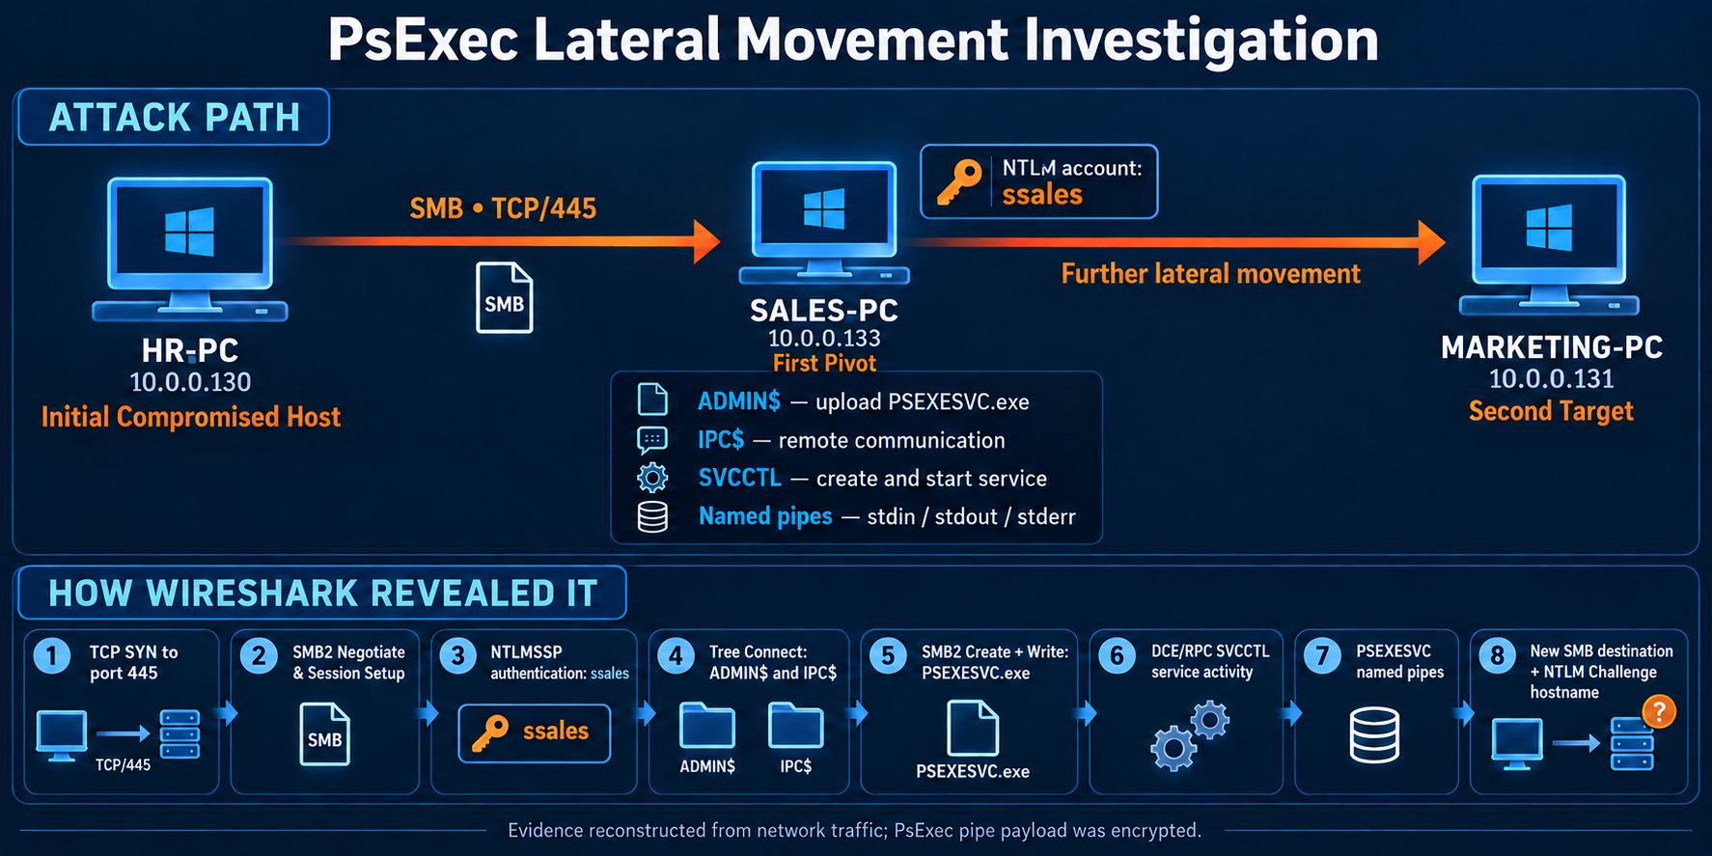
Figure 1. Visual summary of the reconstructed PsExec lateral-movement chain.

1. Scope and Objectives
The objective was to reconstruct the sequence visible in the PCAP and answer the investigation questions without relying on packet volume alone or assuming that every use of PsExec is malicious.
- Identify the machine from which the suspicious SMB activity originated.
- Determine the hostname of the first pivot target.
- Recover the username used during NTLM authentication.
- Identify the remote service executable.
- Determine the shares used for installation and communication.
- Identify the second host targeted for lateral movement.
- Map the observed behaviors to MITRE ATT&CK and document defensive actions.

2. Evidence and Tooling
Item | Details
Evidence | psexec-hunt.pcapng
Packet count | 40,294
Tool | Wireshark
Primary protocols | SMB2, NTLMSSP, DCE/RPC, SVCCTL
Service | SMB over TCP/445
Analysis timezone | UTC

3. Investigation Approach
- Establish a protocol baseline and prioritize SMB-oriented traffic.
- Keep client SMB negotiation requests to identify initiators and targets.
- Use NTLM Session Setup messages to recover server, client, and account identities.
- Trace Tree Connect, Create, Write, Read, and DCE/RPC operations in the relevant conversation.
- Correlate file transfer, service creation, service start, and named-pipe activity.
- Search for later TCP/445 connections from the same source and identify additional targets.
Analytical principle: a single artifact can be benign. The conclusion depends on the correlated sequence: valid-account authentication, administrative-share access, service binary transfer, SVCCTL execution, and PsExec named pipes.

4. Detailed Packet Analysis

4.1 Protocol Baseline
Wireshark's Protocol Hierarchy Statistics showed that SMB2 accounts for approximately 93.5% of the 40,294 packets. DCE/RPC and SVCCTL are also present. This combination is consistent with Windows file sharing plus remote service management and therefore provides a logical starting point.
Statistics → Protocol Hierarchy

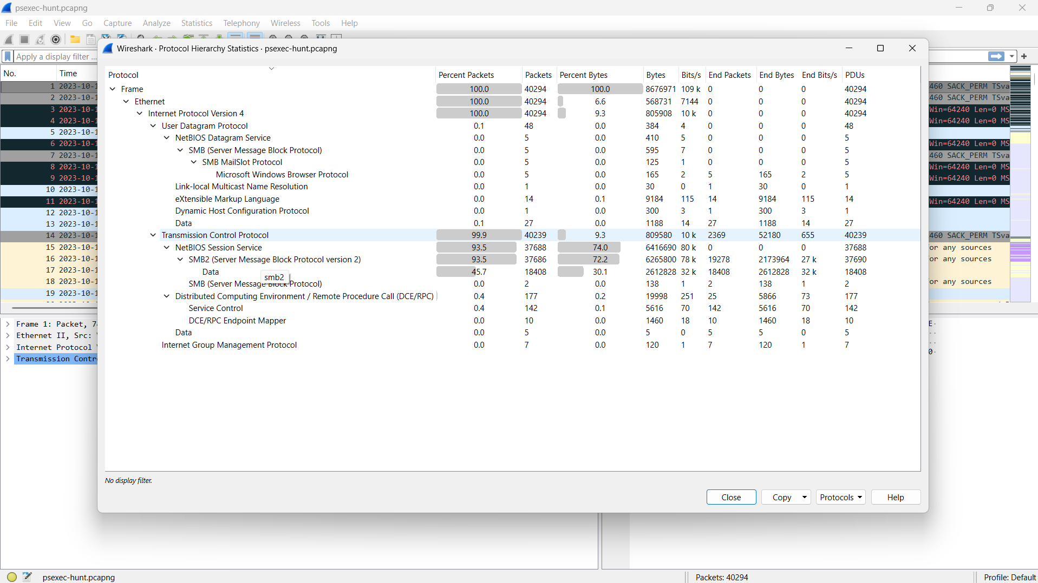
Figure 2. Protocol hierarchy showing SMB2 dominance and DCE/RPC service-control traffic.

4.2 Initial SMB Source and Targets
The following filter keeps SMB2 NEGOTIATE requests and removes responses. For a request, the Source column identifies the initiating client.
smb2.cmd == 0 && smb2.flags.response == 0

The earliest relevant request originates from 10.0.0.130 and targets 10.0.0.133 on TCP/445. Later requests from the same source target 10.0.0.131.
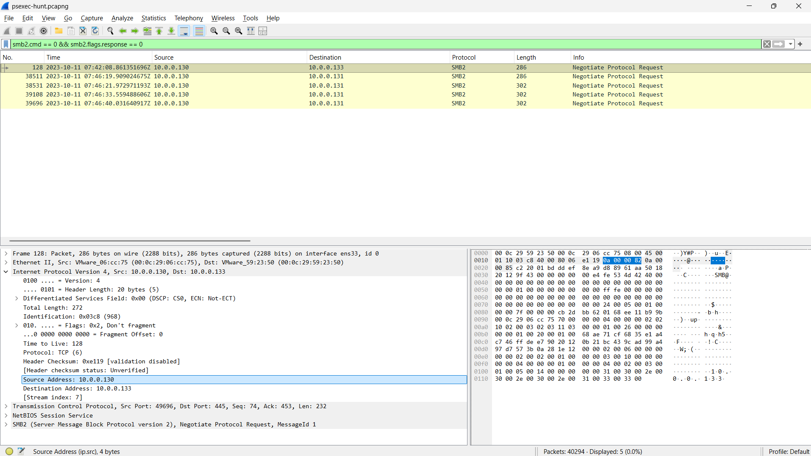
Figure 3. Client-originated SMB2 negotiation requests from 10.0.0.130.

4.3 First Pivot Host Identification
The first SMB exchange is IP conversation 7. Session Setup carries NTLM negotiation and authentication data. The use of ip.stream is intentional because the stream index was taken from the IPv4 conversation details.
ip.stream eq 7 && smb2.cmd == 1

In the server's NTLMSSP_CHALLENGE, Target Info reports the NetBIOS computer name SALES-PC. This associates target IP 10.0.0.133 with SALES-PC.
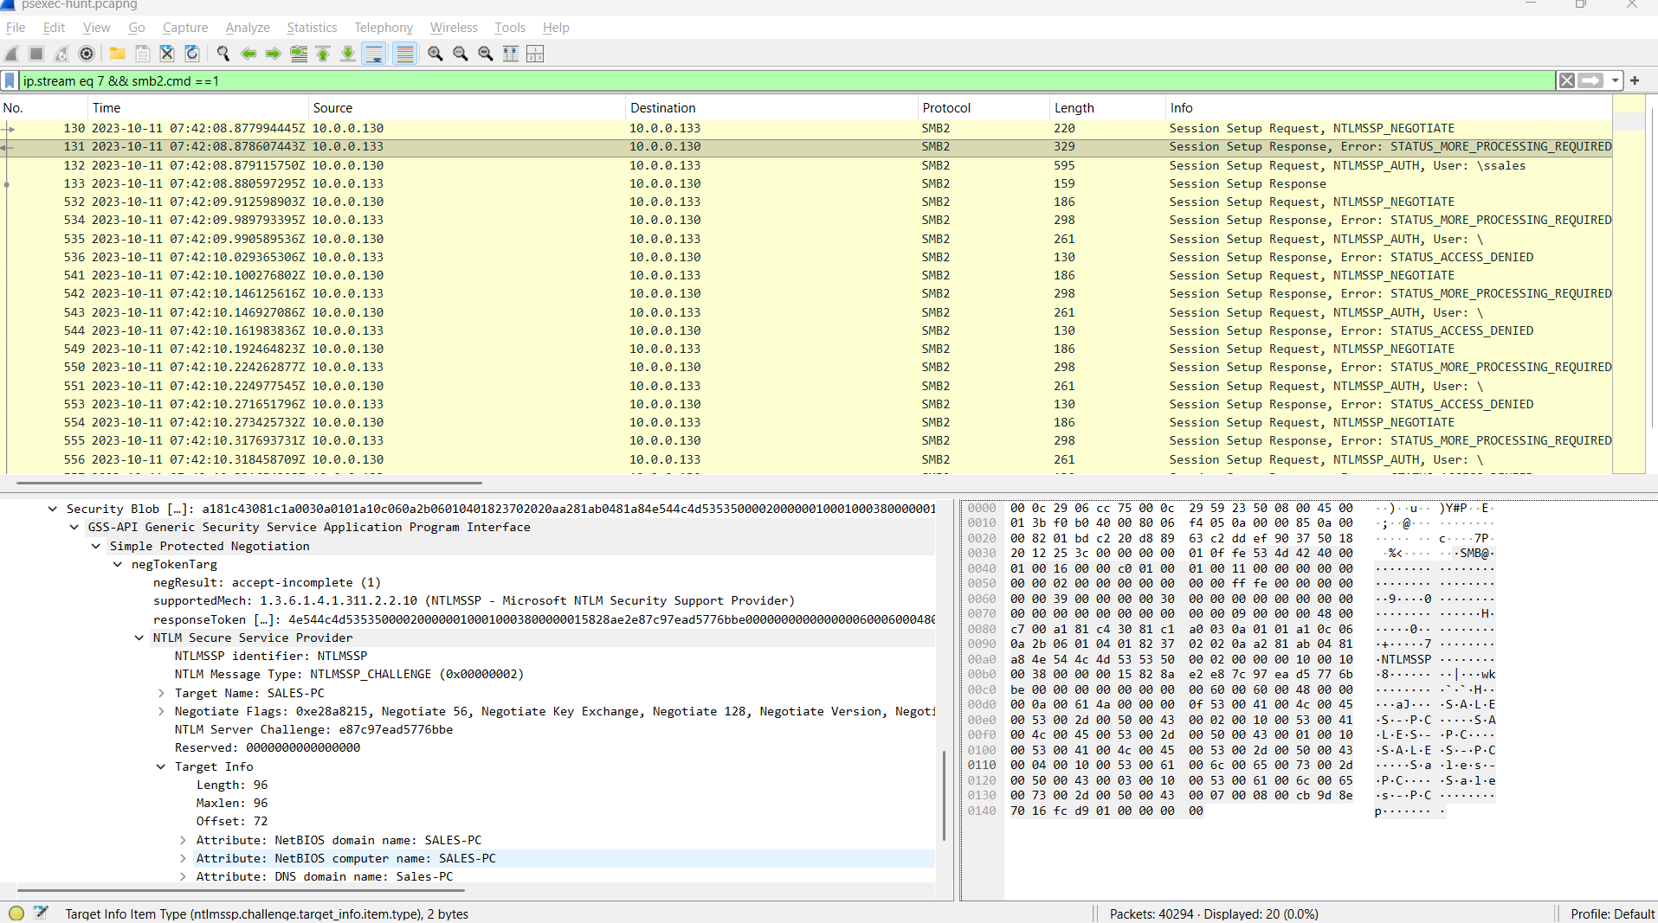
Figure 4. NTLM challenge identifying the first target as SALES-PC.

4.4 NTLM User and Client Workstation
The client NTLMSSP_AUTH message in the same Session Setup exchange contains the account and workstation identifiers. It shows user ssales and host HR-PC, sent from 10.0.0.130 to 10.0.0.133.
ip.stream eq 7 && smb2.cmd == 1

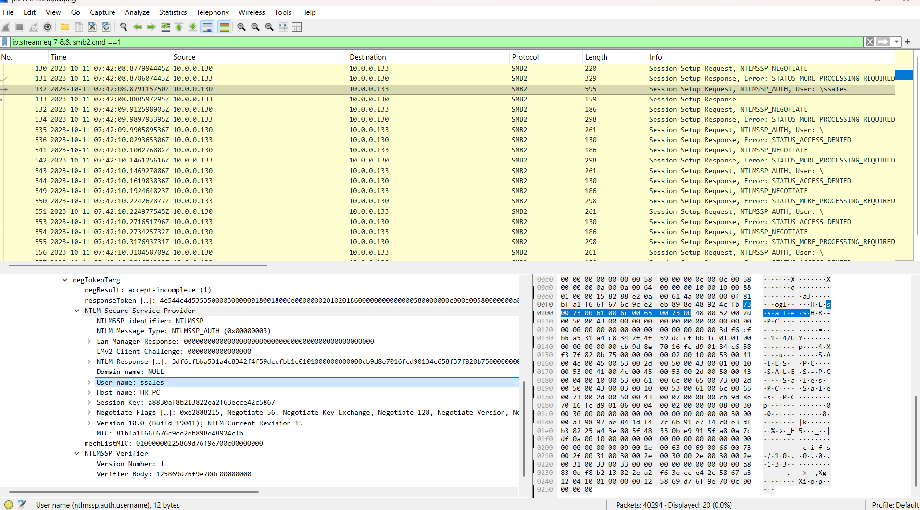
Figure 5. NTLM authentication showing ssales from HR-PC.
The client sends the username and NTLM authentication response. The password is not transmitted in plaintext. The PCAP confirms use of the account but not how its credentials were obtained.

4.5 Administrative and IPC Share Access
SMB2 command 3 is TREE_CONNECT. The client used it to request both ADMIN$ and IPC$ on SALES-PC.
ip.stream eq 7 && smb2.cmd == 3

4.5.1 ADMIN$ — Service Deployment
ADMIN$ maps to the remote Windows directory and provides the location used by PsExec to deploy its temporary service executable.
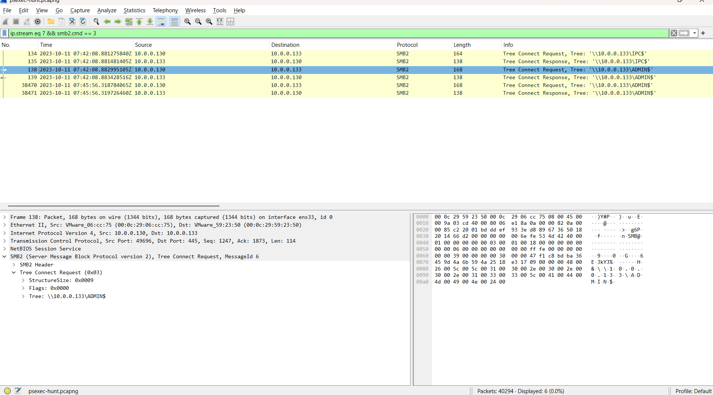
Figure 6. SMB Tree Connect request to the ADMIN$ administrative share.

4.5.2 IPC$ — Control and Communication
IPC$ supports inter-process communication, RPC endpoints, and named-pipe access used by PsExec for control and command I/O.
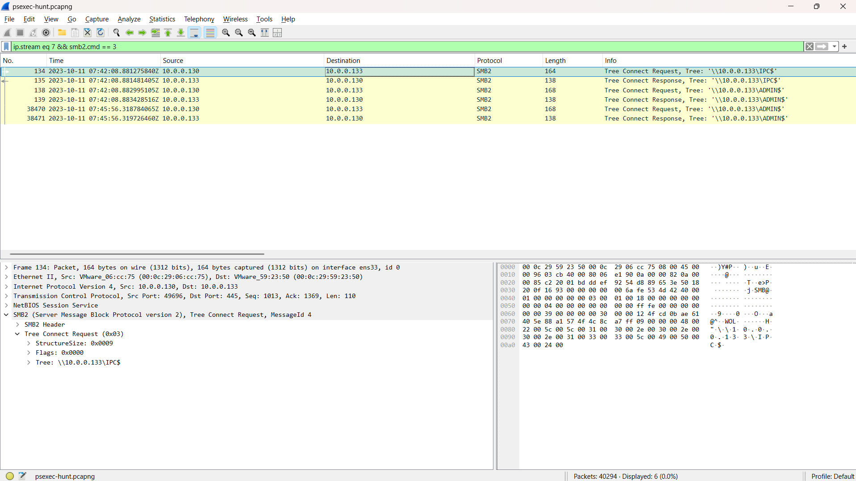
Figure 7. SMB Tree Connect activity showing IPC$ communication access.

4.6 PSEXESVC.exe Creation and Transfer
SMB2 command 5 is CREATE. In SMB, CREATE can open or create a file, directory, or named pipe. The request identifies PSEXESVC.exe.
ip.stream eq 7 && smb2.cmd == 5

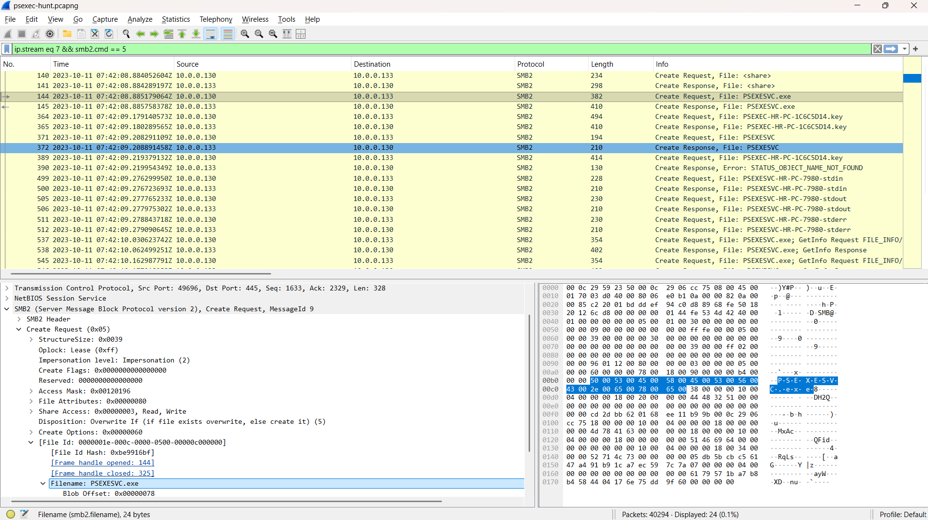
Figure 8. SMB2 Create request for PSEXESVC.exe.

4.6.1 Transfer Confirmation with SMB Write
A file name alone is insufficient to prove transfer. SMB2 command 9 is WRITE; repeated client writes, including large chunks, confirm that executable content was copied to the target.
ip.stream eq 7 && smb2.cmd == 9 && smb2.flags.response == 0

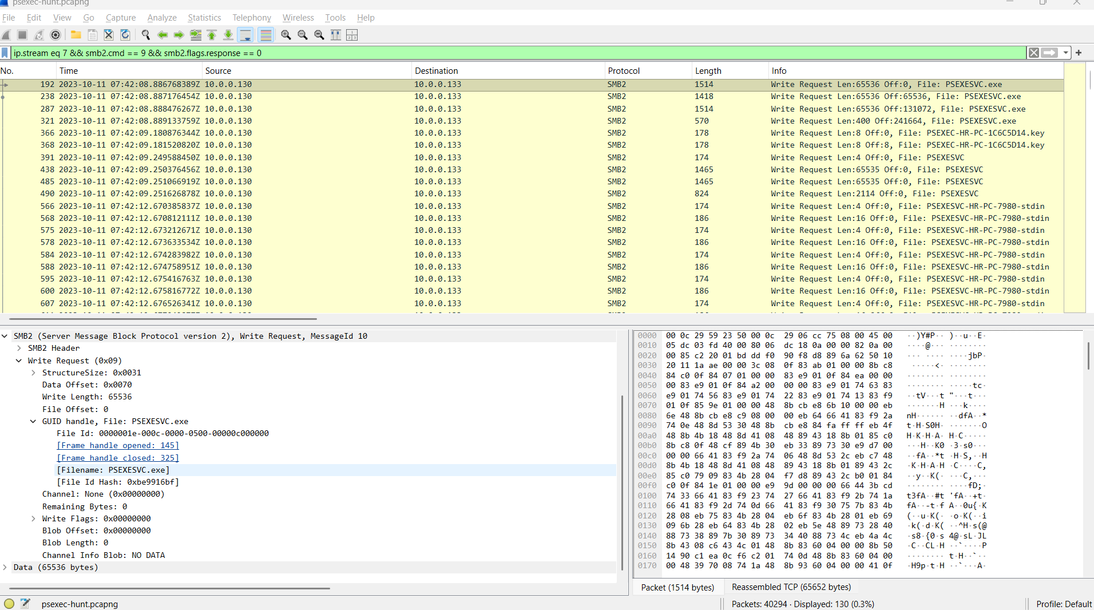
Figure 9. SMB2 Write requests transferring PSEXESVC.exe.
PsExec is a legitimate Microsoft Sysinternals remote-administration utility. Its use becomes incident-relevant through the surrounding unauthorized behavior chain.

4.7 Remote Service Control
After the file transfer, DCE/RPC traffic exposes SVCCTL calls to the remote Windows Service Control Manager.
ip.stream eq 7 && dcerpc

Operation | Analytical meaning
OpenSCManager2 | Open a handle to the Service Control Manager.
CreateServiceW | Register a service on the target.
OpenServiceW | Open the newly created or existing service.
StartServiceW | Start the service and execute its binary.
QueryServiceStatus | Check the resulting service state.

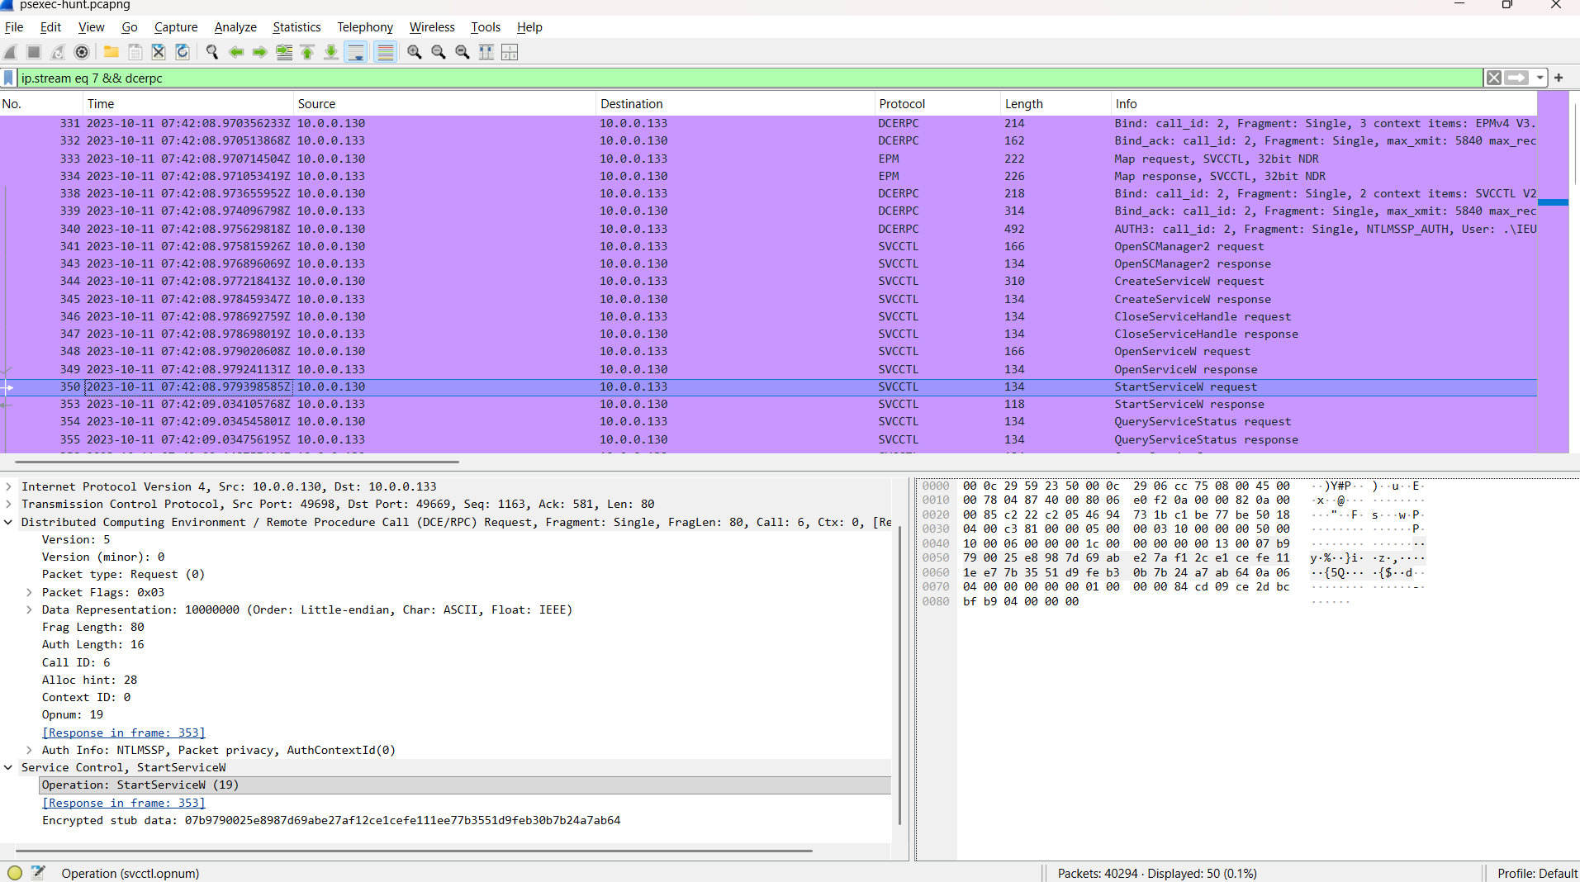
Figure 10. SVCCTL StartServiceW and related remote service-control operations.
The sequence ties the transferred executable to remote execution; PSEXESVC.exe was not merely stored on SALES-PC.

4.8 PsExec Named Pipes
After service start, PsExec opens named pipes for standard input, standard output, and standard error.
ip.stream eq 7 && smb2.filename contains "PSEXESVC-"

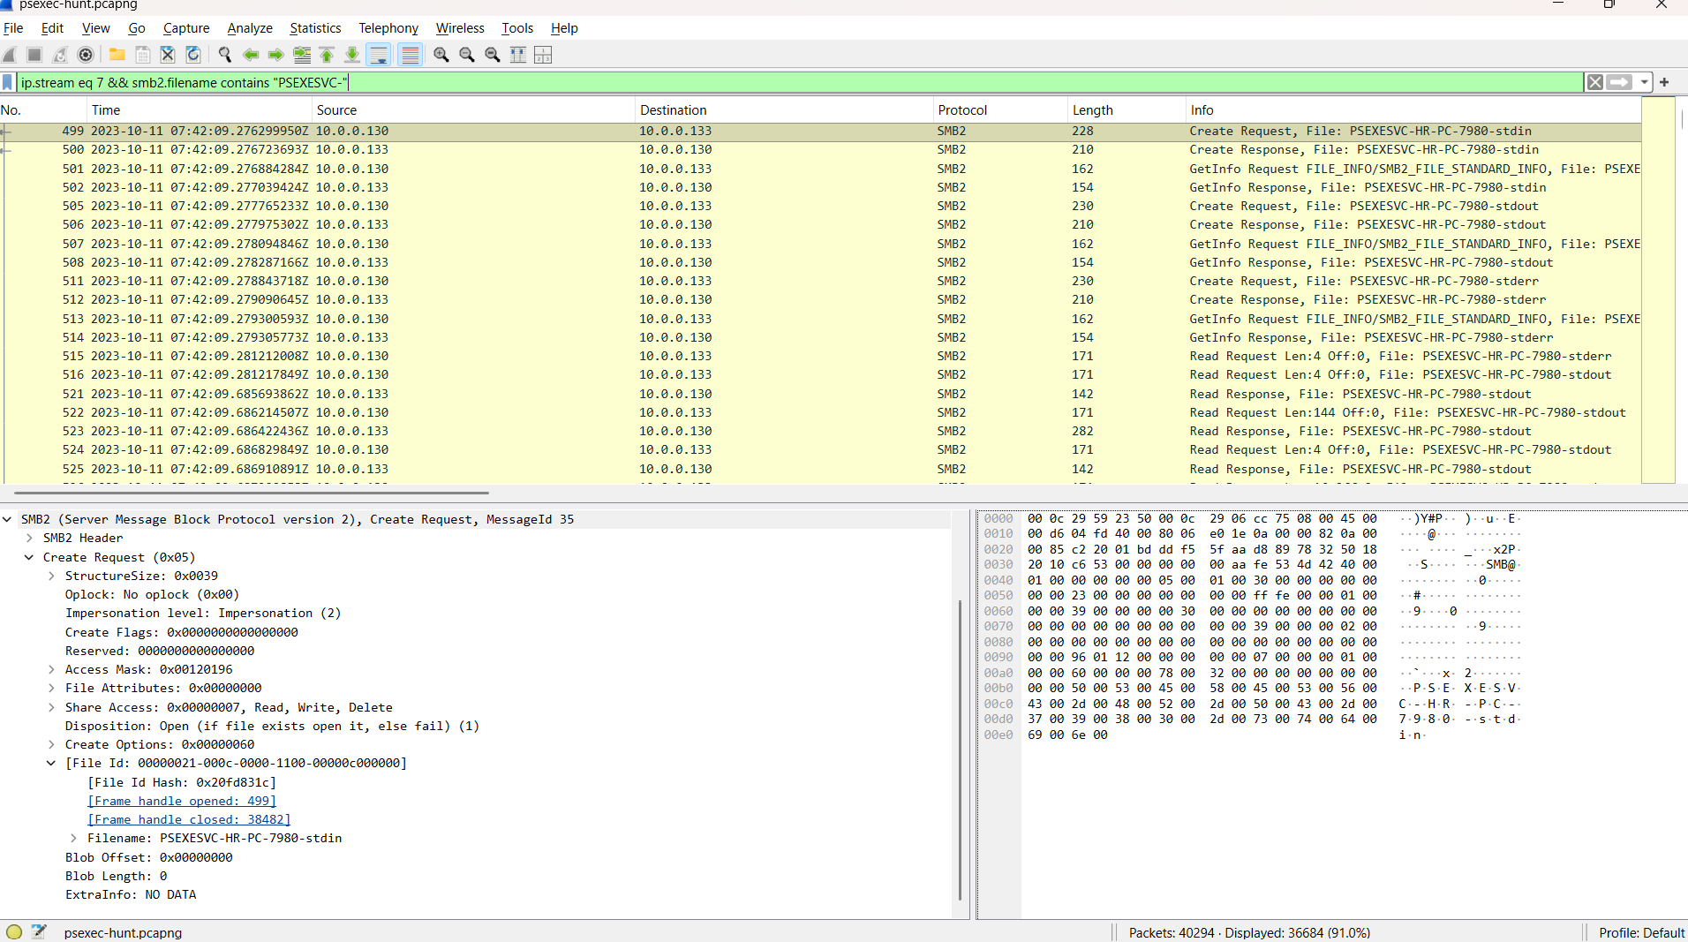
Figure 11. PsExec stdin, stdout, and stderr named pipes.

Named pipe | Function
PSEXESVC-HR-PC-7980-stdin | Carries input or command data to the remote process.
PSEXESVC-HR-PC-7980-stdout | Returns normal process output.
PSEXESVC-HR-PC-7980-stderr | Returns error output.

HR-PC identifies the initiating workstation. The value 7980 is the PsExec client process identifier used to distinguish this set of pipes.

4.8.1 Named-Pipe Payload Limitation
Read responses for the stdout pipe contain data, but the selected 144-byte payload is not readable as plain command output in this capture.
ip.stream eq 7 && smb2.cmd == 8 &&
offset_length(smb2.file_data, 0, 144) &&
smb2.filename contains "stdout"

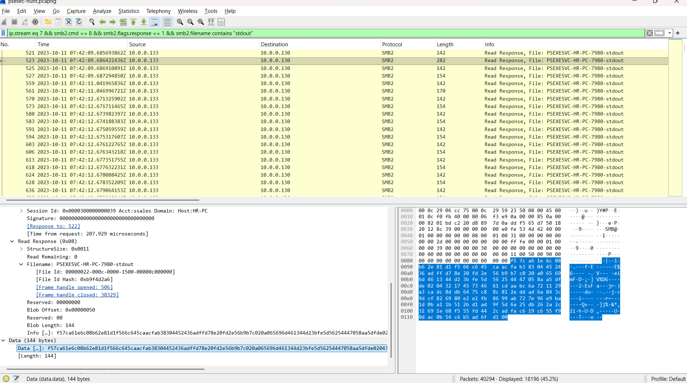
Figure 12. Opaque data returned through the PsExec stdout named pipe.
Defensible conclusion: command output was exchanged through the pipe. The exact command and output cannot be recovered reliably from this PCAP alone.

4.9 Second Pivot Target
Initial TCP SYN packets to destination port 445 reveal later SMB connection attempts from the same source.
ip.src == 10.0.0.130 &&
tcp.dstport == 445 &&
tcp.flags.syn == 1 &&
tcp.flags.ack == 0

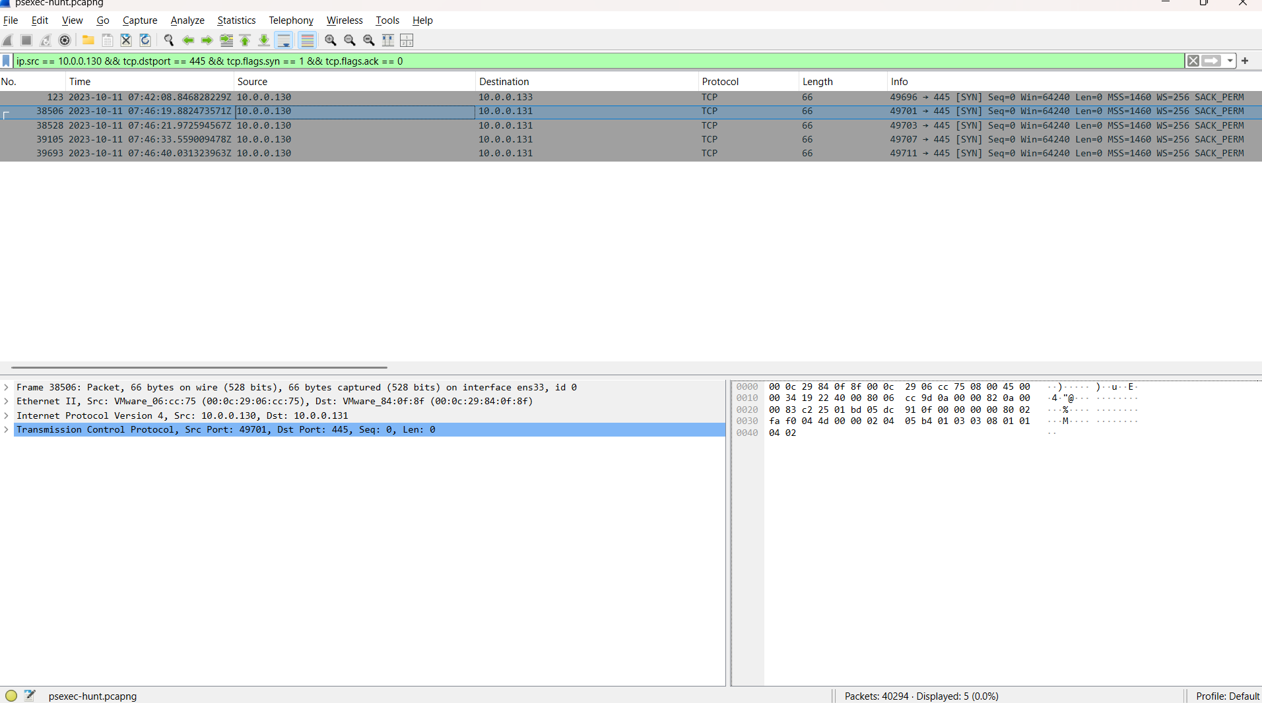
Figure 13. Initial SMB SYN packets to 10.0.0.133 and the later target 10.0.0.131.

The first target appears at approximately 07:42:08 UTC. Beginning around 07:46:19 UTC, 10.0.0.130 initiated multiple TCP/445 connections to 10.0.0.131.
The second server's NTLMSSP_CHALLENGE identifies its hostname through Target Info.
ip.src == 10.0.0.131 && ntlmssp.messagetype == 2

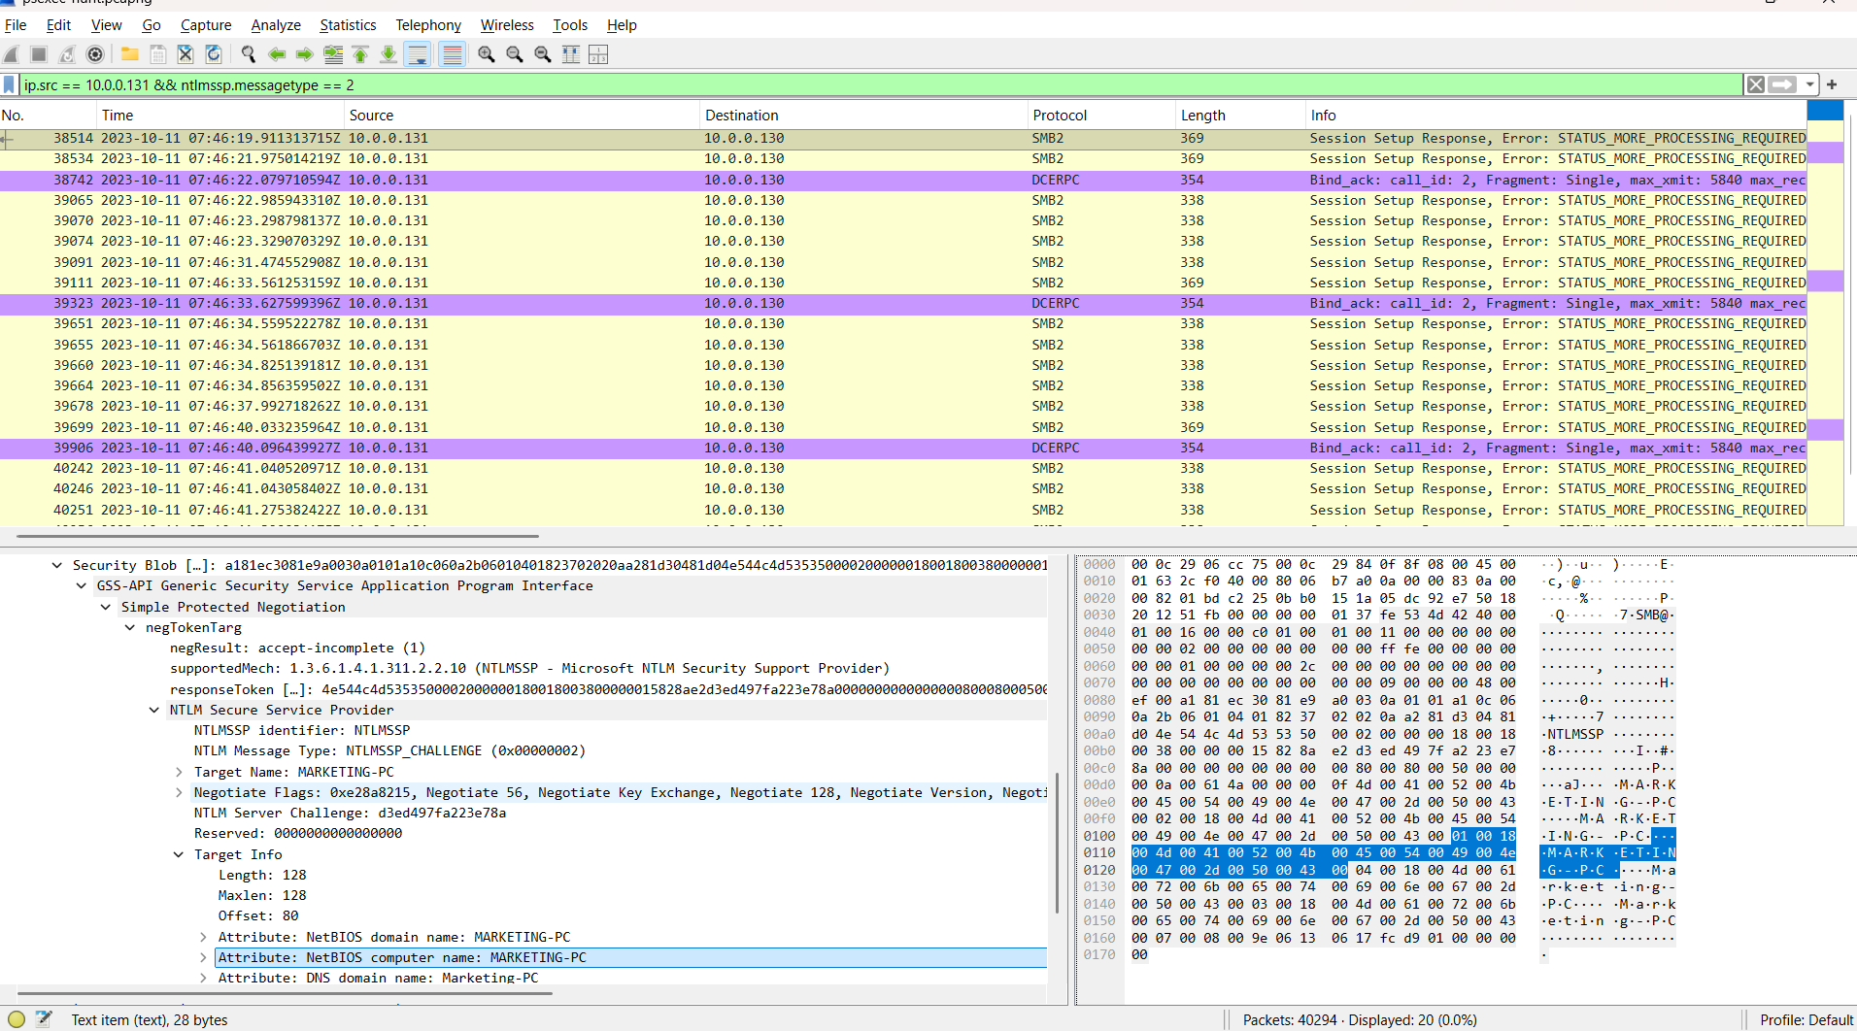
Figure 14. NTLM challenge identifying 10.0.0.131 as MARKETING-PC.

5. Reconstructed Timeline
Time (UTC) | Source | Destination | Observed activity
2023-10-11 07:42:08 | 10.0.0.130 | 10.0.0.133 | SMB connection and negotiation
2023-10-11 07:42:08 | HR-PC | SALES-PC | NTLM authentication using ssales
2023-10-11 07:42:08 | HR-PC | SALES-PC | IPC$ and ADMIN$ access
2023-10-11 07:42:08 | HR-PC | SALES-PC | PSEXESVC.exe transfer
2023-10-11 07:42:08 | HR-PC | SALES-PC | Service creation and start
2023-10-11 07:42:09 | HR-PC | SALES-PC | PsExec named-pipe exchange
2023-10-11 07:46:19 | 10.0.0.130 | 10.0.0.131 | New SMB sessions to MARKETING-PC

6. Answer and Evidence Matrix
Question | Answer | Primary evidence
Q1 — Initial source IP | 10.0.0.130 | Client SMB2 NEGOTIATE requests
Q2 — First pivot hostname | SALES-PC | NTLM challenge Target Info
Q3 — Authentication username | ssales | NTLMSSP_AUTH user field
Q4 — Service executable | PSEXESVC.exe | SMB2 Create and Write
Q5 — Installation share | ADMIN$ | SMB2 Tree Connect
Q6 — Communication share | IPC$ | Tree Connect, RPC, and named pipes
Q7 — Second pivot hostname | MARKETING-PC | Second target NTLM challenge

7. Indicators of Compromise
Type | Value
Source endpoint | 10.0.0.130 / HR-PC
First target | 10.0.0.133 / SALES-PC
Second target | 10.0.0.131 / MARKETING-PC
User account | ssales
Executable | PSEXESVC.exe
Shares | ADMIN$, IPC$
Named-pipe prefix | PSEXESVC-HR-PC-7980-
Service | SMB over TCP/445

8. MITRE ATT&CK Mapping
Tactic | Technique | Evidence
Lateral Movement | T1021.002 — SMB/Windows Admin Shares | SMB authentication and ADMIN$/IPC$ access
Lateral Movement | T1570 — Lateral Tool Transfer | PSEXESVC.exe copied to SALES-PC
Execution | T1569.002 — Service Execution | CreateServiceW and StartServiceW
Multiple | T1078 — Valid Accounts | Successful NTLM use of ssales

9. Detection Opportunities
- Correlate successful NTLM logons with immediate access to ADMIN$ or IPC$.
- Alert on writes of PSEXESVC.exe or similarly named service binaries to administrative shares.
- Detect remote service creation shortly after an SMB file transfer.
- Monitor SVCCTL operations such as CreateServiceW and StartServiceW from workstations.
- Alert on named pipes matching PSEXESVC-*-(stdin|stdout|stderr).
- Correlate Security events 4624, 4672, 4697, 5140, and 5145 with System event 7045.
- Flag one workstation initiating SMB sessions to multiple peer workstations within a short interval.
- Review endpoint process trees for services.exe starting unexpected binaries or shells.

10. Remediation Recommendations
- Isolate HR-PC, SALES-PC, and MARKETING-PC pending endpoint validation.
- Reset ssales credentials and review the account's privileges, group memberships, and logon history.
- Restrict SMB between workstation segments with host and network firewalls.
- Limit ADMIN$ and IPC$ access to approved administrative systems and accounts.
- Reduce or disable NTLM where operationally possible and enforce modern authentication controls.
- Control PsExec and other dual-use remote-administration utilities through application control and monitoring.
- Hunt for the PSEXESVC service, executable remnants, related named pipes, and service-creation events.
- Collect EDR, Active Directory, Windows event, and process telemetry to determine the original compromise path and executed commands.

11. Limitations
- The investigation is limited to the supplied PCAP; no endpoint, Active Directory, or EDR data was available.
- The NTLM exchange confirms that ssales was used but does not establish how the credentials were acquired.
- The visible PsExec pipe payload is opaque, so exact remote commands and outputs are not asserted.
- PSEXESVC.exe is a dual-use artifact. Classification depends on the correlated unauthorized behavior sequence.

12. Conclusion
The packet evidence confirms PsExec-based lateral movement from HR-PC (10.0.0.130) to SALES-PC (10.0.0.133) using the ssales account. The source connected to IPC$ and ADMIN$, transferred PSEXESVC.exe, controlled a remote service through SVCCTL, and exchanged data through PsExec named pipes. The same source subsequently opened SMB sessions to MARKETING-PC (10.0.0.131), showing that the activity extended beyond the first target.
The strongest analytical result is the correlation of multiple protocol artifacts rather than reliance on a single filename or packet. Authentication identity, share access, executable transfer, service execution, and named-pipe communication collectively reconstruct the lateral-movement workflow.

13. References
- Microsoft Sysinternals — PsExec: https://learn.microsoft.com/en-us/sysinternals/downloads/psexec
- MITRE ATT&CK — PsExec (S0029): https://attack.mitre.org/software/S0029/
- MITRE ATT&CK — SMB/Windows Admin Shares (T1021.002): https://attack.mitre.org/techniques/T1021/002/
- MITRE ATT&CK — Service Execution (T1569.002): https://attack.mitre.org/techniques/T1569/002/
- MITRE ATT&CK — Lateral Tool Transfer (T1570): https://attack.mitre.org/techniques/T1570/
- MITRE ATT&CK — Valid Accounts (T1078): https://attack.mitre.org/techniques/T1078/
Final assessment: The environment should be treated as compromised until the involved endpoints, account activity, and service-execution telemetry are validated and remediated.

