Network Forensics Investigation Report
CyberDefenders – JetBrains Lab (Network Forensics)
- Prepared by: Alaa Zahra
- Platform: CyberDefenders
- Lab: JetBrains
- Category: Network Forensics
- Difficulty: Easy
- Primary Tool: Wireshark
- Evidence File: Capture.pcap
- Date: August 2026

1. Executive Summary
This report documents the forensic investigation of a compromised JetBrains TeamCity server using network traffic captured in a PCAP file.
The investigation revealed that the attacker at 23.158.56.196 exploited CVE-2024-27198, an authentication bypass vulnerability affecting TeamCity 2023.11.3.
After bypassing authentication, the attacker created a global administrator account, generated an access token, uploaded a malicious TeamCity plugin containing a JSP web shell, and executed operating-system commands through HTTP POST requests.
During post-exploitation, the attacker modified a credentials file and attempted to escape from the Docker container by mounting the host root filesystem. According to the lab scenario, the container escape attempt was unsuccessful.

2. Investigation Objectives
The objectives of the investigation were to:
- Identify the attacker's IP address.
- Determine the version of the compromised TeamCity server.
- Identify the exploited vulnerability.
- Recover the malicious credentials created by the attacker.
- Identify the uploaded web shell.
- Determine when the first web-shell command was executed.
- Analyze the modification of the credentials file.
- Map the attacker's actions to MITRE ATT&CK.
- Identify the attempted Docker container-escape command.

3. Tools Used
Wireshark
Wireshark was used to:
- Inspect the protocol hierarchy.
- Analyze IPv4 endpoints.
- Filter HTTP requests.
- Follow HTTP streams.
- Examine POST request parameters.
- Recover attacker commands.
- Reconstruct the attack timeline.

External References
The following sources were used to confirm the vulnerability and MITRE ATT&CK mappings:
- JetBrains Security Advisory.
- NIST National Vulnerability Database.
- Rapid7 technical analysis.
- MITRE ATT&CK Enterprise Matrix.

4. Initial Traffic Triage
The supplied PCAP contained a total of 33,279 packets.
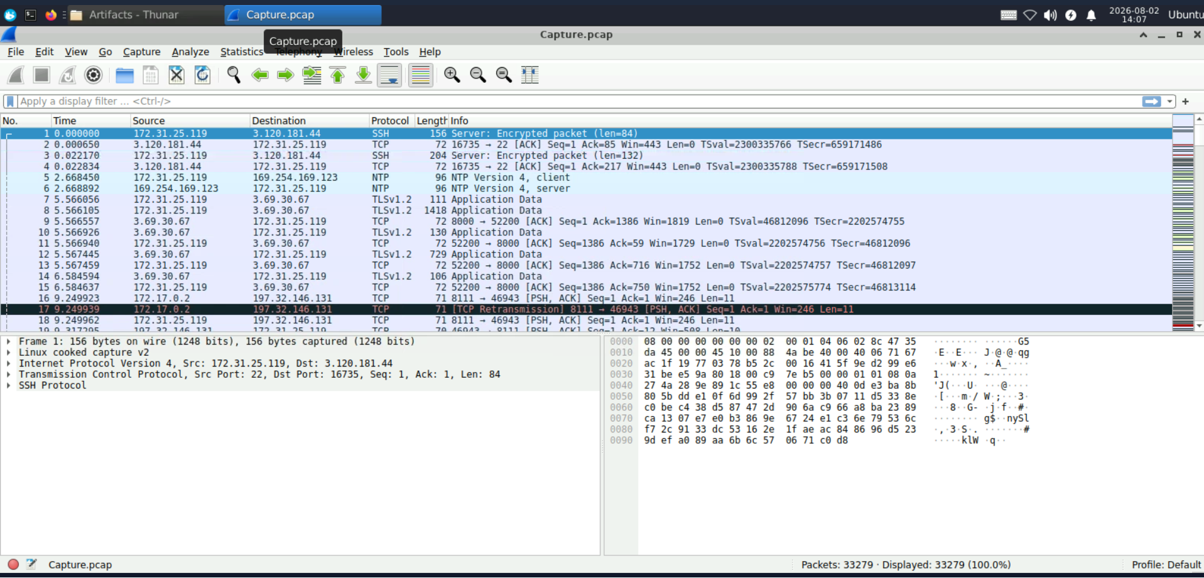
Screenshot – Initial view of Capture.pcap in Wireshark
The Protocol Hierarchy Statistics showed that approximately 97% of the packets used TCP. HTTP represented a significant portion of the transferred data.
Because the TeamCity communication occurred over unencrypted HTTP, the requests, responses, uploaded filenames, account information, and command parameters could be inspected directly.
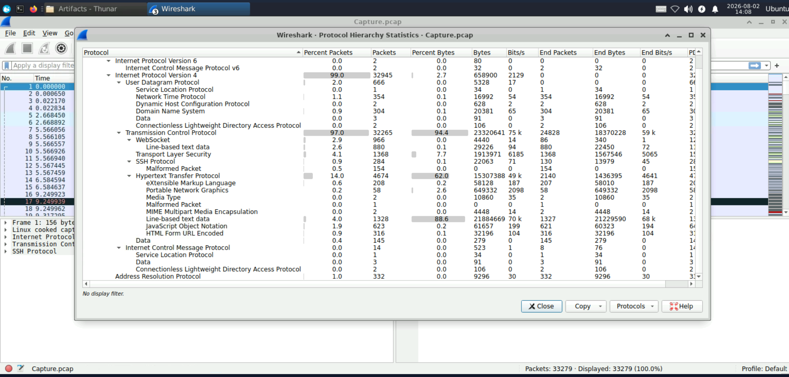
Figure 1 – Wireshark Protocol Hierarchy Statistics
The IPv4 Endpoints window revealed several public and private IP addresses. Packet volume alone was not sufficient to determine which endpoint was malicious. Therefore, the endpoints were investigated based on their behavior.
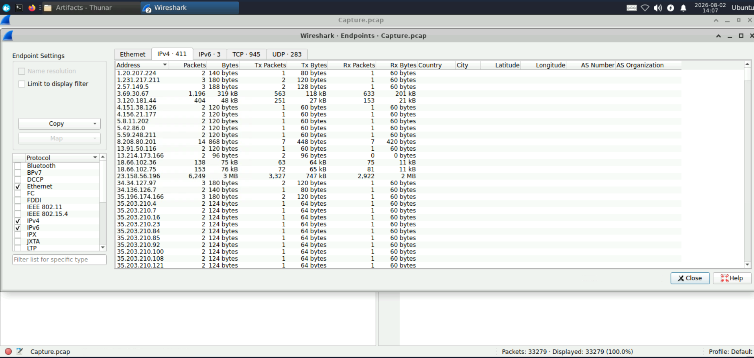
Figure 2 – IPv4 Endpoints
The main systems identified during the investigation were:
Role | IP address
Attacker | 23.158.56.196
Victim public address | 3.71.79.4
Internal host | 172.31.25.119
TeamCity Docker container | 172.17.0.2
TeamCity port | 8111/TCP

Some malicious requests appeared twice because the traffic was likely captured before and after NAT or Docker forwarding. This does not indicate that two separate servers were attacked.

5. Investigation Findings

5.1 Q1 – Attacker IP Address
To identify the attacker without knowing the IP address in advance, HTTP POST requests were examined using the following Wireshark filter:
http.request.method == "POST"
Particular attention was given to requests directed toward sensitive TeamCity endpoints, including the plugin upload page and the JSP web shell.
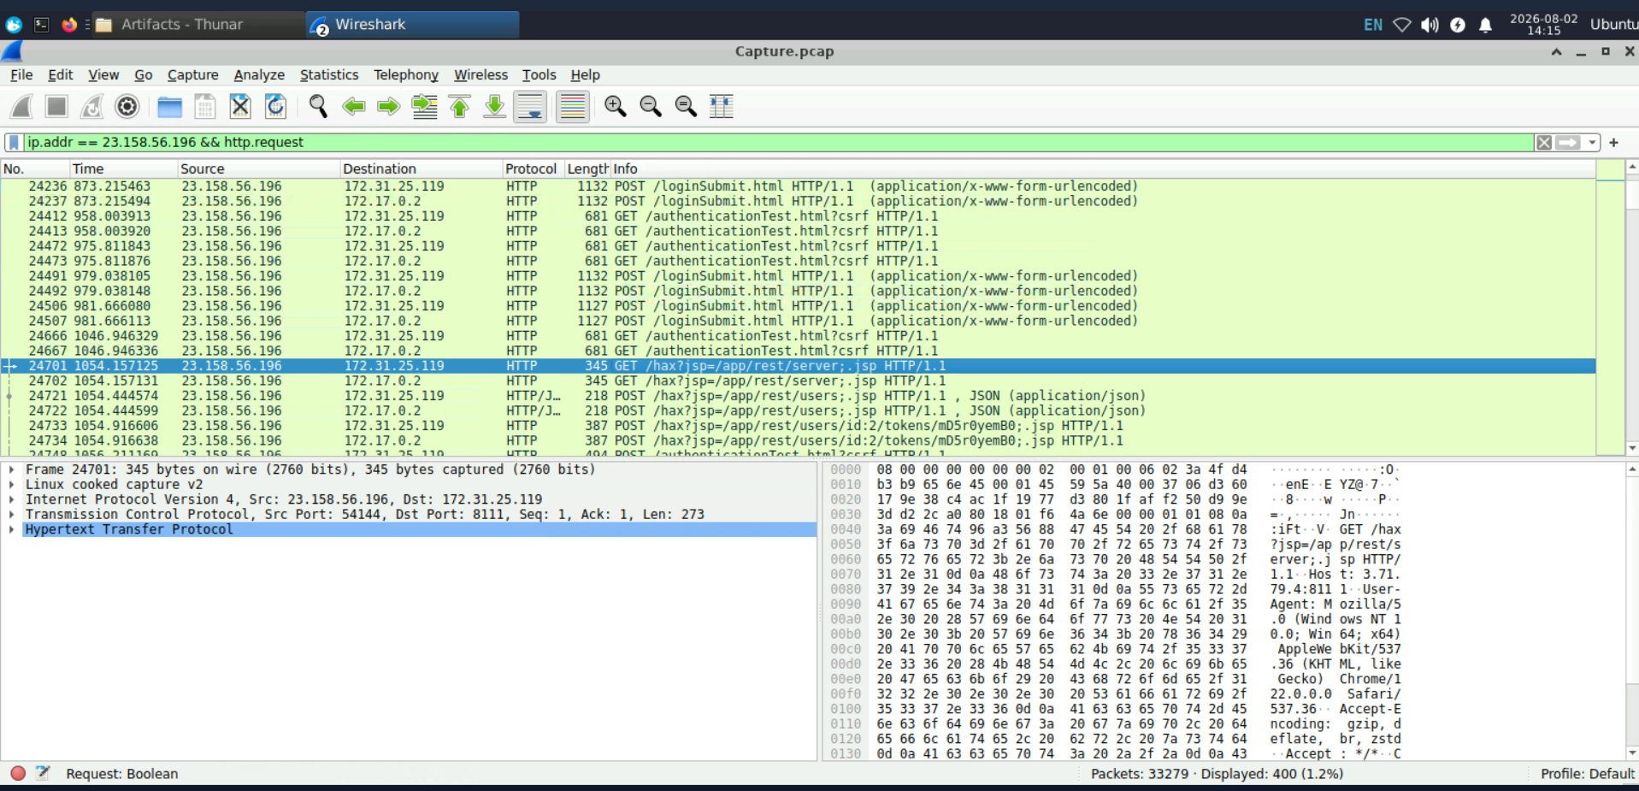
Screenshot – HTTP requests from the attacker's IP to TeamCity endpoints
The source IP responsible for:
- Exploiting TeamCity.
- Creating an administrator account.
- Uploading a malicious plugin.
- Sending commands to the web shell.
was:
23.158.56.196
Answer: 23.158.56.196

5.2 Q2 – TeamCity Version
After identifying the attacker, its HTTP traffic was isolated using:
ip.addr == 23.158.56.196 && http
One of the malicious requests was:
GET /hax?jsp=/app/rest/server;.jsp HTTP/1.1
The server returned an HTTP/1.1 200 response containing the following information:
<server version="2023.11.3" buildNumber="147512" />
This confirmed that the victim was running:
TeamCity 2023.11.3 Build 147512
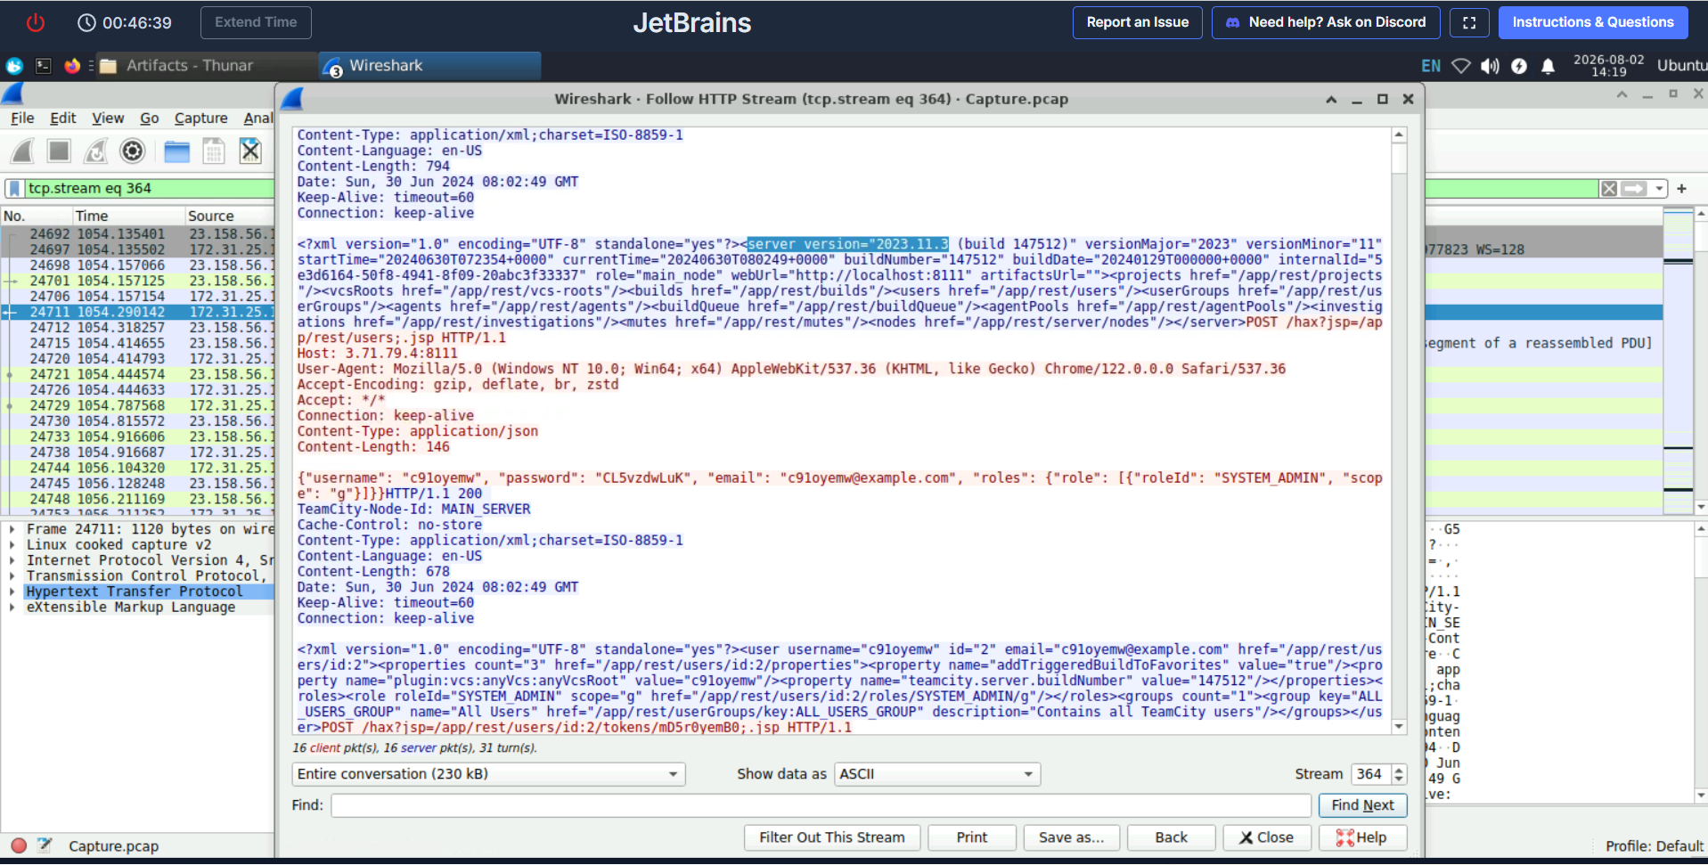
Figure 3 – TeamCity Version Response (highlighted in Follow HTTP Stream)
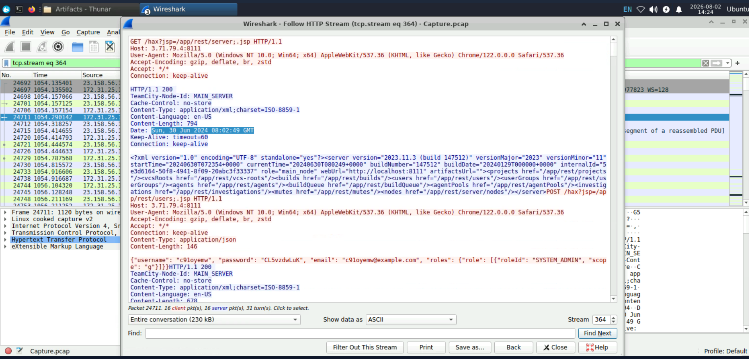
Screenshot – Response timestamp confirming the exploitation window (30 Jun 2024)
Answer: 2023.11.3

5.3 Q3 – Exploited Vulnerability
The attacker accessed protected TeamCity REST API endpoints without providing normal authentication.
The malicious requests used the following crafted URL pattern:
/hax?jsp=/app/rest/...;.jsp
This behavior matches the JetBrains TeamCity authentication bypass vulnerability:
CVE-2024-27198
The affected TeamCity version in the PCAP was 2023.11.3, while the vulnerability was fixed beginning with version 2023.11.4.
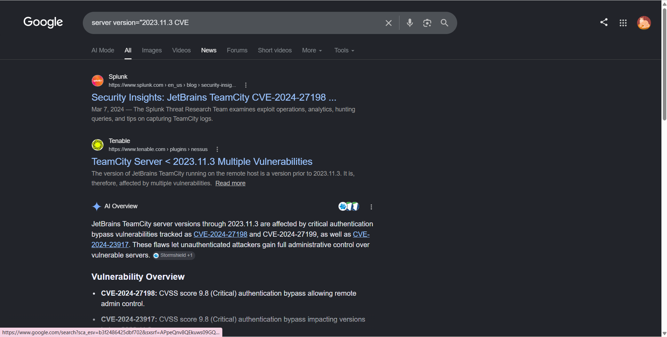
Figure 4 – CVE Research Evidence (CVE-2024-27198)
Answer: CVE-2024-27198

5.4 Q4 – Attacker-Created Credentials
The attacker sent the following request to the TeamCity users REST endpoint:
POST /hax?jsp=/app/rest/users;.jsp HTTP/1.1
The request contained the following JSON body:
{
"username": "c91oyemw",
"password": "CL5vzdwLuK",
"email": "c91oyemw@example.com",
"roles": {
"role": [
{
"roleId": "SYSTEM_ADMIN",
"scope": "g"
}
]
}
}
The role SYSTEM_ADMIN granted the malicious account full administrative privileges. The value g indicates that the permissions applied globally across TeamCity.
The successful HTTP response confirmed that the account was created. The attacker subsequently generated an access token for the account, providing an additional persistence mechanism.
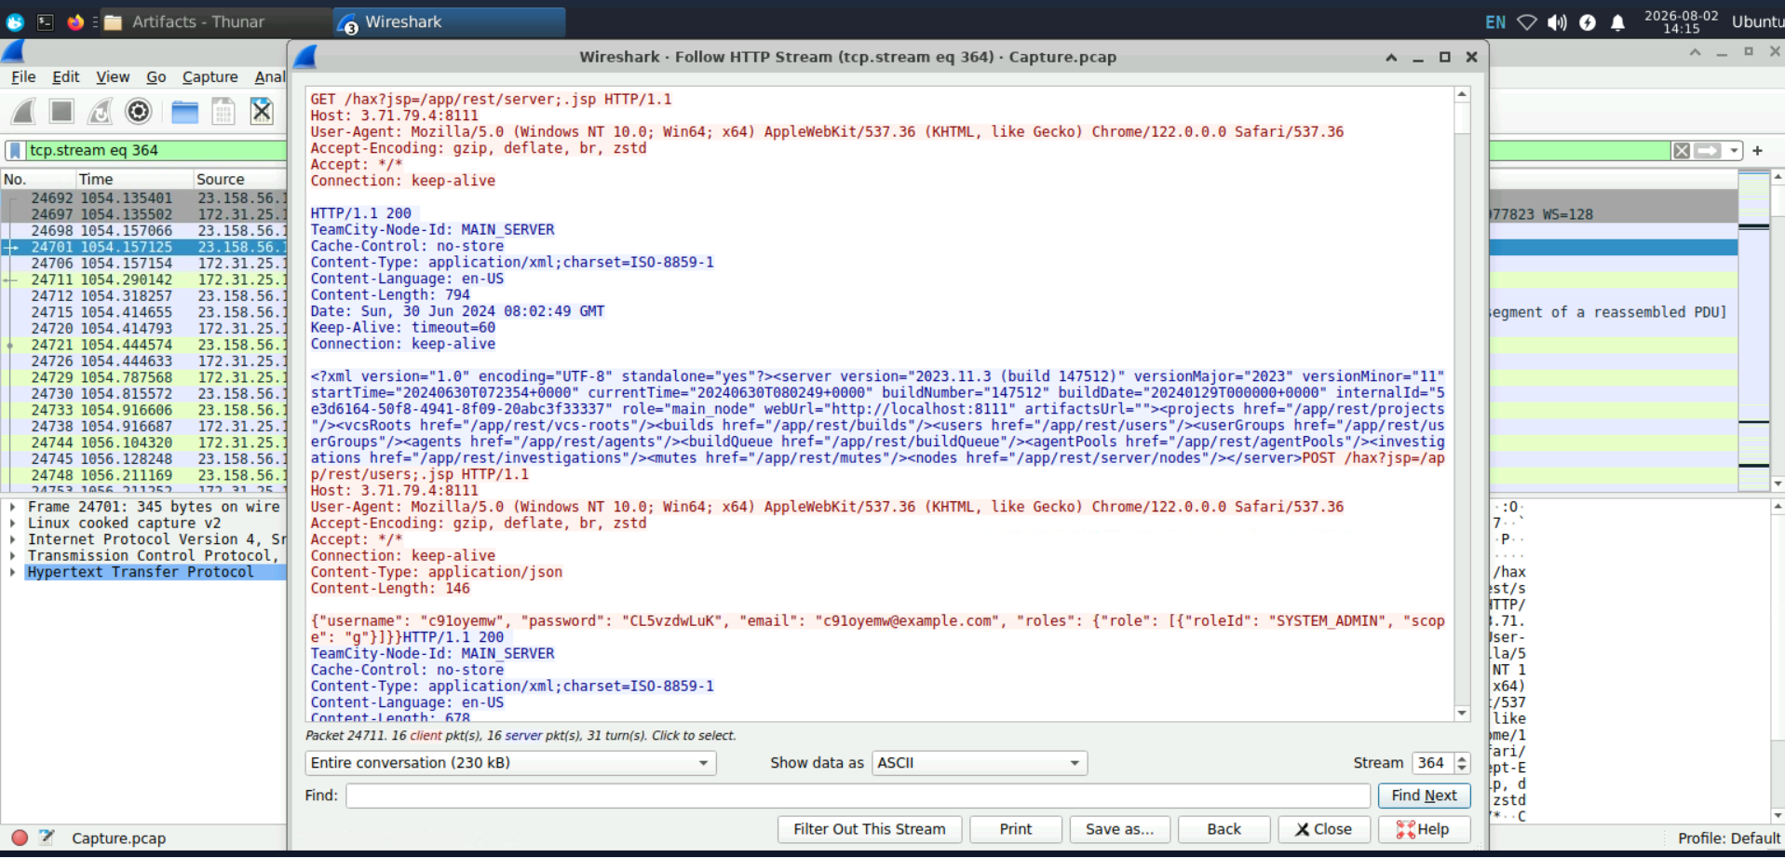
Screenshot – Follow HTTP Stream showing the version response and account-creation request
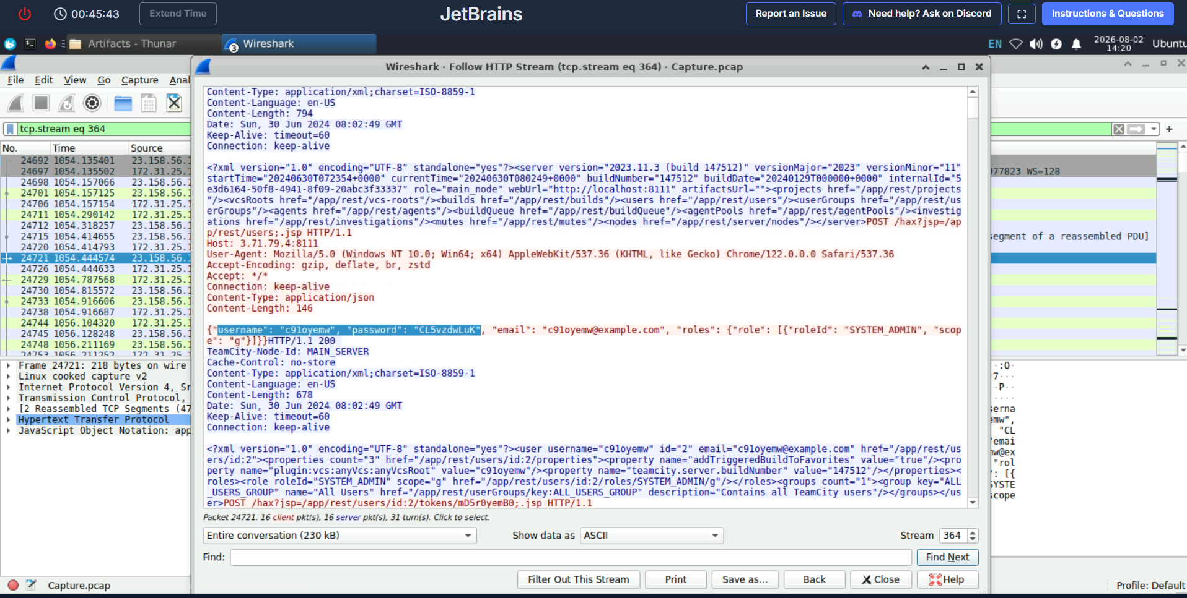
Screenshot – Attacker-created username, password, and SYSTEM_ADMIN role
Answer:
c91oyemw:CL5vzdwLuK

5.5 Q5 – Uploaded Web Shell
After obtaining administrator access, the attacker submitted a multipart POST request to:
POST /admin/pluginUpload.html HTTP/1.1
The multipart request contained:
filename="NSt8bHTg.zip"
Content-Type: application/zip
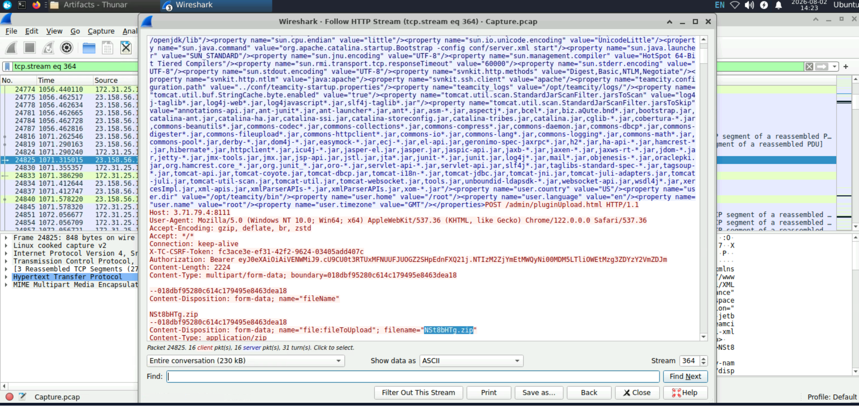
Figure 5 – Malicious Plugin Upload (NSt8bHTg.zip)
The ZIP archive was uploaded as a TeamCity plugin. After deployment, its JSP web-shell component became accessible through:
/plugins/NSt8bHTg/NSt8bHTg.jsp
The JSP file accepted operating-system commands through an HTTP form parameter named cmd.
Uploaded archive: NSt8bHTg.zip
Deployed web shell: NSt8bHTg.jsp

5.6 Q6 – First Web-Shell Command
Requests sent to the JSP web shell were isolated using:
ip.src == 23.158.56.196 &&
http.request.method == "POST" &&
http.request.uri contains "NSt8bHTg.jsp"
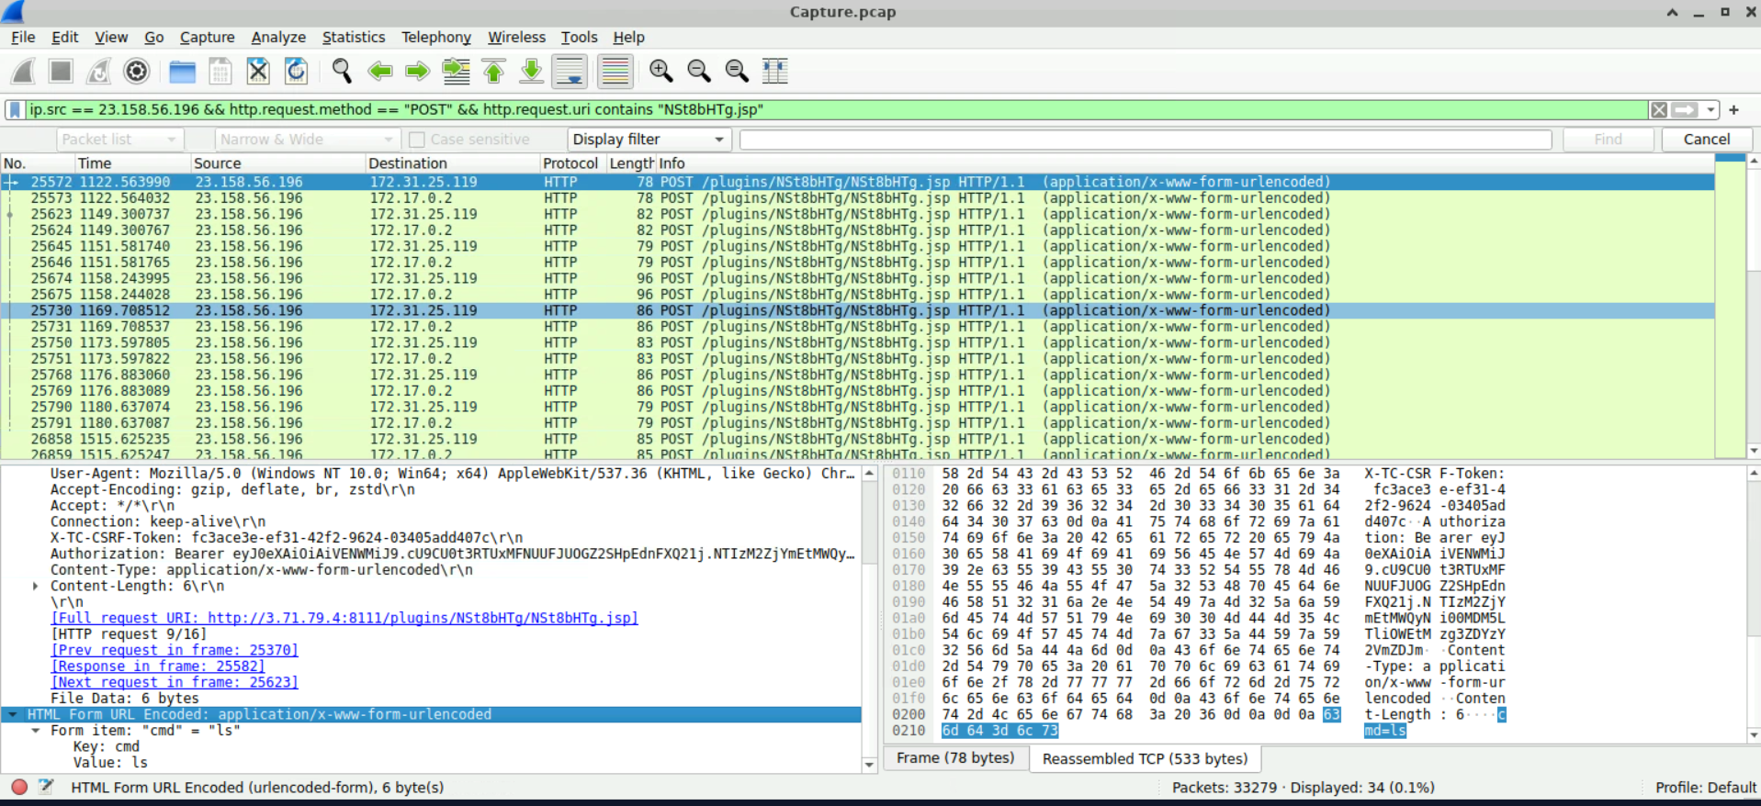
Figure 6 – Web-Shell POST Requests (first command: cmd=ls)
The earliest matching request contained:
cmd=ls
The arrival time was obtained by expanding the Frame section of the packet.
Answer:
2024-06-30 08:03:57 UTC

5.7 Q7 – Credentials File Tampering
The HTTP POST requests sent to the web shell were examined by expanding:
HTML Form URL Encoded
└── Form item: cmd
One of the requests contained the following command:
bash -c 'echo "username:all4m,password:youarecompromised" > /tmp/Creds.txt'
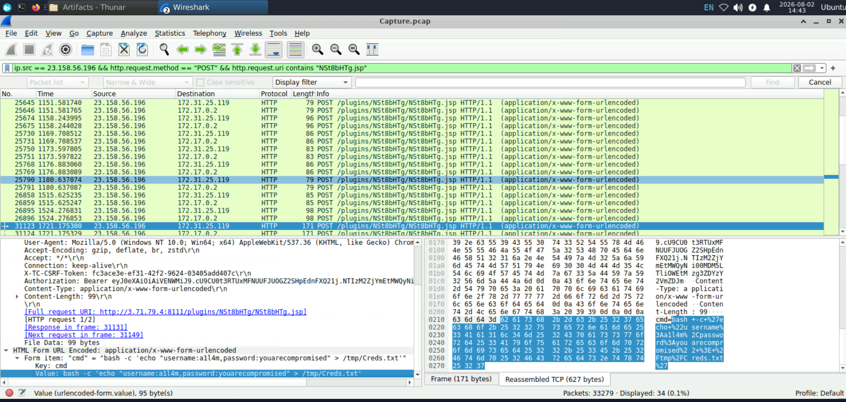
Figure 7 – Credentials File Tampering
Command explanation:
- bash -c executed the supplied command through Bash.
- echo prepared the attacker-controlled text.
- > overwrote the existing contents of the file.
- /tmp/Creds.txt was the modified credentials file.
The attacker wrote the following credentials:
all4m:youarecompromised
Answer: all4m:youarecompromised

5.8 Q8 – MITRE ATT&CK Technique
The attacker overwrote data already stored inside /tmp/Creds.txt.
The action affected the integrity of stored information rather than modifying data during network transmission or program execution.
The corresponding MITRE ATT&CK sub-technique is:
T1565.001 – Stored Data Manipulation
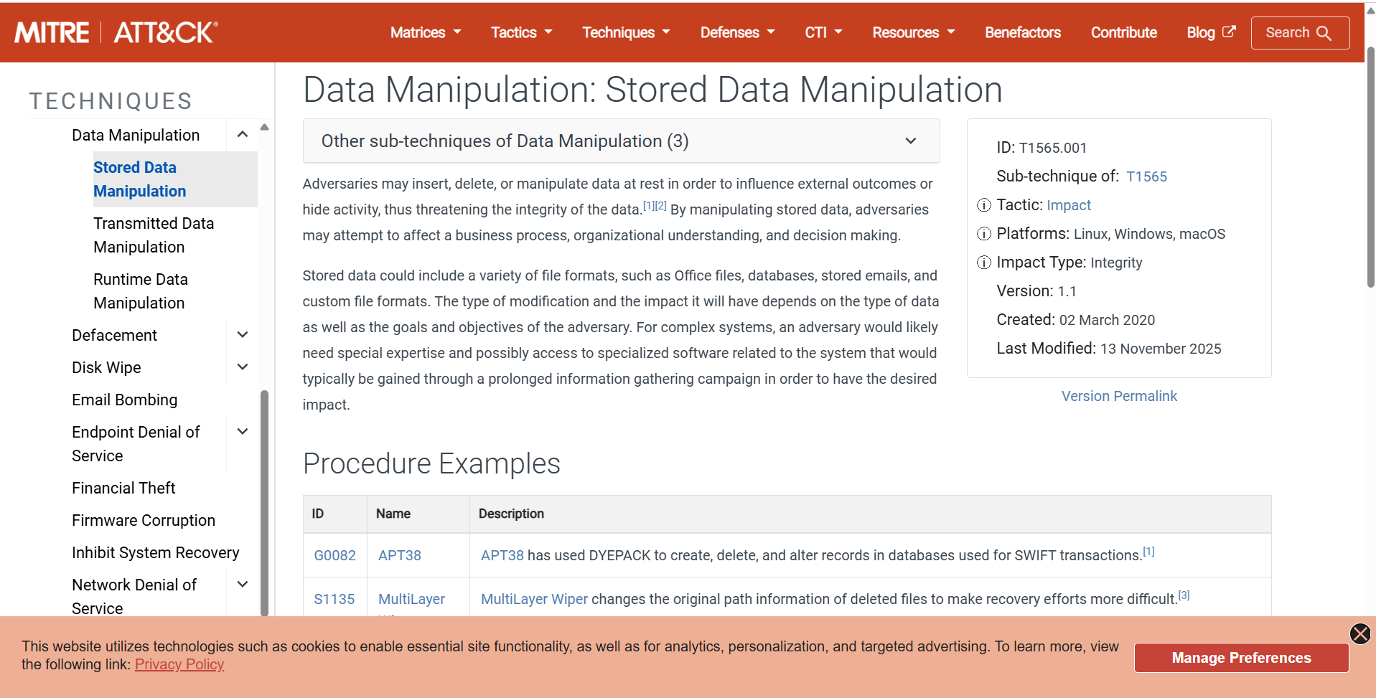
Screenshot – MITRE ATT&CK: Stored Data Manipulation (T1565.001)
Answer: T1565.001

5.9 Q9 – Container-Escape Attempt
Further examination of the web-shell commands revealed several Docker-related commands.
The command used to attempt access to the underlying Docker host was:
docker run --rm -it -v /:/host ubuntu chroot /host
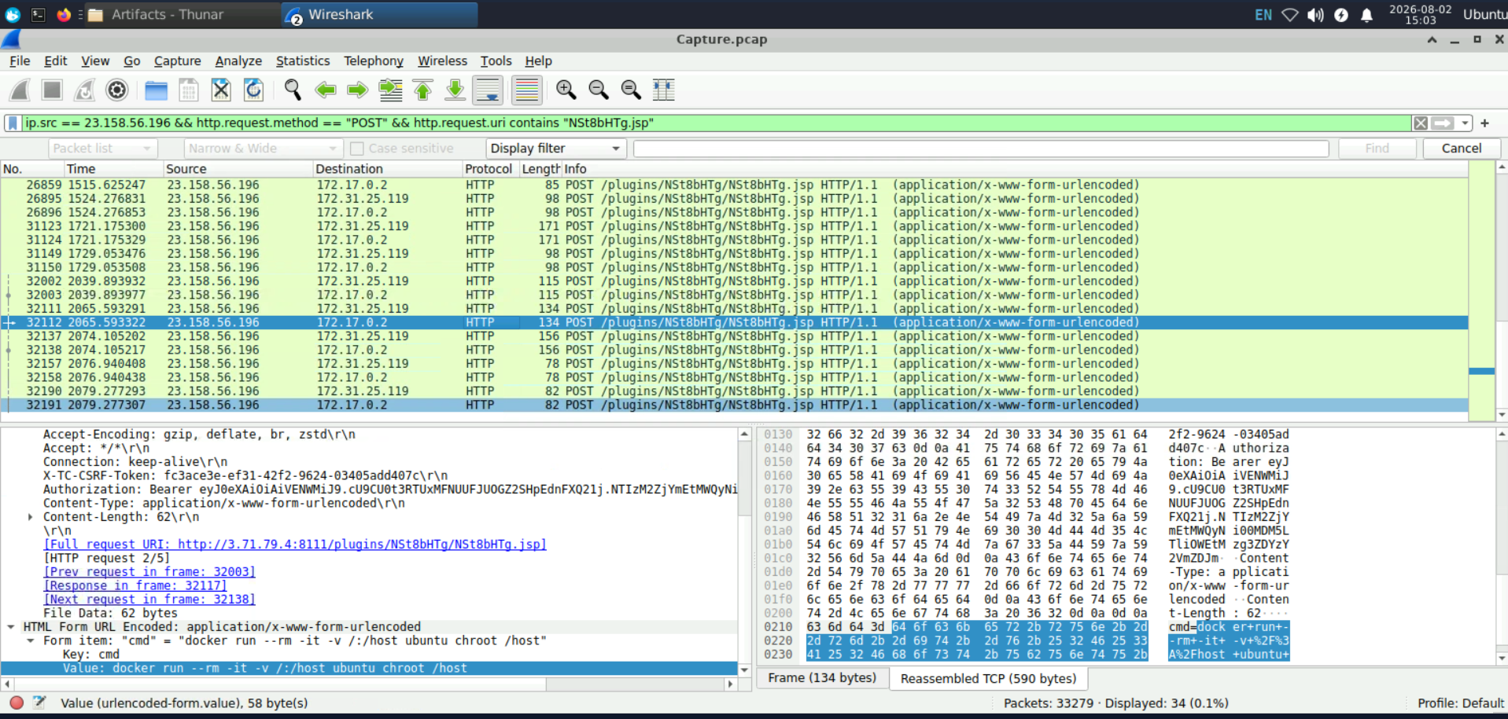
Figure 8 – Container-Escape Attempt
Command explanation:
Command component | Meaning
docker run | Starts a new Docker container
--rm | Removes the container after it exits
-it | Starts an interactive terminal
-v /:/host | Mounts the host root filesystem inside the container at /host
ubuntu | Specifies the container image
chroot /host | Attempts to treat the mounted host filesystem as the new root

The attacker attempted to mount the host's entire filesystem and then use chroot to access it from inside the new container.
According to the lab scenario, this container-escape attempt was unsuccessful.
Answer:
docker run --rm -it -v /:/host ubuntu chroot /host

6. Reconstructed Attack Chain
The complete attack was reconstructed as follows:
- The attacker at 23.158.56.196 connected to the public TeamCity server on TCP port 8111.
- The attacker exploited CVE-2024-27198 to bypass authentication.
- The attacker queried the TeamCity REST API and identified version 2023.11.3.
- A global administrator account named c91oyemw was created.
- The attacker generated an access token for the malicious account.
- The attacker uploaded NSt8bHTg.zip as a TeamCity plugin.
- The plugin deployed the NSt8bHTg.jsp web shell.
- Commands were executed through the cmd HTTP form parameter.
- The attacker overwrote /tmp/Creds.txt with new credentials.
- The attacker attempted, but failed, to escape the Docker container.

7. Indicators of Compromise
Indicator type | Value
Attacker IP | 23.158.56.196
Victim public IP | 3.71.79.4
Service port | 8111/TCP
Internal host | 172.31.25.119
Docker container IP | 172.17.0.2
Product | JetBrains TeamCity
Vulnerable version | 2023.11.3
Build number | 147512
Vulnerability | CVE-2024-27198
Malicious username | c91oyemw
Malicious email | c91oyemw@example.com
Uploaded archive | NSt8bHTg.zip
Web-shell file | NSt8bHTg.jsp
Web-shell path | /plugins/NSt8bHTg/NSt8bHTg.jsp
Modified file | /tmp/Creds.txt
Inserted credentials | all4m:youarecompromised
Suspicious URI pattern | /hax?jsp=/app/rest/...;.jsp

8. MITRE ATT&CK Mapping
Tactic | Technique | Evidence
Initial Access | T1190 – Exploit Public-Facing Application | Exploitation of the exposed TeamCity server
Persistence | T1136 – Create Account | Creation of a global administrator
Persistence | T1505.003 – Web Shell | Deployment of the malicious JSP web shell
Execution | T1059.004 – Unix Shell | Execution of Bash commands
Command and Control | T1071.001 – Web Protocols | Commands submitted through HTTP POST requests
Impact | T1565.001 – Stored Data Manipulation | Modification of /tmp/Creds.txt
Privilege Escalation | T1611 – Escape to Host | Failed Docker container-escape attempt

9. Detection Opportunities
The following detections could help identify similar attacks:
- Alert on requests containing both ?jsp= and ;.jsp in TeamCity URLs.
- Monitor unauthenticated access to protected TeamCity REST endpoints.
- Detect newly created accounts receiving the global SYSTEM_ADMIN role.
- Alert on access-token creation immediately after a new administrator is created.
- Monitor POST requests to /admin/pluginUpload.html.
- Validate the origin and integrity of uploaded TeamCity plugins.
- Hunt for unexpected JSP files inside TeamCity plugin directories.
- Detect repeated HTTP POST requests containing a parameter named cmd.
- Alert when a container attempts to execute Docker commands.
- Detect containers using --privileged, mounting /, accessing docker.sock, or executing chroot.

10. Remediation Recommendations
The following remediation steps are recommended:
- Immediately isolate the affected TeamCity server.
- Preserve the PCAP, TeamCity logs, container logs, authentication logs, and host logs.
- Upgrade TeamCity to a fixed and currently supported version.
- Remove the malicious plugin and JSP web shell.
- Delete the attacker-created user and revoke all related access tokens.
- Restore /tmp/Creds.txt from a trusted source.
- Rotate all administrative accounts, API tokens, repository credentials, build secrets, and signing keys accessible to TeamCity.
- Rebuild the compromised container from a trusted image.
- Investigate the Docker host separately to ensure the failed escape attempt did not cause additional damage.
- Prevent containers from accessing /var/run/docker.sock.
- Block unnecessary privileged containers and host filesystem mounts.
- Restrict access to the TeamCity administration interface using network controls.

11. Conclusion
The network forensic investigation confirmed that the TeamCity server was compromised through CVE-2024-27198.
The attacker bypassed authentication, created a privileged administrator account, uploaded a malicious plugin containing a JSP web shell, and executed operating-system commands through HTTP.
The attacker also manipulated a stored credentials file and attempted to escape from the Docker container. Although the container-escape attempt was unsuccessful, the confirmed web-shell execution means that the affected TeamCity environment should be considered fully compromised.
This investigation demonstrates that identifying an attacker should not rely only on packet volume. The final conclusion was based on a complete behavioral chain consisting of authentication bypass, account creation, plugin upload, web-shell execution, file manipulation, and attempted container escape.

12. References
- CyberDefenders – JetBrains Lab: https://cyberdefenders.org/blueteam-ctf-challenges/jetbrains/
- JetBrains – TeamCity Security Advisory: https://blog.jetbrains.com/teamcity/2024/03/additional-critical-security-issues-affecting-teamcity-on-premises-cve-2024-27198-and-cve-2024-27199-update-to-2023-11-4-now/
- NIST NVD – CVE-2024-27198: https://nvd.nist.gov/vuln/detail/CVE-2024-27198
- Rapid7 – TeamCity Authentication Bypass Analysis: https://www.rapid7.com/blog/post/2024/03/04/etr-cve-2024-27198-and-cve-2024-27199-jetbrains-teamcity-multiple-authentication-bypass-vulnerabilities-fixed/
- MITRE ATT&CK – Stored Data Manipulation: https://attack.mitre.org/techniques/T1565/001/

