CYBERDEFENDERS

PoisonedCredentials Network Forensics Investigation
  - NBNS and LLMNR poisoning with SMB and NTLM analysis
Incident Investigation Report
Evidence: PoisonedCredentials.pcap
Prepared by Alaa Zahra
SOC Analyst Tier 1
1 October 2026
Training-lab report based on the supplied packet capture

Executive Summary
The supplied packet capture records a local-network name-resolution poisoning incident. A workstation attempted to resolve a misspelled file-share name, which triggered NBNS and LLMNR fallback traffic. The host 192.168.232.215 answered the NBNS request and falsely claimed ownership of the requested name.
Scope analysis showed that the same responder also sent forged replies to 192.168.232.176. Several minutes later, 192.168.232.215 initiated an SMB connection to that host and completed an NTLM authentication exchange using the domain identity cybercactus.local\janesmith. The NTLM challenge identified the SMB destination as AccountingPC.cybercactus.local.
The evidence supports an assessment of NBNS/LLMNR poisoning followed by credential misuse and SMB access. The capture does not expose a plaintext password and does not conclusively distinguish between cracking, relaying, pass-the-hash, or another credential-acquisition method.

Key Findings
Question | Finding
Mistyped name | FILESHAARE
Rogue responder | 192.168.232.215
Additional poisoned host | 192.168.232.176
Compromised user | cybercactus.local\janesmith
SMB target | AccountingPC.cybercactus.local

Scope and Evidence
- Evidence file: PoisonedCredentials.pcap
- Packets analyzed: 269
- Primary tool: Wireshark
- Relevant protocols: NBNS, LLMNR, TCP, SMB2, and NTLMSSP
- Timestamps: shown in the Wireshark display format used during the investigation

Investigation Methodology
The investigation followed an evidence-outward workflow: establish a protocol baseline, isolate suspicious fallback name resolution, identify the responding host, expand the victim scope, and correlate the responder with later SMB and NTLM activity.
1. Review protocol statistics before applying assumptions about the attack.
2. Filter the initially supplied workstation's NBNS and LLMNR traffic.
3. Identify the host sending forged NBNS responses.
4. Search for every destination that received replies from the same responder.
5. Pivot from the rogue IP to TCP port 445 and NTLMSSP traffic.
6. Read the client identity from NTLMSSP_AUTH and the server identity from NTLMSSP_CHALLENGE.

Protocol Baseline
Wireshark's Protocol Hierarchy Statistics showed NBNS and LLMNR alongside NetBIOS Session Service, SMB, and SMB2. This combination is significant because unresolved Windows names can fall back to multicast or broadcast protocols, and an unauthorized responder can redirect the victim to an authentication-capable service such as SMB.
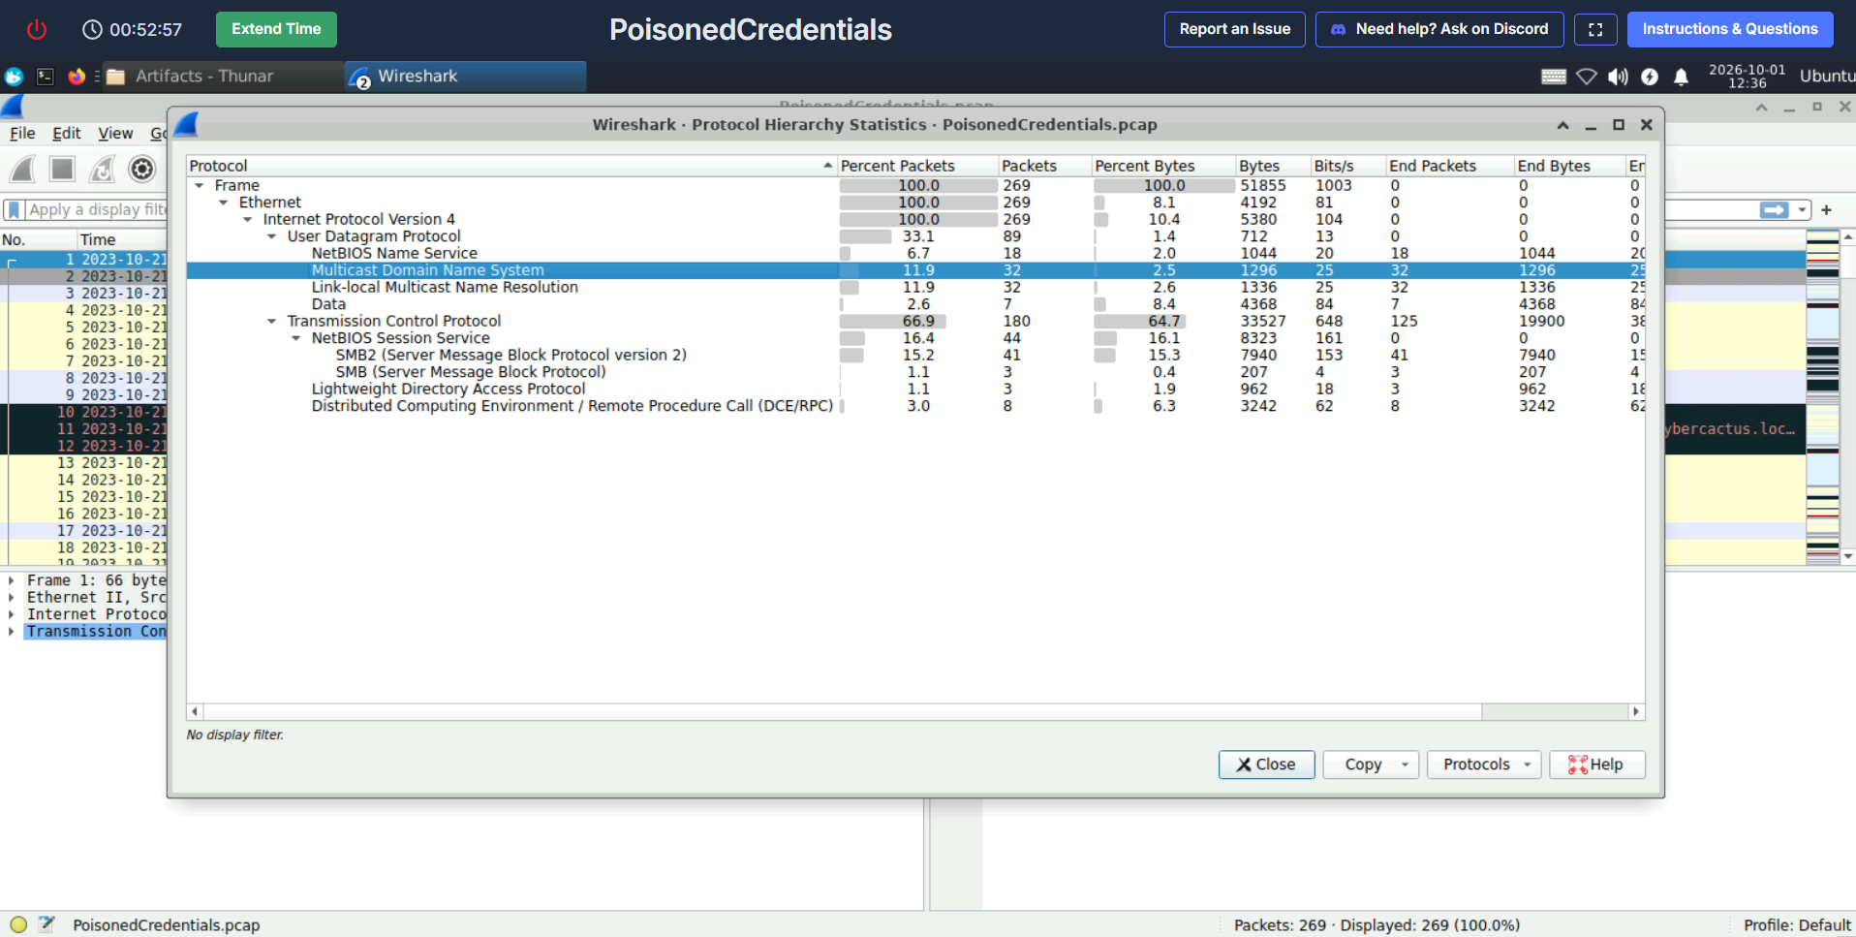
Figure 1. Protocol hierarchy for the 269-packet capture.

Finding 1 Mistyped Name Query
The investigation began with the initially identified workstation, 192.168.232.162. Its outbound NBNS and LLMNR requests were isolated to determine which unresolved name triggered the activity.

Wireshark Filter
ip.src == 192.168.232.162 && (nbns || llmnr)
The result contained a NetBIOS name query for FILESHAARE<20> and LLMNR queries for the equivalent lowercase name. The spelling includes an extra A. The <20> suffix identifies the NetBIOS file-server service, so this was an attempted file-share lookup rather than a general workstation-name lookup.
LLMNR sent its IPv4 request to multicast address 224.0.0.252 on UDP port 5355. NBNS used subnet broadcast on UDP port 137. Both mechanisms allowed any listening host on the local segment to respond.
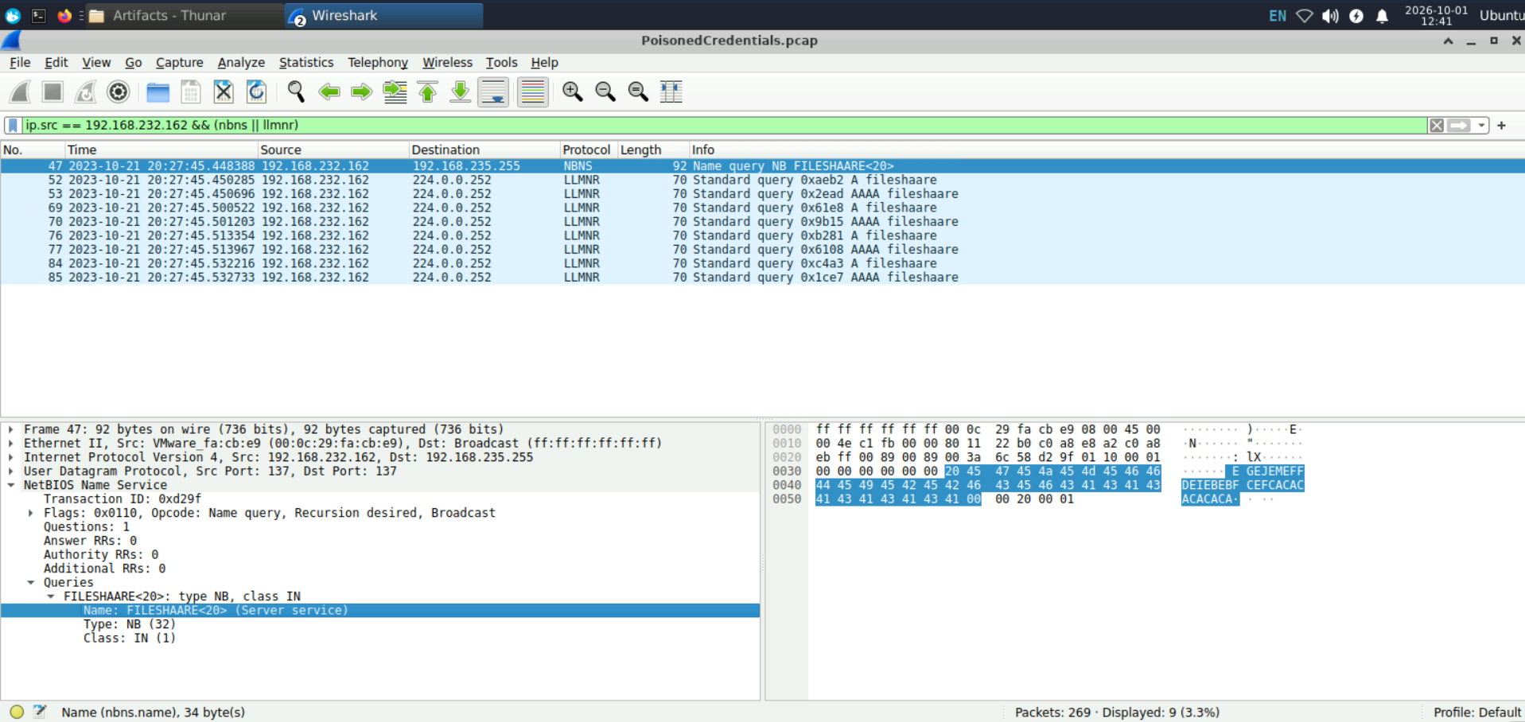
Figure 2. NBNS and LLMNR requests for the misspelled file-share name.
Finding: FILESHAARE

Finding 2 Rogue NBNS Responder
To identify the system that answered the unresolved query, the analysis focused on NBNS response packets sent back to the initial workstation.

Wireshark Filter
nbns.flags.response == 1 && ip.dst == 192.168.232.162
The returned packet originated from 192.168.232.215 and advertised that same address as the resolution for FILESHAARE<20>. Because the host answered a misspelled, non-authoritative name with its own address, the response is consistent with NBNS poisoning.
The response arrived approximately one millisecond after the query, a pattern that is common when a local poisoning tool is waiting to answer broadcast resolution requests.
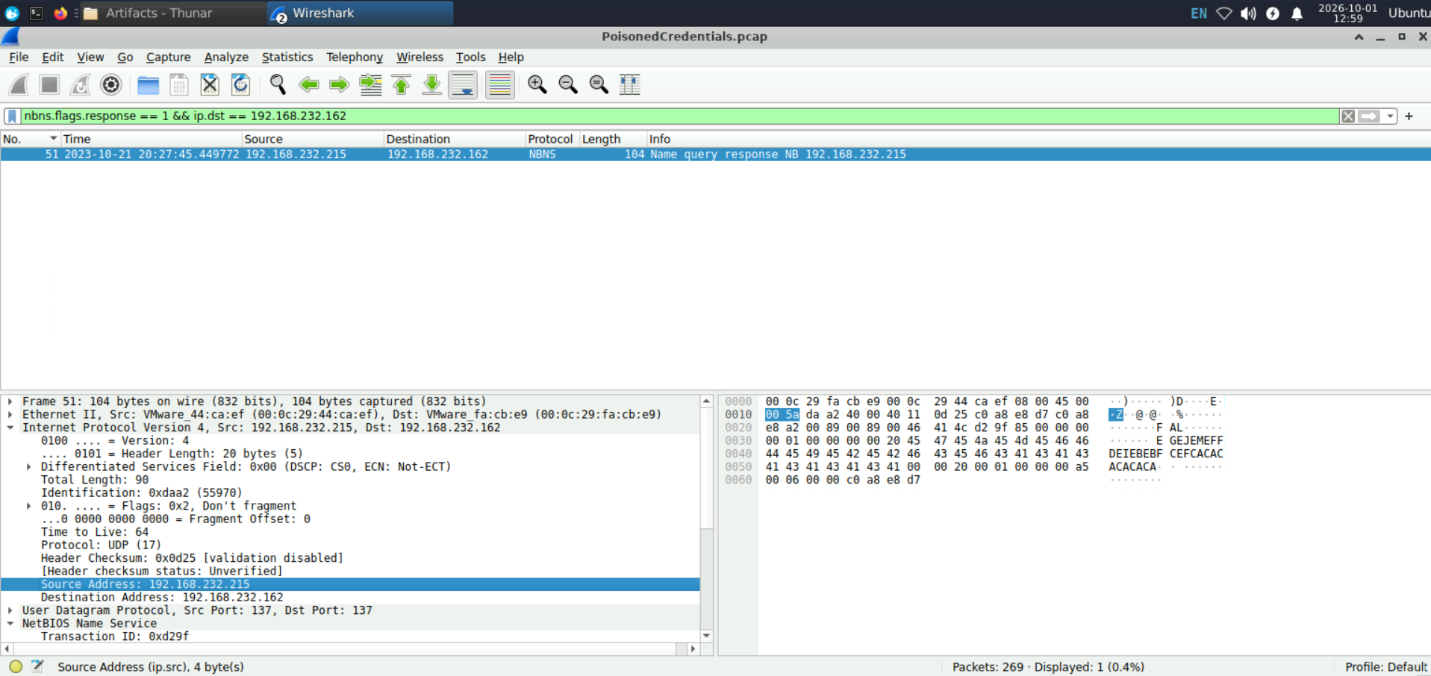
Figure 3. Forged NBNS response sent to the initial victim.
Rogue responder: 192.168.232.215

Finding 3 Additional Poisoned Host
A single endpoint report does not define the full incident scope. The responder was therefore treated as the pivot, and every NBNS response from that address was reviewed.

Wireshark Filter
nbns.flags.response == 1 && ip.src == 192.168.232.215
The result showed forged replies to both 192.168.232.162 and 192.168.232.176. This confirms that the poisoning behavior was not limited to the initially supplied victim.
The distinction matters operationally: the first host revealed the activity, while the second host became the target of the later SMB connection.
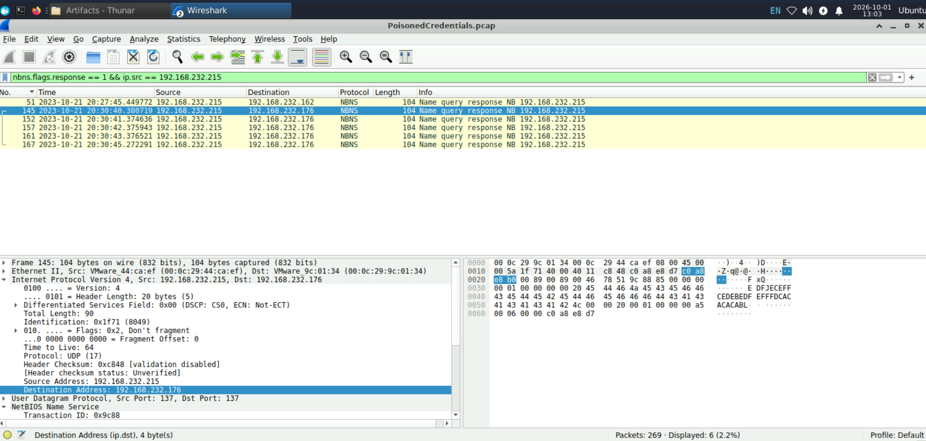
Figure 4. NBNS responses from the rogue host to multiple internal systems.
Additional poisoned host: 192.168.232.176

Finding 4 Compromised User Identity
The investigation then pivoted from poisoning traffic to SMB activity involving the rogue host. The objective was to determine whether name-resolution manipulation was followed by authenticated access.

Wireshark Filter
ip.addr == 192.168.232.215 && tcp.port == 445
The packet sequence showed 192.168.232.215 initiating TCP to 192.168.232.176:445, negotiating SMB, and completing the NTLM message sequence. Frame 242 was an NTLMSSP_AUTH message sent from the rogue host to the SMB target. Its Info column identified the account as cybercactus.local\janesmith.
Step | Direction | Evidence
TCP connection | .215 → .176:445 | SYN followed by SYN/ACK
SMB negotiation | .215 ↔ .176 | Negotiate request and response
NTLM negotiate | .215 → .176 | NTLMSSP_NEGOTIATE
NTLM challenge | .176 → .215 | NTLMSSP_CHALLENGE
NTLM authenticate | .215 → .176 | cybercactus.local\janesmith

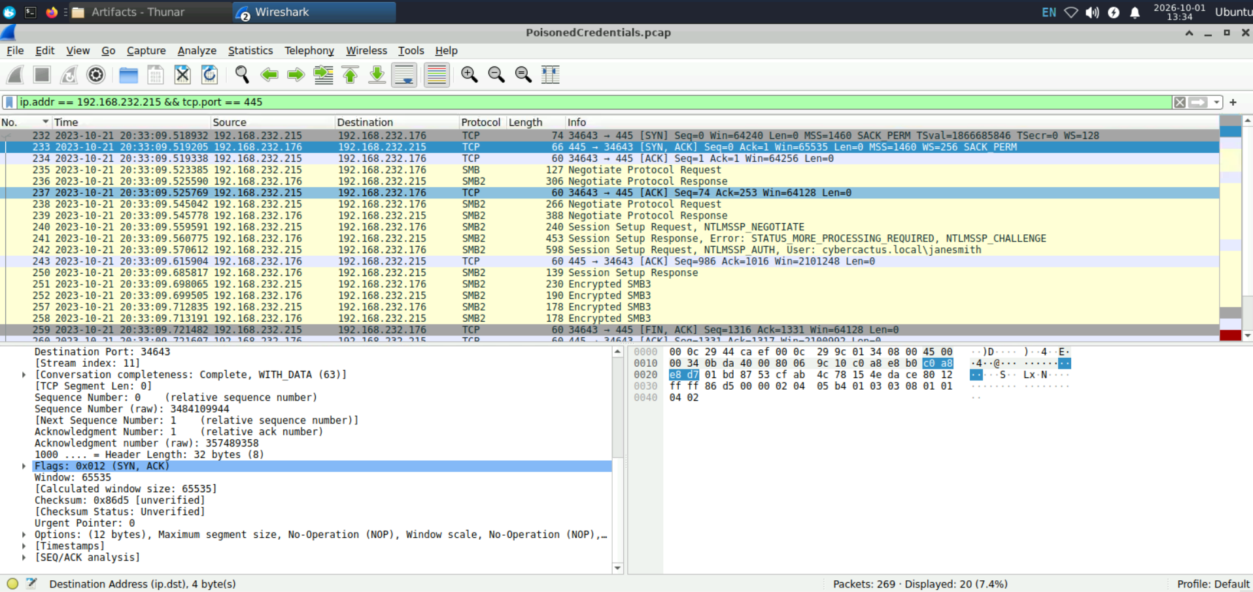
Figure 5. SMB and NTLM authentication sequence involving the rogue host.
Compromised username: janesmith

Interpretation Limitation
The username appears in a client-to-server authentication message because 192.168.232.215 is acting as the SMB client in this later connection. The PCAP proves that the identity was used or relayed; it does not reveal a plaintext password or conclusively prove the credential-acquisition technique.

Finding 5 SMB Target Hostname
The server-side NTLMSSP_CHALLENGE packet contains target information that identifies the destination independently of its IP address. Packet 241 was expanded under SMB2 Session Setup Response, Security Blob, NTLM Secure Service Provider, and Target Info.
NetBIOS computer name: ACCOUNTINGPC
DNS computer name: AccountingPC.cybercactus.local
The NetBIOS value is shown in uppercase because NetBIOS names are case-insensitive. The DNS value provides the full host identity inside the cybercactus.local domain.
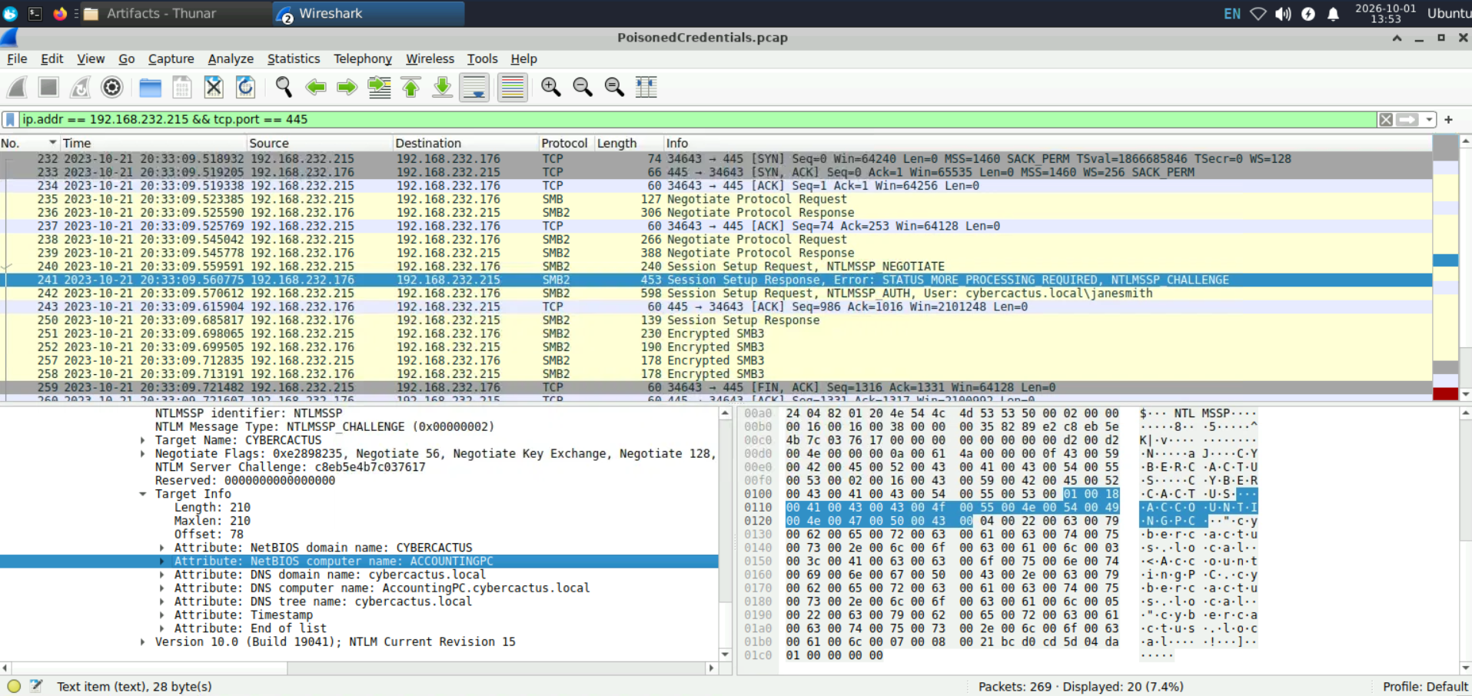
Figure 6. NTLM target information identifying the SMB destination.
SMB target hostname: AccountingPC

Reconstructed Timeline
The following sequence combines the name-resolution and SMB evidence into a single incident timeline.
Time | Event | Evidence
20:27:45.448 | Mistyped file-share lookup | NBNS query from .162 for FILESHAARE<20>
20:27:45.449 | False resolution returned | NBNS response from .215 to .162
20:30:40.380 | Second host poisoned | NBNS response from .215 to .176
20:33:09.518 | SMB connection begins | TCP SYN from .215 to .176:445
20:33:09.560 | NTLM challenge returned | Target information sent by .176
20:33:09.570 | User identity submitted | NTLMSSP_AUTH for janesmith
20:33:09.698 | Session setup completes | Response followed by encrypted SMB3 frames

Attack Chain
1. A user or process referenced the nonexistent file-share name FILESHAARE.
2. Windows fallback resolution generated NBNS and LLMNR queries.
3. 192.168.232.215 falsely claimed the requested name.
4. The same responder poisoned more than one internal workstation.
5. The rogue host later initiated SMB to 192.168.232.176.
6. The NTLM exchange used cybercactus.local\janesmith.
7. The target challenge identified AccountingPC.cybercactus.local.

Indicators of Compromise
Type | Indicator
Rogue IP | 192.168.232.215
Initial victim | 192.168.232.162
Additional host / SMB target | 192.168.232.176
Identity | cybercactus.local\janesmith
Hostname | AccountingPC.cybercactus.local
Queried name | FILESHAARE<20>

MITRE ATT&CK Mapping
Technique | Evidence | Confidence
T1557.001 LLMNR/NBT-NS Poisoning and SMB Relay | A rogue host returned forged NBNS answers for unresolved names. | High
T1078 Valid Accounts | The janesmith identity was used during NTLM authentication. | High
T1021.002 SMB/Windows Admin Shares | The rogue host initiated an SMB session to an internal target over TCP 445. | High

Pass-the-hash and password cracking are not mapped because the capture does not establish either technique. The evidence is consistent with credential misuse, but the exact mechanism remains undetermined.

Detection Opportunities
- Alert on internal endpoints that answer NBNS or LLMNR queries for many unrelated names or victims.
- Correlate fallback name-resolution responses with immediate SMB, HTTP, LDAP, or other authentication-capable connections.
- Identify workstations acting as unexpected NBNS responders.
- Monitor NTLM authentication for users appearing from new internal source systems.
- Alert on lateral SMB connections that violate workstation-to-workstation baselines.
- Preserve the full NTLM negotiate, challenge, and authenticate sequence when triaging suspected relays.

Containment Priorities
- Isolate 192.168.232.215 and preserve volatile evidence.
- Reset janesmith's password and invalidate active sessions.
- Review AccountingPC and 192.168.232.162 for follow-on access or persistence.

Remediation Recommendations
1. Disable LLMNR through Group Policy where it is not operationally required.
2. Disable NetBIOS over TCP/IP on systems that no longer depend on it.
3. Require SMB signing to reduce the effectiveness of relay attacks.
4. Restrict NTLM and prioritize Kerberos for domain authentication.
5. Limit inbound SMB with host firewalls, VLAN boundaries, and access-control lists.
6. Investigate the rogue host for poisoning tools, captured challenge-response material, and other credentials.
7. Review AccountingPC for unauthorized share access, remote administration, or persistence.
8. Train users to verify unexpected credential prompts and carefully check typed network paths.

Conclusion
The packet capture confirms a local name-resolution poisoning incident led by 192.168.232.215. A misspelled file-share lookup triggered NBNS and LLMNR fallback queries, and the rogue host falsely resolved the requested name to itself. The same behavior affected multiple endpoints, expanding the incident beyond the initially reported workstation.
The later SMB sequence connected the poisoning infrastructure to an authenticated session using cybercactus.local\janesmith against AccountingPC.cybercactus.local. Although the capture cannot prove how the credential was acquired, it clearly demonstrates why insecure fallback resolution, NTLM exposure, and unrestricted internal SMB create a viable path for credential abuse and lateral movement.

References
- CyberDefenders — https://cyberdefenders.org/
- MITRE ATT&CK T1557.001 — https://attack.mitre.org/techniques/T1557/001/
- MITRE ATT&CK T1078 — https://attack.mitre.org/techniques/T1078/
- MITRE ATT&CK T1021.002 — https://attack.mitre.org/techniques/T1021/002/
- Wireshark Display Filter Reference — https://www.wireshark.org/docs/dfref/

